UnitedGen

##### **Ketan Sharma1, R.Mallika2, Pranjali Shrivastava3, Ayush Verma4,Eshita Khare5,**

##### **Priyanshi Juneja6, Aaridhi Vishwakarma7, Soumya Naidu8**

VIT Bhopal University

Bhopal  
Madhya Pradesh

***Abstract*- In contemporary societal discourse, intersex individuals often face misidentification and marginalisation, frequently conflated with transgender persons. This research delves into the distinctive nature of intersex identities, where individuals embody a spectrum outside the conventional male/female sex binary. In contrast, transgender individuals experience a deviation between their gender identity and societal expectations associated with their assigned sex at birth. The intersex community in India, unfortunately, encounters derogatory labels and societal relegation, such as the terms "chakke" or "hijre."**

**This proposed initiative seeks to address the unique challenges faced by intersex and transgender individuals in India by creating a dedicated website. The platform aims to provide comprehensive information, support, and resources tailored to the needs of these communities. By bridging identities and fostering understanding, this initiative strives to empower individuals within the intersex and transgender communities, combating stigma and promoting inclusivity.**

***Keywords***- ***LangChain, LLM, Llama2, RAG, Prompt, Tools, Chains***

1. Introduction

T

his article provides a detailed guide on the development and utilisation of a website designed specifically to support intersex and transgender individuals. It outlines the process in a step-by-step manner, offering practical insights into how the website was created to cater to the unique needs of these communities. From conceptualisation to implementation, each stage of the website's development is explored, emphasising its role in providing comprehensive information, assistance, and resources. Through this walkthrough, readers gain a deeper understanding of how the website aims to empower and uplift intersex and transgender individuals.

1. Objective

The project aims to bridge the gap between the transgender/intersex community and society by promoting inclusivity, raising awareness, advocating for equal rights, providing support services, fostering understanding, and creating a more accepting environment. Its objectives vary based on educational, advocacy, or support-driven approaches, ultimately striving to address systemic barriers and biases for full participation and acceptance.

1. Literature Review

Angels Balaguers et al addresses RAG[2] pipeline consists of multiple stages, including extracting information from PDFs, generating questions and answers, using them for fine-tuning, and leveraging GPT-4 for evaluating the results. to the intersection of queer theory and artificial intelligence (AI). There are two common ways in which developers are incorporating proprietary and domain-specific data when building applications of Large Language Models (LLMs): Retrieval-Augmented Generation (RAG) and Fine-Tuning. RAG augments the prompt with the external data, while fine-Tuning incorporates the additional knowledge into the model itself.

Aditi Singh (2024) et al introduces MindGuide[1] leverages the capabilities of LangChain and its ChatModels, specifically ChatOpenAI, as the bedrock of its reasoning engine. The system incorporates key features such as LangChain's ChatPrompt Template, HumanMessage Prompt Template, ConversationBufferMemory, and LLMChain, creating an advanced solution for early detection and comprehensive support within the field of mental health.

1. Methodology

This section covers the data collection, details about the

selected model, the data sources of RAG pipelines, and integration with the FastAPI for web deployment.

### Data Collection

### To gather data from user we majorly expect the type of the problem that the user would be giving us. In this paper we have used three types of problems:-

1. Social: Asking for experiences of other people using social media platforms and other articles.
2. Information: Enquiring about any topic or information that may have doubt in or require awareness.
3. Query: These types of problems are solely questions that one might ask to solve. They might personal or social also.

Along with these three types of information we ask for the use message that user wants to give to LLM. We in backend prompt the message such way that it gives answers relevant to Indian citizens.

### Large Language Model

### We had two options to choose from either we could go for the paid LLM models such GPT-4[1] or any open source model. In order to make the app run locally also and free of cost we chose a famous open source LLM model Llama2[3]. Llama would get the message with an additional prompt from the user generate some output. But due to its lack of information it might fail to generate some outputs efficiently. This is the problem we solve using our RAG pipeline. LLama2 is an open source LLM model which is very powerful for generating embeddings and using it as an AI chatbot for conversations.

### RAG(Retrieval Augmented Generation) Pipeline

### Here we introduce RAG pipeline that will solve the issue with our LLM as stated in above section. In order to fine-tune or extend our LLM model we have used LangChain[4] to create tools to extract data and agent to execute the LLM along with the data retrieved from these sources. The tools we used are as follows:-

1. Google Custom Search API
2. Arxiv API
3. Wikipedia API
4. Document Retrieval Custom Tool

Using these tools we are able to form an advanced pipeline which can generate good amount of results.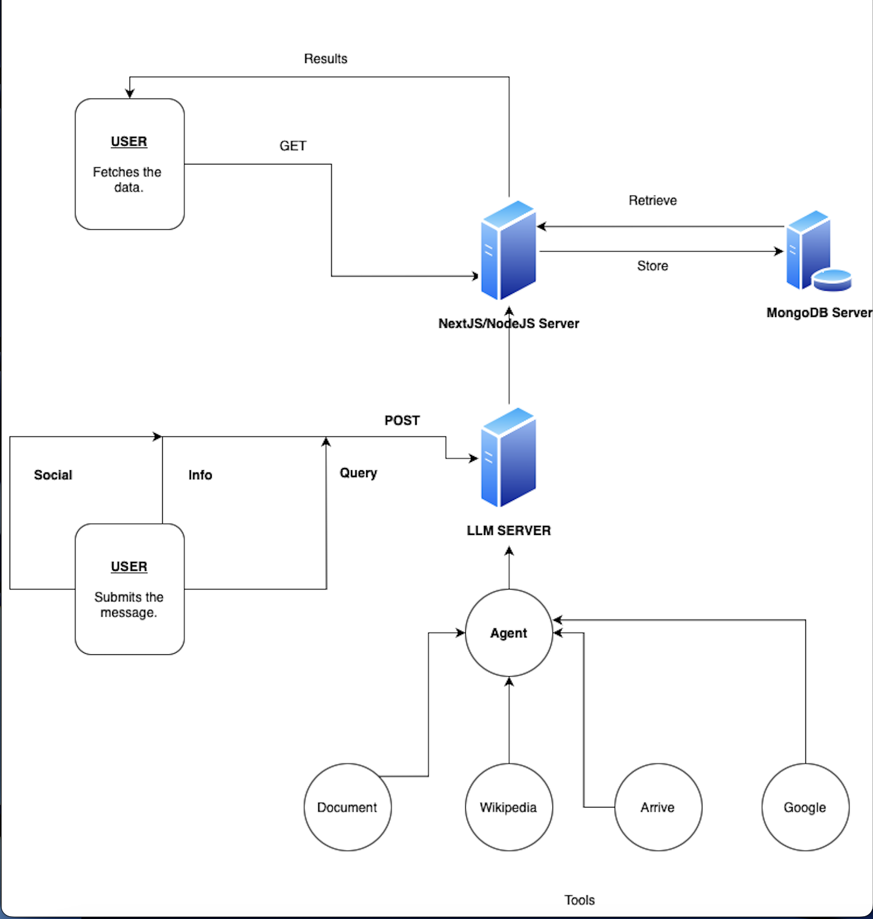

1. Conclusion

Thus, from the above approaches we can conclude that we can create various chatbots and self-help AI in order to solve ones queries and also spread awareness about the whole gender spectrum. We can also train our AI to be gentle and positive towards sensitive citizens. LangChain has comet to be the best tool to fine-tune any model and create chains of prompts, tools and agents which can help developers to create advanced multi-source RAG pipelines.

##### References

1. Singh, A., Ehtesham, A., Mahmud, S., & Kim, J. (2024, January 8). Revolutionizing *Mental Health Care through LangChain: A Journey with a Large Language Model.* <https://doi.org/10.1109/ccwc60891.2024.10427865>
2. Balaguer, A., Benara, V., De Freitas Cunha, R. L., De M Estevão Filho, R., Hendry, T., Holstein, D., Marsman, J., Mecklenburg, N., Malvar, S., Nunes, L. O., Padilha, R., Sharp, M., Silva, B., Sharma, S., Aski, V., & Chandra, R. (2024, January 16). *RAG vs Fine-tuning: Pipelines, Tradeoffs, and a Case Study on Agriculture*. arXiv.org. https://arxiv.org/abs/2401.08406
3. Touvron, H., Martin, L., Stone, K., Albert, P., Almahairi, A., Babaei, Y., Bashlykov, N., Batra, S., Bhargava, P., Bhosale, S., Bikel, D., Blecher, L., Ferrer, C. C., Chen, M., Cucurull, G., Esiobu, D., Fernandes, J., Fu, J., Fu, W., . . . Scialom, T. (2023, July 18). *Llama 2: Open foundation and Fine-Tuned chat models*. arXiv.org. <https://arxiv.org/abs/2307.09288>
4. Pandya, K., & Holia, M. (2023, October 9). *Automating Customer Service using LangChain: Building custom open-source GPT Chatbot for organizations.* arXiv.org. <https://arxiv.org/abs/2310.05421>

*Figure-1*

# Results

In this section, we have provided some results that are generated by our LangChain agent. The table below shows the rating with the output generated of the corresponding prompt or question.

| **Message** | **Tool** | **Rating** |
| --- | --- | --- |
| What is Transgender? | Google | 3 |
| Difference between intersex and trans? | Google | 4 |
| Give me some research on Transgender community. | Wiki/Google | 2 |
| Tell me about transgender rights? | Google | 4 |

*Table - 1*