project in wireless communication report

Koustubh sharma

## Task 1

As per the given setup conditions, the system was implemented and the BER was calculated. We generated a base pulse which was mapped to QPSK modulation and up-converted to be sent over the channel where we added the noise. On the receiver side we first down converted and then matched the received signal, sampled and then demodulated to find out the BER.

Generate base pulse

QPSK Modulation

Up conversion

Matched filter

Down Conversion

Channel

Calculate BER

Demodulate

Sampling

Fig 1. Steps taken to obtain the BER

This figure below shows the resulting BER curve obtained:

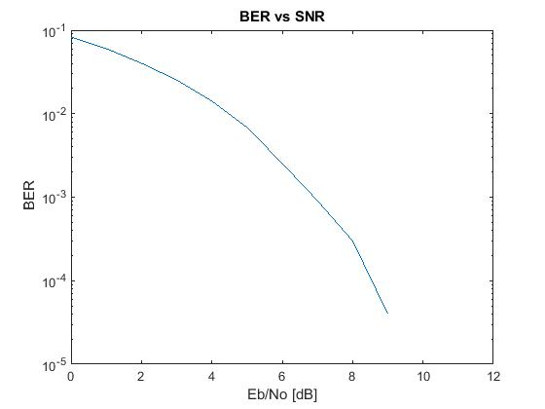

Fig 2. Obtained BER curve

## Task 2

We decoded the given signal similar to task 1 but here we had 2 pilot symbols added to the front and to the end of the signal, so we found out the transmitted signal by synchronizing with the pilots. The following message was decoded from the signal:

*Turbo Codes were invented by Berrou, Glavieux and Thitimajshima 1993.*

Matched Filter implementation

Signal

Down Conversion

ASCII value

Demodulate

Sync & Sample

Message

Fig 3. Task 2-system implementation to extract out message from signal

## Task 3

Just like task 2 we were given a signal, we filtered out the signal using the Butterworth filter and sampled. Then we removed the cyclic prefix from the OFDM blocks to perform FFT on them. After channel estimation and demodulating the QPSK symbols we decoded the Viterbi Algorithm to obtain the following message from the signal:

*Any linear combination of Gaussian random variables is again a Gaussian random variable*.

Low pass filter

Signal

Down Conversion

Sync & Sample

FFT

CP removal

Message

Decode & convert to ASCII

Demodulate

Fig 4. Task 3-system implementation to extract out message from signal