project in wireless communication report
Koustubh sharma

Task 1
As per the given setup conditions, the system was implemented and the BER was calculated. We generated a base pulse which was mapped to QPSK modulation and up-converted to be sent over the channel. where we added the noise. On the receiver side we first down converted and then matched the received signal, sampled and then demodulated to find out the BER.
QPSK Modulation
Generate base pulse
Up conversion
Matched filter
Down Convert
Sampling
Channel
Demodulate
Calculate BER

Fig 1. Steps taken to obtain the BER
This figure below shows the resulting BER curve obtained:

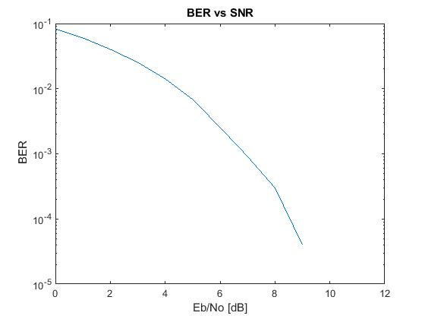
Fig 2. Obtained BER curve

Task 2
We decoded the given signal similar to task 1 but here we had 2 pilot symbols added to the front and to the end of the signal, so we found out the transmitted signal by synchronizing with the pilots. The following message was decoded from the signal:
Turbo Codes were invented by Berrou, Glavieux and Thitimajshima 1993.

Down Conversion
Matched Filter implementation
ASCII value
Demodulate
Message
Sync & Sample
Signal

Fig 3. Task 2-system implementation to extract out message from signal

Task 3
Just like task 2 we were given a signal, we filtered the signal using the Butterworth filter and sampled. Then we removed the cyclic prefix from the OFDM blocks to perform FFT on them. After channel estimation and demodulating the QPSK symbols we decode the Viterbi Algorithm to obtained the following message from the signal:
Any linear combination of Gaussian random variables is again a Gaussian random variable.

Down Conversion

Signal
Low pass filter

FFT

CP removal

Demodulate
Sync & Sample

Decode & convert to ASCII
Message

Fig 4. Task 3-system implementation to extract out message from signal

