

Master Thesis

Comparison of energy efficiency in Heterogeneous Networks scenario between macro and micro cells for 5G deployment.

By

Koustubh Sharma

Department of Electrical and Information Technology Faculty of Engineering, LTH, Lund University

SE-221 00 Lund, Sweden

1

Abstract

Energy plays an important role in our lives, almost every industry depends heavily on energy. In recent times with the rising global temperature and climate change, the importance of saving energy has become ever important. With the rapid development of ICT (Information and Communication Technology) industry the demand for power has also increased. ICT tends to play a significant role in global greenhouse gas emissions. Cellular networks are among the main energy consumers in the ICT field. It was responsible for 10% of world’s total energy consumption in 2010 and is doubling in every 10 years.

With the outset of 5G, many cities will be deployed with micro cells, Pico, and macro cells. The networks will densify at a very fast pace. With the onset of internet of things, we would need a lower latency densified network for self-driving cars, buses etc. New technologies like augmented reality and virtual reality are bound to demand higher data rates. So, the mobile broadband networks will need to be strengthened.

In order to have an environment friendly transit into this era of internet of things, we also need to focus on energy consumption by these networks. There are various approaches for densifying the present network that we have. We will look into an approach to cater to these traffic demands with traditional macro cells versus small cells like micro cells.

Acknowledgments

Thanks to everyone who extended their support during the master thesis. And to my parents for their constant support and motivation.

Koustubh Sharma

Contents

Introduction 3

Introduction 3

Background and Motivation 3

Previous Work 5

Purpose of the Project 6

Outline of the Thesis 7

Theory 9

Heterogeneous Networks 9

Macro Cells: 10

Micro Cells 11

Pico Cells 11

Femto cell 11

LTE Basics 11

OFDM (Orthogonal Frequency Division Multiplex) 11

MIMO (Multiple Input Multiple Output) 12

Power Model 13

Power distribution in base station 13

Variable load power consumption of BS 16

Energy consumption references 18

Energy per bit 18

Power per unit area 18

Averaging power consumption 19

Average power consumption over a day 19

Methodology 21

The Simulator 21

Setup 21

Deployment 22

Traffic 23

Results and Discussions 25

Future Work 31

References 32

# Introduction

## Introduction

Energy plays an important role in our lives, almost every industry depends heavily on energy. In recent times with the rising global temperature and climate change, the importance of saving energy has become ever important. With the rapid development of ICT (Information and Communication Technology) industry the demand for power has also increased. ICT tends to play a significant role in global greenhouse gas emissions. Cellular networks are among the main energy consumers in the ICT field. It was responsible for 10% of world’s total energy consumption in 2010 and is doubling in every 10 years (Dufková, Bjelica, Moon, Kencl, & Le Boudec, n.d.). With increased need for broadband speed, the demand for energy and densification of networks is likely to increase. High energy efficiency is becoming a mainstream concern for the design of future wireless communication networks.

## Background and Motivation

The global mobile data traffic grew by 63 percent in 2016.(“Cisco Visual Networking Index: Forecast and Methodology Cisco Visual Networking Index: Cisco Visual Networking Index: Forecast and Methodology,” 2015) it stood at 7.2 billion Giga bytes per month during the ending of 2016. And by 2021 it will be 49 billion Giga bytes.

Almost half a billion new mobile devices were added in 2016 and according to the Ericsson’s forecast there will be 50 billion connected devices by 2020.

Since the introduction of mobile networks, the focus has often been on optimizing the network to fulfil the coverage, capacity and quality requirements. Products have been developed and network deployments have been designed, focusing mainly on these key requirements. During recent years, operators have started to investigate how energy is consumed in mobile networks. The understanding has increased on how energy consumption can be reduced, and environmental awareness has gained importance in the mobile telecom industry. The challenge with designing an energy efficient network is to avoid reducing quality or coverage and hence reducing the performance.

About 0.5% of the world energy consumption is from mobile radio networks.(Fehske, Richter, & Fettweis, n.d.) In mobile networks, base stations are the ones which consume the most amount of energy. Comparing the life cycle of a mobile and base station, a mobile would contribute to green-house gases the most at the time of its manufacturing while for the base station, it is during its life time as a serving node. A lot of research has been done in order to make mobile more efficient at consuming battery power but, base station remain behind their counterparts. Around 80% of the total energy in mobile networks is consumed in radio access network and majorly in base station which comes around to be 60% of the whole (Fehske et al., n.d.). Which stresses on call for reducing this energy consumption at the base station side.

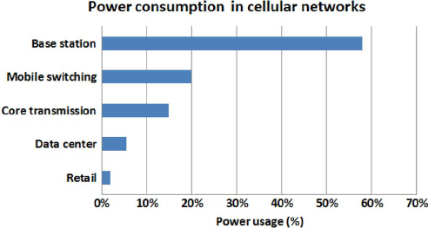

Figure 1. Breakdown of energy consumption in cellular networks (Source Vodafone) (Han et al., 2011)

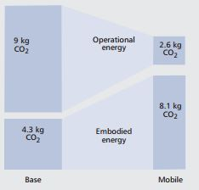

Figure 2. The operational and the embodied CO2 emissions by base stations and mobile phones per subscribers per year (Han et al., 2011)

## Previous Work

There had been studies related to improvement of the base stations energy consumption, and in 2010-2012 a study was conducted under Energy Aware Radio and netWork tecHnologies (EARTH) project in which researchers from around the world tried to achieve deliverables (Domenico & Petersson, 2012) which proved to become standardized principles for working on energy efficiency concepts for base stations.

In the executive summary of their final deliverable they state that: “The Energy Aware Radio and neTwork tecHnologies (EARTH) project had the ambitious overall goal to derive solutions that together can decrease the radio access network energy consumption by 50 % with preserved quality of service. These solutions act all the way from more efficient components in the base station, over improvements affecting individual radio links, up to solutions acting on the radio network level such as deployment strategies. Furthermore, the project not only developed and proposed energy efficient solutions in all these areas, but also combined them into an overall EARTH energy efficient integrated concept. In addition, EARTH is committed to having a real impact on networks in operation; hence the target was not only to carry out theoretical studies in this aspect, but also to provide trustworthy proof-of-concepts of the individual solutions and in particular of the overall EARTH energy efficient integrated concept.” (Domenico & Petersson, 2012).

The EARTH project gave the mathematical power model for calculating the energy consumption in the base stations for various different scenarios of rural, sub-urban and urban, the linear power model is used in generic simulations. It also gives the internal breakdown of energy consumed within different sizes of nodes such as macro, mico, pico and femto.

In (Desset et al., 2012) the study was conducted to break up the energy consumed by different components of the BS in macro, pico and other cells that support the 3GPP LTE standard. It supports the Earth Project’s state of the art (SoTA) power model.

In(Yunas, Valkama, & Niemelä, 2015) a “Manhattan-type city grid” is analyzed for energy performance in which off-loading the macro cells with indoor cells prove to be more energy efficient.

In (Forssell & Auer, 2015) study was conducted to find if in a dense urban scenario, the indoor nodes would prove to be energy efficient or not but, to the contrary they proved to be worse than keeping only the macro BS grid in the scenario.

In (Tombaz, Sung, & Zander, 2012) study was conducted on densification of network in which it was found out that the deployment of smaller cells reduces the transmit power of large BSs and the idle time and backhaul proved to be energy wasters

In (Falconetti, Frenger, Kallin, & Rimhagen, 2012) a heterogeneous network scenario was considered in which network densification strategies were introduced and to save the power; micro DTX and pico node sleep modes were utilized to prove that the network densification could take place successful without increasing the energy requirements. The heterogeneous network was composed of macro nodes and pico nodes. At high traffic energy could be saved a lot by smaller nodes handling large traffic, thereby increasing user performance and decreasing energy consumption at the same time. In one of the deliverables of EARTH Project DTX scheme was also presented.

We will make use of these energy saving features like short term DTX and long term sleep modes in the nodes. We will make use of Ericsson’s static network simulator which will present us a realistic three-dimensional model of a city with buildings, pavements and open spaces. The simulator makes use of ray-tracing propagation models.

## Purpose of the Project

With the outset of 5G, many cities will be deployed with small cells. The networks will densify at a very fast pace. With the onset of internet of things, we would need a lower latency densified network for self-driving cars, buses etc. New technologies like augmented reality and virtual reality are bound to demand higher data rates. So, the mobile broadband networks will need to be strengthened.

In order to have an environment friendly transit into this era of internet of things, we also need to focus on energy consumption by these networks. There are various approaches for densifying the present network that we have. We will look into an approach to cater to these traffic demands with traditional macro cells versus small cells like micro cells.

## Outline of the Thesis

In this thesis chapter 1 deals with the introduction, background and motivation for this project, chapter 2 is about the theory of BSs which describes about various cells used in a typical heterogeneous deployment the LTE basics, chapter 3 is where we explain the Earth Power model and the simulation setup is explained in the chapter 4, results and discussion are in chapter 5 and we conclude with future work in chapter 6.

# Theory

## Heterogeneous Networks

With the onset of 5G, there will be a lot of use of HetNets and densified networks to satisfy the demand for increased traffic. Most of the mobile traffic around 70% will be concentrated around high traffic centers like downtown of an urban city (Ericsson white paper, 2014). There will be small cells which would be deployable as ‘plug and play’ which is going to save a lot of CAPEX for the operators and as these smaller cells will have a small coverage area which will enable frequency to reuse possible being close to each other which will provide large capacity improvement (Yunas et al., 2015).

With the incoming 5G spectrum allocation, speculations are that frequency spectrum for 5G will lie in very high frequencies of the order 30 GHZ, according to a study done with coverage and penetration of these waves in indoor environment will be very problematic. “Achieving indoor coverage at 30 GHz is highly problematic for all cases, and it is concluded that smaller base stations are necessary if frequencies of 10 GHz and above are to be used in future mobile networks.” (Rydén, 2016)

Here is a brief theory about the cells which constitute a HetNet.

|  |  |  |  |  |
| --- | --- | --- | --- | --- |
| Specification | Femtocell | Picocell | Microcell | Macrocell |
| Transmit Power | 20 dBm | 30dBm | 30dBm |  |
| Power Consumption | Low | Low | Moderate | High |
| Coverage distance | Less than 30m | Less than 100 m | Less than 500m | Several kms |
| Deployment | Indoor | Indoor and Outdoor | Outdoor and Indoor | Outdoor |
| Backhaul connectivity | DSL, cable, fiber | Microwave, mm | Microwave, Fiber | Microwave, Fiber |
| Installation | User | Operator | Operator | Operator |

Table 1. Comparison between different types of nodes in a heterogeneous network.

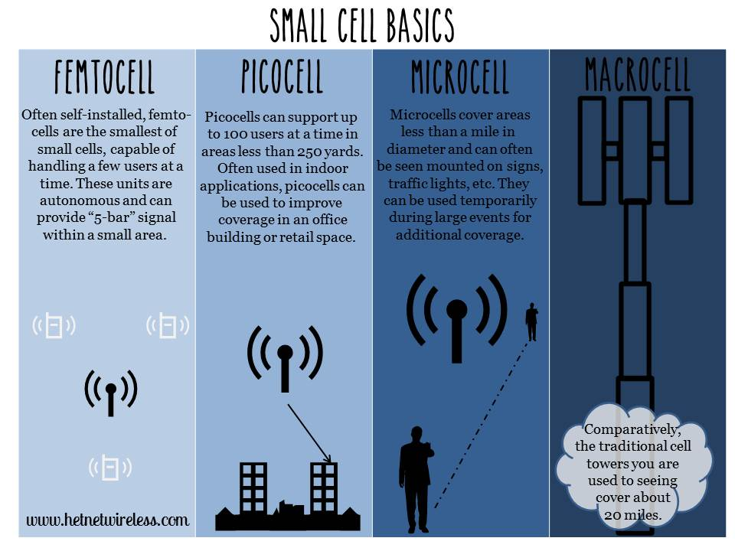

Figure 3. Small cells pictorial representation (www.hetnets.com)

### Macro Cells:

These cells are the base stations that provide coverage to a large area with Inter site distance (ISD) around 200m to several kilometers. depending upon the density. They fulfill the baseline coverage for any LTE network, providing connectivity and up all the time. The power consumption varies from 100 to 180 W. they have sectored antennas normally covering 120 degrees per sector.

### Micro Cells

Micro cells have lower transmit power than macro BSs, they are smaller base stations with full features that can be used to cover both indoor and outdoor crowded areas(Ericcson, n.d.). It can typically cover a range of few metres to one or two kilometers. The power consumption ranges from 40W to 50W. They are generally used for indoor purposes as well as outdoor such as hot-spots.

### Pico Cells

Pico cells have lower transmit power than macro BSs, they have Omni-directional antennas unlike macro BSs which are sectored. The transmit power ranges from 250mW to 2W. They are generally used for indoor purposes around hot-spots like offices, railway stations etc. and are connected over X2 interface. (Landström & Anders, 2011)

### Femto cell

Femto cells are also known as HeNBs are deployment for small rooms and home requirements generally for a very small range coverage less than 30m. They have Omni-directional antennas, transmit power is around 100 mW. They could be plugged in using a DSL line or modem cable. (Landström & Anders, 2011).

## LTE Basics

### OFDM (Orthogonal Frequency Division Multiplex)

In LTE the OFDM modulation technique is used to produce orthogonality between the sub-carriers in frequency domain. A sub-carrier is of 180 kHz. The OFDM provides resistance to interference in between LTE sub-carriers, the LTE uses OFDMA (Orthogonal Frequency Division Multiple Access in down link radio access and SC-OFDMA (Single Carrier - Frequency Division Multiple Access) in uplink radio access. OFDM provides high data rates and tightly spaced orthogonal sub-carriers provides high spectrum efficiency.

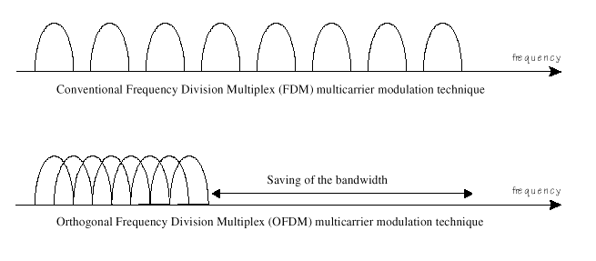

Figure 4. Comparison between conventional FDM modulation technique and OFDM modulation technique

### MIMO (Multiple Input Multiple Output)

A key radio access feature for LTE is MIMO. The data streams going in and out of antenna in radio channel is used to for beamforming and transmit diversity. The diversity will result in low correlation of fading and this could be used for receive / transmitting diversity. Better reception could be generated by sending simultaneously the copies of the same data through the channel and receiving using multiple antennas. MIMO provides spatial multiplexing i.e. sending different data streams transmitted in parallel over separate antennas. MIMO could be used to increase the throughput. As per the need 2 x 2, 4 x 2, or 4 x 4 antennas could be used in LTE.

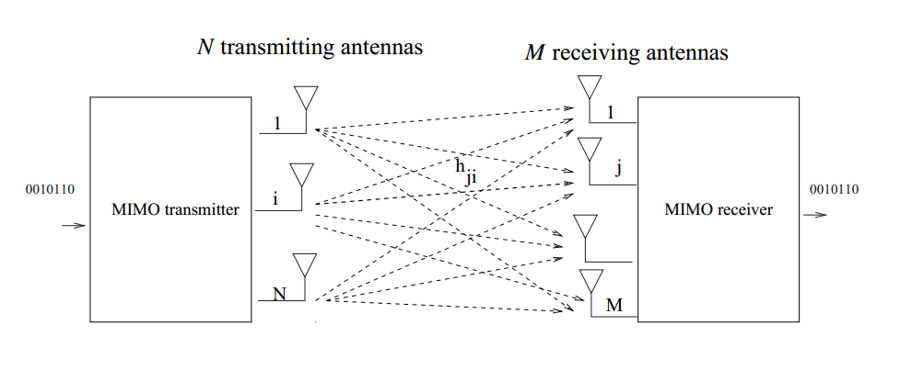Figure 5. Representation of MIMO scheme.

# Power Model

Power distribution in base station

This section defines how could we breakdown and understand comprehensively the energy consumed by the BSs. As per the findings of the Earth Project, Power Amplifier (PA) remains by far the major contributor to energy consumption. Understanding the root cause of this consumption can help us to eradicate the problems and nip the issues which lead to high energy consumption.

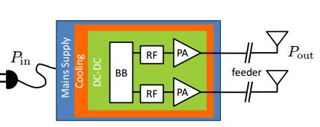

Figure 6. A typical transceiver structure of Base Station.

Figure 6 shows how the block diagram of a typical BS, it could be macro, micro, pico or femto. This model was taken into consideration for developing the Earth Project’s state of the art (SoTA) BS power model. There could be multiple transceivers in a BS. Each transceiver contains the baseband (BB) module, Radio Frequency (RF) module, power amplifier (PA) which connects to the antennas after providing the required power gain, DC to DC power converter, cooling system and a power supply connected to the mains. For macro BS the sector antenna is located at large distance from the PA which leads to large feeder losses and which needs to be compensated by PA. (Auer et al., n.d.)

The PA has poor power efficiency as it is made to work in non-saturated region which is to avoid nonlinear distortion from channel interference. In macro BS digital pre distortion is used to improve the PA efficiency. (Forssell & Auer, 2015)

Radio Frequency module is used to convert analog signals to digital signals. Base Band module serves as digital signal processor for digital up and down conversion of signals, it also does OFDM modulation of the signal. Typical responsibilities for BB are filtering, FFT for OFDM modulation and IFFT for OFDM demodulation, signal detection, channel estimation, it is the brain of transceiver. (Auer et al., n.d.)

So, the total power consumed within a BS could be given as:

(3.1)

* 1. Power consumed at maximum load

When the BS runs on maximum load then the power consumed by it could be defined by:

Consider that there are NTRX transceiver chains in a BS, the breakdown of power consumption in a BS at maximum load will be

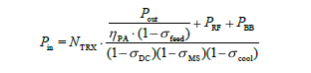 (3.2)

Where PPA = Pout / ηPA is for the power consumption in PA. As we know that, the efficiency is defined by η = Pout / Pin, and the loss is defined by; σ = 1 – η. The power increases linearly with the number of transceiver chains.

Below table lists the energy consumed in different parts of BS in different cells.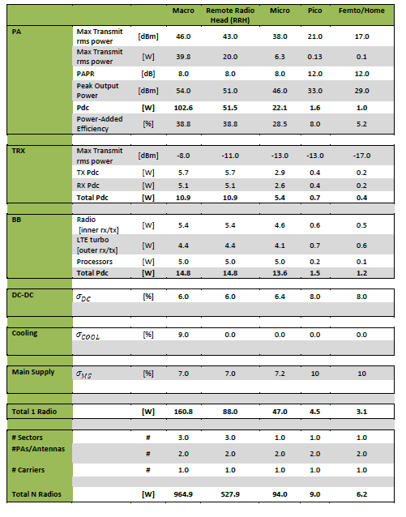

Table 2. SoTA estimation of power consumption in different LTE BSs.(Blume, Giannini, & Gódor, 2010)

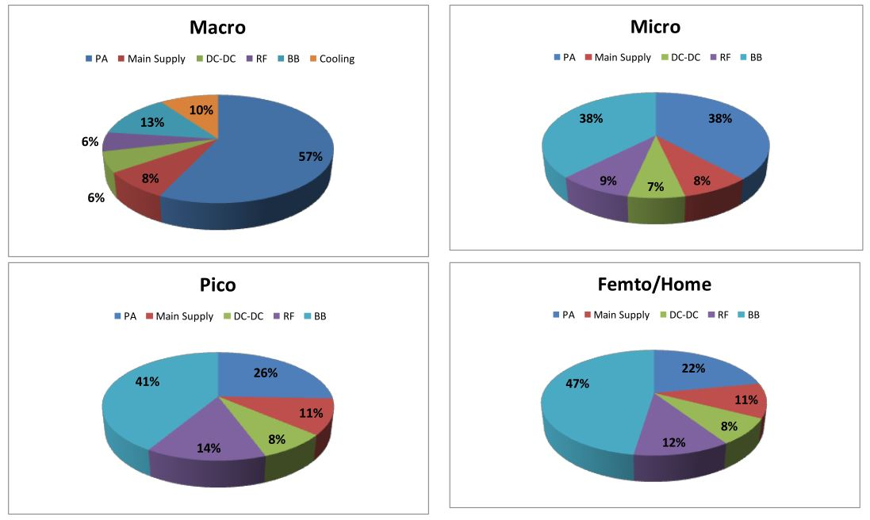

Figure 7. Power consumption in different components of BSs.(Blume et al., 2010)

The figure shows the breakdown of power consumption in different base stations; we can see over here that the macro base station consumes the most energy in PA in macro cells whereas, base band becomes the major component in small cells.

## Variable load power consumption of BS

As we have seen earlier that power amplifier amounts to the most part of energy consumption in BSs. It amounts to approximately 60% of the total power consumption in macro BS whereas, in smaller cells it consumes lesser than 25%. It is because power amplifier’s energy consumption depends upon the traffic load; the more the traffic higher is the power consumption.

The relation between the RF output power and the power consumed by base stations are roughly linear in nature which is shown in figure 8.

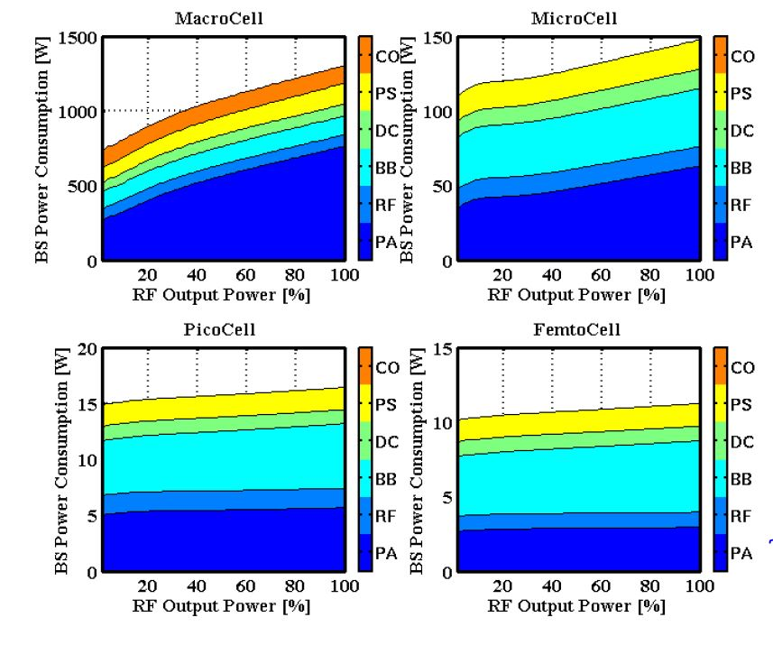

Figure 8. The figure shows linear nature of RF output power versus power consumption in BS versus.(Blume et al., 2010)

The mathematical equation of this relation could be represented as:

 (3.3)

This represents the linear approximation of the power model. Here Pin would represent the power consumed in the BS and Pout is the RF output power, at maximum load the output power would be Pmax. Power consumption at zero load is given by P0, Δp represents the slope of the curve. Psleep represents the sleep mode power consumption in the BS when the load is low and NTRX is the number of transceiver chains.

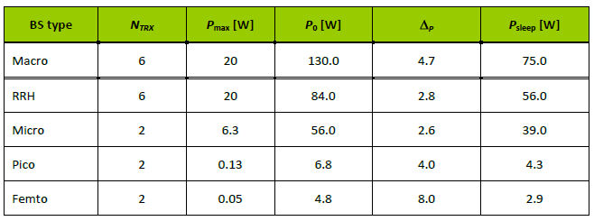

Table 3. This table provides parameters of power model for different BSs.(Blume et al., 2010)

## Energy consumption references

To compare how much energy is consumed in different scenarios we will make use of Power per unit area and Energy per bit as, they provide standard unit for comparison of energy performance.

### Energy per bit

It is the amount of energy consumed in delivering a single bit from the transmitter. It is calculated by dividing the total energy consumed, E over a time interval of, T by the total number of transmitted bits, B during that duration. It is expressed in [W/bps].

 (3.4)

### Power per unit area

It is the amount of power consumed in the network divided on average by the coverage area. It is expressed in [W/m2].

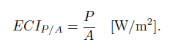 (3.5)

## Averaging power consumption

The simulator used in the project is a static simulator which runs from 0 – T and takes the average of the power consumed during that time period. This falls in confirmation of our model as power consumption is a function, u(t) which depends upon the traffic generated at a particular time instant t. The average power consumed over the time interval is:

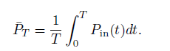 (3.6)

So, by applying eq. 3.3 in 3.6 we get

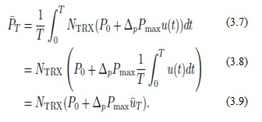

## Average power consumption over a day

Above equation defines the instantaneous power consumption at a moment t. To get an idea of the power consumption over the whole day, we need to average the power consumed over a day. The simulator which we have uses statistical tools to model a dynamic traffic. It measures the networks parameters for a small period of time while keeping the total traffic to be constant. Therefore, to know the network performance over a varied load, we sweep the total traffic value over a sufficient range.

In real scenario the traffic values change over the day in a pattern which is given in (Blume et al., 2010) . By taking the traffic profile as described in (Blume et al., 2010). We can estimate the traffic for every hour as a fraction of the peak throughput. Here we take the case of an urban traffic scenario which shows the average pattern of traffic over a day on hourly scale.

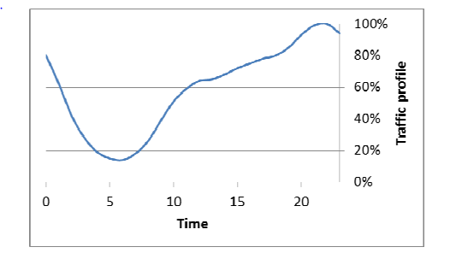

Figure 9. The figure shows the variation of peak throughput percentage over the whole day.

# Methodology

Here we explain the simulator and the deployment strategy used in running the simulations.

## The Simulator

The simulator used is Ericsson’s internal network simulator. The simulator is time static system level simulator written in Matlab. It provides various propagation models from statistical models to ray-tracing models.(Rydén, 2016) The model used in our thesis makes use of statistical model that determines the utilization of the base stations running on a particular load and though this we get estimate of the power being consumed by the whole network.

## Setup

The scenario that we setup makes use of a “real like” dense city network, in which we are deploying the city with streets, buildings, base stations and users. The deployment is made keeping in mind of a typical dense urban Asian network with dense high rise buildings in the center and lesser dense and low height buildings outer wards. This way we make use of a real city like scenario rather than just a statistical propagation analysis.

In our setup we make use of the static simulator with ray-tracing propagation model called BEZT. It makes use of a multipath propagation model that calculates the path gain between the user and the base station. The channel gains over these paths are stored in a huge gain matrix which is used to estimate the throughput for every user.

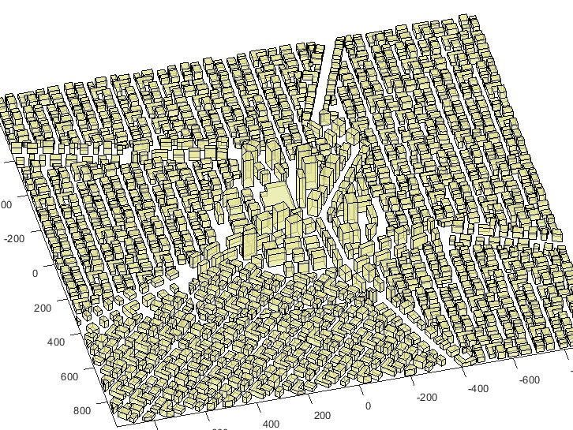

Figure 10. The figure shows the 3D model of the city with buildings and streets, the city center has high rise buildings.

## Deployment

We are deploying a real like city scenario in which the outer layer of macro grid will provide baseline coverage for the users outside the city center, this is the surrounding macro layer. In first scenario we deploy macro cells in the city center complemented by the surrounding macro grid and in second scenario we deploy small micro cells in the city center complemented by the surrounding macro grid.

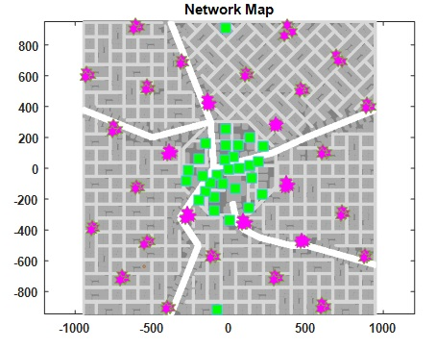

Figure 11. The figure shows deployment of micro cells in the center of the city with macro cells in the surrounding area.

## Traffic

When we deploy a particular scenario in the simulator with buildings, streets, base stations and users. The simulator calculates the SINR between each user and node deployed on macro or micro layer, as the propagation model and the interference is known thus the gain or the propagation loss is calculated for each link. To simulate the dynamic network where the download by users happens at random; equal buffer traffic model is utilized. Each session is of fixed file size where the request comes as per the Poisson distribution. The users fully utilize the link bit rate during the file download. The total air traffic could be given by offered traffic per m2**.** Because of the capacity limitations the served traffic is lower than offered traffic. In the simulations we sweep through varying loads of offered traffic and make use of the served traffic to compare performances.

# Results and Discussions

In this chapter we discuss about the results which we got after running the simulations for the scenarios we deployed. We will compare the energy performance and the network performance of deploying the large cells of macro grid in the city center versus small cells of micro grid.

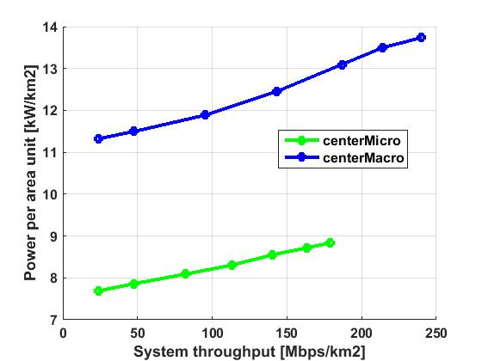

Figure 12. Comparison of Power per area unit versus System throughput for central deployment of macro cells and micro cells.

The Power per unit area is measured for power per 1 km2 around the central area of the map. We calculate the utilization of each node which taken as a factor for calculating the total power consumed by that node for the utilization. As we can see in figure 12, the power per unit area for small cells is lesser than the macro cells. Here we are sweeping the simulation for various loads to test the system for varying units of system throughput. We can see that the Power per area unit increases as the throughput increases as we predicted by the earth power model.

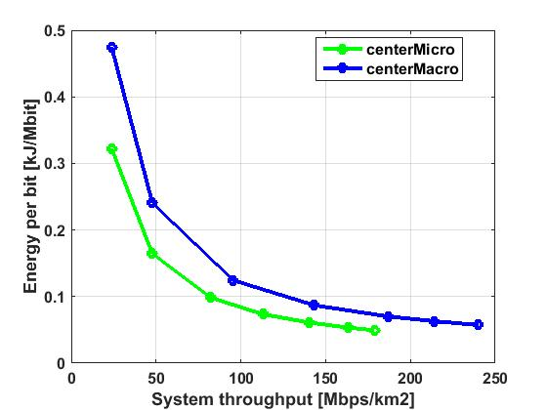

Figure 13. Comparison of Energy per bit versus System throughput for central deployment of macro cells and micro cells.

In figure 13 we compare the energy performance with respect to the energy per bit. For calculating the energy per bit we divide the total energy consumed by the serving nodes by the total traffic served by them. Energy per bit tells us that how much energy is needed in the system to deliver a single bit. As we can observe that the deployment of micro cells proves out to take lesser energy per bit as the power amplifier in the micro cells do not ramp up the energy consumption with the load as much in macro units. The energy per bit is higher for lower load because the system throughput increases faster than the power consumption in the serving nodes.

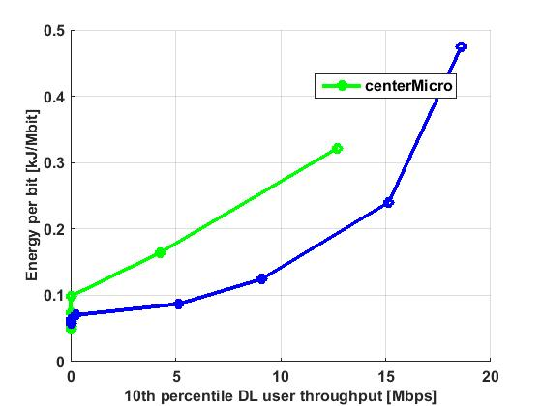

Figure 14. Comparison of Energy per bit versus 10th percentile DL user throughput for central deployment of macro cells and micro cells.

In figure 14 we do a critical analysis of quality of service down to the 10 percentile of users, these users have the worst downlink throughput, they could be considered as edge cell users. So, to deliver a good throughput to these edge cell users say, 11 Mbps we can see the macro cells need something around 1.8 kJ/Mbit while micro cells needs 0.3 kJ/Mbit. Here the macro cells come out to as winner because of they can handle a higher load than micro cells as well as the increased load compensates for the increased power consumption in macro cells.

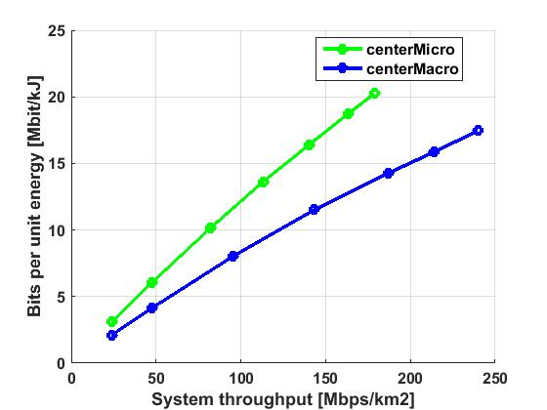

Figure 15. Comparison of bits per unit energy versus system throughput for central deployment of macro cells and micro cells.

Bits per unit energy is the inverse of energy per bit, in order to calculate this, we divide the total traffic by total power consumption. In figure 15 we can see that the micro cells can transfer more bits per unit energy than the macro cells and as the power consumption in micro cells increases less with served traffic load, the number of bits transferred in unit energy (Mbit/kJ) is higher for smaller cells than the large macro cells.

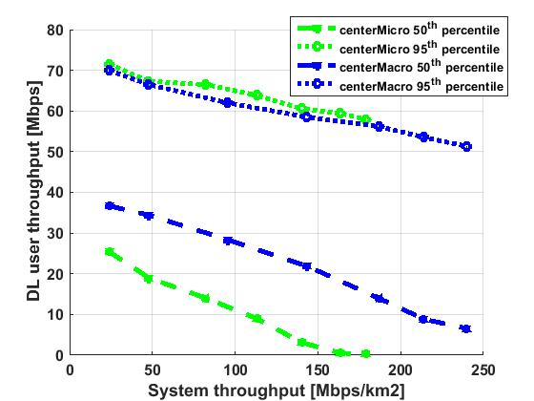

Figure 16. Comparison of DL user throughput for 50 th and 95th percentile versus system throughput.

The DL user throughput is calculated for 10th, 50th and 95th percentile. The 10th percentile refers to the cell edge users the 50th percentile is the median user data rate for the served traffic, the 95th percentile users are the best case users with top 5% data rates. In figure 16 the 95th percentile users have similar data rates in macros and micros. The 50th percentile users experience difference in data rates experience because the data rates at the user side increases with transmit power.

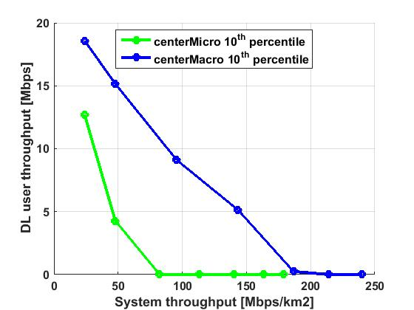

Figure 17. Comparison of DL user throughput for 10th percentile versus system throughput.

The 10th percentile users represents the cell edge users; the figure 17 compares the data rates for the cell edge users between the micro grid and the macro grid. When the data throughput drops to zero then it represents that the total traffic in the area is so high that the cell edge user could not be served. The data rates for these users decreases rapidly for micro case which proves that it is not the best choice for coverage purpose.

# References

Blume, O., Giannini, V., & Gódor, I. (2010). D2. 3: energy efficiency analysis of the reference systems, areas of improvements and target breakdown. *EARTH Deliverable 2.3*, 1–69. Retrieved from https://bscw.ict-earth.eu/pub/bscw.cgi/d71252/EARTH_WP2_D2.3_v2.pdf

Ericcson. (n.d.). *Heterogeneous Network (Hetnet)*. Retrieved from https://www.ericsson.com/res/thecompany/docs/press/media_kits/hetnet_infographic_vertical_04.pdf

Rydén, V. (2016). *Outdoor to Indoor Coverage in 5G Networks*. *Teknisk- naturvetenskaplig fakultet UTH-enheten*. Retrieved from https://uu.diva-portal.org/smash/get/diva2:944408/FULLTEXT01.pdf

Cisco Visual Networking Index: Forecast and Methodology Cisco Visual Networking Index: Cisco Visual Networking Index: Forecast and Methodology. (2015). *Forecast and Methodology*, 2015–2020.

Desset, C., Debaillie, B., Giannini, V., Fehske, A., Auer, G., Holtkamp, H., … Blume, O. (2012). Flexible power modeling of LTE base stations. In *2012 IEEE Wireless Communications and Networking Conference (WCNC)* (pp. 2858–2862). IEEE. https://doi.org/10.1109/WCNC.2012.6214289

Domenico, A. De, & Petersson, S. (2012). Final Integrated Concept. *EARTH Project D.6.4*, 1–95. Retrieved from https://bscw.ict-earth.eu/pub/bscw.cgi/d49431/EARTH_WP6_D6.4.pdf

Dufková, K., Bjelica, M., Moon, B., Kencl, L., & Le Boudec, J.-Y. (n.d.). Energy Savings for Cellular Network with Evaluation of Impact on Data Traffic Performance.

Auer, G., Giannini, V., Gódor, I., Olsson, M., Ali Imran, M., Sabella, D., … Desset, C. (n.d.). How Much Energy is Needed to Run a Wireless Network ?

Falconetti, L., Frenger, P., Kallin, H., & Rimhagen, T. (2012). Energy efficiency in heterogeneous networks. *Online Conference on Green Communications (GreenCom), 2012 IEEE*, 98–103. https://doi.org/10.1109/GreenCom.2012.6519623

Fehske, A. J., Richter, F., & Fettweis, G. P. (n.d.). Energy Efficiency Improvements through Micro Sites in Cellular Mobile Radio Networks.

Forssell, H., & Auer, G. (2015). Energy Efficiency of Heterogeneous Networks in, 53–58. https://doi.org/10.1007/s11265-011-0637-3

Han, C., Harrold, T., Armour, S., Krikidis, I., Videv, S., Grant, P. M., … Hanzo, L. (2011). Green radio: Radio techniques to enable energy-efficient wireless networks. *IEEE Communications Magazine*, *49*(6), 46–54. https://doi.org/10.1109/MCOM.2011.5783984

Landström, S., & Anders, F. (2011). Ericsson Review: Heterogeneous networks-increasing cellular capacity.

Rydén, V. (2016). *Outdoor to Indoor Coverage in 5G Networks*. *Teknisk- naturvetenskaplig fakultet UTH-enheten*. Retrieved from https://uu.diva-portal.org/smash/get/diva2:944408/FULLTEXT01.pdf

Tombaz, S., Sung, K. W., & Zander, J. (2012). Impact of densification on energy efficiency in wireless access networks. *2012 IEEE Globecom Workshops*, 57–62. https://doi.org/10.1109/GLOCOMW.2012.6477544

Yunas, S., Valkama, M., & Niemelä, J. (2015). Spectral and energy efficiency of ultra-dense networks under different deployment strategies. *IEEE Communications Magazine*, *53*(1), 90–100. https://doi.org/10.1109/MCOM.2015.7010521