

Master Thesis

Comparison of energy efficiency in Heterogeneous Networks scenario between macro and micro cells for 5G deployment.
Comparison of energy efficiency between macro and micro cells with energy saving schemes.

By

Koustubh Sharma

Department of Electrical and Information Technology Faculty of Engineering, LTH, Lund University

SE-221 00 Lund, Sweden

1
Abstract

Energy plays an important role in our lives, almost every industry depends heavily on energy. In recent times with the rising global temperature and climate change, the importance of saving energy has become ever important. With the rapid development of ICT (Information and Communication Technology) industry the demand for power has also increased. ICT tends to play a significant role in global greenhouse gas emissions. Cellular networks are among the main energy consumers in the ICT field. It was responsible for 10% of world’s total energy consumption in 2010 and is doubling in every 10 years.
With the outset of 5G, many cities will be deployed with micro cells, Pico, and macro cells. The networks will densify at a very fast pace. With the onset of internet of things, we would need a lower latency densified network for self-driving cars, buses etc. New technologies like augmented reality and virtual reality are bound to demand higher data rates. So, the mobile broadband networks will need to be strengthened.
In order to have an environment friendly transit into this era of internet of things, we also need to focus on energy consumption by these networks. There are various approaches for densifying the present network that we have. We will look into an approach to cater to these traffic demands with traditional macro cells versus small cells like micro cells.

Acknowledgments

Thanks to everyone who extended their support during the master thesis. And to my parents for their constant support and motivation.

Koustubh Sharma

Contents
Introduction 2
Introduction 2
Background and Motivation 2
Previous Work 2
Purpose of the Project 2
Outline of the Thesis 2
Theory 2
Heterogeneous Networks 2
Macro Cells: 2
Micro Cells 2
Pico Cells 2
Femto cell 2
LTE Basics 2
OFDM (Orthogonal Frequency Division Multiplex) 2
MIMO (Multiple Input Multiple Output) 2
Power Model 2
Power distribution in base station 2
Variable load power consumption of BS 2
Energy consumption references 2
Energy per bit 2
Power per unit area 2
Averaging power consumption 2
Average power consumption over a day 2
Methodology 2
The Simulator 2
Setup 2
Deployment 2
Traffic 2
Results and Discussions 2
Future Work Error! Bookmark not defined.
References 2

Introduction

Introduction
Energy plays an important role in our lives, almost every industry depends heavily on energy. In recent times with the rising global temperature and climate change, the importance of saving energy has become ever important. With the rapid development of Information and Communication Technology (ICT) industry the demand for power has also increased. ICT tends to play a significant role in global greenhouse gas emissions. Cellular networks are among the main energy consumers in the ICT field. It was responsible for 10% of world’s total energy consumption in 2010 and is doubling in every 10 years (Dufková, Bjelica, Moon, Kencl, & Le Boudec, n.d.). With increased need for broadband speed, the demand for energy and densification of networks is likely to increase. High energy efficiency is becoming a mainstream concern for the design of future wireless communication networks.

Background and Motivation
The global mobile data traffic grew by 63 percent in 2016.(“Cisco Visual Networking Index: Forecast and Methodology Cisco Visual Networking Index: Cisco Visual Networking Index: Forecast and Methodology,” 2015) it stood at 7.2 billion Giga bytes per month during the ending of 2016. And by 2021 it will be 49 billion Giga bytes.
Almost half a billion new mobile devices were added in 2016 and according to the Ericsson’s forecast there will be 50 billion connected devices by 2020.
Since the introduction of mobile networks, the focus has often been on optimizing the network to fulfil the coverage, capacity and quality requirements. Products have been developed and network deployments have been designed, focusing mainly on these key requirements. But, the focus has shifted a bit during recent years, operators have started to investigate how energy is consumed in mobile networks. The understanding has increased on how energy consumption can be reduced, and environmental awareness has gained importance in the mobile telecom industry. The challenge with designing an energy efficient network is to avoid reducing quality or coverage and hence reducing the performance.
About 0.5% of the world energy consumption is from mobile radio networks. (Fehske, Richter, & Fettweis, n.d.) In mobile networks, base stations are the ones which consume the most amount of energy. Comparing the life cycle of a mobile and base station, a mobile would contribute to green-house gases the most at the time of its manufacturing while for the base station, it is during its life time as a serving node. A lot of research has been done to make mobile more efficient with consuming battery power but, base stations remain behind their counterparts. Around 80% of the total energy in mobile networks is consumed in radio access network and majorly in base stations which comes around to be 60% of the whole (Fehske et al., n.d.). Which stresses on call for reducing this energy consumption at the base station side.
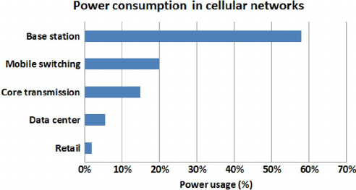

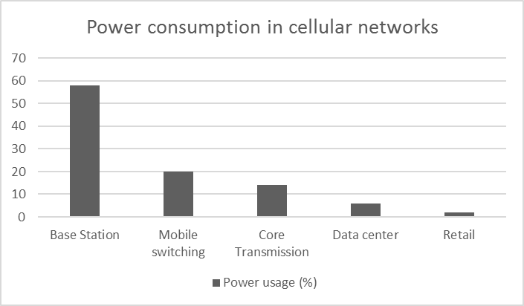
Figure 1. Breakdown of energy consumption in cellular networks (Source Vodafone) (Han et al., 2011)
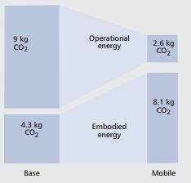

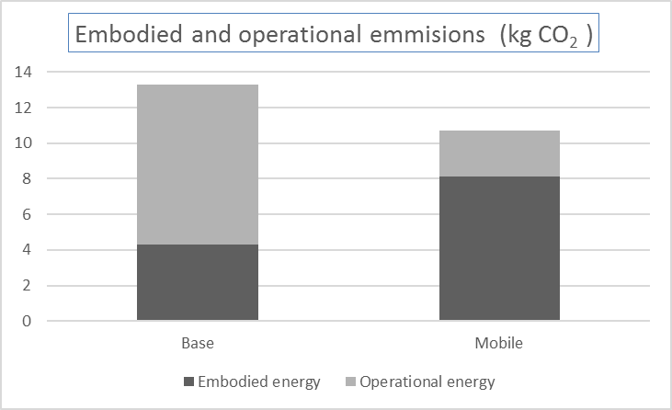

Figure 2. The operational and the embodied CO2 emissions by base stations and mobile phones per subscribers per year (Han et al., 2011)

Previous Work
There had been studies related to improvement of the base stations energy consumption, and in 2010-2012 a study was conducted under Energy Aware Radio and netWork tecHnologies (EARTH) project in which researchers from around the world tried to achieve deliverables (Domenico & Petersson, 2012) which proved to become standardized principles for working on energy efficiency concepts for base stations.
The EARTH project gave the mathematical power model for calculating the energy consumption in the base stations for various scenarios of rural, sub-urban and dense urban, the linear power model is used in generic simulations. It also gives the internal breakdown of energy consumed within different sizes of nodes such as macro, micro, pico and femto.
In (Desset et al., 2012) the study was conducted to break up the energy consumed by different components of the BS in macro, pico and other cells that support the 3GPP LTE standard. It supports the Earth Project’s state of the art (SoTA) power model.
In(Yunas, Valkama, & Niemelä, 2015) a “Manhattan-type city grid” is analyzed for energy performance in which off-loading the macro cells with indoor cells prove to be more energy efficient.
In (Forssell & Auer, 2015) study was conducted to find if in a dense urban scenario, the indoor nodes would prove to be energy efficient or not but, to the contrary they proved to be worse than keeping only the macro BS grid in the scenario.
In (Tombaz, Sung, & Zander, 2012) study was conducted on densification of network in which it was found out that the deployment of smaller cells reduces the transmit power of large base stations (BSs) and the idle time and backhaul proved to be energy wasters.
In (Falconetti, Frenger, Kallin, & Rimhagen, 2012) a heterogeneous network scenario was considered in which network densification strategies were introduced and to save the power; micro DTX and pico node sleep modes were utilized to prove that the network densification could take place successful without increasing the energy requirements. The heterogeneous network was composed of macro nodes and pico nodes. At high traffic energy could be saved a lot by smaller nodes handling large traffic, thereby increasing user performance and decreasing energy consumption at the same time.
We will make use of these energy saving features like micro DTX, lean carrier and MBSFN in the nodes.
We will make use of Ericsson’s static network simulator which will present us a realistic three-dimensional model of a city with buildings, pavements and open spaces. The simulator makes use of ray-tracing propagation models like BEZT.

Purpose of the Project
With the outset of 5G, many cities will be deployed with small cells. The networks will densify at a very fast pace. The internet of things (IoT) would need densified network with lower latency and higher throughput for self-driving cars, buses etc. New technologies like augmented reality and virtual reality are bound to demand higher data rates. These advancements will call for a strengthened mobile broadband network.
To have an environment friendly transit into this era of internet of things, we also need to focus on energy consumption by these networks. There are various approaches for densifying the present network that we have. We will consider an approach to cater to the traffic demands with traditional macro cells versus micro cells.
We will setup a dense urban real like scenario in our simulator and compare the energy efficiencies between macro cells centric deployment versus a micro cells centric deployment, and we will make use of energy saving schemes like micro DTX, lean carrier and MBSFN to reduce the power consumed in the network. We will deploy these cells in the city center where the highest traffic demand is highest.
With results presented in this thesis, we will contribute to the understanding of how these cells behave in a realistic traffic scenario and how much gains we can achieve by implementing the above-mentioned energy saving schemes. To keep the results more generic and not specific to any particular set of radio base stations we will implement EARTH power model.

Outline of the Thesis
In this thesis chapter 1 deals with the introduction, background and motivation for this project, chapter 2 is about the theory of BSs which describes about various cells used in a typical LTE heterogeneous deployment and the transmission techniques used by these BSs like MIMO and OFDM, chapter 3 is where we explain about the Earth Power model and the energy saving schemes, chapter 4 deals with the simulation setup, which is followed by chapters on results and discussions, conclusion and future work.

Theory

Heterogeneous Networks
With the onset of 5G, there will be a lot of use of HetNets and densified networks to satisfy the demand for increased traffic. Most of the mobile traffic around 70% will be concentrated around high traffic centers like downtown of an urban city (Ericsson white paper, 2014). There will be small cells which would be deployable as ‘plug and play’ which is going to save a lot of CAPEX for the operators and as these smaller cells will have a small coverage area which will enable frequency to reuse possible being close to each other which will provide large capacity improvement (Yunas et al., 2015).
With the incoming 5G spectrum allocation, speculations are that frequency spectrum for 5G will lie in very high frequencies of the order 30 GHZ, according to a study done with coverage and penetration of these waves in indoor environment will be very problematic. “Achieving indoor coverage at 30 GHz is highly problematic for all cases, and it is concluded that smaller base stations are necessary if frequencies of 10 GHz and above are to be used in future mobile networks.” (Rydén, 2016)
Here is a brief theory about the cells which constitute a HetNet.

Specification | Femtocell | Picocell | Microcell | Macrocell
Transmit Power | 20 dBm | 30dBm | 30dBm
Power Consumption | Low | Low | Moderate | High
Coverage distance | Less than 30m | Less than 100 m | Less than 500m | Several kms
Deployment | Indoor | Indoor and Outdoor | Outdoor and Indoor | Outdoor
Backhaul connectivity | DSL, cable, fiber | Microwave, mm | Microwave, Fiber | Microwave, Fiber
Installation | User | Operator | Operator | Operator
Table 1. Comparison between different types of nodes in a heterogeneous network.

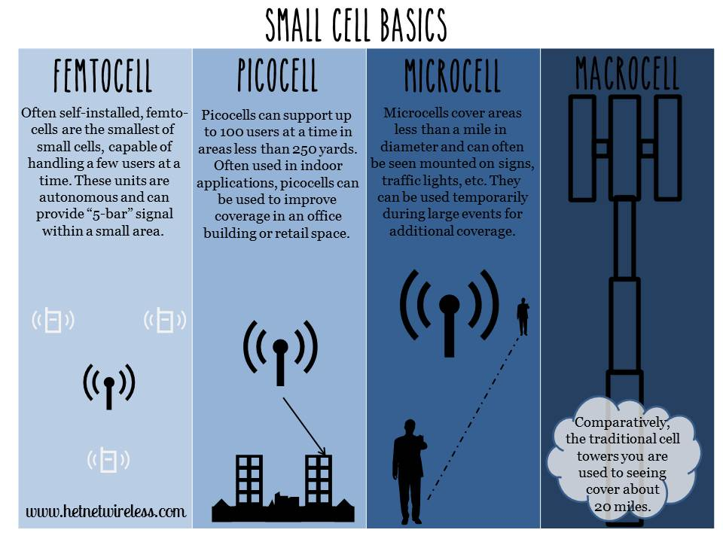
Figure 3. Small cells pictorial representation (www.hetnets.com)

Macro Cells:
These cells are the base stations that provide coverage to a large area with Inter site distance (ISD) around two to several kilometers. depending upon the density. They fulfill the baseline coverage for any LTE network, providing connectivity and up all the time. The power consumption varies from 100 to 180 W. they have sectored antennas normally covering 120 degrees per sector.

Micro Cells
Micro cells have lower transmit power than macro BSs, they are smaller base stations with full features that can be used to cover both indoor and outdoor crowded areas[1]. It can typically cover a range of few metres to one or two kilometers. The power consumption ranges from 40W to 50W. They are generally used for indoor purposes as well as outdoor such as hot-spots.

Pico Cells
Pico cells have lower transmit power than macro BSs, they have Omni-directional antennas unlike macro BSs which are sectored. The transmit power ranges from 250mW to 2W. They are generally used for indoor purposes around hot-spots like offices, railway stations etc. and are connected over X2 interface. (Landström & Anders, 2011)

Femto cell
Femto cells are also known as HeNBs are deployment for small rooms and home requirements generally for a very small range coverage less than 30m. They have Omni-directional antennas, transmit power is around 100 mW. They could be plugged in using a DSL line or modem cable. (Landström & Anders, 2011).

LTE Basics

OFDM (Orthogonal Frequency Division Multiplex)
In LTE the OFDM modulation technique is used to produce orthogonality between the sub-carriers in frequency domain. A sub-carrier is of 180 kHz. The OFDM provides resistance to interference in between LTE sub-carriers, the LTE uses OFDMA (Orthogonal Frequency Division Multiple Access in down link radio access and SC-OFDMA (Single Carrier - Frequency Division Multiple Access) in uplink radio access. OFDM provides high data rates and tightly spaced orthogonal sub-carriers provides high spectrum efficiency.
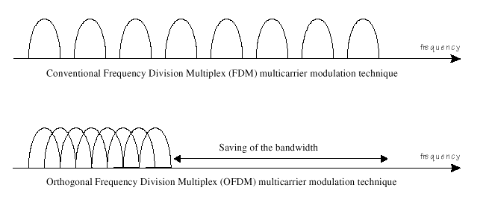
Figure 4. Comparison between conventional FDM modulation technique and OFDM modulation technique

MIMO (Multiple Input Multiple Output)
A key radio access feature for LTE is MIMO. The data streams going in and out of antenna in radio channel is used to for beamforming and transmit diversity. The diversity will result in low correlation of fading and this could be used for receive / transmitting diversity. Better reception could be generated by sending simultaneously the copies of the same data through the channel and receiving using multiple antennas. MIMO provides spatial multiplexing i.e. sending different data streams transmitted in parallel over separate antennas. MIMO could be used to increase the throughput. As per the need 2 x 2, 4 x 2, or 4 x 4 antennas could be used in LTE.
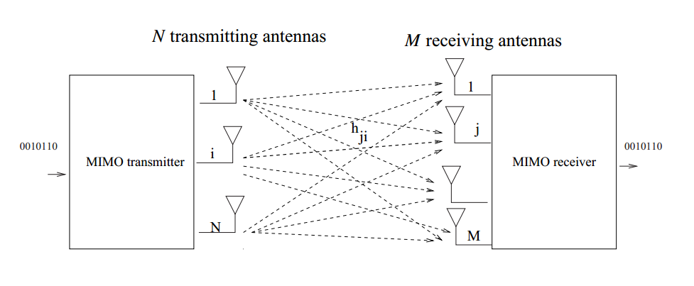Figure 5. Representation of MIMO scheme.

Power Model

Power distribution in base station
This section defines how could we breakdown and understand comprehensively the energy consumed by the BSs. As per the findings of the Earth Project, Power Amplifier (PA) remains by far the major contributor to energy consumption. Understanding the root cause of this consumption can help us to eradicate the problems and nip the issues which lead to high energy consumption.
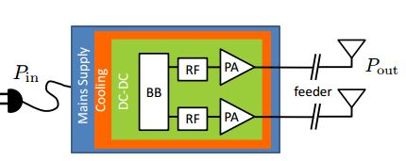

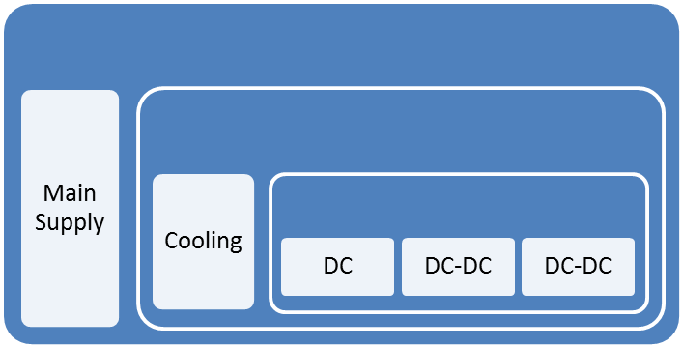Figure 6. A typical transceiver structure of Base Station.

Figure 6 shows how the block diagram of a typical BS, it could be macro, micro, pico or femto. This model was taken into consideration for developing the Earth Project’s state of the art (SoTA) BS power model. There could be multiple transceivers in a BS. Each transceiver contains the baseband (BB) module, Radio Frequency (RF) module, power amplifier (PA) which connects to the antennas after providing the required power gain, DC to DC power converter, cooling system and a power supply connected to the mains. For macro BS the sector antenna is located at large distance from the PA which leads to large feeder losses and which needs to be compensated by PA. (Auer et al., n.d.)
The PA has poor power efficiency as it is made to work in non-saturated region which is to avoid nonlinear distortion from channel interference. In macro BS digital pre distortion is used to improve the PA efficiency. (Forssell & Auer, 2015)
Radio Frequency module is used to convert analog signals to digital signals. Base Band module serves as digital signal processor for digital up and down conversion of signals, it also does OFDM modulation of the signal. Typical responsibilities for BB are filtering, FFT for OFDM modulation and IFFT for OFDM demodulation, signal detection, channel estimation, it is the brain of transceiver. (Auer et al., n.d.)
So, the total power consumed within a BS could be given as:

(3.1)

  - Power consumed at maximum load
When the BS runs on maximum load then the power consumed by it could be defined by:
Consider that there are N_{TRX} transceiver chains in a BS, the breakdown of power consumption in a BS at maximum load will be
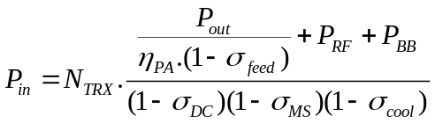 (3.2)
Where P_{PA} = P_{out} / η_{PA} is for the power consumption in PA. As we know that, the efficiency is defined by η = P_{out} / P_{in,} and the loss is defined by; σ = 1 – η. The power increases linearly with the number of transceiver chains.

Below table lists the energy consumed in different parts of BS in different cells.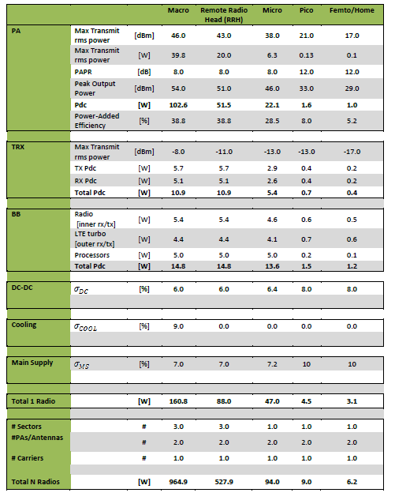

 |  |  | Macro | Remote Radio | Micro | Pico | Femto/Home
PA | Max Transmit  rms power | [dBm] | 46.0 | 43.0 | 38.0 | 21.0 | 17.0
PA | Max Transmit  rms power | [W] | 39.8 | 20.0 | 6.3 | 0.13 | 0.1
PA | PAPR | [dB] | 8.0 | 8.0 | 8.0 | 12.0 | 12.0
PA | Peak Output | [dBm] | 54.0 | 51.0 | 46.0 | 33.0 | 29.0
PA | Pdc | [W] | 102.6 | 51.5 | 22.1 | 1.6 | 1.0
PA | Power-Added Efficiency | [%] | 38.8 | 38.8 | 28.5 | 8.0 | 5.2
TRX | Max Transmit  rms power | [dBm] | -8.0 | -11.0 | -13.0 | -13.0 | -17.0
TRX | TX Pdc | [W] | 5.7 | 5.7 | 2.9 | 0.4 | 0.2
TRX | RX Pdc | [W] | 5.1 | 5.1 | 2.6 | 0.4 | 0.2
TRX | Total Pdc | [W] | 10.9 | 10.9 | 5.4 | 0.7 | 0.4
BB | Radio [inner rx/tx] | [W] | 5.4 | 5.4 | 4.6 | 0.6 | 0.5
BB | LTE turbo [outer rx/tx] | [W] | 4.4 | 4.4 | 4.1 | 0.7 | 0.6
BB | Processors | [W] | 5.0 | 5.0 | 5.0 | 0.2 | 0.1
BB | Total Pdc | [W] | 14.8 | 14.8 | 13.6 | 1.5 | 1.2
DC-DC | σ_{DC} | [%] | 6.0 | 6.0 | 6.4 | 8.0 | 8.0
Cooling | σ_{COOL} | [%] | 9.0 | 0.0 | 0.0 | 0.0 | 0.0
Main Supply | σ_{MS} | [%] | 7.0 | 7.0 | 7.2 | 10 | 10
Total 1 Radio |  | [W] | 160.8 | 88.0 | 47.0 | 4.5 | 3.1
# Sectors |  | # | 3.0 | 3.0 | 1.0 | 1.0 | 1.0
#PAs/Antennas |  | # | 2.0 | 2.0 | 2.0 | 2.0 | 2.0
# Carriers |  | # | 1.0 | 1.0 | 1.0 | 1.0 | 1.0
Total N Radios |  | [W] | 964.9 | 527.9 | 94.0 | 9.0 | 6.2

Table 2. SoTA estimation of power consumption in different LTE BSs.[2]

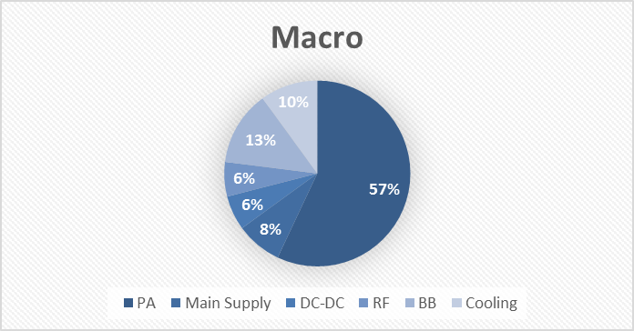
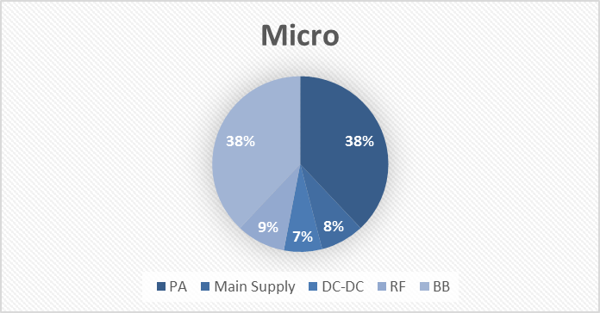
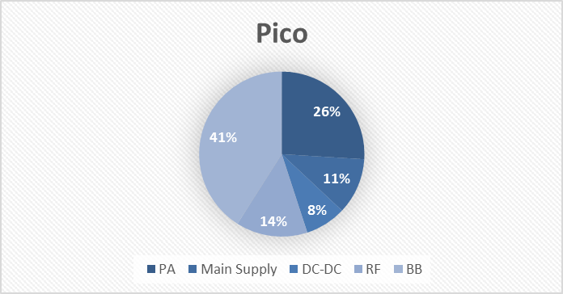
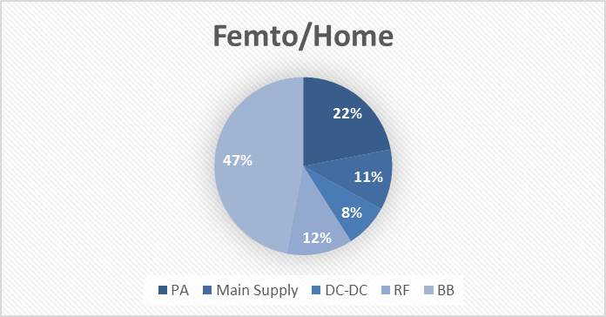
Figure 7. Power consumption in different components of BSs.[2]
The figure shows the breakdown of power consumption in different base stations; we can see over here that the macro base station consumes the most energy in PA in macro cells whereas, base band becomes the major component in small cells.

Variable load power consumption of BS
As we have seen earlier that power amplifier amounts to the most part of energy consumption in BSs. It amounts to approximately 60% of the total power consumption in macro BS whereas, in smaller cells it consumes lesser than 25%. It is because power amplifier’s energy consumption depends upon the traffic load; the more the traffic higher is the power consumption.
The relation between the RF output power and the power consumed by base stations are roughly linear in nature which is shown in figure 8.

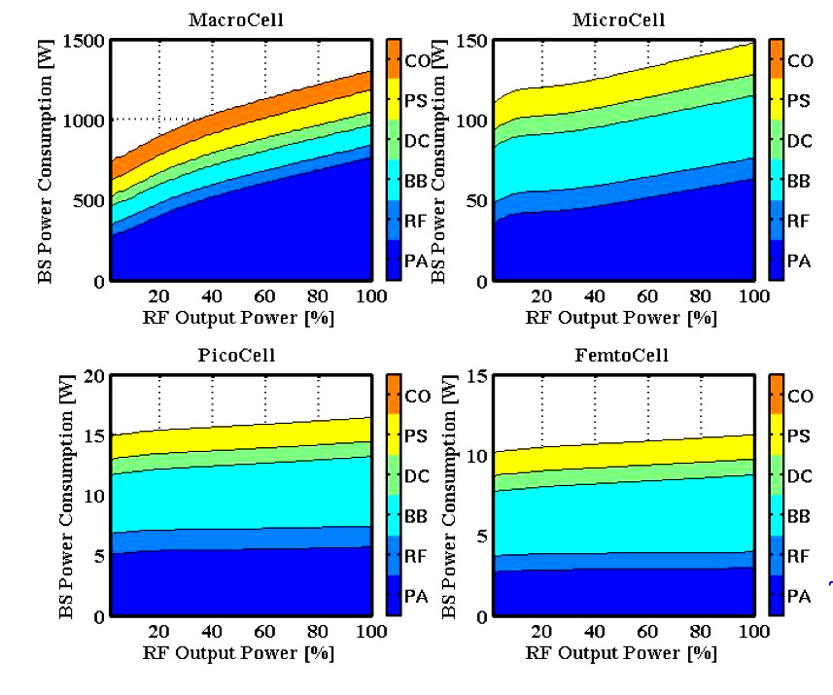
Figure 8. The figure shows linear nature of RF output power versus power consumption in BS versus.[2]
The mathematical equation of this relation could be represented as:
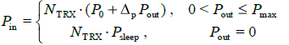 (3.3)
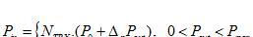
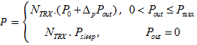 (3.3)

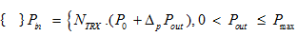
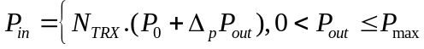
This represents the linear approximation of the power model. Here Pin would represent the power consumed in the BS and Pout is the RF output power, at maximum load the output power would be Pmax. Power consumption at zero load is given by P₀, Δp represents the slope of the curve. P_{sleep} represents the sleep mode power consumption in the BS when the load is low and N_{TRX} is the number of transceiver chains.
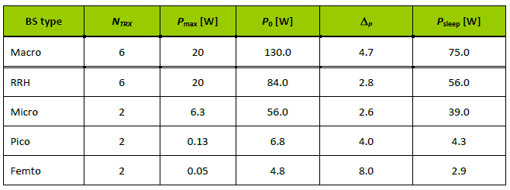
BS type | N_{TRX} | P_{max}[W] | P₀[W] | Δ_{p} | P_{sleep}[W]
Macro | 6 | 20 | 130.0 | 4.7 | 75.0
RRH | 6 | 20 | 84.0 | 2.8 | 56.0
Micro | 2 | 6.3 | 56.0 | 2.6 | 39.0
Pico | 2 | 0.13 | 6.8 | 4.0 | 4.3
Femto | 2 | 0.05 | 4.8 | 8.0 | 2.9

Table 3. This table provides parameters of power model for different BSs.[2]

Energy consumption references
To compare how much energy is consumed in different scenarios we will make use of Power per unit area and Energy per bit as, they provide standard unit for comparison of energy performance.

Energy per bit
It is the amount of energy consumed in delivering a single bit from the transmitter. It is calculated by dividing the total energy consumed, E over a time interval of, T by the total number of transmitted bits, B during that duration. It is expressed in [W/bps].
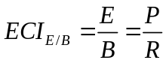 (3.4)

Power per unit area
It is the amount of power consumed in the network divided on average by the coverage area. It is expressed in [W/m²].

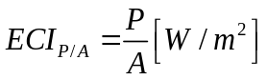 (3.5)

Averaging power consumption
The simulator used in the project is a static simulator which runs from 0 – T and takes the average of the power consumed during that time period. This falls in confirmation of our model as power consumption is a function, u(t) which depends upon the traffic generated at a particular time instant t. The average power consumed over the time interval is:
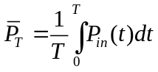 (3.6)
So, by applying eq. 3.3 in 3.6 we get

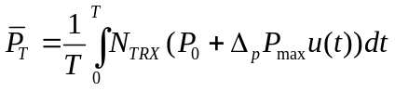 (3.7)
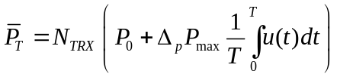 (3.8)
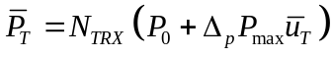 (3.9)

Average power consumption over a day
Above equation defines the instantaneous power consumption at a moment t. To get an idea of the power consumption over the whole day, we need to average the power consumed over a day. The simulator which we have uses statistical tools to model a dynamic traffic. It measures the networks parameters for a small period of time while keeping the total traffic to be constant. Therefore, to know the network performance over a varied load, we sweep the total traffic value over a sufficient range.
In real scenario the traffic values change over the day in a pattern which is given in [2] . By taking the traffic profile as described in [2]. We can estimate the traffic for every hour as a fraction of the peak throughput. Here we take the case of an urban traffic scenario which shows the average pattern of traffic over a day on hourly scale.

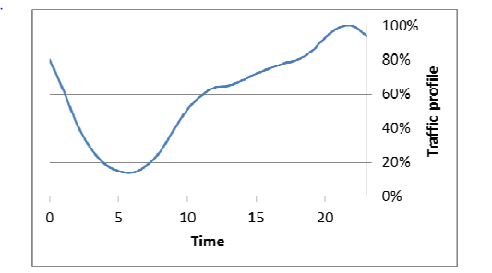

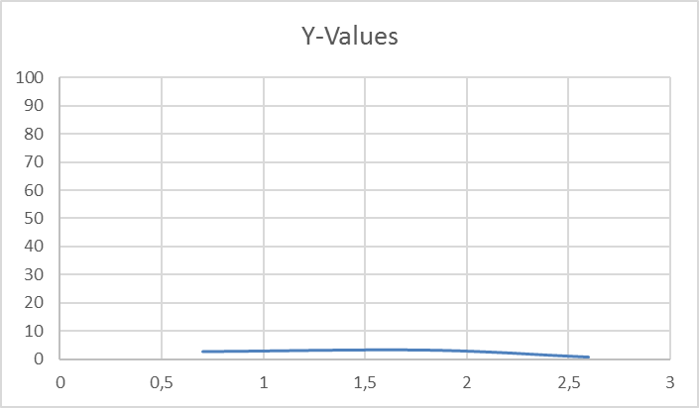
Figure 9. The figure shows the variation of peak throughput percentage over the whole day.
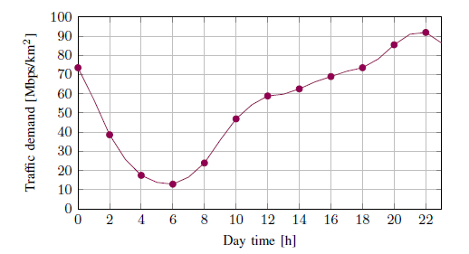

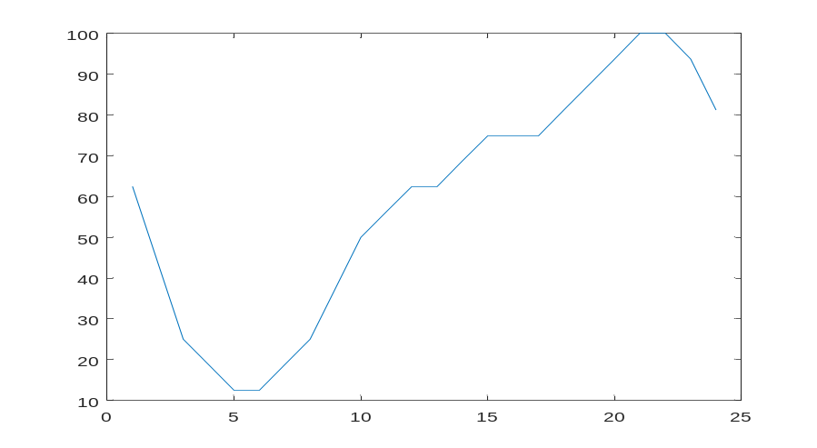

https://www.youtube.com/watch?v=vrwn1W_mc6M

Energy Saving schemes
We will mainly consider the following energy saving schemes which are Lean Carrier, Micro TX sleep and MBSFN.

Lean Carrier
The Lean carrier makes use of the sleep modes and switching off the cell whenever there is no transmission of data. It makes use of different features like transmitting the signal only when it is required, transmitting faster with high modulation scheme, effectively utilizing the carrier aggregation to have large spectrum and making use of beam forming antennas. These features reduce extraneous signaling and interference.
Minimizing the overhead cell specific reference signaling and using the spectrum flexibility it reduces energy consumption. With lean carrier design, it is possible to achieve fraction of sleep at no load condition to 100%. More details about lean carrier can be found in.[3]

Micro TX sleep
The radio’s RRU component does not transmit all the time. There are time slots when the radio can be put to sleep mode depending upon the traffic handled and the scheduled transmission. When this point comes then the biasing of the final stage amplifiers is turned off, which can be achieved by sending a strobe signal based on the information of the data that the DU needs to send. This information is sent in a message that gives the symbols which will be sent over the radio during the transmission time interval. [1]
An LTE RRU transmits 140 OFDM symbols per radio frame consisting of cell-specific radio signal (CSRS) and physical downlink control channel (PDCCH). Assuming a no load situation when there is no scheduled users out of 140 OFDM symbols power amplifier could be put in sleep mode for 73 of them with 37 wake up events, this equals to 4.1 ms of sleep time during each radio frame or 41% of time.

MBSFN
In a LTE radio frame six out of ten sub-frames can be Multicast and Broadcast Single-Frequency Network (MBSFN) for FDD system. [4] The MBSFN sub-frames are used to predict the future traffic load for a base station. Using these MBSFN a base station could calculate the load it needs to handle in subsequent frames and the resources required to cater to the traffic. This load prediction is made based on the previously served load information exchanged between the base stations over X2 interface. This load prediction is used to turn off the idle resources and setup the switch off intervals. Moreover, the MBSFN sub-frames have less number of reference signals than normal sub-frame, which gives an opportunity to turn off these sub-frames when there is no data available.[5]
Using MBSFN scheme in no load condition we get 91 OFDM symbols with 19 wake up events per radio frame. Which gives a window of 5.9 ms or 59% with sleep mode enabled.
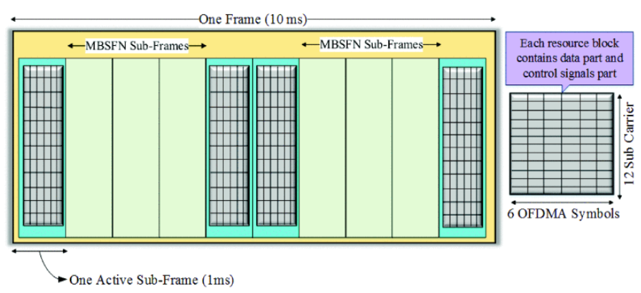

Methodology

Here we explain the simulator and the deployment strategy used in running the simulations.

The Simulator
The simulator used is Ericsson’s internal network simulator. The simulator is time static system level simulator written in Matlab. It provides various propagation models from statistical models to ray-tracing based models.[6] The model used in our thesis makes use of statistical model that determines the utilization of the base stations running on a particular load and using this we get estimate of the power being consumed by the whole network.

Setup
The scenario that we setup makes use of a “real like” dense city network, in which we are deploying the city with streets, buildings, base stations and users. The deployment is made keeping in mind of a typical dense urban network with high-rise buildings in the center and lesser dense and low height buildings outer wards. This way we make use of a real city like scenario rather than just a statistical propagation analysis.
In our setup, we make use of the static simulator with ray-tracing propagation model called BEZT. The simulator makes use of the multipath propagation model that calculates the path gain between the user and the base station. The channel gains over these paths are stored in a huge gain matrix which is used to estimate the throughput for every user.
In the center part of the map

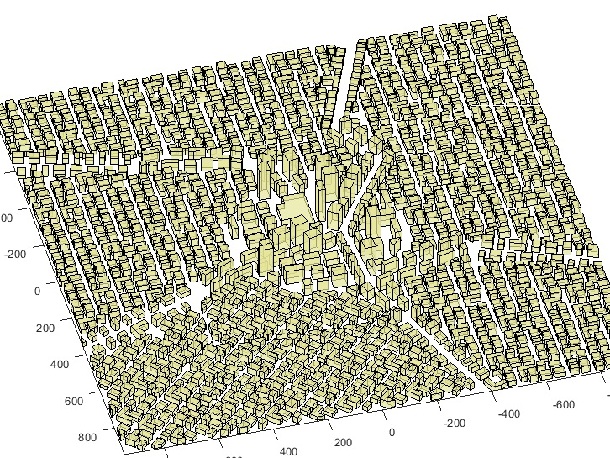

Figure 10. The figure shows the 3D model of the city with buildings and streets, the city center has high rise buildings.

Deployment
We are deploying a real like city scenario in which the outer layer of macro grid will provide baseline coverage for the users outside the city center, this is the surrounding macro layer. In first scenario, we deploy macro cells in the city center complemented by the surrounding macro grid and in second scenario we deploy small micro cells in the city center complemented by the surrounding macro grid.
In the first scenario setup, we have taken 21 macro cells deployed in the central grid of the city with inter-site distance of 200m surrounded by a base layer of macro cells inter-site distance of 400m.
In the second scenario setup, we have taken 28 micro cells deployed in the central grid of the city with inter-site distance of _m surrounded by a base layer of macro cells inter-site distance of 400m.
Considered propagation model is BEZT, the system under consideration is a LTE network with carrier frequency of 2 GHz, highest modulation scheme is 64 QAM, each site has three-sectors, In the power model we have considered the P₀ = 130W for the whole macro cell including the three sectors. For the micro cell we have considered the P₀ = 56W taking into account the EARTH power model. The central grid area is considered to be 1000m². The max Output Power out per antenna in DL from the macros is 40 W. deltaP = 4.7 pSleep = 75.0 for macro cells and deltaP = 2.6 and pSleep = 39.0 for micro cells.
The max Output Power out per antenna in DL from the micros is 10 W.

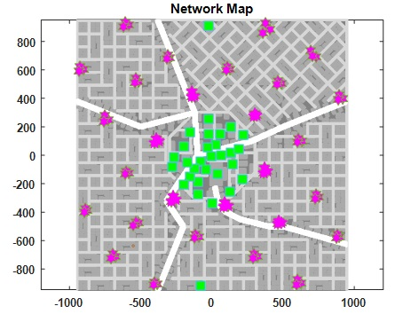
Figure 11. The figure shows deployment of micro cells in the center of the city with macro cells in the surrounding area.

Traffic
When we deploy a particular scenario in the simulator with buildings, streets, base stations and users. The simulator calculates the SINR between each user and node deployed on macro or micro layer, as the propagation model and the interference is known thus the gain or the propagation loss is calculated for each link. To simulate the dynamic network where the download by users happens at random; equal buffer traffic model is utilized. Each session is of fixed file size where the request comes as per the Poisson distribution. The users fully utilize the link bit rate during the file download. The total air traffic could be given by offered traffic per m². Because of the capacity limitations the served traffic is lower than offered traffic. In the simulations, we sweep through varying loads of offered traffic and make use of the served traffic to compare performances.

For macro the power model is like Po = 130, deltaP = 4.7 and
p1 = p0 + maxOutputPower/nTxAntennas*deltaP;
= 130 + maxOutputPower=40 / nTxAntennas =2 * 4.7;
P1 = 224

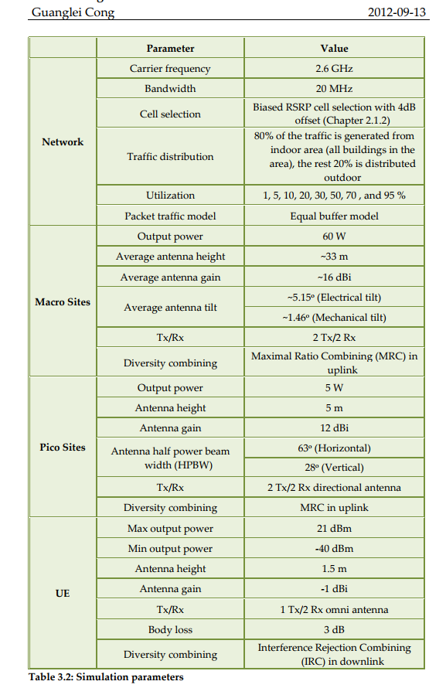
 | Parameter | Value
Network | Carrier frequency | 2.6 GHz
 | Bandwidth | 20 MHz
 | Cell Selection | Biased RSRP cell selection with 4dB offset (Chapter 2.1.2)
 | Traffic distribution | 80% of the traffic is generated from indoor area (all buildings in the area), the rest 20% is distributed outdoor
 | Utilization | 1,5,10,20,30,50,70, and 95%
 | Packet traffic model | Equal buffer model
Macro Site | Output power | 60 W
 | Average antenna height | ~33 m
 | Average antenna gain | ~16 dBi
 | Average antenna tilt | ~5.15 deg (Electrical tilt)
 |  | ~1.46 deg (Mechanical tilt)
 | Tx/Rx | 2 Tx/2 Rx
 | Diversity combining | Maximal Ratio Combining (MRC) in uplink
Pico Sites | Output power | 5 W
 | Antenna height | 5 m
 | Antenna gain | 12 dBi
 | Antenna half power beam width (HTBW) | 63 degree (Horizontal)
 |  | 28 degree (Vertical)
 | Tx/Rx | 2 Tx/2 Rx directional antenna
 | Diversity combining | MRC in uplink
UE | Max output power | 21 dBm
 | Min output power | -40 dBm
 | Antenna height | 1.5 m
 | Antenna gain | -1 dBi
 | Tx/Rx | 1 Tx/2 Rx omni antenna
 | Body loss | 3 dB

Results and Discussions
The addition of small cells inherently comes with increased energy consumption (+ 42 % respect to baseline 3- sector macro (first column from left)), which can be reduced by long-term adaptation techniques by around 1/3rd, little below the original baseline 3-sector macro reference. However, micro DTX and efficient hardware together can reduce the power consumption of the heterogeneous network by close to 2/3rd already, and less potential remains for the long-term adaptation energy efficiency techniques. Ref : Domenico, A. De, & Petersson, S. (2012). Final Integrated Concept. EARTH Project D.6.4, 1–95. Retrieved from https://bscw.ict-earth.eu/pub/bscw.cgi/d49431/EARTH_WP6_D6.4.pdf

Comparison macro v/s micro without energy saving schemes

In this chapter, we discuss about the results which we got after running the simulations for the scenarios we deployed. We will compare the energy performance and the network performance of deploying the large cells of macro grid in the city center versus small cells of micro grid.

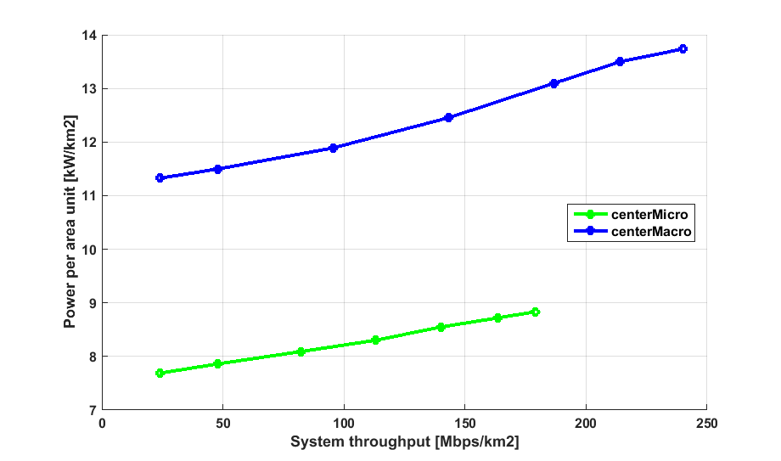

Figure 12. Comparison of Power per area unit versus System throughput
for central deployment of macro cells and micro cells.
The Power per unit area is measured for power per 1 km² around the central area of the map. We calculate the utilization of each node which taken as a factor for calculating the total power consumed by that node for the utilization. As we can see in figure 12, the power per unit area for micro cells is lesser than the macro cells. Here we are sweeping the simulation for various loads to test the system for varying units of system throughput. We can see that the Power per area unit increases as the throughput increases as we predicted by the earth power model.
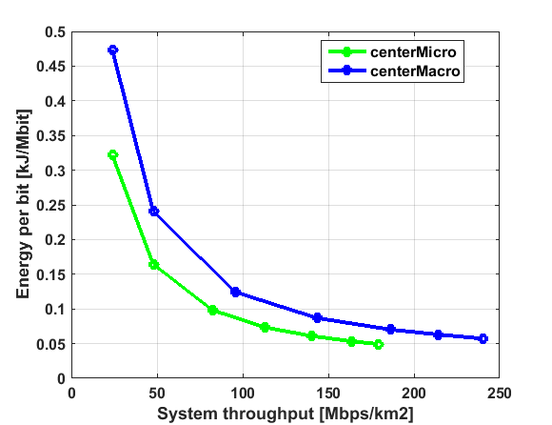

Figure 13. Comparison of Energy per bit versus System throughput for central deployment of macro cells and micro cells.

In figure 13 we compare the energy performance with respect to the energy per bit. For calculating the energy per bit, we divide the total energy consumed by the serving nodes by the total traffic served by them. Energy per bit tells us that how much energy is needed in the system to deliver a single bit. As we can observe that the deployment of micro cells proves out to take lesser energy per bit as the power amplifier in the micro cells do not ramp up the energy consumption with the load as much in macro units. The energy per bit is higher for lower load because the system throughput increases faster than the power consumption in the serving nodes.

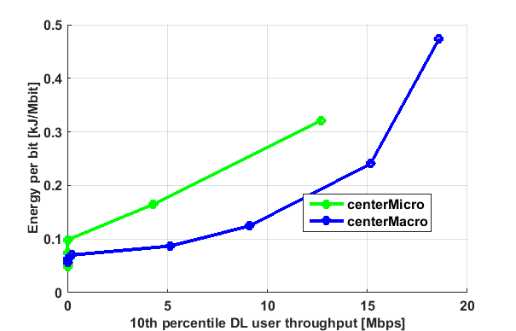
Figure 14. Comparison of Energy per bit versus 10th percentile DL user throughput for central deployment of macro cells and micro cells.

In figure 14 we do a critical analysis of quality of service down to the 10 percentiles of users, these users have the worst downlink throughput, they could be considered as edge cell users. So, to deliver a good throughput to these edge cell users say, 11 Mbps we can see the macro cells need something around 1.8 kJ/Mbit while micro cells need 0.3 kJ/Mbit. Here the macro cells come out to as winner because of they can handle a higher load than micro cells as well as the increased load compensates for the increased power consumption in macro cells.
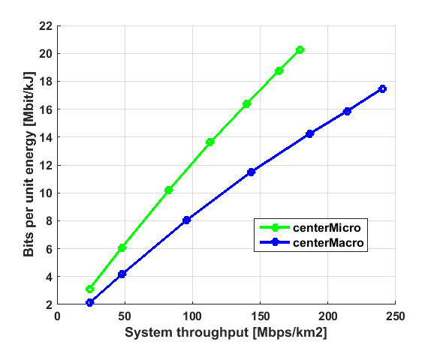
Figure 15. Comparison of bits per unit energy versus system throughput for central deployment of macro cells and micro cells.
Bits per unit energy is the inverse of energy per bit, to calculate this, we divide the total traffic by total power consumption. In figure 15 we can see that the micro cells can transfer more bits per unit energy than the macro cells and as the power consumption in micro cells increases less with served traffic load, the number of bits transferred in unit energy (Mbit/kJ) is higher for smaller cells than the large macro cells.

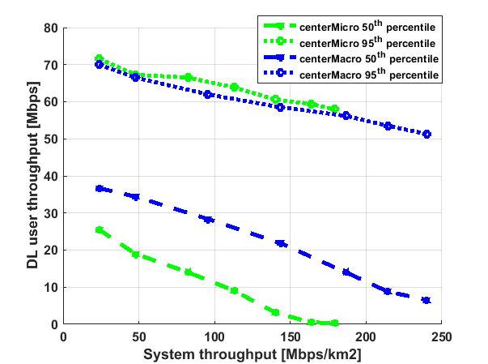
Figure 16. Comparison of DL user throughput for 50th and 95th percentile versus system throughput.
The DL user throughput is calculated for 10th, 50th and 95th percentile. The 10th percentile refers to the cell edge users the 50th percentile is the median user data rate for the served traffic, the 95th percentile users are the best-case users with top 5% data rates. In figure 16 the 95th percentile users have similar data rates in macros and micros. The 50th percentile users experience difference in data rates experience because the data rates at the user side increases with transmit power.

The DL data rate decreases with the increasing traffic load this is because at lower load there are enough of resources available for the cells to serve the users with high data rates but as the traffic load increases the bandwidth and the available resources reduces and hence it leads to a lowered data rate.

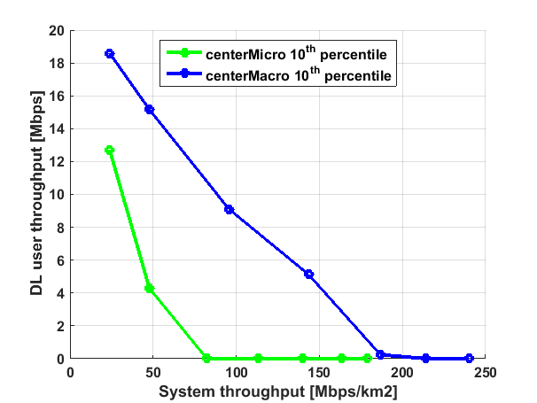

Figure 17. Comparison of DL user throughput for 10th percentile versus system throughput.
The 10th percentile users represents the cell edge users; the figure 17 compares the data rates for the cell edge users between the micro grid and the macro grid. When the data throughput drops to zero then it represents that the total traffic in the area is so high that the cell edge user could not be served. The data rates for these users decreases rapidly for micro case which proves that it is not the best choice for coverage purpose. This clearly shows that the capacity of macro cells is more than micro cells.

Comparison macro with and without energy saving schemes

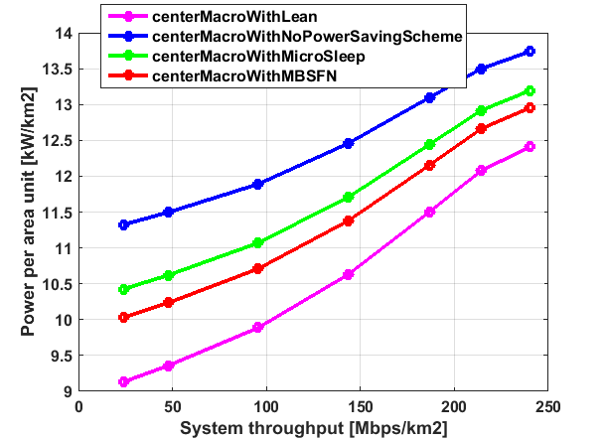

Figure 18. Comparison of power per area unit versus system throughput for central deployment of macro cells.

As we can see in figure 18, the power per unit area for micro cells with energy saving schemes is lesser than micro cells without energy saving schemes. Here we can see that as the traffic load increases the power required to serve that traffic also goes up. The Lean energy saving scheme seems to be more energy efficient than MBSFN and micro sleep. We can easily save around 10-15% energy using any of the energy saving schemes. Lean scheme proved to be the most energy efficient with 17% savings on energy.

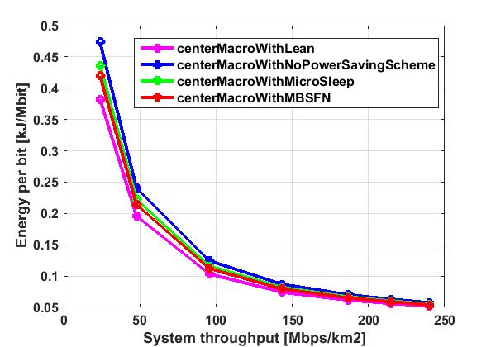

Figure 19. Comparison of energy per bit unit versus system throughput for central deployment of macro cells.

From fig 19 we can derive that there is some difference in energy needed to transmit a bit for lower traffic load in different schemes but, as we gradually move towards higher loads this difference comes close together because at higher traffic loads there will be less idle time for the cells to save energy.

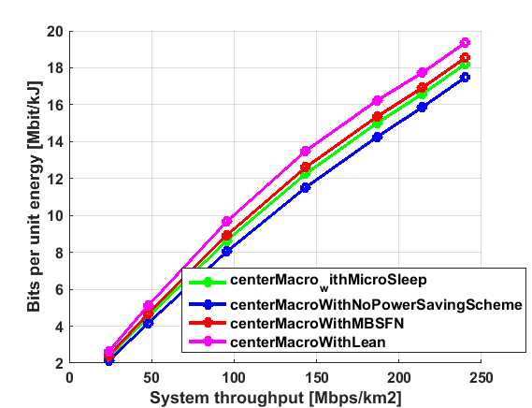

Figure 20. Comparison of bits per unit energy versus system throughput for central deployment of macro cells.
In the continuation to figure 19 we plot the bits per unit energy versus traffic demand in figure 20 and we encounter that there are more number of bits which could be transferred per unit energy where we make use of energy saving schemes.

Comparison micro with and without energy saving schemes
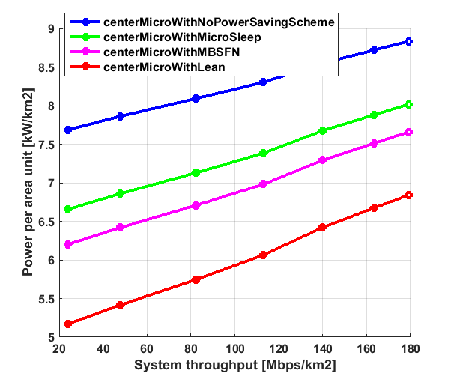
Figure . Comparison of Power per area unit versus System throughput for central deployment of macro cells.
As we can see in figure , the Power per area unit variation for micro cells also follows the similar pattern as in the power per unit area for macro cells. The energy saving schemes can save upto 2 kW/km² for varying traffic load lesser than micro cells without energy saving schemes. Here we can see that as the traffic load increases the power required to serve that traffic also goes up. The Lean energy saving scheme seems to be more energy efficient than MBSFN and micro sleep. We can see over here that deployment with lean power saving scheme can save 23.5% energy compared with when deployment without any energy saving scheme.

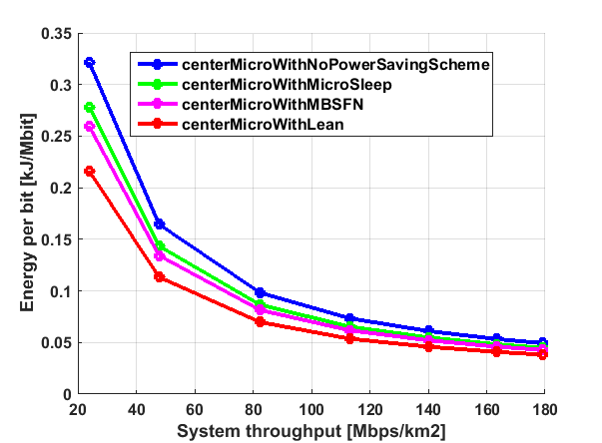

Figure . Comparison of energy per bit unit versus system throughput for central deployment of micro cells.

The follows the same pattern as the one we saw in central macro deployment case however the energy per bit needed in micro is lesser than that of macros. The energy schemes can save upto 25% on energy per bit for micro deployment.

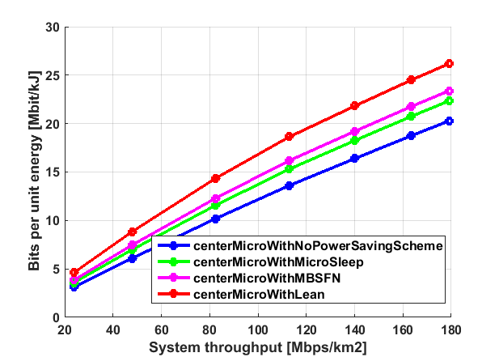
Figure . Comparison of bits per unit energy versus system throughput for central deployment of macro cells.
In figure , we see the behaviour as expected, deployment with enegy saving schemes have potential to fit in upto 30% more bits per unit energy than deployments without energy saving schemes.

Comparison macro v/s micro with energy saving schemes
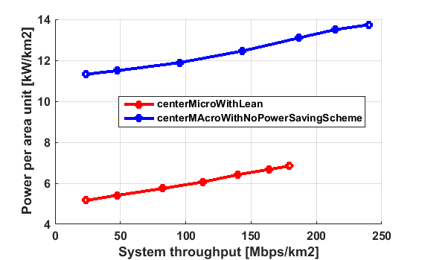
Figure . Comparison of Power per area unit versus System throughput for central deployment of macro cells versus micro cells.
In figure we can compare the amount of energy savings we can achieve by having a micro cell with lean carrier energy saving scheme against a macro cell with no energy saving schemes. For 100 Mbps/km² of system throughput the micro consumes 6 kW//km² whereas macro consumes double than that 12 kW//km² . So, implementing a scheme like this one reduce power consumption to half.

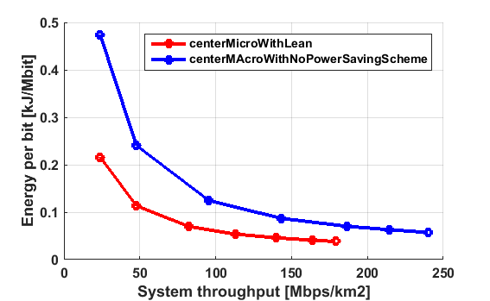
Figure . Comparison of energy per bit unit versus system throughput for central deployment of micro cells versus macro cells.
Now let’s consider the energy per bit, we see in figure , the energy per bit requirement for micro cells with energy saving scheme is much less than that of macro counterpart. The energy per bit is high for low traffic load because the total served traffic is low for low load and hence, the energy per bit increases.
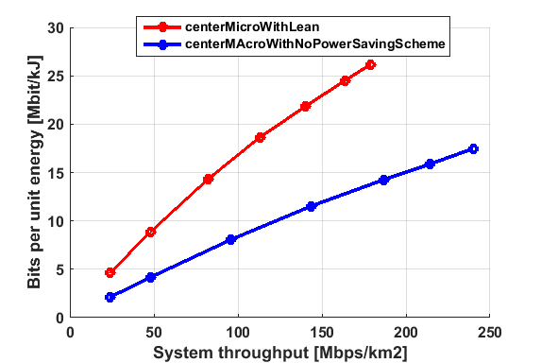
Figure . Comparison of bits per unit energy versus system throughput for central deployment of micro cells versus macro cells.
The bits per unit energy for micro cells with lean carrier energy saving scheme is almost double than that of the macro cells without energy saving schemes as seen in figure in .
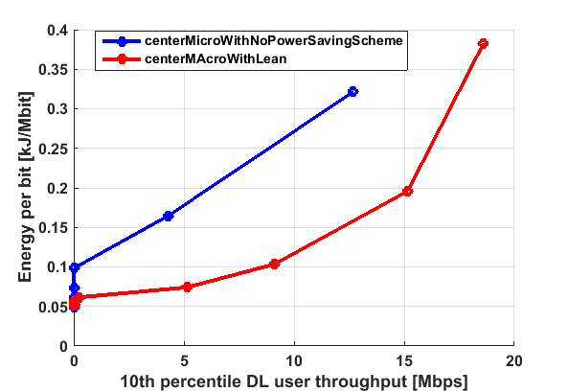

Figure . Comparison of energy per bit unit versus system throughput for central deployment of micro cells versus macro cells.
When it comes to reaching the last mile of user throughput, the micros could not provide as good user throughput as macros do. That’s why the energy per bit needed for providing high through for the edge cell users is high in case of micro cells.
So, the macro cells are needed to provide a good coverage area and decent throughput to the bottom 10th percentile users.

Daily power consumption

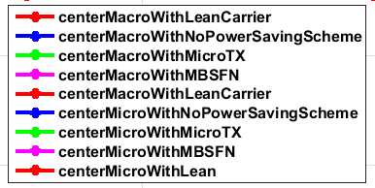
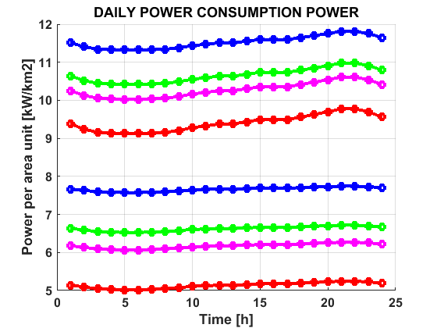
For calculating the daily power consumption we kept a threshold of 10 DL Mbps for 10th percentile users during the peak hours. The figure shows the power consumption of macro and micro with different energy saving schemes.
At peak load for macro deployment we can see there is a possibility of 17% saving using the lean carrier energy saving scheme and 20% energy saving could be achieved at low load.
In case of micro deployment, at peak load we can see 29% saving using the lean carrier energy saving scheme and a good 33% energy saving at low load. This is because lower utilization of nodes at lower loads gives more scope for energy saving schemes to be implemented.
From these patterns we can verify that the traffic demand is low during early morning hours and is high during the evening hours.

Conclusion
We used 28 center micro cells and 21 macro cells in the center grid which is a third times more number of micro units used to cover the central city area and provide an acceptable throughput performance to the users in the area.
As the number of resources is limited with macro cells so, as the traffic load goes up these resources need to be shared among the UEs. This leads to reduced data rate per UE and longer time to receive a file. So, it is advantageous to complement macro cells in the network with micro cells for increased quality of service and improved data rates. The results on the energy savings were much better by using the micro only base stations as they saved almost half of the energy required to run the network when implemented with energy saving schemes. The energy saving features does not affect the resultant data rates to the users. The data rates remain the same regardless of using the energy saving schemes
The energy saving schemes proved out to save a lot of energy in the operation of both macro and micro cells. It was observed that using the discontinuous transmission around 20% to 30% of energy could be saved. The amount of savings from these energies saving schemes depend upon the utilization and sleep time of these nodes.
- For Macro deployment, the power consumption for a day without using any energy saving scheme is 283.44 kWhr/km² which is 103455.6 kWhr/km² for a year. Using micro TX energy saving scheme it is 263.52 kWhr/km² which is 96184.8 kWhr/km² for a year. Using MBSFN energy saving scheme it is 254.64 kWhr/km² which is 92943.6 kWhr/km² for a year. Using lean carrier energy saving scheme it is 234.62 kWhr/km² which is 85637.76 kWhr/km² for a year.
- For Micro deployment, the power consumption for a day without using any energy saving scheme is 185.80 kWhr/km² which is 67819.92 kWhr/km² for a year. Using micro TX energy saving scheme it is 161.23 kWhr/km² which is 58849.68 kWhr/km² for a year. Using MBSFN energy saving scheme it is 150.24 kWhr/km² which is 54837.6 kWhr/km² for a year. Using lean carrier energy saving scheme it is 125.85 kWhr/km² which is 45937.44 kWhr/km² for a year.
So, we can see that using energy saving schemes in macro cell deployment can give savings as much as 17% and 33% in micro cell deployment over a year.
And comparing the macro without energy saving scheme to micro with lean carrier energy saving scheme results in 55% of energy saving. So, from an energy saving point of view, it would be much better to implement a heterogeneous network with more micro cells and small cells with energy saving schemes than with more number of macro cells.
This sort of heterogeneous cell deployment would help the network engineers in analyzing which type of cells are better suited for energy efficient deployment.
Here we can also see that macro grid performs much better when it comes to coverage, as the performance of the big macro cells is better than micro cells for the 10th percentile users for this reason we need to deploy the small cell networks complemented by the macro cells for coverage purposes. To provide sufficient coverage to the edge cell users.
So, at last I would like to conclude that it would be more efficient to substitute macro cells with micro cells especially in the parts of the city which require higher data rates and this will be a backbone of 5G deployments.
Applying these energy saving schemes in across thousands of sites in a mobile network will accumulate to tens of millions of kilowatt hours (kWh) in power savings annually. However, it would be the responsibility of the network planners to ensure that these cells are placed in the areas where they are needed the most otherwise adding small cells on top of the macro cells will only result in higher energy consumption.

Future Work

As the simulation was carried out in a realistic dense urban scenario there is scope of finding out the energy efficiency gains in other scenarios as well such as sub-urban and rural. These scenarios are equally important because there is a huge amount of diesel energy consumed for fueling up the cells in rural environments.
As the results are dependent over the deployment of the cells one could might as well deploy the cells on other buildings to analyze the energy and throughput efficiencies.
The propagation model used in this study was BEZT however, there are various other propagation models like WINNER II etc. that could be used to calculate propagation losses in a real city like environment.
As the simulator which was used is a static, one can also make use of dynamic simulators to analyze the traffic and latency in each of the energy saving schemes.

References

[1] Ericcson, “Heterogeneous Network (Hetnet).”
[2] O. Blume, V. Giannini, and I. Gódor, “D2. 3: energy efficiency analysis of the reference systems, areas of improvements and target breakdown,” EARTH Deliv. 2.3, pp. 1–69, 2010.
[3] Ericsson AB, “KEY TECHNOLOGIES AND DESIGN PRINCIPLES The role of network energy performance in 5G.”
[4] D. Migliorini, G. Stea, M. Caretti, and D. Sabella, “Power-Aware Allocation of MBSFN Subframes Using Discontinuous Cell Transmission in LTE Systems,” in 2013 IEEE 78th Vehicular Technology Conference (VTC Fall), 2013, pp. 1–5.
[5] K. Kanwal, G. A. Safdar, M. Ur-Rehman, and X. Yang, “Energy Management in LTE Networks,” IEEE Access, vol. 5, pp. 4264–4284, 2017.
[6] V. Rydén, “Outdoor to Indoor Coverage in 5G Networks,” 2016.

Cisco Visual Networking Index: Forecast and Methodology Cisco Visual Networking Index: Cisco Visual Networking Index: Forecast and Methodology. (2015). Forecast and Methodology, 2015–2020.
Desset, C., Debaillie, B., Giannini, V., Fehske, A., Auer, G., Holtkamp, H., … Blume, O. (2012). Flexible power modeling of LTE base stations. In 2012 IEEE Wireless Communications and Networking Conference (WCNC) (pp. 2858–2862). IEEE. https://doi.org/10.1109/WCNC.2012.6214289
Domenico, A. De, & Petersson, S. (2012). Final Integrated Concept. EARTH Project D.6.4, 1–95. Retrieved from https://bscw.ict-earth.eu/pub/bscw.cgi/d49431/EARTH_WP6_D6.4.pdf
Dufková, K., Bjelica, M., Moon, B., Kencl, L., & Le Boudec, J.-Y. (n.d.). Energy Savings for Cellular Network with Evaluation of Impact on Data Traffic Performance.
Auer, G., Giannini, V., Gódor, I., Olsson, M., Ali Imran, M., Sabella, D., … Desset, C. (n.d.). How Much Energy is Needed to Run a Wireless Network ?

Falconetti, L., Frenger, P., Kallin, H., & Rimhagen, T. (2012). Energy efficiency in heterogeneous networks. Online Conference on Green Communications (GreenCom), 2012 IEEE, 98–103. https://doi.org/10.1109/GreenCom.2012.6519623
Fehske, A. J., Richter, F., & Fettweis, G. P. (n.d.). Energy Efficiency Improvements through Micro Sites in Cellular Mobile Radio Networks.
Forssell, H., & Auer, G. (2015). Energy Efficiency of Heterogeneous Networks in, 53–58. https://doi.org/10.1007/s11265-011-0637-3
Han, C., Harrold, T., Armour, S., Krikidis, I., Videv, S., Grant, P. M., … Hanzo, L. (2011). Green radio: Radio techniques to enable energy-efficient wireless networks. IEEE Communications Magazine, 49(6), 46–54. https://doi.org/10.1109/MCOM.2011.5783984
Landström, S., & Anders, F. (2011). Ericsson Review: Heterogeneous networks-increasing cellular capacity.
Rydén, V. (2016). Outdoor to Indoor Coverage in 5G Networks. Teknisk- naturvetenskaplig fakultet UTH-enheten. Retrieved from https://uu.diva-portal.org/smash/get/diva2:944408/FULLTEXT01.pdf
Tombaz, S., Sung, K. W., & Zander, J. (2012). Impact of densification on energy efficiency in wireless access networks. 2012 IEEE Globecom Workshops, 57–62. https://doi.org/10.1109/GLOCOMW.2012.6477544
Yunas, S., Valkama, M., & Niemelä, J. (2015). Spectral and energy efficiency of ultra-dense networks under different deployment strategies. IEEE Communications Magazine, 53(1), 90–100. https://doi.org/10.1109/MCOM.2015.7010521
Energy Optimization of Radio NGR Micro G1 B2/25 Authors: Kasper Ornstein Mecklenburg & Anton Blomgren

Bibliography

[1] | A. B. K. Mecklenburg, "Energy Optimization of Radio," 2016.

For the thesis presentation
The number of macro and micro cells are estimated from avoiding the cell interference and providing the optimal coverage with the good throughput. Based on the deployed users we have automatic and manual setting up of deploying and positioning the cells inside the region we got these numbers from the simulator. 28 micro cells for 21 macro cells. Based on the ISD provided to the Axcel simulator.
The simulator automatically calculates and fits in the cells for a typical deployment
Difference between DAS and micro cells
http://internet-access-guide.com/increasing-network-coverage-and-capacity-with-micro-and-picocells/
In general and with the assumptions made, a macrocell base station consumes about 4.4 times more than a microcell base station
REF: [http://onlinelibrary.wiley.com/doi/10.1002/ett.2565/abstract]
In summary, we distinguish between
- Macro-cellular nets, with cell radius 1 - 30 km
- Micro-cellular net, with cell radius 200 - 2000 m
- Pico-cellular nets, with cell radius 4 - 200 meter
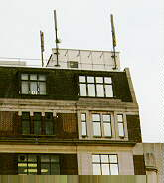
Decreasing cell size gives
- Increased user capacity
- Increased number of handovers per call
- Increased complexity in locating the subscriber
- Lower power consumption in mobile terminal: so it gives longer talk time, safer operation
However, system design differs for macro, micro and pico cells:
- Small cells have a different propagation environment
- Different cell layout, micro-cells are often confined to one block of an urban street grid.
REF:[ http://www.wirelesscommunication.nl/reference/chaptr04/cellplan/cellsize.htm]
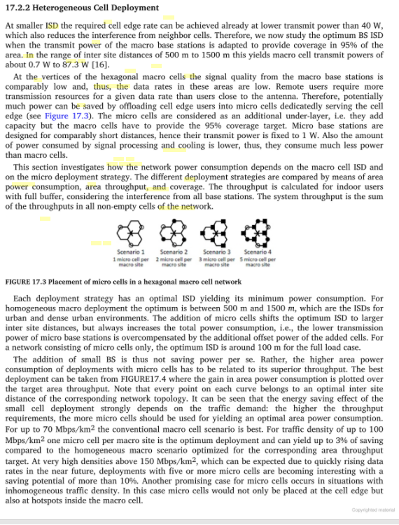
REF: [https://books.google.se/books?id=IWMvyiQfhkMC&pg=PT670&lpg=PT670&dq=micro+cells+power+consumption&source=bl&ots=S-k9-LNIdV&sig=USIIAq3mugyFYTmF8kI28tZ4y-E&hl=en&sa=X&ved=0ahUKEwib2LeM9aLXAhXBA8AKHTplAOs4ChDoAQgtMAE#v=onepage&q=micro%20cells%20power%20consumption&f=false]
More details of the deployment refer to this :
https://biblio.ugent.be/publication/5683273/file/5683281
Datasheet for micro base station :
https://www.scribd.com/document/352951621/RBS-6501-Datasheet
https://kupdf.com/download/rbs-6501-datasheet_59e1226e08bbc52744e65316_pdf
In this paper we have shown that the we can achieve high rates to cater to the needs for the future and still maintaining the power consumption to a reasonable level.
As the number of resources is limited with macro cells so, as the traffic load goes up these resources need to be shared among the UEs. This leads to reduced data rate per UE and longer time to receive a file. So, it is advantageous to complement macro cells in the network with micro cells for increased quality of service and improved data rates.
Using the energy saving features does not affect the resultant data rates to the users as implied by the figures _ . The data rates remains the same regardless of using the energy saving schemes.

The energy saving schemes make use of putting the cell the cell to sleep when they are not carrying any traffic. Using these energy saving schemes, we can achieve a very high amount of saving and hence, keep the carbon footprint for the mobile networks to a low level.

