Introduction

* 1. Introduction

Energy plays an important role in our lives, almost every industry depends heavily on energy. In recent times with the rising global temperature and climate change, the importance of saving energy has become ever important. With the rapid development of ICT (Information and Communication Technology) industry the demand for power has also increased. ICT tends to play a significant role in global greenhouse gas emissions. Cellular networks are among the main energy consumers in the ICT field. It was responsible for 10% of world’s total energy consumption in 2010 and is doubling in every 10 years (Dufková, Bjelica, Moon, Kencl, & Le Boudec, n.d.). With increased need for broadband speed, the demand for energy and densification of networks is likely to increase. High energy efficiency is becoming a mainstream concern for the design of future wireless communication networks.

* 1. Background and Motivation

The global mobile data traffic grew by 63 percent in 2016.(“Cisco Visual Networking Index: Forecast and Methodology Cisco Visual Networking Index: Cisco Visual Networking Index: Forecast and Methodology,” 2015) it stood at 7.2 billion Giga bytes per month during the ending of 2016. And by 2021 it will be 49 billion Giga bytes.

Almost half a billion new mobile devices were added in 2016 and according to the Ericsson’s forecast there will be 50 billion connected devices by 2020.

Since the introduction of mobile networks, the focus has often been on optimizing the network to fulfil the coverage, capacity and quality requirements. Products have been developed and network deployments have been designed, focusing mainly on these key requirements. During recent years, operators have started to investigate how energy is consumed in mobile networks. The understanding has increased on how energy consumption can be reduced, and environmental awareness has gained importance in the mobile telecom industry. The challenge with designing an energy efficient network is to avoid reducing quality or coverage and hence reducing the performance.

About 0.5% of the world energy consumption is from mobile radio networks.(Fehske, Richter, & Fettweis, n.d.) In mobile networks, base stations are the ones which consume the most amount of energy. Comparing the life cycle of a mobile and base station, a mobile would contribute to green-house gases the most at the time of its manufacturing while for the base station, it is during its life time as a serving node. A lot of research has been done in order to make mobile more efficient at consuming battery power but, base station remain behind their counterparts. Around 80% of the total energy in mobile networks is consumed in radio access network and majorly in base station which comes around to be 60% of the whole (Fehske et al., n.d.). Which stresses on call for reducing this energy consumption at the base station side.

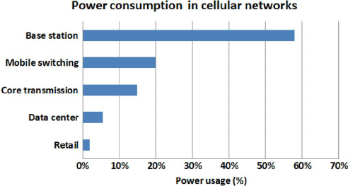

Figure 1. Breakdown of energy consumption in cellular networks (Source Vodafone)(Han et al., 2011)

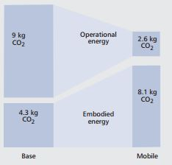

Figure 2. The operational and the embodied CO2 emissions by base stations and mobile phones per subscribers per year (Han et al., 2011)

* 1. Previous Work

There had been studies related to improvement of the base stations energy consumption, and in 2010-2012 a study was conducted under Energy Aware Radio and netWork tecHnologies (EARTH) project in which researchers from around the world tried to achieve deliverables (Domenico & Petersson, 2012) which proved to become standardized principles for working on energy efficiency concepts for base stations.

In the executive summary of their final deliverable they state that: “The Energy Aware Radio and neTwork tecHnologies (EARTH) project had the ambitious overall goal to derive solutions that together can decrease the radio access network energy consumption by 50 % with preserved quality of service. These solutions act all the way from more efficient components in the base station, over improvements affecting individual radio links, up to solutions acting on the radio network level such as deployment strategies. Furthermore, the project not only developed and proposed energy efficient solutions in all these areas, but also combined them into an overall EARTH energy efficient integrated concept. In addition, EARTH is committed to have a real impact on networks in operation; hence the target was not only to carry out theoretical studies in this aspect, but also to provide trustworthy proof-of-concepts of the individual solutions and in particular of the overall EARTH energy efficient integrated concept.”(Domenico & Petersson, 2012).

The EARTH project gave the mathematical power model for calculating the energy consumption in the base stations for various different scenarios of rural, sub-urban and urban, the linear power model is used in generic simulations. It also gives the internal breakdown of energy consumed within different sizes of nodes such as macro, mico, pico and femto.

In (Desset et al., 2012) the study was conducted to break up the energy consumed by different components of the BS in macro, pico and other cells that support the 3GPP LTE standard. It supports the Earth Project’s state of the art (SoTA) power model.

In(Yunas, Valkama, & Niemelä, 2015) a “Manhattan-type city grid” is analyzed for energy performance in which off-loading the macro cells with indoor cells prove to be more energy efficient.

In (Forssell & Auer, 2015) study was conducted to find if in a dense urban scenario, the indoor nodes would prove to be energy efficient or not but, to the contrary they proved to be worse than keeping only the macro BS grid in the scenario.

In (Tombaz, Sung, & Zander, 2012) study was conducted on densification of network in which it was found out that the deployment of smaller cells reduces the transmit power of large BSs and the idle time and backhaul proved to be energy wasters

In (Falconetti, Frenger, Kallin, & Rimhagen, 2012) a heterogeneous network scenario was considered in which network densification strategies were introduced and to save the power; micro DTX and pico node sleep modes were utilized to prove that the network densification could take place successful without increasing the energy requirements. The heterogeneous network was composed of macro nodes and pico nodes. At high traffic energy could be saved a lot by smaller nodes handling large traffic, thereby increasing user performance and decreasing energy consumption at the same time. In one of the deliverables of EARTH Project DTX scheme was also presented.

We will make use of these energy saving features like short term DTX and long term sleep modes in the nodes. We will make use of Ericsson’s static network simulator which will present us a realistic three-dimensional model of a city with buildings, pavements and open spaces. The simulator makes use of ray-tracing propagation models.

* 1. Purpose of the Project

With the outset of 5G, many cities will be deployed with indoor cells, pico, DAS and radio dots. Out of 100% of Ericsson’s deployment in cities like Beijing, 50% is indoor deployment and cities like Seoul, Dubai, Shanghai have much more.

As in South Korea telecom operators have bought 28 GHz band for their frequency spectrum, this will be impenetrable to the buildings from outside so for base coverage indoor we would need micro, pico and radio dots and other indoor deployments for e.g. at GHz and other radio frequencies.

For an assumption as we foresee 5G will develop with HetNets in radio frequency plus high frequency base stations for the baseline coverage of the traffic. Therefore, it is more required than ever that this type of research should take place to compare and investigate the scenarios which are energy efficient and which provide a deeper understanding of the amount of energy consumed in hetnets with pico cells, micro cells and macro cells deployment.

* 1. Outline of the Thesis

In this thesis the first chapter deals with the introduction, background and motivation for this project, chapter 2 is about the theory of BSs which describes about various cells used in a typical heterogeneous deployment the LTE basics chapter 3 is where we explain the Earth Power model and the simulation setup is explained in the chapter 4, results and discussion is in chapter 5, conclusion inn chapter 6 and future work in chapter 7.

1. Theory

* 1. Heterogeneous Networks

With the onset of 5G, there will be a lot of use of HetNets and densified networks to satisfy the demand for increased traffic. Most of the mobile traffic will be concentrated indoors, around 70 percent of the traffic will come from indoor users in shopping malls, airport terminals etc. (Ericsson white paper, 2014). There will be small cells which would be deployable as ‘plug and play’ which is going to save a lot of CAPEX for the operators and as these small cells will have a small coverage area which will enable frequency to reuse possible being close to each other which will provide large capacity improvement (Yunas et al., 2015).

With the incoming 5G spectrum allocation, speculations are that frequency spectrum for 5G will lie in very high frequencies of the order 30 GHZ, according to a study done with coverage and penetration of these waves in indoor environment will be very problematic. “Achieving indoor coverage at 30 GHz is highly problematic for all cases, and it is concluded that indoor base stations are necessary if frequencies of 10 GHz and above are to be used in future mobile networks.” (Rydén, 2016)

Here is a brief theory about the cells which constitute a HetNet.

|  |  |  |  |  |
| --- | --- | --- | --- | --- |
| Specification | Femtocell | Picocell | Microcell | Macrocell |
| Transmit Power | 20 dBm | 30dBm | 30dBm |  |
| Transmission power | 10- 100mW | 200 mW- 2W |  | 40 W |
| Power Consumption | Low | Low | Moderate | High |
| Coverage distance | Less than 30m | Less than 100 m | Less than 500m | Several kms. |
| Deployment | Indoor | Indoor and Outdoor | Outdoor | Outdoor |
| Backhaul connectivity | DSL, cable, fiber | Microwave, mm | Microwave, Fiber | Microwave, Fiber |
| Installation | User | Operator | Operator | Operator |

Table 1. Comparison between different types of nodes in a heterogeneous network.

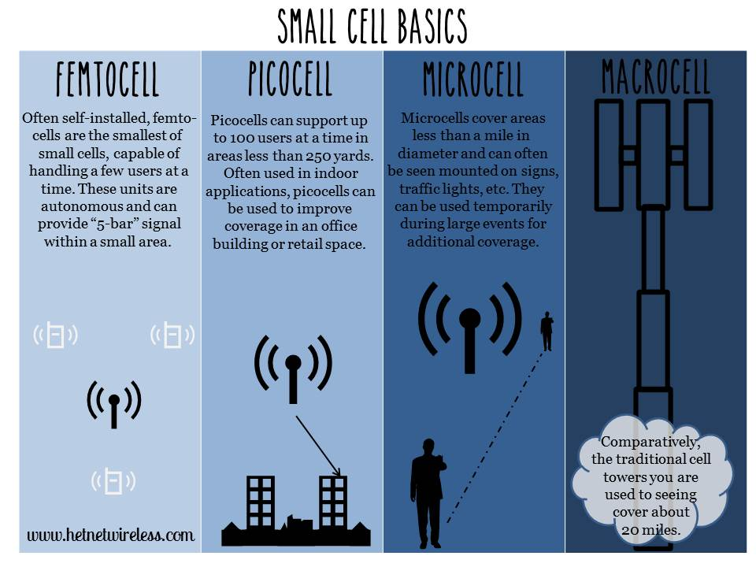

Figure 3. Small cells pictorial representation (www.hetnets.com)

* + 1. Macro Cells:

These cells are the base stations that provide coverage to a large area with Inter site distance (ISD) around 200m to several kilometers. depending upon the density. They fulfill the baseline coverage for any LTE network, providing connectivity and up all the time. The output transmit power varies from 5 to 40 W. they have sectored antennas normally covering 120 degrees per sector.

* + 1. Pico Cells

Pico cells have lower transmit power than macro BSs, they have Omni-directional antennas unlike macro BSs which are sectored. The transmit power ranges from 250mW to 2W. They are generally used for indoor purposes around hot-spots like offices, railway stations etc. and are connected over X2 interface. (Landström & Anders, 2011)

* + 1. Femto cell

Femto cells are also known as HeNBs are deployment for small rooms and home requirements generally for a very small range coverage less than 30m. They have Omni-directional antennas, transmit power is around 100 mW. They could be plugged in using a DSL line or modem cable. (Landström & Anders, 2011)

* 1. LTE Basics:
     1. OFDM (Orthogonal Frequency Division Multiplex)

In LTE the OFDM modulation technique is used to produce orthogonality between the sub-carriers in frequency domain. A sub-carrier is of 180 kHz. The OFDM provides resistance to interference in between LTE sub-carriers, the LTE uses OFDMA (Orthogonal Frequency Division Multiple Access in down link radio access and SC-OFDMA (Single Carrier - Frequency Division Multiple Access) in uplink radio access. OFDM provides high data rates and tightly spaced orthogonal sub-carriers provides high spectrum efficiency.

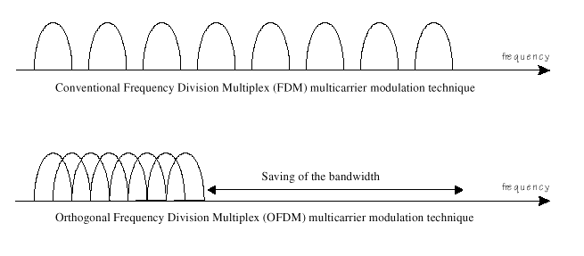

Figure 4. Comparison between conventional FDM modulation technique and OFDM modulation technique

* + 1. MIMO (Multiple Input Multiple Output)

A key radio access feature for LTE is MIMO. The data streams going in and out of antenna in radio channel is used to for beamforming and transmit diversity. The diversity will result in low correlation of fading and this could be used for receive / transmitting diversity. Better reception could be generated by sending simultaneously the copies of the same data through the channel and receiving using multiple antennas. MIMO provides spatial multiplexing i.e. sending different data streams transmitted in parallel over separate antennas. MIMO could be used to increase the throughput. As per the need 2 x 2, 4 x 2, or 4 x 4 antennas could be used in LTE.

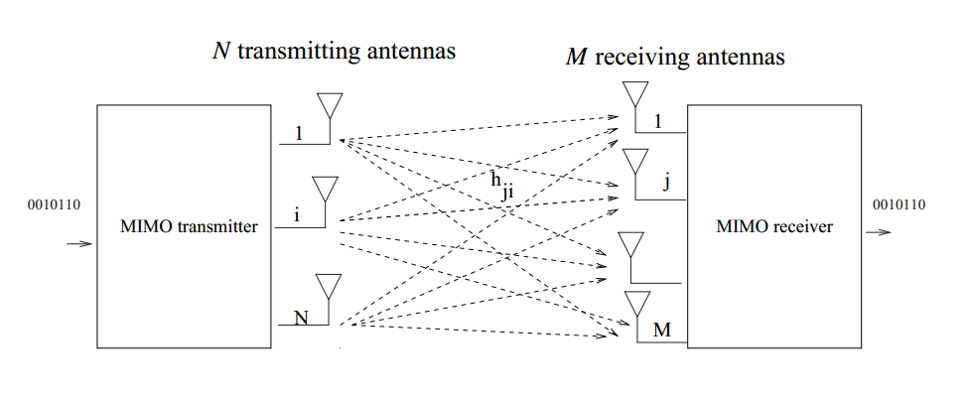

Figure 5. Representation of MIMO scheme.

1. Power Model

3.1. Power distribution in base station

This section defines how could we breakdown and understand comprehensively the energy consumed by the BSs. As per the findings of the Earth Project, Power Amplifier (PA) remains by far the major contributor to energy consumption. Understanding the root cause of this consumption can help us to eradicate the problems and nip the issues which lead to high energy consumption.

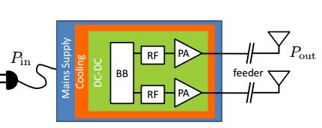

Figure 6. A typical transceiver structure of Base Station.

Figure 6 shows how the block diagram of a typical BS, it could be macro, micro, pico or femto. This model was taken into consideration for developing the Earth Project’s state of the art (SoTA) BS power model. There could be multiple transceivers in a BS. Each transceiver contains the baseband (BB) module, Radio Frequency (RF) module, power amplifier (PA) which connects to the antennas after providing the required power gain, DC to DC power converter, cooling system and a power supply connected to the mains. For macro BS the sector antenna is located at large distance from the PA which leads to large feeder losses and which needs to be compensated by PA.(Auer et al., n.d.)

The PA has poor power efficiency as it is made to work in non-saturated region which is to avoid nonlinear distortion from channel interference. In macro BS digital pre distortion is used to improve the PA efficiency. (Forssell & Auer, 2015)

Radio Frequency module is used to convert analog signals to digital signals. Base Band module serves as digital signal processor for digital up and down conversion of signals, it also does OFDM modulation of the signal. Typical responsibilities for BB are filtering, FFT for OFDM modulation and IFFT for OFDM demodulation, signal detection, channel estimation, it is the brain of the a transceiver.(Auer et al., n.d.)

So, the total power consumed within a BS could be given as:

$$\begin{aligned}PTotal = PBB + PRF + PPA + POverhead\#(3.1)\end{aligned}$$

Below table lists the energy required in different components of BS in different cells.

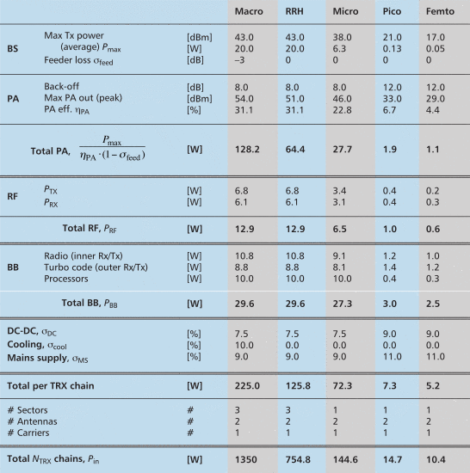

Table 2. A comparison of energy consumed in different components of a BS.

1. Simulation setup
   1. Deployment

We will deploy a layer of outer grid comprising of Macro cells and a layer of inner indoor cells for high traffic requirements and then we will measure the Energy performance with keeping only the Macro layers outside the central grid keeping the base stations inside cover the traffic and the outside layer of macro cells for coverage purposes.

References

Auer, G., Giannini, V., Gódor, I., Olsson, M., Ali Imran, M., Sabella, D., … Desset, C. (n.d.). How Much Energy is Needed to Run a Wireless Network ?

Cisco Visual Networking Index: Forecast and Methodology Cisco Visual Networking Index: Cisco Visual Networking Index: Forecast and Methodology. (2015). *Forecast and Methodology*, 2015–2020.

Desset, C., Debaillie, B., Giannini, V., Fehske, A., Auer, G., Holtkamp, H., … Blume, O. (2012). Flexible power modeling of LTE base stations. In *2012 IEEE Wireless Communications and Networking Conference (WCNC)* (pp. 2858–2862). IEEE. https://doi.org/10.1109/WCNC.2012.6214289

Domenico, A. De, & Petersson, S. (2012). Final Integrated Concept. *EARTH Project D.6.4*, 1–95. Retrieved from https://bscw.ict-earth.eu/pub/bscw.cgi/d49431/EARTH_WP6_D6.4.pdf

Dufková, K., Bjelica, M., Moon, B., Kencl, L., & Le Boudec, J.-Y. (n.d.). Energy Savings for Cellular Network with Evaluation of Impact on Data Traffic Performance.

Falconetti, L., Frenger, P., Kallin, H., & Rimhagen, T. (2012). Energy efficiency in heterogeneous networks. *Online Conference on Green Communications (GreenCom), 2012 IEEE*, 98–103. https://doi.org/10.1109/GreenCom.2012.6519623

Fehske, A. J., Richter, F., & Fettweis, G. P. (n.d.). Energy Efficiency Improvements through Micro Sites in Cellular Mobile Radio Networks.

Forssell, H., & Auer, G. (2015). Energy Efficiency of Heterogeneous Networks in, 53–58. https://doi.org/10.1007/s11265-011-0637-3

Han, C., Harrold, T., Armour, S., Krikidis, I., Videv, S., Grant, P. M., … Hanzo, L. (2011). Green radio: Radio techniques to enable energy-efficient wireless networks. *IEEE Communications Magazine*, *49*(6), 46–54. https://doi.org/10.1109/MCOM.2011.5783984

Landström, S., & Anders, F. (2011). Ericsson Review: Heterogeneous networks-increasing cellular capacity.

Rydén, V. (2016). *Outdoor to Indoor Coverage in 5G Networks*. *Teknisk- naturvetenskaplig fakultet UTH-enheten*. Retrieved from https://uu.diva-portal.org/smash/get/diva2:944408/FULLTEXT01.pdf

Tombaz, S., Sung, K. W., & Zander, J. (2012). Impact of densification on energy efficiency in wireless access networks. *2012 IEEE Globecom Workshops*, 57–62. https://doi.org/10.1109/GLOCOMW.2012.6477544

Yunas, S., Valkama, M., & Niemelä, J. (2015). Spectral and energy efficiency of ultra-dense networks under different deployment strategies. *IEEE Communications Magazine*, *53*(1), 90–100. https://doi.org/10.1109/MCOM.2015.7010521

Appendix A: Extended material

Some extra information for readers who would like more.