TECHNICAL DOCUMENTATION
Equity Research AI Terminal
A Multi-Agent AI Pipeline for Company Research
Design, Architecture, Build Process, and Use Cases
July 2026

1. Overview
The Equity Research AI Terminal is an interactive tool that automates the first draft of an equity research note using a coordinated pipeline of AI agents rather than a single prompt-and-response interaction. A user enters one company (for a full single-name report) or up to three companies (for a side-by-side comparison), and the system runs each company through five specialised agents before producing a structured, sourced research note in a terminal-styled interface.
The project was built as a response to a public discussion of how quantitative hedge funds — Magnetar Capital's AI-driven fund being the specific example that prompted this build — are replacing parts of traditional junior-analyst research work with fleets of AI agents that source ideas, analyse companies, and draft recommendations, with humans retaining final decision authority. This tool is a small-scale, transparent illustration of that same idea: decompose "do research on this company" into discrete, auditable steps rather than one opaque model call.

2. How This Was Generated — Process and Authorship
In the interest of giving you an accurate account for your mentor: this tool was built collaboratively through an iterative, prompt-driven conversation with Claude (Anthropic's AI model). You supplied the direction — the initial challenge (build a working AI tool that analyses a stock, inspired by the LinkedIn post on Magnetar), and follow-up requests to add a compliance/risk-check agent and multi-company comparison. Claude wrote the actual HTML, CSS, and JavaScript, tested the code for syntax errors, and debugged a reported runtime issue by reviewing the API request pattern and tightening error handling.
Concretely, the build proceeded in these stages:
- Stage 1 — Single-agent prototype: a command-bar UI plus one set of News / Fundamentals / Sentiment / Synthesis agents producing a single-company report.
- Stage 2 — Robustness pass: after you reported an error, the API-calling logic was reviewed against Anthropic's documented web search tool behaviour, token limits were increased, and JSON-parsing was made more forgiving with clearer error messages.
- Stage 3 — Extension: a fifth Compliance/Risk-Audit agent was added, along with support for comparing up to three companies via a pipeline-status grid and a comparison summary table.
If your mentor's evaluation criteria distinguish between "used AI as a tool" versus "wrote it unaided," this section is intentionally worded so you can represent the work accurately: the concept, direction, and iteration were yours; the code generation was AI-assisted end-to-end.

3. System Architecture
The core design principle is agent decomposition: instead of asking one model call to "research and analyse this stock," the task is split into five narrower agents, each with a single responsibility, chained together with explicit data hand-offs.
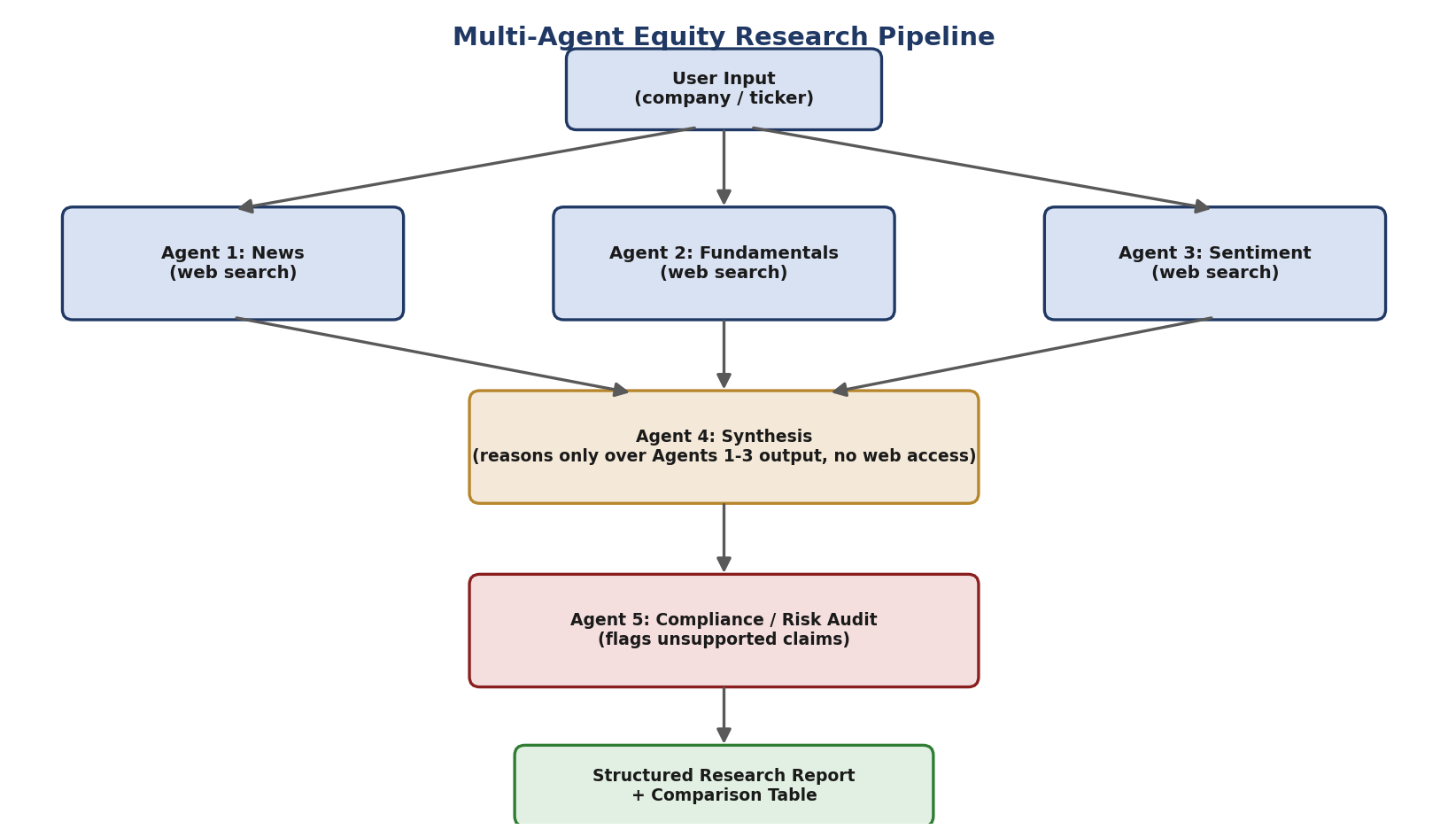
Figure 1: Data flow through the five-agent pipeline, from user input to final report.

3.1 The Five Agents
Agent | Web Access | Responsibility
1. News | Yes | Finds recent, dated, concrete news and catalysts (last 3-6 months)
2. Fundamentals | Yes | Finds revenue, margins, valuation multiples, and balance-sheet figures
3. Sentiment | Yes | Finds analyst ratings, price-target trends, and market/media sentiment
4. Synthesis | No (by design) | Reasons only over Agents 1-3's output to draft the bull/bear case and signal
5. Compliance / Risk Audit | No | Re-checks the synthesis against the original findings and flags unsupported claims

3.2 Why Isolate the Synthesis Agent from Web Access
Agent 4 deliberately has no web search tool available to it. It can only see the structured JSON output already produced by Agents 1-3. This mirrors how a real analyst works from a research packet rather than re-researching from scratch at the drafting stage, and it makes the pipeline auditable: any claim in the final note can be traced back to a specific upstream agent's findings, rather than being freshly (and invisibly) pulled from the web at synthesis time.

3.3 Why a Dedicated Compliance Agent
Agent 5 exists specifically to counteract a known failure mode of language models: confident-sounding claims that outrun the evidence. It is prompted to be deliberately skeptical and to compare every claim in the bull case, bear case, risks, and synthesis note against the actual source material gathered earlier in the pipeline, flagging anything fabricated or overstated. This status (Clear / Flagged, with itemised notes) is surfaced directly in the UI before the user reads the note, rather than being a hidden step.

4. Technical Implementation
The tool is a single self-contained HTML file (embedding CSS and JavaScript) designed to run as an interactive artifact. It makes direct client-side calls to Anthropic's Messages API endpoint for each agent step.
Component | Detail
Model | claude-sonnet-4-6, called once per agent per company
Web search | Anthropic's native web_search_20250305 tool, enabled for Agents 1-3 only
Data contract | Each agent is instructed to return a single JSON object (items/sources, or structured synthesis fields), parsed defensively (direct parse → fenced-block parse → brace-match parse)
Token budget | 2200 tokens for web-search agents (room for search + final answer), 1200 for reasoning-only agents
Error handling | Network failures, non-2xx responses, and empty/unparseable model output are each caught and surfaced with a specific message rather than failing silently
UI | Dependency-free HTML/CSS/JS; a live status grid shows each agent's state (queued / running / done / flagged) per company as the pipeline executes

5. Features
- Single-company mode: full research note with news, fundamentals, sentiment, bull/bear case, risks, synthesis, compliance status, and clickable sources
- Multi-company mode (2-3 companies): the same five-agent pipeline run per company, plus a comparison summary table (signal, confidence, top catalyst, top risk, compliance status side by side)
- Live pipeline visualisation: a status grid (companies × agents) so the user can see which stage is running, completed, or flagged in real time
- Source transparency: every research agent is required to return the URLs it drew on, de-duplicated and shown per company
- Compliance layer: an explicit, visible audit step that can flag the synthesis agent's own output rather than presenting it as unquestioned truth

6. Use Cases
Where a tool like this is genuinely useful — and where it is not — matters for how you present it:

6.1 Appropriate uses
- First-pass research drafting: generating a structured starting point (news, fundamentals, sentiment) that a human analyst then verifies and deepens, rather than a finished output
- Rapid comparative screening: quickly lining up 2-3 candidate companies on the same dimensions before deciding where to spend deeper human research time
- Teaching and demonstration: illustrating, concretely, how a multi-agent AI research pipeline can be structured (decomposition, hand-offs, and an auditing step) — useful in exactly the context of a mentor-evaluated challenge like this one
- Internal process design reference: the agent-decomposition and compliance-audit pattern shown here is a reusable template for other AI-assisted research or due-diligence workflows

6.2 Not appropriate for
- Making actual investment decisions without independent verification — the tool says this explicitly in its own disclaimer
- Any use requiring guaranteed real-time or complete financial data (the tool depends on whatever a live web search surfaces at query time)
- Regulatory or compliance-grade research where a true compliance officer's sign-off is required — Agent 5 is a claims-grounding check, not a substitute for real regulatory review

7. Limitations
- Web search results can be incomplete, outdated, or contradictory across sources; the tool does not independently verify figures beyond the compliance agent's claims-grounding check
- Language models can still make confident-sounding errors even with a compliance step; the check reduces but does not eliminate this risk
- No proprietary data, real-time tick data, or paid research terminal feeds are used — only what is publicly discoverable via web search at the time the tool runs
- Multi-company runs take longer, since each company runs the full five-agent sequence

8. Possible Future Extensions
- A macro/industry-context agent (sector trends, rates, regulatory backdrop) feeding into synthesis alongside the existing three research agents
- A quantitative/technicals agent using code execution to compute momentum or valuation-relative metrics rather than relying purely on narrative web search
- Persistent storage of past runs so a user can track how the AI's view of a company changes over time
- A confidence-weighted source-quality check (e.g., prioritising company filings and primary sources over aggregator sites)

9. Closing Summary
This tool is a working, small-scale demonstration of the same underlying idea described in the Magnetar coverage that prompted it: replacing a single opaque research step with a pipeline of narrower, coordinated AI agents whose work can be inspected and checked, culminating in a dedicated audit step before the output is trusted. It was built through iterative, AI-assisted development directed by the user's own prompts, challenge selection, and feature requests, and is intended as an educational and first-draft research aid rather than a source of investment advice.

