AI Email Outreach & Campaign Automation Platform
Detailed Product Requirements, Architecture, Security, Compliance and Implementation Plan

1. Executive Summary
The proposed platform is an AI-powered email outreach and campaign automation system. Its primary purpose is not lead generation. Customers can provide recipient/contact data through CSV, Excel, manual entry, CRM/API integrations, or optional data-acquisition modules. The platform then converts the customer's communication objective into personalized email campaigns, schedules delivery through authorized Google, Microsoft or SMTP sender accounts, monitors delivery and replies, and provides analytics and compliance controls.
The core product principle is controlled, permission-aware and reputation-conscious automation. The platform must not attempt to bypass Gmail, Microsoft Exchange/Outlook, SMTP-provider controls, spam filters, domain reputation systems or anti-abuse mechanisms. Instead, it should use provider APIs, adaptive scheduling, authentication checks, suppression lists, unsubscribe handling, bounce/complaint controls and auditable policies.

2. Product Scope and Positioning
Recommended product name/category: AI Email Outreach & Campaign Automation Platform.
The platform has four major business functions: recipient/contact management; AI message creation and personalization; campaign scheduling and sending; conversation and campaign analytics.
Lead generation is an optional input module rather than the product's primary identity. A Google/business-data connector can be added as a separate module later.

3. Target User Workflow
1. User creates or joins a workspace. 2. User imports or selects recipients. 3. User defines the communication objective. 4. AI generates a campaign template. 5. The user reviews and approves the content. 6. The system validates sender, domain, recipient and campaign policy. 7. The scheduler determines eligible sending windows and queue times. 8. The sending adapter delivers through Google, Microsoft, SMTP or an approved email service. 9. Events are processed for delivery, bounce, unsubscribe, complaint and reply. 10. AI classifies replies and suggests next actions. 11. Analytics show campaign and sender performance.

4. Functional Modules
4.1 Workspace & Multi-user: organizations, teams, roles, permissions, audit logs, usage limits and tenant isolation.
4.2 Contact Center: import CSV/Excel, manual contacts, API/CRM import, custom fields, tags, lists, segmentation, validation, deduplication, suppression and unsubscribe status.
4.3 Sender Center: Google OAuth, Microsoft Graph, SMTP, sender profiles, signatures, credentials/tokens, sender health, provider limits and connection status.
4.4 AI Message Studio: objective-to-email generation, tone, CTA, subject generation, variants, personalization, variable mapping and human approval.
4.5 Campaign Manager: one-time campaigns, scheduled campaigns, recurring campaigns, sequences, follow-ups, recipient selection, sender selection and campaign state management.
4.6 Adaptive Scheduler: recipient timezone, business-hour windows, provider limits, sender limits, queue smoothing, retries, exponential backoff and automatic pause conditions.
4.7 Compliance & Reputation Center: SPF/DKIM/DMARC checks, sender authorization, unsubscribe, suppression, bounce/complaint controls, domain health and policy enforcement.
4.8 Conversation Center: incoming reply ingestion, thread association, AI classification, suggested responses, follow-up tasks and opportunity handoff.
4.9 Analytics: sent, accepted, delivered where provider data is available, bounced, unsubscribed, complained, replied, positive reply and campaign-level performance.
4.10 Optional Data Acquisition: Google/business search, websites and other lawful/authorized sources. This module should remain decoupled from the email sending engine.

5. High-Level Architecture
Recommended architecture: React frontend; Python FastAPI backend; PostgreSQL primary database; Redis for caching and queue coordination; Celery or an equivalent durable worker system for asynchronous jobs; provider adapter services for Gmail, Microsoft Graph and SMTP/ESP; object storage for large imports/exports; centralized audit/event storage; optional AI gateway for model providers.
Logical flow: User Interface → API Gateway/Application API → Authentication/RBAC → Contact Service / AI Message Service / Campaign Service / Compliance Service → Scheduler → Queue → Provider Adapter → Email Provider → Recipient. Provider events and mailbox replies return through webhooks/polling into the Event Processor → Conversation/Analytics services.

6. Architecture Diagram
Presentation Layer
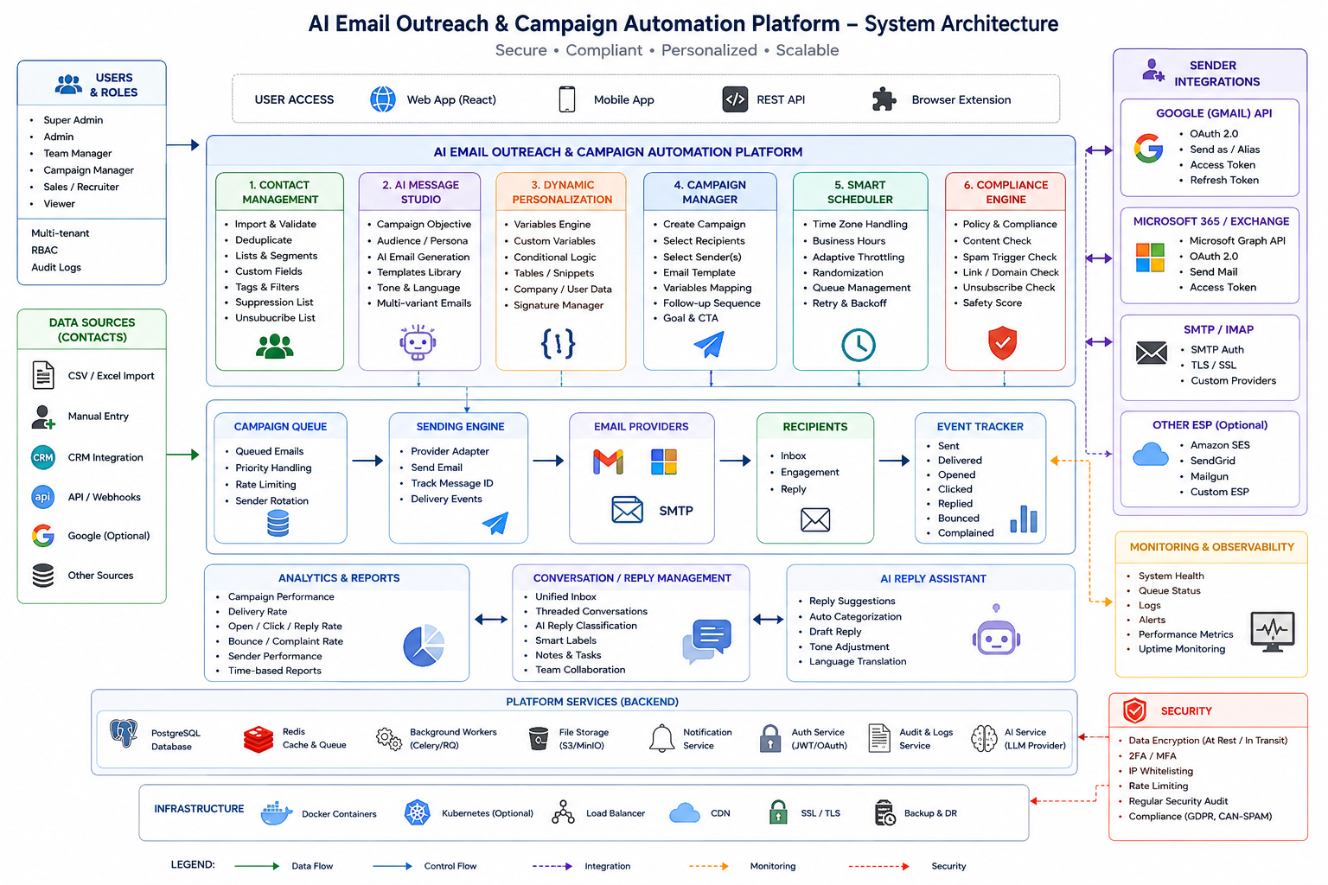
React Web Application
│
├── Dashboard
├── Contacts
├── Message Studio
├── Campaigns
├── Senders
├── Conversations
├── Analytics
└── Administration
Application Layer
FastAPI / Python
│
├── Auth & RBAC Service
├── Contact Service
├── Import/Validation Service
├── AI Message Service
├── Template/Variable Service
├── Campaign Service
├── Compliance Service
├── Scheduler
├── Sending Service
├── Event Processor
├── Conversation Service
└── Analytics Service
Infrastructure Layer
PostgreSQL | Redis | Worker Queue | Object Storage | Secrets Manager | Monitoring
External Integrations
Google Gmail API | Microsoft Graph | SMTP/ESP | CRM/API | Optional Data Sources

7. Provider Adapter Architecture
The sending layer should use a common interface so that business logic does not depend on a single provider.
Common interface: connect(), authenticate(), get_profile(), send(), get_message/thread(), create_draft(), get_events(), disconnect(). Implementations: GmailProvider, MicrosoftGraphProvider, SMTPProvider and later ESPProvider adapters.
OAuth credentials and refresh tokens must be encrypted and stored separately from ordinary application data. Passwords should never be stored when OAuth or app-specific credentials can be used.

8. Google Integration
Use Google's supported OAuth and Gmail APIs for authorized mailbox access and sending. The application should request the minimum scopes needed for the features enabled. The system must implement quotas and error handling because Gmail API usage is quota-controlled.
Recommended flow: Connect Google → OAuth consent → token exchange → encrypted credential storage → sender verification → provider capability discovery → campaign eligibility → send through adapter → capture response/event.

9. Microsoft Integration
Use Microsoft Entra ID authentication and Microsoft Graph for Microsoft 365/Exchange Online mailboxes. The application should use least-privilege permissions and tenant/admin consent only when the selected feature requires it.
Recommended flow: Connect Microsoft 365 → Entra OAuth → token storage → mailbox/profile verification → Graph send → event/reply processing.

10. SMTP Integration
SMTP should be treated as a generic provider adapter. Configuration includes hostname, port, TLS mode, username/credential reference, from address and reply-to address. Credentials must be encrypted. Connection testing should validate authentication and TLS before a sender is enabled.

11. Contact and Variable Model
Contacts should use a flexible schema rather than a fixed set of fields. Core fields include first_name, last_name, email, phone, company, designation, location, website and source. Custom attributes support business-specific variables such as skills, job_title, experience, requirement, service, service_area, budget, technology and availability.
Template syntax can use {{first_name}}, {{company}}, {{designation}}, {{location}}, {{skills}}, {{job_title}}, {{service}}, {{sender_name}}, {{sender_company}}, {{sender_signature}} and custom variables. The renderer must escape unsafe content and show a final per-recipient preview before sending.

12. AI Message Generation
Input: objective, audience, available data, tone, CTA, sender profile and optional reference material. Output: subject options, email body, CTA, personalization instructions and optional follow-up sequence.
AI must not invent facts about a recipient or company. The system should label information as user-provided, source-derived, inferred or AI-generated and allow the user to inspect source context where applicable.
Recommended lifecycle: AI draft → validation → human review → approval → campaign snapshot. Once approved, the exact campaign version should be immutable for audit purposes.

13. Campaign Engine
Campaign states: Draft → Review → Approved → Scheduled → Running → Paused → Completed → Cancelled → Failed.
A campaign should store recipient list/version, sender policy, template version, schedule, follow-up rules, compliance snapshot and approval history. Changes after launch should create a new version rather than silently changing previously approved content.

14. Adaptive Scheduling
The scheduler should smooth delivery rather than create bursts. Inputs include provider limits, sender capacity, campaign priority, recipient timezone, configured business windows, previous failures, temporary provider errors and campaign policy.
Use queue-based scheduling with retry/backoff. If a provider returns throttling or temporary errors, the system should defer messages. If bounce or complaint indicators cross configured safety thresholds, the campaign or sender can be paused automatically.
Do not implement sender rotation, timing randomization or content variation as a mechanism to evade spam detection or provider enforcement. Any timing variation should be for operational smoothing, recipient timezone alignment and controlled delivery.

15. Compliance and Reputation Architecture
Every send request should pass through a policy engine. Checks include: sender authorization, sender connection health, domain authentication status, suppression status, unsubscribe status, recipient validity, campaign classification, provider capacity, configured sending policy and account/domain risk state.
A campaign can be blocked with a clear reason, for example: missing sender authentication, recipient is suppressed, sender connection expired, domain policy failure or provider capacity unavailable.
The system should maintain a global suppression list per tenant and optionally a global account-level suppression policy. Unsubscribe and hard-bounce records must prevent subsequent marketing sends to the affected recipient.

16. Email Authentication and Domain Health
Domain checks should cover SPF, DKIM, DMARC, MX and TLS-related configuration where technically observable. The system should present configuration status, detected problems and recommended remediation.
For high-volume or promotional mail, the platform should support appropriate unsubscribe mechanisms and monitor provider/domain reputation signals. The system should never promise inbox placement or guaranteed deliverability.

17. Bounce, Complaint and Unsubscribe Processing
Hard bounce: suppress recipient. Soft/temporary failure: retry according to policy and provider response. Repeated failures: suppress or quarantine. Unsubscribe: immediately update suppression state. Complaint: immediately suppress and mark the sender/campaign for reputation review where event data is available.
All suppression decisions should be auditable with timestamp, source event, campaign, sender and reason.

18. Conversation and Reply Intelligence
Replies should be associated with the original campaign and recipient when technically possible. AI classification categories can include Interested, Not Interested, Need Information, Meeting Requested, Send Details, Wrong Person, Out of Office, Unsubscribe and Other.
The AI reply assistant should initially operate as a suggestion system requiring human approval. Automated reply sending should be optional and policy-controlled.

19. Security Architecture
Use tenant isolation, RBAC, MFA/SSO where appropriate, HTTPS/TLS, encrypted secrets, encrypted database/storage where supported, secure OAuth token storage, short-lived access tokens, refresh-token rotation where supported, audit logs, rate limiting, CSRF protection for browser flows, input validation, secure file handling and malware scanning for uploaded files.
Sensitive provider credentials must never appear in logs. Application logs should use correlation IDs and redact tokens, passwords and message content where not required for operation.

20. Data Model
Core tables/entities: tenants, users, roles, permissions, contacts, contact_custom_fields, contact_lists, contact_list_members, sources, import_jobs, email_accounts, provider_credentials, sender_profiles, domains, domain_checks, templates, template_versions, template_variables, campaigns, campaign_versions, campaign_recipients, scheduled_messages, messages, message_events, threads, replies, suppressions, unsubscribes, bounces, complaints, ai_generations, audit_logs, webhooks, usage_records and subscriptions.
Use UUIDs or equivalent non-sequential identifiers for externally exposed objects. Add created_at, updated_at and tenant_id consistently to tenant-scoped entities.

21. Recommended API Structure
Authentication: /auth/*; Contacts: /contacts/*; Lists: /lists/*; Imports: /imports/*; Senders: /senders/*; Domains: /domains/*; Templates: /templates/*; AI: /ai/*; Campaigns: /campaigns/*; Scheduling: /schedules/*; Messages: /messages/*; Conversations: /conversations/*; Analytics: /analytics/*; Webhooks: /webhooks/*; Administration: /admin/*.
Use REST/JSON for the main application API. Use asynchronous jobs for imports, validation, AI generation, large campaign preparation and event processing. WebSockets or server-sent events can be used for live campaign status.

22. Observability
Monitor API latency, worker queue depth, provider errors, send throughput, retry counts, bounce rate, complaint events, unsubscribe events, authentication failures, OAuth refresh failures, campaign pauses and domain health changes.
Provide both technical dashboards and customer-facing health dashboards. Every major operation should have an audit trail.

23. Recommended Technology Stack
Frontend: React + Vite + TypeScript + Tailwind CSS. Backend: Python + FastAPI + Pydantic + SQLAlchemy. Database: PostgreSQL. Queue/cache: Redis + Celery or an equivalent durable worker framework. Reverse proxy: Nginx or a managed ingress. Deployment: Docker containers; later Kubernetes if scale requires it. Monitoring: Prometheus + Grafana, with centralized logs such as Loki/OpenSearch depending on operational requirements.
For AI, use a provider abstraction so the platform can switch between model providers and maintain tenant-level configuration, budget limits and safety controls.

24. Deployment Architecture
Internet → WAF/Reverse Proxy → React frontend/API → private application network → FastAPI services → PostgreSQL/Redis/Workers. External provider connections use HTTPS/TLS. Secrets are stored in a dedicated secret manager or encrypted configuration store. Backups should be encrypted, tested and separated from production credentials.
For an initial deployment, a single Linux VM can host Docker Compose services. As customer count and campaign volume grow, separate API, worker, scheduler and database workloads. PostgreSQL should eventually be on managed or dedicated infrastructure with tested backups and restore procedures.

25. MVP Development Plan
Phase 1: Multi-tenant authentication, RBAC, PostgreSQL, contacts, CSV/Excel import, custom fields, lists and deduplication.
Phase 2: Google OAuth/Gmail and Microsoft Graph sender connections, SMTP, sender management and secure credential storage.
Phase 3: Template engine, variables, AI message generation, campaign builder and human approval.
Phase 4: Scheduler, queue, provider limits, timezone scheduling, retries, bounce/unsubscribe/suppression handling.
Phase 5: Compliance center, domain checks, sender health, campaign analytics and audit logs.
Phase 6: Reply ingestion, conversation management, AI reply classification and suggested responses.
Phase 7: Optional data-acquisition connectors such as Google/business data, websites and CRM integrations.

26. Enterprise Roadmap
Add SSO/SAML, SCIM, advanced audit export, approval workflows, data retention policies, tenant-level encryption options, regional data controls, DLP integrations, CRM synchronization, webhooks, public API, dedicated sending-provider integrations, advanced reporting and configurable compliance policies.

27. Key Product KPIs
Business KPIs: active workspaces, active senders, campaigns created, campaigns completed, qualified replies, positive reply rate, meetings generated and conversion to opportunity.
Deliverability KPIs: hard bounce rate, soft bounce rate, complaint rate, unsubscribe rate, provider rejection rate, authentication failures and sender/domain health. Open rate should not be treated as the primary success metric because privacy protections can make it unreliable.

28. Risks and Controls
Risk: sending unsolicited or inappropriate messages. Control: tenant policies, suppression, unsubscribe, campaign approval and configurable compliance checks.
Risk: provider account suspension. Control: official APIs, provider limits, adaptive throttling, sender health monitoring and automatic pause rules.
Risk: domain reputation damage. Control: SPF/DKIM/DMARC checks, bounce/complaint monitoring, suppression and campaign controls.
Risk: AI hallucination. Control: source-aware generation, fact labels, user approval and no unsupported claims.
Risk: credential compromise. Control: OAuth, encryption, least privilege, secret management and audit logs.
Risk: cross-tenant data leakage. Control: tenant_id enforcement, authorization middleware, database-level controls where appropriate and security testing.

29. Important Product Boundaries
The platform should not include anti-detection mechanisms, spam-filter bypasses, domain-blacklist evasion, fake sender identities, credential harvesting, mass account rotation, or methods intended to defeat Google/Microsoft enforcement. The product should optimize for authorized sending, reputation preservation and operational reliability.
The platform also should not promise that a campaign will reach the inbox. Deliverability is affected by recipient behavior, provider policies, domain reputation, message content and many external factors.

30. Final Recommended Architecture
The strongest architecture is a modular SaaS platform with Contact Management, AI Message Studio, Campaign Engine, Sender/Provider Adapters, Compliance & Reputation Engine, Adaptive Scheduler, Conversation Intelligence and Analytics. Optional data acquisition connectors should sit outside the core campaign engine.
This structure lets the product start small—contacts + Google/Microsoft/SMTP + AI templates + campaigns—and later add CRM integrations, business-data connectors, dedicated email service providers and advanced enterprise controls without redesigning the core.

Appendix A — Suggested MVP Navigation
- Dashboard
- Contacts
- Lists & Segments
- Message Studio
- Campaigns
- Senders
- Domains & Health
- Conversations
- Analytics
- Compliance Center
- Administration
- Audit Logs

