

HYBRID DATABASE SYSTEM USING MYSQL AND MONGODB
Course Name:
Course Code:

Submission Date:

Table of Contents
1. Introduction 3
2. Objectives 4
3. Tools and Technologies 4
4. System Architecture 5
5. Phase 1 — Database Design 6
5.1 SQL Design 6
5.2 NoSQL Design 7
6. Phase 2 — SQL Implementation 7
7. Phase 3 — NoSQL Implementation 10
8. Phase 4 — Integration Layer 20
9. Challenges Faced 22
10. Results and Observations 23
11. Conclusion 23
References 25
Appendix 27

List of Figures
Figure 1: Entity-Relationship (ER) Diagram of the E-commerce SQL Database 6
Figure 2: NoSQL Data Model Showing Collections and Relationships in MongoDB 7
Figure 3: SQL Implementation 10
Figure 4: NoSQL Implementation 20
Figure 5: Python Output Showing Hybrid Integration of SQL and MongoDB Data 21

1. Introduction
A database is a structured set of stored information that enables users to store, manage and access information easily. It is important in the recent applications since it makes data structured, secure and easily accessible. The operations that are assisted by databases include data addition, modification, removal and querying. They are popular in application in areas such as banking, e-commerce, healthcare and social media where vast volumes of data must be processed with reliability (Adam, Mohammed and Alsammani, 2023).
There are two general types of databases SQL and NoSQL. SQL databases or relational databases are databases where the data is stored in tables with predefined schema. They manipulate data with structured query language (SQL) and impose relationships with the help of primary and foreign keys. This renders them to be appropriate in the structured data and transactional systems. NoSQL databases on the contrary store the data in a flexible form like documents, key-value pairs or collections. They do not need a fixed schema and hence they can more effectively deal with unstructured or semi-structured data. This is what makes NoSQL systems suitable to use in applications where the data formats are in constant flux.
Hybrid database systems are a combination of SQL and NoSQL database systems to leverage their benefits. SQL, through consistency and integrity, provides structured data and NoSQL, through scalability and flexibility, provides dynamic data. A combination of both systems enables applications to be more adaptable and perform well. This methodology is widely applied in the current applications where various kinds of data require to be handled under one system.
An example that can be found in the real world is an e-commerce platform. A relational database is used to store structured data, including users, orders, and payment, whereas product information, reviews, and user activity are stored in a NoSQL database. In this project, MySQL and MongoDB will be used as the hybrid system. It also makes use of Python to bridge the two databases as well as produce combined outputs. The project illustrates the ability of data among various sources to be combined to aid in real business activities.

2. Objectives
The primary objective of this project is to design and deploy a hybrid database system which integrates the merits of both, SQL and NoSQL technologies. The project is about effectively handling various kinds of data and performance, flexibility and scalability of data in real life application scenario.
The objectives of this project are to design a relational database, using the MySQL database, to store transactional data like users, orders and payments. The other goal is to deploy a NoSQL database with MongoDB to store flexible and semi-structured data like product details, reviews and user activity. The project will also seek to incorporate the two databases through python, which will facilitate smooth flow of data between the two systems. Also, the system is employed to create valuable business knowledge via queries and data analysis to aid decision-making in an e-commerce setting (Aravindhan Ragunathan et al., 2025).

3. Tools and Technologies
In this project, a hybrid data solution is constructed by using a mix of database systems, as well as, programming tools. All the tools have a particular purpose in managing and integrating data. The relational database system is MySQL, where structured data like users, orders, payments and cart details are stored. It supports tabular storage with specified schemas and manipulates and retrieves the data using SQL queries. MySQL guarantees the consistency of data and makes use of primary and foreign keys to support relationship.
The NoSQL database is MongoDB which is used to store semi-structured and flexible data. It handles collection of products, reviews, user activity and wish list. Data is represented in the form of JSON-like documents, which make such data easy to modify and also to scale without having strict schema requirements. Python will be the integration layer in linking the two databases. It assists in retrieving, handling and integrating the data of MySQL and MongoDB into a single output. Python also makes it easy to automate and deal with data.
MongoDB Compass is a graphical interface that is used to manage MongoDB. It enables users to access collections, query and analyse data without command-line tools.

There are two important libraries used in the project. MySQL is a database which is connected to Python through MySQL. Connector library and uses the library to run SQL queries. Pymongo library is a Python library that connects Python and MongoDB and manipulates collections. The combination of these tools will facilitate the entire hybrid system (Bjeladinovic, 2025).

4. System Architecture
The system adheres to a hybrid system of database structure that integrates both the relational and the NoSQL database type to effectively handle various types of information. This will enable the system to leverage the capabilities of both technologies rather than using one database model. The architecture will accommodate an e-commerce platform where structured and flexible data must be supported in order to run it smoothly.
Structured data is taken care of in this system using MySQL. It keeps the data in clearly defined tables, which include: Users, Orders, OrderItems, Payments, Cart and Shipments. All tables have an established schema and connections are established with primary and foreign keys. This guarantees data consistency, integrity as well as reliable transaction processing. SQL queries are used to handle operations like order management, payment tracking and user management.
MongoDB is employed to deal with semi-structured and flexible data. It contains collections like products, reviews, product logs, user activity and wishlist. Data is kept in documents that are in the format of JSON and this enables easy updating and scaling. The structure can be applied to work with product information, user actions and dynamic content where fields can vary with time.
Python is the intermediary between MySQL and MongoDB. It links with both databases via special libraries and reads data of each system. Python then takes this information and uses it to create coherent outputs, including showing user orders and product information. This integration enables the system to give full business insights through the combination of structured and unstructured data.

5. Phase 1 — Database Design

5.1 SQL Design
The relational database is structured to handle structured and transactional data needed in an e-commerce system. To model the various business entities and their relationships, numerous tables are developed. The Users table contains the customer information like the name, email and the date when the account was created. The Orders table stores every purchase made by users, date of making an order, and the total amount. Products table contains simple product references which are utilized in transactions.

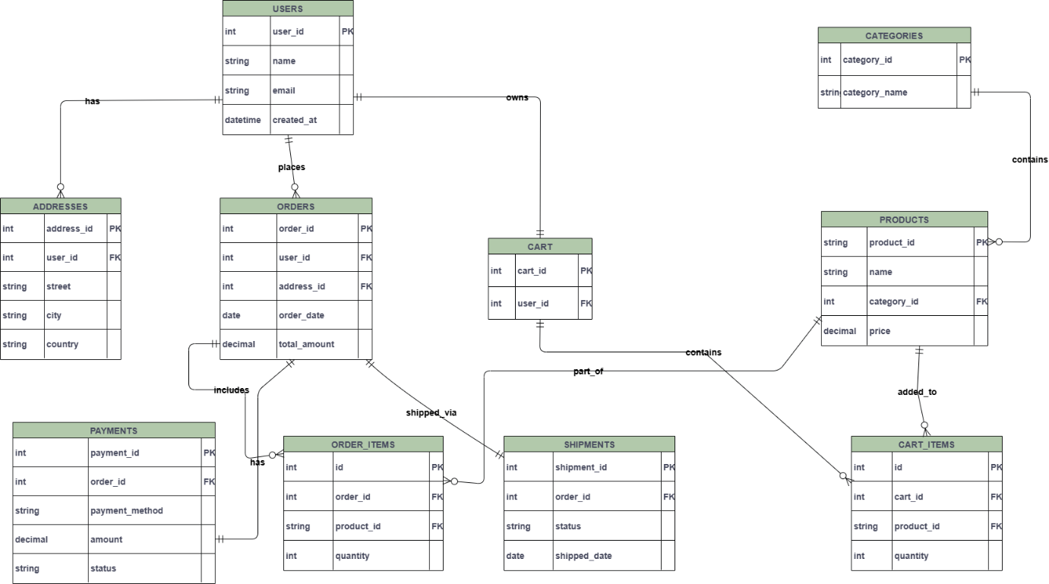
Figure 1: Entity-Relationship (ER) Diagram of the E-commerce SQL Database

OrderItems table will be associated with orders and will hold the quantity and price of the product. Payments are documented in the Payments table that contains the payments related to every order. The Cart and CartItems tables deal with shopping cart user data prior to purchase. Shipments table follows up on the delivery of individual orders. Primary and foreign keys are used to connect all the tables together and to preserve the integrity of the data and the proper relationships between entities (Bjeladinovic, Marjanovic and Babarogic, 2020).

5.2 NoSQL Design
MongoDB collections are NoSQL database that is designed to store flexible and semi-structured data. The products collection contained product details including name, category, price and stock. The reviews collection will store user feedback and rating of products. The product logs table monitors the activities of products e.g. updates and product changes.
The user-activity collection is used to record user behavior data, including browsing and interactions. The wishlist collection is a collection of products that users would wish to buy in the future. These collections are based on a loose document structure, and can be easily updated and scaled without a rigid schema.
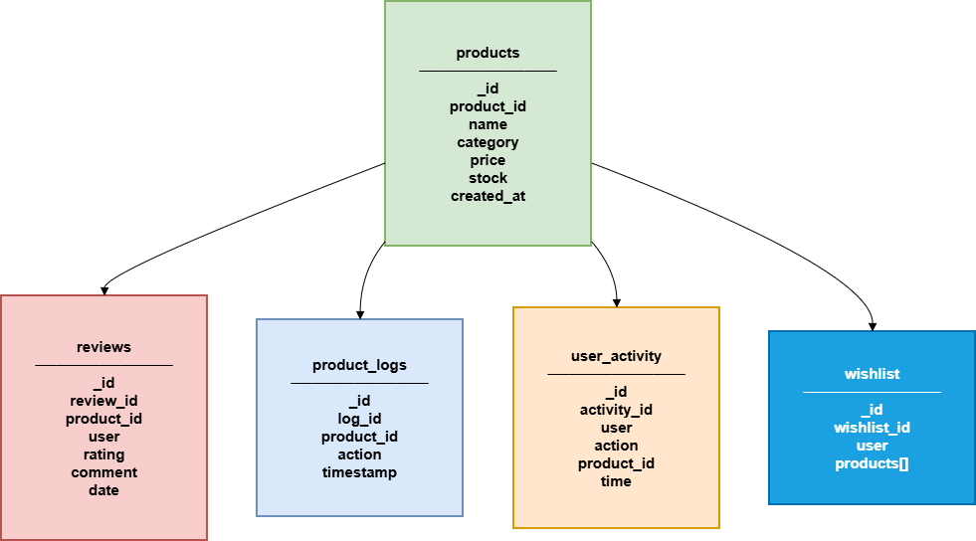
Figure 2: NoSQL Data Model Showing Collections and Relationships in MongoDB

6. Phase 2 — SQL Implementation
The SQL implementation is aimed at designing a relational database to store transaction data in the e-commerce system. The database is developed in MySQL, and all the tables needed are defined by SQL Data definition language (DDL) statements. Tables like Users, Orders, Products, OrderItems, Payments, Cart, CartItems and Shipments have well-defined attributes. There is a primary key in each table to uniquely identify records whereas foreign keys are used to create a relationship between tables. To give an example, the Orders table has one column that is a reference to the Users table (user_id) and another column that is a reference to the OrderItems table (order_id) and the Products table (product_id). Such relationships guarantee data consistency and guarantee referential integrity.
Once the tables are created data is inserted into each table. To fill the database with over 100 records in each table, a Python-based data generator script generates the data. Such a big dataset can be used to recreate a realistic world and can be analyzed with queries. The data that is inserted comprises of user information, product information, order transaction, order payment information, and shipment information.
Various SQL queries will be run to test the system and create business insights. Simple queries like SELECT Count(*) are employed to find out the total number of users, orders, products and other records. These findings are an indication that the database is filled properly with adequate information (Khan et al., 2023).
Aggregation queries can be applied to compute the total sales by adding up the amounts of orders. It uses Products and OrderItems tables to analyze the Sales by category which is joined and results are grouped on product categories. The number of orders placed by each user is also calculated using queries, which are useful to determine customer activity.
To come up with high-value customers, the queries are performed to discover the top customers, according to total spending. The other query is a combination of both Orders and Cart tables to identify the busiest users of the system. These queries indicate that the relational database is able to deal with complex data analysis effectively.
SELECT COUNT(*) FROM Users;
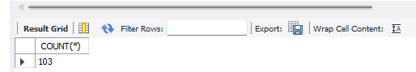
SELECT COUNT(*) FROM Orders;
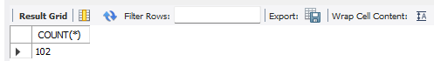
SELECT COUNT(*) FROM Products;
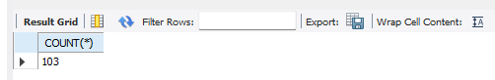
SELECT COUNT(*) FROM OrderItems;
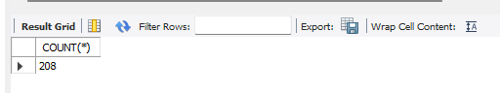
SELECT COUNT(*) FROM Payments;
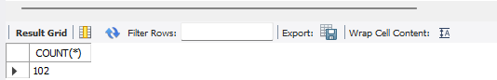
SELECT COUNT(*) FROM Cart;
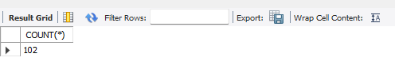
SELECT COUNT(*) FROM CartItems;
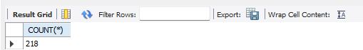
SELECT COUNT(*) FROM Shipments;
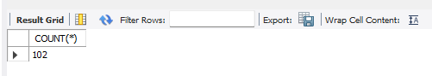
Top 5 Customers

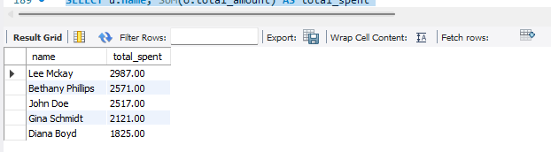
Most Active Users (Cart + Orders)
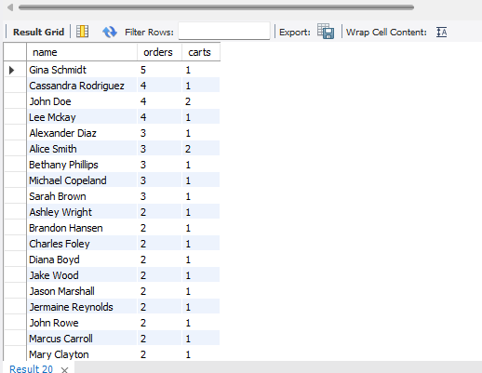
Figure 3: SQL Implementation

7. Phase 3 — NoSQL Implementation
MongoDB is used to implement the NoSQL to handle flexible and semi-structured data to support the e-commerce system. Another database is generated (ecommerce_nosql) and several collections are formed to store various kinds of data. The collections used are: product, review, product-logs, user-activity and wishlist. Each collection is optimally suited to store certain types of information but does not impose a rigid schema which is easily scalable and modified.
The collection stores held detailed product data of products including productid, name, category, price, stock and the date of creation. This collection is the primary source of product information. The reviews collection contains the user reviews of products, such as user id, product id, rating and comments. Products logs collection follows the changes and activities that occur on the products such as updates and modifications. The user activity collection tracks the user activities such as browsing, clicks and actions of the platform. The wishlist product is a collection of products stored in the wishlist to be purchased in future.
The data is injected into each collection through scripts and this is done to add over 100 documents to mimic the usage of the data in real-world. The structure of the document is written in the form of JSON, with the possibility of having nested fields and dynamic properties. This flexibility will assist in storing intricate and dynamic data without having to redesign the database.
The data are analyzed with a number of MongoDB queries being run to test the system. The successful insertion of data is checked by using the countDocuments() function to check the number of products inserted into the database. A query is used to locate products that cost more than 2000 and this can be used to locate the good products in the catalog. Aggregation pipelines are used to calculate the average price of products, which can give information on the trend of prices (Kumar, 2025).
The customer behavior and product performance are analyzed with the help of further queries. Grouping operations are used to compute the number of reviews that a product has received, to gain insight into the popularity of the product. Recommendation systems can be supported by identifying top-rated products whose rating is based on the average ratings. The activity of the users is checked to find out the most active users according to their activity.
The number of times products are added by customers is counted in the wishlist collection which shows that they have an interest in them. Products logs collection is used to summarize product-related activities which can be used to monitor updates and changes in the system.
These questions illustrate how powerful MongoDB is in dealing with flexible data and conducting aggregation processes without any problems. The outcomes support the idea that the NoSQL database may support the scalable storage of data and offer crucial information to the business decisions.

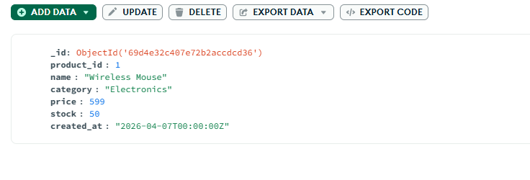
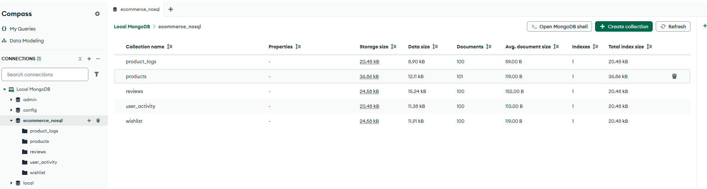
products

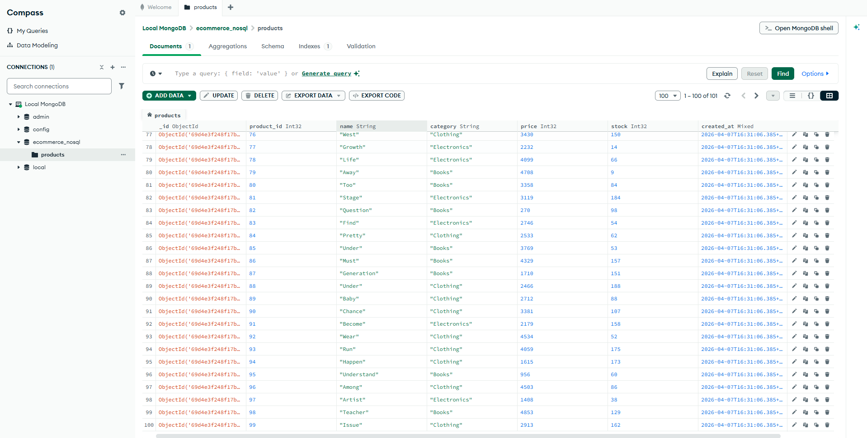
reviews

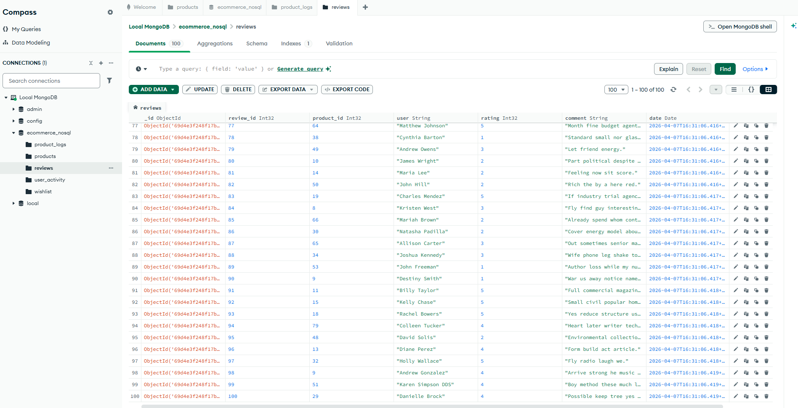

product_logs
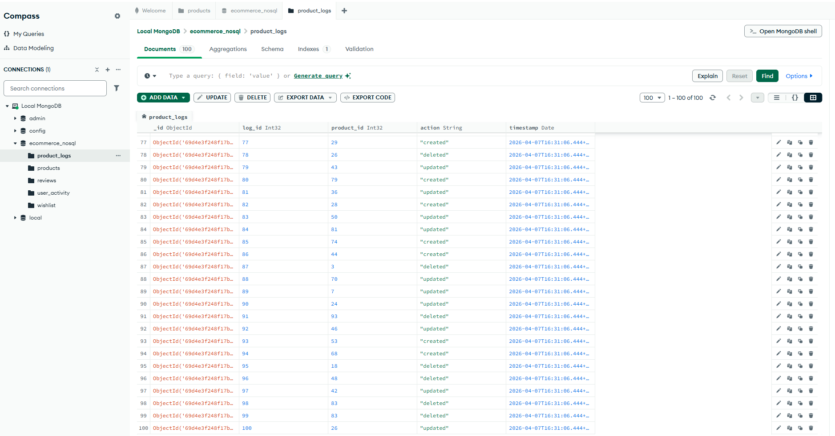

user_activity

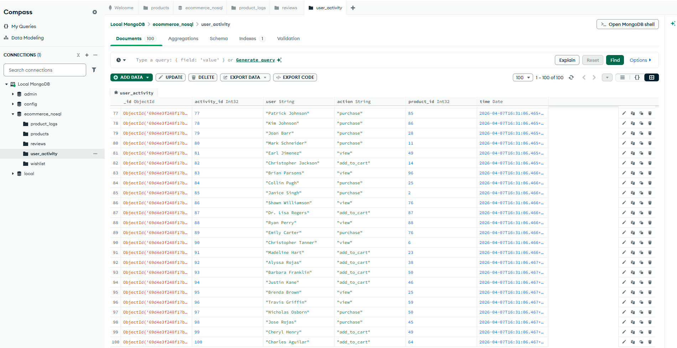

wishlist
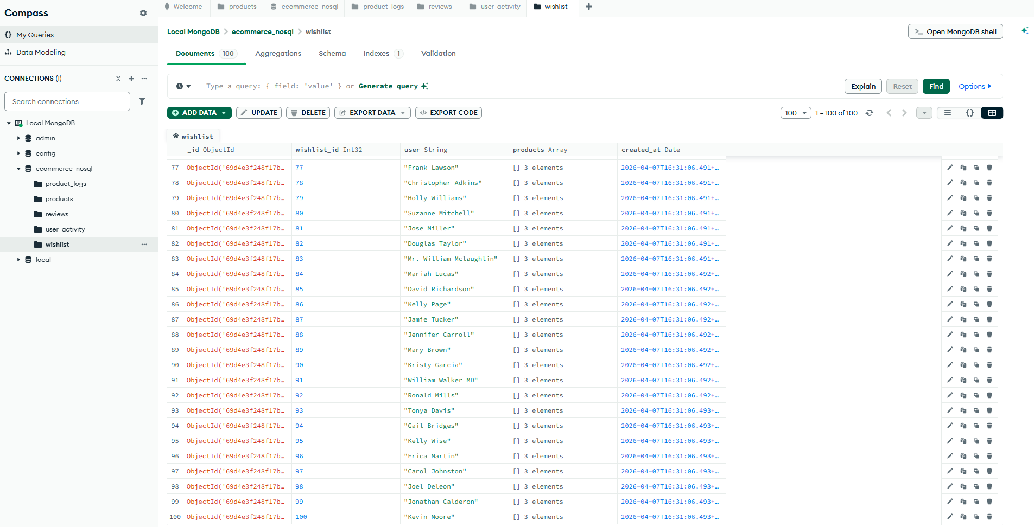
MongoDB Queries
1. Count total products
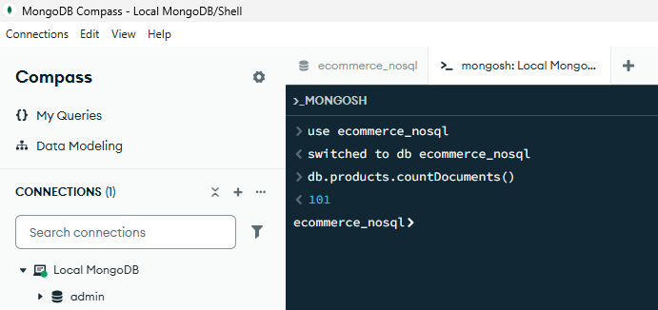
2. Find products with price > 2000
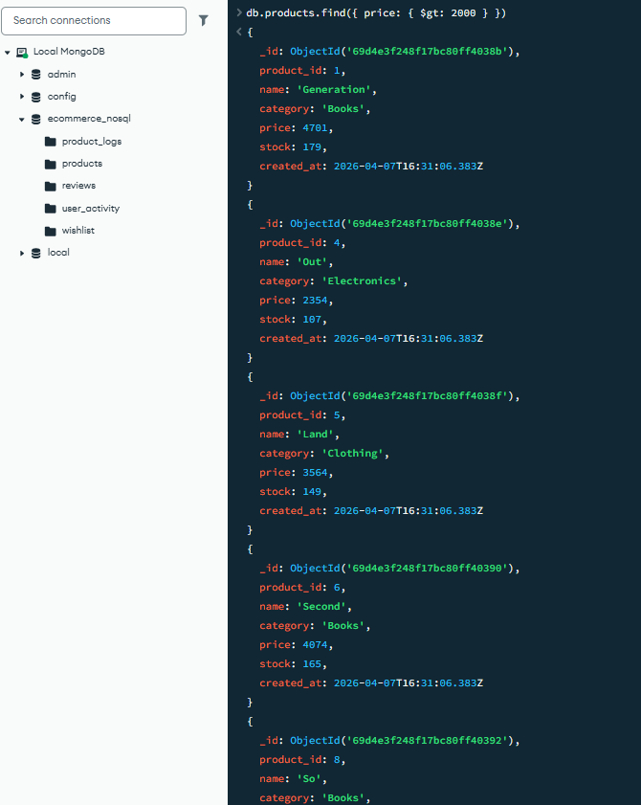
3. Average product price
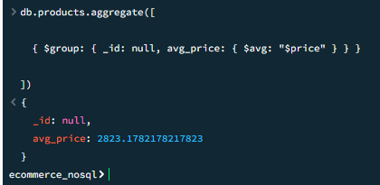
4. Total reviews per product
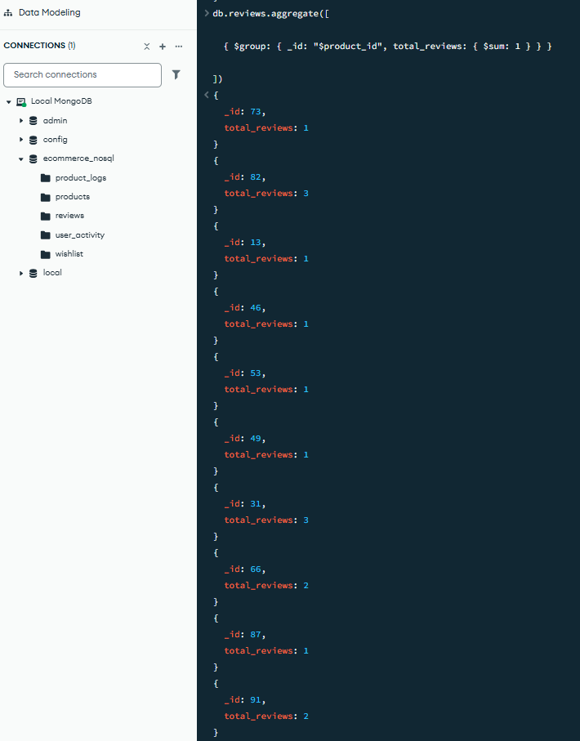
5. Top rated products
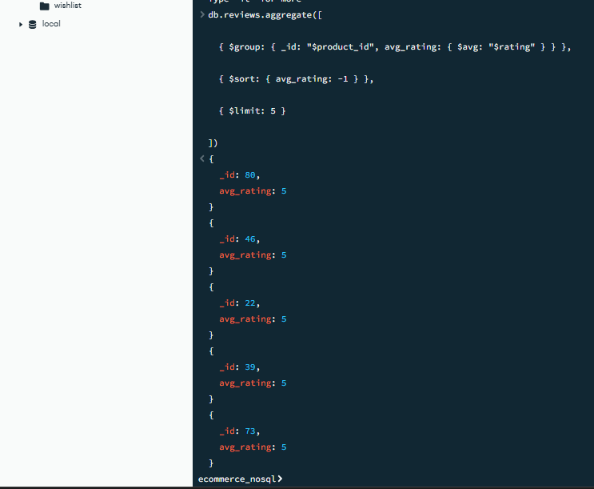
6. Most active users
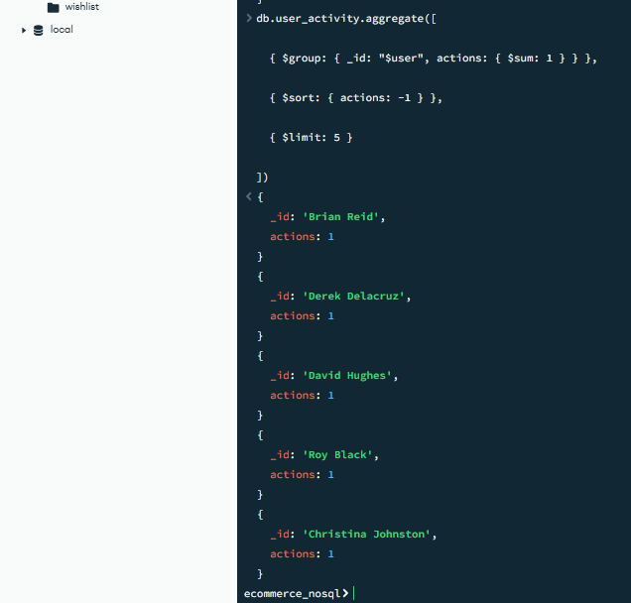
7. Products added to wishlist count
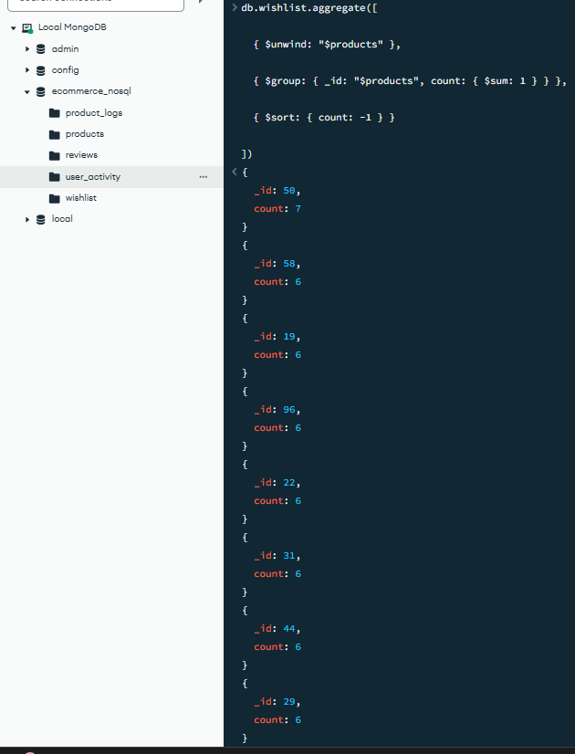

Products added to wishlist count

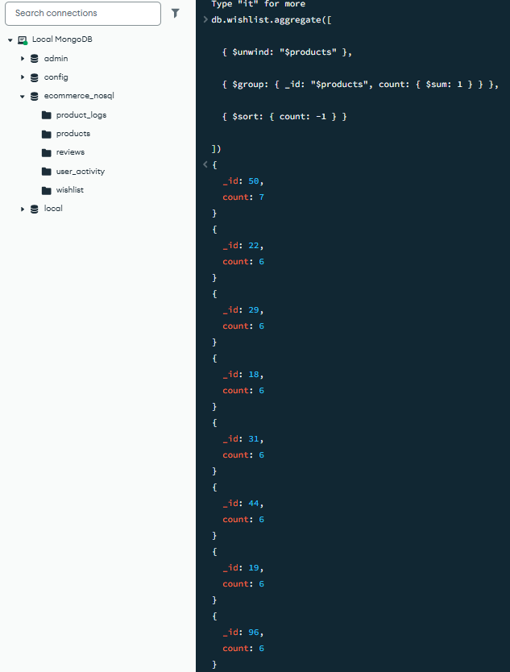
Product activity logs count
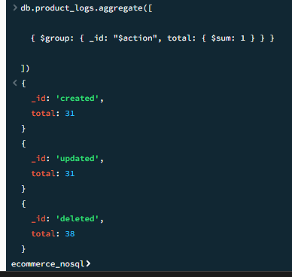
Figure 4: NoSQL Implementation

8. Phase 4 — Integration Layer
The Python language is used to create the integration layer to integrate and access data in both MySQL and MongoDB. This layer is important to the hybrid system, because it facilitates the interaction of structured and flexible data sources. Python is chosen due to its ability to connect to databases, process data as well as automating tasks with a simple scripting language (Lal Bh, ari and Roshan Chitrakar, 2020).
The installation starts with installing necessary libraries. Mysql.connector library is used to connect Python to MySQL database whereas pymongo is used to connect to MongoDB. These libraries are piped in and imported by the Python script. After the environment is prepared, both databases connections are made. Host, user, password and database name are used to create the MySQL connection. The results are fetched in key-value format with the help of a cursor that has dictionary support. The MongoClient is used to connect to the MongoDB and the necessary database and collections are chosen.
Once the linkages are made, hybrid operations are applied. The initial operation consists of getting user information in MySQL and product information in MongoDB. In a SQL query, the user information like user_id, name and email is obtained. Meanwhile, a MongoDB query retrieves product data, according to product-id. The findings of the two databases are then presented as a combination. This demonstrates that it is possible to mix structured user data with flexible product data in one output (Lindström, 2020).
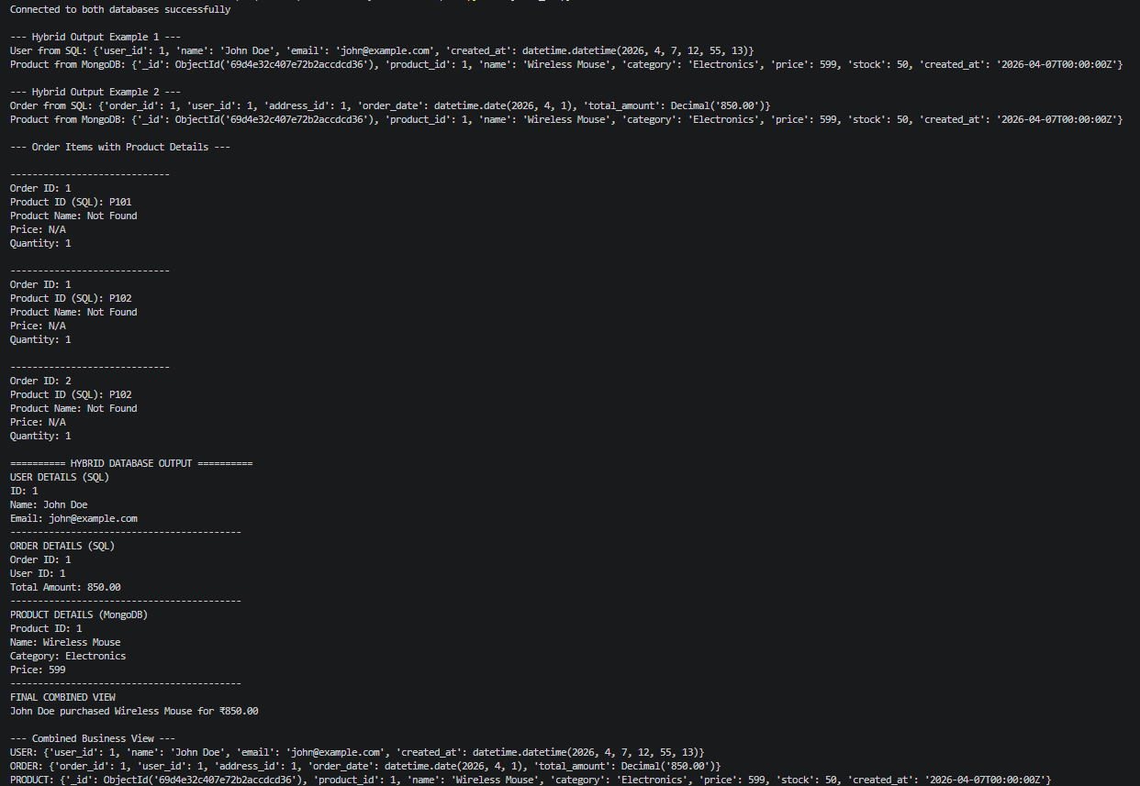
Figure 5: Python Output Showing Hybrid Integration of SQL and MongoDB Data
The second operation is geared towards consolidating order and product details. MySQL is used to get order information including order id, user id and total amount. Next, a fetch of product details in MongoDB is made, based on the product_id reference. This enables the system to show all the order information and also product information and this is helpful in business reporting.
The other significant operation is dealing with various order items. A SQL query is used to select some of the records of the OrderItems table. The product of each of the items is searched in MongoDB. The identifiers of products can be in varied formats, so the script contains logic to deal with mismatches and missing data. In case a product is not located, default values of either Not Found or N/A will be displayed. This guarantees that the system will not crash in the process and can deal with the errors in a graceful manner.
The last output unites information in both databases into a business perspective. It presents the user information, order details and product information in simple format. Indicatively, output will indicate who bought which product, and how much they spent. A mixed dictionary also is created that has user, order and product information. This illustrates that hybrid systems have the ability to come up with complete and meaningful insights by combining data across various sources (Mansouri and Ali, 2020).
This integration ensures that the system has been able to integrate MySQL and MongoDB and is doing hybrid data operations. It points out practical application of Python in connecting various database technologies and producing unified results to be used in real-world applications.

9. Challenges Faced
A number of challenges were faced when developing the hybrid database system. The incompatibility of the identifiers of the products between MySQL and MongoDB was one of the primary problems. Product IDs were represented in SQL database as product101, whereas in MongoDB as an integer number, say 1. This brought about issues when integrating data. This was solved by pulling out the numeric values in SQL IDs and translating them into a similar format and then querying MongoDB.
The other difficulty was to connect with both databases in the same Python script. Different libraries and connection methods were needed with each of the databases. Connection parameters were carefully configured and mysql.connector and pymongo were used properly to maintain stable connection. Missing data was also an issue particularly when a product was not located in the MongoDB of a particular SQL record. This was handled by conditional checks to the code and showing default values in the form of Not Found or not applicable as opposed to halting the execution (Mansouri, Prokhorenko and Ali, 2020).
The syntax and structure of query were also different in SQL and MongoDB. SQL queries have joins and structured queries whereas MongoDB queries have document-based queries and aggregation pipelines. These differences and the knowledge of how to use the right method in each database contributed towards the successful completion of the project.

10. Results and Observations
The system implemented has performed as per in all the phases. The SQL database is able to store and retrieve structured data error free. Table relationships are properly functioning, and all the constraints keep data integrity. Table counts verify that in all tables, the number of entries is above 100, meaning that they can be analyzed.
Every SQL query provides the correct results. Aggregate queries like total users, orders and products are a match to the data that is inserted. The calculations of sales and the summary by categories yield the same values. The queries that provide the name of the top customers and the most active users will give valid and logical results, based on the transaction data.
NoSQL database works as well. Documents that are flexible are stored in collections and queries give expected results. Counting products, filtering by price and computing average price give the correct result on their operations. Review, user activity, and wishlist aggregation pipes do not have any problems.
The integration layer is able to effectively integrate the information of the two databases. Python retrieves user and order information in MySQL and product information in MongoDB and presents the information in a tabular format. The hybrid output will be a clear display of all business information, i.e., who bought what product. Generally, the system ensures consistency in data in both databases and proves that integration of the hybrid database is effective in real-life applications (Scherzinger and Sidortschuck, 2020).

11. Conclusion
This project assisted to develop a clear picture of the collaboration of various systems of databases within one application. I have created a relational database of structured data and NoSQL database of flexible data. I also linked the two systems with python and were able to generate composite outputs. This enhanced your database design, query writing and integration of data.
Hybrid databases are important in cases where my application will deal with various data types. The transactions you did with MySQL were users, orders and payments. I have employed MongoDB to store product information, reviews and logs of activities. This division enables each system to do its best. SQL provides you with strong data integrity and NoSQL with flexibility. I have experienced practical advantages in testing. Inquiries yielded straight forward answers. The aggregations provided valuable information like the best customers and products. Integration layer generated one image of user, order and product information. This comes in handy in reporting and decision making.
The system can be further enhanced. Include live APIs to access data. Index the databases in order to accelerate queries. Caching of frequent reads. Include validation rules and error log. It is possible to create a simple dashboard to show insights as well.

References
Adam, Mohammed, M. and Alsammani, A. (2023). Enhancement of database access performance by improving data consistency in a non-relational database system (NoSQL). arXiv (Cornell University). [online] doi: https://doi.org/10.48550/arxiv.2308.13921.
Aravindhan Ragunathan, Bhavani K, Archana Sasi and Sathish Kumar R (2025). Integration of NoSQL and Relational Databases for Efficient Data Management in Hybrid Cloud Architectures. Journal of Machine and Computing, [online] pp.1277–1287. doi: https://doi.org/10.53759/7669/jmc202505100.
Bjeladinovic, S. (2025). Extending hybrid SQL/NoSQL database by introducing statement rewriting component. Computer Science and Information Systems, [online] 22(3), pp.1011–1046. doi: https://doi.org/10.2298/csis241024034b.
Bjeladinovic, S., Marjanovic, Z. and Babarogic, S. (2020). A proposal of architecture for integration and uniform use of hybrid SQL/NoSQL database components. Journal of Systems and Software, [online] 168, p.110633. doi: https://doi.org/10.1016/j.jss.2020.110633 .
Khan, W., Kumar, T., Zhang, C., Raj, K., Roy, A.M. and Luo, B. (2023). SQL and NoSQL Database Software Architecture Performance Analysis and Assessments—A Systematic Literature Review. Big Data and Cognitive Computing, [online] 7(2), p.97. doi: https://doi.org/10.3390/bdcc7020097.
Kumar, A. (2025). Hybrid Database Solutions for Real-Time Educational Data Processing. Iconic Research And Engineering Journals, [online] 8(12), pp.1766–1774. doi: https://www.irejournals.com/paper-details/1709489.
Lal Bh, H., ari and Roshan Chitrakar (2020). Comparison of Data Migration Techniques from SQL Database to NoSQL Database. Journal of Computer Engineering & Information Technology, [online] 2020. doi: https://www.scitechnol.com/peer-review/comparison-of-data-migrationtechniques-from-sql-databaseto-nosql-database-rxXk.php?article_id=13829.
Lindström, O.-P. (2020). Integration of SQL and NoSQL database systems. [online] Available at: https://fileserver-az.core.ac.uk/download/401689974.pdf [Accessed 8 Apr. 2026].
Mansouri, Y. and Ali, B.M. (2020). The Impact of Distance on Performance and Scalability of Distributed Database Systems in Hybrid Clouds. arXiv (Cornell University). [online] doi: https://doi.org/10.48550/arxiv.2007.15826.
Mansouri, Y., Prokhorenko, V. and Ali, B.M. (2020). An Automated Implementation of Hybrid Cloud for Performance Evaluation of Distributed Databases. [online] arXiv.org. Available at: https://arxiv.org/abs/2006.02833 [Accessed 8 Apr. 2026].
Scherzinger, S. and Sidortschuck, S. (2020). An Empirical Study on the Design and Evolution of NoSQL Database Schemas. arXiv:2003.00054 [cs]. [online] doi: https://arxiv.org/abs/2003.00054.

Appendix
GitHub Link: https://github.com/sharmamanju133/ecommerce-hybrid-database

