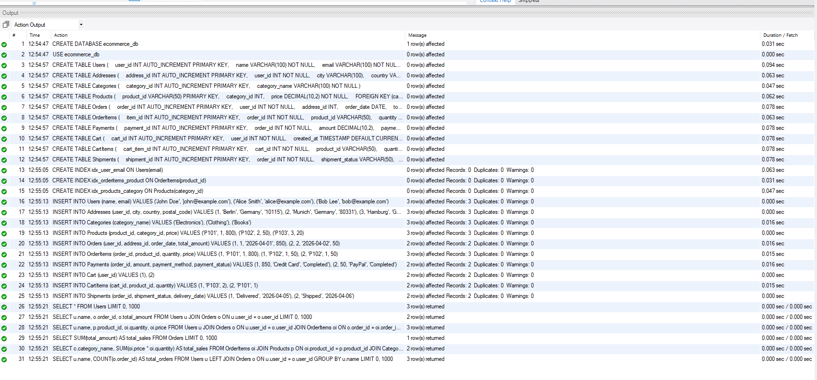

Phase 2 — SQL Implementation
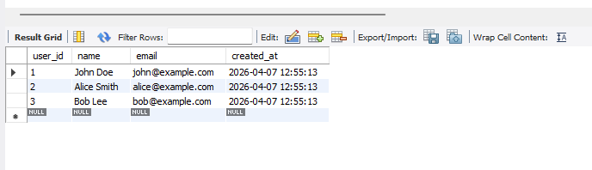
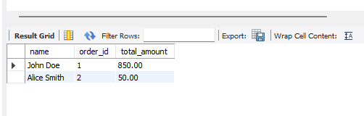
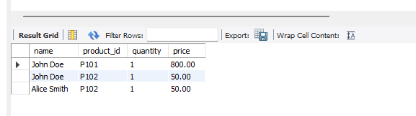
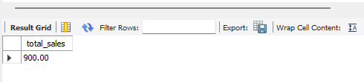
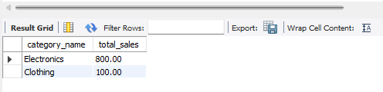
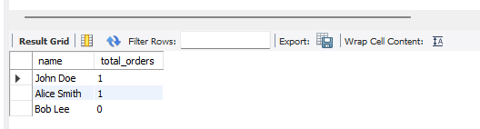
100 entries by script

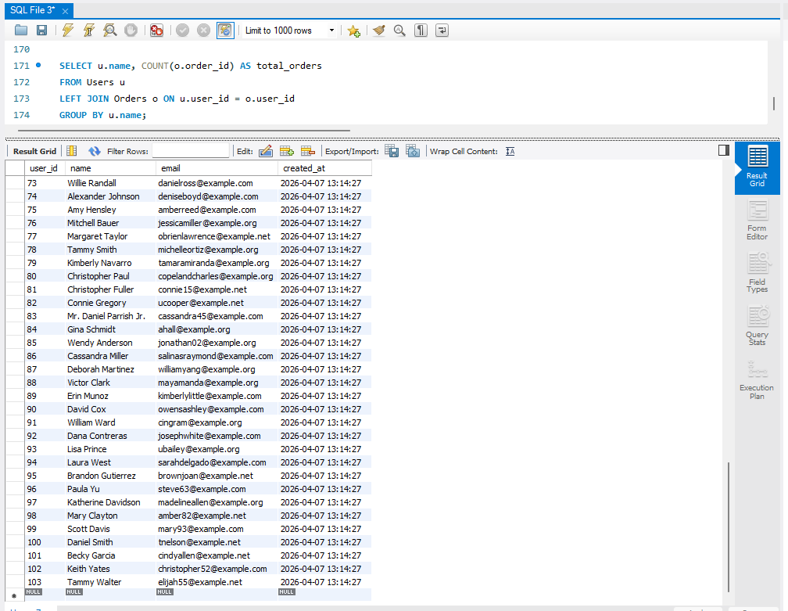

SELECT COUNT(*) FROM Users;
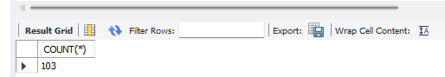

SELECT COUNT(*) FROM Orders;
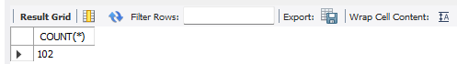
SELECT COUNT(*) FROM Products;
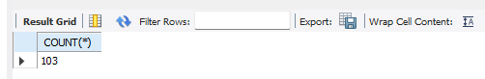
SELECT COUNT(*) FROM OrderItems;
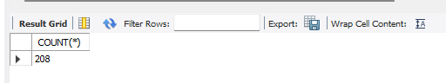
SELECT COUNT(*) FROM Payments;
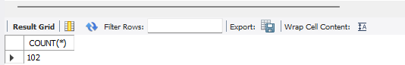
SELECT COUNT(*) FROM Cart;
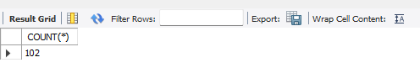
SELECT COUNT(*) FROM CartItems;
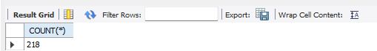
SELECT COUNT(*) FROM Shipments;
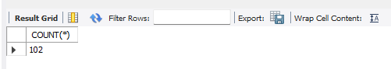
-- Top 5 Customers

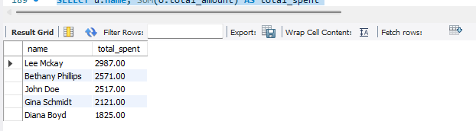

-- Most Active Users (Cart + Orders)
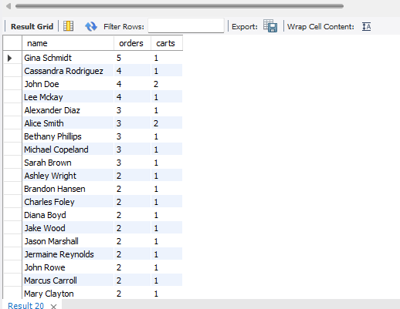

Phase 3 — NoSQL Implementation
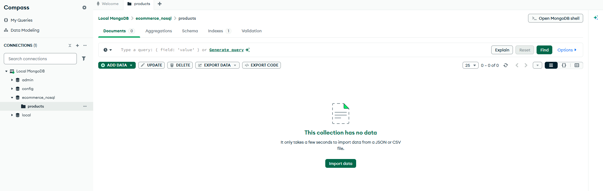
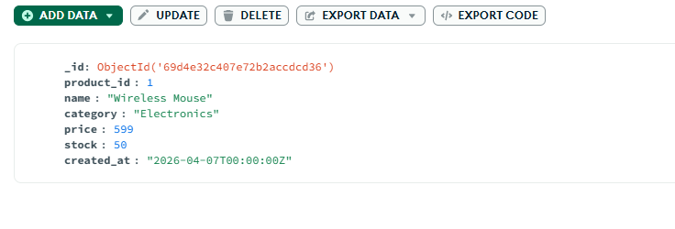
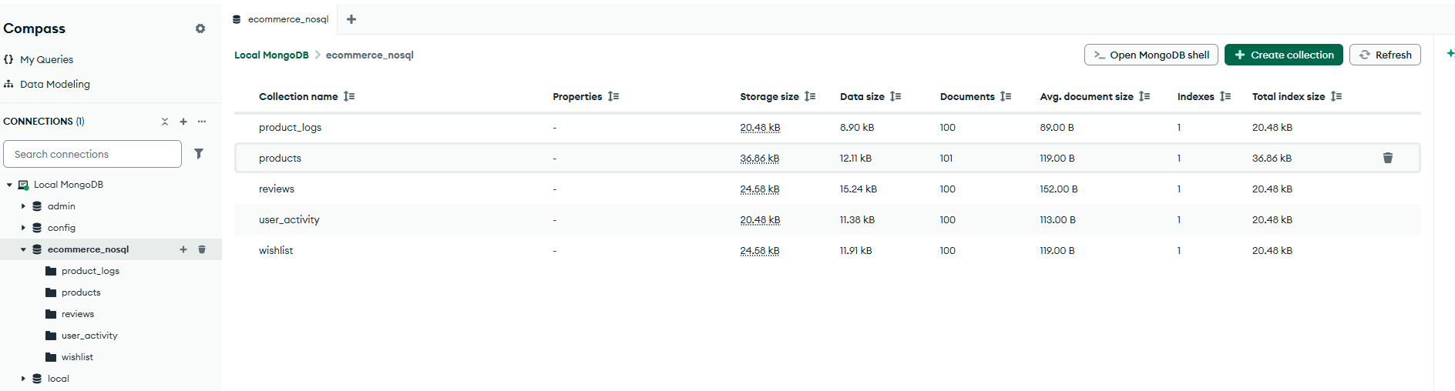
products

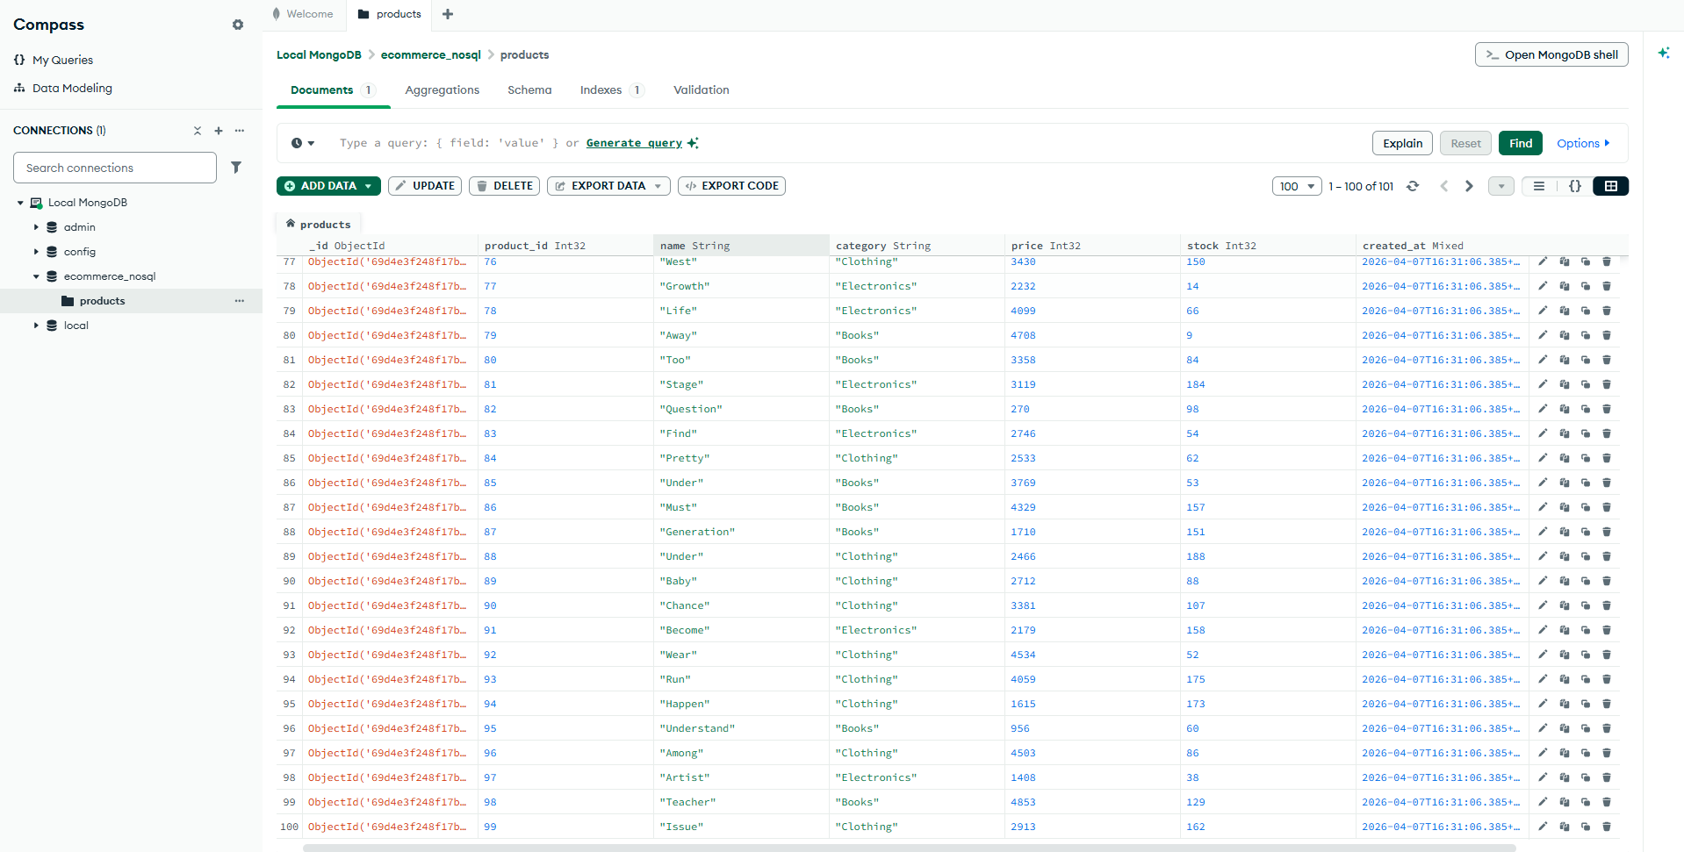
reviews

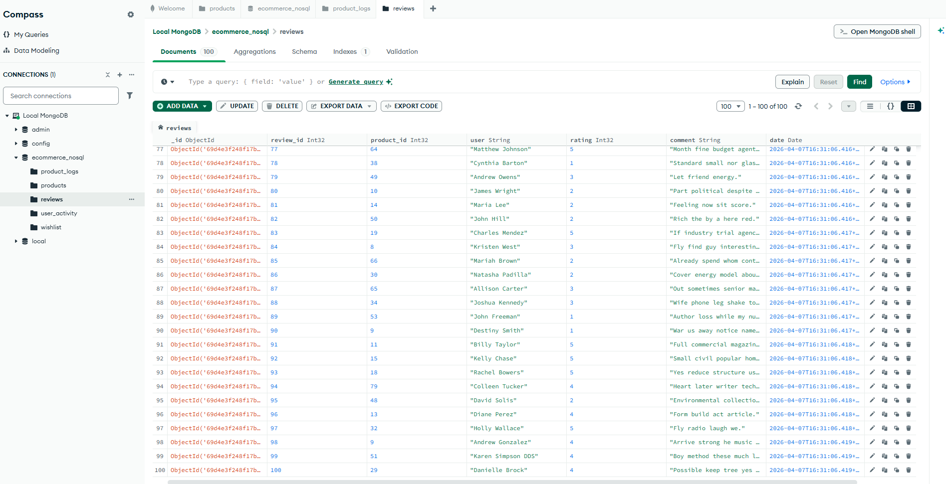

product_logs
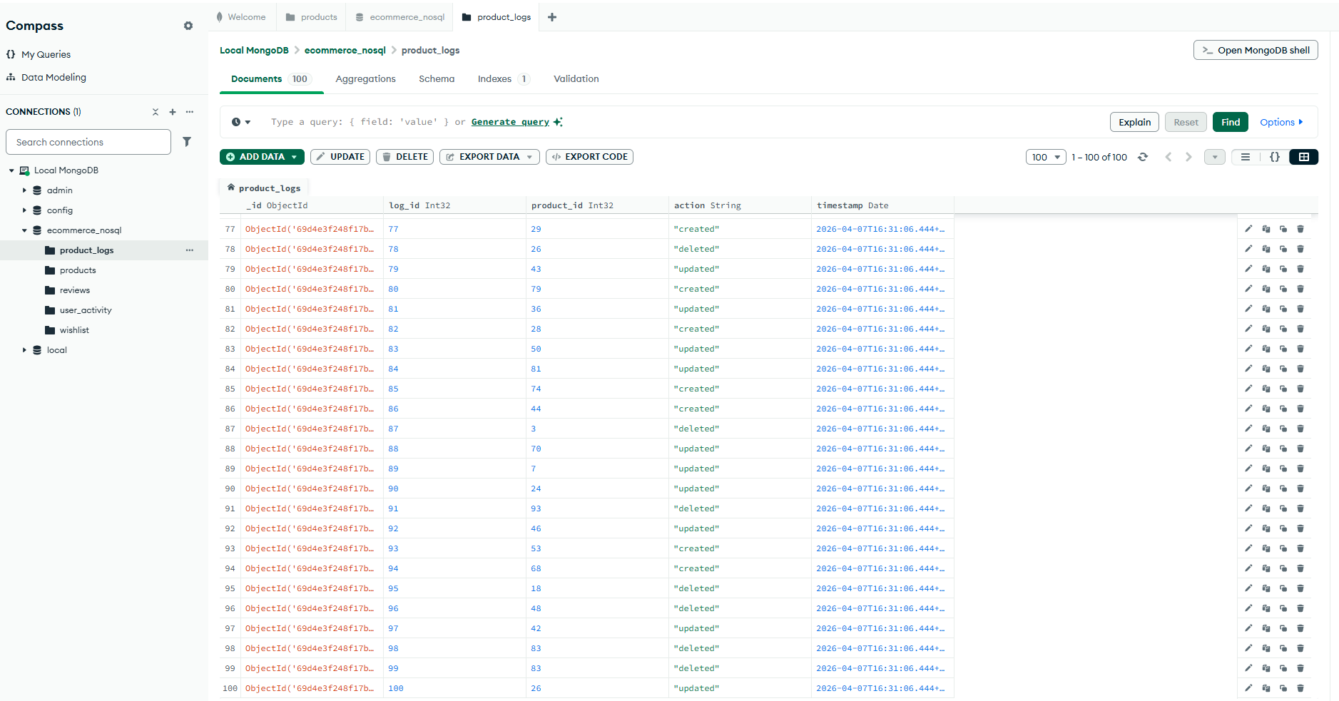

user_activity

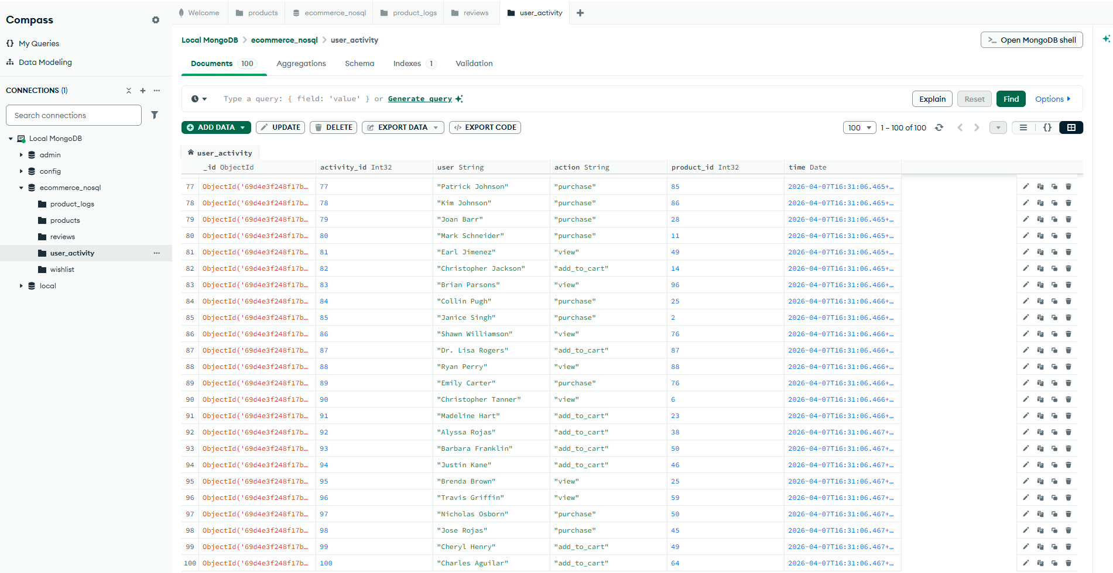

wishlist
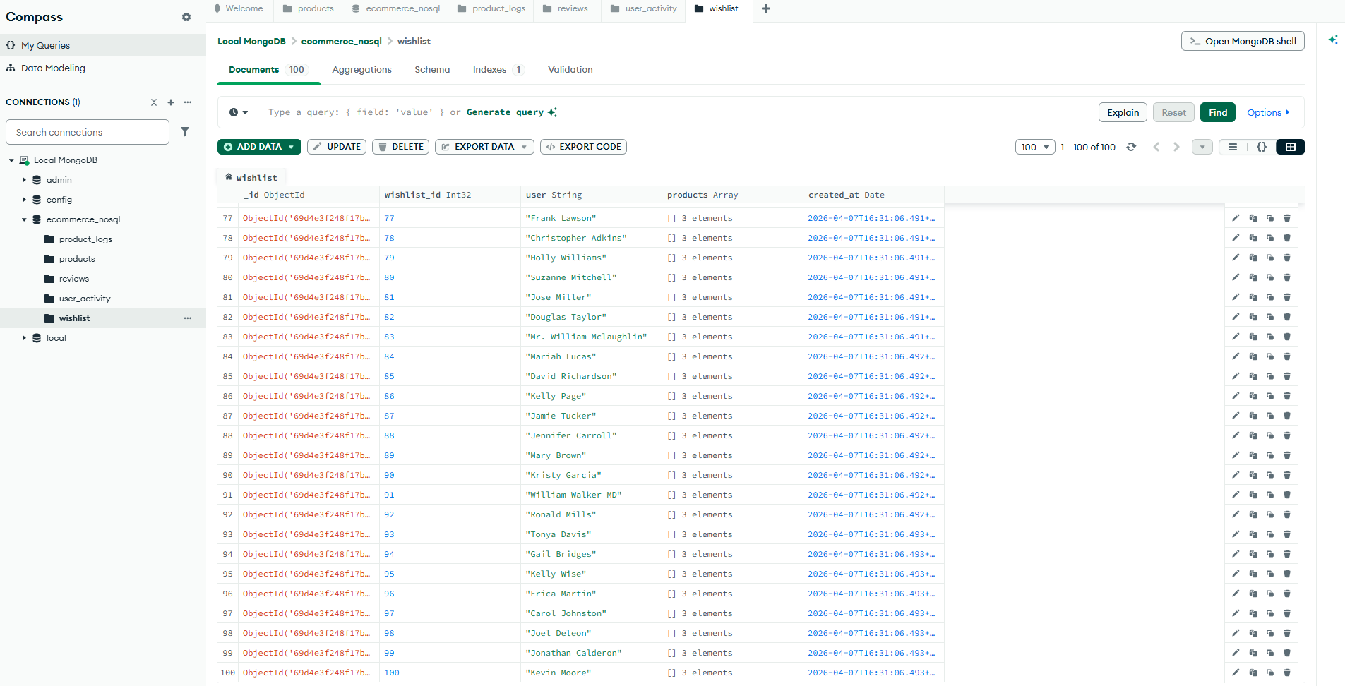
MongoDB Queries (For Report + Screenshots)

1. Count total products
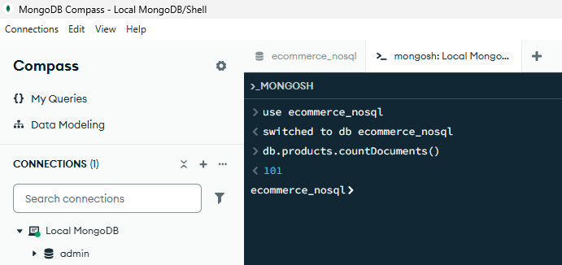
2. Find products with price > 2000
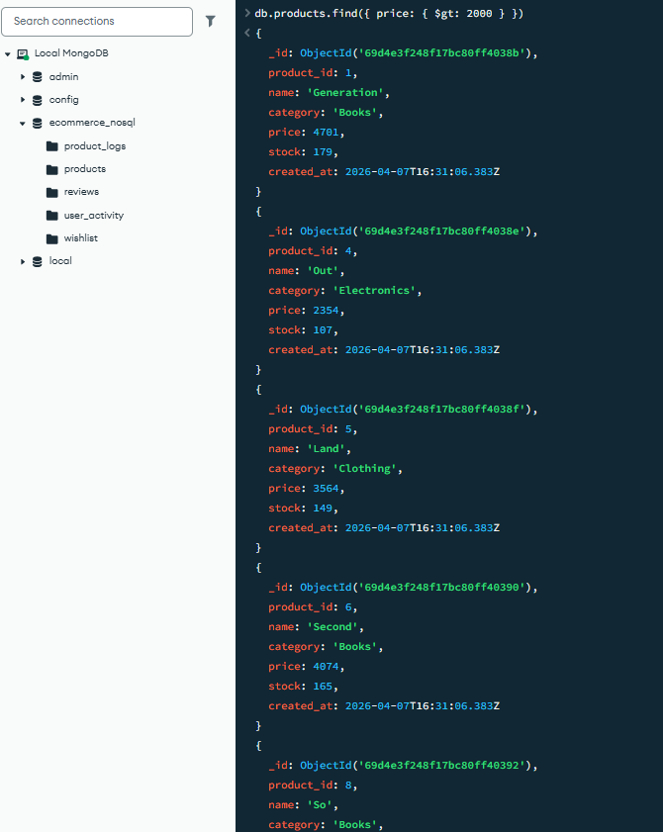
3. Average product price
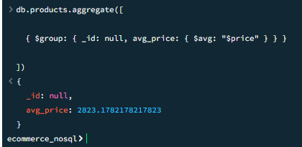
4. Total reviews per product
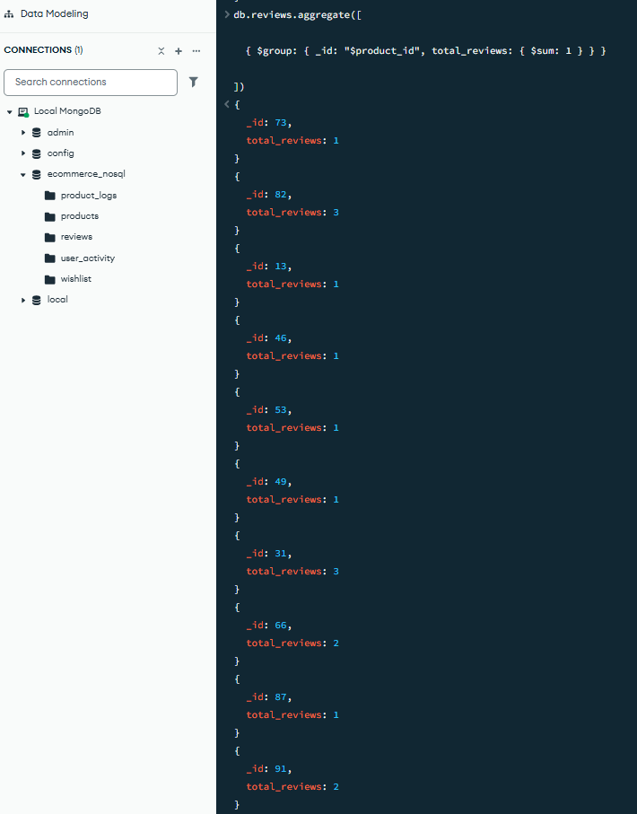
5. Top rated products
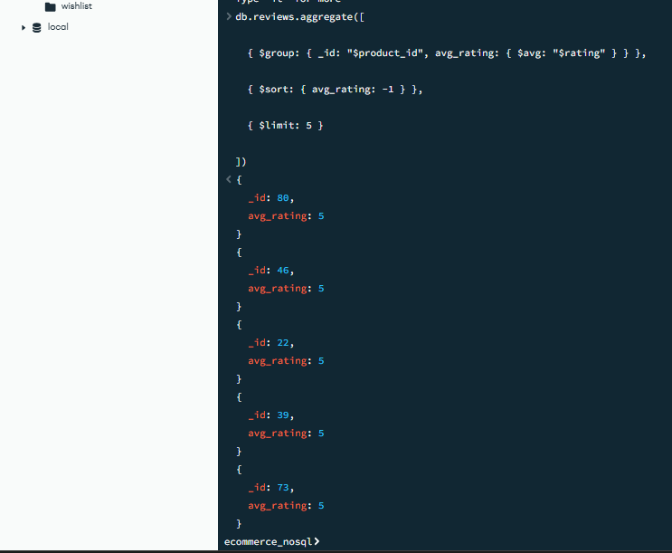
6. Most active users
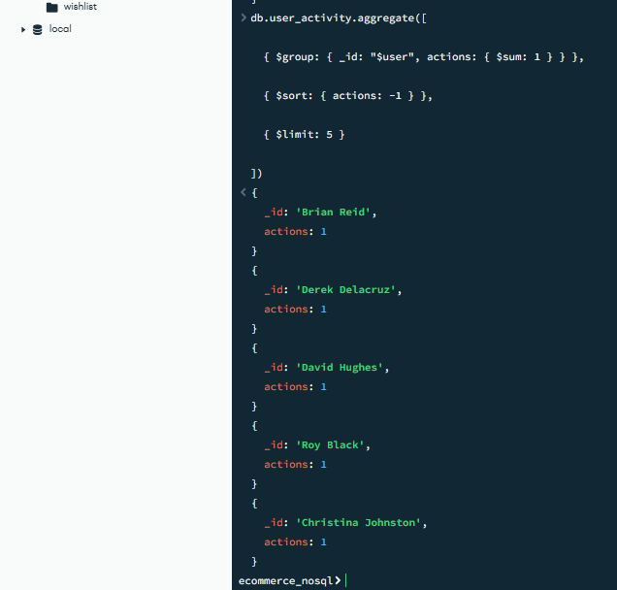
7. Products added to wishlist count
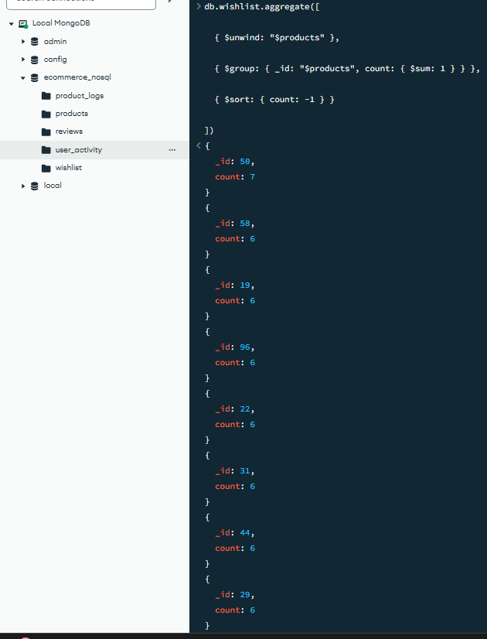

7. Products added to wishlist count

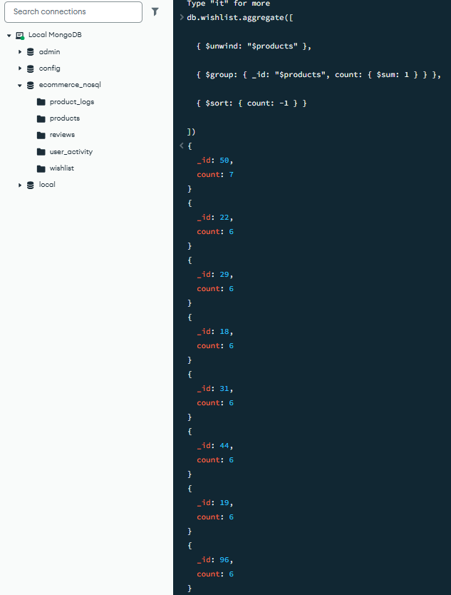

8. Product activity logs count
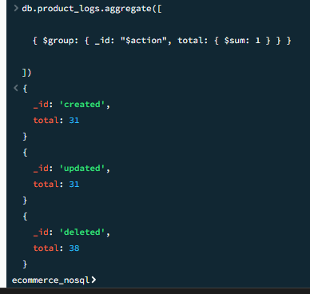

Phase 4 — Integration Layer
