**Nodejs**

#Yum install docker-ce docker-ce-cli containerd.io - Installing docker packages. Docker Version - 20.10.12

Download package docker-compose and install - Docker Compose version v2.2.3

#cd jenkins

#vim docker-compose.yml

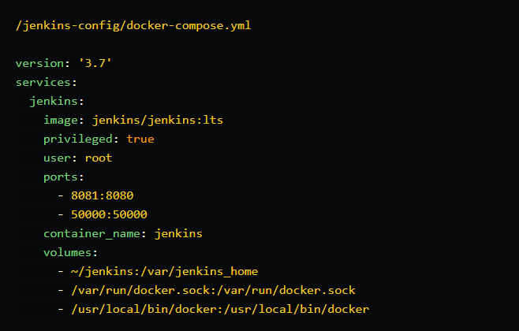

#docker-compose up -d - Create container and run it.

#mkdir nodeapp

#vim package.json #vim 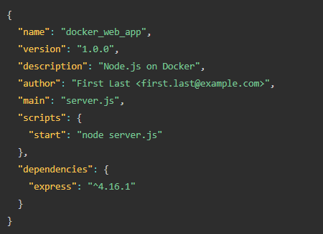 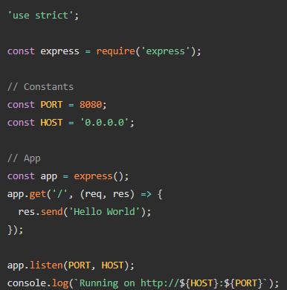

#vim **DockerFile**

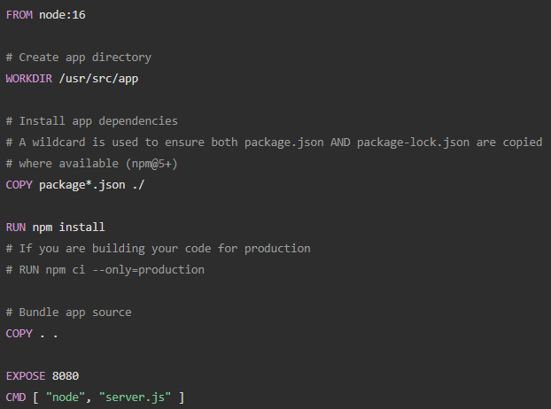

#docker build . -t nodejs/node-web-app

#docker image

#docker run -p 49160:8080 -d nodejs/node-web-app

#docker exec -it <container id> /bin/bash - **If you need to go inside the container.**

#curl -i localhost:49160

* **GIT**

create directory named :- **github in /root/**

#git init - **initialized local repository and create .git directory(contain information about changes).**

#git remote add origin {Link of GIT repo}

#git config --global user.name "ShubhamNagarwal"

#git remote -v - **Check permissions**

#git add . - **add all your changes**

#git commit -m "push code"

#git status - **To check status**

#git push origin master - **To push the updated code**