# **MERCEDES-BENZ**

# **C-Class (C205) Coupe 2015+**

Mercedes-Benz C-Class (C205) Coupe 2015-2023 Air Suspension System has 2 Front Air Struts and 2 Rear Air Spring Bags with 2 Rear Shock Absorbers. Height Sensors tell the Control Module when the Air Suspension Compressor needs to inflate or deflate the Air Suspension System. The Solenoid Valve Block will distribute the Air accordingly trough out the Air Suspension System. Here at Bavaria Center you will find many of the necessary parts and components to fix your Mercedes-Benz C-Class (C205) Coupe 2015-2023 Air Suspension System for less. Your satisfaction is our guarantee!

# **Mercedes C C205 AMG Air springs airsuspension AIRMATIC, rear**

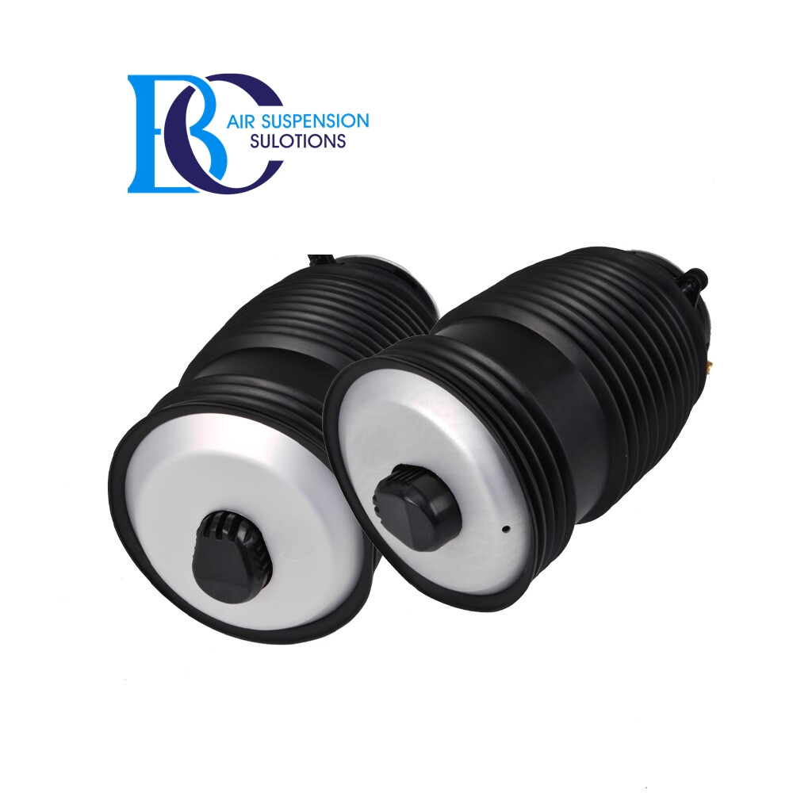

Installation side in driving direction

Left side

Right side

Left and right side

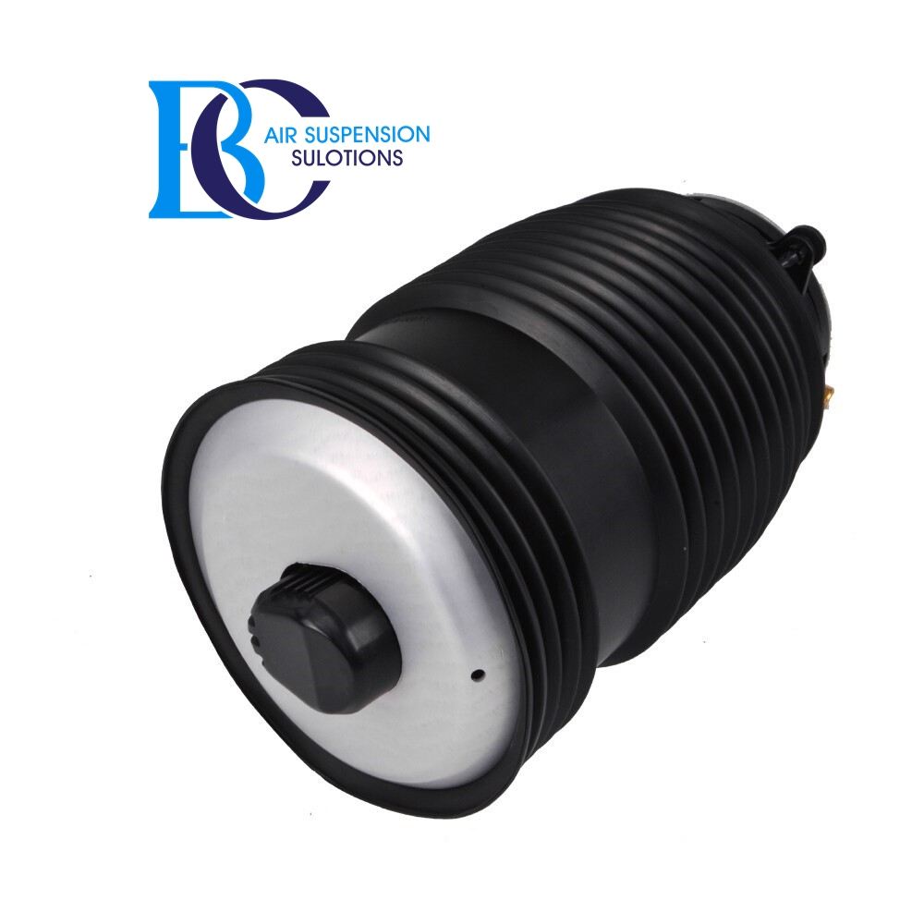left

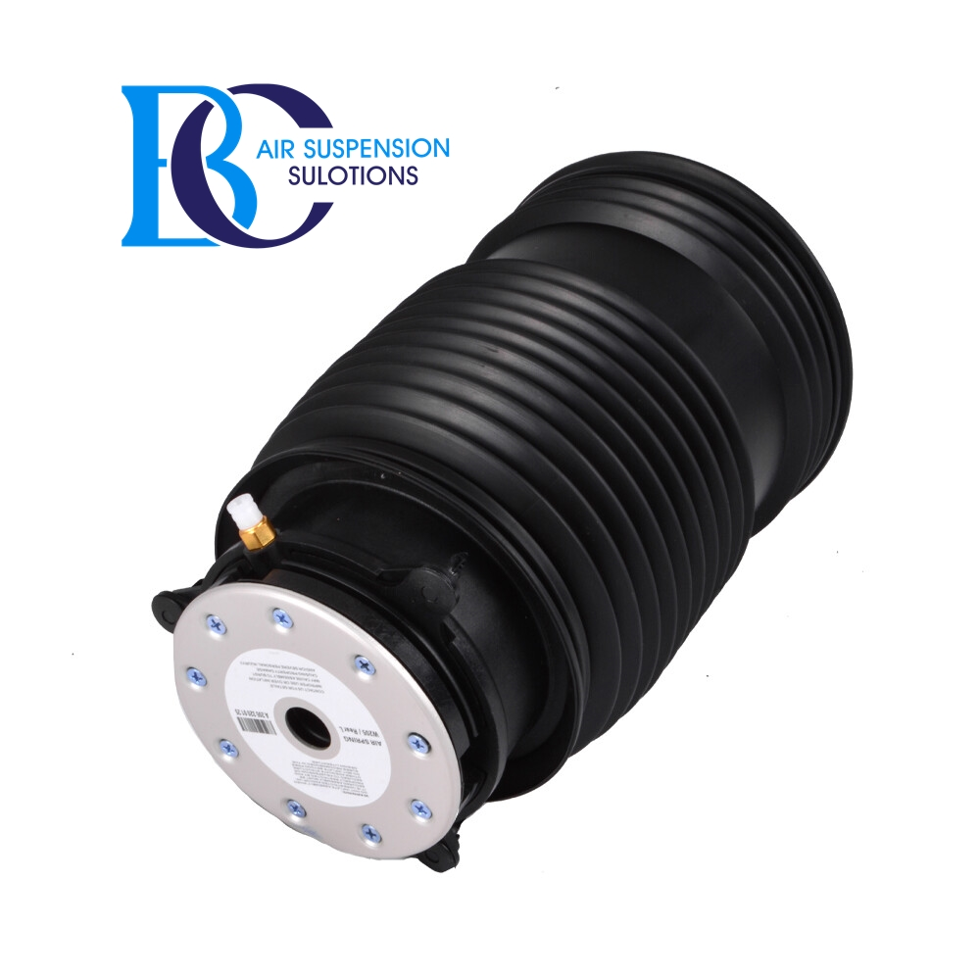left

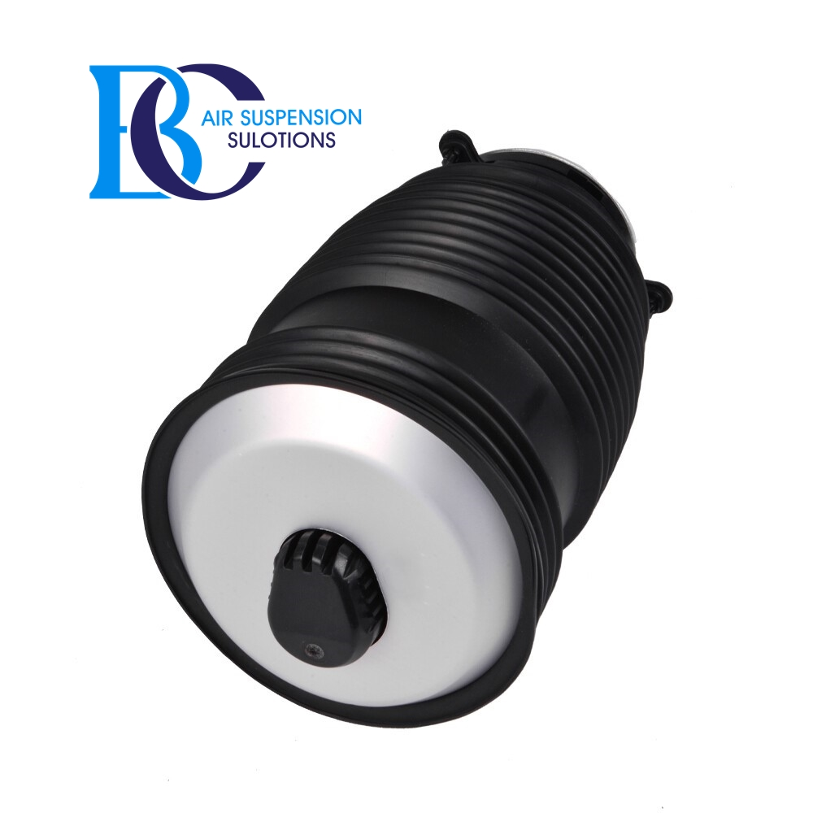

Right

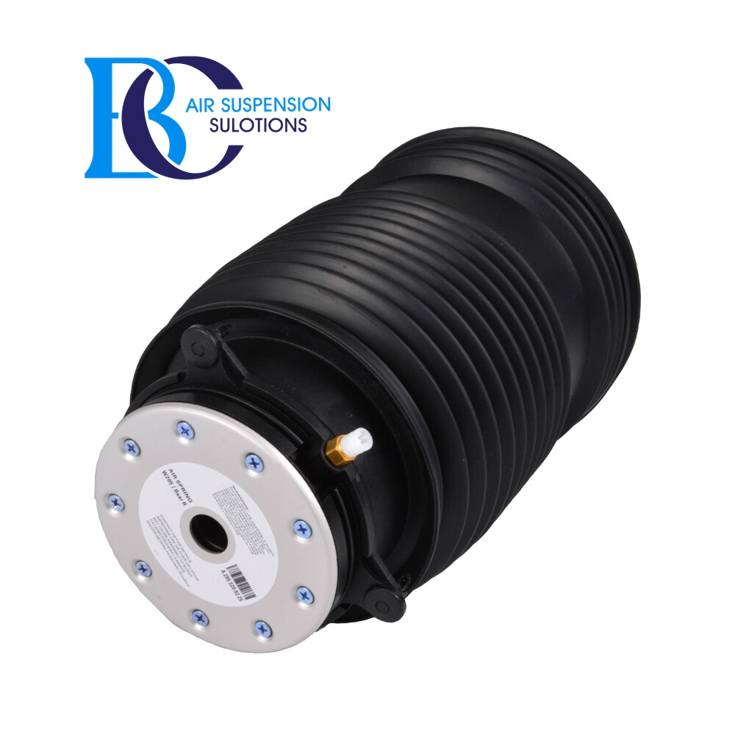

Right

* Description

|  |  |
| --- | --- |
| Original spare part numbers: | A2053200225 2053200225 A2053200125 2053200125 |
| Item condition: | New |
| Features: | 100% Accuracy of Fit |
| Placement on Vehicle: | rear (right)[rear (left)](https://www.miessler-automotive.com/rear-left)[rear](https://www.miessler-automotive.com/rear) |
|  |  |
|  |  |
| Type: | Air spring |