ClickPost AI Engineer Intern -Memo
Name: Mimanshi Sharma
Role Applied: AI Engineer Intern

Layer 1: Define Intent

I looked at 5 possible signals and ranked them by one question – Does this show the brand is struggling right now, or does it mean they might struggle later?

Signals showing real, current pain were given more weightage than those signals which only hint at future problems.

Complaints (highest weight): This is the only signal that shows active pain today. One bad review could just be a bad day. But a pattern of complaints which are showing up on more than one review site, recently, specifically about returns or refunds- means the process itself is broken, not the customer.

Leadership hire (2nd): A new CX Head, COO, CTO, or Founder often re-checks the tools their company uses in their first few months. This is a signal that something might change soon, not proof that something's wrong yet. I only counted hires from roughly the last 12 months because the older hires have likely already made their vendor decisions.

Tech stack (3rd): This tells me if a brand's current fix is working. A brand with no returns tool has a real gap. A brand using a competitor tool, but customers are still complaining means their current fix isn't working and that's actually the strongest tech-stack signal, because it's a warm lead, not a cold one.

Hiring postings (4th): Open roles for Returns Manager or Logistics Ops mean the team is already spending money on this problem. Acting as supporting evidence, not the main signal.

Growth (bonus only): I did not score this on its own. A brand raising funding or expanding doesn't tell you their post-purchase experience is broken; it only means strain might be coming. It only added a small bonus, and only when paired with a real signal above.

Layer 2: Capture Signals
I researched the real signals for each of the 25 sample brands using public sources- Trustpilot, BBB, company career pages, and news articles. Every claim is tied to a real source URL so it can be checked. I recorded this in a spreadsheet with two parts per brand:
- Raw findings — the actual text I found (e.g. specific complaint quotes, hiring posting details, leadership news)
- Tier codes — my judgment on how strong each signal is (e.g. weak/moderate/strong for complaints), based on fixed rules I set upfront (see Section 3)
All 25 brands have at least some research, but depth varies. Given the time box, I researched 5 brands in full depth first (Brooklinen, Rothy's, Vuori, Solo Stove, Chubbies), then extended coverage to the remaining 20 with a lighter pass.

Layer 3: Score Intent

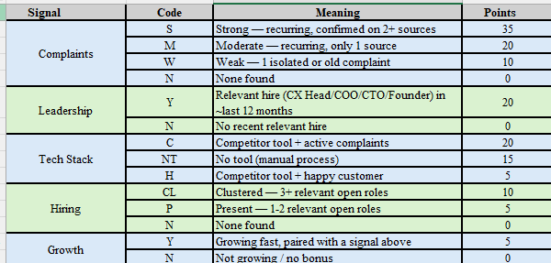

Maximum possible score: 90

Key Tradeoffs
- Leadership is scored Yes/No, not graded by strength — faster to check, still reliable given the time box.
- Scoring itself has no AI in it — every point value is a fixed rule, so the same input always gives the same score. I used a local LLM only to help classify some raw text into tier codes and to reword explanations — never to decide the actual score.
- Research depth varies across the 25 brands. I went deep on 5 first, then did a lighter pass on the rest. Where I couldn't confirm something, I left it blank rather than guess.
What I'd Build Next
- Automate the research itself (Layer 2), not just the scoring
- Add a second score dimension for "ease to convert," not just pain shown
- My ICP-fit filter assumes food/beverage brands have no post-purchase needs, since they rarely have returns. But research shows this isn't quite right because Olipop uses Malomo, a shipment-tracking tool, just not a returns platform. A more refined version would treat "returns" and "delivery tracking" as separate signals, not one combined category.
- Wrap the pipeline as a small web service, easier to run without setup
Limitations
- Complaint severity is judged by reading a sample of reviews, not a precise count — I don't have a tool to tag every review.
- Some signals (like hiring postings) were hard to verify when buried in large, unfiltered career pages — noted rather than guessed.
- Getting the local LLM running took real trial and error (a hosted API got network-blocked, so I switched to running a model locally).
- Scores reflect a snapshot in time and would need re-running periodically to stay current.

Throughout this project, I used AI as a leverage tool, not a judgment tool. Every scoring decision comes from a fixed rule that I set. I think for this project that is the right approach- an LLM doesn't have the judgment that human intuition brings.

