Blocking Queue:

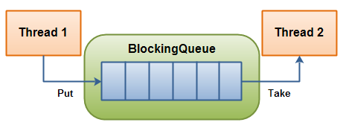
The Java Blocking Queue interface in the java.util.concurrent package represents a queue which is thread safe to put into, and take instances from.
The producing thread will keep producing new objects and insert them into the queue, until the queue reaches some upper bound on what it can contain. It's limit, in other words. If the blocking queue reaches its upper limit, the producing thread is blocked while trying to insert the new object. It remains blocked until a consuming thread takes an object out of the queue.
The consuming thread keeps taking objects out of the blocking queue, and processes them. If the consuming thread tries to take an object out of an empty queue, the consuming thread is blocked until a producing thread puts an object into the queue.

Blocking Queue Methods:
A Blocking Queue has 4 different sets of methods for inserting, removing and examining the elements in the queue. Each set of methods behaves differently in case the requested operation cannot be carried out immediately.
 | Throws Exception | Special Value | Blocks | Times Out
Insert | add(o) | offer(o) | put(o) | offer(o, timeout, timeunit)
Remove | remove(o) | poll() | take() | poll(timeout, timeunit)
Examine | element() | peek()

The 4 different sets of behaviour mean this:
- Throws Exception:
If the attempted operation is not possible immediately, an exception is thrown.
- Special Value:
If the attempted operation is not possible immediately, a special value is returned (often true / false).
- Blocks:
If the attempted operation is not possible immediately, the method call blocks until it is.
- Times Out:
If the attempted operation is not possible immediately, the method call blocks until it is, but waits no longer than the given timeout. Returns a special value telling whether the operation succeeded or not (typically true / false).
It is not possible to insert null into a BlockingQueue. If you try to insert null, the BlockingQueue will throw a NullPointerException.
Delay Queue:
When the consumer wants to take an element from the queue, they can take it only when the delay for that particular element has expired.
The Delayed interface also extends the java.lang.Comparable interface, as you can see, which means that Delayed objects can be compared to each other. This is probably used internally in the Delay Queue to order the elements in the queue, so they are released ordered by their expiration time.

Priority Blocking Queue:

It uses the same ordering rules as the java.util.PriorityQueue class. You cannot insert null into this queue.
All elements inserted into the PriorityBlockingQueue must implement the java.lang.Comparable interface. The elements thus order themselves according to whatever priority you decide in your Comparable implementation.

Synchronous Queue :

The SynchronousQueue is a queue that can only contain a single element internally. A thread inseting an element into the queue is blocked until another thread takes that element from the queue. Likewise, if a thread tries to take an element and no element is currently present, that thread is blocked until a thread insert an element into the queue.

BlockingDeque :

The BlockingDeque interface in the java.util.concurrent class represents a deque which is thread safe to put into, and take instances from.
A deque is short for "Double Ended Queue". Thus, a deque is a queue which you can insert and take elements from, from both ends.
A BlockingDeque could be used if threads are both producing and consuming elements of the same queue. It could also just be used if the producting thread needs to insert at both ends of the queue, and the consuming thread needs to remove from both ends of the queue.
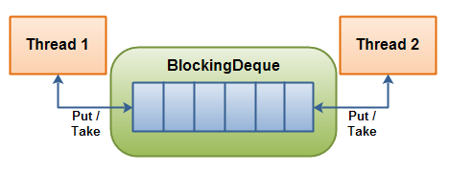
A thread will produce elements and insert them into either end of the queue. If the deque is currently full, the inserting thread will be blocked until a removing thread takes an element out of the deque. If the deque is currently empty, a removing thread will be blocked until an inserting thread inserts an element into the deque.
A BlockingDeque has 4 different sets of methods for inserting, removing and examining the elements in the deque. Each set of methods behaves differently in case the requested operation cannot be carried out immediately. Here is a table of the methods:
 | Throws Exception | Special Value | Blocks | Times Out
Insert | addFirst(o) | offerFirst(o) | putFirst(o) | offerFirst(o, timeout, timeunit)
Remove | removeFirst(o) | pollFirst(o) | takeFirst(o) | pollFirst(timeout, timeunit)
Examine | getFirst(o) | peekFirst(o)

 | Throws Exception | Special Value | Blocks | Times Out
Insert | addLast(o) | offerLast(o) | putLast(o) | offerLast(o, timeout, timeunit)
Remove | removeLast(o) | pollLast(o) | takeLast(o) | pollLast(timeout, timeunit)
Examine | getLast(o) | peekLast(o)
The 4 different sets of behaviour mean this:
- Throws Exception:
If the attempted operation is not possible immediately, an exception is thrown.
- Special Value:
If the attempted operation is not possible immediately, a special value is returned (often true / false).
- Blocks:
If the attempted operation is not possible immediately, the method call blocks until it is.
- Times Out:
If the attempted operation is not possible immediately, the method call blocks until it is, but waits no longer than the given timeout. Returns a special value telling whether the operation succeeded or not (typically true / false).

CountDownLatch:

A java.util.concurrent.CountDownLatch is a concurrency construct that allows one or more threads to wait for a given set of operations to complete. A CountDownLatch is initialized with a given count. This count is decremented by calls to the countDown()method. Threads waiting for this count to reach zero can call one of the await() methods. Calling await()blocks the thread until the count reaches zero. After the Decrementer has called countDown() 3 times on the CountDownLatch, the waiting Waiter is released from the await() call.

CyclicBarrier:
The java.util.concurrent.CyclicBarrier class is a synchronization mechanism that can synchronize threads progressing through some algorithm. In other words, it is a barrier that all threads must wait at, until all threads reach it, before any of the threads can continue. Here is a diagram illustrating that:
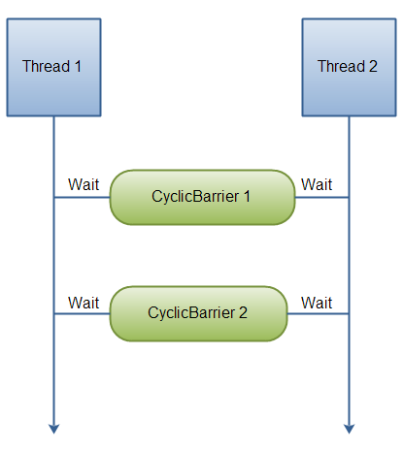
The threads wait for each other by calling the await() method on the Cyclic Barrier. Once N threads are waiting at the Cyclic Barrier, all threads are released and can continue running.

Executor Service:

The java.util.concurrent.ExecutorService interface represents an asynchronous execution mechanism which is capable of executing tasks in the background. An ExecutorService is thus very similar to a thread pool. In fact, the implementation of ExecutorService present in the java.util.concurrent package is a thread pool implementation.
ExecutorService Implementations
Since ExecutorService is an interface, you need to its implementations in order to make any use of it. The ExecutorService has the following implementation in the java.util.concurrent package:
- ThreadPoolExecutor
- ScheduledThreadPoolExecutor
The shutdown() method doesn’t cause an immediate destruction of the ExecutorService. It will make the ExecutorService stop accepting new tasks and shut down after all running threads finish their current work.
The shutdownNow() method tries to destroy the ExecutorService immediately, but it doesn’t guarantee that all the running threads will be stopped at the same time. This method returns a list of tasks which are waiting to be processed. It is up to the developer to decide what to do with these tasks.
One good way to shut down the ExecutorService (which is also recommended by Oracle) is to use both of these methods combined with the awaitTermination() method. With this approach, the ExecutorService will first stop taking new tasks, the wait up to a specified period of time for all tasks to be completed. If that time expires, the execution is stopped immediately.

Future Interface

The submit() and invokeAll() methods return an object or a collection of objects of type Future, which allows us to get the result of a task’s execution or to check the task’s status (is it running or executed). The Future interface provides a special blocking method get() which returns an actual result of the Callable task’s execution or null in the case of Runnable task. Calling the get() method while the task is still running will cause execution to block until the task is properly executed and the result is available.

With very long blocking caused by the get() method, an application’s performance can degrade. If the resulting data is not crucial, it is possible to avoid such a problem by using timeouts:

String result = future.get(200, TimeUnit.MILLISECONDS);

If the execution period is longer than specified (in this case 200 milliseconds), a TimeoutException will be thrown.The isDone() method can be used to check if the assigned task is already processed or not. The Future interface also provides for the cancellation of task execution with the cancel() method, and to check the cancellation with isCancelled() method:

ForkJoinPool

The ForkJoinPool is similar to the Java ExecutorServicebut with one difference. The ForkJoinPool makes it easy for tasks to split their work up into smaller tasks which are then submitted to the ForkJoinPool too. Tasks can keep splitting their work into smaller subtasks for as long as it makes to split up the task. It may sound a bit abstract, so in this fork and join tutorial I will explain how the ForkJoinPool works, and how splitting tasks up work.

The fork and join principle consists of two steps which are performed recursively. These two steps are the fork step and the join step.

Fork
A task that uses the fork and join principle can fork (split) itself into smaller subtasks which can be executed concurrently.
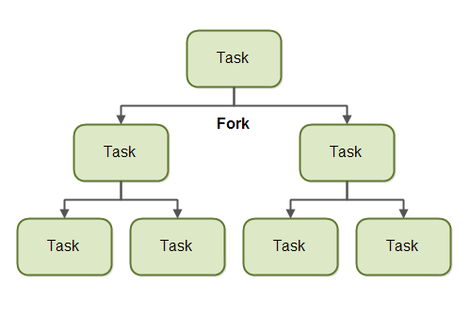
By splitting itself up into subtasks, each subtask can be executed in parallel by different CPUs, or different threads on the same CPU.
A task only splits itself up into subtasks if the work the task was given is large enough for this to make sense. There is an overhead to splitting up a task into subtasks, so for small amounts of work this overhead may be greater than the speedup achieved by executing subtasks concurrently.
The limit for when it makes sense to fork a task into subtasks is also called a threshold. It is up to each task to decide on a sensible threshold. It depends very much on the kind of work being done.

Join
When a task has split itself up into subtasks, the task waits until the subtasks have finished executing.
Once the subtasks have finished executing, the task may join (merge) all the results into one result.
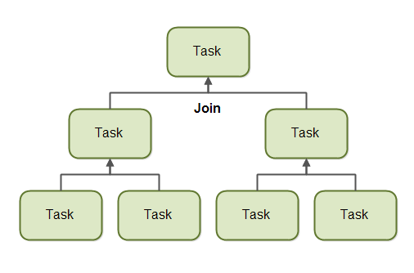
Of course, not all types of tasks may return a result. If the tasks do not return a result then a task just waits for its subtasks to complete. No result merging takes place then.

ForkJoinPool
The ForkJoinPool is a special thread pool which is designed to work well with fork-and-join task splitting. The ForkJoinPool located in the java.util.concurrent package, so the full class name isjava.util.concurrent.ForkJoinPool.

Creating a ForkJoinPool
You create a ForkJoinPool using its constructor. As a parameter to the ForkJoinPool constructor you pass the indicated level of parallelism you desire. The parallelism level indicates how many threads or CPUs you want to work concurrently on on tasks passed to the ForkJoinPool.
ForkJoinPool forkJoinPool = new ForkJoinPool(4);

Submitting Tasks to the ForkJoinPool
You submit tasks to a ForkJoinPool similarly to how you submit tasks to an ExecutorService. You can submit two types of tasks. A task that does not return any result (an "action"), and a task which does return a result (a "task"). These two types of tasks are represented by the RecursiveAction and RecursiveTaskclasses.

Lock

A java.util.concurrent.locks.Lock is a thread synchronization mechanism just like synchronized blocks. A Lock is, however, more flexible and more sophisticated than a synchronized block.
Main Differences Between Locks and Synchronized Blocks
- A synchronized block makes no guarantees about the sequence in which threads waiting to entering it are granted access.
- You cannot pass any parameters to the entry of a synchronized block. Thus, having a timeout trying to get access to a synchronized block is not possible.
- The synchronized block must be fully contained within a single method. A Lock can have it's calls to lock() and unlock() in separate methods.

Lock Methods
- lock()
- lockInterruptibly()
- tryLock()
- tryLock(long timeout, TimeUnit timeUnit)
- unlock()
- The lock() method locks the Lock instance if possible. If the Lock instance is already locked, the thread calling lock() is blocked until the Lock is unlocked.
- The lockInterruptibly() method locks the Lock unless the thread calling the method has been interrupted. Additionally, if a thread is blocked waiting to lock the Lock via this method, and it is interrupted, it exits this method calls.
- The tryLock() method attempts to lock the Lock instance immediately. It returns true if the locking succeeds, false if Lock is already locked. This method never blocks.
- The tryLock(long timeout, TimeUnit timeUnit) works like the tryLock() method, except it waits up the given timeout before giving up trying to lock the Lock.
- The unlock() method unlocks the Lock instance. Typically, a Lock implementation will only allow the thread that has locked the Lock to call this method. Other threads calling this method may result in an unchecked exception (RuntimeException).
A java.util.concurrent.locks.ReadWriteLock is an advanced thread lock mechanism. It allows multiple threads to read a certain resource, but only one to write it, at a time.
The idea is, that multiple threads can read from a shared resource without causing concurrency errors. The concurrency errors first occur when reads and writes to a shared resource occur concurrently, or if multiple writes take place concurrently.

ReadWriteLock Locking Rules
Read Lock If no threads have locked the ReadWriteLock for writing, and no thread have requested a write lock (but not yet obtained it). Thus, multiple threads can lock the lock for reading.
Write Lock If no threads are reading or writing. Thus, only one thread at a time can lock the lock for writing.

AtomicInteger
The AtomicInteger class also has an atomic compareAndSet() method. This method compares the current value of the AtomicInteger instance to an expected value, and if the two values are equal, sets a new value for the AtomicInteger instance.
AtomicInteger atomicInteger = new AtomicInteger(123);
int expectedValue = 123;
int newValue = 234;
atomicInteger.compareAndSet(expectedValue, newValue);
you can get the value of an AtomicInteger instance via the get() method. You can set the value of an AtomicInteger instance via the set() method.
The AtomicInteger class contains a few methods you can use to add a value to the AtomicInteger and get its value returned.
- addAndGet()
- getAndAdd()
- getAndIncrement()
- incrementAndGet()
The first method, addAndGet() adds a number to the AtomicInteger and returns its value after the addition. The second method, getAndAdd() also adds a number to the AtomicInteger but returns the value the AtomicInteger had before the value was added.

