Factory Method is a creational design pattern that provides an interface for creating objects in superclass, but allows subclasses to alter the type of objects that will be created.

UML Diagram
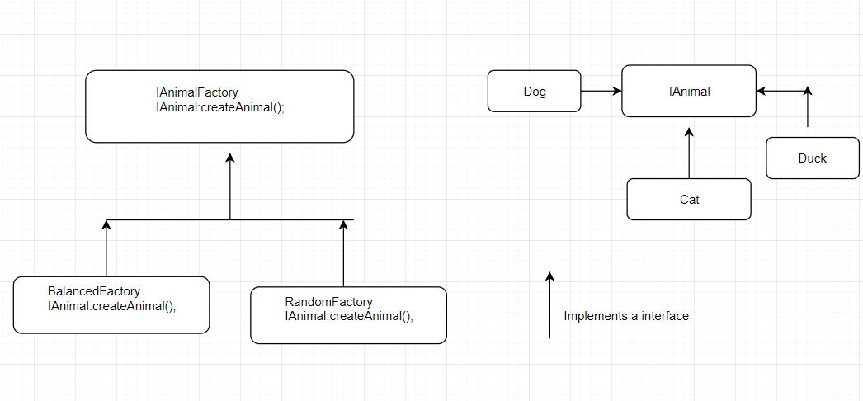
Here in above UML diagram you can see that we need to create object of type IAnimal and we do have IAnimalFactory . But how we are going to create the instance depends upon subclass i.e. Balanced factory OR Random factory.
Usage : when you need to create a particular type of object (you have a parent class and n number of subclass) but you don’t know which class object you need to create and it is entirely depends upon input from client/randomly . then we should use factory design pattern.

