**GN Current Alarm Monitoring Script User Manual**

**Purpose :** The Purpose of this Script is to Retrieve All Current Alarms of Ground Network (GN) based on user Requirement.

* The Script is intended to use for Retrieve All Current Alarms having Severity as :
  + - **Critical**
    - **Major**
    - **Minor**

**Preconditions and Requirements:**

1. The Script should be run on CentOS Linux OS system/server having python 2.7 or above installed.
2. Possibly all python libraries should also be installed on the system.
3. User should also have the root permissions is a plus.

**Working** : The Script is completely based on the options selected by the user for retrieving alarms of GN.

1. Firstly Place the provided script named as “**HSC_GN_ALARM_ANALYZER.py**” on any specific path on the system.
2. Change the permissions of the script by using chmod +x command.
3. Run the script as: python **HSC_GN_ALARM_ANALYZER.py**.
4. Upon running the script, a user menu is getting displayed as shown below:

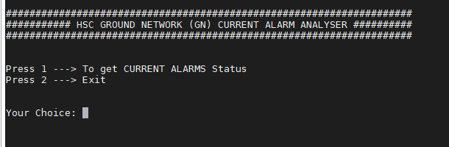

1. For retrieving the current alarms Press 1 and following user menu is displayed :

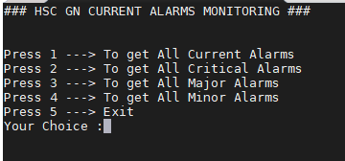

1. As shown select the appropriate option to get all alarms and alarms based on severity.
2. For Eg : If user want to get Minor Alarms so **press 4** and after this enter the EMS IP address as shown below :

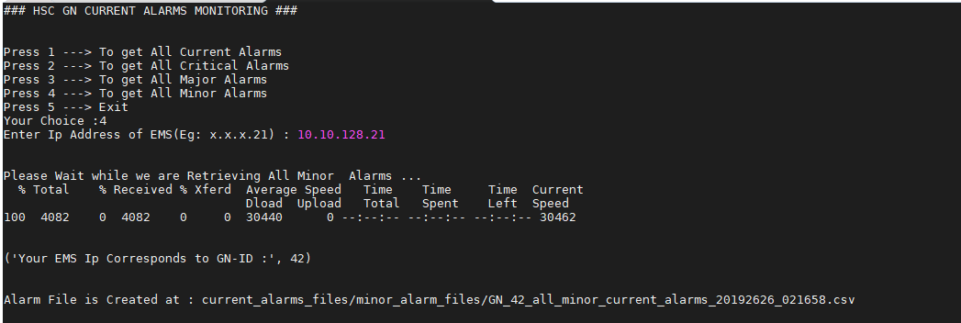

1. After giving the IP address of EMS, alarms are retrieved and saved in a “**.csv**” file is generated at mentioned path along with a specific name having GN Id and date-time of generation.
2. You can open the file on the system or in Excel in order to analyze the alarms.
3. You can also check the logs in “gn_logs” folder created on the same path.