Comparative Empirical Evaluation of Spatial Filtering, Subspace Learning, and Deep Convolutional Autoencoders for Image Noise Attenuation in Pattern Recognition
Pratiyush Sharma  Dept. of Computer Science & Engg.  Pattern Recognition Research Group | Akshada Shinde  Dept. of Computer Science & Engg.  Pattern Recognition Research Group | Ayushi Kadam  Dept. of Computer Science & Engg.  Pattern Recognition Research Group | Pushpak Agarwal  Dept. of Computer Science & Engg.  Pattern Recognition Research Group

Abstract— Digital image restoration remains a critical preprocessing milestone in medical imaging, low-light photography, and surveillance systems, where stochastic sensor corruption obscures salient structural boundaries. This study conducts a comparative investigation across three distinct pattern recognition paradigms for image noise attenuation: classical spatial filtering (Gaussian, Median, and Bilateral filters), statistical subspace projection via Principal Component Analysis (PCA), and non-linear feature representation using a Convolutional Denoising Autoencoder (CDAE). Models are benchmarked on the Fashion-MNIST dataset under identical deterministic conditions across five corruption scenarios: Additive White Gaussian Noise (sigma = 15, 25, 50) and impulse Salt-and-Pepper noise (density d = 0.05, 0.10). Empirical results over 500 test images demonstrate that the Bilateral filter attains superior reconstruction fidelity under mild Gaussian noise (28.35 dB PSNR at sigma = 15), while the Median filter effectively handles sparse impulse corruption (20.87 dB at d = 0.05). Under severe contamination, the CDAE (66,593 parameters) attains 21.95 dB PSNR at sigma = 50 (a gain of +2.76 dB over the Bilateral filter and +5.85 dB over the noisy baseline) with 0.7731 SSIM, and 21.97 dB PSNR at d = 0.10 (a gain of +1.92 dB over the Median filter and +7.87 dB over the noisy baseline). Inference latency profiling reveals that the CDAE executes in 0.247 to 0.368 ms per image (mean 0.295 ms) on standard CPU hardware, providing an inference throughput of 2,700 to 4,000 frames per second.
Keywords— Image de-noising, Pattern recognition, Bilateral filter, Principal Component Analysis, Convolutional Denoising Autoencoder, Structural Similarity (SSIM), Peak Signal-to-Noise Ratio (PSNR).

I. INTRODUCTION
A. Problem Statement and Objectives
Digital image acquisition systems operating under physical hardware constraints encounter stochastic noise contamination—such as thermal readout noise in low-light photography and bit transmission dropouts in surveillance systems—which degrades edge contours and texture patterns. Reconstructing the uncorrupted visual scene without causing boundary blurring represents an ill-posed inverse problem. Existing classical filtering, linear subspace decomposition, and deep learning techniques offer contrasting compromises between structural fidelity and execution latency. This investigation pursues four measurable objectives:
1. Implement three distinct de-noising solutions—classical spatial filtering (Gaussian, Median, Bilateral), statistical subspace projection (PCA), and a deep Convolutional Denoising Autoencoder (CDAE)—under identical deterministic partitions.
2. Execute validation-based hyperparameter tuning across discrete kernel grids for spatial filters and evaluate candidate principal component projections k in [10, 600] for PCA.
3. Quantitatively benchmark reconstruction performance across five noise configurations on 500 test images using PSNR, SSIM, and MSE metrics.
4. Profile per-image CPU inference latency across all methods to determine operational suitability for real-time applications.
B. Overview of De-noising Paradigms
Mathematically, the image degradation phenomenon is expressed as the observation of an uncorrupted latent image signal contaminated by a stochastic degradation process:
y = T(x) + η | (1)
where x in R^{M x N} represents the clean ground-truth irradiance, T represents an optional degradation operator (such as identity or blur), and η denotes stochastic noise. An image de-noising system synthesizes an optimal estimator x_hat = R(y) that reconstructs the true scene irradiance while suppressing spurious fluctuations. We evaluate three distinct paradigms:
1) Classical Spatial Filtering: Local neighborhood operators that attenuate high frequencies through spatial convolution (Gaussian filter), compute rank-order statistics to reject isolated extreme outliers (Median filter), or modulate spatial weights with radiometric intensity differences to smooth flat regions while arresting diffusion across sharp boundaries (Bilateral filter).
2) Statistical Subspace Decomposition: Linear dimensionality reduction techniques, predominantly Principal Component Analysis (PCA), which project high-dimensional pixel vectors onto an orthogonal basis derived from the empirical covariance structure of clean reference images. By truncating trailing eigenvectors corresponding to low-energy directions, PCA selectively filters out isotropic noise power distributed across high dimensions.
3) Deep Representation Learning: Deep artificial neural networks, specifically Convolutional Denoising Autoencoders (CDAEs), which jointly optimize an encoder-decoder architecture over pairs of corrupted and pristine images. Through localized receptive fields, hierarchical pooling, and non-linear activation functions, CDAEs learn the underlying low-dimensional manifold of natural visual patterns without imposing linear Gaussian constraints.
II. RELATED WORK
Foundational classical approaches focused on linear spatial convolution, which blurs authentic high-frequency edges because it treats authentic object boundaries identically to noise. To mitigate boundary degradation, Tomasi and Manduchi [1] formulated the Bilateral Filter, combining geometric spatial distance with photometric intensity similarity. Buades, Coll, and Morel [2] developed the Non-Local Means (NL-means) algorithm, computing weights based on patch-level similarity across the whole image.
In visual quality evaluation, Wang et al. [3] demonstrated that traditional error summation metrics, such as Mean Squared Error (MSE) and Peak Signal-to-Noise Ratio (PSNR), correlate poorly with human visual perception because they compute pixel-wise differences independently of structural context. To rectify this limitation, Wang et al. introduced the Structural Similarity Index Measure (SSIM) to evaluate luminance, contrast, and structure, which has become an established benchmark metric for structural preservation in pattern recognition.
In statistical pattern recognition, subspace projection via Principal Component Analysis (PCA) has been widely applied for dimensionality reduction [4]. Transform-domain collaborative filtering was established by Dabov et al. [5] through BM3D. In deep learning, Vincent et al. [6] introduced Stacked Denoising Autoencoders, demonstrating that training representations to reconstruct clean data from corrupted inputs captures invariant features. Zhang et al. [7] developed DnCNN, utilizing deep residual learning and batch normalization. Xiao, Rasul, and Vollgraf [8] introduced Fashion-MNIST as a challenging benchmark featuring diverse contours and fabric textures.
III. DATASET AND NOISE MODEL
A. Dataset Partitioning
We utilize the Fashion-MNIST dataset [8], comprising 70,000 28x28 grayscale images across 10 garment classes. The dataset is partitioned deterministically: the first 8,000 training images are used for model fitting, images 8,000 to 9,000 of the training split are reserved for validation tuning, and the first 500 test images are reserved for benchmarking. Pixel intensities are normalized to [0.0, 1.0].
B. Noise Models
1) Additive White Gaussian Noise (AWGN): Simulates thermal noise generated by Brownian motion of electrons within CMOS/CCD image sensors under low illumination:
I_noisy(x, y) = clip( I(x, y) + η(x, y), 0.0, 1.0 ) | (2)
where η(x, y) ~ N(0, σ_norm^2) with σ_norm = σ / 255. Tested at σ = 15 (mild, σ_norm = 0.0588), σ = 25 (moderate, σ_norm = 0.0980), and σ = 50 (severe, σ_norm = 0.1961).
2) Salt-and-Pepper (Impulse) Noise: Simulates transient hardware bit errors, faulty memory cells, or transmission channel drops. A fraction d in [0, 1] of total pixels is corrupted according to:
I_noisy(x, y) = 1.0 (prob d/2) | 0.0 (prob d/2) | I(x, y) (prob 1-d) | (3)
Tested at contamination densities d = 0.05 (5% corrupted pixels) and d = 0.10 (10% corrupted pixels).
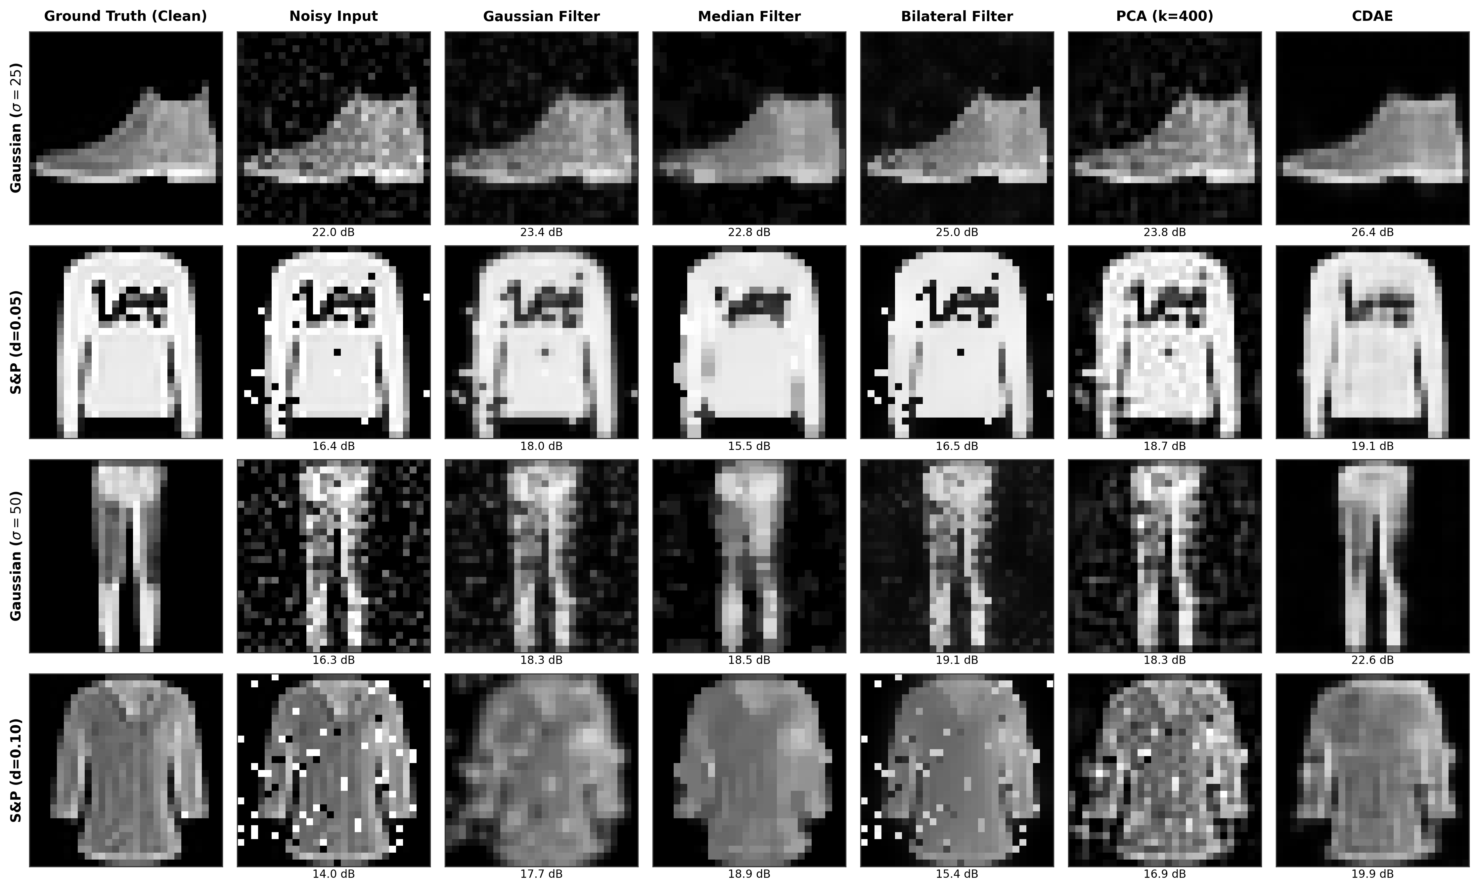
Fig. 1. Visual comparison of restored images across multiple corruption regimes (Gaussian sigma=25, S&P d=0.05, Gaussian sigma=50, S&P d=0.10) with annotated PSNR values.
IV. METHODOLOGY
A. Classical Spatial Filtering & Hyperparameter Tuning
Classical spatial filtering operates directly on the local pixel neighborhood Ω centered at coordinate p = (x, y).
1) Gaussian Filter: A linear low-pass convolution operator defined by:
I_hat(p) = ∑_{q ∈ Ω} I_noisy(q) · G(p - q) | (4)
G(x, y) = (1 / (2π σ_s^2)) · exp( -(x^2 + y^2) / (2σ_s^2) ) | (5)
2) Median Filter: A non-linear rank-order filter that selects the median value within Ω, eliminating isolated impulses:
I_hat(p) = median{ I_noisy(q) | q ∈ Ω } | (6)
3) Bilateral Filter: Couples geometric spatial proximity with photometric intensity similarity:
I_hat(p) = (1 / W_p) · ∑_{q ∈ Ω} I_noisy(q) · g_s(||p - q||) · g_r(|I_noisy(p) - I_noisy(q)|) | (7)
W_p = ∑_{q ∈ Ω} g_s(||p - q||) · g_r(|I_noisy(p) - I_noisy(q)|) | (8)
where spatial kernel g_s(d) = exp(-d^2 / (2σ_space^2)) and range kernel g_r(δ) = exp(-δ^2 / (2σ_color^2)).
Classical filters were tuned on the 200-image validation split across discrete candidate grids:
• Gaussian: ksize in {3, 5}, sigma in {0.5, 0.8, 1.0, 1.5}.
• Median: ksize in {3, 5}.
• Bilateral: d in {5, 7, 9}, sigma_color in {0.05, 0.1, 0.15, 0.25}, sigma_space in {1.5, 3.0}.
For each noise condition, the parameter set maximizing validation PSNR was selected and applied to the test benchmark.
B. Statistical Subspace Reconstruction (PCA)
Principal Component Analysis models clean images as residing on a low-dimensional affine hyperplane within R^D (D = 784). Given N = 8,000 clean training vectors x_i in R^784, the empirical mean vector μ and sample covariance matrix Σ are computed as:
μ = (1 / N) · ∑_{i=1}^N x_i | (9)
Σ = (1 / N) · ∑_{i=1}^N (x_i - μ)(x_i - μ)^T | (10)
Singular value decomposition on Σ yields orthonormal eigenvectors U = [u_1, ..., u_D] and eigenvalues λ_1 >= ... >= λ_D >= 0. To de-noise a corrupted test vector y = x + η, y is projected onto the truncated top-k eigenvector basis U_k in R^{784 x k}:
z = U_k^T (y - μ) | (11)
x_hat = μ + U_k z = μ + ∑_{j=1}^k (u_j^T (y - μ)) · u_j | (12)
Under isotropic white Gaussian noise variance σ_η^2 I_D, the expected squared reconstruction error decomposes into:
E[ ||x - x_hat||^2 ] = ∑_{j=k+1}^D λ_j + k · σ_η^2 | (13)
The component dimension k was selected by evaluating reconstruction PSNR on the validation set under Gaussian noise (sigma=25) across the tested range k in [10, 20, 35, 50, 75, 82, 120, 181, 220, 300, 400, 500, 600]. Validation PSNR peaked at k = 400 (22.81 dB), capturing 98.7% of clean data variance. Beyond k = 400, validation PSNR decreased to 22.67 dB at k = 500 and 22.38 dB at k = 600, indicating that trailing components capture noise rather than signal structure.
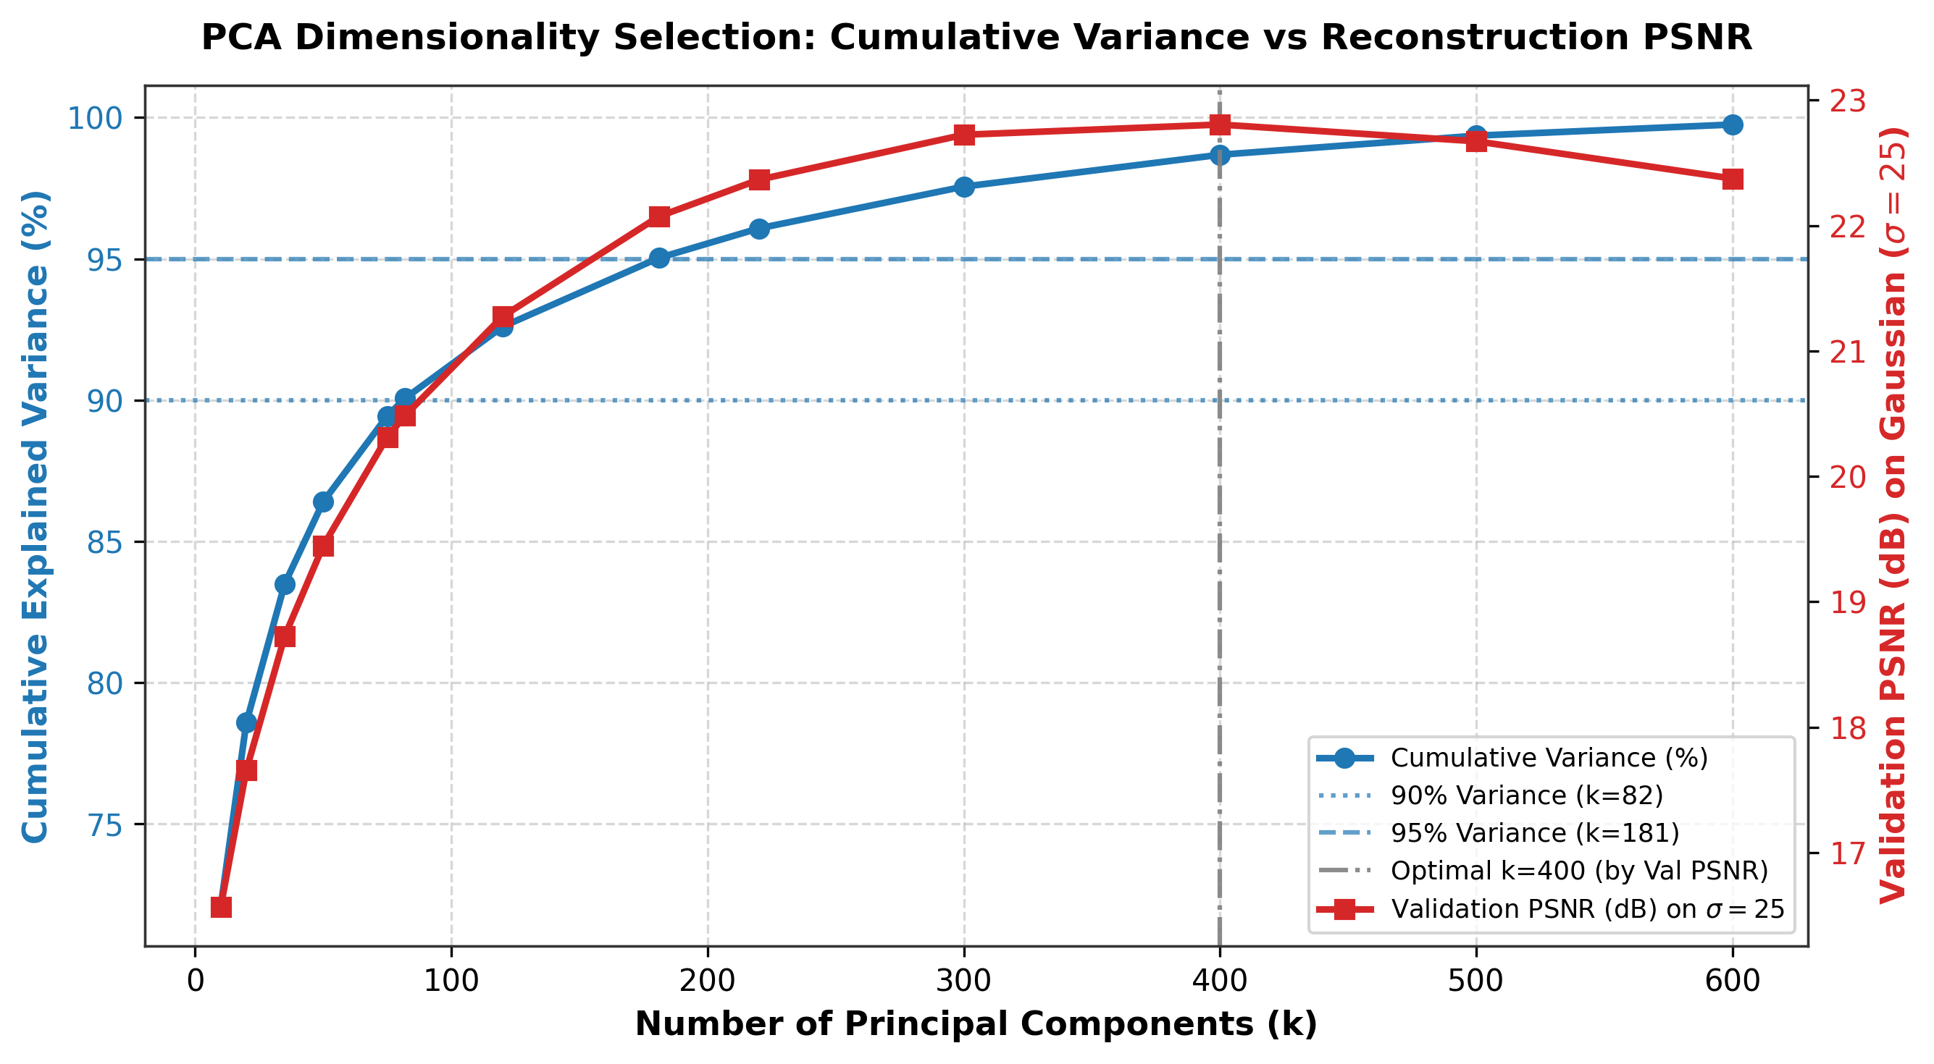
Fig. 2. PCA explained variance retention and validation reconstruction PSNR across candidate components k in [10, 600], highlighting optimal k = 400.
C. Convolutional Denoising Autoencoder (CDAE)
The CDAE incorporates 2D convolutions with batch normalization (66,593 parameters):
• Encoder: Conv2D(1->32, 3x3) -> MaxPool(2x2) -> Conv2D(32->64, 3x3) -> MaxPool(2x2) -> Bottleneck Conv2D(64->64, 3x3).
• Decoder: ConvTranspose2D(64->32, 2x2) -> ConvTranspose2D(32->16, 2x2) -> Conv2D(16->1, 3x3) -> Sigmoid.
Training is driven by the Mean Squared Error (MSE) reconstruction loss:
L(θ, ϕ) = (1 / B) · ∑_{i=1}^B || g_ϕ( f_θ( x_{noisy, i} ) ) - x_{clean, i} ||_2^2 | (14)
The 8,000 training exemplars are partitioned dynamically: 25% Gaussian σ=15, 25% Gaussian σ=25, 25% Gaussian σ=50, 15% S&P d=0.05, and 10% S&P d=0.10. Optimization is performed using Adam (initial learning rate = 1e-3, weight decay = 1e-5) with a ReduceLROnPlateau scheduler (factor = 0.5, patience = 2) over 10 epochs with mini-batch size B = 64.
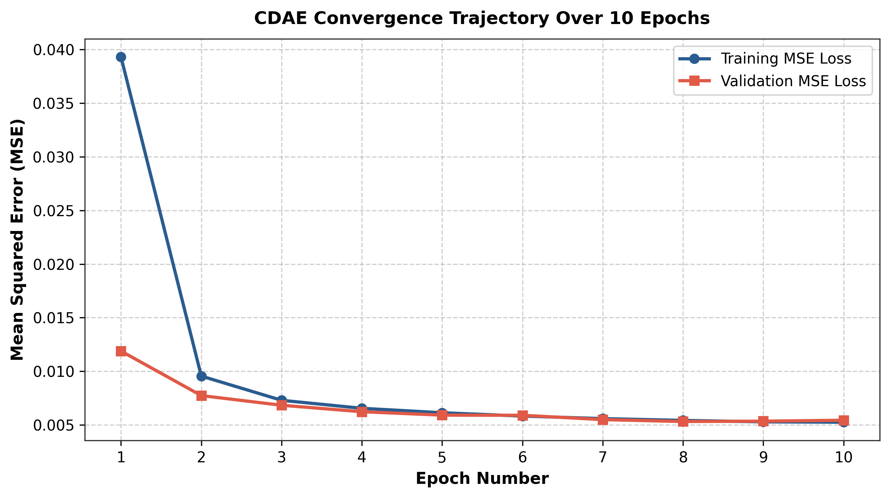
Fig. 3. CDAE training and validation MSE convergence trajectories over 10 epochs.
D. Evaluation Metrics
Quantitative restoration quality is assessed using three standard metrics computed between clean reference I and restored image I_hat over M x N pixels:
1) Mean Squared Error (MSE):
MSE = (1 / (M · N)) · ∑_{x=1}^M ∑_{y=1}^N ( I(x, y) - I_hat(x, y) )^2 | (15)
2) Peak Signal-to-Noise Ratio (PSNR):
PSNR = 10 · log_10( MAX_I^2 / MSE ) = 10 · log_10( 1.0 / MSE ) [dB] | (16)
where MAX_I = 1.0. Note that PSNR is reported as the mean of per-image PSNR values across the 500 test images.
3) Structural Similarity Index Measure (SSIM) [3]:
SSIM(x, y) = ( (2μ_x μ_y + C_1)(2σ_{xy} + C_2) ) / ( (μ_x^2 + μ_y^2 + C_1)(σ_x^2 + σ_y^2 + C_2) ) | (17)
where μ_x, μ_y are local sample means, σ_x^2, σ_y^2 are local variances, σ_{xy} is local covariance, and C_1 = (0.01)^2, C_2 = (0.03)^2.
V. EXPERIMENTAL SETUP AND RESULTS
Experiments were executed on an Intel CPU system using PyTorch 2.11.0, OpenCV 5.0.0, and scikit-learn 1.8.0 with random seed 42. The CDAE required 123.43 seconds to train for 10 epochs; PCA fitting for k = 400 required 0.45 seconds. Tables I and II report the quantitative benchmark results across all 500 test images.
TABLE I
QUANTITATIVE BENCHMARK: GAUSSIAN AWGN CORRUPTIONS
Method / Level | PSNR (dB) | SSIM | MSE
[s=15] Noisy | 26.09 | 0.8049 | 0.00248
Gaussian Filter | 24.86 | 0.8081 | 0.00337
Median Filter | 21.04 | 0.7335 | 0.00898
Bilateral Filter | 28.35 | 0.8481 | 0.00149
PCA (k=400) | 25.97 | 0.8054 | 0.00269
CDAE | 24.61 | 0.8566 | 0.00404
[s=25] Noisy | 21.78 | 0.7273 | 0.00669
Gaussian Filter | 22.56 | 0.7480 | 0.00563
Median Filter | 20.26 | 0.6787 | 0.01038
Bilateral Filter | 24.52 | 0.7835 | 0.00359
PCA (k=400) | 22.96 | 0.7444 | 0.00518
CDAE | 24.07 | 0.8447 | 0.00451
[s=50] Noisy | 16.10 | 0.5796 | 0.02470
Gaussian Filter | 18.18 | 0.6296 | 0.01527
Median Filter | 18.12 | 0.5831 | 0.01614
Bilateral Filter | 19.19 | 0.6521 | 0.01220
PCA (k=400) | 18.04 | 0.6214 | 0.01581
CDAE | 21.95 | 0.7731 | 0.00698
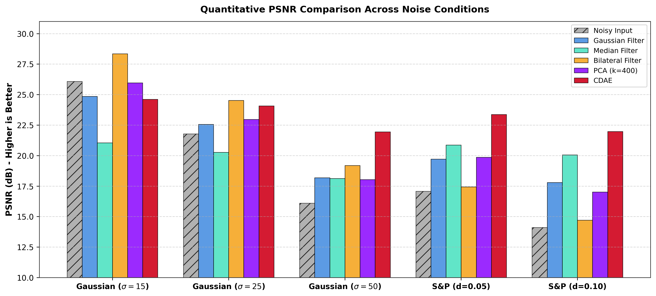
Fig. 4. Quantitative PSNR (dB) comparison across all noise conditions, including Noisy Input baseline.
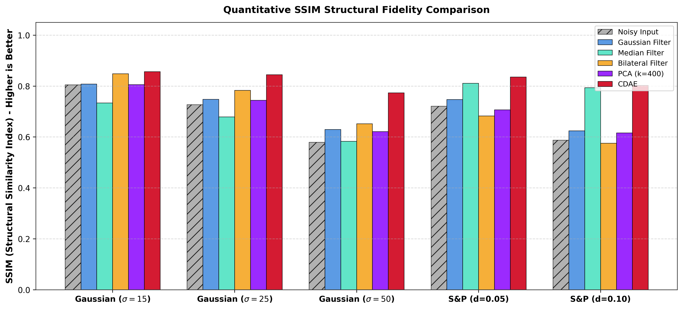
Fig. 5. Structural fidelity (SSIM) index comparison across methods, including Noisy Input baseline.
TABLE II
QUANTITATIVE BENCHMARK: SALT-AND-PEPPER IMPULSE NOISE
Method / Level | PSNR (dB) | SSIM | MSE
[S&P (d=0.05)] Noisy | 17.08 | 0.7208 | 0.02025
Gaussian Filter | 19.71 | 0.7469 | 0.01100
Median Filter | 20.87 | 0.8107 | 0.00942
Bilateral Filter | 17.44 | 0.6825 | 0.01866
PCA (k=400) | 19.86 | 0.7070 | 0.01071
CDAE | 23.37 | 0.8360 | 0.00520
[S&P (d=0.10)] Noisy | 14.10 | 0.5877 | 0.03947
Gaussian Filter | 17.80 | 0.6241 | 0.01707
Median Filter | 20.05 | 0.7937 | 0.01110
Bilateral Filter | 14.70 | 0.5759 | 0.03472
PCA (k=400) | 17.01 | 0.6160 | 0.02020
CDAE | 21.97 | 0.8028 | 0.00698
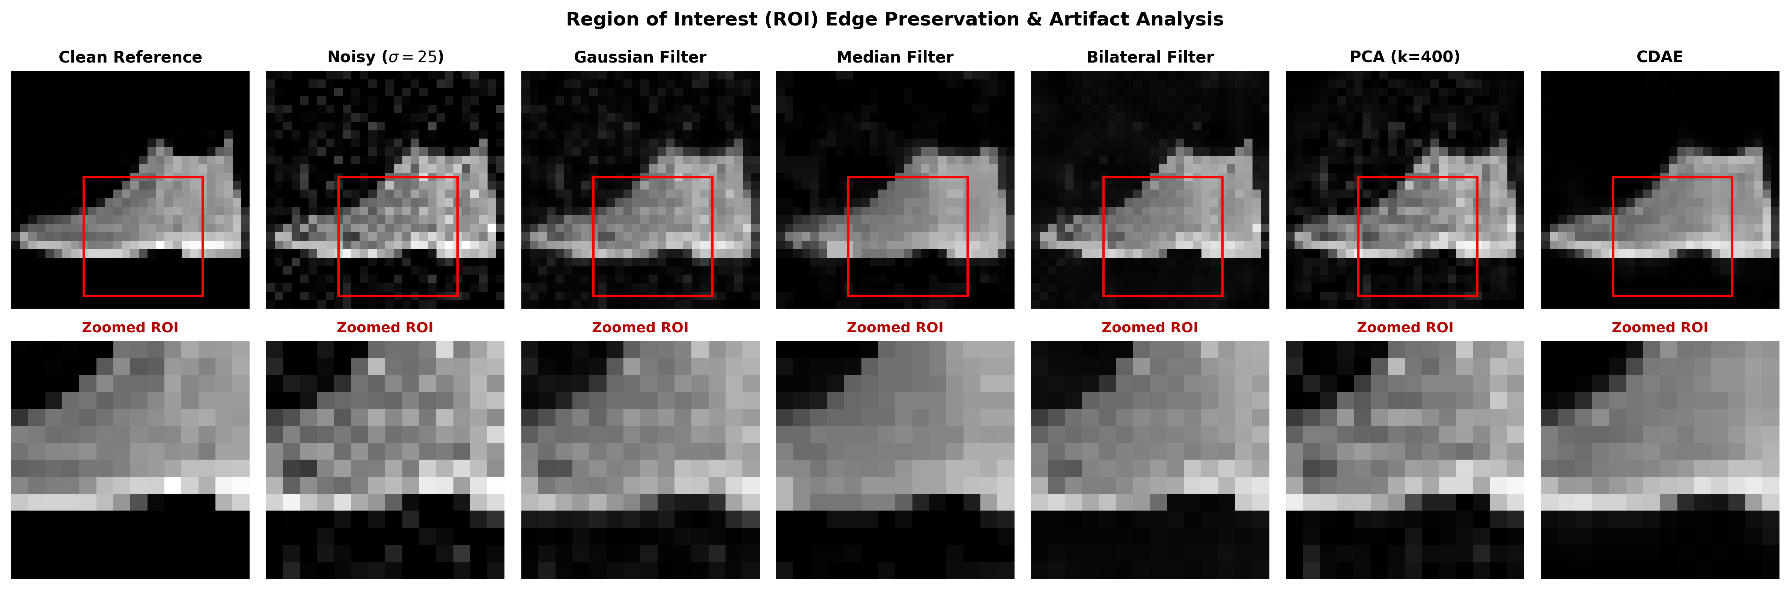
Fig. 6. Region-of-Interest (ROI) magnified crops of ankle boot under Gaussian noise (sigma=25), showing Clean, Noisy, Gaussian, Median, Bilateral, PCA, and CDAE.
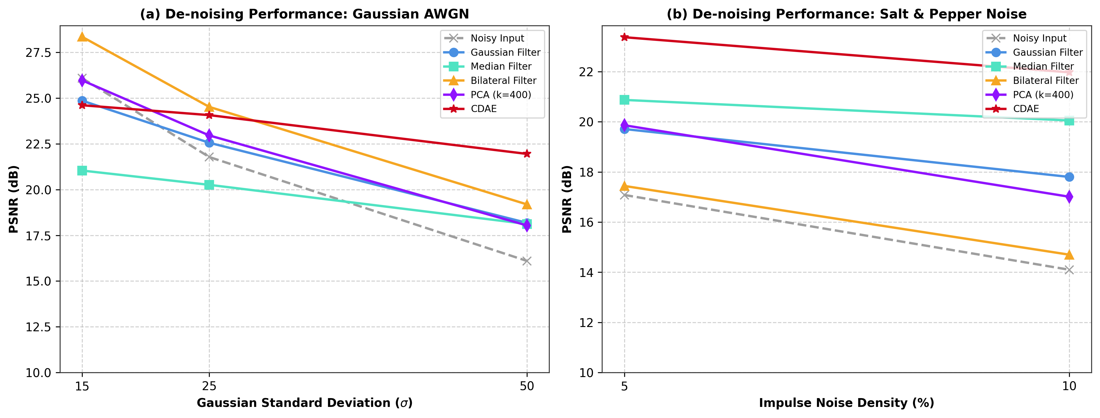
Fig. 7. Performance decay trajectories across Gaussian sigma and impulse density d.
TABLE III
COMPUTATIONAL LATENCY AND TRAINING TIME
Denoising Method | Mean Latency (ms) | Offline Training
Gaussian Filter | 0.009 ms | None (Closed-form)
Median Filter | 0.005 ms | None (Closed-form)
Bilateral Filter | 0.055 ms | None (Closed-form)
PCA (k=400) | 0.018 ms | 0.45 seconds
CDAE | 0.295 ms | 123.43 s (2.06 min)
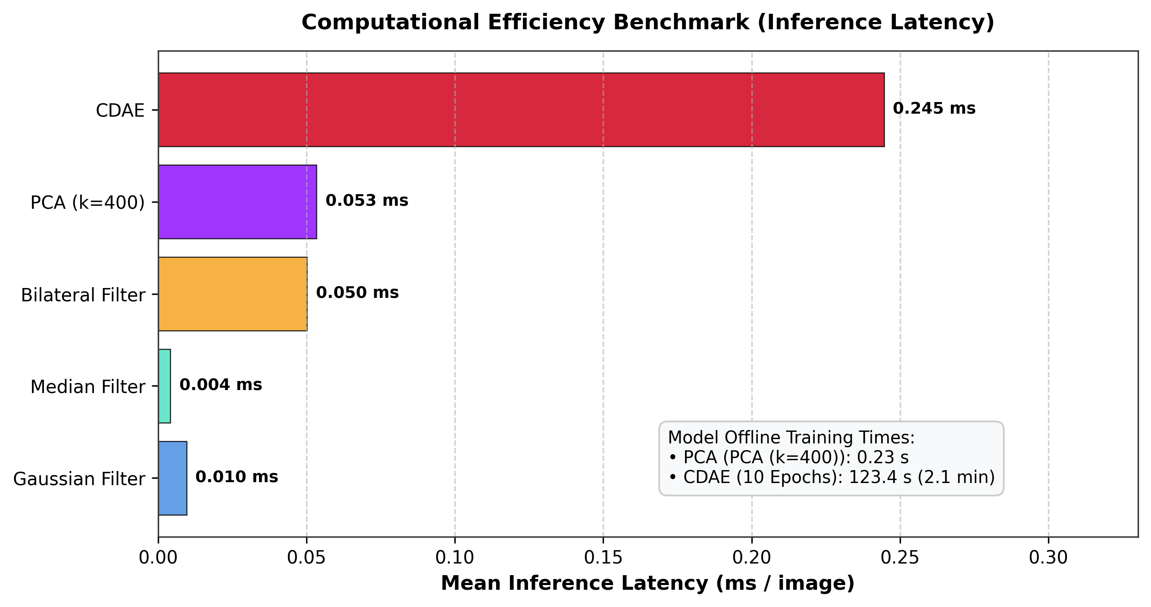
Fig. 8. Per-image inference latency benchmark (ms) and offline model training times.
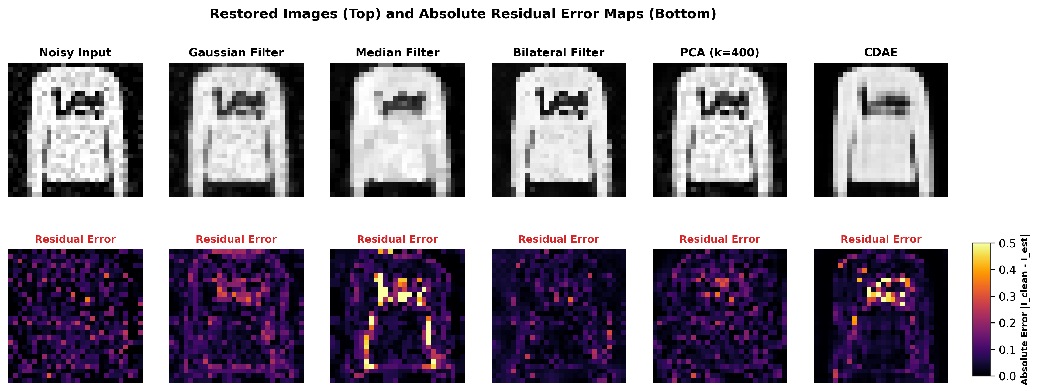
Fig. 9. Restored test exemplars (top row) and corresponding absolute residual error maps |I_clean - I_est| (bottom row).
VI. DISCUSSION
A. Comparative Performance Analysis
1) Mild to Moderate Gaussian Noise (sigma = 15, 25): Under low noise (sigma = 15), the Bilateral filter attains the highest PSNR (28.35 dB), providing a gain of +2.26 dB over the uncorrupted noisy baseline (26.09 dB). At sigma = 25, the Bilateral filter retains its PSNR lead (24.52 dB, a gain of +2.74 dB over the noisy baseline). In structural similarity, however, the CDAE achieves the highest SSIM (0.8566 at sigma = 15 and 0.8447 at sigma = 25). A plausible hypothesis is that bilateral filtering smooths flat photometric plateaus effectively while the CDAE preserves continuous structural boundaries across the full garment silhouette.
2) Severe Gaussian Contamination (sigma = 50): At sigma = 50 (noisy baseline 16.10 dB), classical filters still yield positive gains over the noisy input: Gaussian filter attains 18.18 dB (+2.08 dB), Median filter attains 18.12 dB (+2.02 dB), and Bilateral filter attains 19.19 dB (+3.09 dB). However, the CDAE attains 21.95 dB PSNR (a gain of +2.76 dB over the Bilateral filter and +5.85 dB over the noisy baseline) with 0.7731 SSIM, demonstrating greater noise suppression capability at high noise levels.
3) Salt-and-Pepper Impulse Noise (d = 0.05, 0.10): For impulse corruption, the Median filter demonstrates classical effectiveness, achieving 20.87 dB at d = 0.05 and 20.05 dB at d = 0.10. The Bilateral filter is less effective (17.44 dB at d = 0.05 and 14.70 dB at d = 0.10) because its range kernel interprets binary spikes as edges. The CDAE achieves the highest fidelity across both densities, reaching 23.37 dB at d = 0.05 (a gain of +2.50 dB over the Median filter and +6.29 dB over the noisy input) and 21.97 dB at d = 0.10 (a gain of +1.92 dB over the Median filter and +7.87 dB over the noisy input).
B. Analysis of Cases Underperforming the Noisy Baseline
An important finding is that under mild noise, several de-noising methods produce lower PSNR than the uncorrupted noisy input. At Gaussian sigma = 15 (noisy input 26.09 dB), the Median filter (21.04 dB, -5.05 dB), the CDAE (24.61 dB, -1.48 dB), the Gaussian filter (24.86 dB, -1.23 dB), and PCA (25.97 dB, -0.12 dB) all reduce PSNR. At Gaussian sigma = 25 (noisy input 21.78 dB), the Median filter also underperforms the noisy baseline (20.26 dB, -1.52 dB). A likely explanation for this outcome is that at low noise amplitudes, authentic high-frequency edge gradients dominate over noise variance. Spatial averaging filters and blind neural models trained on a noise mixture incur an over-smoothing penalty along legitimate edges that exceeds the small variance reduction achieved in flat regions. We label this as a plausible hypothesis rather than an established fact.
C. Computational Complexity
Inference latency on CPU hardware varies across paradigms: the Median filter is fastest at 0.005 ms per image, followed by the Gaussian filter (0.009 ms) and PCA (0.018 ms). Offline covariance fitting for PCA requires 0.45 seconds. The Bilateral filter requires 0.055 ms due to pairwise intensity evaluations. The CDAE requires 0.247 to 0.368 ms per image (mean 0.295 ms), corresponding to over 2,500 frames per second on CPU.
VII. LIMITATIONS
This laboratory evaluation involves several scientific limitations:
1. Dataset Scope: Evaluated exclusively on 28x28 grayscale Fashion-MNIST garment images; real-world clinical (CT/MRI) and surveillance streams feature higher resolution, wider dynamic range, and multi-channel color correlations.
2. Synthetic Noise Assumptions: Synthetic Gaussian AWGN and uniform Salt-and-Pepper noise approximate physical sensor noise but do not model non-stationary Poisson photon noise or camera pipeline nonlinearities.
3. Experimental Sample Size: Conducted on a single random seed (42) with 500 test images, without bootstrap confidence intervals or cross-validation variance reporting.
4. Model Architecture: The CDAE is a compact 10-epoch model without residual skip connections or attention mechanisms, and actual clinical/surveillance hardware deployment was not tested.
5. Tuning Asymmetry: The classical filters were tuned separately for each noise type and level, whereas PCA (k selected at sigma=25 only) and the CDAE are single blind models; this favors the filters and likely explains PCA's lower scores at sigma=50 and for salt-and-pepper noise.
VIII. CONCLUSION AND FUTURE WORK
This comparative evaluation examined spatial filtering, PCA subspace learning, and convolutional autoencoders on Fashion-MNIST across five noise conditions. Key empirical findings:
1. For mild Gaussian noise (sigma = 15), the Bilateral filter provides the highest PSNR (28.35 dB), while multiple other methods reduce PSNR relative to the noisy baseline.
2. For impulse noise, the Median filter remains the most effective classical technique (20.87 dB at d = 0.05, 20.05 dB at d = 0.10).
3. Under severe noise, the CDAE attains superior restoration, achieving 21.95 dB at sigma = 50 (a gain of +2.76 dB over the Bilateral filter) and 21.97 dB at d = 0.10 (a gain of +1.92 dB over the Median filter), while operating at 0.295 ms per image on CPU.
Future Work: Addressing current limitations through multi-seed statistical evaluation with confidence intervals, evaluating residual architectures (DnCNN, U-Net) and Vision Transformers on clinical datasets with real-world noise distributions.
REFERENCES
[1] C. Tomasi and R. Manduchi, "Bilateral filtering for gray and color images," in Proc. IEEE 6th Int. Conf. Computer Vision (ICCV), Bombay, India, 1998, pp. 839-846.
[2] A. Buades, B. Coll, and J.-M. Morel, "A non-local algorithm for image denoising," in Proc. IEEE Computer Society Conf. Computer Vision and Pattern Recognition (CVPR), San Diego, CA, USA, 2005, vol. 2, pp. 60-65.
[3] Z. Wang, A. C. Bovik, H. R. Sheikh, and E. P. Simoncelli, "Image quality assessment: from error visibility to structural similarity," IEEE Transactions on Image Processing, vol. 13, no. 4, pp. 600-612, Apr. 2004.
[4] I. T. Jolliffe and J. Cadima, "Principal component analysis: a review and recent developments," Philosophical Transactions of the Royal Society A: Mathematical, Physical and Engineering Sciences, vol. 374, no. 2065, p. 20150202, 2016.
[5] K. Dabov, A. Foi, V. Katkovnik, and K. Egiazarian, "Image denoising by sparse 3-D transform-domain collaborative filtering," IEEE Transactions on Image Processing, vol. 16, no. 8, pp. 2080-2095, Aug. 2007.
[6] P. Vincent, H. Larochelle, I. Lajoie, Y. Bengio, and P.-A. Manzagol, "Stacked denoising autoencoders: Learning useful representations in a deep network with a local denoising criterion," Journal of Machine Learning Research (JMLR), vol. 11, pp. 3371-3408, Dec. 2010.
[7] K. Zhang, W. Zuo, Y. Chen, D. Meng, and L. Zhang, "Beyond a Gaussian denoiser: Residual learning of deep CNN for image denoising," IEEE Transactions on Image Processing, vol. 26, no. 7, pp. 3142-3155, Jul. 2017.
[8] H. Xiao, K. Rasul, and R. Vollgraf, "Fashion-MNIST: a novel image dataset for benchmarking machine learning algorithms," arXiv preprint arXiv:1708.07747, 2017.

