Real-World Dataset Analysis
Exploratory Data Analysis of the Wisconsin Breast Cancer (Diagnostic) Dataset
AI/ML Research Specialist Internship – Week 3 | Prayag
Tools: Python, Pandas, NumPy, SciPy, Matplotlib, Seaborn, Scikit-learn

1. Executive Summary
This report analyses 569 patient records from the Wisconsin Diagnostic Breast Cancer dataset (UCI Machine Learning Repository). The goal is to understand which measurable properties of cell nuclei separate malignant tumours from benign ones. Key results:
- Dataset: 357 benign (62.7%) and 212 malignant (37.3%) cases; no missing values and no duplicate rows.
- Strongest differences: Malignant tumours have a mean radius of 17.46 vs 12.15 for benign (+43.8%), and mean concavity of 0.161 vs 0.046 (3.5× higher).
- Most predictive features: "worst concave points" (r = −0.794 with the benign label) and "worst perimeter" (r = −0.783).
- Multicollinearity: 21 feature pairs have |r| > 0.90, so size features (radius, perimeter, area) are largely redundant.
- Predictability: a baseline logistic regression on standardised features reaches 98.2% test accuracy and 97.6% recall on malignant cases (5-fold CV accuracy 98.1%).

2. Dataset Selection and Context
Source: UCI Machine Learning Repository / scikit-learn (load_breast_cancer). Each record describes a digitised image of a fine-needle aspirate (FNA) of a breast mass. Ten properties of the cell nuclei are measured and summarised three ways – mean, standard error and "worst" (mean of the three largest values) – giving 30 numeric features plus the diagnosis label.
Property | Description
Rows × Columns | 569 × 31 (30 features + diagnosis); 32 columns after adding a text label
Target | diagnosis: Malignant (0) / Benign (1)
Measures (×3 each) | radius, texture, perimeter, area, smoothness, compactness, concavity, concave points, symmetry, fractal dimension
Business / analytical context | Support early, accurate screening by identifying which nucleus measurements best indicate malignancy
Expected outcome | Identify key discriminating features and confirm that a simple model can separate the classes

3. Data Exploration

3.1 Structure and data types
All 30 predictors are float64; the target is integer-coded (0/1). Memory use is small (~140 KB), so no sampling was required.

3.2 Missing values and duplicates
- Missing values: df.isna().sum().sum() = 0 – no missing values in any of the 569 × 30 cells.
- Duplicates: df.duplicated().sum() = 0 – every record is unique.

3.3 Class distribution
The dataset is moderately imbalanced: 357 benign (62.7%) vs 212 malignant (37.3%). This is mild enough that accuracy is usable, but recall on the malignant class is the more important metric.
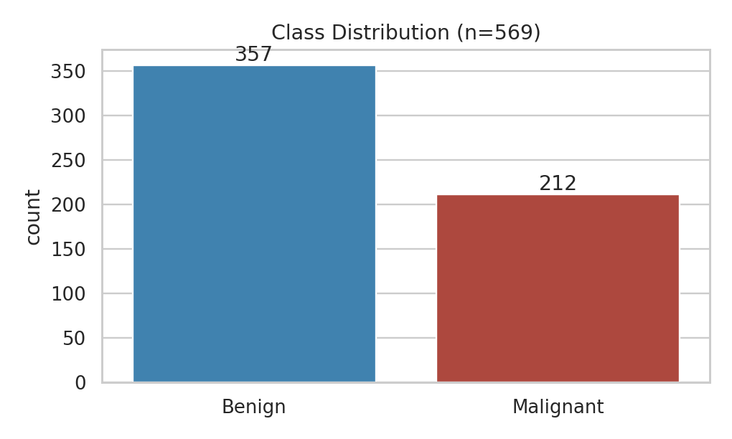
Figure 1: Class distribution

3.4 Summary statistics (selected features)
Feature | Mean | Std | Min | Median | Max
Mean radius | 14.13 | 3.52 | 6.98 | 13.37 | 28.11
Mean texture | 19.29 | 4.30 | 9.71 | 18.84 | 39.28
Mean area | 654.89 | 351.91 | 143.50 | 551.10 | 2501.00
Mean concavity | 0.09 | 0.08 | 0.00 | 0.06 | 0.43

Mean area has a standard deviation (351.9) more than half its mean (654.9) and its maximum (2501) is 4.5× the median (551.1), which signals strong right skew. Skewness is highest for "area error" (5.45), "concavity error" (5.11) and "fractal dimension error" (3.92).
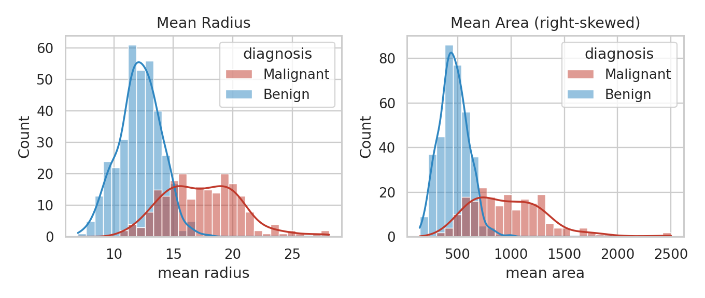
Figure 2: Distribution of mean radius and mean area by diagnosis

4. Data Cleaning and Preprocessing
Issue | Check performed | Result / action
Missing values | isna().sum() | 0 found – no imputation required
Duplicates | duplicated().sum() | 0 found – nothing removed
Data types | df.dtypes | All numeric; target mapped to labels (0 = Malignant, 1 = Benign) for readable plots
Inconsistent values | min/max range check | No negative sizes; mean concavity min = 0.00 is a valid value (smooth, convex nuclei)
Outliers | IQR rule (Q1 − 1.5·IQR, Q3 + 1.5·IQR) | Flagged, analysed, retained (see below)
Scale differences | Mean area ≈ 655 vs smoothness ≈ 0.10 | StandardScaler applied (mean 0, std 1) before modelling

Outlier analysis
Using the IQR rule, the features with most outliers are area error (65 rows), radius error (38), perimeter error (38), worst area (35), smoothness error (30) and compactness error (28). For mean area the upper fence is 1326.3; 25 records exceed it (4.4% of the data), with the largest value at 2501.
Key decision: all 25 mean-area outliers are malignant cases. These are genuine large tumours rather than data-entry errors, so removing them would delete clinically meaningful information and bias the analysis towards benign cases. They were therefore retained, and a scaler plus a regularised model were used to limit their influence.

5. Exploratory Data Analysis

5.1 Benign vs malignant comparison
Feature (mean) | Benign | Malignant | Ratio | Difference
Mean radius | 12.15 | 17.46 | 1.44× | +43.8%
Mean area | 462.79 | 978.38 | 2.11× | +111.4%
Mean concavity | 0.046 | 0.161 | 3.49× | +249.1%
Mean concave points | 0.026 | 0.088 | 3.42× | +242.1%
Mean texture | 17.92 | 21.61 | 1.21× | +20.6%
Mean smoothness | 0.092 | 0.103 | 1.11× | +11.3%

Concavity-related and size-related features show the largest gaps, while smoothness differs only slightly (11%).
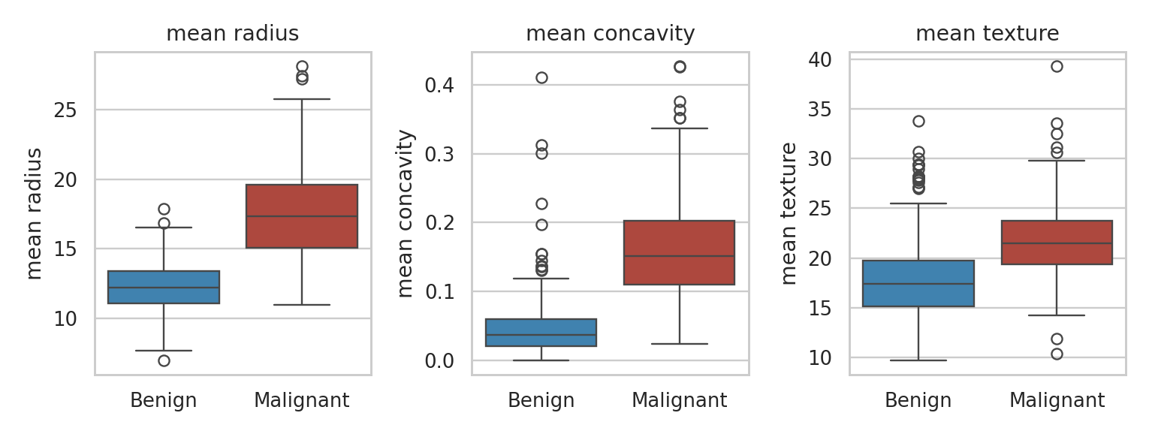
Figure 3: Box plots of key features by diagnosis

5.2 Statistical test
A Welch two-sample t-test on mean radius gives t = 22.21 and p ≈ 1.7 × 10⁻⁶⁴, so the difference between groups is overwhelmingly statistically significant. Cohen's d = 2.05, a very large effect (> 0.8 is considered large).

5.3 Correlation analysis
- Redundant features: radius–perimeter r = 0.998; radius–area r = 0.987; concavity–concave points r = 0.921.
- Strongest correlations with diagnosis: worst concave points (−0.794), worst perimeter (−0.783), mean concave points (−0.777), worst radius (−0.776), mean perimeter (−0.743). Negative values mean higher readings go with malignancy (benign = 1).
- Weakest: texture error (0.008), mean fractal dimension (0.013) and smoothness error (0.067) are almost uncorrelated with diagnosis.
- Multicollinearity: 21 feature pairs exceed |r| = 0.90.
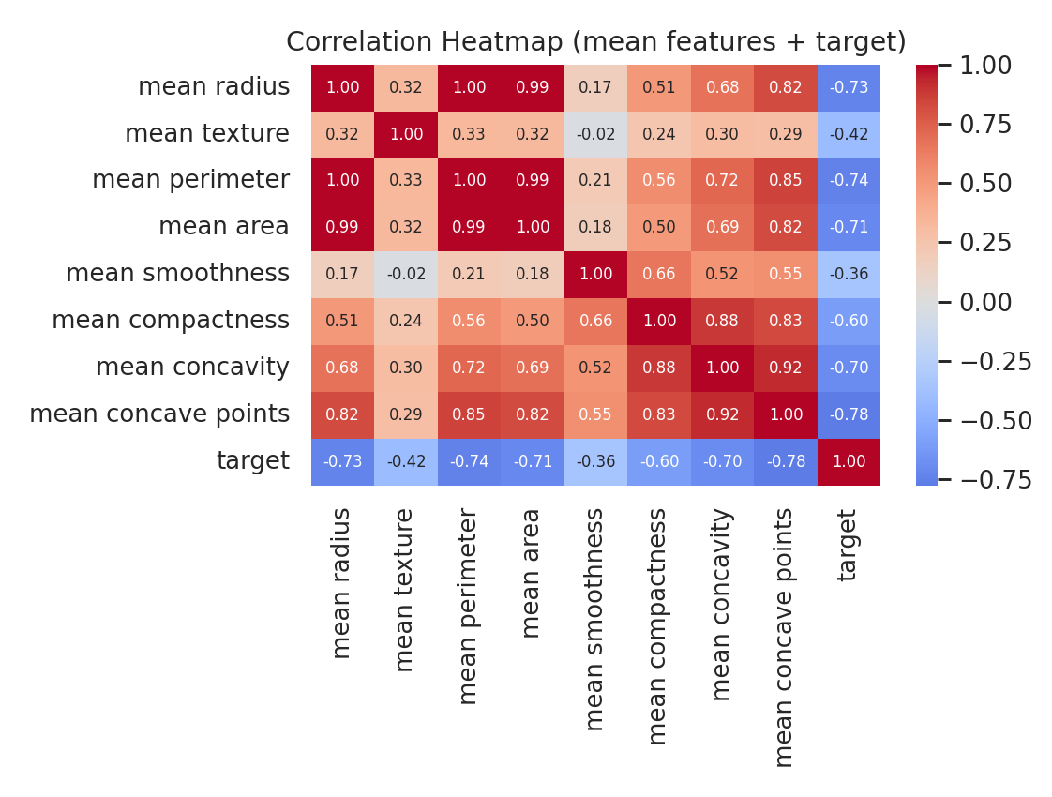
Figure 4: Correlation heatmap
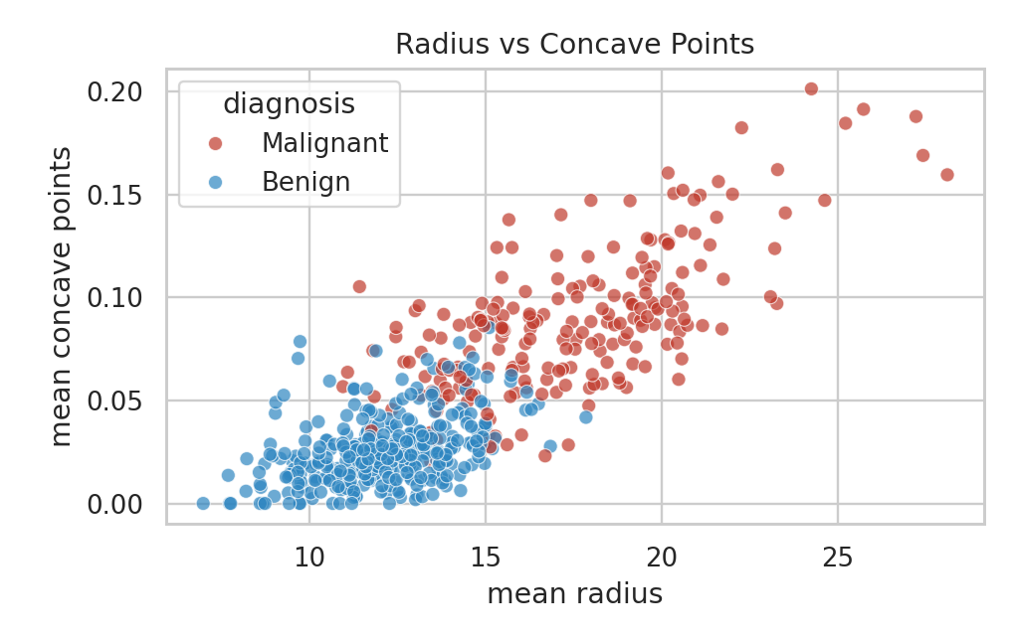
Figure 5: Mean radius vs mean concave points – the two classes form fairly distinct clusters

6. Baseline Modelling (Validation of Findings)
To check that the patterns found are useful, a logistic regression (with StandardScaler) was trained on an 80/20 stratified split (random_state = 42).
Metric | Result
Test accuracy | 98.2%
Malignant recall (sensitivity) | 97.6%
Malignant precision | 97.6%
5-fold cross-validation accuracy | 98.1%

The consistency between test (98.2%) and cross-validated (98.1%) accuracy suggests the model is not overfitting and that the features identified in the EDA carry strong signal.

7. Key Findings and Interpretation
- Size and shape matter most. Malignant nuclei are larger (radius 17.46 vs 12.15) and have far more irregular boundaries (concavity 0.161 vs 0.046).
- Many features are redundant. Radius, perimeter and area move together (r ≥ 0.987), so using all three adds little information.
- Outliers are informative. All 25 extreme mean-area values belong to malignant tumours.
- Classification is highly feasible. A simple linear model reaches 98.2% accuracy, so the classes are close to linearly separable.
- Some features add noise. Texture error, mean fractal dimension and smoothness error show |r| < 0.07 with diagnosis and are candidates for removal.

8. Conclusions
The Wisconsin Breast Cancer dataset is clean (0 missing values, 0 duplicates) and well suited to classification. Differences between malignant and benign samples are large and statistically significant (p ≈ 10⁻⁶⁴), and are concentrated in nucleus size and concavity features.

9. Recommendations
- Reduce dimensionality: use PCA or drop one feature from each pair with |r| > 0.90 to reduce multicollinearity from 30 features to a smaller set.
- Focus on top features: prioritise worst concave points, worst perimeter, worst radius and mean concavity.
- Optimise for recall: because missing a malignant case is costlier than a false alarm, tune the decision threshold to maximise recall rather than accuracy alone.
- Compare models: try Random Forest or Gradient Boosting and compare with the 98.1% cross-validated baseline; report a confusion matrix and ROC-AUC.
- Validate externally: this dataset has 569 samples from a single source, so results should be validated on external data before any real-world use.

10. Methodology Summary
Workflow: (1) load data → (2) inspect shape, dtypes, missing values, duplicates → (3) IQR outlier detection → (4) group comparison, Welch t-test, correlation analysis → (5) visualisation with Matplotlib/Seaborn → (6) standardisation and baseline logistic regression → (7) interpretation. All numbers in this report were computed directly from the data using Pandas, NumPy, SciPy and scikit-learn.

