ANALYTICS REPORT
Analytics Report & Insights Documentation
Business Performance Analysis, Insights and Recommendations
Reporting period: FY2025 (Jan – Dec)
Prepared for: Executive Leadership Team
Prepared by: Analytics Team
Date: October 24, 2026
Note: This report uses illustrative sample data (a multi-region retail business) to demonstrate the full reporting framework. Replace figures, charts and commentary with your own dataset before distribution.

Table of Contents

1. Business Objectives

1.1 Business Problem
Revenue grew steadily through FY2025, yet profitability did not keep pace. Leadership needs to understand where growth is coming from, why margin declined, and which regions and categories deserve investment or corrective action going into FY2026.

1.2 Reporting Requirements
- Scope: Single, consistent view of revenue, cost, margin, orders and customer metrics.
- Granularity: Monthly granularity, with comparisons by region, product category and customer segment.
- Cadence: Quarterly executive review; this report serves as the annual baseline.

1.3 Key Questions
- How did revenue and margin trend across the year, and what drove the changes?
- Which regions and categories over- or under-performed?
- Are customers becoming more or less valuable and loyal?
- Which actions would most improve profit in FY2026?

1.4 Stakeholders and Expectations
Stakeholder | Primary Interest | Expectation
CEO / Executive Team | Overall performance and strategic direction | One-page summary, clear priorities
Finance (CFO) | Margin, cost and forecast accuracy | Reconciled, auditable figures
Sales & Regional Heads | Regional and category performance | Drill-downs and clear targets
Marketing | Customer acquisition and retention | Segment and campaign insight

1.5 Success Metrics
KPI | Definition | Target Direction
Revenue | Total net sales (USD) | Growth vs prior year
Gross margin % | (Revenue – COGS) / Revenue | Maintain or improve
Average order value | Revenue / orders | Increase
Repeat purchase rate | Customers with 2+ orders / all customers | Increase

2. Data and Methodology

2.1 Data Sources
Dataset | Description | Source
Sales transactions | 412K order lines, Jan–Dec 2025 | ERP / order system
Product master | Category, cost, price | Merchandising database
Customer records | Segment, region, first-order date | CRM
Marketing spend | Monthly spend by channel | Finance ledger

2.2 Data Preparation
- Removed duplicate order lines and cancelled or test orders.
- Standardized region, category and date fields across systems.
- Handled missing values (<0.8% of records) by exclusion for revenue metrics.
- Reconciled totals with the finance general ledger (variance under 0.3%).

2.3 Analytical Approach
The analysis combined descriptive statistics, year-over-year and month-over-month trend comparison, segmentation by region, category and customer cohort, and contribution (variance) analysis to isolate the drivers of margin change.

3. Data Analysis and Key Findings

3.1 Performance Dashboard
$58.6M  Total Revenue  +11.4% YoY | 27.8%  Gross Margin  -1.9 pts YoY | 412K  Orders  +6.2% YoY | $142  Avg. Order Value  +4.9% YoY

Figures are illustrative.

3.2 Revenue and Cost Trend
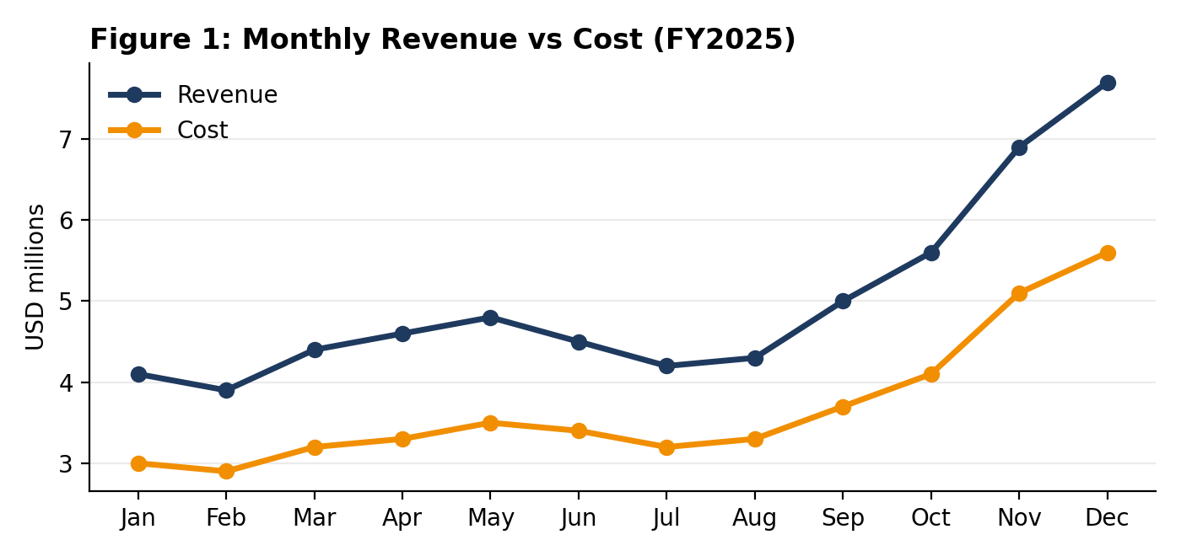
- Seasonality: Revenue grew steadily from Q1 to Q2, dipped over summer, then accelerated into Q4, peaking at $7.7M in December.
- Cost pressure: Cost grew faster than revenue in Q4 (promotional discounts and expedited shipping), compressing margin.
- Concentration: Q4 produced 35% of annual revenue, creating dependency on the holiday season.

3.3 Regional Performance
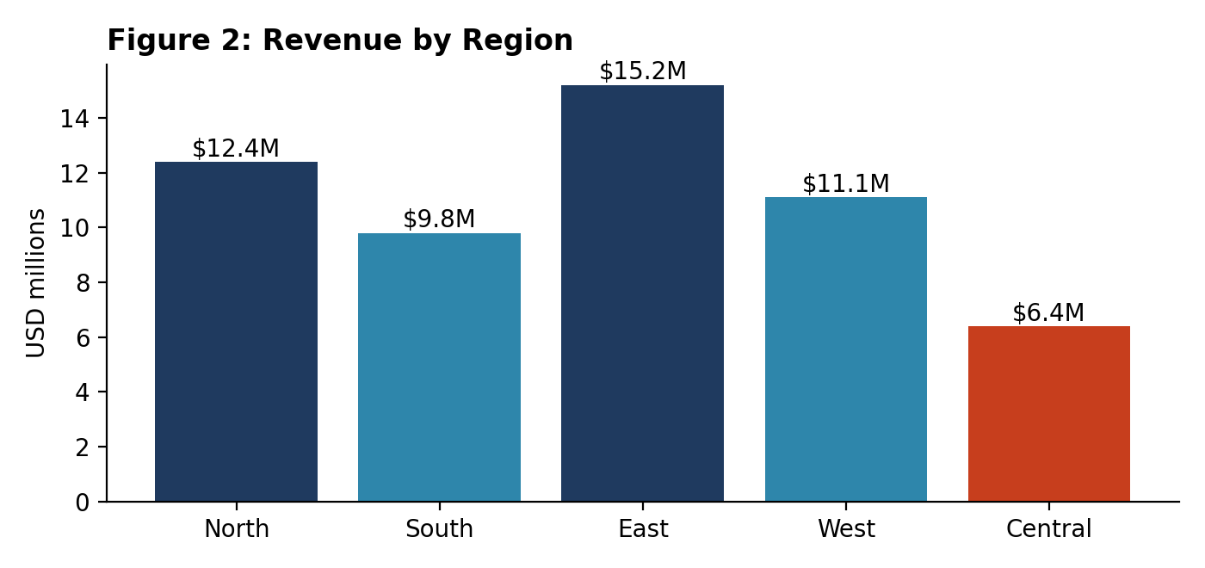
- Leaders: East ($15.2M) and North ($12.4M) generated 47% of total revenue.
- Laggard: Central contributed only $6.4M and is the clear underperformer.
Region | Revenue | YoY Growth | Gross Margin | Status
North | $12.4M | +12.8% | 29.1% | On track
South | $9.8M | +8.1% | 27.4% | Moderate
East | $15.2M | +14.6% | 28.3% | Strong
West | $11.1M | +10.2% | 27.9% | Stable
Central | $6.4M | +1.9% | 23.5% | Needs attention

3.4 Category Profitability
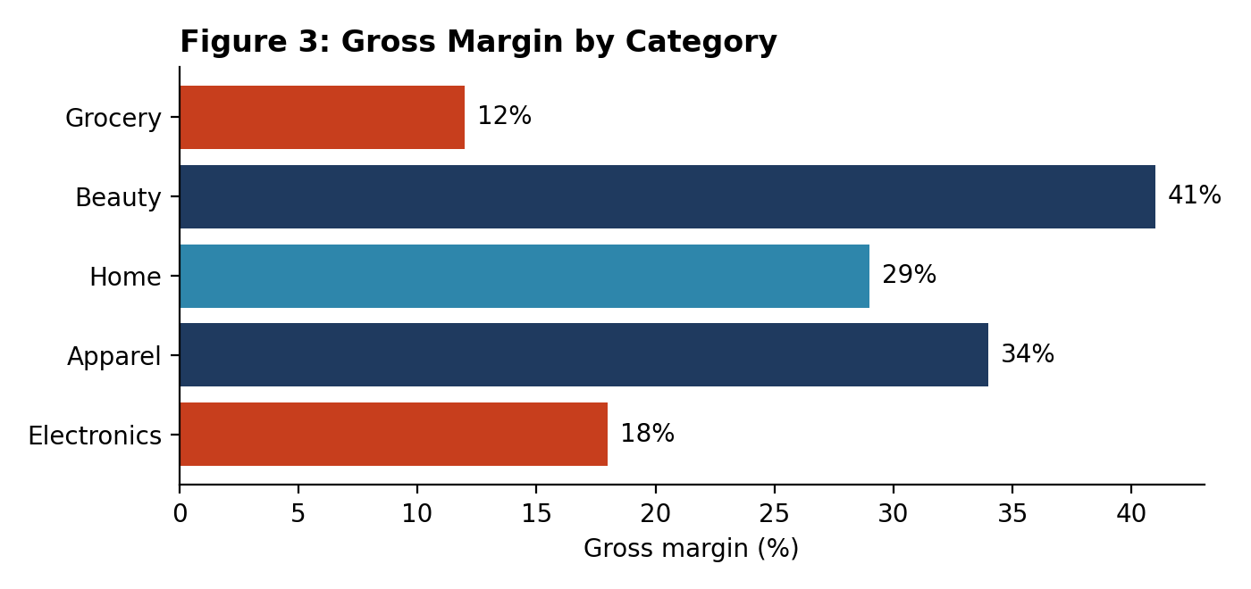
- High margin: Beauty (41%) and Apparel (34%) are the most profitable categories.
- Low margin: Electronics (18%) and Grocery (12%) generate high volume but thin margin and contributed most of the overall margin decline.

3.5 Customer Behavior
Metric | FY2025 | FY2024 | Change
Repeat purchase rate | 34% | 37% | -3 pts
New customers | 118K | 109K | +8.3%
Avg. order value | $142 | $135 | +4.9%
Customer acquisition cost | $38 | $31 | +22.6%

Acquisition grew, but at a notably higher cost, and repeat purchasing weakened, indicating that growth relied on paid acquisition rather than loyalty.

3.6 Areas Requiring Attention
- Gross margin fell 1.9 points due to category mix and Q4 discounting.
- Central region growth is nearly flat and margin is 4+ points below average.
- Rising acquisition cost and falling repeat rate threaten long-term profitability.

4. Business Insights

4.1 What the Results Mean
Finding | Contributing Factors | Potential Business Impact
Margin erosion | Mix shift toward low-margin Electronics and Grocery, plus heavier Q4 promotions | Each 1 pt of margin is worth roughly $0.6M annually
Regional gap | Central has weaker store coverage and lower category breadth | Closing half the margin gap adds about $0.15M
Loyalty decline | Growth driven by discount-led new customers with low repeat intent | Higher long-term acquisition cost, volatile revenue
Seasonal dependence | One-third of revenue lands in one quarter | Supply and cash-flow risk if peak underperforms

4.2 Factors Influencing Performance
- Internal: Pricing and discount policy, especially during Q4 campaigns.
- Operational: Product mix, supply-chain costs and fulfillment speed.
- External: Consumer demand shifts, competitor promotions and inflation.
Key insight: Growth is real but low quality. Revenue is rising because of volume and paid acquisition, while profit per sale and customer loyalty are declining. Improving mix, discount discipline and retention matters more than adding further volume.

5. Executive Summary
Objective | Evaluate FY2025 business performance, explain the decline in profitability, and identify priorities for FY2026.
Headline result | Revenue reached $58.6M (+11.4% YoY) but gross margin declined to 27.8% (-1.9 points).
Major findings | East and North drive growth; Central underperforms. Beauty and Apparel are profitable; Electronics and Grocery dilute margin. Customer acquisition cost rose 22.6% while repeat rate fell to 34%.
Key insight | Growth is volume- and promotion-led rather than profit- or loyalty-led.
Conclusion | The business is healthy at the top line but needs margin and retention actions to turn growth into sustainable profit.

6. Actionable Recommendations
# | Recommended Action | Expected Impact | Priority | Owner
1 | Reduce deep Q4 discounts; shift to targeted offers | Recover ~1 pt of margin (~$0.6M) | High | Pricing and Marketing
2 | Rebalance mix: promote Beauty and Apparel; renegotiate Electronics and Grocery supplier terms | Improve category margin by 2-3 pts | High | Merchandising
3 | Launch loyalty and retention program | Lift repeat rate from 34% to 40% | High | Marketing and CRM
4 | Central region turnaround plan (assortment, coverage, pricing) | Close half the margin gap | Medium | Regional Head
5 | Optimize acquisition channels; cut lowest-ROI spend | Reduce CAC toward $32 | Medium | Marketing
6 | Build monthly KPI dashboard with alerts | Earlier detection of margin drift | Medium | Analytics / BI

6.1 Implementation Roadmap
Timeline | Key Activities | Deliverables
0-30 days | Approve discount guardrails; assign owners; launch KPI dashboard design | Policy sign-off, dashboard spec
30-90 days | Supplier renegotiations; retention program pilot; Central diagnostic | Pilot results, new terms
90-180 days | Scale loyalty program; execute Central plan; reoptimize channel mix | Margin and repeat-rate gains

6.2 Next Steps and Further Analysis
- Run A/B tests on discount levels to quantify price elasticity.
- Build a customer lifetime value model by acquisition channel.
- Develop a demand forecast to smooth Q4 inventory and cash-flow risk.
- Review progress at the next quarterly business review.

6.3 Assumptions and Limitations
- Figures in this document are illustrative sample data and must be replaced with actual results.
- Impact estimates are directional and should be validated with Finance before commitments.
- Correlation between factors does not by itself prove causation.

