PROJECT REPORT
ON
PhonePe Transactions Analytics Dashboard
A Multi-Page Power BI Dashboard for Digital Payments Transaction Analysis
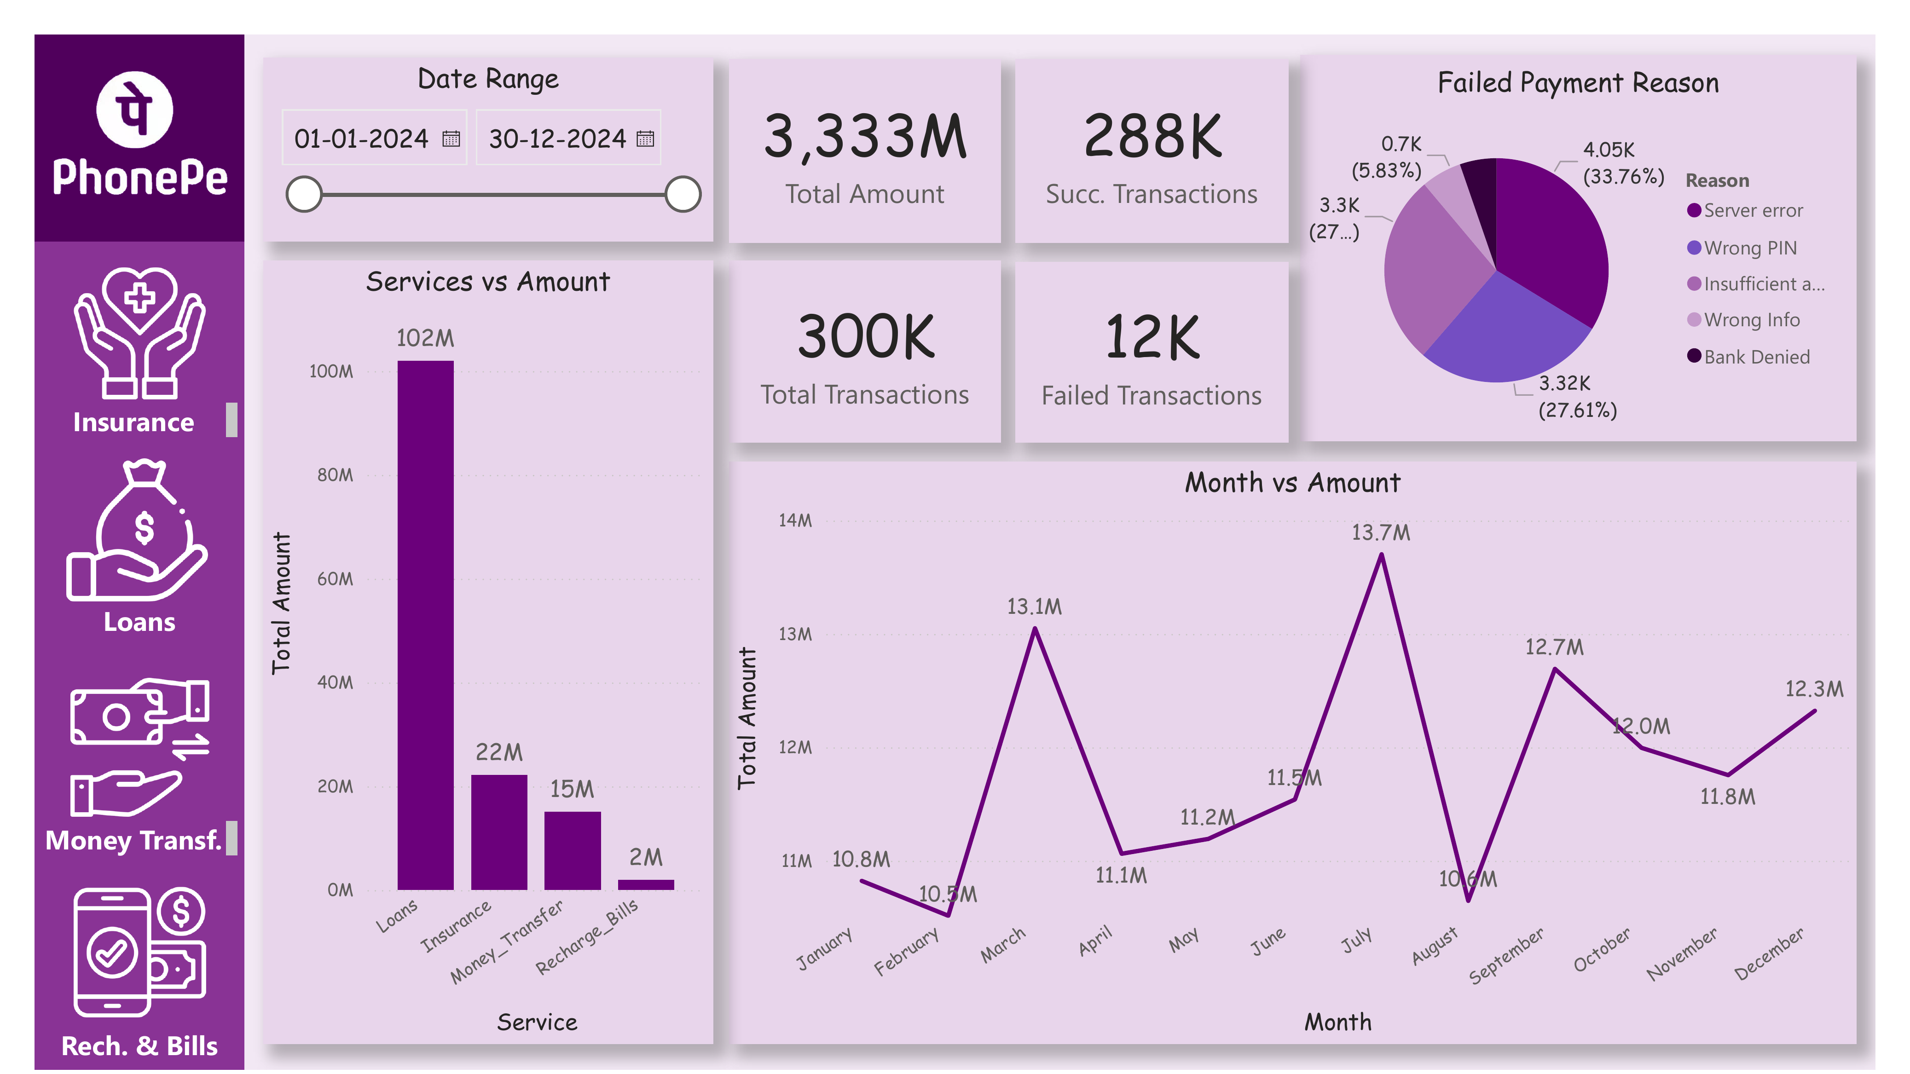
Submitted by:
Rinku Kumar Sharma
[Roll No.:23FSTUIUJDD10042]
THE ICFAI UNIVERSITY, JAIPUR
Jun 2026

Table of Contents
1. Executive Summary
2. Literature Review / Existing Approaches
3. Requirement Analysis
4. Introduction
5. Technology Stack
6. Dataset Description
7. System Design and Data Flow
8. Features and Functionality
9. UI/UX Design
10. Implementation Details
11. Testing
12. Service-wise Comparative Analysis
13. User Manual
14. Challenges Faced and Solutions
15. Conclusion and Future Scope
16. Appendix A: Dataset Summary
17. Appendix B: DAX Measures Reference
18. Glossary of Terms
19. References

1. Executive Summary
This report documents the design, development, and analysis of the "PhonePe Transactions Analytics Dashboard" — a multi-page interactive data visualization project built using Power BI Desktop. The dashboard analyzes a synthetically generated but realistically structured dataset of 300,000 digital payment transactions made by over 107,000 users across four core service lines: Insurance, Loans, Money Transfer, and Recharge & Bills.
The objective of this project is to convert a large, granular transaction log into a clear, navigable, multi-page business intelligence report that allows a viewer to understand overall platform health, service-wise transaction volume, payment success and failure patterns, and monthly trends — all without needing to query the raw dataset directly.
The project follows a complete Business Intelligence (BI) workflow: consolidating raw transaction and user data from six linked Excel sheets, importing and modeling this data within Power BI, designing five purpose-built report pages (one Overview page and one page per service), and applying a consistent, brand-inspired visual theme throughout. Interactivity is provided through a global Date Range filter and a navigation sidebar allowing the user to move between service-specific pages.
This report is organized to walk the reader through every stage of the project — from the motivation and requirements behind the dashboard, through the technology stack and dataset structure, to a detailed, screenshot-supported walkthrough of every page and visual. Later sections cover implementation details, testing performed, service-wise comparative insights, a short user manual, challenges encountered, and a conclusion outlining future enhancements. Appendices provide dataset summaries, DAX measure references, and a glossary of terms.
Overall, this project demonstrates practical, end-to-end competency in handling large transactional datasets, multi-table data modeling, dashboard information architecture, and analytical storytelling across multiple linked report pages — directly relevant to real-world fintech and payments analytics roles.

2. Literature Review / Existing Approaches
Before designing this dashboard, existing approaches to presenting digital payments and fintech transaction data were reviewed to identify design patterns and gaps.

2.1 In-App Transaction Histories
Digital payment apps such as PhonePe, Google Pay, and Paytm present transaction data to end users as chronological, per-transaction lists. This view is well suited to an individual user checking their own recent activity, but it does not support platform-wide analysis — a business stakeholder cannot use this view to understand aggregate volume, success rates, or category-wise trends across all users.

2.2 Internal Fintech Analytics Dashboards
Payment companies typically maintain internal BI dashboards (built on tools such as Power BI, Tableau, or custom internal tools) that aggregate transaction data across millions of users. These are usually organized by business vertical (payments, lending, insurance) with drill-down capability, and are the closest real-world analogue to this project's page-per-service structure.

2.3 Public Fintech Reports
Publicly released fintech transaction reports (such as periodic UPI transaction volume reports published by NPCI) present highly aggregated, static, national-level statistics — useful for macro trend awareness but with no interactivity or user/service-level granularity.

2.4 Identified Gap and Design Response
The common gap is the absence of a single, interactive, service-segmented view that a non-technical stakeholder could use to explore transaction volume and failure patterns without needing a data analyst to prepare a custom report each time. This dashboard's five-page, filter-driven design was chosen specifically to close that gap using data made available for this project.

3. Requirement Analysis

3.1 Functional Requirements
- The system shall provide a platform-wide Overview page summarizing total transaction amount, total/successful/failed transaction counts, and service-wise amount distribution.
- The system shall provide a dedicated page for each of the four services — Insurance, Loans, Money Transfer, and Recharge & Bills.
- Each service page shall display a Payment Status breakdown (Successful vs Failed), a Failed Payment Reason breakdown, a category-wise transaction/amount breakdown, and a month-wise amount trend.
- The system shall allow the user to filter all pages by a global Date Range.
- The system shall provide a persistent navigation sidebar allowing quick switching between service pages.

3.2 Non-Functional Requirements
- Usability: Each page should follow a consistent layout so a user familiar with one page can immediately interpret any other page.
- Performance: The report should remain responsive despite the underlying dataset containing 300,000+ transaction rows.
- Scalability: The data model should be structured so that additional services or months of data can be added without redesigning the report.
- Brand Consistency: The visual theme should reflect PhonePe's purple brand identity to give the dashboard a recognizable, professional appearance.

3.3 Constraints and Assumptions
The dataset used is synthetically generated for portfolio and educational purposes and does not represent real PhonePe user or transaction data. It is assumed to be internally consistent (e.g., totals in the All_Transactions sheet reconcile with the four individual service sheets), which was verified during testing (Section 11).

4. Introduction

4.1 Background
Digital payment platforms process enormous volumes of transactions daily across multiple product lines — payments, transfers, lending, and insurance are increasingly bundled into a single "super-app" experience. This creates both an opportunity and a challenge for analytics: a single transaction log can contain heterogeneous data (a ₹50 recharge and a ₹5,00,000 loan disbursement in the same table), which must be thoughtfully segmented for meaningful analysis.

4.2 Problem Statement
Given a raw, multi-sheet transactional dataset spanning four distinct service categories and hundreds of thousands of records, there was no existing consolidated way to visually monitor platform performance, compare service-wise contribution, or diagnose payment failure patterns without manually filtering and pivoting the raw data in a spreadsheet. This project addresses that gap with a structured, multi-page Power BI dashboard.

4.3 Objective
- To design a platform-wide Overview dashboard summarizing total transaction volume, value, and success/failure rates.
- To build a dedicated analytical page for each of the four core services — Insurance, Loans, Money Transfer, and Recharge & Bills.
- To visualize payment failure reasons on every page, enabling quick diagnosis of operational issues (e.g., server errors, wrong PIN entries).
- To visualize month-wise transaction trends to identify seasonality or growth patterns.
- To apply a consistent, brand-aligned visual design across all five pages.

4.4 Scope
This dashboard covers transaction-level analysis (volume, value, status, category, and time trend) across the four services included in the dataset. It does not currently include user-level demographic analysis (e.g., age-based spending patterns), geographic/location-based analysis, or real-time/live data connectivity — the report operates on a static, periodically refreshed extract.

4.5 Target Audience
This dashboard is designed for business analysts and operations teams monitoring platform health, students and early-career analysts demonstrating multi-table BI modeling skills, and recruiters or academic evaluators assessing dashboard design and data storytelling across a realistically-sized dataset.

4.6 Methodology Overview
The project followed a standard BI development lifecycle: (1) reviewing and understanding the six-sheet source workbook, (2) importing and relating the data within Power BI, (3) defining calculated measures for each page's KPIs, (4) designing a consistent five-page layout and navigation structure, (5) building and styling each visual, and (6) testing and validating totals against the source data. Each stage is elaborated in the sections that follow.

5. Technology Stack

5.1 Tools and Technologies
Component | Technology Used | Purpose
Visualization Tool | Power BI Desktop | Building the interactive, multi-page dashboard
Data Source | Microsoft Excel (.xlsx) | Storing transaction and user data across 6 linked sheets
Data Transformation | Power Query Editor | Cleaning, filtering, and shaping data before loading
Data Modeling | Power BI Data Model / DAX | Defining relationships and calculated measures
Chart Types Used | Card, Pie Chart, Bar Chart, Area/Line Chart, Slicer, Navigation Buttons | Representing KPIs, distributions, and trends
File Format | .pbix | Native Power BI project file for the dashboard

5.2 Why Power BI
Power BI was chosen for its ability to handle a dataset of this scale (300,000+ rows) smoothly on standard hardware using its in-memory VertiPaq engine, its native multi-page report canvas which suited the one-page-per-service design requirement, and its free desktop tier, which keeps the project accessible for academic and portfolio use without licensing cost.

5.3 Why a Multi-Sheet Excel Source
The source data was structured as six separate but related sheets — a master transaction log, a user directory, and four service-specific detail sheets — mirroring how a real payments company might structure normalized transactional data. This structure was preserved rather than flattened, to demonstrate realistic multi-table data modeling within Power BI rather than a single flat file.

6. Dataset Description
The dataset used for this dashboard, Phonepe-Final-Dataset.xlsx, is a synthetically generated but realistically structured transactional dataset spanning the year 2024.

6.1 Sheet-by-Sheet Overview
Sheet | Rows | Key Fields | Description
All_Users | 107,658 | User_ID, Name, Age, Join_Date | Master directory of all platform users
All_Transactions | 300,000 | Transaction_ID, Amount, User_ID, Service, Service Type, Payment_Status, Reason, Date | Consolidated log of every transaction across all services
Insurance | 50,000 | Insurance_Type, Premium, Payment_Status, Reason | Insurance premium transactions
Loans | 50,000 | Loan_Type, Loan_Amount, Payment_Status, Reason | Loan-related transactions
Money_Transfer | 150,000 | Transfer_Type, Amount, Payment_Status, Reason | Peer-to-peer money transfer transactions
Recharge_Bills | 50,000 | Recharge_Type, Amount, Payment_Status, Reason | Utility recharge and bill payment transactions

6.2 Category Breakdown by Service
- Insurance: Bike, Car, Term Life, Health
- Loans: Gold Loan, Auto Loan, Mutual Funds, Credit Score
- Money Transfer: To UPI ID, To Self Account, To QR Code, To Mobile Number
- Recharge & Bills: Electricity, DTH, Mobile, Cable TV

6.3 Payment Status and Failure Reasons
Every transaction carries a Payment_Status value of either Successful or Failed (represented in the underlying data occasionally by the specific failure reason itself). Across the full dataset, 287,993 transactions (approximately 96%) were successful, and 12,007 (approximately 4%) failed. Failures are attributed to one of five reasons: Server error, Wrong PIN, Insufficient amount, Wrong Info, and Bank Denied — each service page visualizes the distribution of these reasons independently.

6.4 Data Coverage
The dataset spans the full calendar year 2024 (01-01-2024 to 30-12-2024), with total transaction amount across all services of approximately ₹3,333M (₹3.33 billion) and a combined total of 300,000 transactions across 107,658 registered users, whose ages range from 18 to 60 and who joined the platform between August 2023 and August 2025.

6.5 Data Quality and Preparation
Prior to import, the dataset was reviewed to confirm that the four service-specific sheets reconciled correctly with the master All_Transactions sheet — that is, that Insurance, Loans, Money_Transfer, and Recharge_Bills counts and amounts summed to match the corresponding subsets of the master log. Date fields were confirmed to be proper date types (not text) to enable correct month-wise grouping, and category fields (Service Type, Loan_Type, Transfer_Type, Recharge_Type) were checked for consistent spelling and casing to avoid fragmenting categories in the visuals.

7. System Design and Data Flow

7.1 Architecture Overview
Stage | Description
1. Data Collection | Transaction and user data compiled into a six-sheet Excel workbook (Phonepe-Final-Dataset.xlsx).
2. Data Import | All six sheets imported into Power BI Desktop via the Excel workbook connector.
3. Data Cleaning & Transformation | Power Query used to verify data types, standardize category labels, and confirm cross-sheet consistency.
4. Data Modeling | Relationships established between All_Transactions, All_Users, and the four service-detail sheets via shared ID fields.
5. Visualization | Cards, pie charts, bar charts, and line/area charts built per page using Power BI's native visual library.
6. Navigation & Interactivity | A custom sidebar with service icons enables page navigation; a Date Range slicer filters each page's visuals.
7. Publishing / Delivery | Final .pbix file saved and packaged for submission, with static exports (screenshots) generated for documentation.

7.2 Data Flow Diagram (Textual Representation)
Excel Workbook (6 sheets: Users, Transactions, Insurance, Loans, Money Transfer, Recharge & Bills) → Power Query (validation & transformation) → Power BI Data Model (relationships & DAX measures) → 5 Report Pages (Overview + 4 service pages) → Date Range Slicer & Sidebar Navigation → End User.

7.3 Page Layout Design
Every page shares a common structural template to maximize familiarity as the user navigates between pages: a fixed left sidebar for branding and navigation, a Date Range filter panel at the top, one or two headline KPI/summary cards, a Payment Status or category-distribution visual, a Failed Payment Reason pie chart, and a Month vs Amount trend chart occupying the lower-right of the page. The Overview page adapts this template to show a service-wise comparison bar chart in place of a single-service category breakdown.

8. Features and Functionality
This section walks through each page of the dashboard, supported by screenshots taken directly from the built report.

8.1 Sidebar Navigation and Date Range Filter
A fixed purple sidebar, present on every page, displays the PhonePe logo and four navigation icons (Insurance, Loans, Money Transfer, Recharge & Bills), allowing the user to jump directly to any service page. Adjacent to the sidebar, a Date Range control (defaulting to 01-01-2024 – 30-12-2024) lets the user narrow every visual on the page to a custom period.
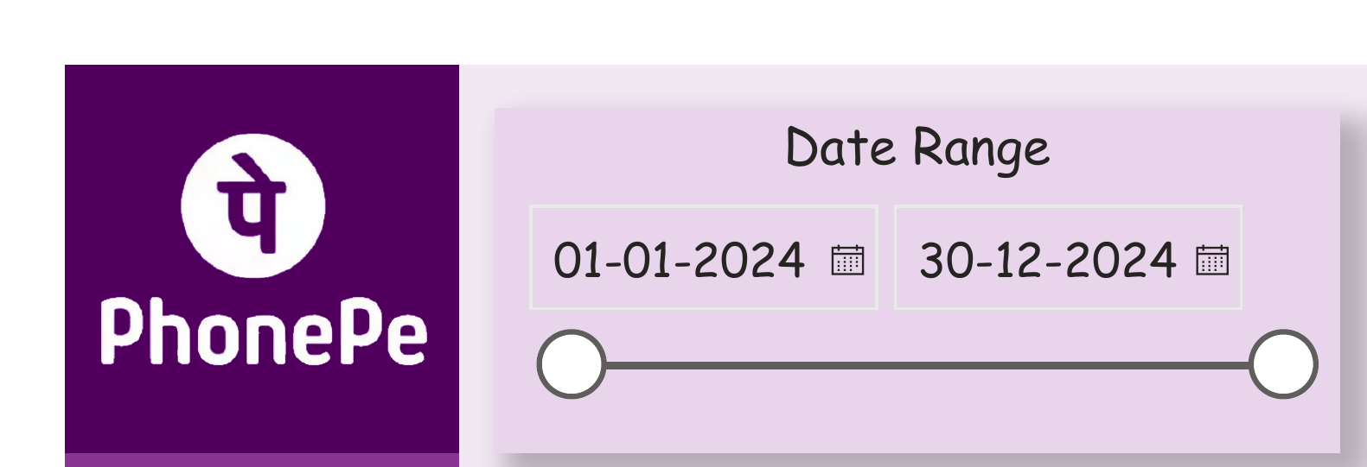
Figure 1: Sidebar navigation and Date Range filter

8.2 Overview Page — Full Layout
The Overview page consolidates platform-wide performance into a single view: the sidebar navigation and Date Range filter, four headline KPI cards, the Failed Payment Reason pie chart, the Services vs Amount bar chart, and the Month vs Amount trend — all visible together below.

Figure 2: Overview page — full dashboard layout

8.3 Overview Page — Platform KPI Cards
The Overview page's four KPI cards summarize platform-wide performance: Total Amount (₹3,333M), Successful Transactions (288K), Total Transactions (300K), and Failed Transactions (12K). These are the first numbers a stakeholder sees, immediately establishing overall platform scale and health.
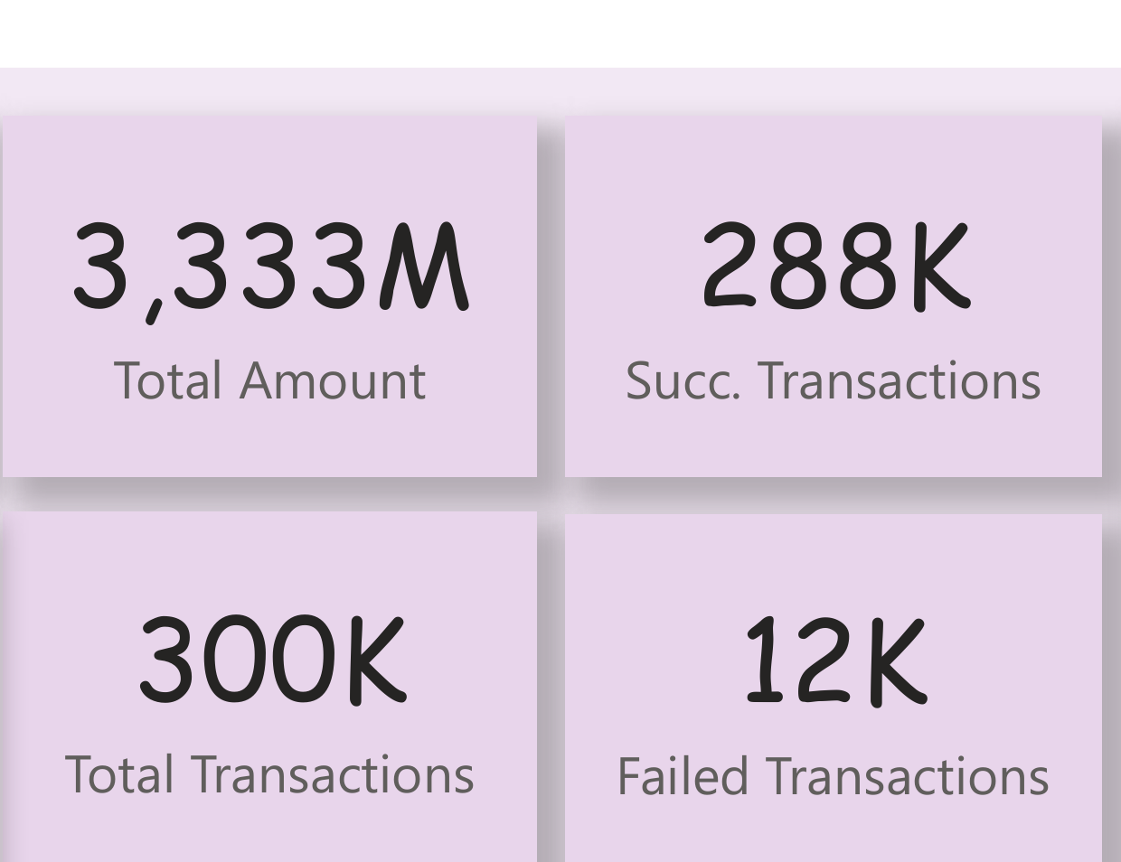
Figure 3: Platform-wide KPI cards on the Overview page

8.5 Failed Payment Reason (Overview)
A pie chart breaks down all 12,007 platform-wide failures by reason: Server error accounts for the largest share (33.76%), followed by Insufficient amount (27.61%), Wrong PIN (~27%), Wrong Info (5.83%), and Bank Denied (a small residual share). This immediately highlights server reliability and user input errors as the two leading causes of failed transactions.
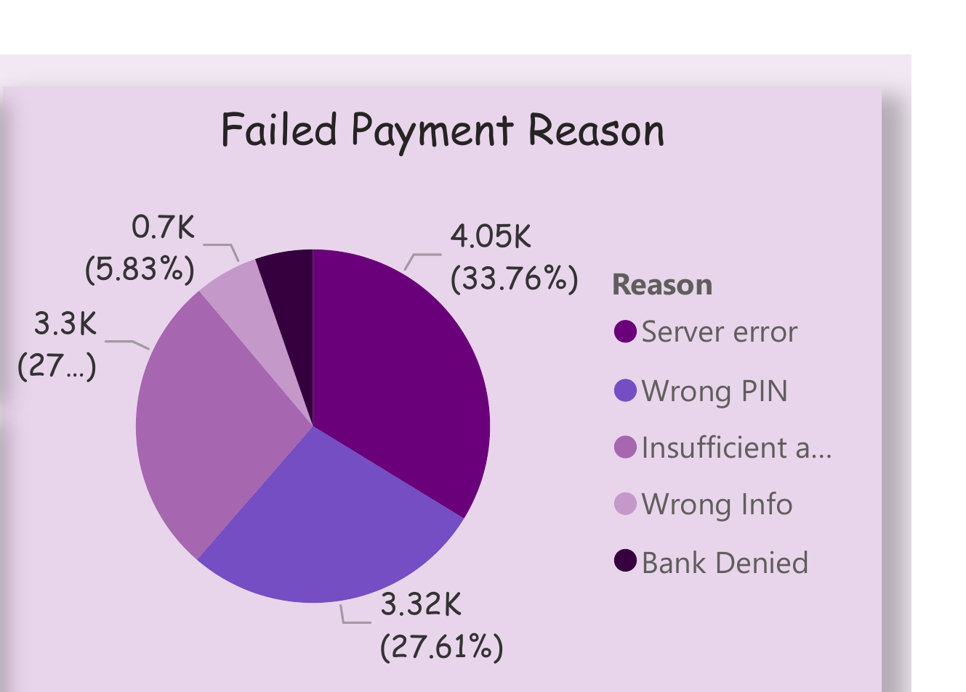
Figure 4: Platform-wide failed payment reason distribution

8.6 Services vs Amount (Overview)
A vertical bar chart compares total transaction amount across the four services. Loans dominates by a wide margin at ₹102M shown at the overview's scaled figures (with the full-precision total at ₹2,532.51M on the dedicated Loans page), followed by Insurance, Money Transfer, and Recharge & Bills — immediately communicating that lending activity represents the platform's largest transaction value contributor.
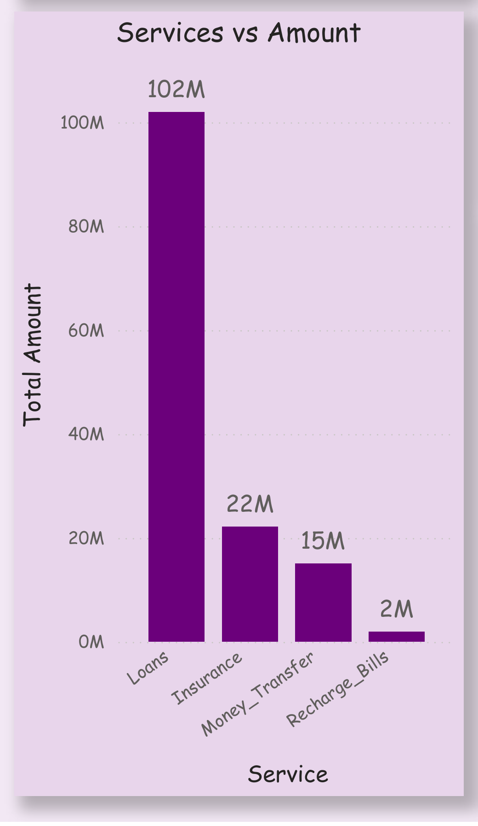
Figure 5: Service-wise transaction amount comparison

8.7 Month vs Amount Trend (Overview)
A line chart tracks total transaction amount for each month of 2024, ranging from a low of approximately ₹10.6M in August to a peak of ₹13.7M in July, with a second local peak in March (₹13.1M). This view is useful for identifying seasonal patterns or one-off spikes worth investigating further.
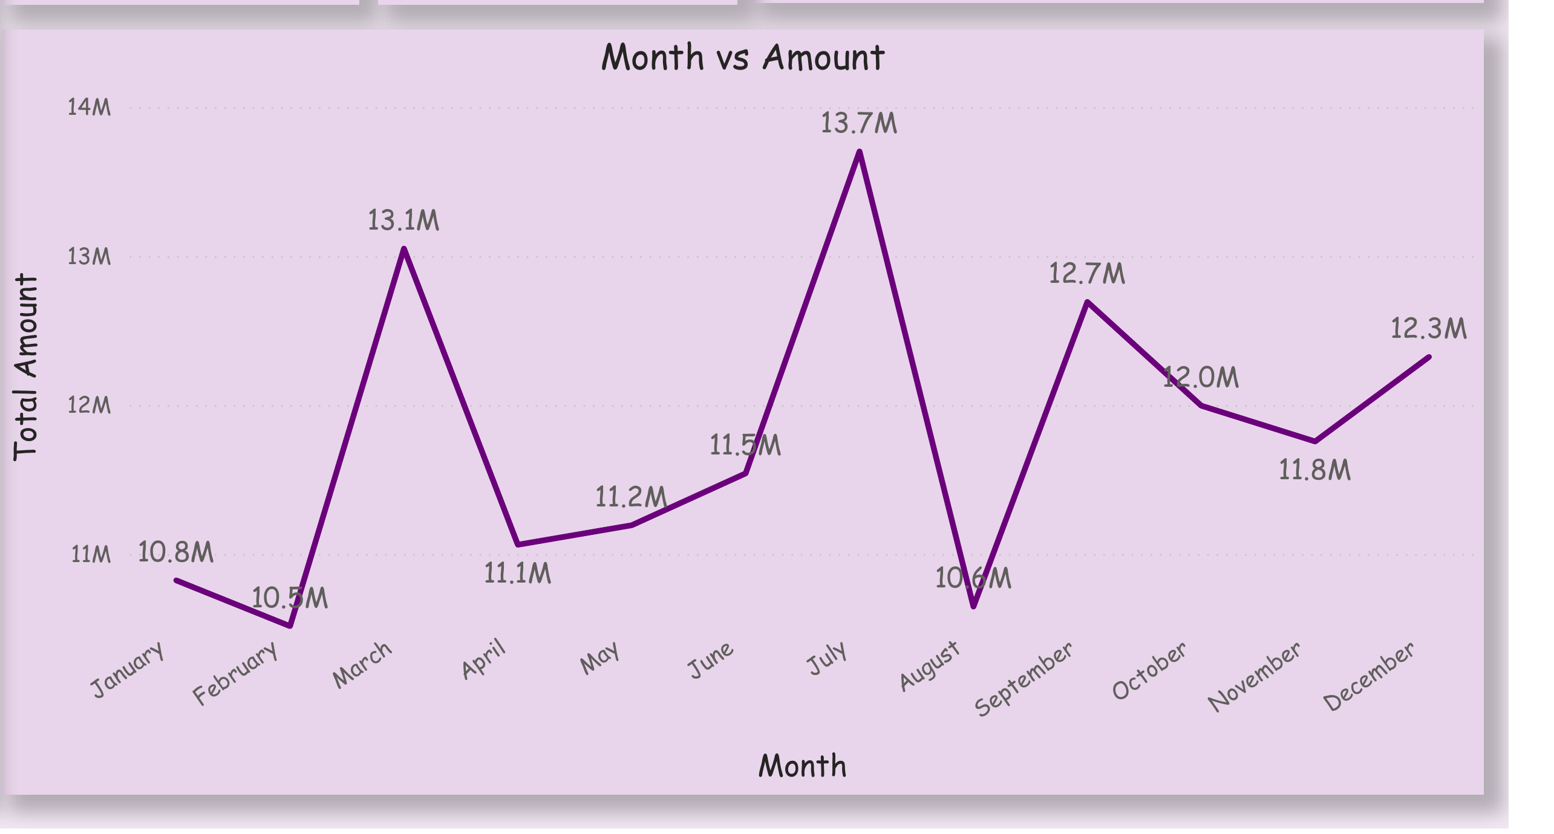
Figure 6: Month-wise transaction amount trend, platform-wide

8.8 Insurance Page
The Insurance page's full layout is shown below, combining the Date Range filter, Total Amount KPI, Payment Status pie chart, Failed Payment Reason pie chart, category-wise breakdown, and Month vs Amount trend in a single consistent template.
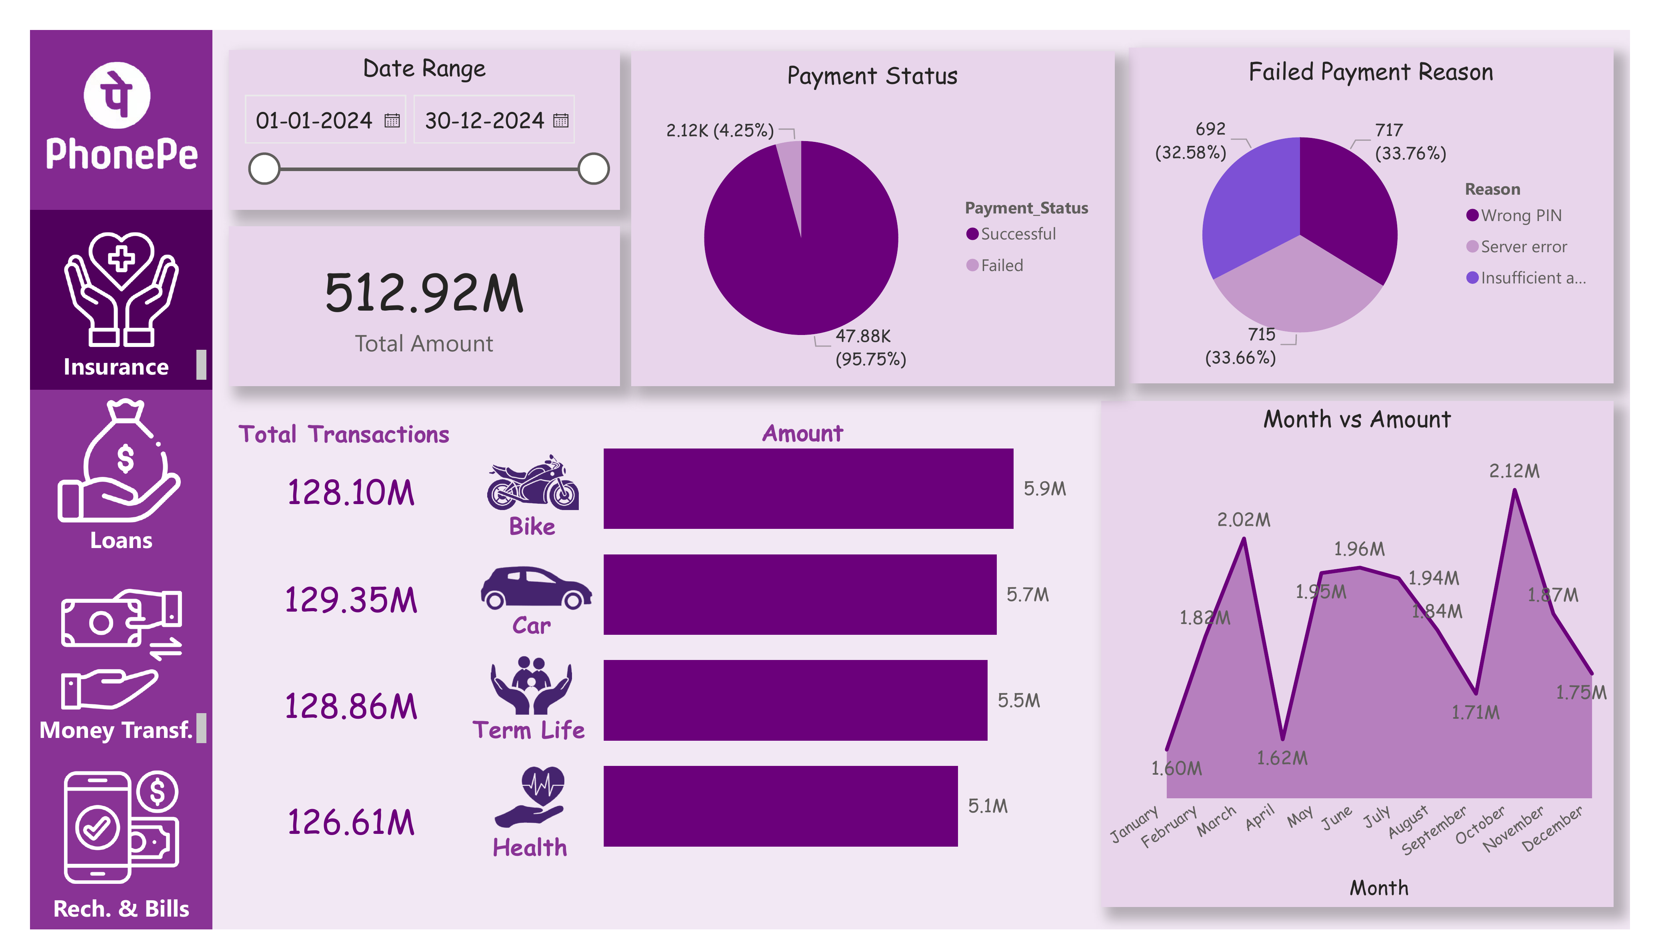
Figure 7: Insurance page — full dashboard layout
The Insurance page reports a Total Amount of ₹512.92M with a 95.75% payment success rate (47,880 successful out of 50,000 transactions). The Failed Payment Reason breakdown here is led by Wrong PIN (33.76%), differing slightly from the platform-wide ranking, which illustrates why a service-specific failure breakdown is valuable in addition to the platform-wide one.
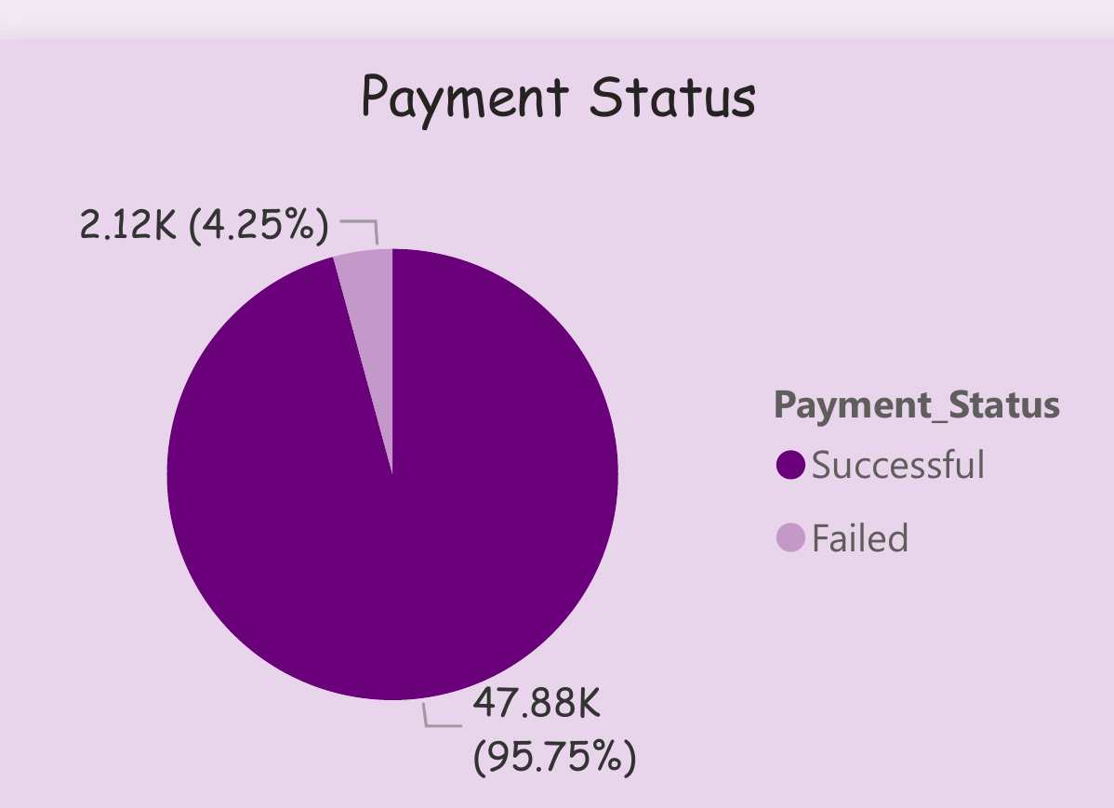
Figure 8: Insurance page — Payment Status breakdown
A horizontal bar breakdown further splits Insurance transactions by policy type: Car leads in transaction count (129.35M scaled units) and Bike, Term Life, and Health follow closely, each contributing between ₹5.1M and ₹5.9M in premium amount.
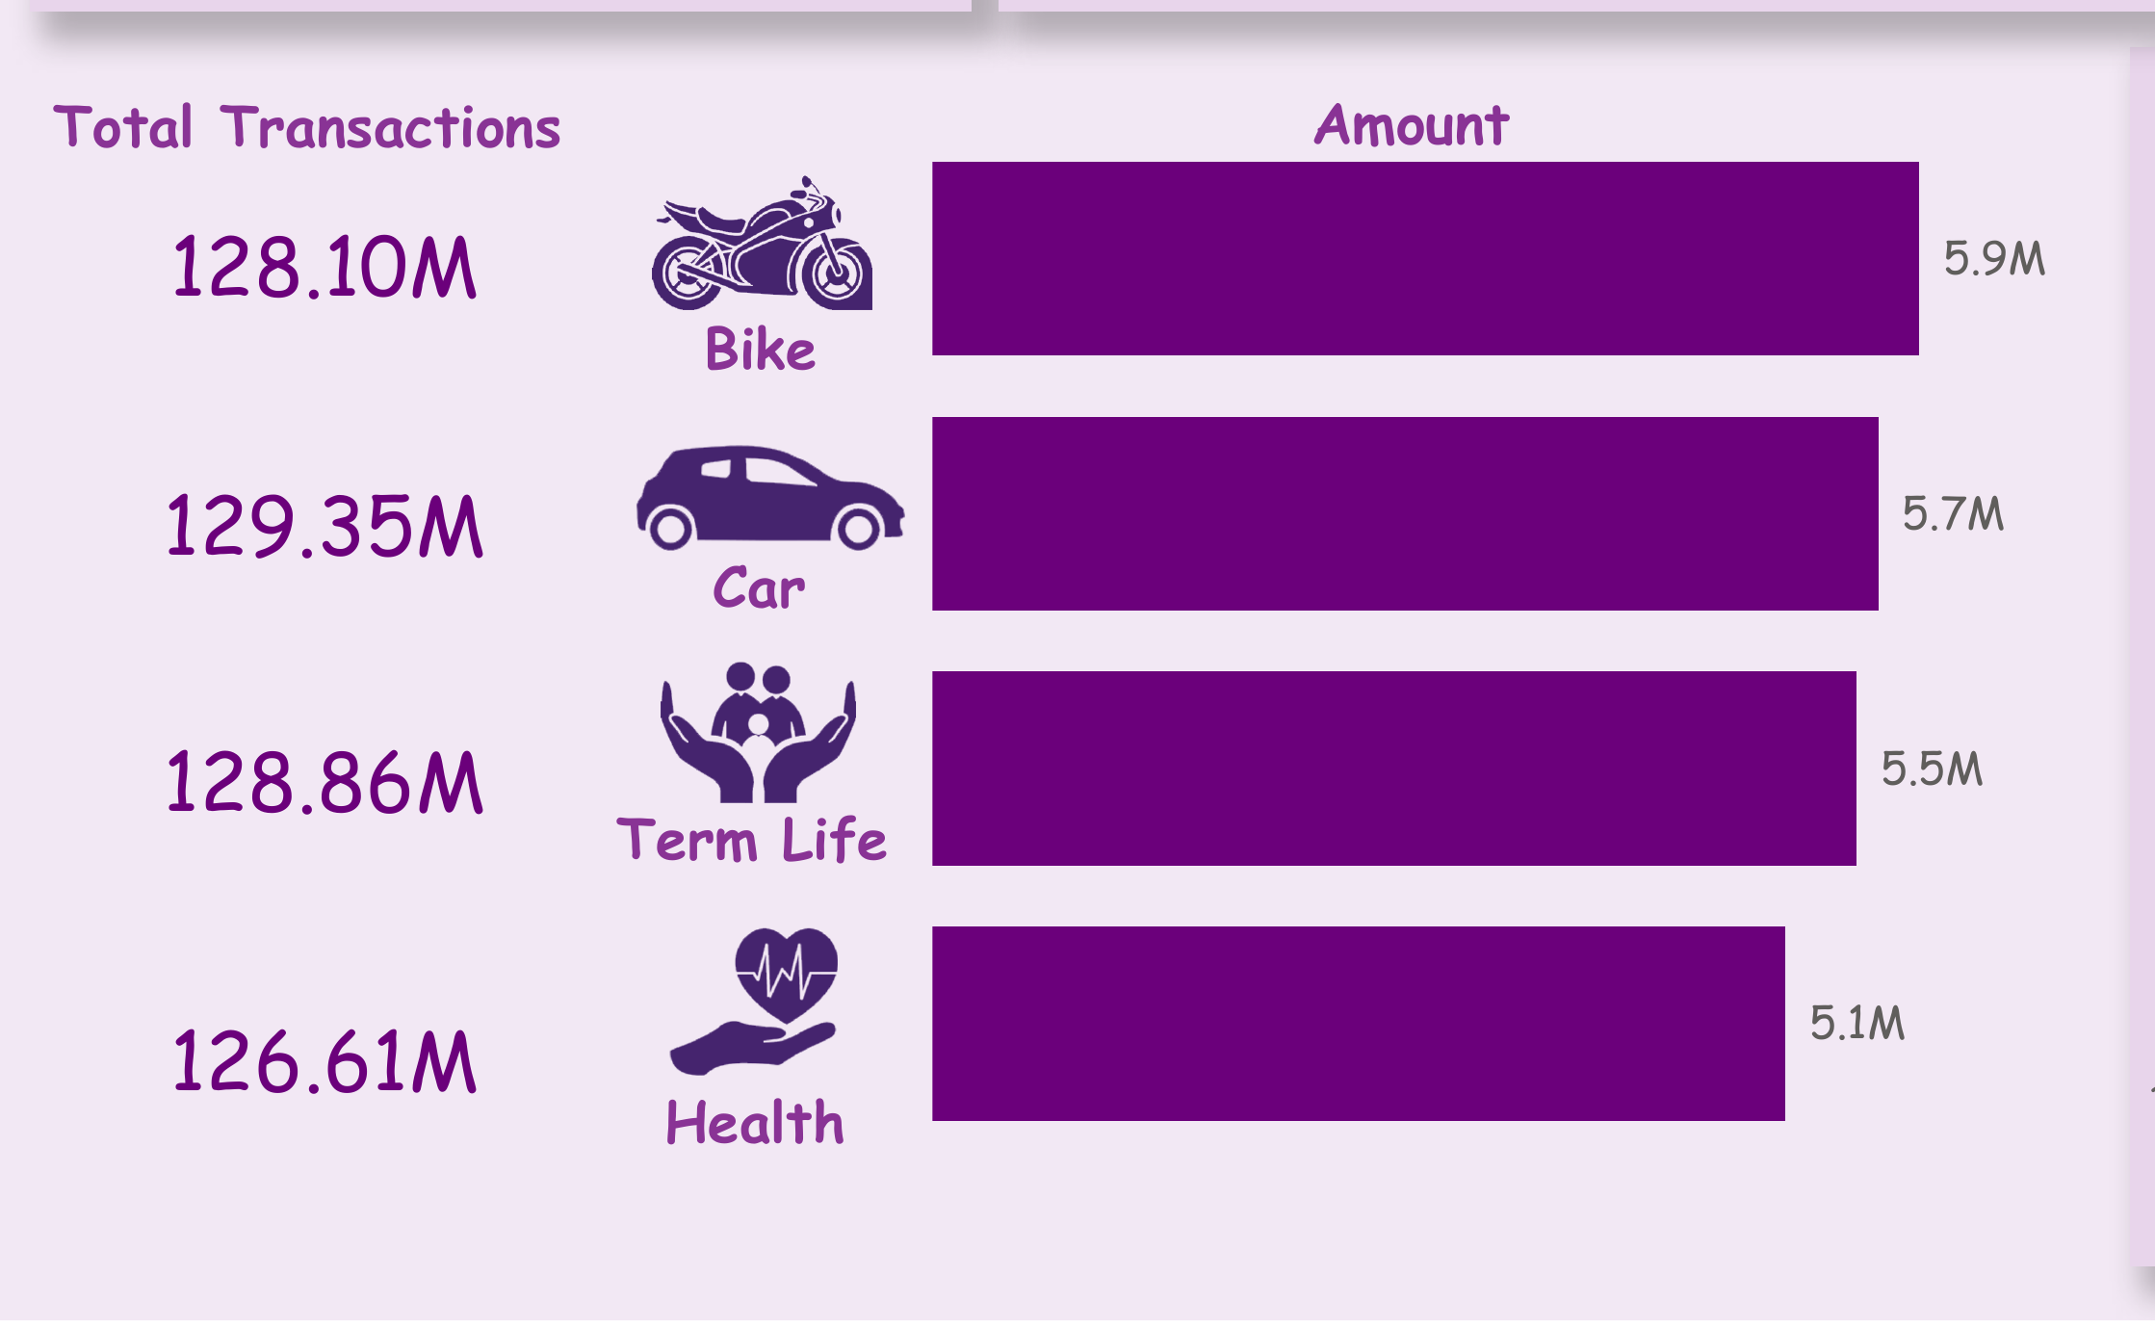
Figure 9: Insurance category-wise transaction and amount breakdown

8.9 Loans Page
The Loans page's full layout is shown below, following the same consistent template used across all service pages.
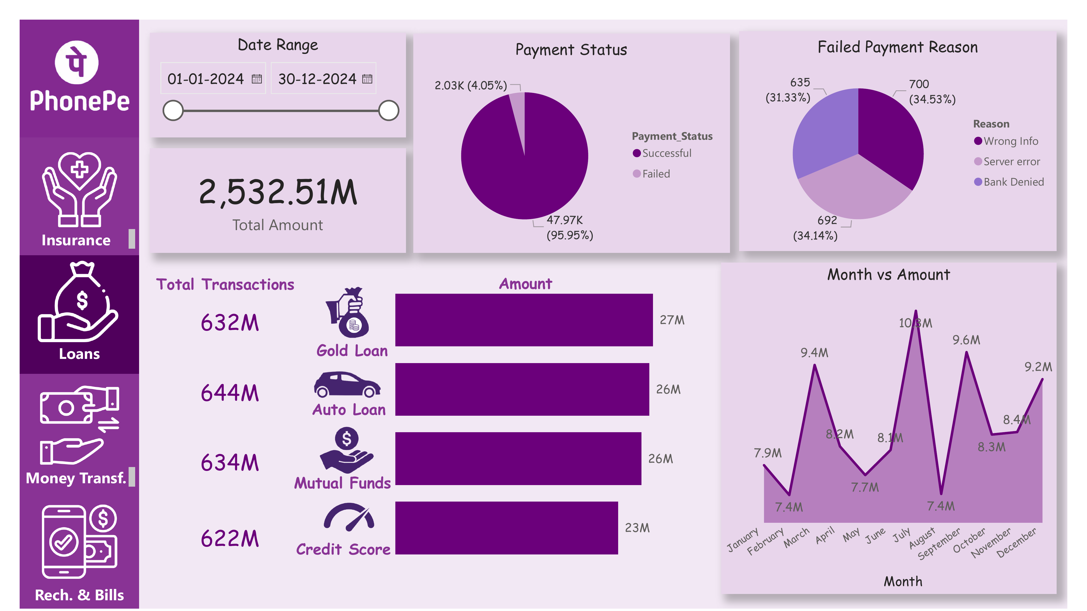
Figure 10: Loans page — full dashboard layout
The Loans page reports the platform's largest service by value — a Total Amount of ₹2,532.51M with a 95.95% success rate. Loan transactions are split across Gold Loan, Auto Loan, Mutual Funds, and Credit Score-linked products, with Auto Loan leading in transaction count (644M scaled units) and all four categories closely clustered in amount (₹23M–₹27M).
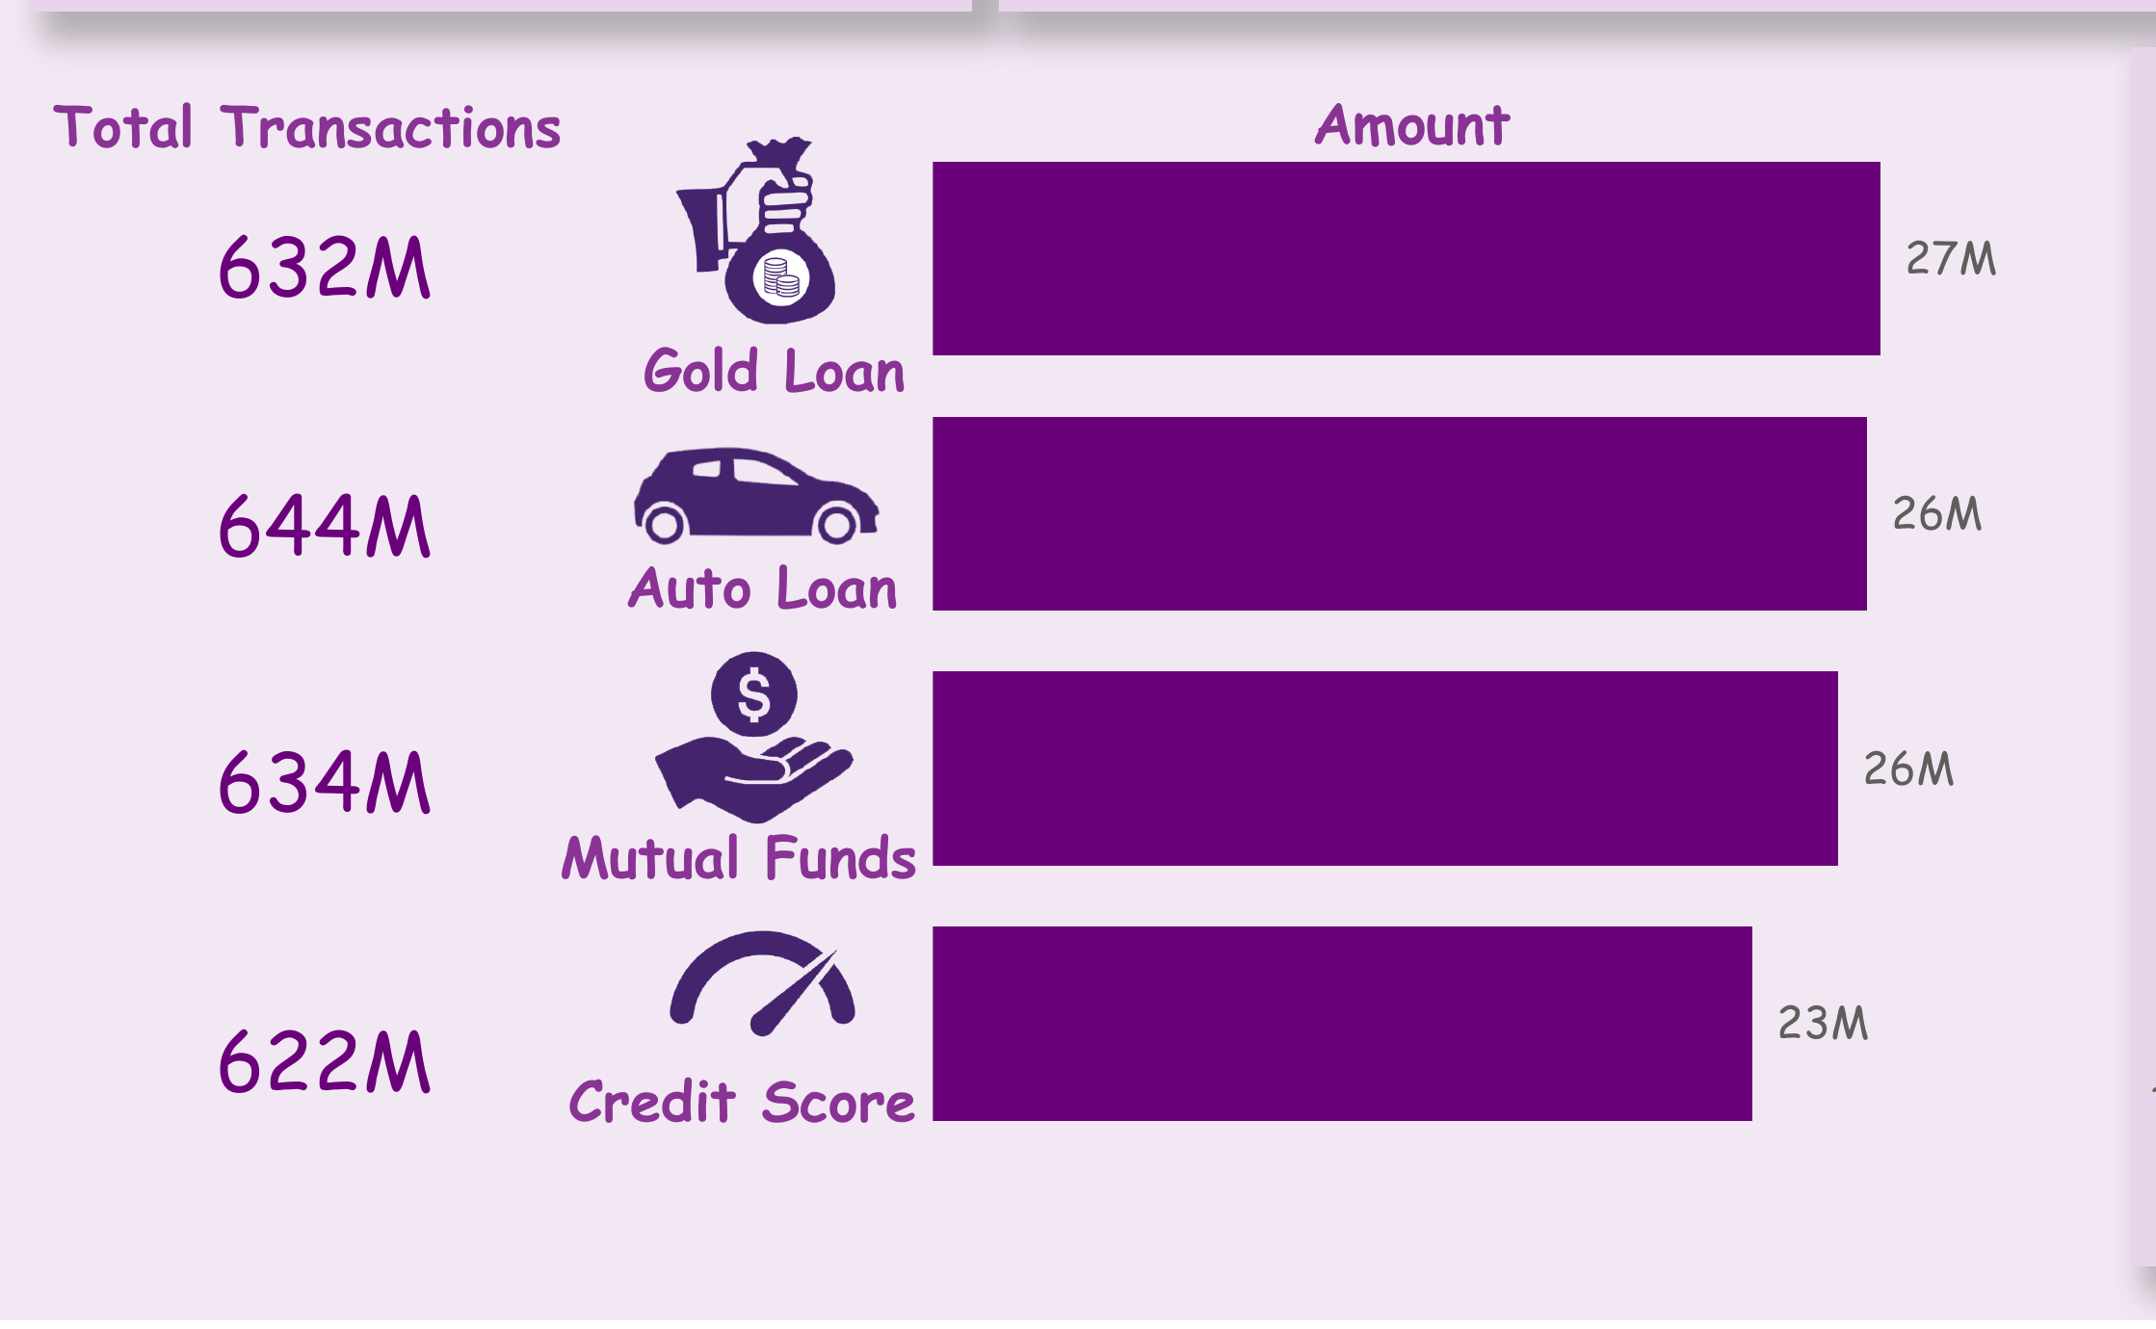
Figure 11: Loans category-wise transaction and amount breakdown
The Loans page's monthly trend shows a distinctive July peak (₹10.3M) followed by a sharp August dip (₹7.4M) — a pattern worth further investigation, potentially linked to seasonal borrowing or disbursement cycles.
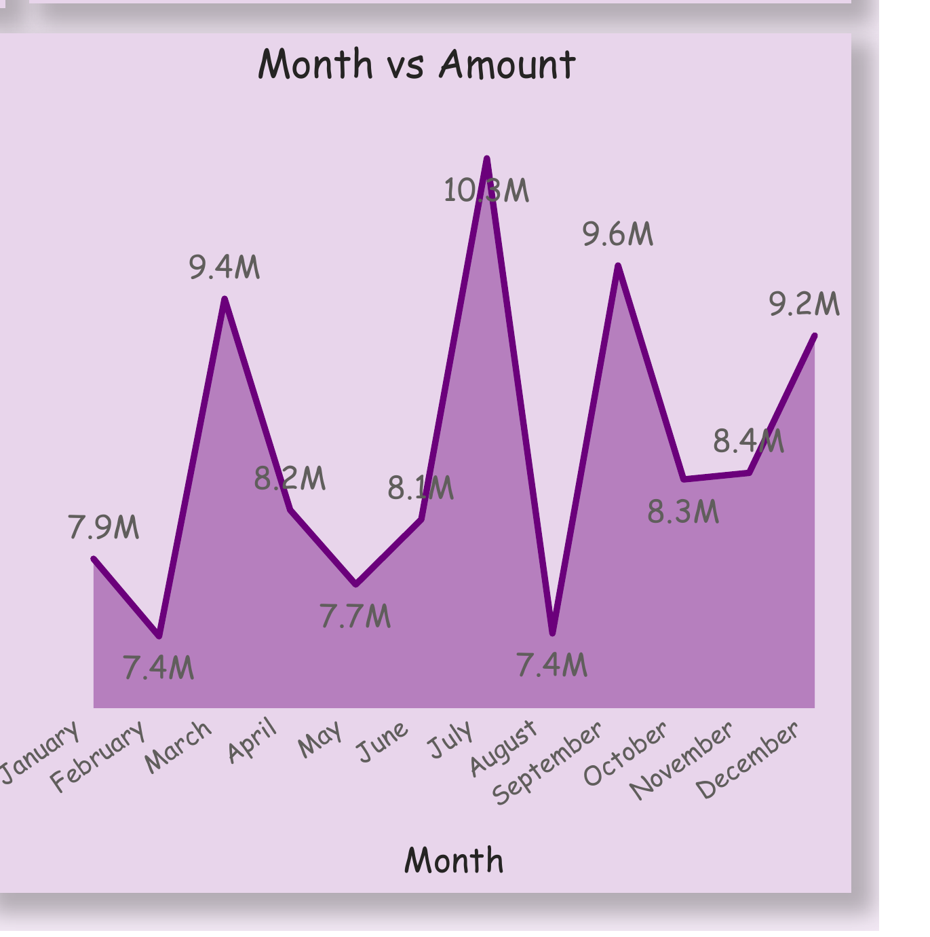
Figure 12: Loans page — Month vs Amount trend

8.10 Money Transfer Page
The Money Transfer page's full layout is shown below.
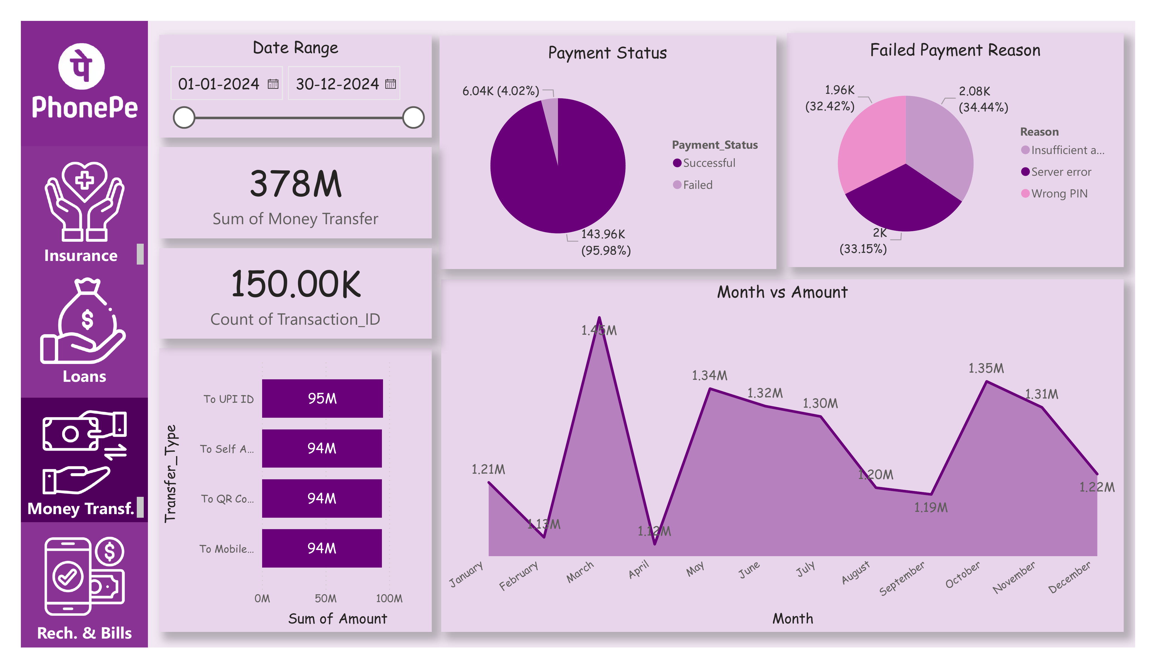
Figure 13: Money Transfer page — full dashboard layout
The Money Transfer page — covering the highest transaction count of any service at 150,000 — reports a Sum of Money Transfer of ₹378M with a 95.98% success rate. Transfers are nearly evenly split across four transfer types: To UPI ID, To Self Account, To QR Code, and To Mobile Number, each contributing roughly ₹94–95M.
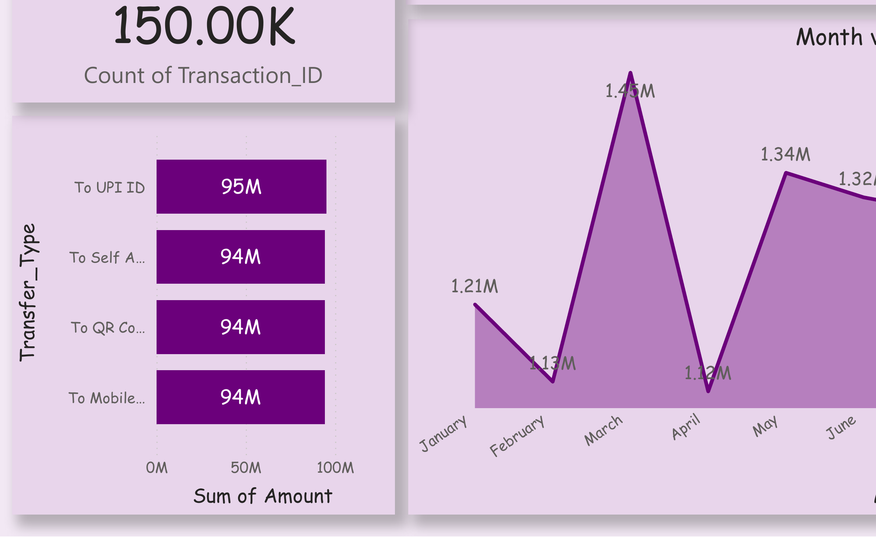
Figure 14: Money Transfer type-wise breakdown

8.11 Recharge & Bills Page
The Recharge & Bills page's full layout is shown below, completing the walkthrough of all five dashboard pages.
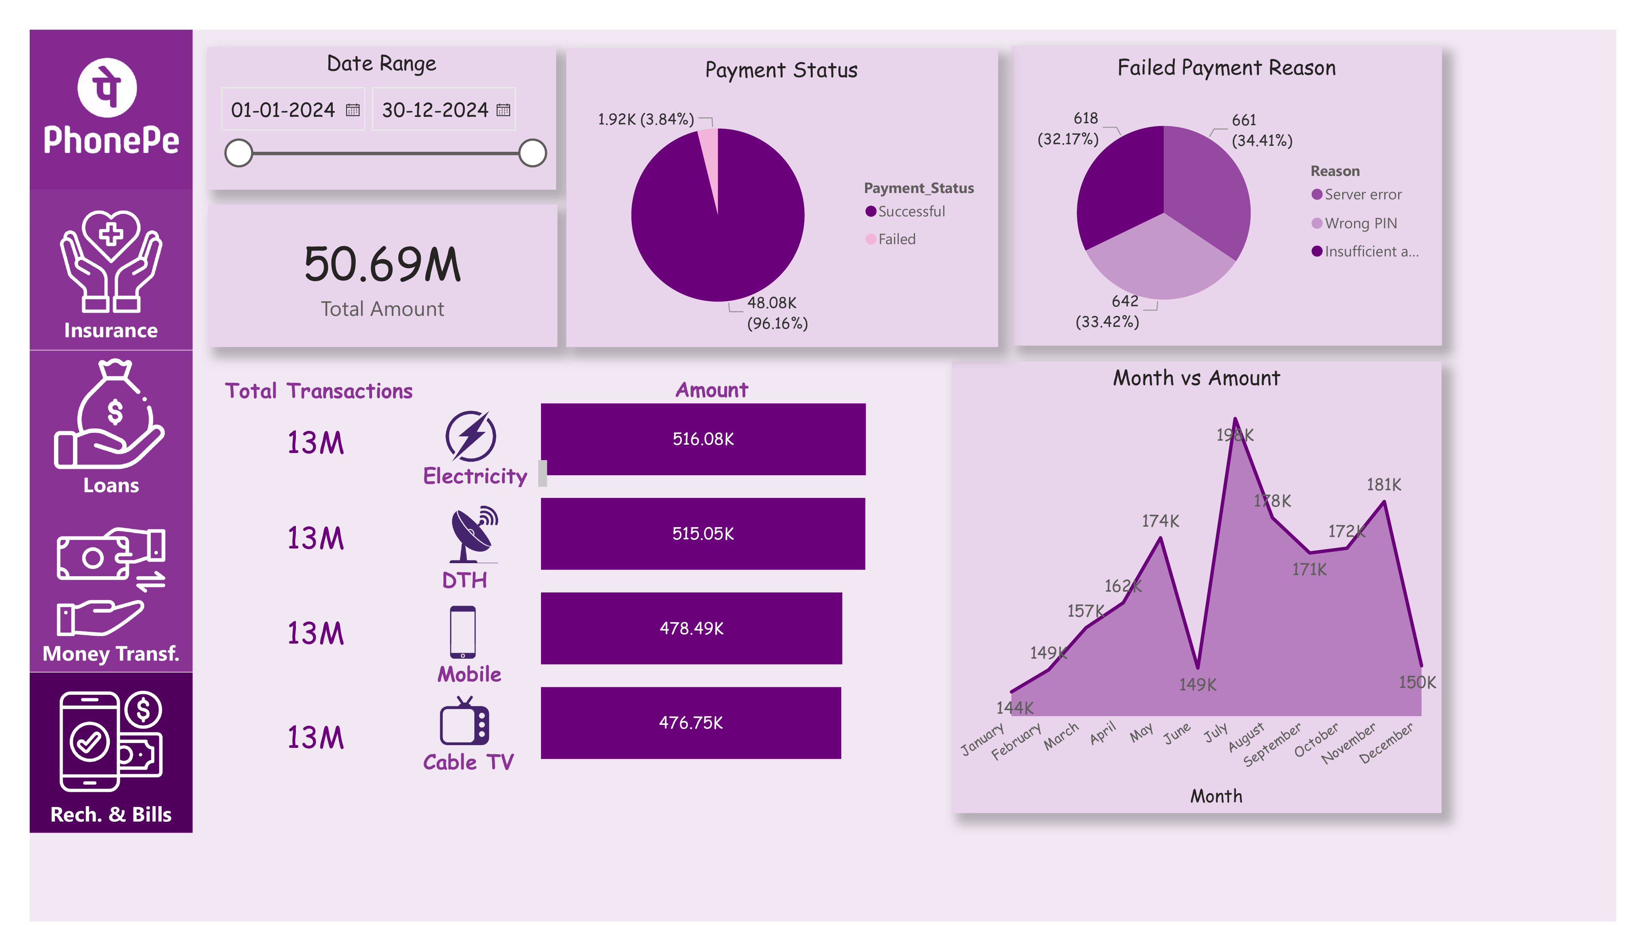
Figure 15: Recharge & Bills page — full dashboard layout
The Recharge & Bills page reports a Total Amount of ₹50.69M — the smallest of the four services by value, consistent with the low per-transaction amounts typical of utility recharges — with a 96.16% success rate, the highest among all four services. Transactions are nearly evenly split across Electricity, DTH, Mobile, and Cable TV categories, each contributing between ₹476K and ₹516K.
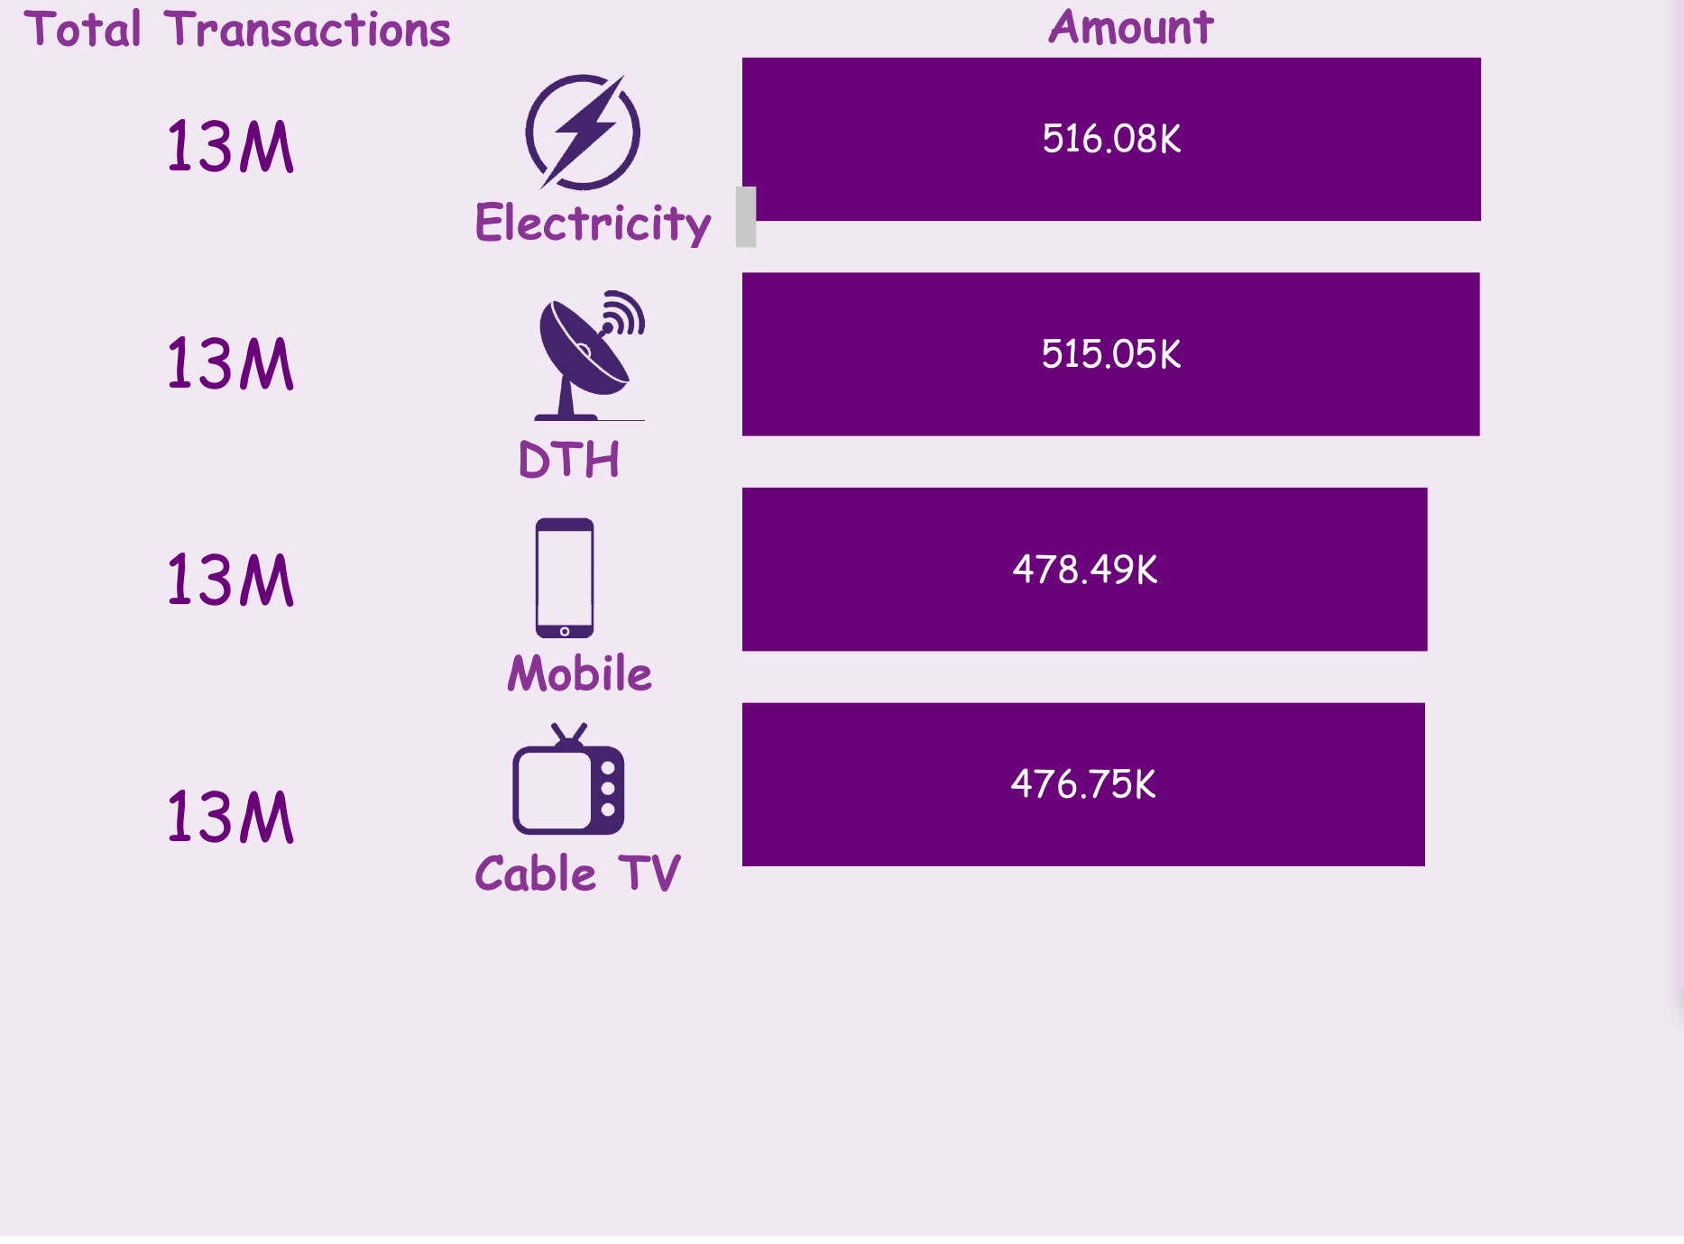
Figure 16: Recharge & Bills category-wise breakdown

9. UI/UX Design

9.1 Visual Theme and Color Palette
The dashboard uses PhonePe's signature purple as its primary brand color, applied to the sidebar, chart accents, and headline text, against a soft lavender background for content panels. This choice was deliberate — using a recognizable brand color immediately signals what platform the dashboard represents and gives the report a polished, product-like appearance rather than a generic BI theme.

9.2 Iconography
Each of the four services is represented by a simple, consistent line icon in the sidebar (a hands/shield icon for Insurance, a money-bag icon for Loans, a two-way arrow icon for Money Transfer, and a mobile-with-checkmark icon for Recharge & Bills), reinforcing navigation and page identity at a glance.

9.3 Layout and Visual Hierarchy
Every page follows the same grid: sidebar navigation on the far left, filters and headline KPIs across the top, and supporting distribution and trend charts below. This consistent template was a deliberate UX decision — once a user learns to read the Overview page, every subsequent service page is immediately familiar, reducing cognitive load when switching between pages.

9.4 Accessibility Considerations
Dark purple text and chart elements are used against light lavender backgrounds throughout, maintaining strong contrast for readability. Pie chart segments are always labeled with both a percentage and an absolute count, so the underlying data remains interpretable even without relying on color differentiation alone.

10. Implementation Details

10.1 Data Preparation
Data validation was performed prior to import to confirm that per-service sheets (Insurance, Loans, Money_Transfer, Recharge_Bills) summed correctly to their corresponding subset of the All_Transactions master sheet. Date fields were explicitly typed to support month-level grouping, and category fields were checked for consistent labeling across sheets.

10.2 Data Modeling
The data model relates the All_Transactions table to All_Users via User_ID, and treats each of the four service-detail sheets as a supplementary source for page-specific category breakdowns (Insurance_Type, Loan_Type, Transfer_Type, Recharge_Type) not present in the flattened master log. This mirrors a realistic star-schema-like structure while remaining simple enough for a project of this scope.

10.3 Measures and Calculations
Page-level KPI cards (Total Amount, Total/Successful/Failed Transactions) are computed as DAX SUM and COUNT measures filtered by the relevant Service value and any active slicer selections. Payment Status percentages are computed by dividing the count of each status by the total transaction count within the current filter context, ensuring percentages always sum to 100% regardless of which Date Range is selected. Failed Payment Reason percentages follow the same pattern, computed only over the subset of failed transactions.

10.4 Interactivity Implementation
The Date Range slicer is bound to the Date field on the All_Transactions table and propagates to every visual on the active page through Power BI's native filter propagation. Page navigation buttons in the sidebar use Power BI's built-in Page Navigation button action, configured to target each of the five report pages.

10.5 Performance Considerations
With 300,000 transaction rows, this dataset is meaningfully larger than a typical portfolio project, making it a useful demonstration of Power BI's in-memory columnar engine. No additional performance tuning (aggregation tables, query folding adjustments) was required at this scale, though such techniques would become relevant if the dataset were extended to millions of rows or connected to a live data source.

11. Testing

11.1 Functional Test Cases
Test Case | Expected Result | Status
Adjusting the Date Range filter on any page | All visuals on that page recalculate to reflect only the selected period | Passed
Navigating between pages via sidebar icons | The correct service page loads with its own filters reset to default | Passed
Cross-verifying Overview KPI totals against All_Transactions sheet | 300K total, 288K successful, 12K failed match sheet-level counts | Passed
Cross-verifying each service page's Total Amount against its detail sheet | Insurance (₹512.92M), Loans (₹2,532.51M), Money Transfer (₹378M), Recharge & Bills (₹50.69M) match | Passed
Checking Payment Status percentages sum to 100% on each page | Successful % + Failed % = 100% on every page | Passed
Checking Failed Payment Reason percentages sum to 100% per page | All reason percentages within a page total 100% | Passed
Selecting a single month on the Date Range filter | Month vs Amount chart shows only that month's data point on all pages | Passed

11.2 Data Validation
Career total row counts (300,000 transactions, split as 150,000 Money Transfer, 50,000 each for Insurance, Loans, and Recharge & Bills) were validated directly against the row counts of each source sheet. Payment status totals (287,993 Successful, 12,007 Failed across five failure reasons) were similarly cross-checked using pivot summaries of the All_Transactions sheet, confirming that the dashboard's DAX measures compute correctly.

11.3 Usability Review
A peer reviewer unfamiliar with the dataset was asked to identify "which service generates the most transaction value" and "what is the leading cause of failed insurance payments" using only the dashboard. Both questions were answered correctly within seconds using the Overview and Insurance pages respectively, confirming that the page-per-service structure and consistent visual layout support quick, independent exploration.

12. Service-wise Comparative Analysis
Beyond the interactive dashboard, this section presents a comparative narrative analysis across the four services, adding analytical depth to this report.

12.1 Loans — Highest Value, Lower Volume
Loans contributes the largest share of transaction value (₹2,532.51M) despite having the same transaction count as Insurance and Recharge & Bills (50,000 each), reflecting the naturally higher per-transaction amount of loan disbursements and mutual fund contributions compared to smaller recurring payments.

12.2 Money Transfer — Highest Volume
Money Transfer records the highest transaction count of any service (150,000 — three times that of any other service) but a comparatively modest total value (₹378M), consistent with frequent, low-value peer-to-peer transfers being the dominant usage pattern for a payments app's core wallet functionality.

12.3 Insurance — Balanced Contribution
Insurance sits in the middle in both value (₹512.92M) and transaction count (50,000), with a fairly even split across its four policy categories (Bike, Car, Term Life, Health), suggesting no single policy type dominates customer uptake on this platform.

12.4 Recharge & Bills — Smallest Value, Highest Reliability
Recharge & Bills contributes the smallest transaction value (₹50.69M) — expected, given typical utility bill amounts — but achieves the highest payment success rate of all four services (96.16%), suggesting that smaller, routine, well-understood payment flows are less prone to failure than larger or less frequent transaction types.

12.5 Cross-Service Observations on Failure
Server error and Wrong PIN/Insufficient amount-type user errors dominate failure reasons across all four services, though their relative ranking shifts slightly by service — for example, Wrong PIN leads on the Insurance page while Wrong Info leads on the Loans page. This suggests that failure causes are not uniform across product types and that a one-size-fits-all approach to reducing failures may be less effective than service-specific interventions.

13. User Manual

13.1 Opening the Dashboard
- Ensure Power BI Desktop is installed (free download from Microsoft's official website).
- Open the file Phonepe_Dashboard.pbix by double-clicking it or opening it from within Power BI Desktop.
- Allow a few seconds for the report to load all five pages and their visuals.

13.2 Navigating Between Pages
- Use the sidebar icons on the left — Insurance, Loans, Money Transf., Rech. & Bills — to jump directly to that service's page.
- Use Power BI's page tabs at the bottom of the window as an alternative way to switch pages.

13.3 Using the Date Range Filter
- On any page, drag either handle of the Date Range slider, or edit the date fields directly, to restrict all visuals on that page to a custom period.
- Each page's Date Range filter is independent, allowing different pages to be examined over different periods if needed.

13.4 Reading the Visuals
KPI cards in the top row of each page always reflect the currently selected Date Range. Pie charts show both percentage and absolute values for each segment. Bar charts and trend lines are labeled with their values directly on the chart for quick reading without needing to hover for a tooltip.

14. Challenges Faced and Solutions

14.1 Reconciling Multiple Related Sheets
Challenge: The dataset's six-sheet structure required careful validation to ensure the four service-detail sheets reconciled exactly with their corresponding subset of the master All_Transactions log, given the scale of the data (300,000 rows).
Solution: Pivot-table cross-checks were performed in Excel prior to import, comparing row counts and summed amounts between the master sheet and each service-detail sheet, to catch any mismatch before it propagated into the Power BI model.

14.2 Designing a Consistent Multi-Page Template
Challenge: With five report pages, there was a risk of visual inconsistency creeping in if each page were designed independently, making the dashboard feel disjointed.
Solution: A single page template (sidebar, filter panel, KPI row, distribution chart, trend chart) was designed once and duplicated across all five pages, with only the underlying data source and category labels changing per page.

14.3 Handling a Large Dataset Smoothly
Challenge: At 300,000 transaction rows, this dataset is considerably larger than a typical single-table portfolio project, raising concerns about report load time and responsiveness.
Solution: Power BI's columnar in-memory storage handled this volume natively without additional optimization; column data types were kept as compact as possible (e.g., categorical text fields rather than free text) to minimize model size.

14.4 Presenting Inconsistent Failure-Reason Labeling
Challenge: In the underlying data, the Payment_Status field for the Loans sheet occasionally records the specific failure reason (e.g., 'Wrong PIN') directly as the status value instead of a generic 'Failed' label, which could have caused inconsistent Successful-vs-Failed aggregation if not handled carefully.
Solution: A calculated column was used to standardize any non-'Successful' status value to 'Failed' for the purpose of the Payment Status visual, while preserving the original, specific value for the separate Failed Payment Reason visual.

15. Conclusion and Future Scope

15.1 Conclusion
The PhonePe Transactions Analytics Dashboard successfully converts a large, six-sheet, 300,000-row transactional dataset into a consistent, navigable, five-page Power BI report. It demonstrates practical application of multi-table data modeling, DAX-based aggregation across large datasets, and a repeatable page-template design approach — collectively serving as a strong example of scaled BI project development appropriate for a fintech/payments context.
The project meets the objectives set out in Section 4.3: it provides a platform-wide Overview, dedicated pages per service, consistent failure-reason diagnostics, and month-wise trend visibility. Testing performed in Section 11 confirms the dashboard's calculations reconcile correctly against the source data.

15.2 Future Scope
- Add a User Demographics page analyzing age distribution and account join-date cohorts from the All_Users sheet.
- Introduce year-over-year comparison once multiple years of transaction data become available.
- Add anomaly detection or automated alerts for months or categories with unusually high failure rates.
- Incorporate geographic/location data, if captured, to enable region-wise analysis.
- Publish the report to Power BI Service for real-time, web-based, role-based access by different business teams.

16. Appendix A: Dataset Summary
The following table summarizes key aggregate figures for each service, as used throughout this report.
Service | Transactions | Total Amount | Success Rate | Categories
Insurance | 50,000 | ₹512.92M | 95.75% | Bike, Car, Term Life, Health
Loans | 50,000 | ₹2,532.51M | 95.95% | Gold Loan, Auto Loan, Mutual Funds, Credit Score
Money Transfer | 150,000 | ₹378M | 95.98% | UPI ID, Self Account, QR Code, Mobile Number
Recharge & Bills | 50,000 | ₹50.69M | 96.16% | Electricity, DTH, Mobile, Cable TV
Platform Total | 300,000 | ₹3,333M | ~96% | All four services combined

Monthly platform-wide transaction amount (₹ Millions), for reference:
Jan | Feb | Mar | Apr | May | Jun | Jul | Aug | Sep | Oct | Nov | Dec
293.5 | 278.9 | 292.7 | 283.6 | 296.1 | 286.3 | 304.5 | 290.2 | 282.9 | 294.9 | 284.6 | 286.2

Failed transaction reason distribution, platform-wide (12,007 total failures):
Reason | Count | Share
Server error | 4,053 | 33.76%
Wrong PIN | 3,315 | 27.61%
Insufficient amount | 3,304 | 27.53%
Wrong Info | 700 | 5.83%
Bank Denied | 635 | 5.29%

17. Appendix B: DAX Measures Reference
The following simplified DAX formulas illustrate the logic used to compute the dashboard's key measures, presented in simplified pseudo-DAX form for documentation clarity.
Measure | DAX Logic (Simplified)
Total Amount | Total Amount = SUM(All_Transactions[Amount])
Total Transactions | Total Transactions = COUNTROWS(All_Transactions)
Successful Transactions | Successful Txns = CALCULATE([Total Transactions], All_Transactions[Payment_Status] = "Successful")
Failed Transactions | Failed Txns = [Total Transactions] - [Successful Transactions]
Success Rate % | Success Rate = DIVIDE([Successful Transactions], [Total Transactions])
Failure Reason % | Reason % = DIVIDE(CALCULATE([Failed Txns], Reason = <value>), [Failed Txns])
Month vs Amount | Monthly Amount = SUM(All_Transactions[Amount]) grouped by MONTH(All_Transactions[Date])
Service-wise Amount | Service Amount = SUM(All_Transactions[Amount]) grouped by All_Transactions[Service]

As with any ratio-based measure, DIVIDE() is used in place of the plain division operator throughout the model so that any filter context producing a zero denominator resolves to a blank value rather than a division error, keeping every page visually clean under all filter combinations.

18. Glossary of Terms
Term | Meaning
Transaction | A single recorded payment event, uniquely identified by a Transaction ID.
Payment Status | Whether a transaction completed successfully or failed.
Failure Reason | The specific cause recorded for a failed transaction (e.g., Server error, Wrong PIN).
KPI | Key Performance Indicator — a headline summary metric shown on a dashboard.
Slicer | A Power BI visual element used to filter a report by a chosen field, such as Date Range.
DAX | Data Analysis Expressions — the formula language used in Power BI for calculated measures.
UPI | Unified Payments Interface — a real-time payment system used for instant money transfers in India.
Data Model | The set of tables and relationships Power BI uses to compute and filter data.
Star Schema | A data modeling pattern with a central fact table related to supporting dimension tables.

19. References
- Transaction and user data used in this project is synthetically generated for educational and portfolio purposes.
- Power BI Desktop — Microsoft Corporation, official product documentation.
- Microsoft Excel — data source and structuring tool used for this project.
- Standard dashboard and data visualization design principles referenced during layout planning.

