Data Visualization – Heart Disease Prediction

- Introduction
In this task, the Heart Disease dataset was visualized using Python and Matplotlib to analyse patterns such as Age Distribution, Cholesterol Levels, and presence of heart disease.
- Tools Used
- VS Code
- Python
- Pandas
- Matplotlib

- Visualizations
- Presence vs Absence
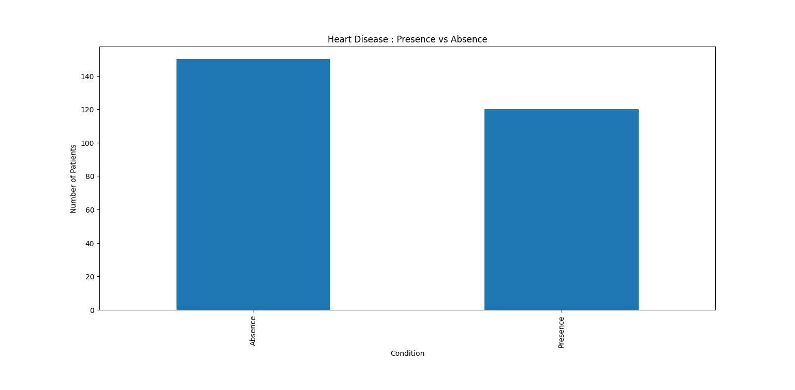

- Age Distribution
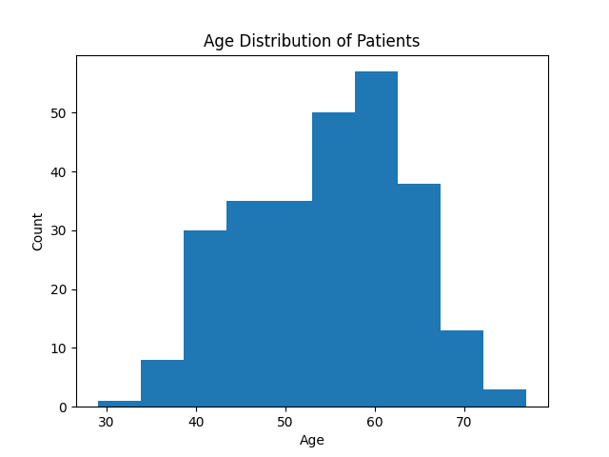

- Age vs Cholesterol
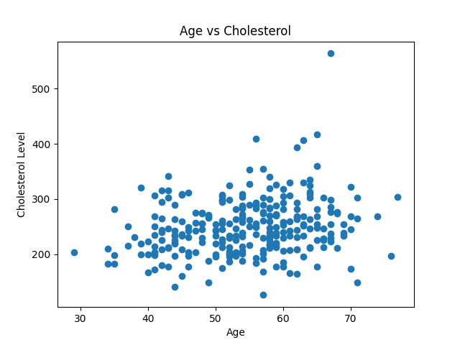

- Max Heart Rate (HR)
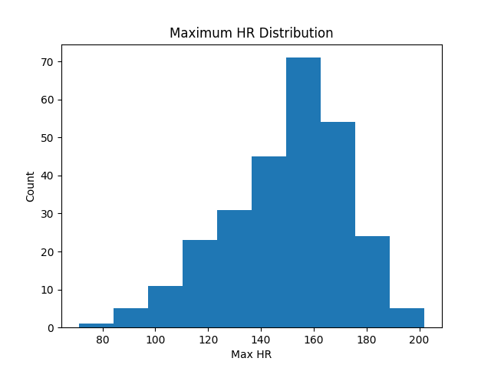

- Conclusion
- Age affects heart disease
- Cholesterol shows impact
- Dataset gives clear patterns

- Learning & Experience
- I understood how to analyse real-world health data using visual representation with Matplotlib in VS Code.
- I learned to interpret relationships between age, cholesterol, and heart disease.
- Working with this dataset improved my analytical thinking.

