LAB REPORT-4

SUBJECT:-ESE-3014

GROUP - 5

*Submitted By*

*Ankitkumar Patel – C0747455*

*Ronakkumar Sharma - C0747019*

*Professor - linchen*

*Email id -* [*Linchen.wang@cestarcollege.com*](mailto:Linchen.wang@cestarcollege.com)

CODE:

amplitude=2;

frequency=2;

time=[0:0.2:2];

time_s=[0:0.02:2];

a=3;

x=amplitude*cos(2*pi*frequency*time);

freq_1=2*frequency;

u=amplitude*cos(2*pi*freq*time_s);

x_1=u+amplitude;

x_1=x_1/(2*amplitude);

l=(-1+2^a);

x_1=l*x_1;

quanti_x=round(x_1);

% disp(xq);

m=[];

for i=l:length(quanti_x);

d=dec2bin(quanti_x(i),a);

m = [m double(d)-36];

m = [m double(d)-36];

end;

figure(1);

plot(time,x,'linewidth',2)

plot(time,x);

stem(time_s,u,'r','linewidth',2);

hold off;

title('Sampling','fontsize',16);

ylabel('Amplitude\rightarrow');

xlabel('time t\rightarrow');

hold on;

figure(2);

stem(time_s,x_1-(l/2),'linewidth',2);

title('Quantization','fontsize',16)

ylabel('levels l\rightarrow');

xlabel('Samples\rightarrow');

hold on;

stem(time_s,quanti_x-(l/2),'r','linewidth',2);

plot(time_s,quanti_x-(l/2),'--k');

hold off;

legend('Sampled signal','Quantized signal');

figure(3);

stairs([m (length(m))],'linewidth',2);

title('Encoded_waveform','fontsize',16)

ylabel('Binarysignal\rightarrow');

xlabel('bits\rightarrow');

axis([0 length(m) 0 3]);

grid on;

SCREENSHOTS:

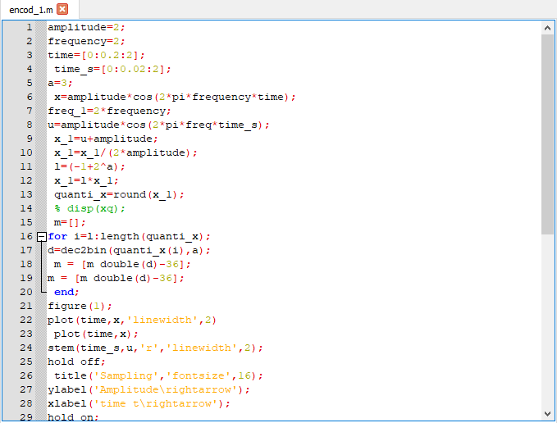

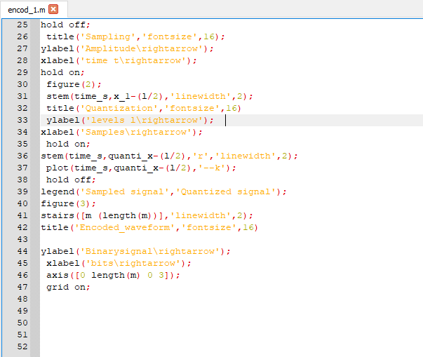

GRAPHS:

