LAB REPORT- 1

SUBJECT:-ESE-3014
GROUP - 5

Submitted By
Ankitkumar Patel – C0747455
Ronakkumar Sharma - C0747019
Professor - linchen
Email id - Linchen.wang@cestarcollege.com

C program for BBB is submitted as separate file.

Step 1:- Check available i2c bus on BBB.
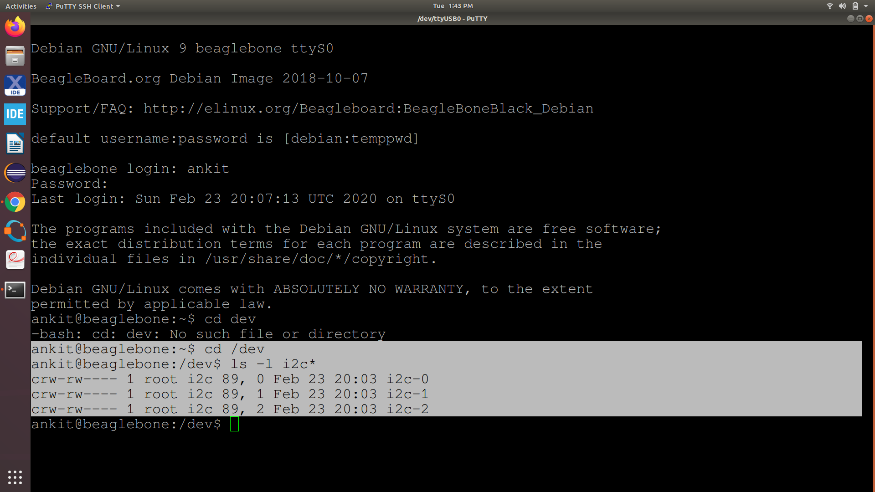

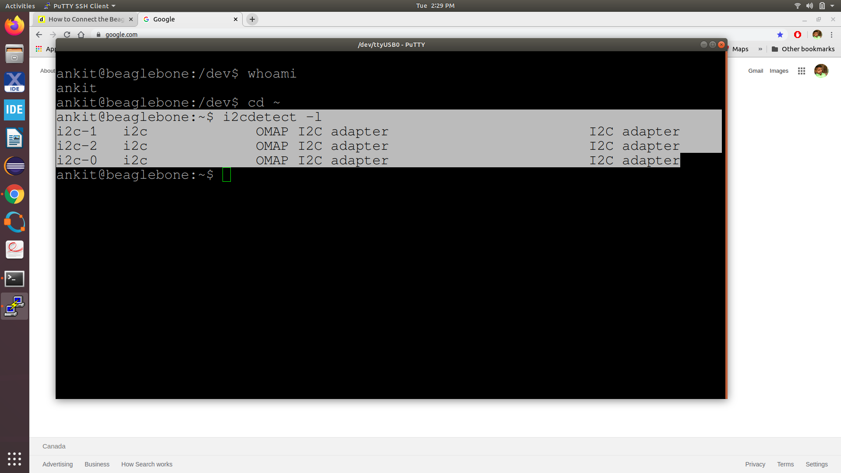

Step 2:- check availble attached sensor on i2c bus
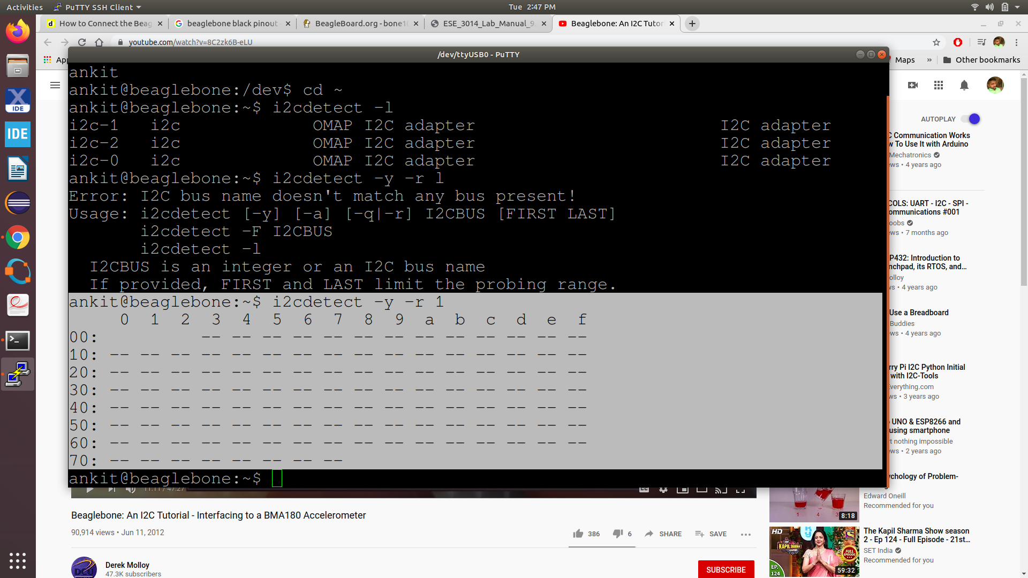

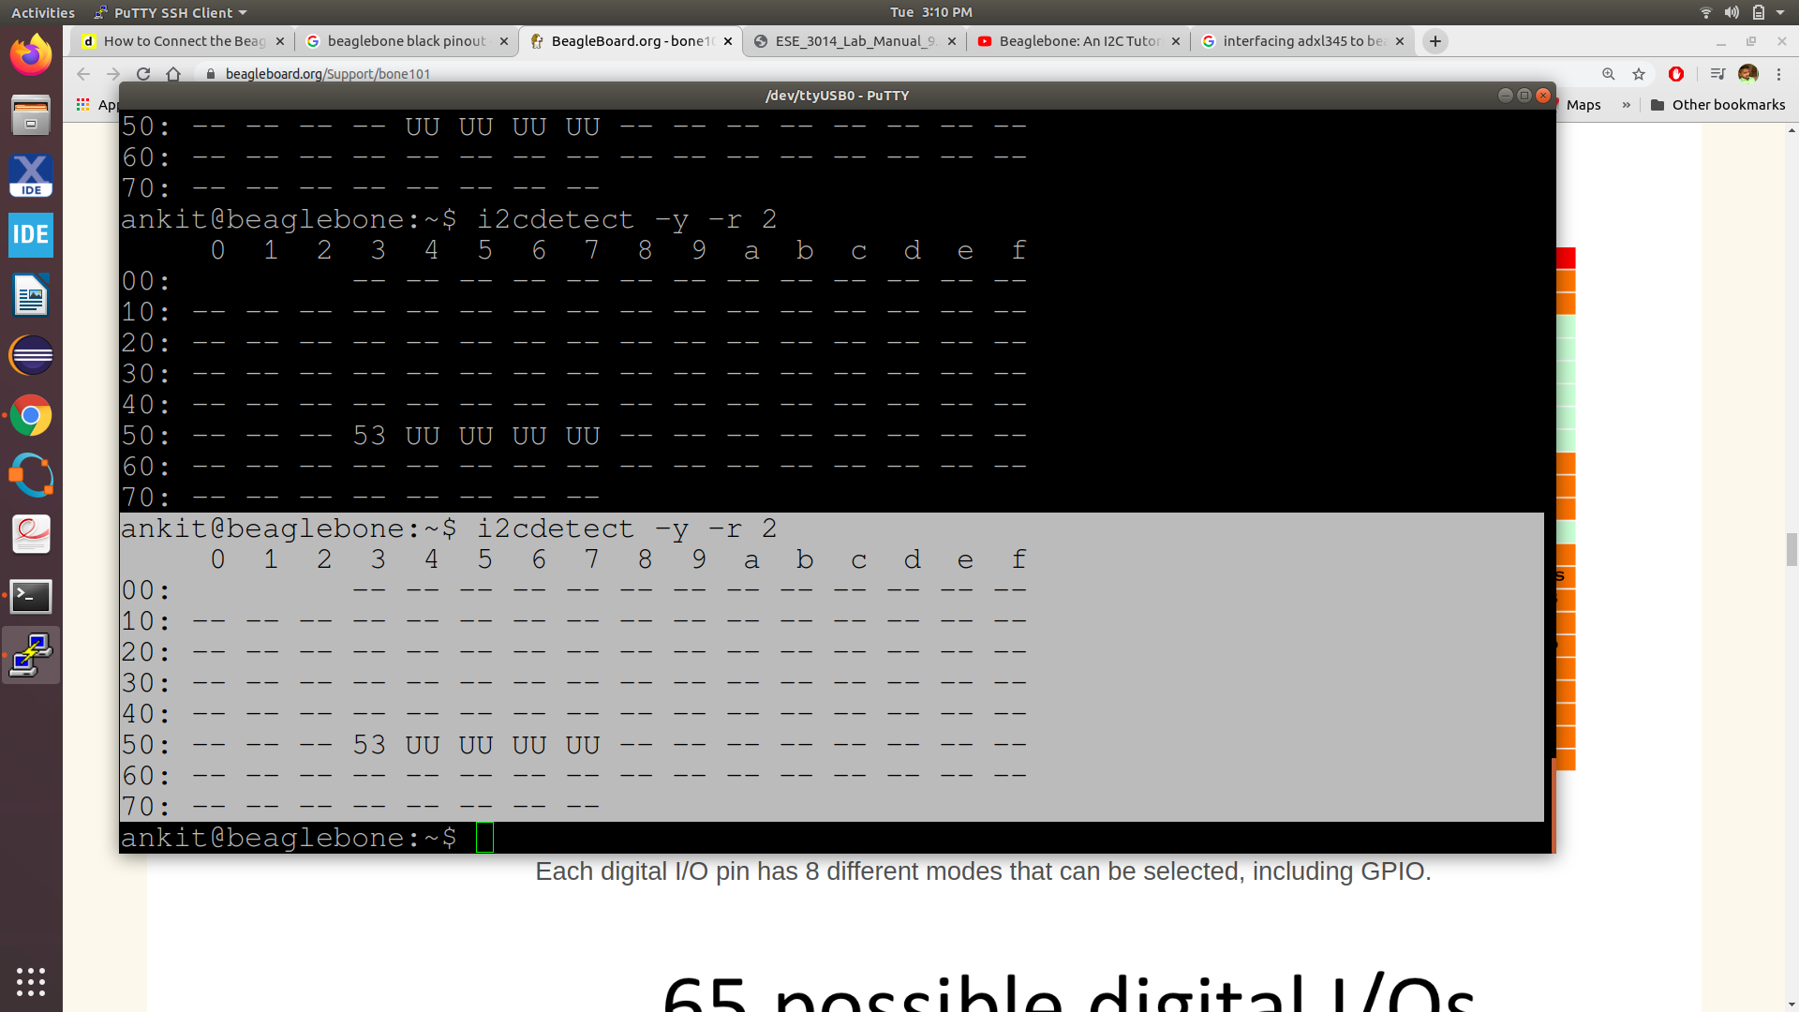

Our Sensor is attached to i2c bus 2 and address is 0x53

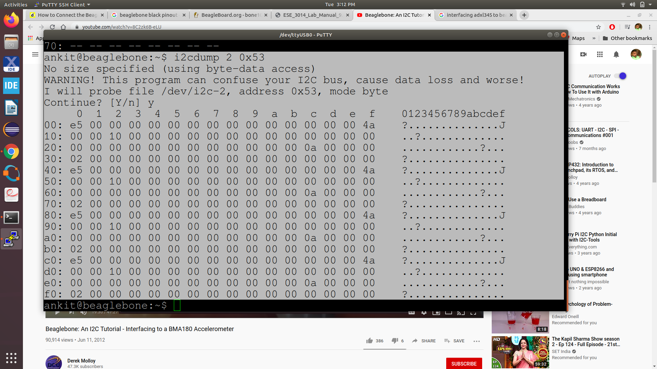

Step 3:- Now run ADXL345.c compiled file on BBB
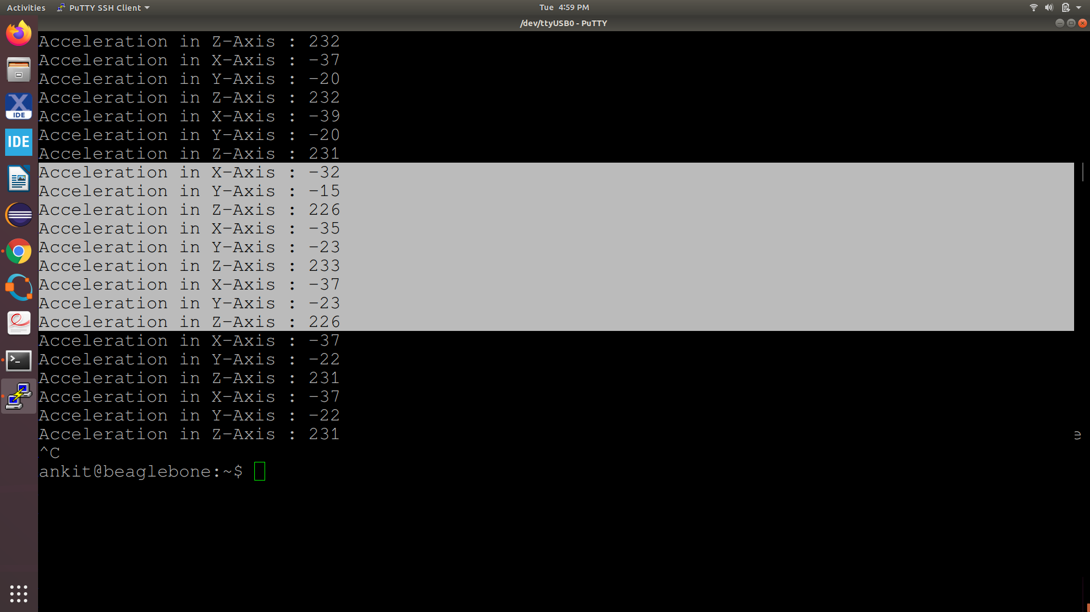
Tilt the sensor is changing X,Y,Z axis value.

