LAB REPORT- 10

SUBJECT:-ESE-3014

GROUP - 5

*Submitted By*

*Ankitkumar Patel – C0747455*

*Ronakkumar Sharma - C0747019*

*Professor - linchen*

*Email id - Linchen.wang@cestarcollege.com*

Interfacing communication - SPI 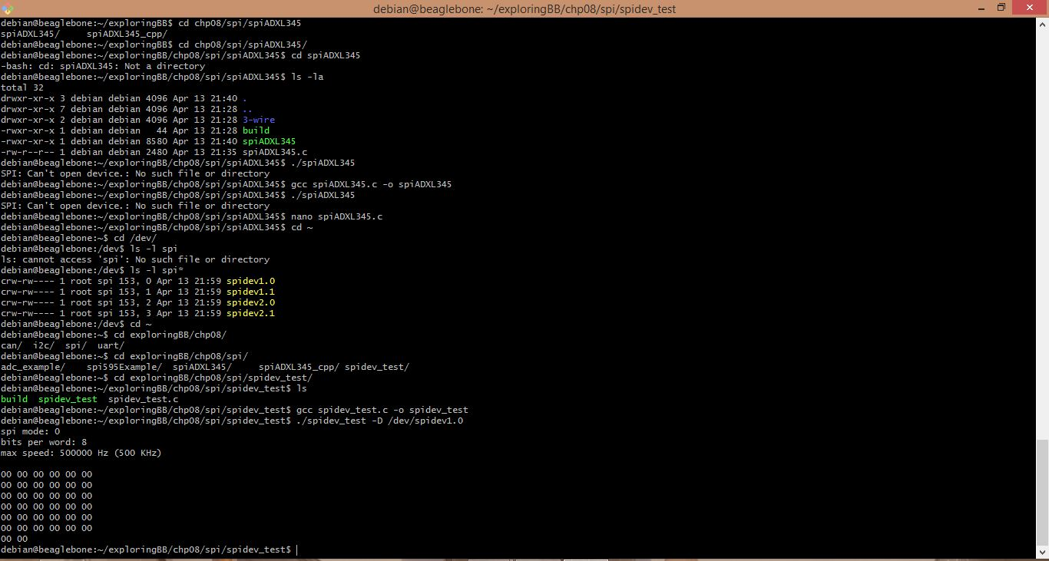

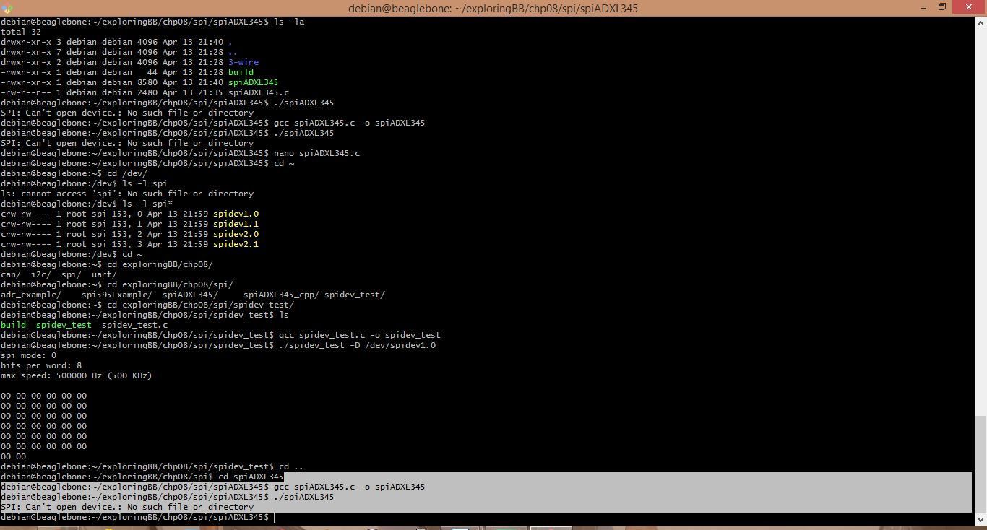

Youtube Link for connection:

<https://youtu.be/axs0udLF7C8>