LAB REPORT- 8

SUBJECT:-ESE-3014

GROUP - 5

*Submitted By*

*Ankitkumar Patel – C0747455*

*Ronakkumar Sharma - C0747019*

*Professor - linchen*

*Email id - Linchen.wang@cestarcollege.com*

TASK1

Screenshots:

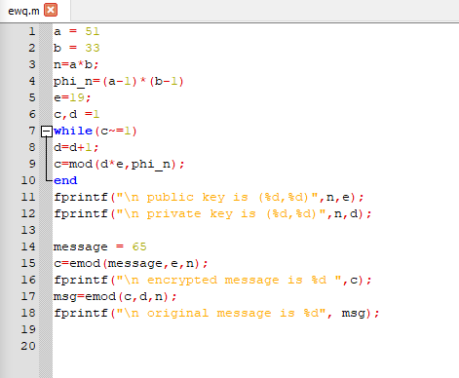

Output:

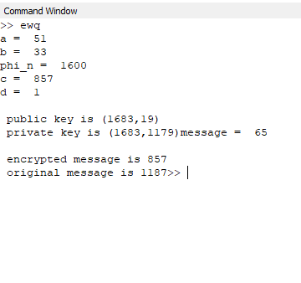

TASK2

Screenshots:

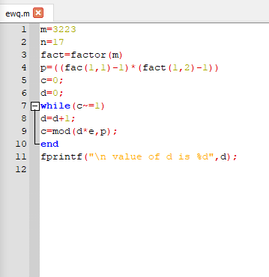

Output:

