

**Embedded System Architecture 2**

# LAB 06

**Winter 2020**

# CLASS: ESE 3005

|  |  |  |
| --- | --- | --- |
| Student Name | Student ID | Signature* |
| Darshan Mistry  Ronak Sharma | C0749864  C0747019 | D.M  R.S |
| Ankit Patel | C0747455 | A.P |

*\*By signing above you attest that you have contributed to this submission and confirm that all work you have contributed to this submission is your own work. Any suspicion of copying or plagiarism in this work will result in an investigation of Academic Misconduct and may result in a “0” on the work, an “F” in the course, or possibly more severe penalties.*

***Problem Set:-***

*Perorm a Cross Compilation,*

*Using a Eclipse:*[***http://exploringbeaglebone.com/chapter7/***](http://exploringbeaglebone.com/chapter7/)

The video may be old, and you can refer from the page 308 of Derek Molloy's Exploring Beaglebone Second Edition

The link for Linaro download (gcc-linaro-7.5.0-2019.12-i686_arm-linux-gnueabihf.tar.xz): <https://releases.linaro.org/components/toolchain/binaries/latest-7/arm-linux-gnueabihf/>

***Ans:-***

***Step:-1***

*SO, First of all we have to update pur system and after bing done that thing* install a copy of the Eclipse IDE for C/C++ Developers in your home directory.

Also ,install on aHost machine to complete toolchain to cross compile the Linux Kernel, the Linux device drivers, the Linux applications and the boot loader..

Commands:-

~$ cd /usr/bin/

/usr/bin$ sudo apt-get update

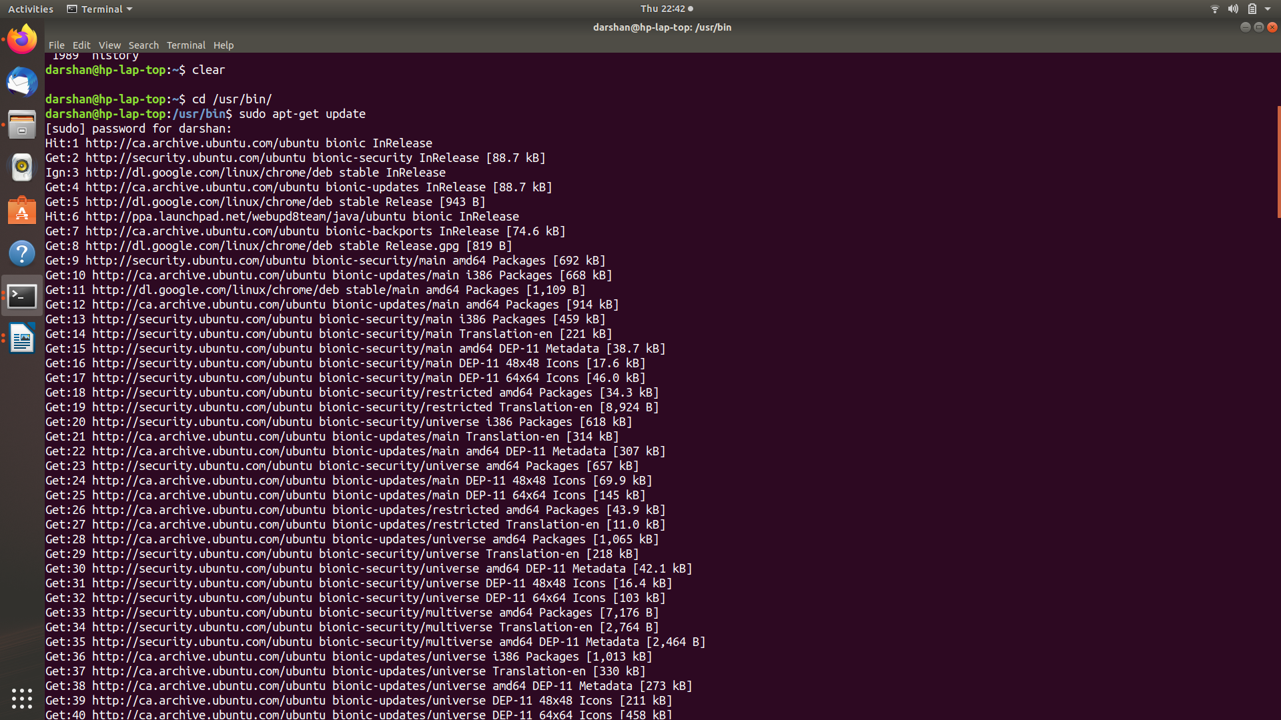

***Step:-2***

*Create A cross tollchain envairoment by using a command*

*Cpommand:-*

*usr/bin$ sudo apt-get install g++-arm-linux-gnueabihf*

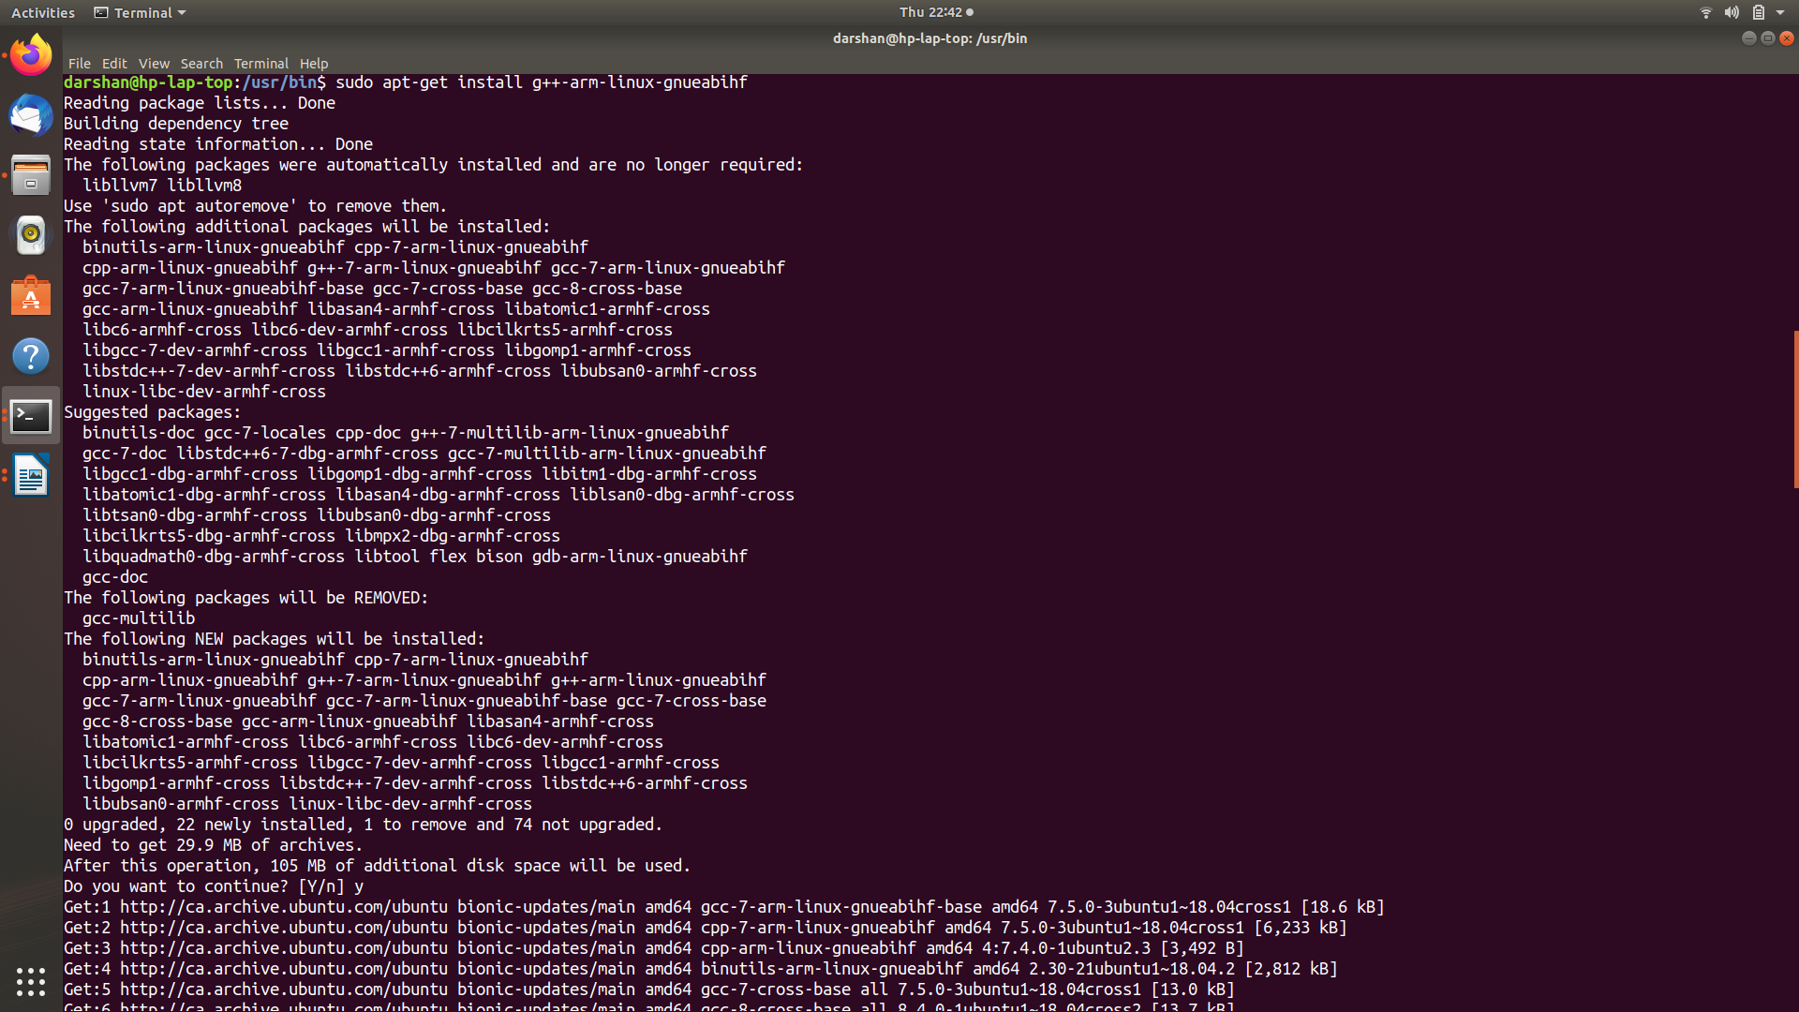

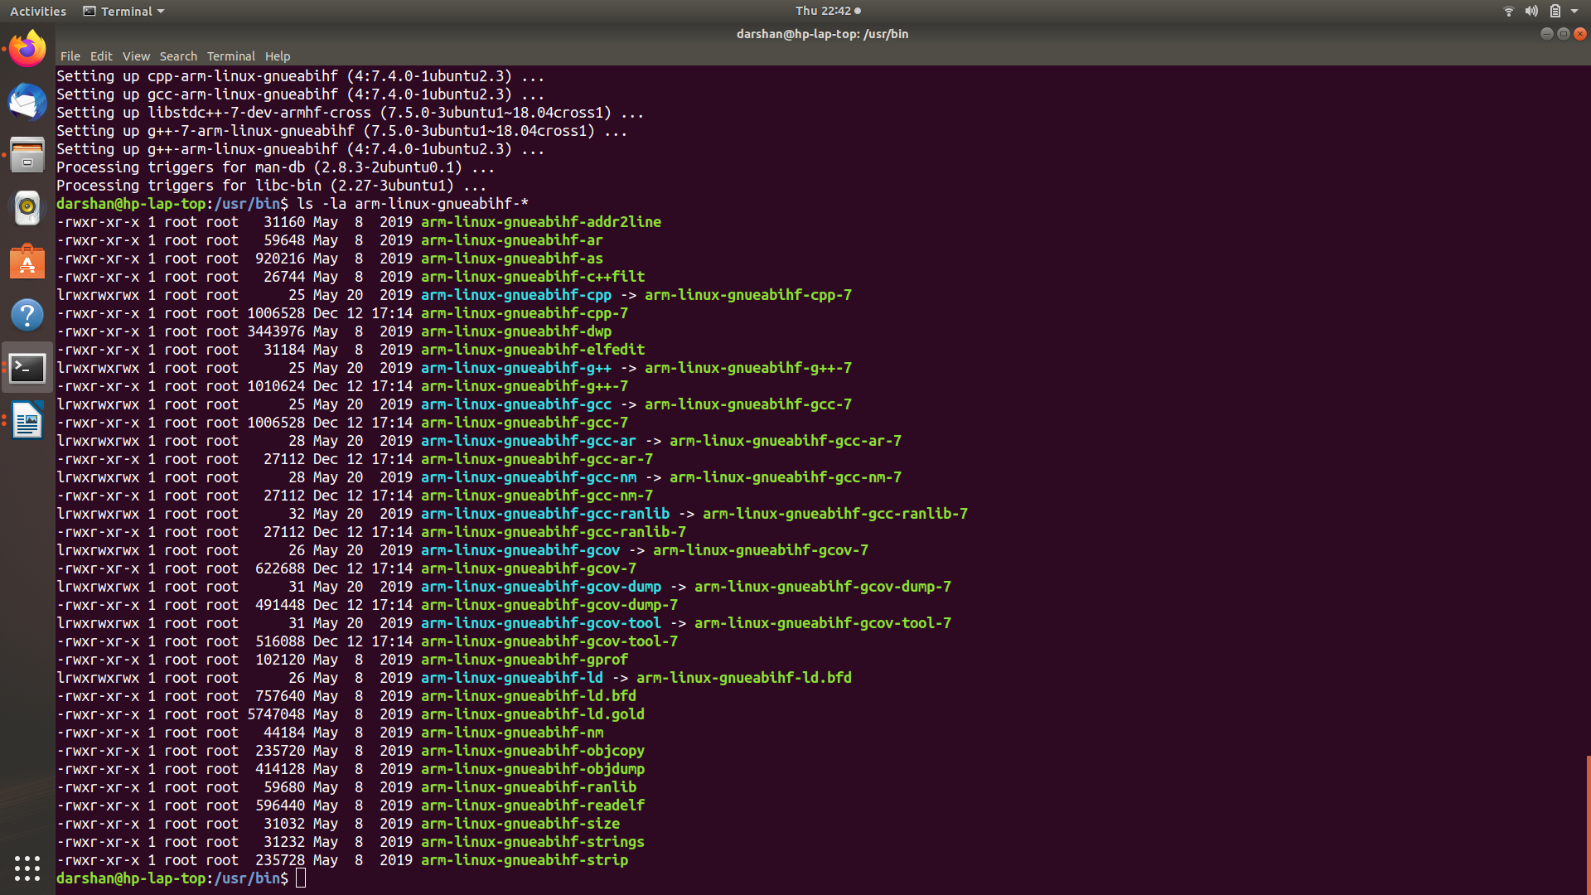***Step-3:-***

*To check a created file by using a list command*

*Command*

*ls -la [file name]*

***Step-4:-***

*Create a C/c++ program in a Eclips ..*

*Create a Hello world program and debug it using a croos tool chain plateform..*

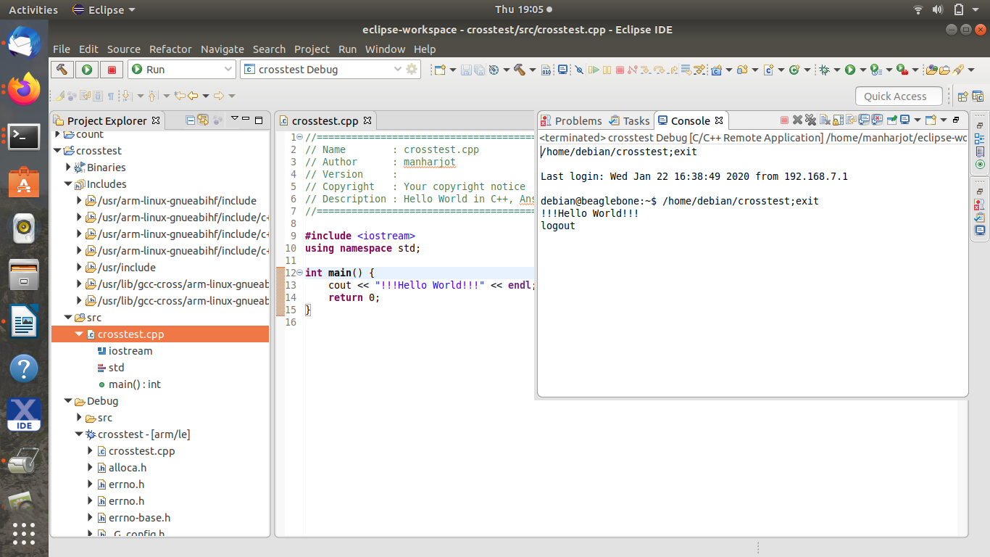

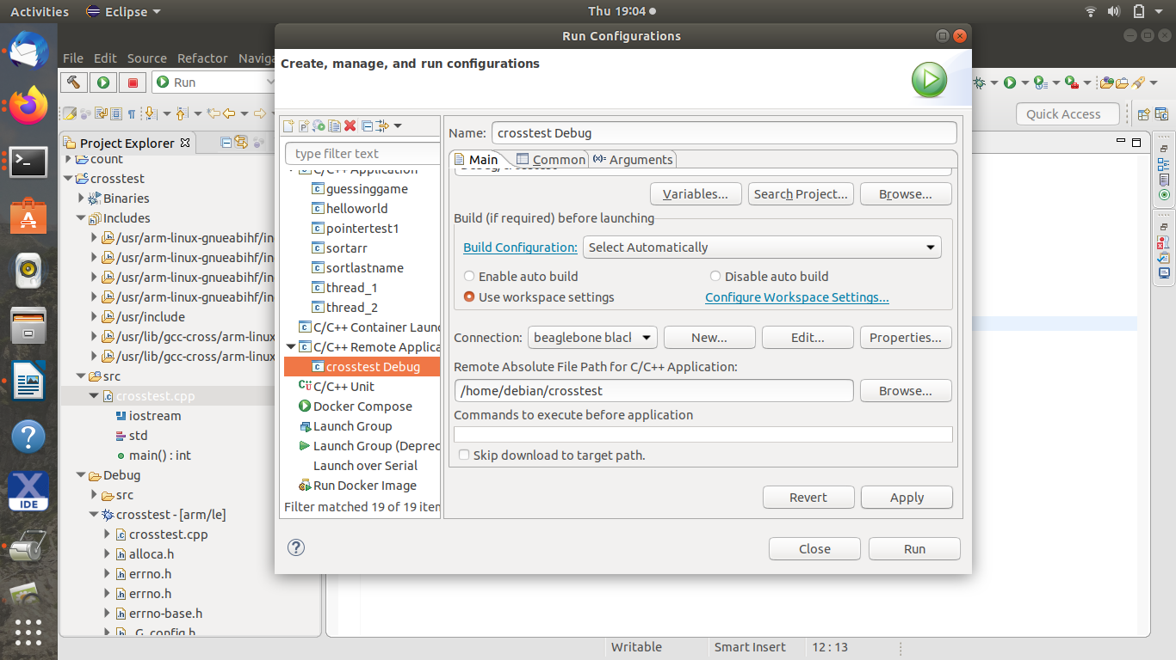

***Step-5***

*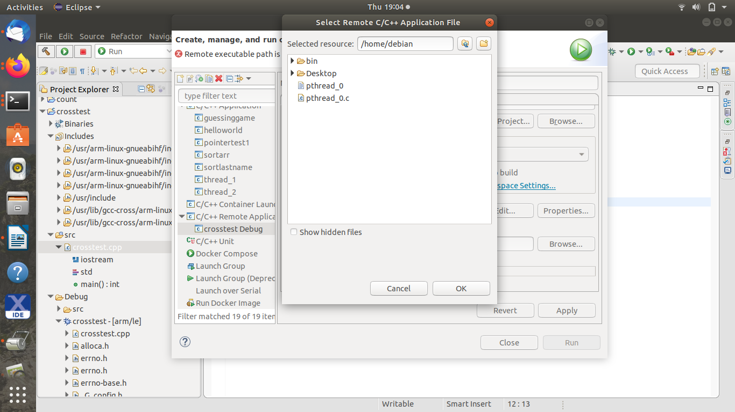Create a path for to debug in BBB.*

***Step:-6***

*Login into the BBB by using host machine ..*

*Command :-*

*Secure shell scripting*

*$ sudo ssh 192.168.6.2/7.2 -l debian*

*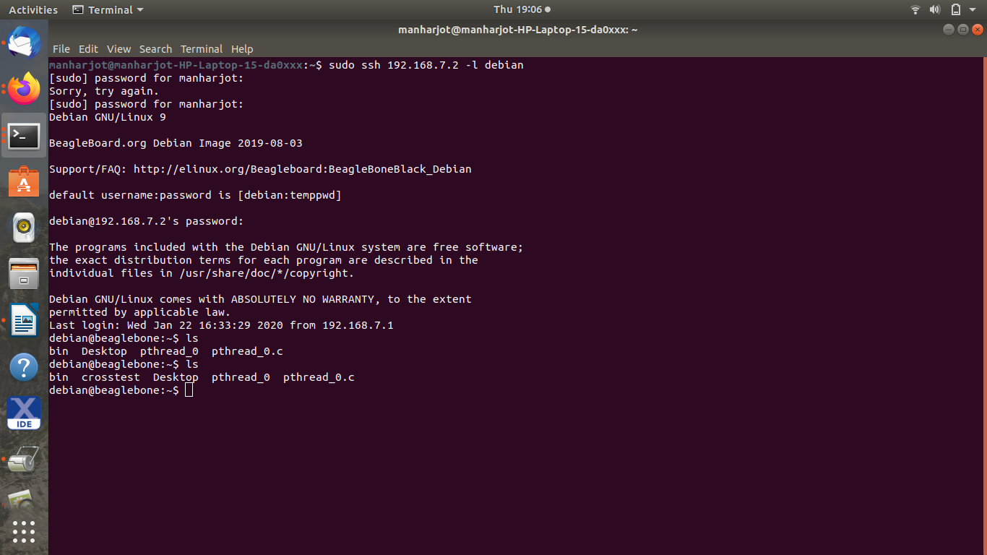One can easily shows in the SC that the file created on the BBB file directory..*

***Step-7:-***

*To run a saved C/C++ program simply type “./[file_name]”*

*Make sure the file is in the same directory then and then only it will run ...*

*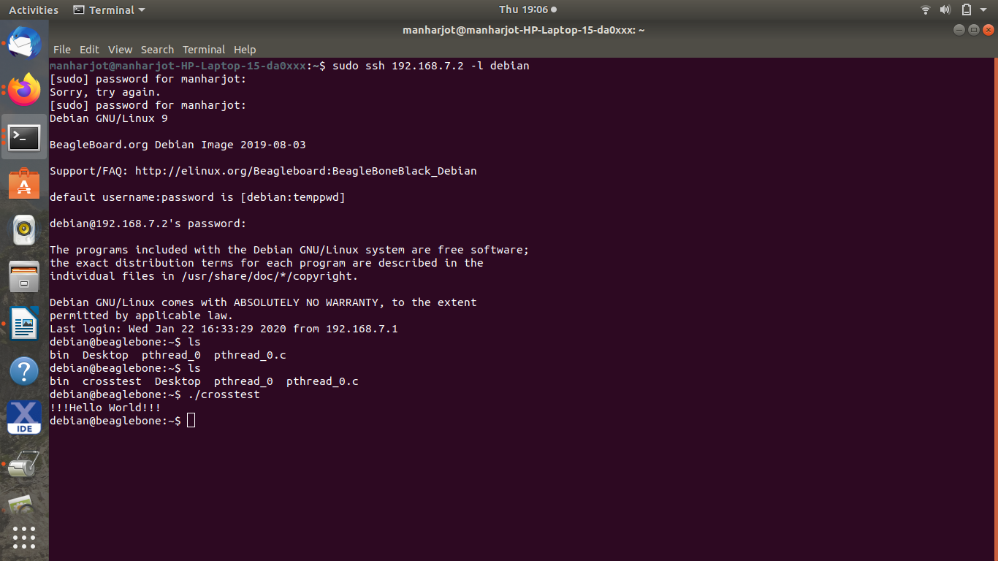so when I do that it will shows me the output..*