

**Embedded System Architecture 2**

# Assignment - 3

**Winter 2020**

**Date:-** 21st -FEB-2020

# CLASS: ESE 3005

|  |  |  |
| --- | --- | --- |
| Student Name | Student ID | Signature* |
| Darshan Mistry | C0749864 | D.M |
| Ankit Patel  Ronakkumar Sharma | C0747455  C0747019 | A.P  R.S |

*\*By signing above you attest that you have contributed to this submission and confirm that all work you have contributed to this submission is your own work. Any suspicion of copying or plagiarism in this work will result in an investigation of Academic Misconduct and may result in a “0” on the work, an “F” in the course, or possibly more severe penalties.*

**1. create a service file:**

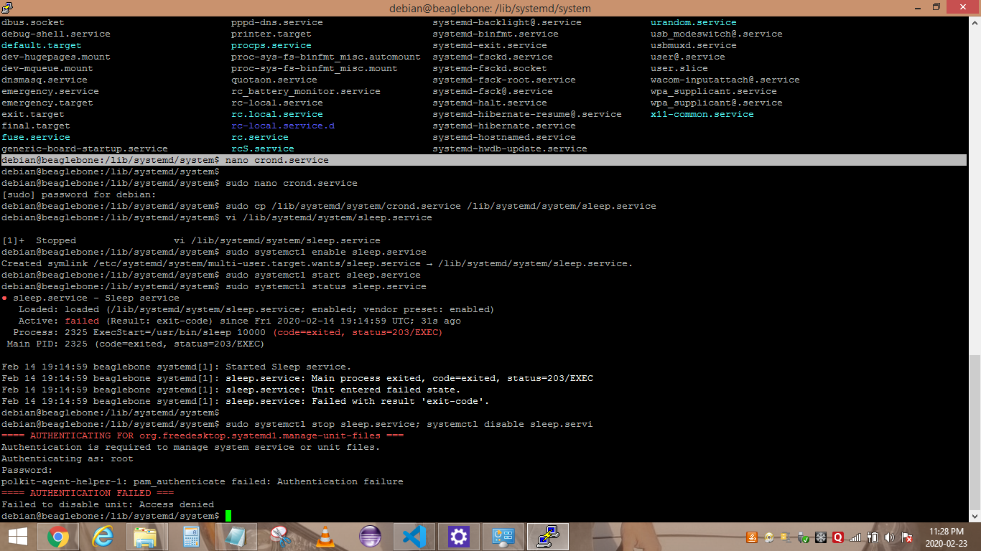

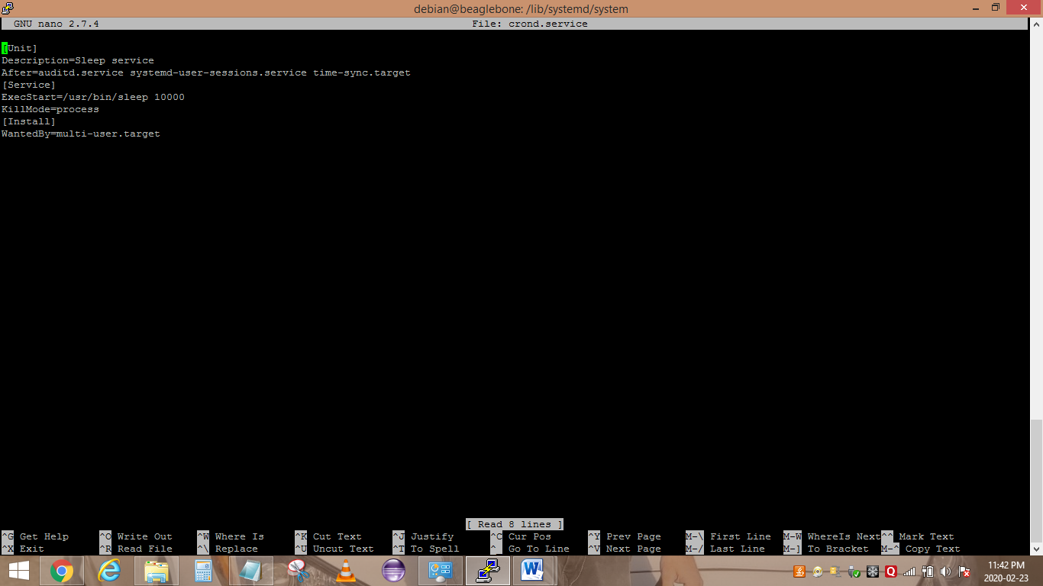

**2. enable the service start the service check status stop and disable the service**

