Experiment 9

Name: SHIVAM SHARMA |  | UID: 24BAI70553
Branch: CSE _AIML |  | Section/Group: 24NTPP-3B

Sem: 5
Subject: Power BI |  | Subject Code: 24CSH-341

BI Security: Authentication, Authorization and Access Control using Microsoft Power BI

Aim
To perform BI Security: Authentication, Authorization and Access Control using Microsoft Power BI.

Tools / Software Required
1. Microsoft Power BI Desktop
2. Global Superstore Dataset.xlsx
3. Power Query Editor
4. DAX (Data Analysis Expressions)
Dataset Source:
Global Superstore Dataset (Kaggle)
https://www.kaggle.com/datasets/apoorvaappz/global-super-store-dataset

Theory
Online Analytical Processing (OLAP) is a Business Intelligence technique used for multidimensional analysis of business data. OLAP enables users to analyze information from different perspectives and perform complex analytical queries efficiently.
Common OLAP operations include:
Slice: Selecting a single dimension value from a dataset.
Dice: Selecting multiple dimensions and values simultaneously.
Drill-down: Moving from summarized data to detailed data.
Drill-up: Moving from detailed data to summarized data.
Power BI supports OLAP-style analysis through hierarchies, filters, slicers, visual interactions, and drill functionality.

Conduct - Part A: Load Dataset and Build Report
Step 1: Open Power BI Desktop.
Step 2: Open the Power BI model created in Experiment 3 or import the Global Superstore dataset.
Step 3: Verify relationships between Orders, Returns, and People tables.
Step 4: Create report visuals:
• Sales by Region
• Profit by Category
• Sales by Segment
• Sales Trend by Year

Conduct - Part B: Slice Operation
Step 5: Add a slicer visual using Region.
Step 6: Select a single Region such as West.
Step 7: Observe changes in Sales, Profit, and Orders.
Step 8: Record observations and capture screenshot evidence.

Conduct - Part C: Dice Operation
Step 9: Apply multiple filters simultaneously.
Example:
• Region = West
• Category = Technology
• Year = 2022
Step 10: Analyze filtered business metrics.
Step 11: Record observations and capture screenshots.

Conduct - Part D: Drill-down Operation
Step 12: Create a hierarchy using Region → State → City.
Step 13: Create a bar chart using the hierarchy.
Step 14: Use Drill-down mode to navigate from Region level to City level.
Step 15: Observe detailed sales patterns.
Step 16: Capture screenshots.

Conduct - Part E: Drill-up Operation
Step 17: Navigate back from City level to State level and then Region level.
Step 18: Compare aggregated values at each level.
Step 19: Record observations.
Step 20: Capture screenshots.

Conduct - Part F: OLAP Analysis
Step 21: Compare results obtained from Slice, Dice, Drill-down, and Drill-up operations.
Step 22: Create a summary table documenting observations.
Step 23: Explain how each operation supports business decision-making.

Procedure
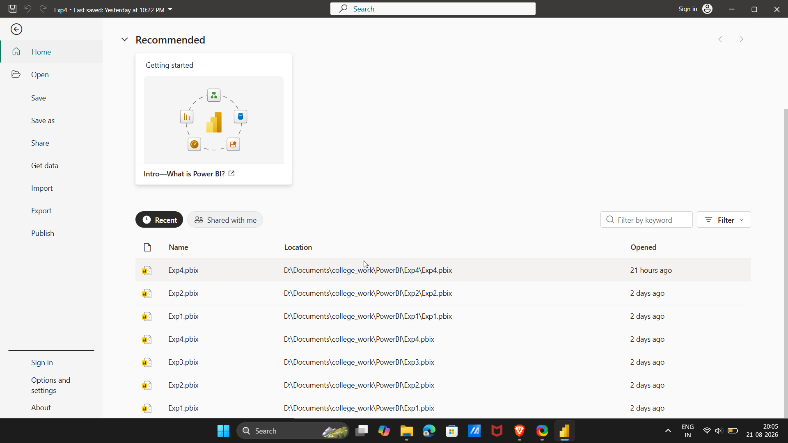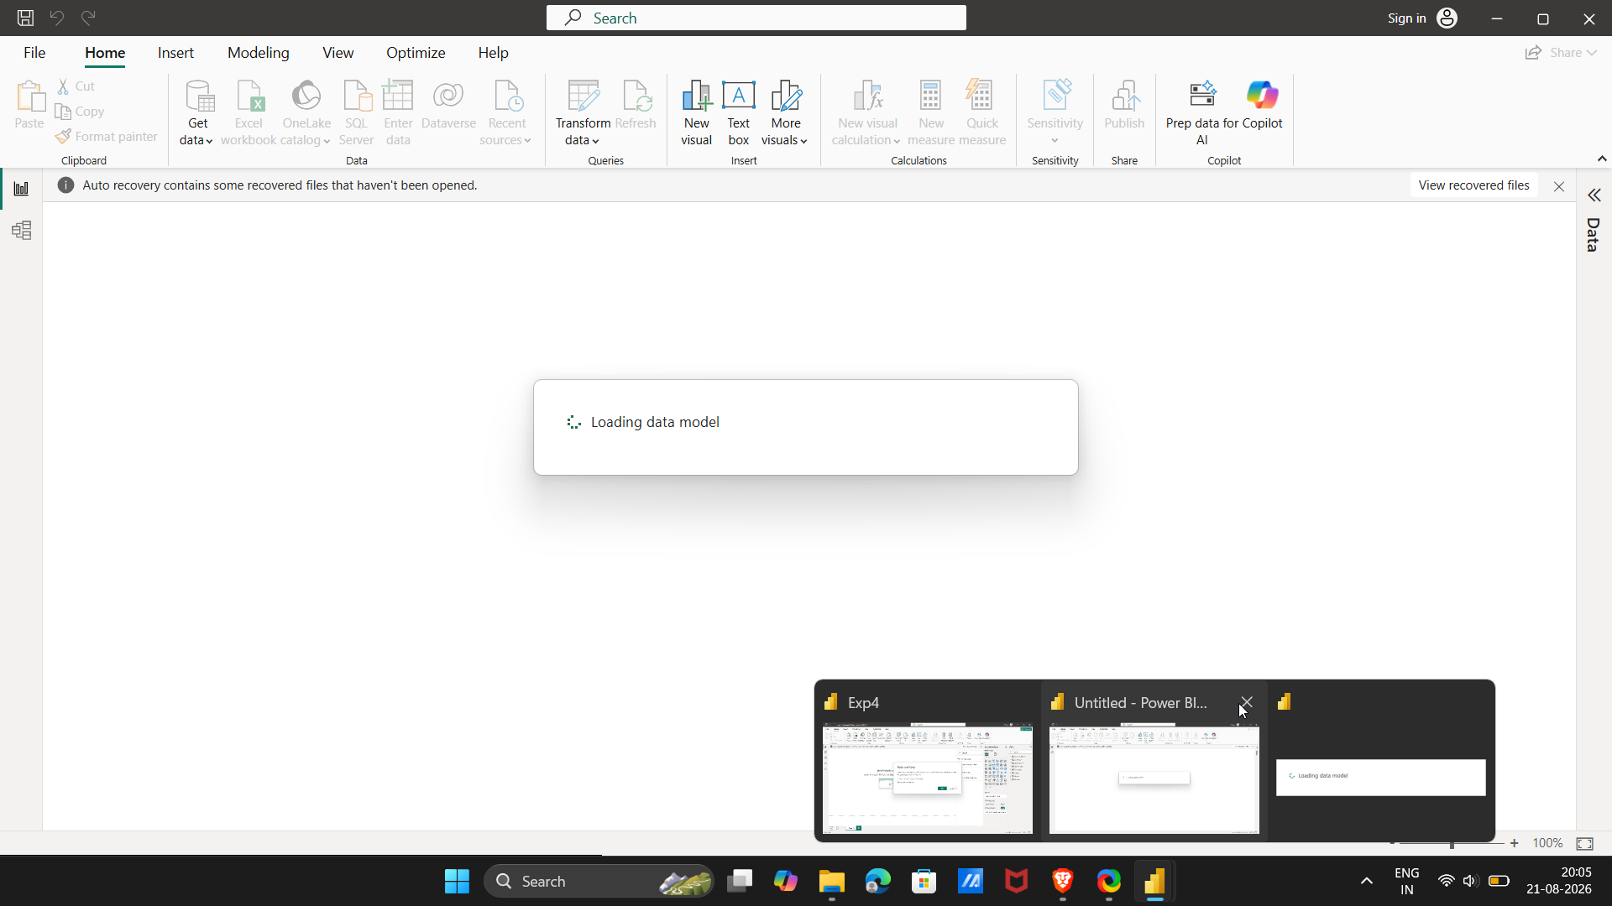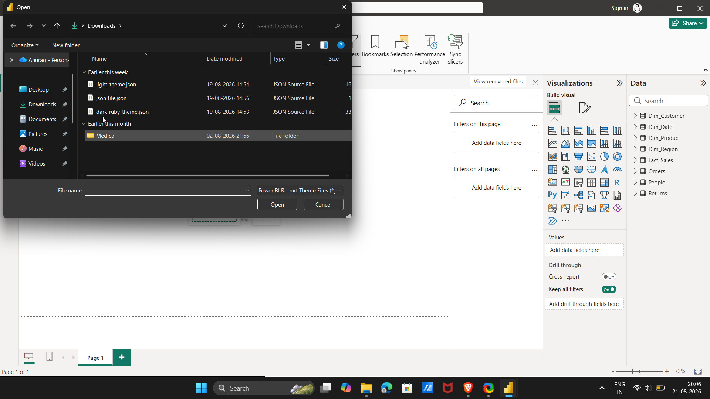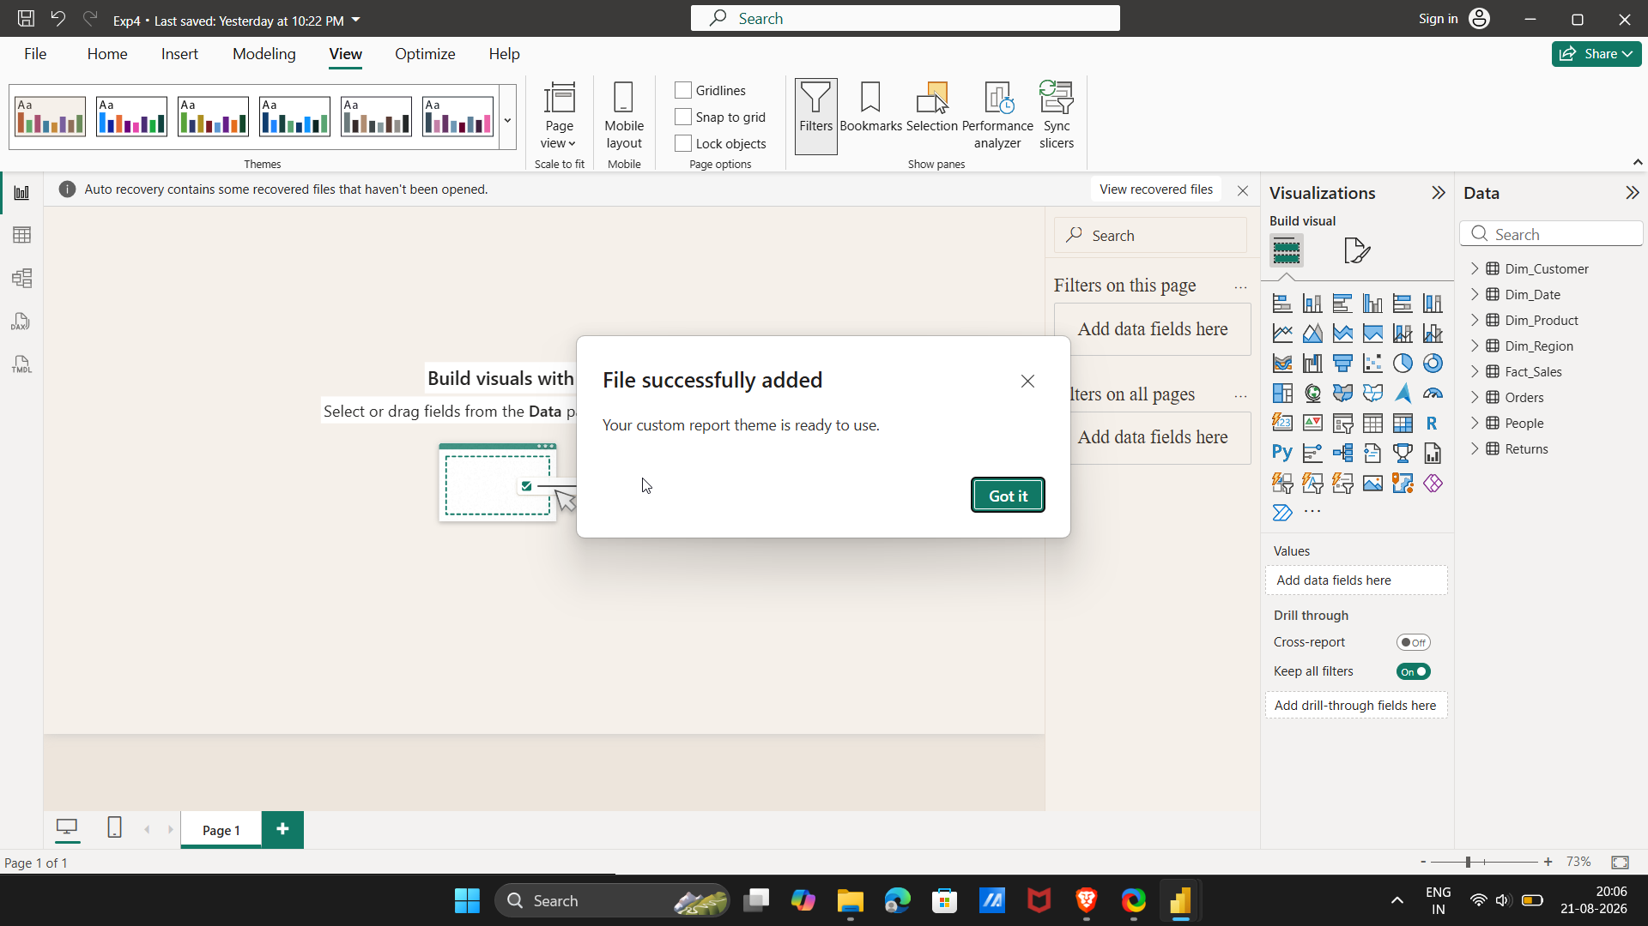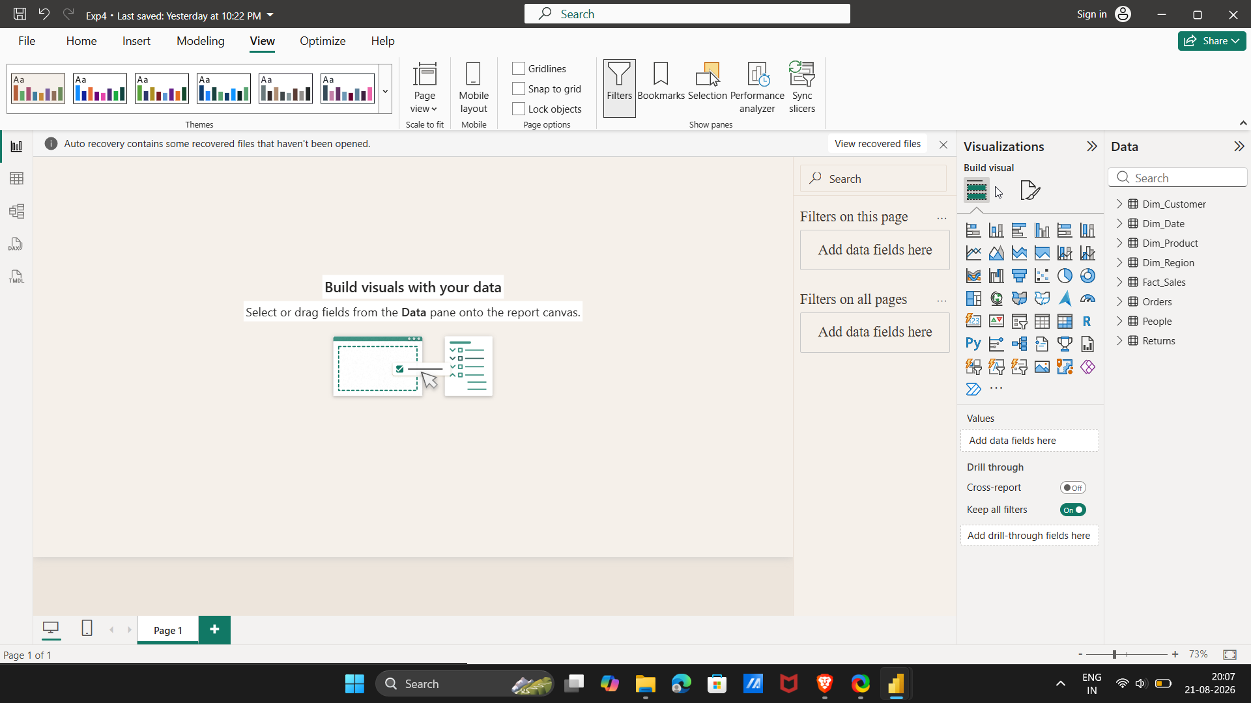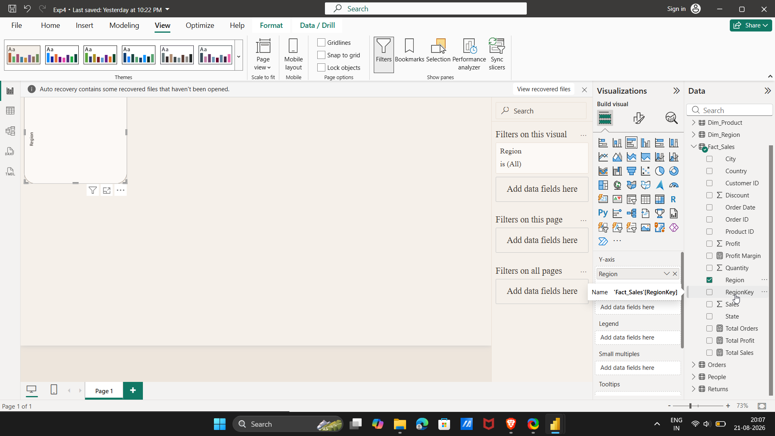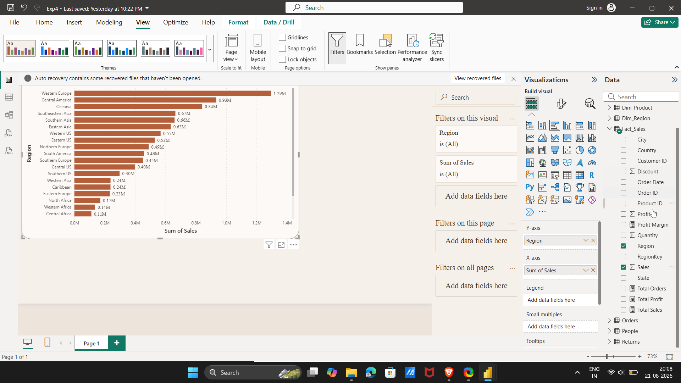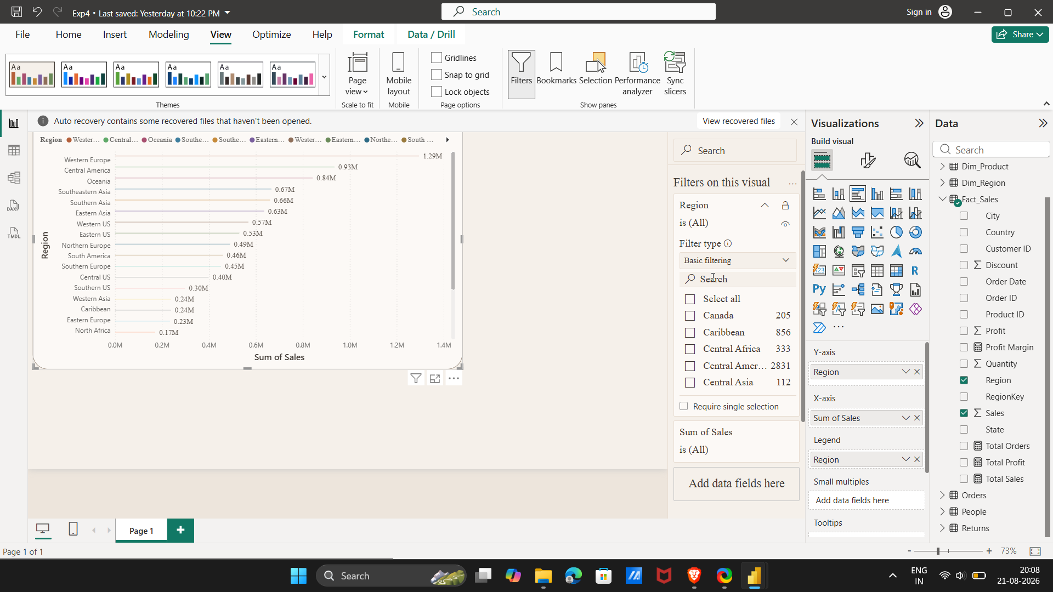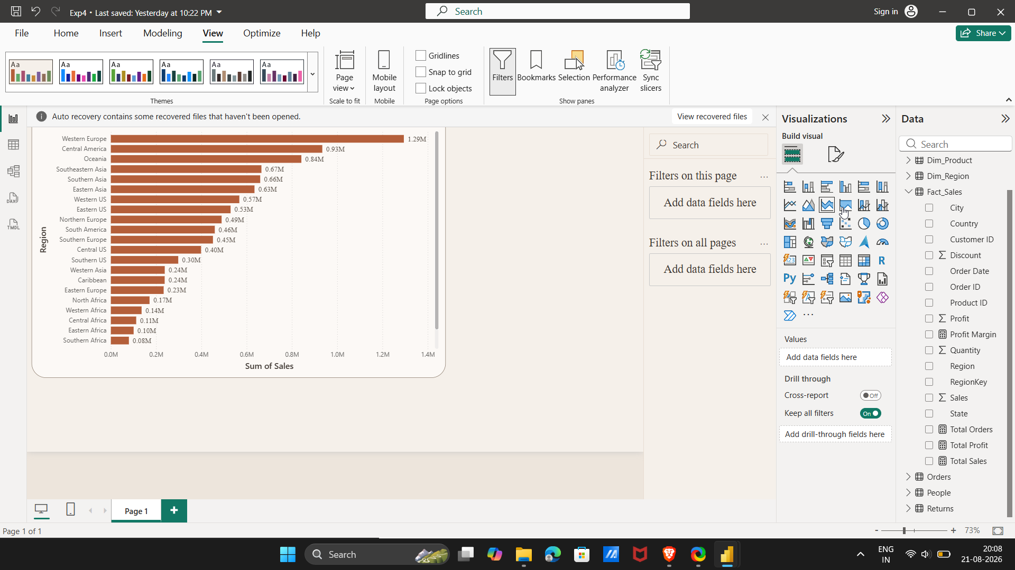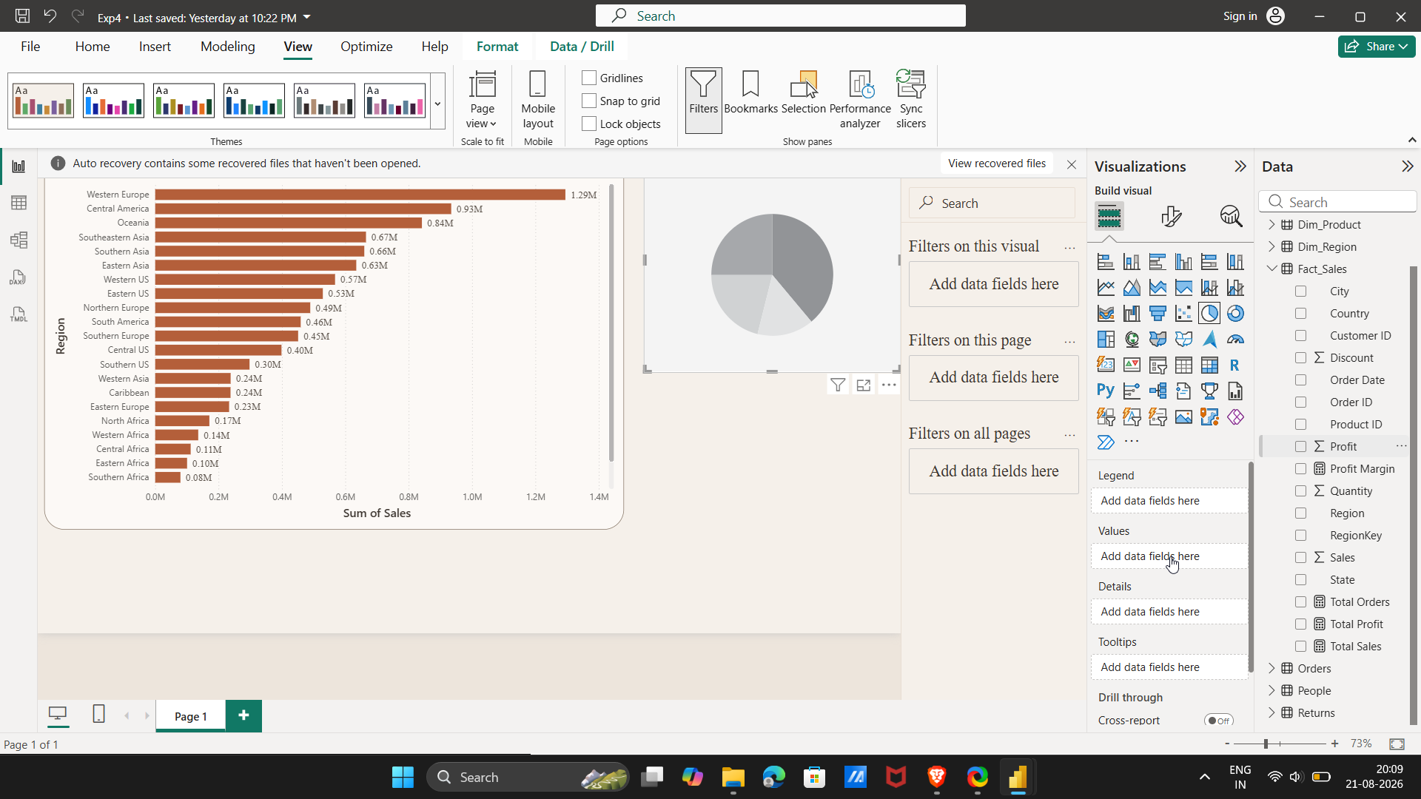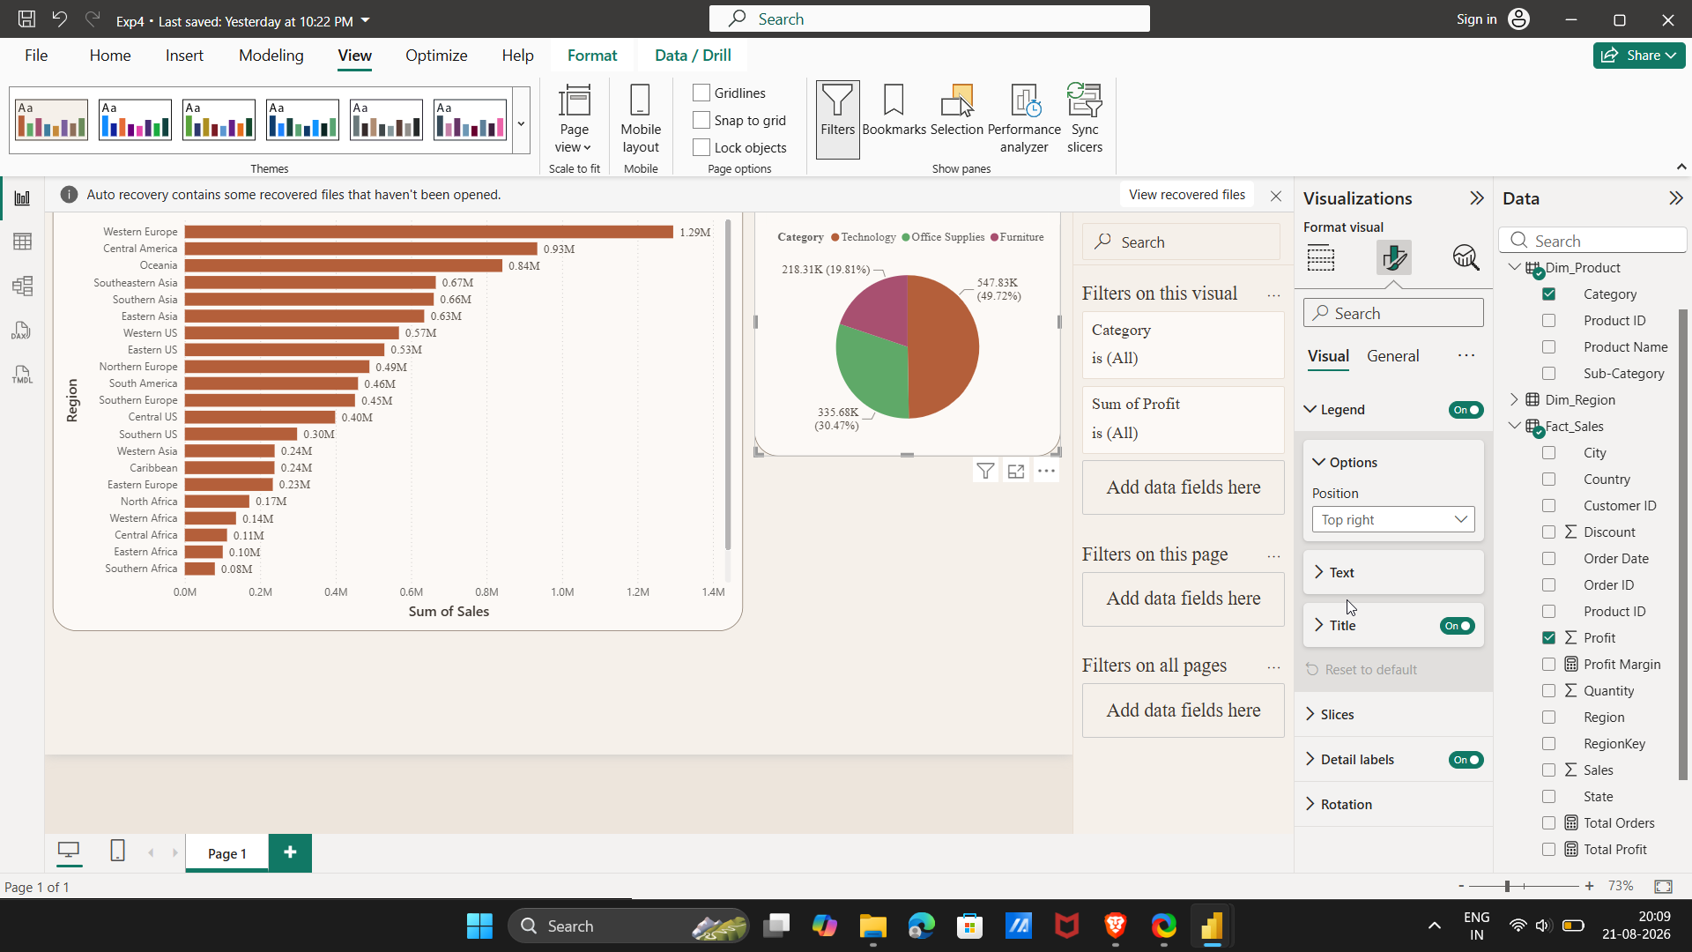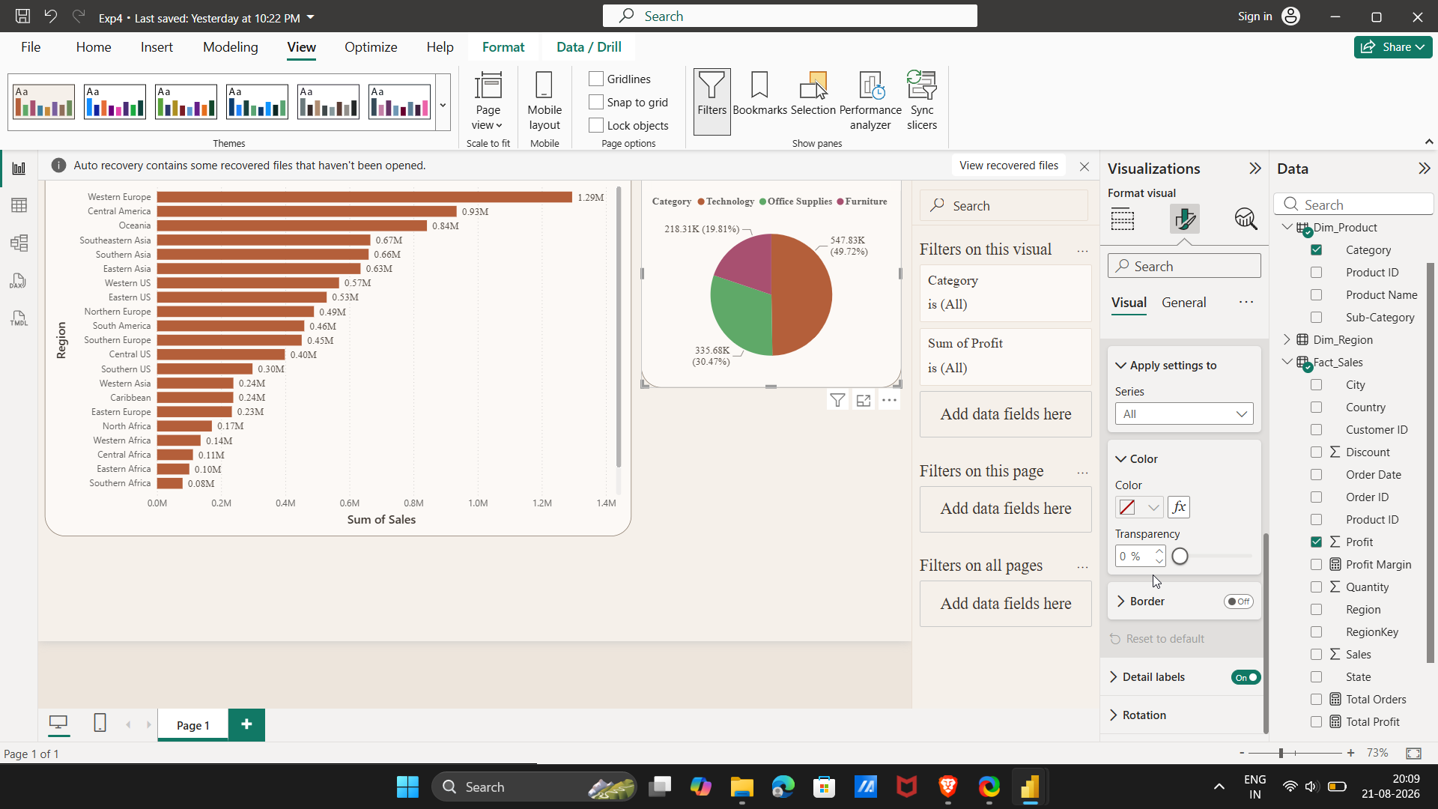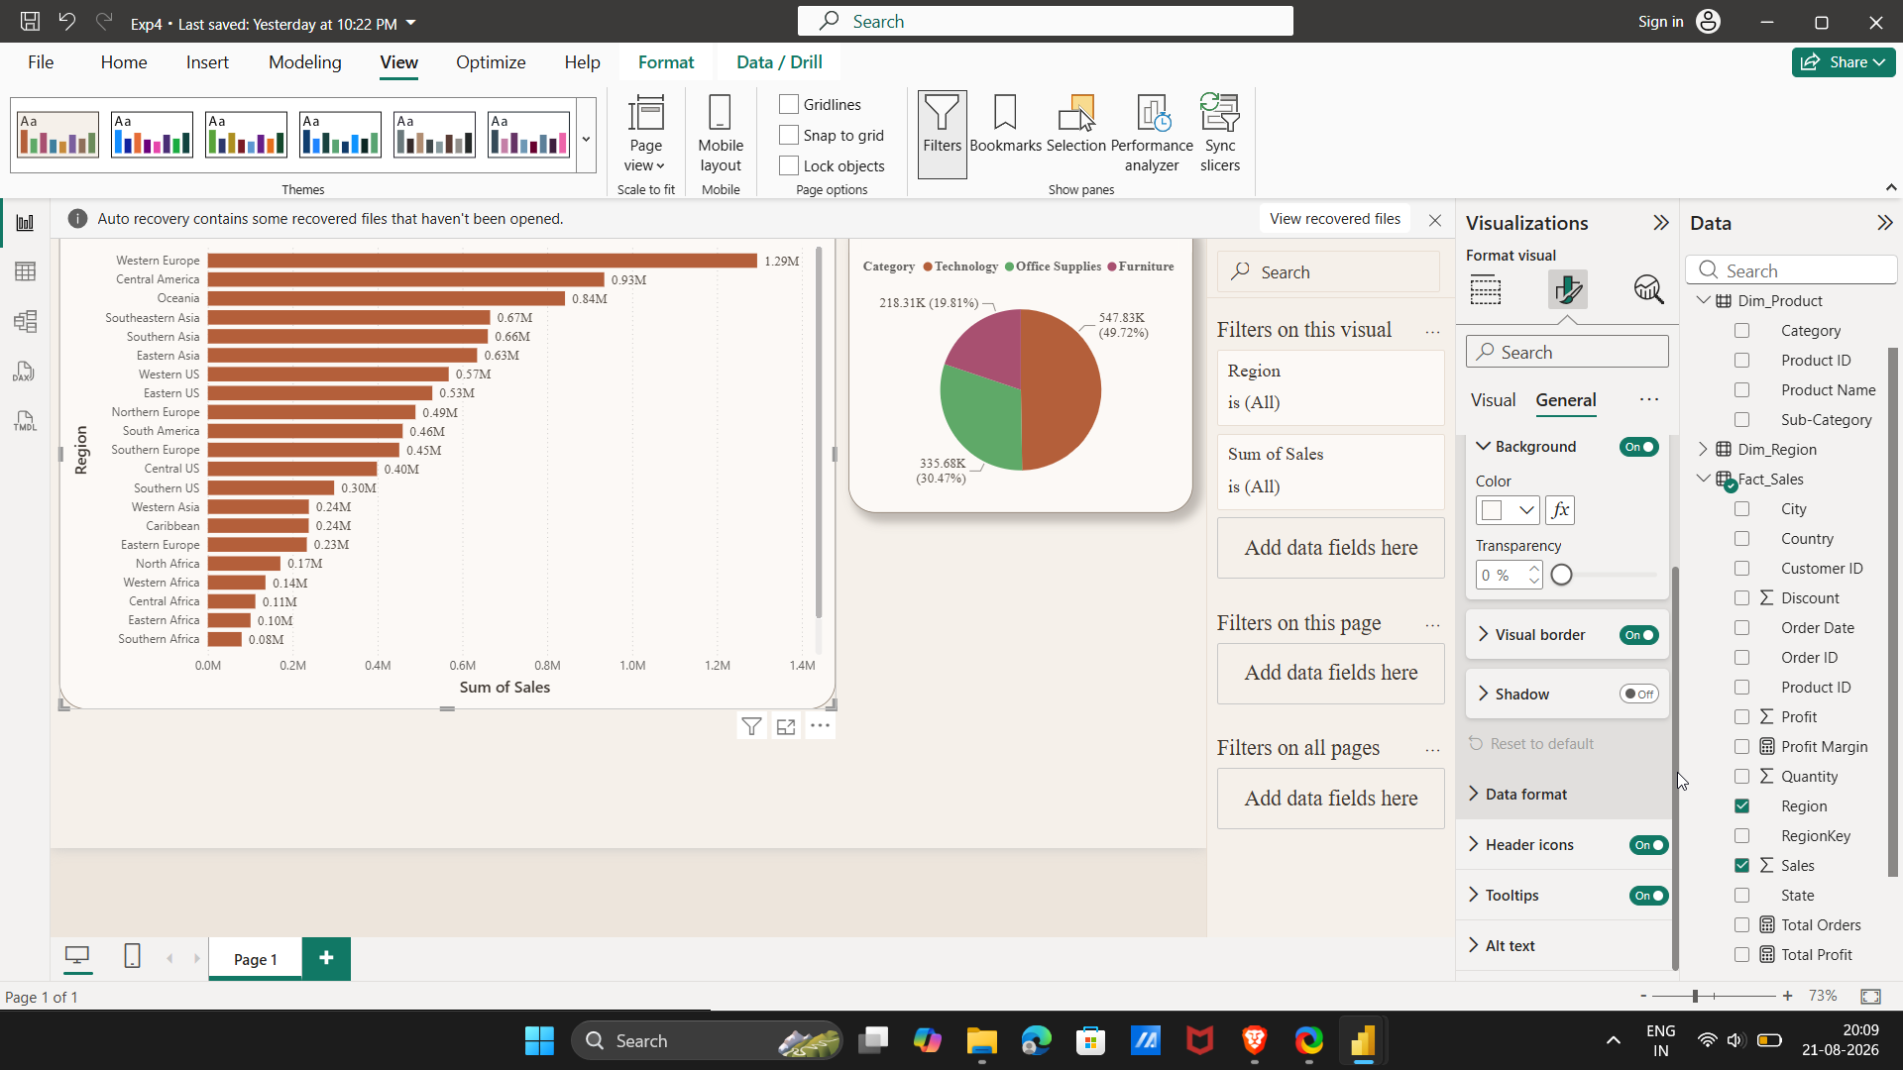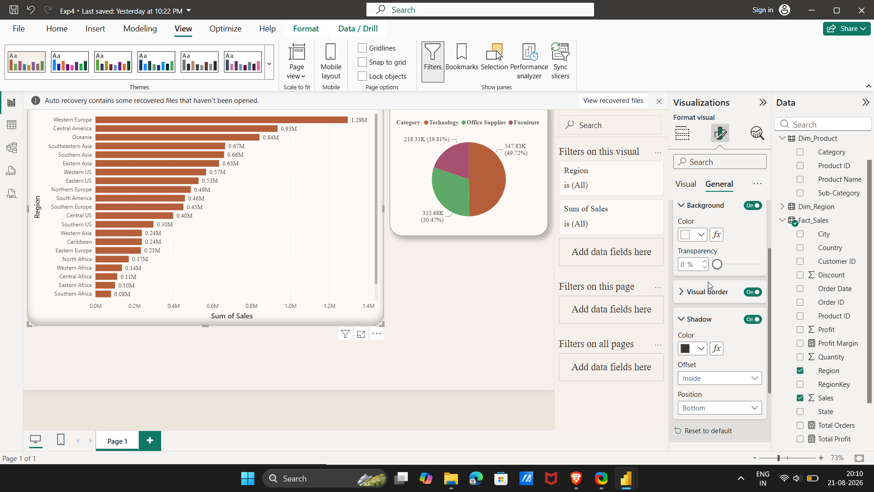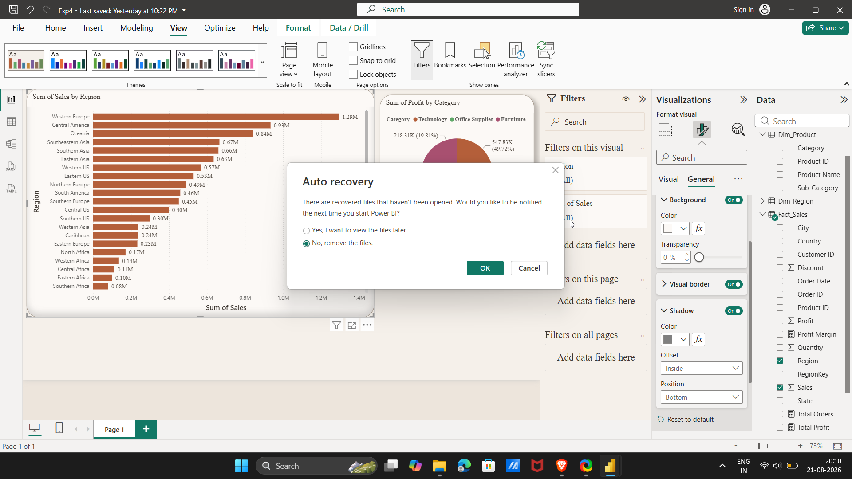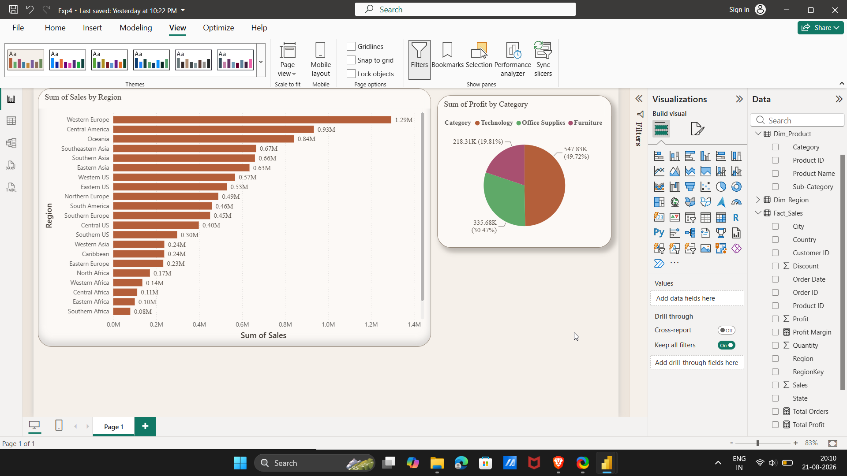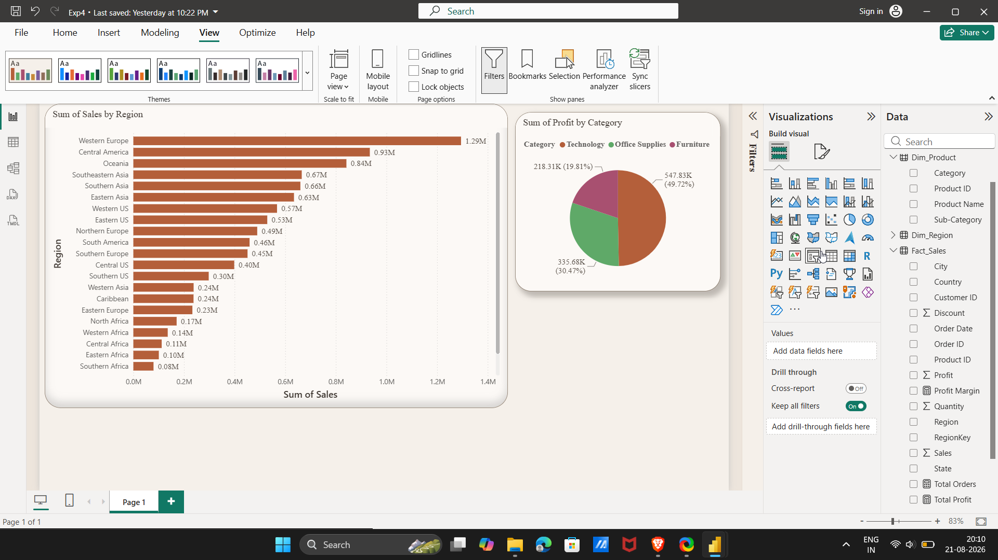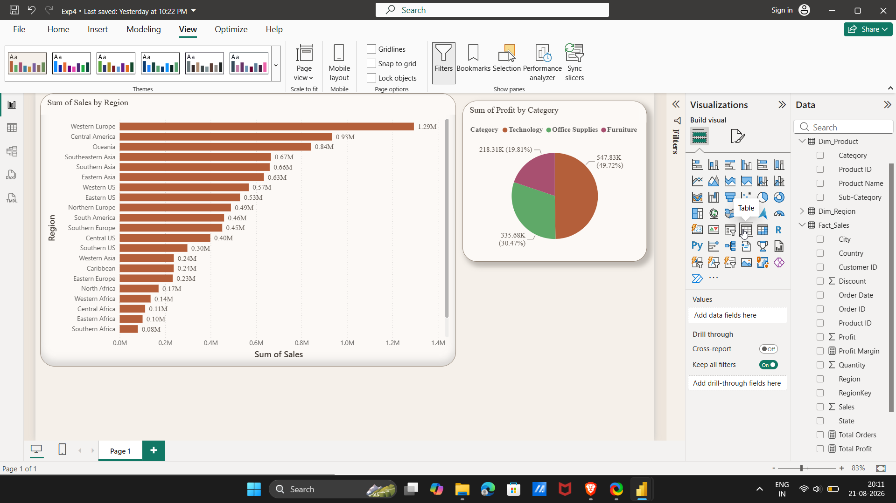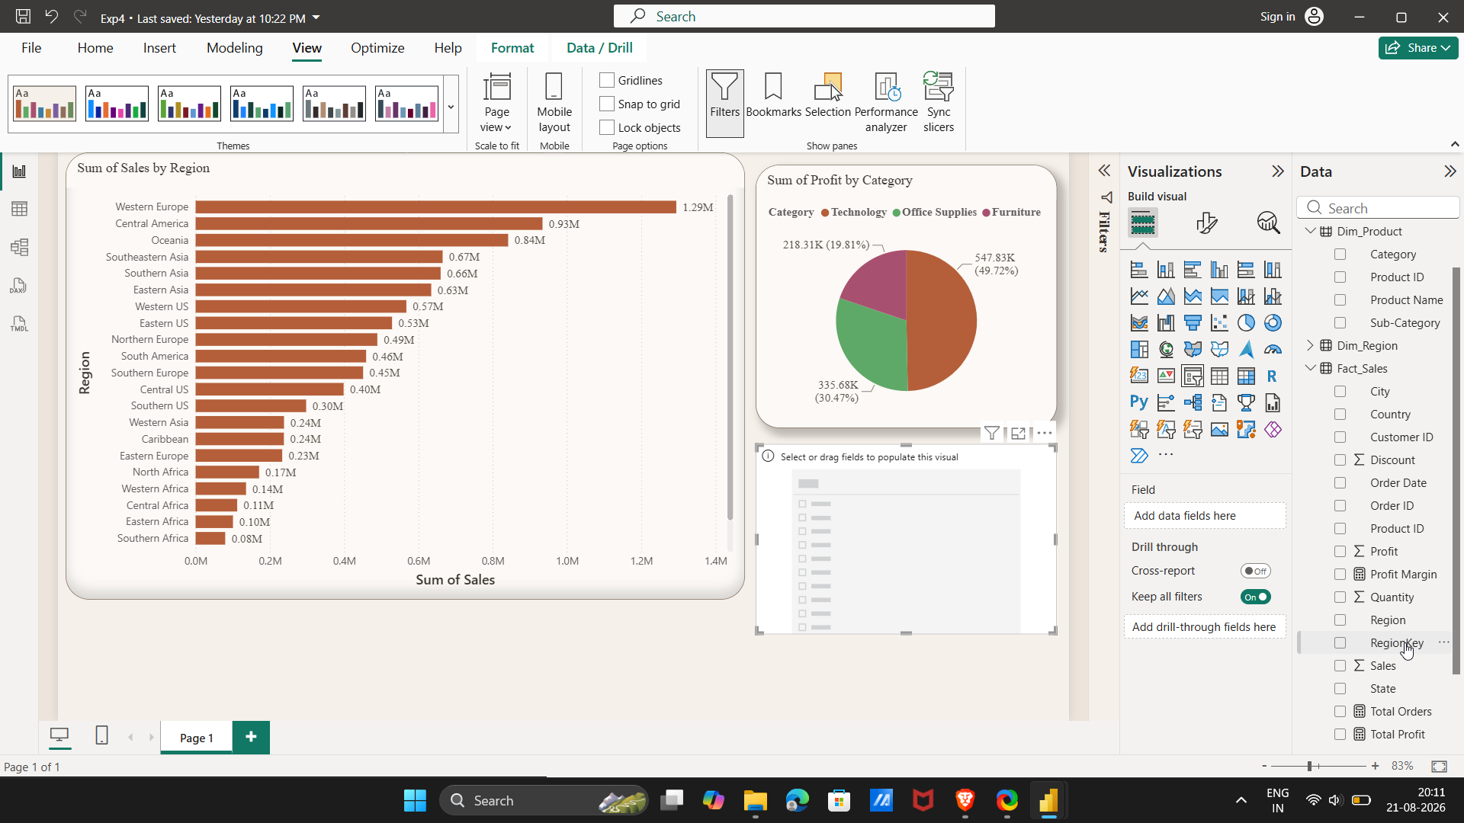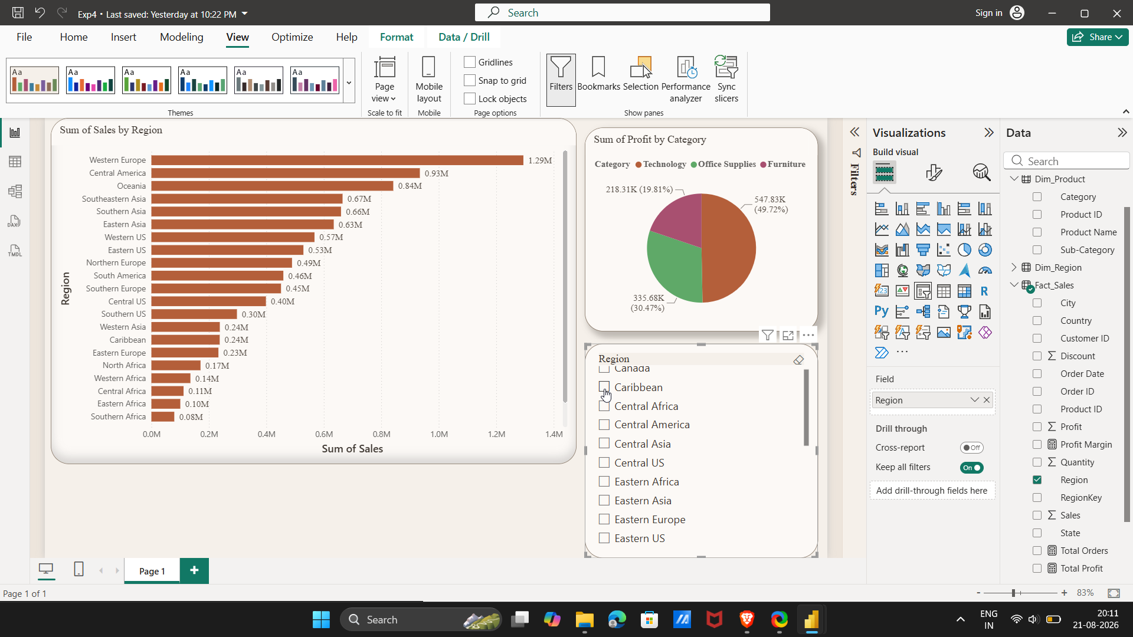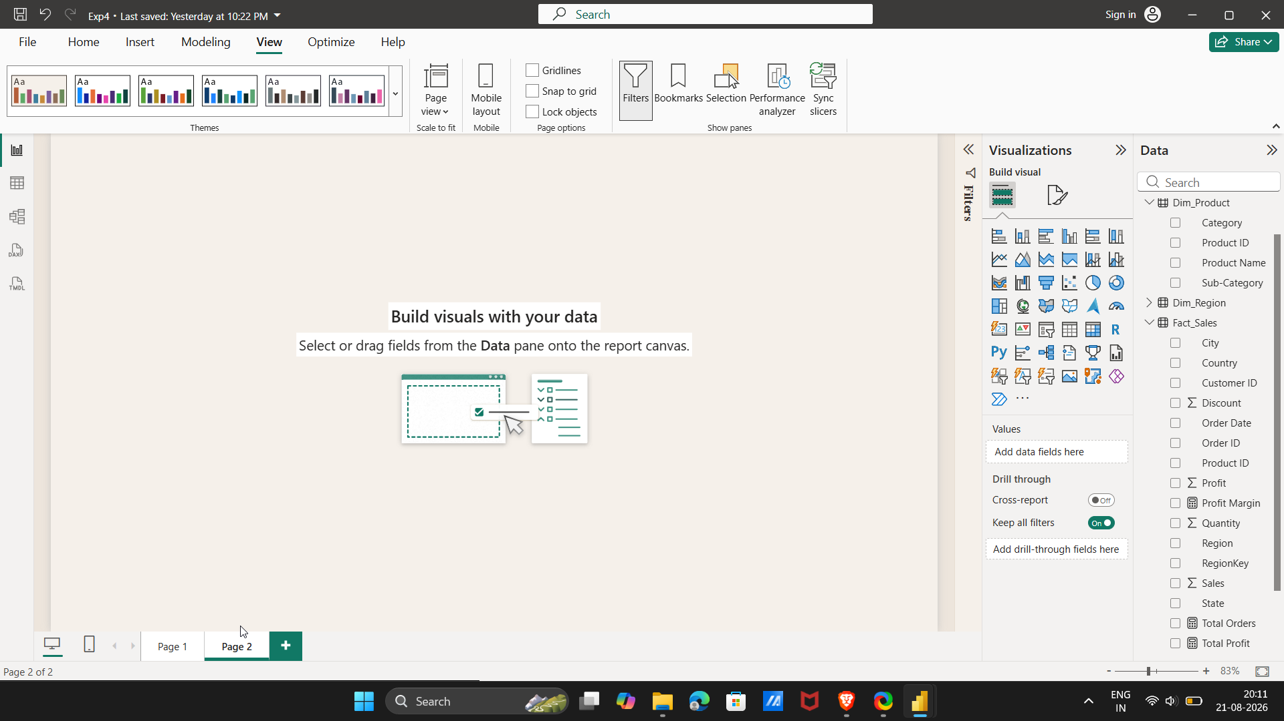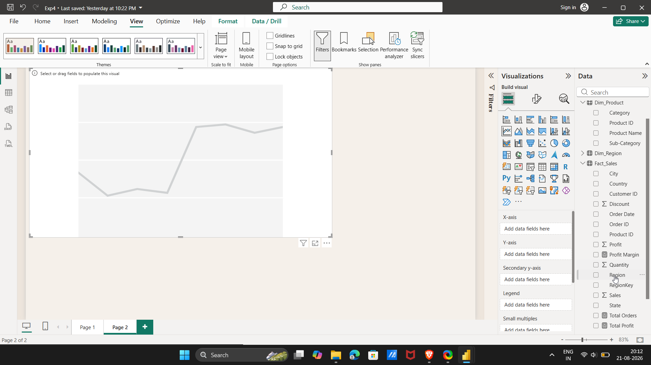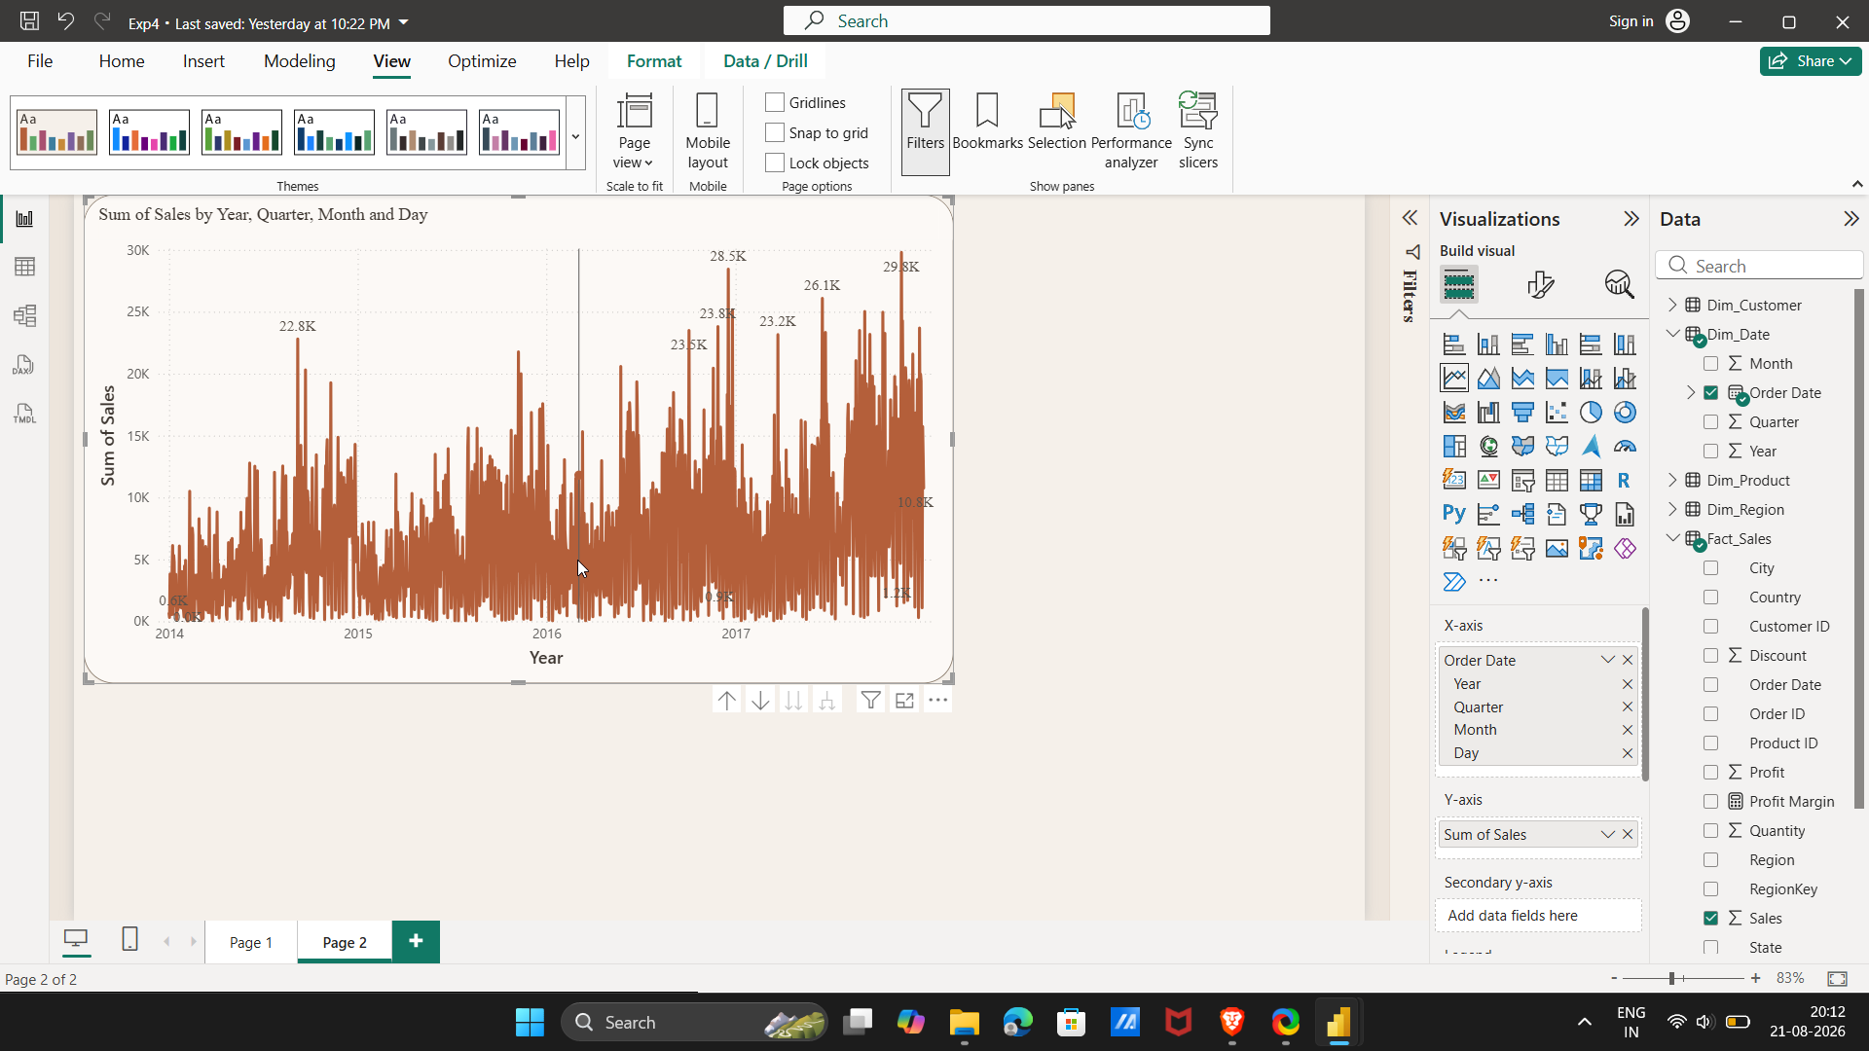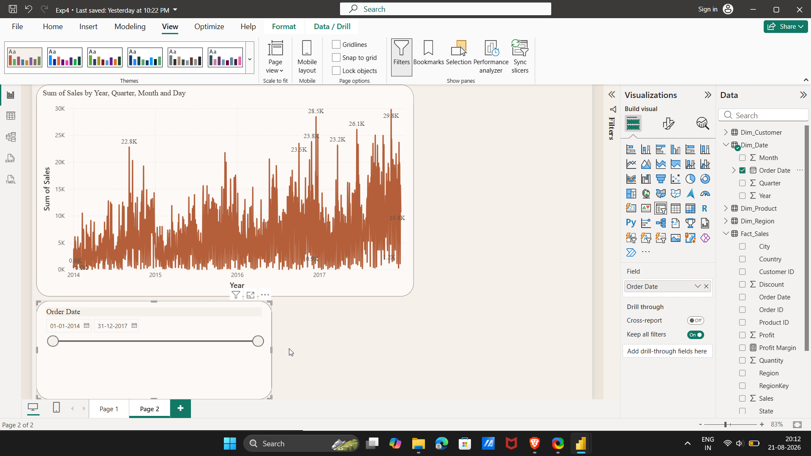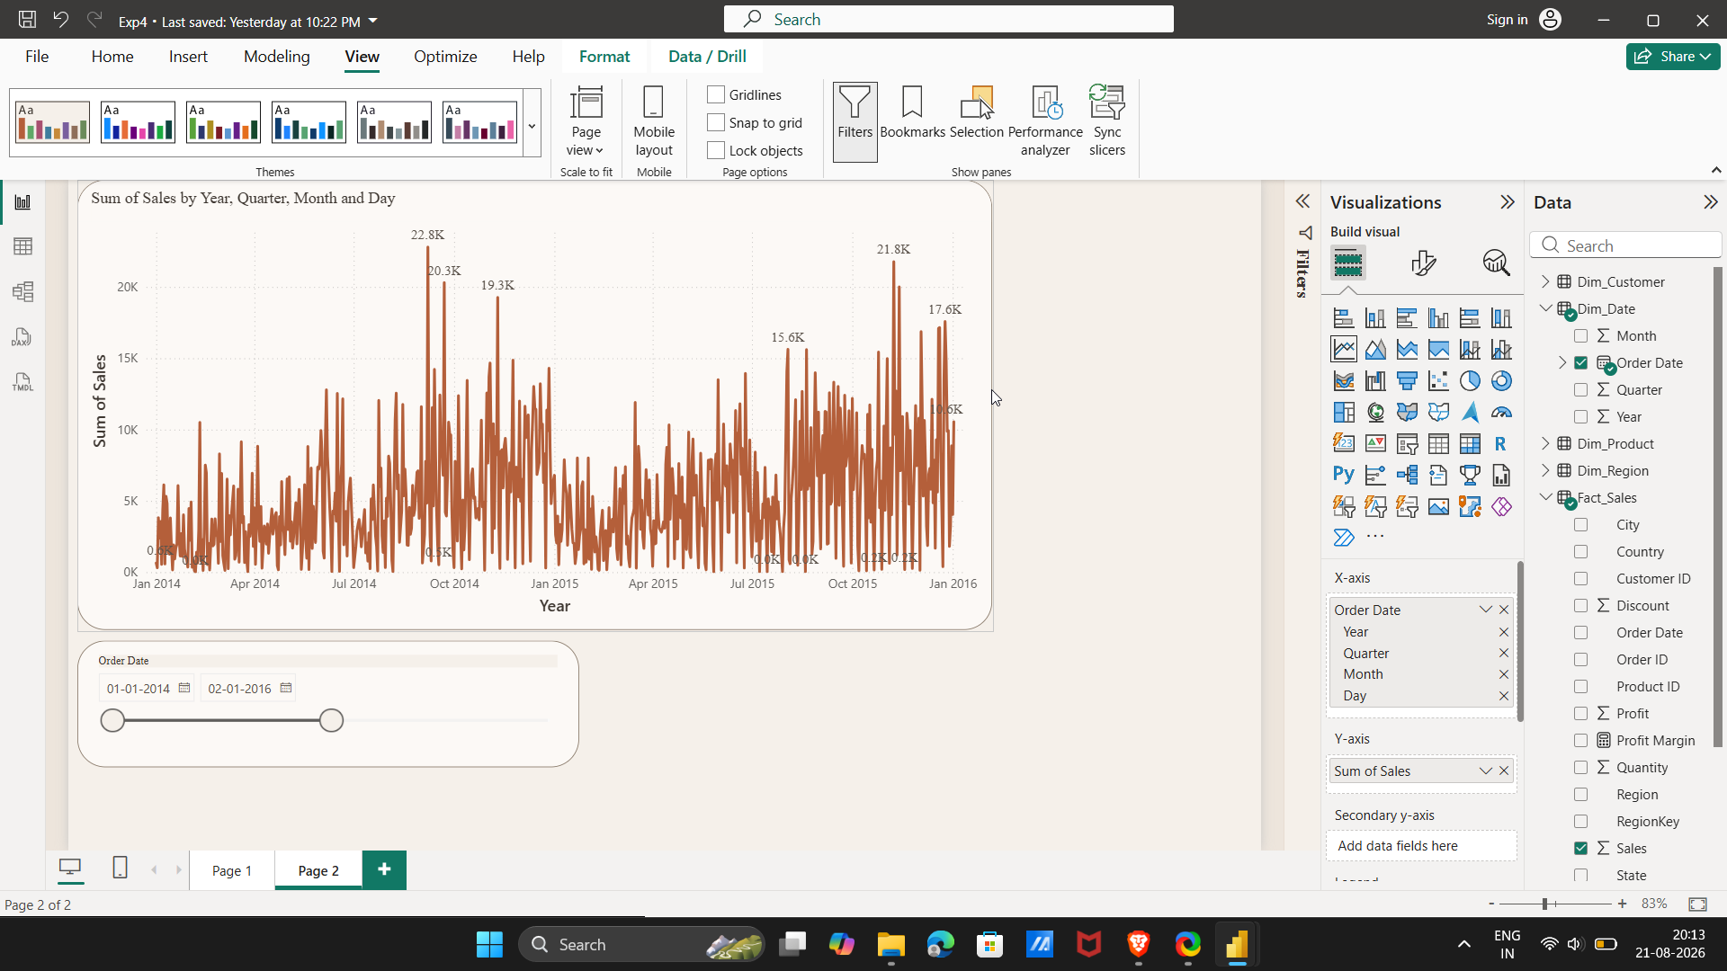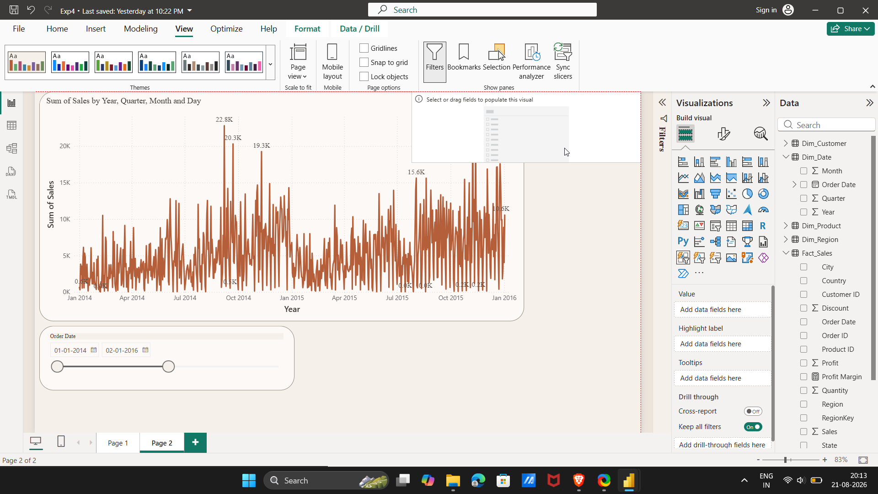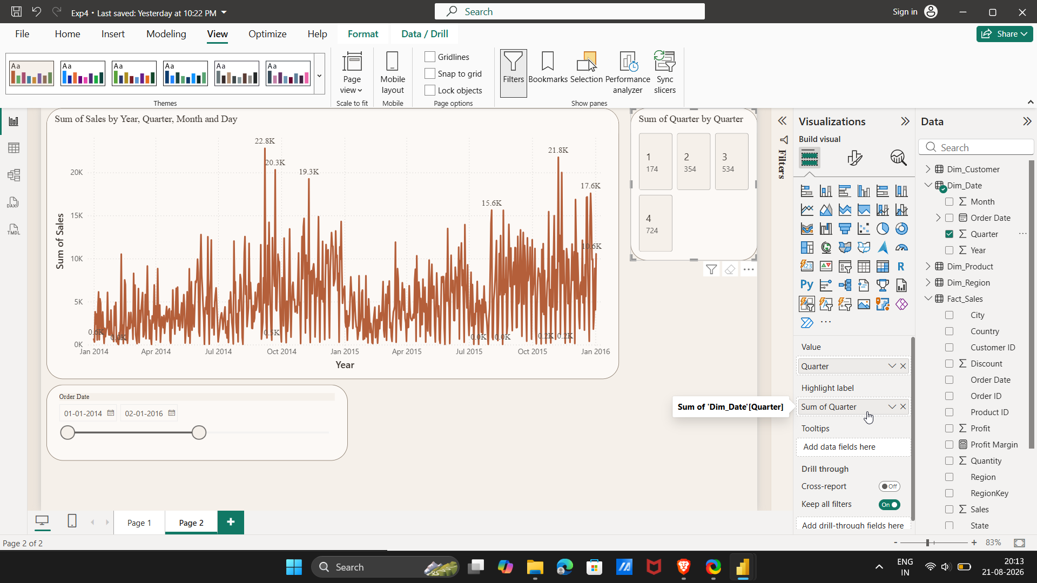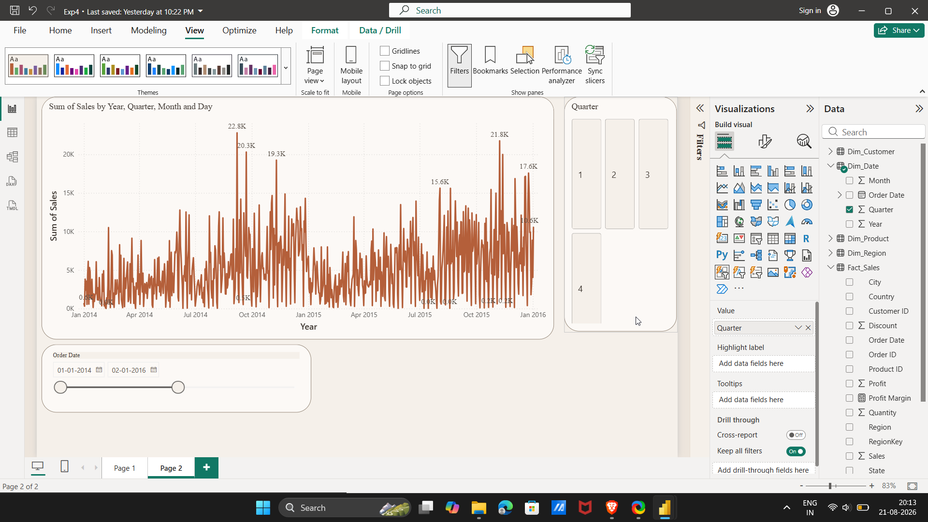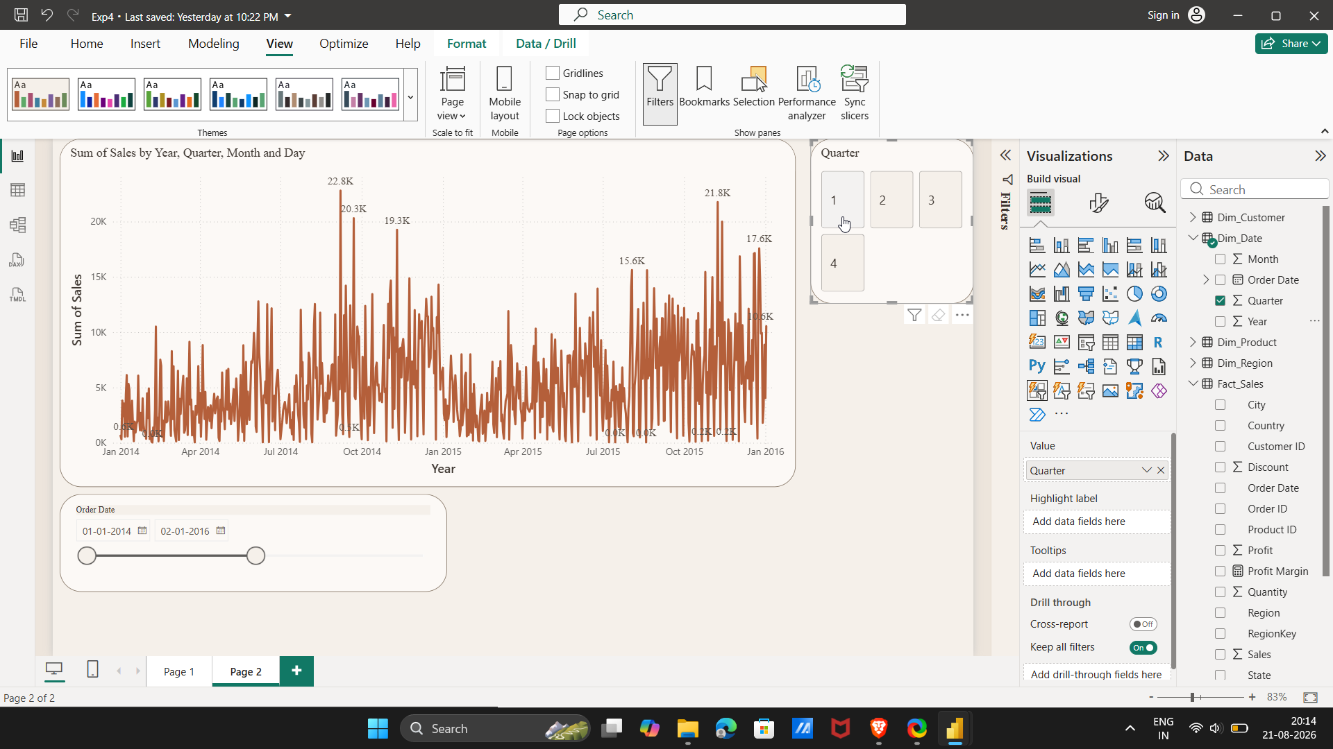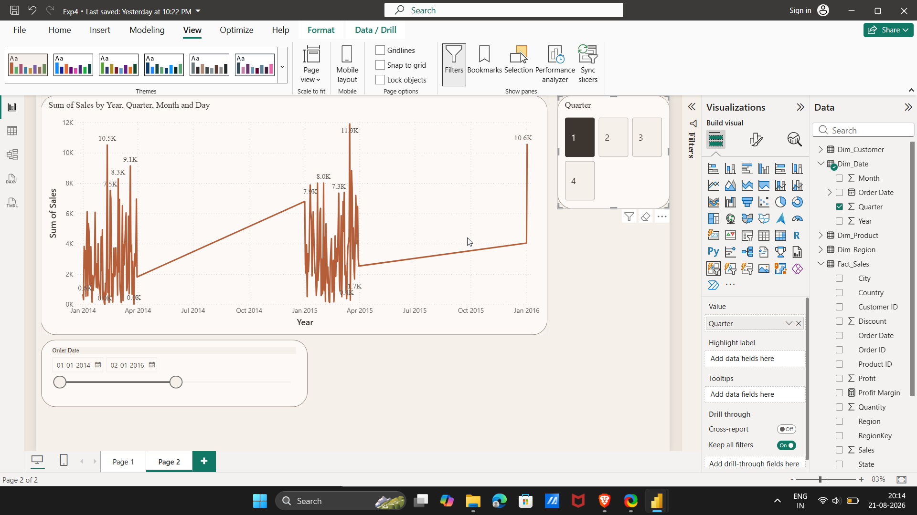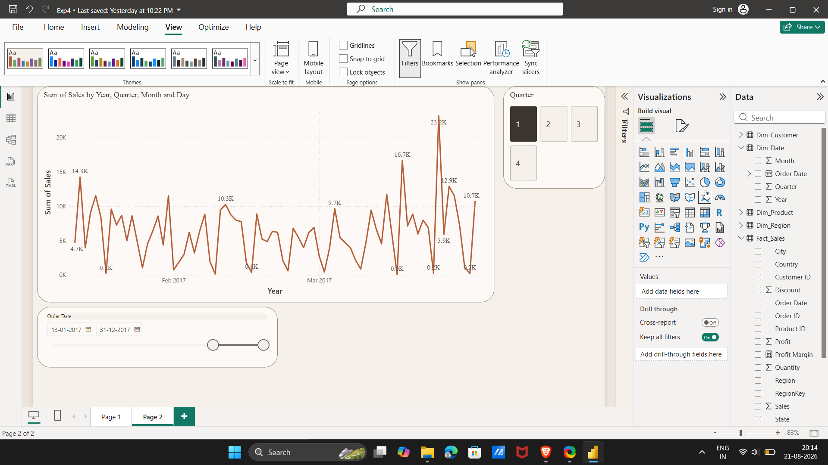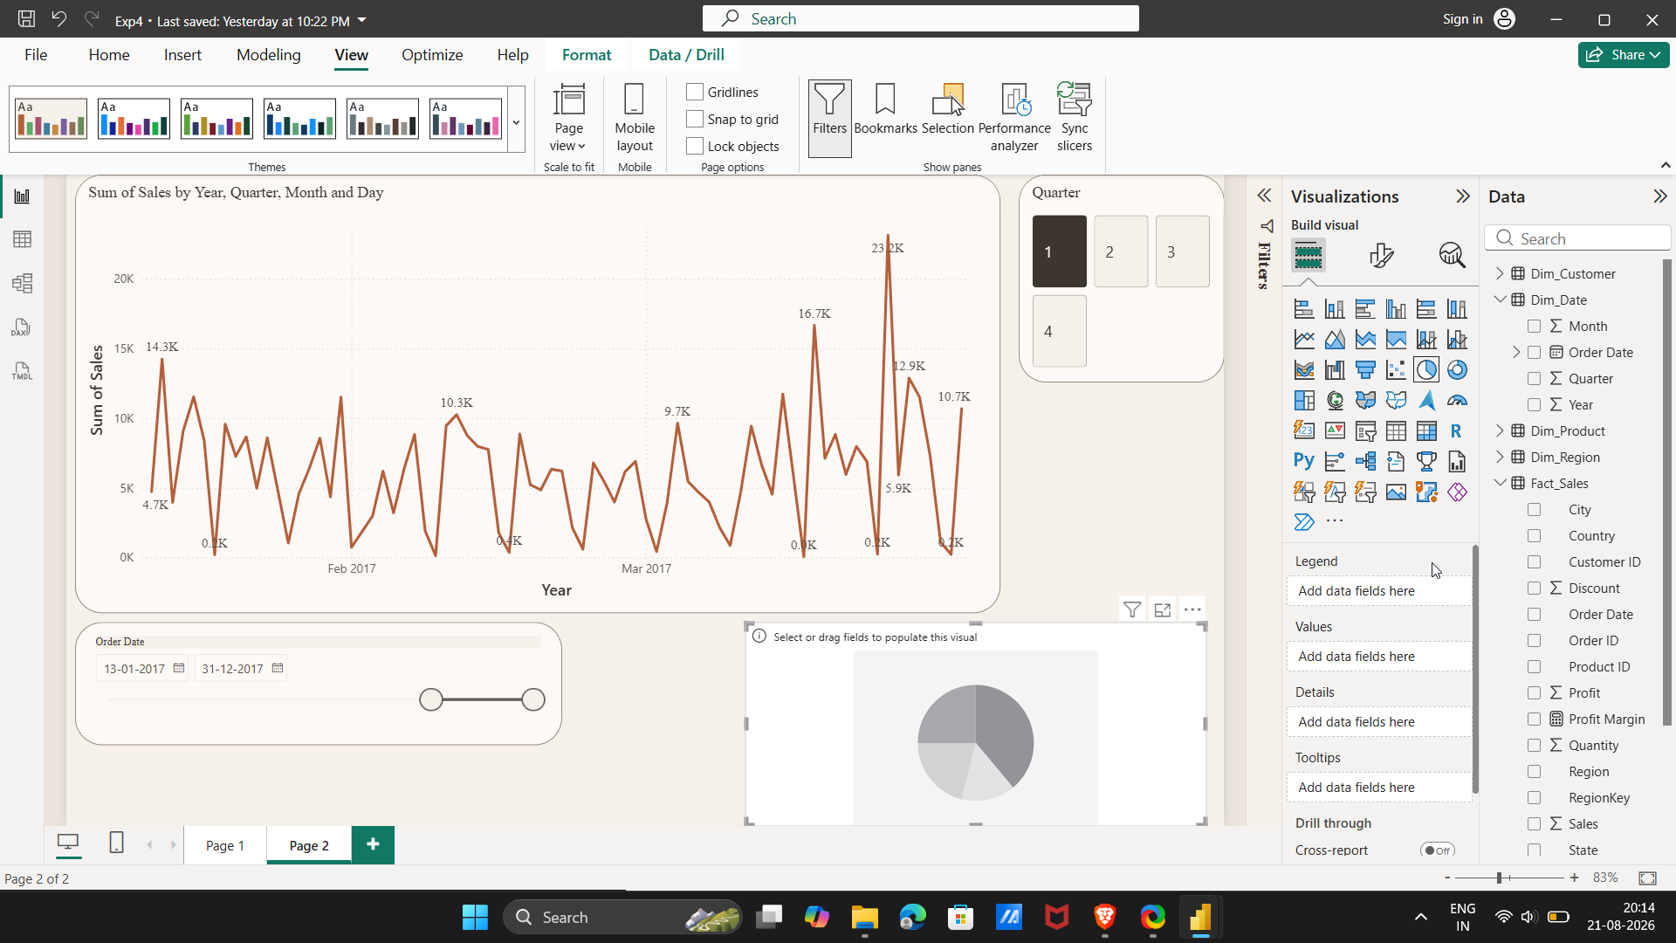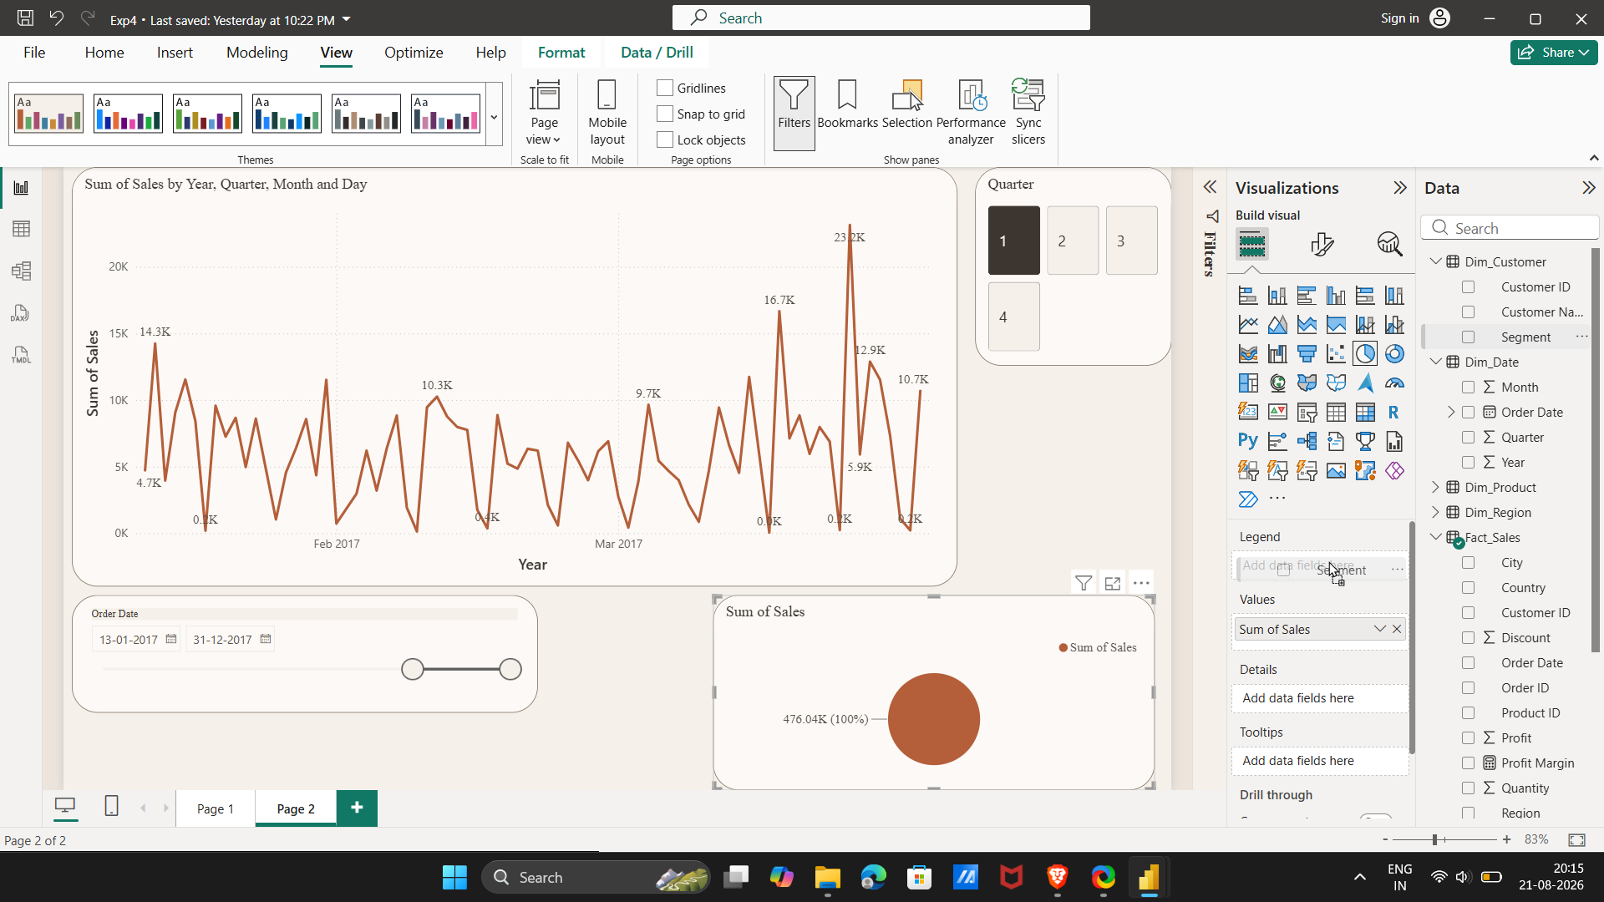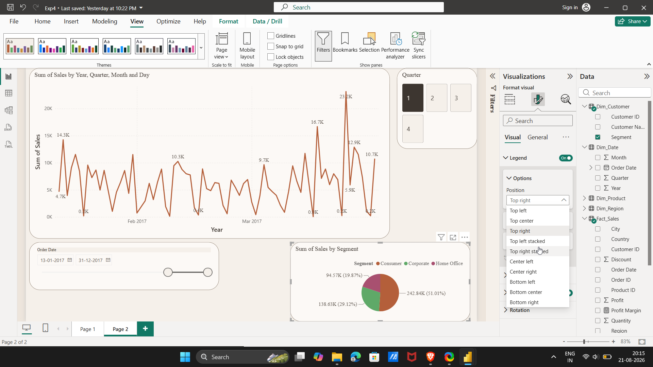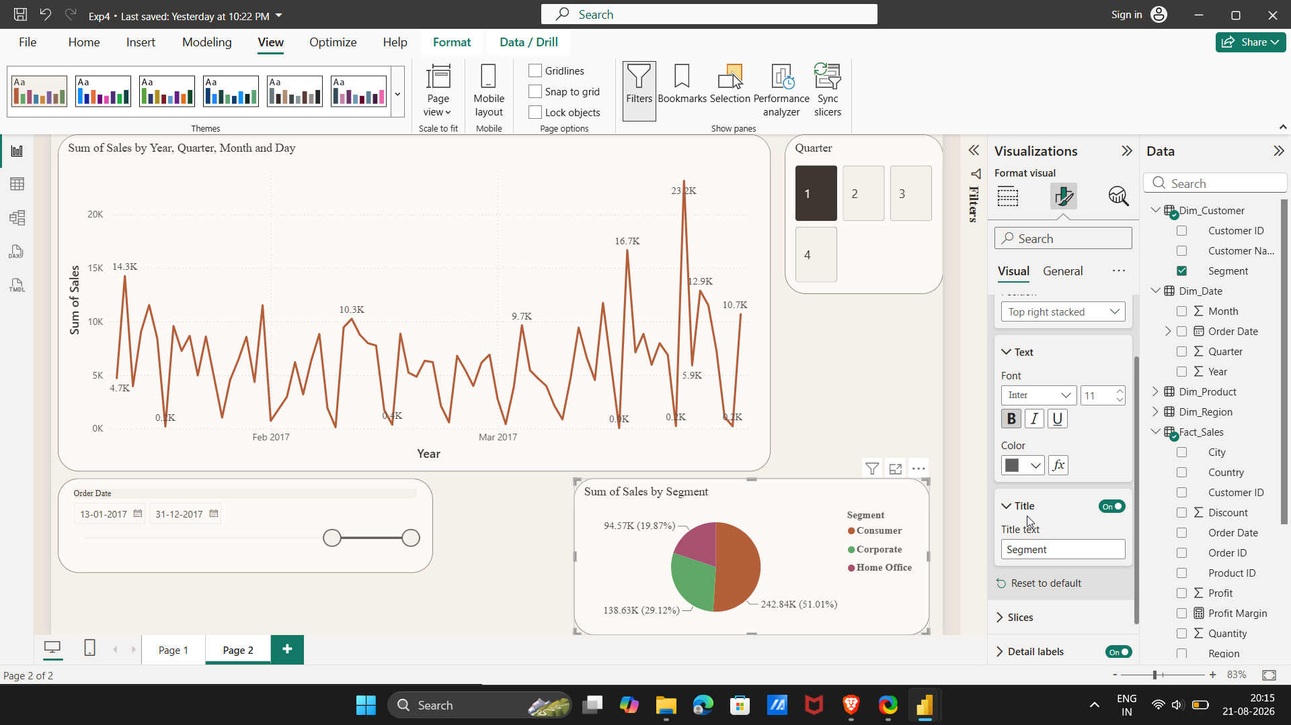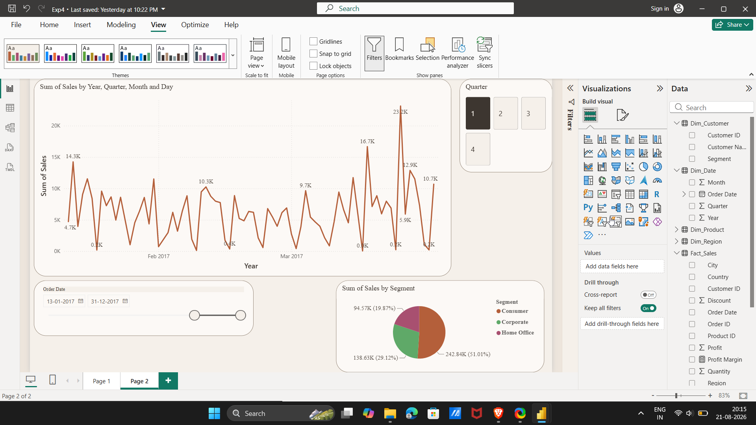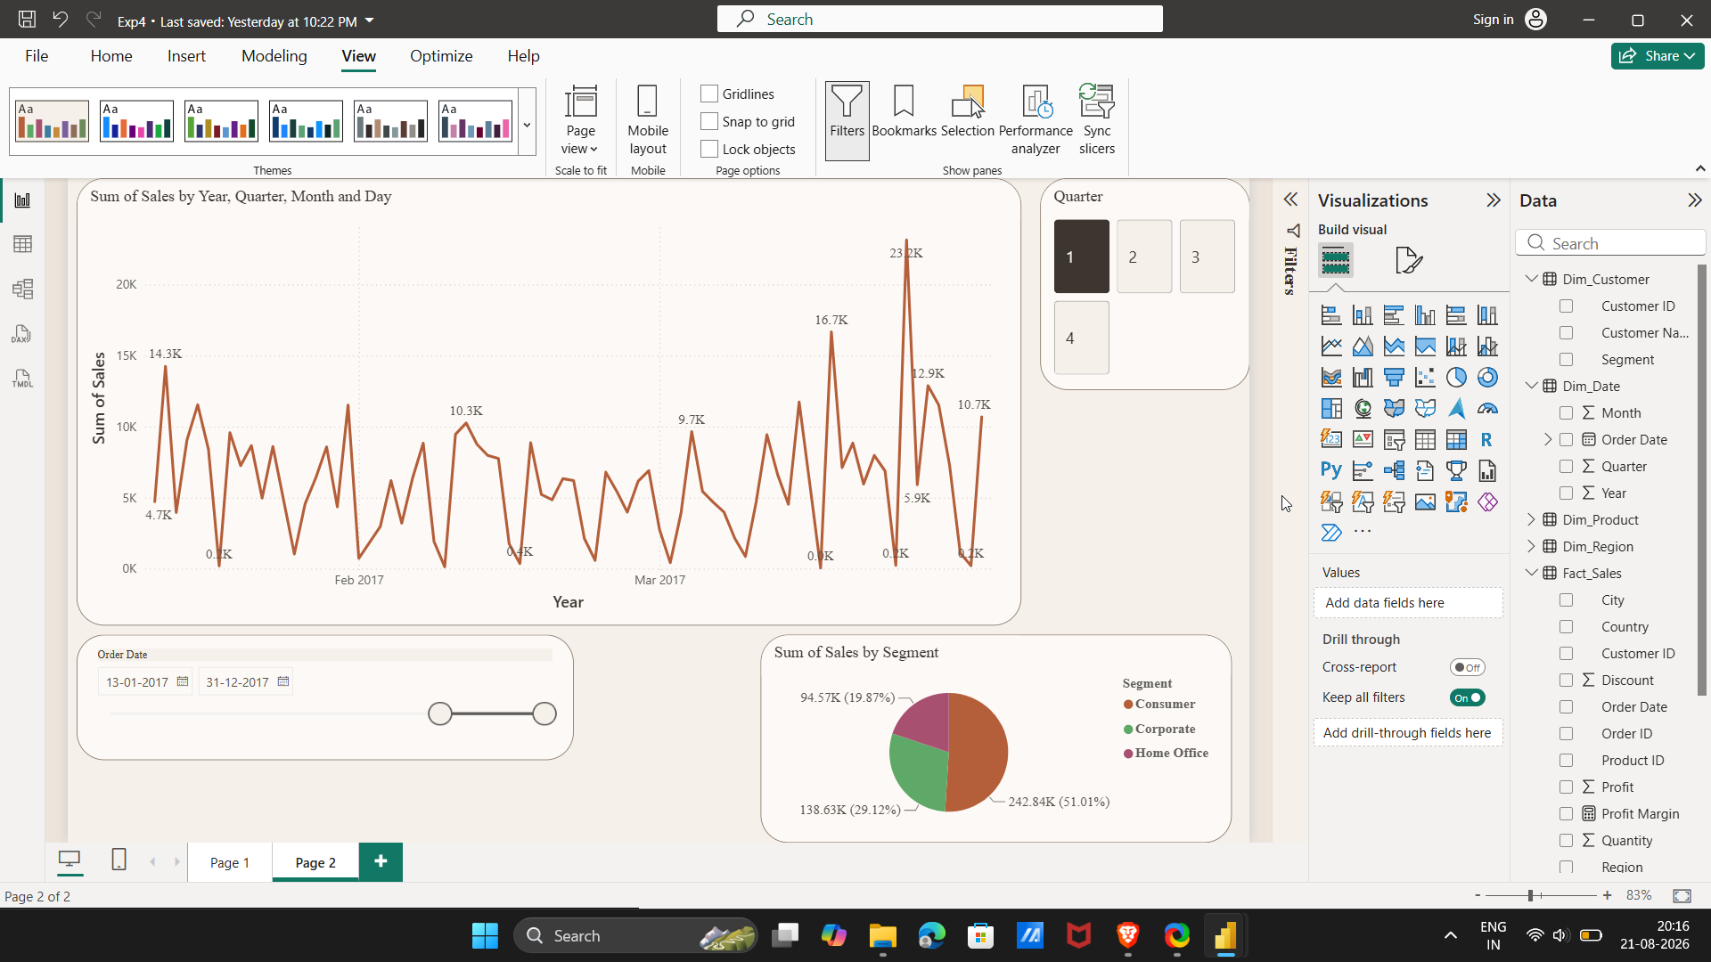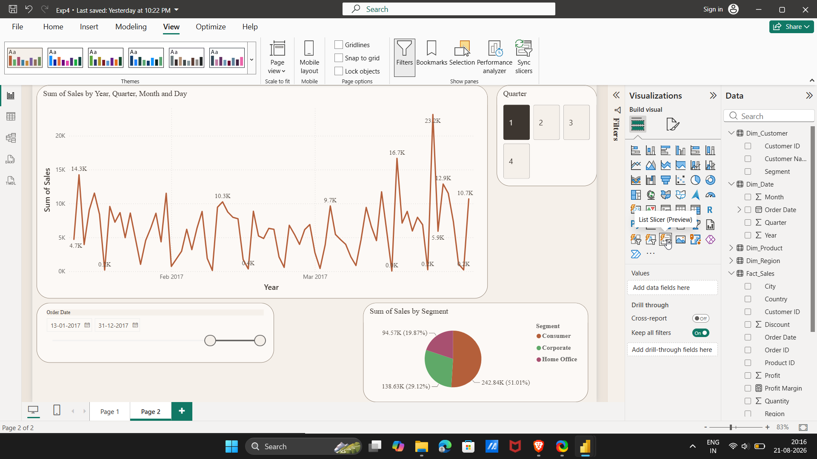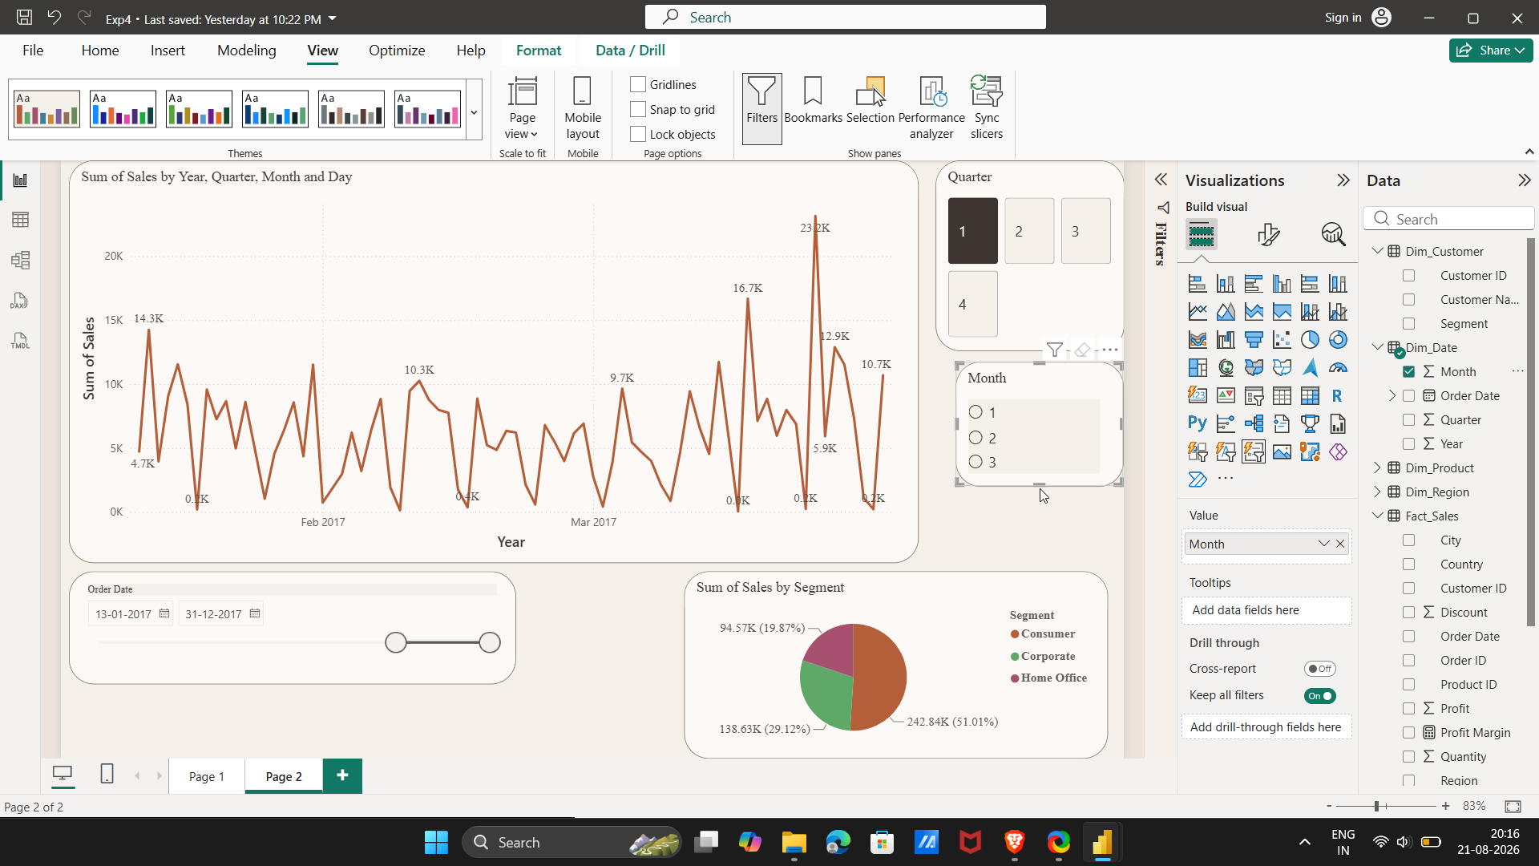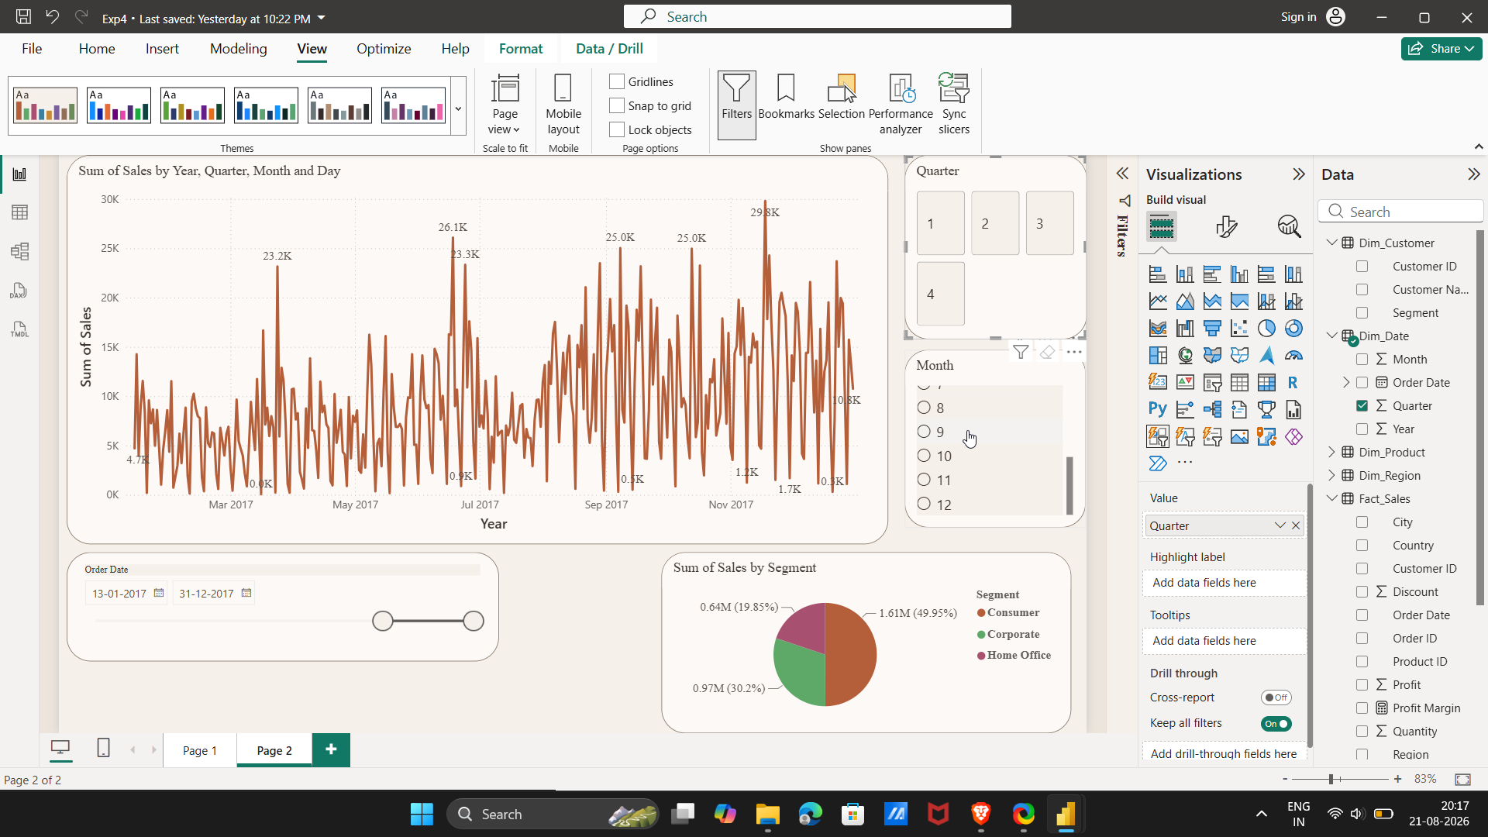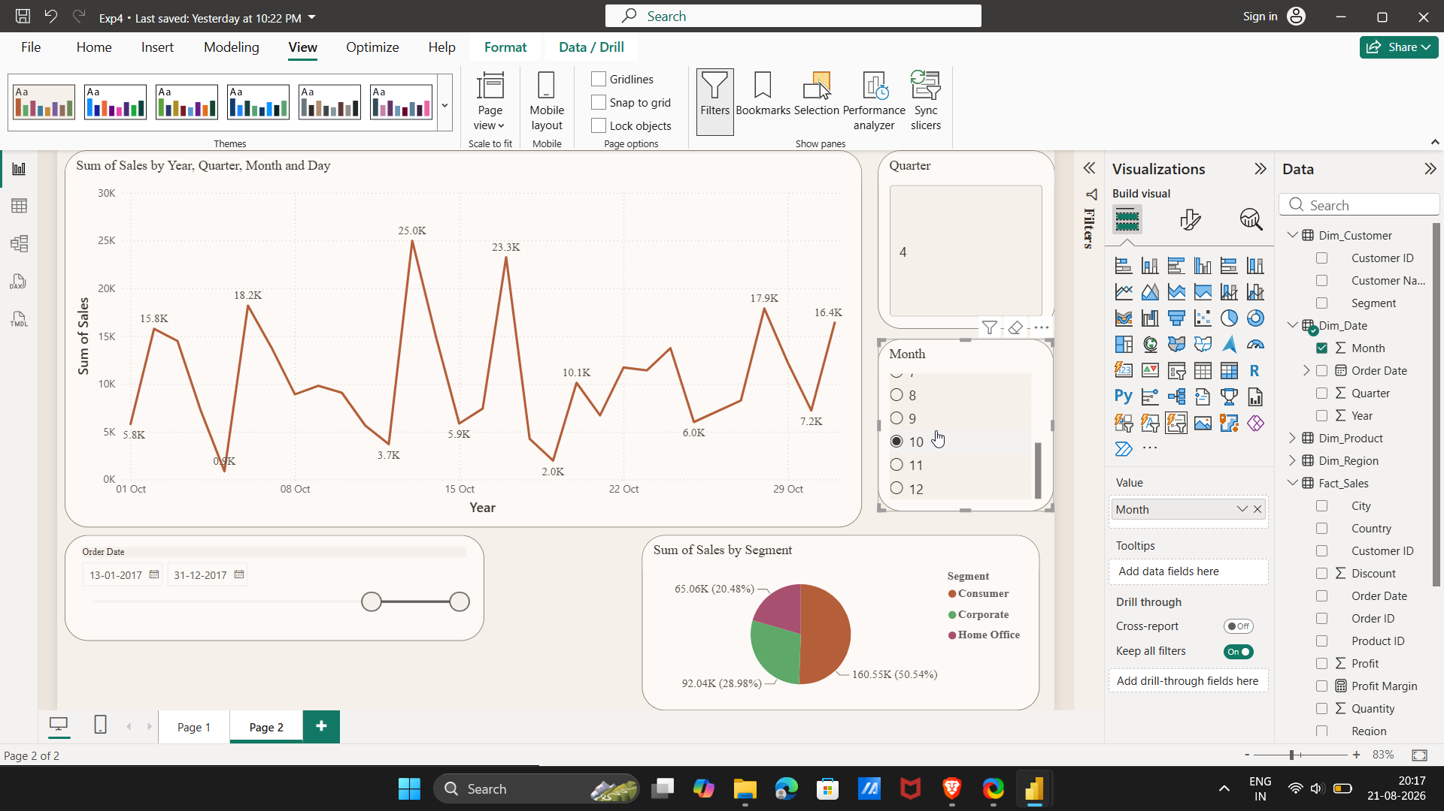

Output
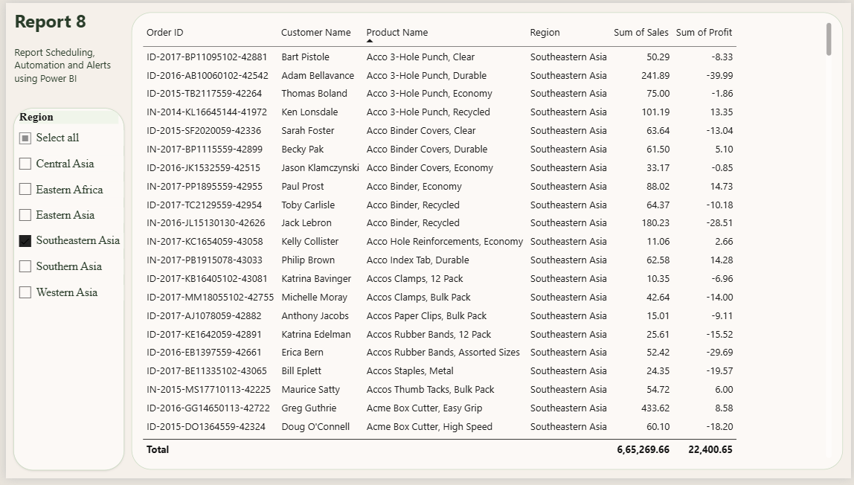
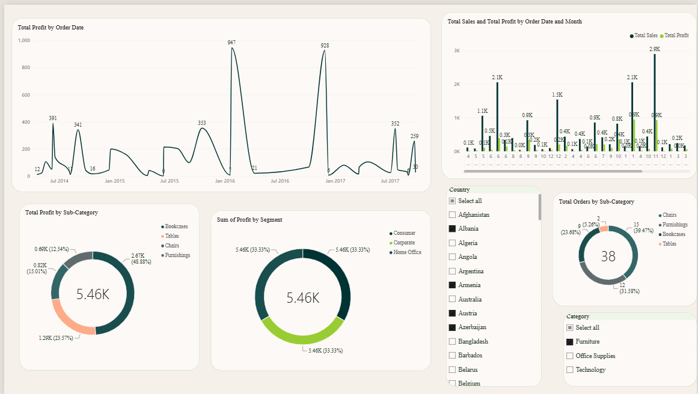
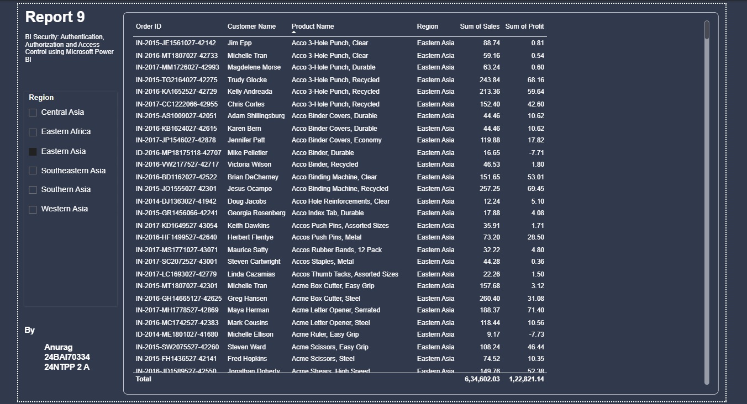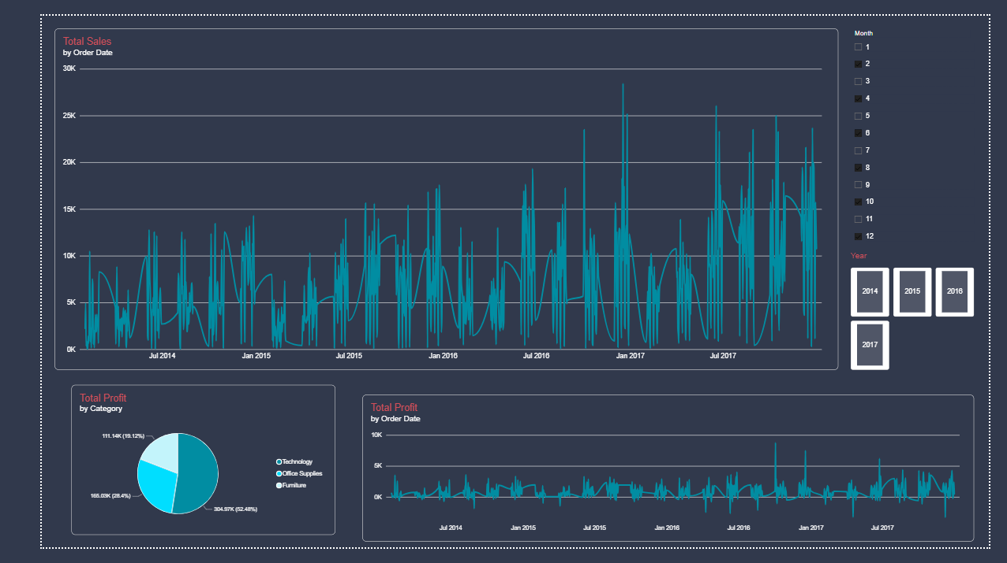
Figure A: Cluster bar chart and Donut chart

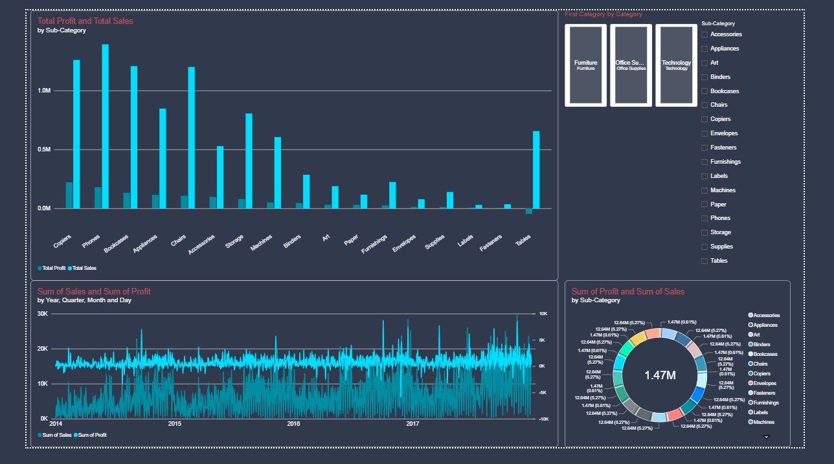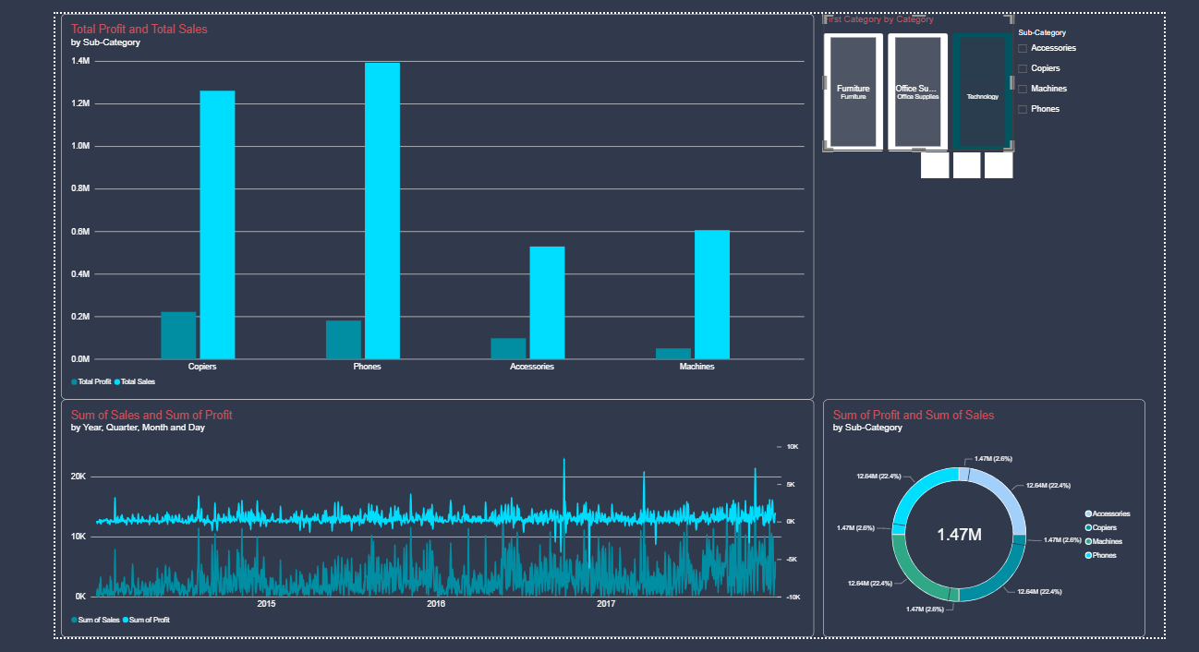
Figure B: Line Chart with Slicer
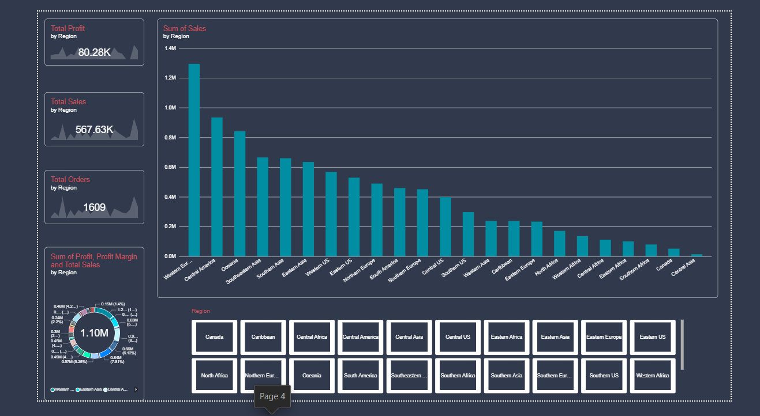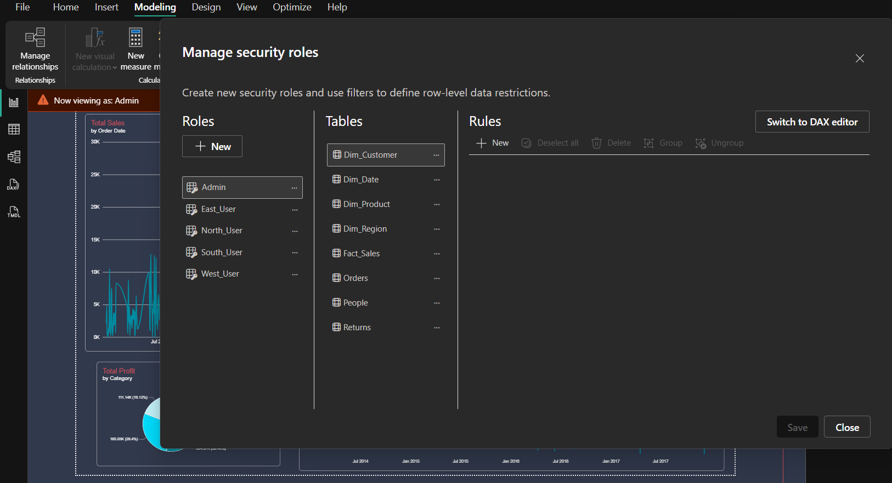
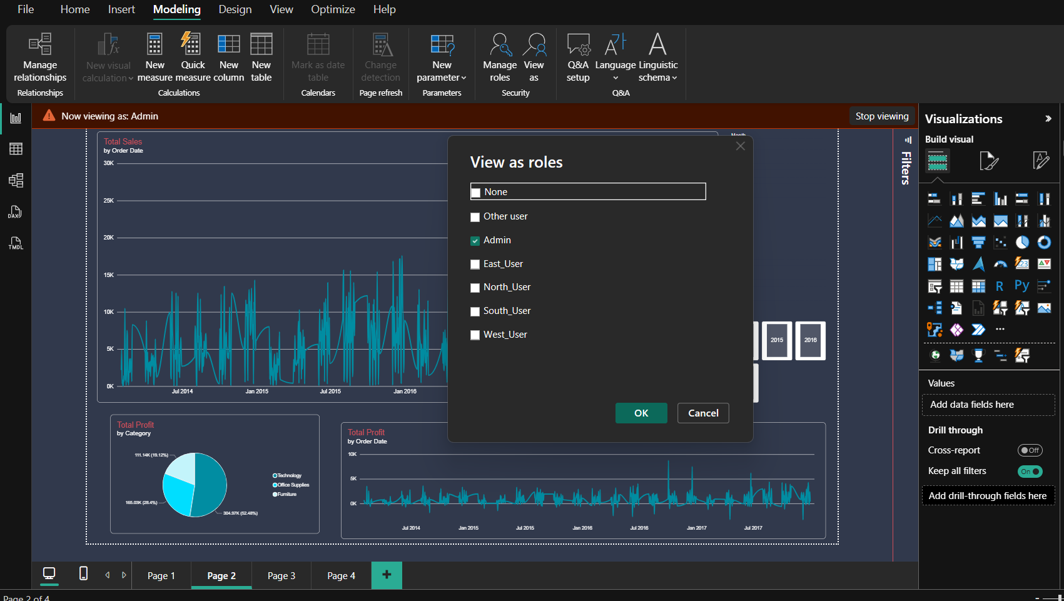

Result
OLAP operations including Slice, Dice, Drill-down, and Drill-up were successfully performed using Microsoft Power BI. Multidimensional analysis was carried out on the Global Superstore dataset, enabling detailed and summarized views of business performance from multiple perspectives.

Learning Outcomes
• Explain OLAP concepts and multidimensional analysis. (CO3-BT3)
• Perform Slice and Dice operations using filters and slicers. (CO3-BT3)
• Create hierarchies and perform Drill-down and Drill-up analysis. (CO5-BT6)
• Interpret analytical insights generated through OLAP operations. (CO3-BT4)
• Design interactive analytical reports for business users. (CO5-BT6)

Text / Reference Books
1. Sharda, Delen & Turban, Business Intelligence and Analytics.
2. Ralph Kimball & Margy Ross, The Data Warehouse Toolkit.
3. Cindi Howson, Successful Business Intelligence.
4. Microsoft Power BI Documentation.

