Task - 1

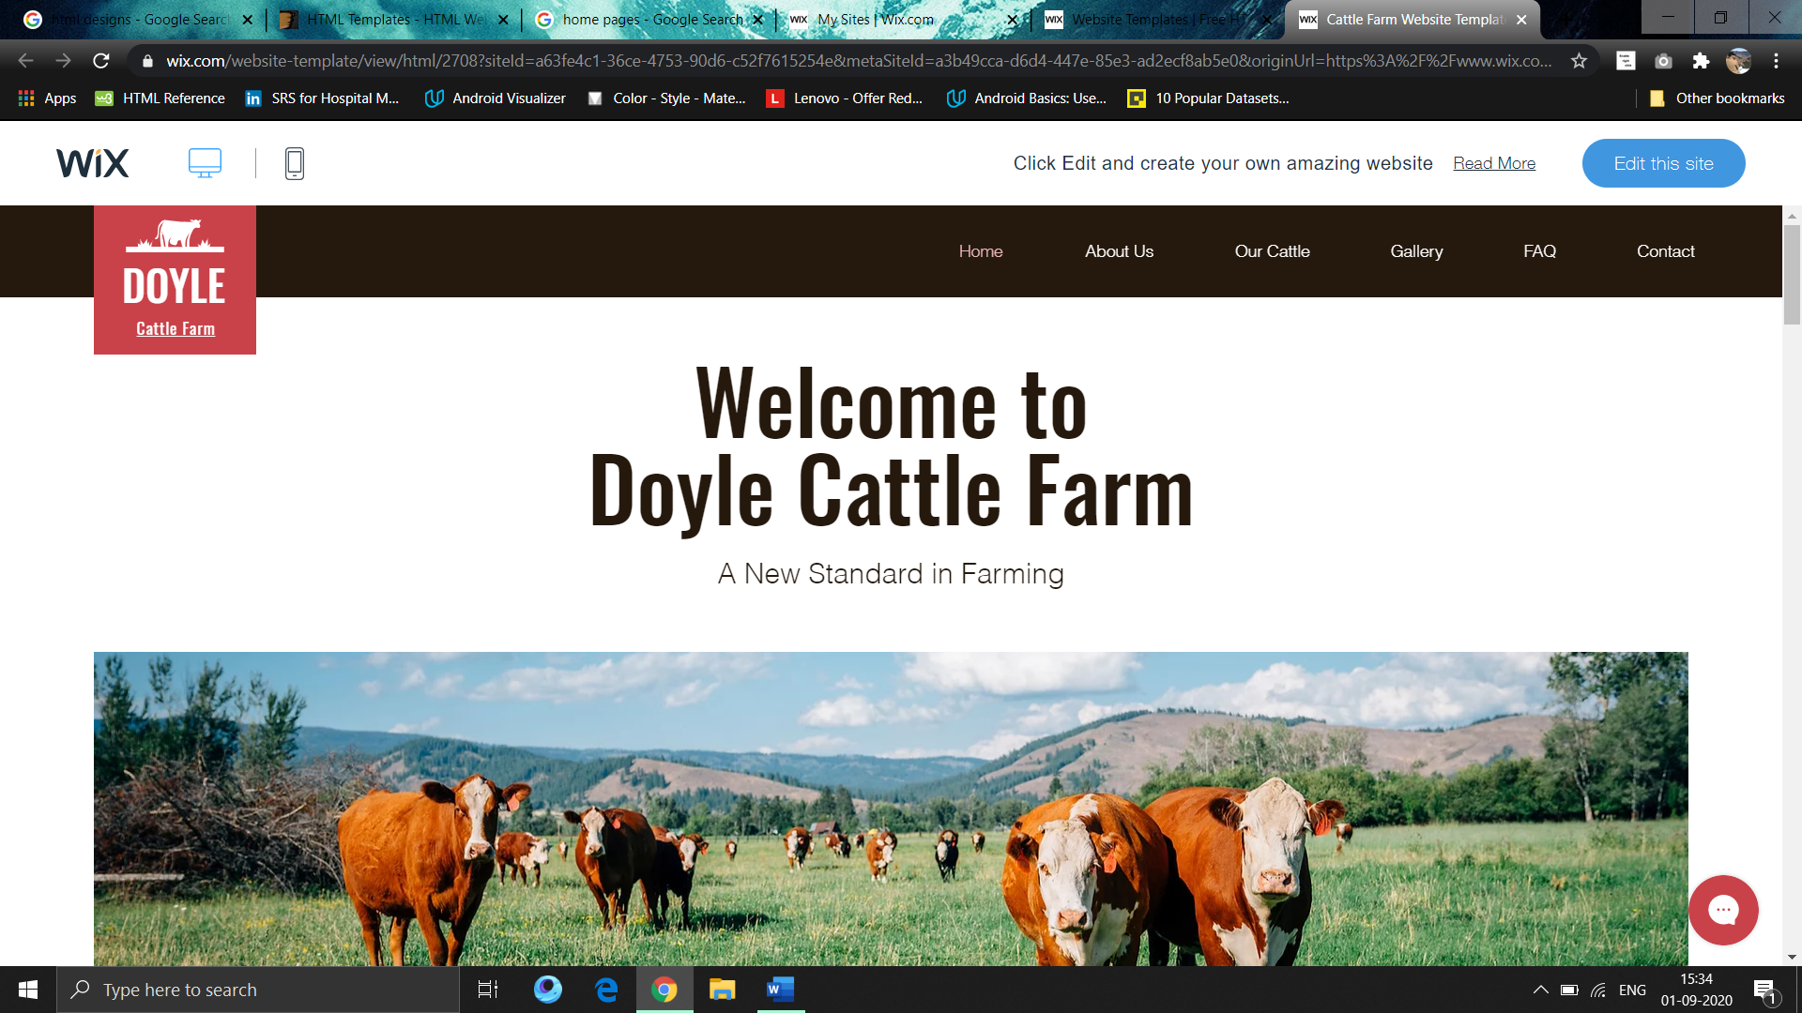

Create a menu bar with a logo and options on the right.

A main heading and a description below the menu-bar.

A picture like the given sample.

Note: Make sure that the website must be completely responsive.

