**[Welcome Speech]**

Host:  
Good [morning/afternoon/evening] everyone,

It is with great pleasure that I welcome you all to this momentous occasion—the inauguration and felicitation ceremony of our new AI & Data Science (AI & DS) department. Today marks a significant milestone as we embark on a new journey towards innovation and excellence in the field of artificial intelligence and data science.

Thank you all for joining us to celebrate this exciting chapter. We are thrilled to have an esteemed group of dignitaries, faculty members, and distinguished guests with us today. Your presence adds great value to this event, and we look forward to an inspiring and memorable ceremony.

Certainly! Here's a comprehensive script for the inauguration and felicitation ceremony of the AI & DS (Artificial Intelligence and Data Science) department:

**[Welcome Speech]**

*Host:*  
Good [morning/afternoon/evening] everyone,

It is with great pleasure that I welcome you all to this momentous occasion—the inauguration and felicitation ceremony of our new AI & Data Science (AI & DS) department. Today marks a significant milestone as we embark on a new journey towards innovation and excellence in the field of artificial intelligence and data science.

Thank you all for joining us to celebrate this exciting chapter. We are thrilled to have an esteemed group of dignitaries, faculty members, and distinguished guests with us today. Your presence adds great value to this event, and we look forward to an inspiring and memorable ceremony.

**[Introduction of Dignitaries]**

*Host:*  
At this point, it is my honor to introduce the dignitaries who have graced us with their presence today:

1. **Dr. Alam n shaikh, [principal]** ( bouquet will be given)
2. **[Name], [vice principal]**
3. **[dr. k sailakshmi parvathi], [hod]**

Please join me in giving them a warm round of applause.

**[Revealing Logo]**

Host:  
Next, we are excited to reveal the logo of our new AI & DS department. This logo represents our commitment to innovation, excellence, and the future of technology.

[Reveal the logo]

We believe this logo symbolizes our vision and values, and we hope it will inspire everyone involved in this department to strive for greatness.

**Overview of association**

It is with great enthusiasm that I share the mission and vision of our new department. Our primary aim is to foster cutting-edge research, innovative solutions, and comprehensive learning opportunities in AI and Data Science.

Over the coming months, we plan to host workshops, seminars, and collaborative projects that will not only enhance our academic environment but also contribute to industry advancements. Our goal is to create a vibrant community of learners and professionals who are passionate about pushing the boundaries of technology.

**[Felicitation of Previous Members]**

Host:  
Now, we would like to take a moment to recognize and felicitate the previous members who have laid the foundation for this department. Their dedication and hard work have been crucial in bringing this vision to life.

[Call on previous members for felicitation]

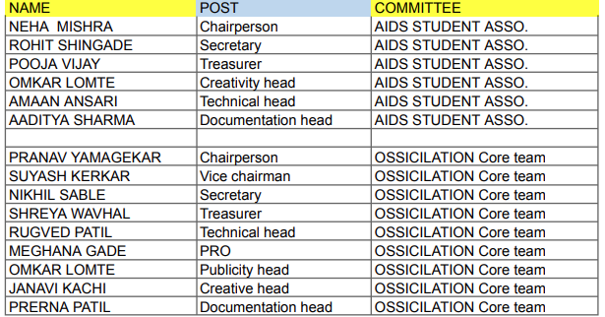

[Introduction of New Committee Members]

Host:  
We are also excited to introduce the new committee members who will lead the AI & DS department. Their expertise and leadership will be vital as we advance our goals.

New members

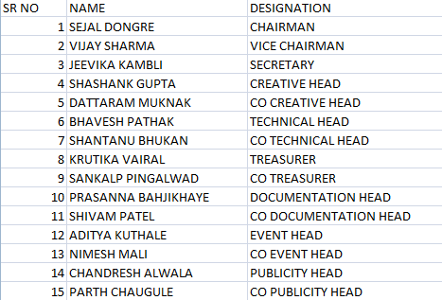

[HOD Speech]

Host:  
To provide insights into the future of our department, I would like to invite our Head of Department, [HOD's Name], to share a few words.

[Principal speech]

Host:  
We are now privileged to hear from our Principal speech

[Announcement of Upcoming Events]

Host:  
Before we conclude, I would like to announce some of the upcoming events organized by the AI & DS department:

[Vote of Thanks]

Host:  
In closing, I would like to extend my heartfelt thanks to everyone who has made today’s event possible.A special thank you to our dignitaries, our Chief Guest, and all those who have contributed to the establishment of the AI & DS department. Your support and dedication are truly appreciated.

To our guests, faculty, and students, thank you for your presence and enthusiasm. Let us move forward with excitement and commitment as we begin this new chapter.

Thank you all once again, and have a wonderful [day/afternoon/evening].