**Dashboard Documentation**

Xml Document Detail:

**<URL >**: URL is the parent tag of the xml all the other tags are enclosed in the url tag. The details of the internal tags are below :

**<PATHDETAILS>**: PATHDETAILS known as the header tag of the xml this contain the basic information of the xml. Below are the details of the path you have to be configured as and when required.

* + **<D_TMP>** : This path is used in the downloading the mis. If the remote path isshow mounted on the server where outfile is being created.

<D_TMP>/tmp/misdownloadfiles/</D_TMP>

* + **<D_FINAL>** : This is the location on the server from where the streaming of the file is done to the client machine.

<D_FINAL>/tmp/misdownloadfiles/</D_FINAL>

* + **<U_TMP >**: Path where all the uploaded files are stored on the server.

<U_TMP>/logs/upload/</U_TMP>

* + **<DND_FILE>** : Location where dnd file is created and stored and zipped unzipped before and after filtering.

<SPEAKERPATH>/tmp/recording/daburreal/</SPEAKERPATH>

* + **<LOGPATH>** : Path where logs of the xml is created on the server.

<LOGPATH>E:/logs/dashboard/</LOGPATH>

* + **<SOXCOMMAND>** : This tag is added under PATHDETAIL Section with this is required when you want to convert a mp3 file to wav file.

<SOXCOMMAND>D:/TEMP/AUDIO/ "source" -r 8k -b 8 -c 1 "target"</SOXCOMMAND>

* + **<SPEAKERPATH>** : Path of the sound files are stored.

<SPEAKERPATH>E:/EntUtilities/ApplicationFolder/promptPath/</SPEAKERPATH>

* + **<UTILITYPATH>**: Path of the external utility if you want to execute any before or after uploading your data file.

<UTILITYPATH>E:/</UTILITYPATH>

* + **<TABLOGOIMAGE>** : this will contain the name of the image or http url location of the image if you want to access the tab logo image online.

<TABLOGOIMAGE height=”” width=”” padding-left='' padding-right='' padding-top='' paddingbottom=''>https://images.google.com/images/branding/googlelogo/2x/googlelogo_color_120x44dp.png</TABLOGOIMAGE>

* + **<IMAGE_NAME>**: Name of the image file which you want to choose as the logo of the mis and the addressbar icon, *height,width,padding-left,padding-right,padding-top,padding-bottom* attributes are optional. You can also provide the http url location of the image.

<IMAGE_NAME height=”” width=”” padding-left='' padding-right='' padding-top='' paddingbottom=''>iim.jpg</IMAGE_NAME>

* + **<HEADING> :** Heading text is used at the top of the page as a header message of all the tabs of the mis.
  + <HEADING>One97 Communications</HEADING>
  + **<SOXCOMMAND> :** This tag is added under PATHDETAIL Section with this is required when you want to convert a mp3 file to wav file.

<SOXCOMMAND>D:/TEMP/AUDIO/ "source" -r 8k -b 8 -c 1 "target"</SOXCOMMAND>

* + **<SKIN>** : Skin is known as the theme of the GUI there are total 19 reports available with the dashboard. Report,report1,report2.....report18 and some additional themes too.

<SKIN>report</SKIN>

* + **<IP>** : This is used when you configured multiple datasource in the struts configuration file and want to use the specific one then you have to define the name of that dsn otherwise you have to put the LOCAL which is default datasource of the struts-config.xml file.

<IP>local</IP>

* + **<UPLOADERIP> :** In this you are able to provide the dataSource name which exist on struts configuration file then that particular datasource is used for uploading and resetting the base. Remember this is not used in the case of DNDSCRUBBING if you want to use the same for dnd scrubbing too then you have to mount the dndscrubbing path between both configured dataSource server. If skip this tag then IP tag datasource is used for all the database operation include uploading too.

<UPLOADERIP>dbserver32</UPLOADERIP>

* + **<HEADERREQUIRED> :**  YES or NO as per the requirement whether you want to show the header or not which contain the organization logo and name etc. If skip this tag then YES is applicable, height,width,padding-left,padding-right,padding-top,padding-bottom attributes are optional..

<HEADERREQUIRED>NO</ HEADERREQUIRED>

* + **<MENUREQUIRED>** : YES or NO as per the requirement whether you want to show the menu in your panel or not. If you skip this tag then YES is applicable.

<MENUREQUIRED>NO</ MENUREQUIRED>

* + **<MENUORDER> :** This tag is added under the PATHDETAILS if you skip this tag then default style is applicable.

<MENUORDER>

<MENU>MIS</MENU>

<MENU>UPLOADER</MENU>

<MENU>RESET</MENU>

<MENU>EXTERNALLINKS</MENU>

<MENU>INSERT</MENU>

</MENUORDER>

* + **<MENUSTYLE> :** HORIZONTAL /DROPDOWN if you skip this tag then HORIZONTAL menu style is applicable.

<MENUSTYLE>HORIZONTAL</MENUSTYLE>

* + **<LOGINAPI>** AND **<LOGOUTAPI>** : This is used when you want to want to send the information like USERNAME(login username),ID(login id generated),DATETIME,IP(remote server ip)

<LOGINAPI>http://localhost:8080/send_data?

username=&lt;USERNAME&gt;&amp;login_time=&lt;DATETIME&gt;&amp;server_ip=&lt;IP&gt;&amp;login_id=&lt;I

D&gt;</LOGINAPI>

<LOGOUTAPI>http://localhost:8080/logout.do?

username=&lt;USERNAME&gt;&amp;login_time=&lt;DATETIME&gt;&amp;server_ip=&lt;IP&gt;&amp;login_id=&lt;I

D&gt;</LOGOUTAPI>

* + **<LOGINQUERY>** AND **<LOGOUTQUERY> :** This is used when you want to execute addition insert or update on login or logout. You can pass the details in this likeUSERNAME, DATETIME,IP,ID .

<LOGINQUERY>INSERT INTO db1.login_table set

login_name='&lt;USERNAME&gt;',login_id='&lt;ID&gt;',server_ip='&lt;IP&gt;',login_time='&lt;DATETIME&gt;'</LO

GINQUERY>

* + **<RESET_PASSWORD> :** This is used to enable the reset password option after login.

<RESET_PASSWORD>TRUE</RESET_PASSWORD>

To regenerate the password we have to use below query

SELECT CONCAT("*",SHA1(UNHEX(SHA1("dashboard_testing"))))

* + **<WHITELISTED_IP> :** This is used if you want that the access of the mis will be provided on the limited number of PCs. You can provide the multiple ips seperated from , operator or you can use regular expression to whitelist a particular domain. With the help of *. You can also provide the whitelisted for the database based user with the help of **dashboard_login_master** table’s attribute named whitelisted_ip.

<WHITELISTED_IP>10.0.28.42,203.122.59.23</WHITELISTED_IP>

**Example :**

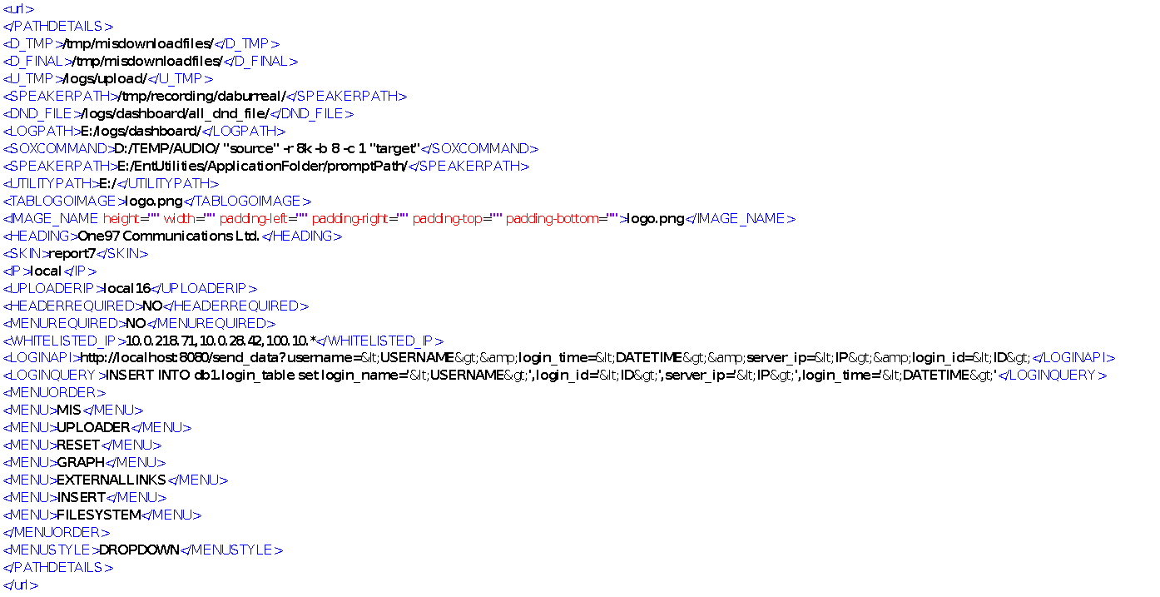

**<UPLOADER>**

Next Section In the dashboard is **Uploader** Section :

With the help of the uploader tag you are able to upload the prompts csv files in the database transfer the prompts from uploaded server to the application server one or n number of servers possible.

Desciption of the tags contain under this section is as below :

**<DBDETAILS>** : This contain the dbname and title attribute.

* 1. dbname : used to set the database name in you are going to perform.
  2. title : used to set the title of the tab

There are multiple tags comes under DBDETAILS tag :

* **<PASSWORD>** : contains the password of the mis if want to use encoded password then you have to use ~ before ecoded password.
* **<MAXUPLOADSIZE>** : Size of file allowed to upload (Size is provided in Kb)
* **<RESETTABNAME> :** With the help of this tag you are able to give the name to the reset panel previous the name of the reset panel is hard coded in the code but now you are able to provide the same with the help of this tag.
* **<BASE_DISTRIBUTOR>** : With the help of this tag you are able to distribute the uploaded base across multiple servers

**<BASE_DISTRIBUTOR>bajaj</BASE_DISTRIBUTOR>** here bajaj is the unique identifier of the uploader. The base uploader base distribution ports are defined in the table name dashboard_base_distributor

* **<TABLENAME>** : contains the name of the table in which the data is being uploaded.
* **<UNIQUE>** : this is used to avoid or replace the data file uploading. There are two possible values for this tag replace/ignore
* **<LOADTYPE> :** Put this tag blank if you do not want to upload the file when an error or warning occurred during the file loading otherwise put local or do not use this tag if you want to put local and ignore the errors or warn.ings.
* **<RESETTABLENAME>** : Provide the name of the table in which reset operation you want to perform.
* **<SUSPEND>** : set to true if you want that user have control to suspended in the middle of the execution.
* **<RESETTIME2RUN> :** This is used when you want to reset the time2run of the uploaded base. This is tag is not itself dependent this is depend on SUSPEND tag. After you suspend the uploaded base edit calling time is activated and then you are able to change the time2run of the uploaded base. After changing the time2run of the uploaded base you have to click on resume button to start the calling on the changed time **value must be true or false**
* **<SKIPLINES>** : Is used in the uploader panel to skip the header in the csv file while uploading.
* **<RESUME>** : set to true if you want that user is being able to resume the suspended base.
* **<VALID>** : 0 if validation of uploaded file is not required 1 is validation of the uploaded file is required on the bases of the provided **REGEX**
* **<RESET>** : set tot true if you want to give the option to the user to reset the base resetting the base mean reattempt all the failed call (failed calls means those status is 3).
* **<SHIFT> :** this contain the

1. server_attribute attribute which contains the name of the attribute if the server selection is exist in the uploader panel otherwise we are not being able to shift the base counts from one server to another server.

* **<RESETADDONPARAMS>** : In this we can write the default condition which are being user while reseting the base.
* **<TEXT> : <TEXT title=”Name” property=”param6” attribute=”param6” value=”” style=””/>** : This is used to put the text box. This text box contain maximum 50 character length and does not allow ' as a part of input. You can also use the textbox for taking the input from calender(datetime) for this you have to use attribute **defaultq='calender'**
* **<FILEPARAMETER>** : this will contain the below attribute :

Mendatory

* 1. **attribute** : this will contain the columns of the database in which base are being uploaded.

Optional attributes used when multiple base format is available on the selection of the option

2. **id** : this which contain the identifier used to show the user when the options are multiple.

3. **appname_clmn** : in this we have to pass the name of the column in which application identifier in being set while uploading the base.

4. **table_name or tablename** : This is used when you want to use different tables or different uploader then you have to pass the tablename or table_name if you do not pass any of this then default table name is picked from the uploader and the file is uploaded on that table.

1. **blklist_table** : table which contain the numbers which you want to blacklist.
2. **blklist_status** : status which you want to put to indicate the blacklisted numbers
3. **blklist_where** : where condition you want to put to whitelist the uploaded numbers.
4. **count_query :** this is used to show the number of counts successfully uploaded in the database in the case you want to manipulate the actual uploaded counts.<ORG_COUNT> for use the original uploaded count use <FILE_ID> to replace the same with the generated file id (upload time).

<FILEPARAMETER id="Add" count_query="SELECT '&lt;ORG_COUNT&gt;','Total Rows Uploaded' UNION SELECT COUNT(*),'Total Success' FROM db_tradeindia.tbl_agent_details WHERE file_id=&lt;FILE_ID&gt; UNION SELECT COUNT(*),'Total Failure' FROM db_tradeindia.tbl_agent_details_failure WHERE file_id=&lt;FILE_ID&gt;" appname_clmn="method" table_name="tbl_agent_details_upload" attribute='get_virtualno,agent_number,callin_onhours,callin_offhours,is_agent_mobile'>'vno,agentno,offhour,onhour,type</FILEPARAMETER>

* **<REGEX>** : This is used to validate the base in the case regular expression
* **<TIME2RUNINDEX>** : this is set to be 1 if you require calender in the uploaded which is used to set the date and time when the calling is initiated on the uploaded base.
* **<VALID> :**
* **<SET> :** this will contain and attribute element named attribute in this we have to pass the name of the column of the table in which we are going to upload the base. The value of the same is in the between the closing and ending tag.
* **<DEFAULTINSERT> :** used to set the values while uploading the base without any modification means passing hardcoded values for setting in the parameters while uploading.
* **<LOGINUSERNAMEIN> :** This is used if you want to save the login name of the base uploader then you have to pass the name of the attribute in which you want to the login username.
* **<COMBO> :** You can also use the combo through that you can also insert the dropdown through this option

1. **attribute** : attribute is used to put the column name of the table in which selected value in set.
2. **property** : property is the id of the dropdown.
3. **autoquery** : in this we can put the query which will fetch two columns in which first one is visible to the user and second one is the key of that value.
4. query: in this you can pass the query used for dynamic dropdown bases on the other column the result will be fetched in the index column.
5. index: this is used in the case of dynamic dropdown values for passing the reference of the column.
6. title : is used to give the title of the combo

You can also provide the hard coded value in the combo using <OPTION> tag

<OPTION> tag contain the key tag which contain the key value and key name like

<KEY value='Camp1'>Camp1</KEY>

<DBDETAILS dbname='uploadcheck' title="Iimi Uploader">

<PASSWORD>iimi</PASSWORD>

<RESETTABNAME>RESET PANEL</RESETTABNAME>

<TABLENAME>campdesigner_test</TABLENAME>

<UNIQUE>replace/ignore</UNIQUE>

<RESETTABLENAME>campdesigner_test</RESETTABLENAME>

<SUSPEND>TRUE</SUSPEND>

<RESUME>TRUE</RESUME>

<RESET>TRUE</RESET>

<SKIPLINES>1</SKIPLINES>

<RESETTIME2RUN>TRUE</RESETTIME2RUN>

<RESETADDONPARAMS>c_date=date_sub(current_date,interval 10 year)</RESETADDONPARAMS>

<FILEPARAMETER id="Flow1" appname_clmn="param10" attribute='no2dial,param1,param2,param3' tablename='campaingmanager_dialer1' >Mobile No,DD No.,Fee Amount,Dispatch Date</FILEPARAMETER>

<FILEPARAMETER id="Flow2" appname_clmn="param10" attribute='no2dial,param5,param3,param4'>Mobile No,Docket Id,Dispatch Date,Delivery Date</FILEPARAMETER>

<FILEPARAMETER id="Flow3" appname_clmn="param10" attribute='no2dial,docket_id,param3'>Mobile No,Docket Id,Dispatch Date</FILEPARAMETER>

<FILEPARAMETER id="Flow4" appname_clmn="param10" attribute='no2dial,param1,param2,param3' table_name='campaingmanager_dialer2'>Mobile No,DD No.,Fee Amount,Dispatch Date</FILEPARAMETER>-->

<!--<FILEPARAMETER attribute='no2dial'>Mobile No</FILEPARAMETER>

<REGEX>[0-9]{10}</REGEX>

<TIME2RUNINDEX>-1</TIME2RUNINDEX>

<SET attribute='outdialer_id'>1</SET>

<DEFAULTINSERT> isactive=1</DEFAULTINSERT>

<!--<COMBO title="Server Name" attribute='server_ip' property='server_ip' autoquery='select server_name,dailer_uniqueid from db_utilities.server_ip_details where server_ip in ("5","8","9","10") and server_isactive=1 order by server_ip'>  
 </COMBO>-->  
 <COMBO title="CampaignId" attribute="param2" property="campaign_name" style=””>  
 <OPTION>  
 <KEY value='Camp1'>Camp1</KEY>  
 </OPTION>  
 <OPTION>  
 <KEY value='Camp2'>Camp2</KEY>  
 </OPTION>

<OPTION>

<KEY value="76' , session_name='Tata Power_Payment Reminder', app_lang='LHIN',dwh_obd_applog_detail='app_category=Advertising &amp; Marketing;;app_subcategory=TATA Power;;app_type=OUT;;app_name=Tata Power_Payment Reminder;;duration=0;" > Hindi </KEY>

</OPTION>

</COMBO>

</DBDETAILS>

**NEXT SECTION OF THE UPLOADER IS <DND> CHECKING ENABLE OR DISABLING**

if you want to enable or disable the dnd checking on the base then you have to use

DND tag like

<DND default='yes' disable='false'>  
 <OPTION>yes</OPTION>  
 <OPTION>No</OPTION>  
</DND>

**NEXT SECTION IN THE UPLOADER IS <GENERIC> TAG SECTION This can contain the above tags**

* **<RUNBEFOREUPLOAD> :** This contain the name of the script file which you want to execute before uploading the base fileid to pass file_id as an argument.
* **<RUNAFTERUPLOAD> :** Same as <RUNBEFOREUPLOAD> but as the name shows this execute after the base uploading. fileid to pass file_id as an argument.
* **COLUMNS :** Configurable want you want to show to the user of the reset panel. In the previous version of the enterprise dashboard this feature is not avaiable all the columns are hard coded in the tag.
* **<ORGPROMPTNAMEATTRIBUTE>** : This is used when you want to put the original file name in you dialer table to display in mis or any other purpose.
* **<SENDPROMPTTOURL> :** This tag contain multiple **<PROMPTINFO>** tags which contain the information about the server on which the uploaded prompts are being transferred finally. This <PROMPTINFO> tag detail is below :

1. server_attribute : this contain the attribute name of the server if there is any selection of the server from the gui panel.
2. server_property : this is also used in the case of server selection is given to the gui.
3. server_id : in this we have to pass the value of the server on which we want to send the prompt file.
4. Url : This is the url through which ivr server receive the prompt sended why the dashboard and save at
5. location : location is the place when the prompt is saved by the client.

* **<TIME2RUN>** : if the value of the tag is calender then the calendar is visible for the gui used to select the execution time of the uploaded base.
* **<PROMPTTYPE>** : DYNAMIC value is used in the case if the uploaded prompt is applicable for the previous base to and the new base is applicable for the old prompt too in both the case we require this as an indicater that we are going to perform this kind of operation with our base or sound file.
* **<PROMPTIDPARAM>** : name of the column in which you want to put the file id of the sound file being put to pick and play by the ivr.
* **<PROMPTS mandatory=”FALSE”>** : This tag contain the name of the prompt which you want to be name on the server. If you want to put the generated file id in the prompt then your promt name should contain the **fileid** which is replaced with the generated file id at the time of uploading.
* **<PATH>** : in the case remote prompt transfer is not require then this path is used to store the prompt.
* **<ADDPATH>** : this is used to add the extra detail on the prompt path on the bases of the user selection like language or campaing if the uploader contain the uploader for the multiple campaigns. Options for this tag is as below

1. **<OPTION>** : this tag contain the attribute title (display information to the gui user),attribute (column name in which the user final selection is stored.),property(the id of the tag). Each option contain the **<KEY>** attribute through which key value paring is given to the user for the selection purpose in the gui window.

Example of generic Block Is as Below :

<GENIRIC>  
 <!--<RUNBEFOREUPLOAD>hello.bat</RUNBEFOREUPLOAD>-->  
 <!--<RUNBEFOREUPLOAD>hello.bat fileid</RUNBEFOREUPLOAD>-->  
 <!--<RUNAFTERUPLOAD>end.bat</RUNAFTERUPLOAD>-->  
 <!--<RUNAFTERUPLOAD>end.bat fileid</RUNAFTERUPLOAD>-→

<SENDPROMPTTOURL>  
 <PROMPTINFO server_attribute="param2" server_property="campaign_name" server_id="Camp1" url="http://10.0.28.35:8080/FileReceiverV2/ReceiveFile?" location="D:/Fwork/"/>  
 <PROMPTINFO server_attribute="param2" server_property="campaign_name" server_id="Camp1" url="http://10.0.28.35:8080/FileReceiverV2/ReceiveFile?" location="D:/Fwork/"/>  
 <PROMPTINFO server_attribute="param2" server_property="campaign_name" server_id="Camp1" url="http://10.0.28.35:8080/FileReceiverV2/ReceiveFile?" location="D:/Fwork/"/>  
 <PROMPTINFO server_attribute="param2" server_property="campaign_name" server_id="Camp1" url="http://10.0.28.35:8080/FileReceiverV2/ReceiveFile?" location="D:/Fwork/"/>  
 </SENDPROMPTTOURL>  
 <TIME2RUN>calendar</TIME2RUN>   
 <PROMPTTYPE>DYNAMIC</PROMPTTYPE>  
 <PROMPTIDPARAM>param2</PROMPTIDPARAM>  
 <PROMPTS mandatory=”true”>1</PROMPTS>

<ORGPROMPTNAMEATTRIBUTE>param5</ORGPROMPTNAMEATTRIBUTE>  
 <PATH>D:\Fwork\Generic_OBD\Prompts\IIMI\</PATH> <ADDPATH title="Language" attribute="app_lang" property="language">  
 <OPTION>  
 <KEY value='LHIN'>LHIN</KEY>  
 </OPTION>  
 <OPTION>  
 <KEY value='LENG'>LENG</KEY>  
 </OPTION> </ADDPATH>  
 </GENIRIC>

**COMPLETE EXAMPLE OF THE UPLOADER OF THE DASHBOARD IS GIVEN BELOW**

<UPLOADER>  
 <DBDETAILS dbname='uploadcheck' title="Iimi Uploader"> <PASSWORD>iimi</PASSWORD>  
 <TABLENAME>campdesigner_test</TABLENAME>  
 <!--<UNIQUE>replace/ignore</UNIQUE>-->  
 <RESETTABLENAME>campdesigner_test</RESETTABLENAME>  
 <SUSPEND>False</SUSPEND>  
 <RESUME> </RESUME>  
 <RESET>TRUE</RESET>  
  
 <!--<RESETADDONPARAMS>c_date=date_sub(current_date,interval 10 year)</RESETADDONPARAMS>  
 <FILEPARAMETER id="Flow1" appname_clmn="param10" attribute='no2dial,param1,param2,param3'>Mobile No,DD No.,Fee Amount,Dispatch Date</FILEPARAMETER>  
 <FILEPARAMETER id="Flow2" appname_clmn="param10" attribute='no2dial,param5,param3,param4'>Mobile No,Docket Id,Dispatch Date,Delivery Date</FILEPARAMETER>  
 <FILEPARAMETER id="Flow3" appname_clmn="param10" attribute='no2dial,docket_id,param3'>Mobile No,Docket Id,Dispatch Date</FILEPARAMETER>  
 <FILEPARAMETER id="Flow4" appname_clmn="param10" attribute='no2dial,param1,param2,param3'>Mobile No,DD No.,Fee Amount,Dispatch Date</FILEPARAMETER>-->  
 <FILEPARAMETER attribute='no2dial'>Mobile No</FILEPARAMETER>  
 <TIME2RUNINDEX>-1</TIME2RUNINDEX>  
 <REGEX>[0-9]{10}</REGEX> <SET attribute='outdialer_id'>1</SET> <!--<COMBO title="Server Name" attribute='server_ip' property='server_ip' autoquery='select server_name,dailer_uniqueid from db_utilities.server_ip_details where server_ip in ("5","8","9","10") and server_isactive=1 order by server_ip'>  
 </COMBO>-->  
 <COMBO title="CampaignId" attribute="param2" property="campaign_name" style=””>  
 <OPTION>  
 <KEY value='Camp1'>Camp1</KEY>  
 </OPTION>  
 <OPTION>  
 <KEY value='Camp2'>Camp2</KEY>  
 </OPTION> </COMBO>  
 <DEFAULTQUERY> </DEFAULTQUERY>

<COLUMNS attribute="user_name">Application Name</COLUMNS>

<COLUMNS attribute="login_id">Login Id</COLUMNS>

<COLUMNS attribute="activity">Activity Name</COLUMNS>

<COLUMNS attribute="activity_time">Activity Time</COLUMNS>

<COLUMNS attribute="login_id">Login Id</COLUMNS>

<COLUMNS attribute="org_count">Uploaded Records</COLUMNS>  
 </DBDETAILS>  
 <DND default='yes' disable='false'>  
 <OPTION>yes</OPTION>  
 <OPTION>No</OPTION>  
 </DND>  
 <GENIRIC>  
 <!--<RUNBEFOREUPLOAD>hello.bat</RUNBEFOREUPLOAD>-->  
 <!--<RUNBEFOREUPLOAD>hello.bat fileid</RUNBEFOREUPLOAD>-->  
 <!--<RUNAFTERUPLOAD>end.bat</RUNAFTERUPLOAD>-->  
 <!--<RUNAFTERUPLOAD>end.bat fileid</RUNAFTERUPLOAD>-->  
 <SENDPROMPTTOURL>  
 <PROMPTINFO server_attribute="param2" server_property="campaign_name" server_id="Camp1" url="http://10.0.28.35:8080/FileReceiverV2/ReceiveFile?" location="D:/Fwork/"/>  
 <PROMPTINFO server_attribute="param2" server_property="campaign_name" server_id="Camp1" url="http://10.0.28.35:8080/FileReceiverV2/ReceiveFile?" location="D:/Fwork/"/>  
 <PROMPTINFO server_attribute="param2" server_property="campaign_name" server_id="Camp1" url="http://10.0.28.35:8080/FileReceiverV2/ReceiveFile?" location="D:/Fwork/"/>  
 <PROMPTINFO server_attribute="param2" server_property="campaign_name" server_id="Camp1" url="http://10.0.28.35:8080/FileReceiverV2/ReceiveFile?" location="D:/Fwork/"/>  
 </SENDPROMPTTOURL>  
 <TIME2RUN>calender</TIME2RUN>   
 <PROMPTTYPE>DYNAMIC</PROMPTTYPE>  
 <PROMPTIDPARAM>param2</PROMPTIDPARAM>  
 <PROMPTS>1</PROMPTS> <PATH>D:\Fwork\Generic_OBD\Prompts\IIMI\</PATH> <ADDPATH title="Language" attribute="app_lang" property="language">  
 <OPTION>  
 <KEY value='LHIN'>LHIN</KEY>  
 </OPTION>  
 <OPTION>  
 <KEY value='LENG'>LENG</KEY>  
 </OPTION> </ADDPATH>  
 </GENIRIC>  
</UPLOADER>

**Uploader Panel ZIP file uploading**

This change is done in the uploader panel of the dashboard

Now you are able to upload the zip file also which contain only single csv file.

If login user are uploading a zip file which contains more than or no csv file then a response display msg is displayed to the user and no file is uploaded.

**SNAPSHOT OF THE UPLOADER**

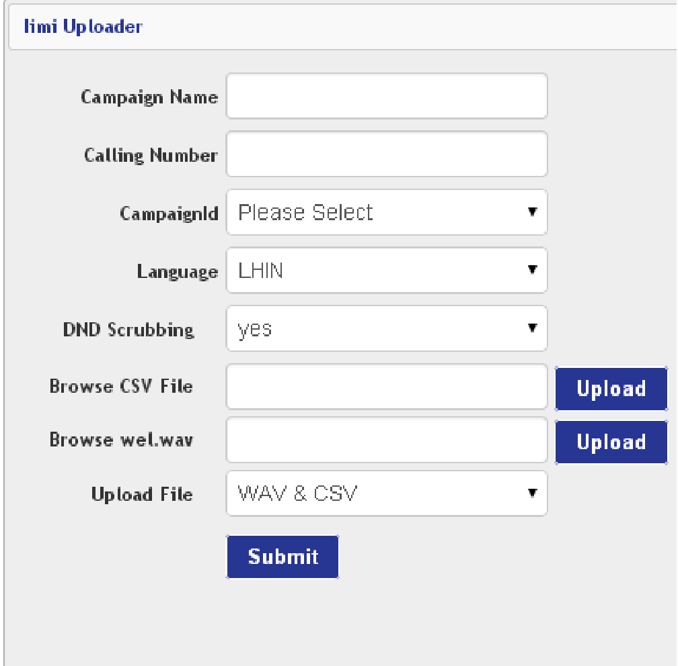

**SNAPSHOT OF THE RESET TAB**

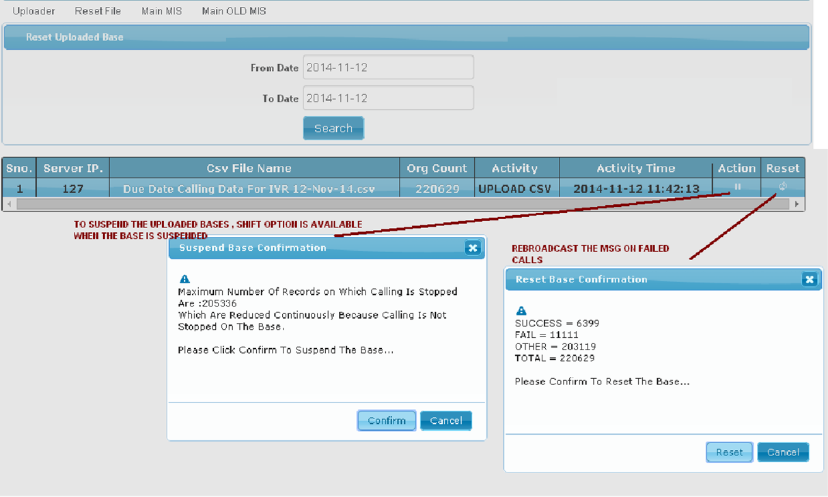

NOTE : ONLY A SINGLE UPLOADER SECTION WILL BE AVAILABLE IN A XML

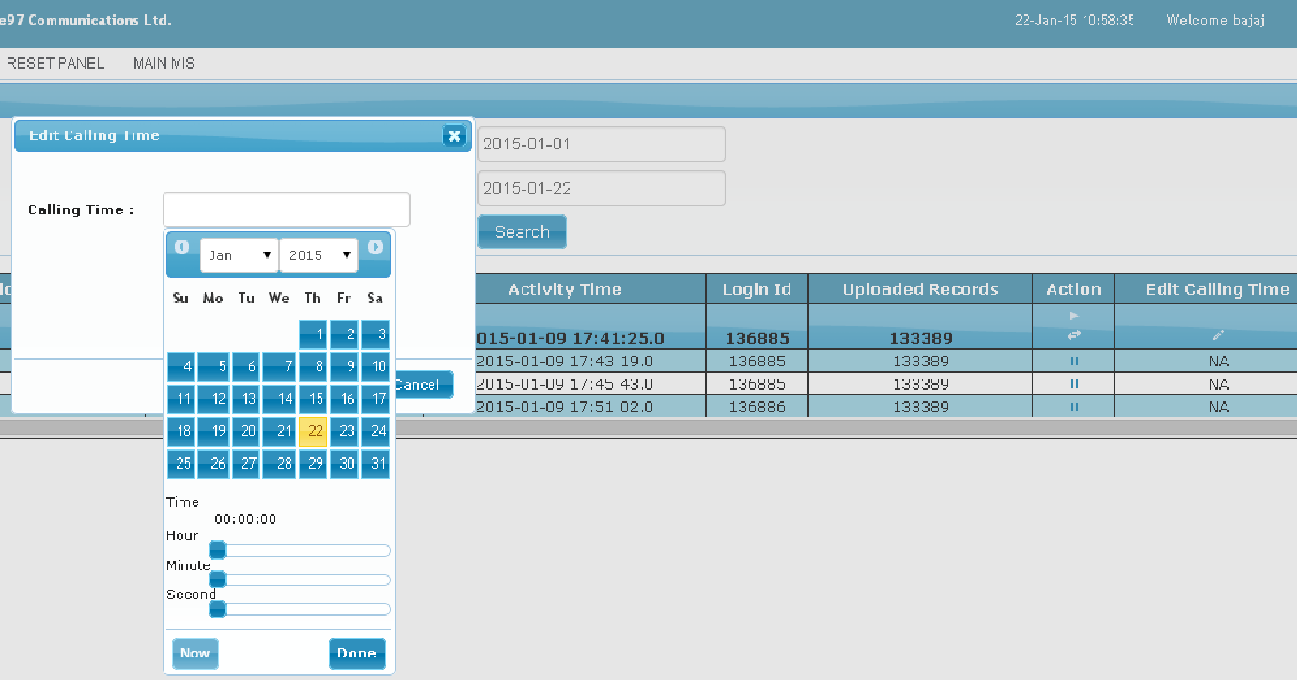

**FILE BROWSER AND DOWNLOADER SECTION**

**<FILESYSTEM> :** This tag is used to browse the locations available on the server this tag contain an attribute name title which is shown as a header of the page.

* **<LOCATION> :** This contain the value which you want to browse. There are multiple LOCATION tags possible inside the FILESYSTEM tag

Example :

<FILESYSTEM title='File System'> <LOCATION>C:/</LOCATION>  
 <LOCATION>D:/configfile</LOCATION>  
 <LOCATION>E:/</LOCATION>  
</FILESYSTEM>

NOTE : NO NEED TO CONFIGURE MULTIPLE FILESYSTEM TAGS BECAUSE NESTED LOCATION TAG WILL FULLFILL ALL THE REQUIREMENT OF BROWSING THE MULTIPLE LOCATIONS IN A SINGLE SERVER. REMOTE DIRECTORY ACCESS IS NOT POSSIBLE THROUGH THIS.

SNAPSHOT OF THE SAME

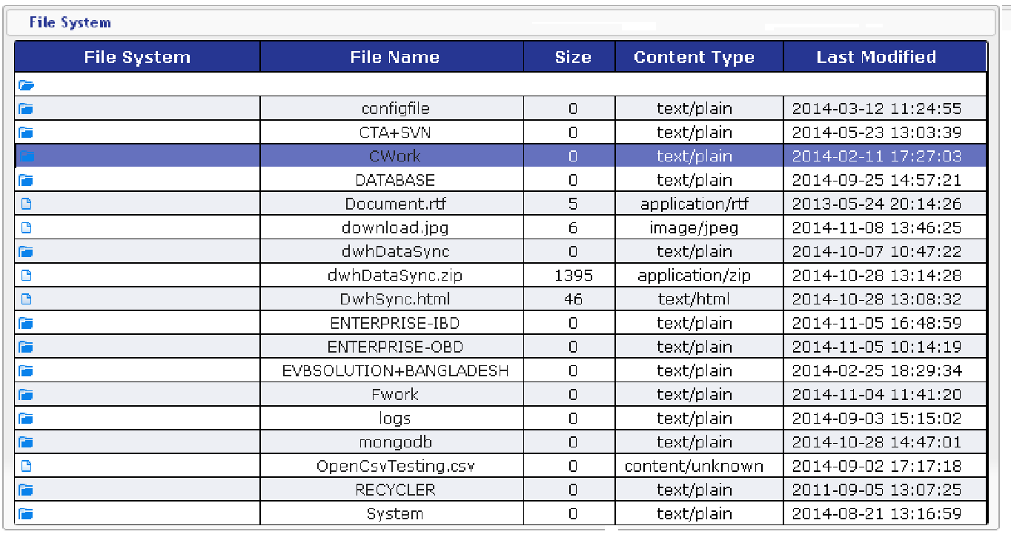

**URL LINKING TAG**

Through this we are able to link up any external or internal url in the dashboard mis as a menu option

* **<LINK> :** This will contain two attributes named

1. **title :** this contain the value of the header.
2. **Httplocation :** this will contain the url location which you want to browse on the clicking of the title value given the title attribute

Example

<LINK title='ADTV' httplocation="<http://192.168.1.48:8080/ADTVCampaign/>username=${username}"/>

<LINK title='ADTV' httplocation="<http://192.168.1.48:8080/ADTVCampaign/>username=<USERNAME>"/>

NOTE : MULTIPLE LINK TAGS ARE POSSIBLE IN A SINGLE XML FILE

Sample 1.

Old syntax of LINK work as before there is no change in it

<LINK title='IFRAME OLD' httplocation="http://10.98.1.95/enterpriseIVR/acd/html/logo512.png"/>

<LINK title='OLD PDF' httplocation="<http://www.africau.edu/images/default/sample.pdf>"/>

But if you want to change it into new ways calling the changes are as below

<LINK title='POSTING' httplocation="http://210.210.26.45:8080/icici_trading/Login.do" from="FRONTEND" linktype="NEW" method="POST" tlsversion="TLSv1.2" responsein="IFRAME">

<PARAM name="username" value="icici"/>

<PARAM name="password" value="trading"/>

<PARAM name="Submit" value="Login"/>

<!--<HEADER name="Authorization" value="Basic YWRtaW46YWRtaW4=" />

<PARAM name="username" value="Cipla"/>-->

<BODY dataraw='{"user":"admin","password":"admin"}'/>

</LINK>

New attributes are introduced in this tag which are

|  |  |  |
| --- | --- | --- |
| Attribute | Possible Values | Description |
| title | Any | Title of the Tab which you want to display to end user. |
| httplocation | Http(s) URL | Any url you want to display to end user |
| from | FRONTEND  BACKEND | FRONTEND -> In this we can display the html page to the IFRAME or any other media object in the OBJECT tag of the html to the user this is generally without any authentication we can pass the authenticated username to the url by embedding <USERNAME> tag in the url  BACKEND -> using new authentication url response string comes from the backend url calling and simply display the response string to the user in formatted html. |
| linktype | NEW  OLD | New authentication support dynamic response mimetype display in object element and backend auth and response to the user |
| method | GET  POST | POST works only for the new backend api calling process |
| tlsversion | Currently Support TLSv1, TLSv1.2, TLSv1.3 | Transport layer version it depend on JDK version also |
|  |  |  |
| responsein | IFRAME  OBJECT | OBJECT like showing pdf,video,audio, images or other media content  IFRAME used to show html pages output |

1. HEADER: This is header parameters you want to pass in the header of the authentication request contains two attribute name and value where name is the name of the header and value is the value of header
2. PARAM: This is the extra parameters you want to pass with the authentication url attributes are same as HEADER tag.
3. BODY : This is used when you want to pass the body as application/json in the request or other to the httplocation from the BACKEND calling type

Examples:

<LINK title='IFRAME OLD' httplocation="http://10.98.1.95/enterpriseIVR/acd/html/logo512.png"/>

<LINK title='OLD PDF' httplocation="http://www.africau.edu/images/default/sample.pdf"/>

<LINK title='POSTING' httplocation="https://uat-trust.myfidelity.in/CheckWalletBalance/1" from="BACKEND" linktype="NEW" method="POST" tlsversion="TLSv1.2" responsein="IFRAME">

<!--<PARAM name="username" value="icici"/>

<PARAM name="password" value="trading"/>

<PARAM name="Submit" value="Login"/>-->

<HEADER name="Content-Type" value="application/json" />

<!--<PARAM name="username" value="Cipla"/>-->

<BODY dataraw='{"uname":"admin","password":"admin"}'/>

</LINK>

**<INSERT index=”2” api_calling=”TRUE/FALSE” action=”**[**http://enterprise_ivr/phpcalling.jsp**](http://enterprise_ivr/phpcalling.jsp)**” saveifstatus=”TRUE” buttonname=”Submit”>** Tag is used to create the insert tab title attribute value is used as a header of the insert panel.

The tags related to this are as below :

**index** is used to present the number of columns you want to represent in a row.

**api_calling** :true/false if you want to call an api on form submit.

**action** : name of the url on which you want to send the data.

**saveifstatus** : response received from the api must contain status and message property and the return response must be JSON

like {“status”:”true”,”message”:”data saved successfully”}

* **<DBNAME>** : Name of the database passed in this tag.
* **<LOGINUSERNAMEIN> :** database column name required if you want to save the login username in the datanase.
* **<SEQUENCE>:** This is used when you want to represent the element of the jsp page in a particular order than you have to set the value of SEQUENCE to true
* **<TABLENAME>** : table name in which insertion is going to perform.
* **<INSERTIGNORE>** : This will contain one value either **IGNORE** or **DUPLICATE KEY UPDATE** through this we can avoid the problem of duplication or update specific value on the basis of duplicate key.
* **<DEFAULTINSERT> :** Used to insert the default value at the time of insertion this will not depend on the gui used for passing the hard coded values in the database.
* **CHECKQUERYBEFOREINSERT :** you can write your select query here which will fetched the data and compare the data with **CHECKQUERYSUCCESSVALUE** if it is metched then operation insertion is aborted.
* **CHECKQUERYSUCCESSVALUE :**in this you can pass multiple values seperated by , operator if you do not pass the value and if **CHECKQUERYBEFOREINSERT** return true or return 1 then it is treated as successful and insert operation is aborted.
* **INSERTSUCCESSMSG :** message to display to the user when insert operation is successful.
* **INSERTFAILMSG :** message to display to the user when insert operation is failed or aborted from the **CHECKQUERYBEFOREINSERT** value bases.
* **PROMPTBEFORESAVE**
* **<INSERTPARAMETER> :** Inside this tag you are able to put your input fields in which you can collect the data from the user. This contain the above tags

1. **<CALENDER>** : this is used to collect the data from the user. Attribute of this tags are below

* title : to show the value to the user
* attribute : name of the column in which insertion is performed
* operator : operator used to put the values.
* Value : default value if any.
  1. **<TEXT> :** This used to get the textbox as an input the attributes of this tag is as below
  + **title** : to show the message to the user
  + **attribute** : database column name in which value is inserted
  + **operator** : operator used at the time of insertion
  + **value** : default value shown to the user if any
  + **check_query_before_insert** : select query to check entry is valid to submit or not
  + **check_query_success_value**: values seperated by , to match the values fetched from check_query_before_insert to check whether this data is valid to submit or not.
  + **insert_fail_msg** : in the case of failure showing this message.
  + **insert_success_msg** : in the case showing this message.
  + **property** : we can put the validation in this like

|  |  |  |  |
| --- | --- | --- | --- |
| **DATA TYPE** | **DESCRIPTION** | **EXAMPLE** | **DESCRIPTION** |
| int | For Integer Value only | int,10 | maximum 10 digit allowed |
| int,10,s | 10 Digit integer only |
| int,3,S,5 | 3 to 5 digit long number is acceptable |
| int,3,R,5 | For 3,4,5 values are allowed |
| int,3,R,5,0 | For 3,4,5 and 0 values are allowed |
| signed_number | For positive integer value only | SAME AS INT | SA ME AS INT BUT FOR POSITIVE VALUES ONLY |
| datetime | For datetime format 0000-00-00 00:00:00 NOT ALLOWED | NA | NA |
| date | For date format 0000-00-00 NOT ALLOWED | NA | NA |
| time | For time format 00:00:00 NOT ALLOWED | NA | NA |
| nospecial | *|,\":<>[]{}`\';()@&$#% characters are not allowed | nospecial,100 | Maximum 100 number of characters allowed |
| Nospecial,100,G | Strictly 100 character long string accepted |
| Nospecial,100,G,200 | A string between 100 and 200 is acceptable |
| nospecial,10,G,100,L | This means that the string is only acceptable only when it contain 10 to 100 characters. |
| nospecial,10,G,100,L,STARTWITH,VINEET | only those string are acceptable which startwith with VINEET or vineet this is non case sensitive |
| nospecial,10,G,100,L,ENDSWITH,VINEET | only those string are acceptable which endswith with VINEET or vineet this is non case sensitive |
| nospecial,10,G,100,L,STARTWITHCS,VINEET | only those string are acceptable which startwith with VINEET and this is case sensitive |
| nospecial,10,G,100,L,ENDSWITHCS,VINEET | only those string are acceptable which endswith with VINEET and this is case sensitive |
| nospecial,10,G,30,L,REGX,MESSAGE,REGEXPRESSION  Example :  all,5,G,20,L,REGX,No special characters are allowed instead _,^[a-zA-Z0-9_ ]*$ | Here REGX is to indicate that REGX check is applicable for the input string if it does not match with the REGEXPRESSION then the MESSAGE is prompted. |
| all | No Restriction | Same as nospecial | Same as nospecial |
| db | No database related special characters are not allowed only “’ NOT ALLOWED | Same as nospecial | Same as nospecial |
| pancard | To validate the pancard number like ABCDS1111G | Same as nospecial | Same as nospecial |
| alphanumeric | For only alphabet and numbers like 123ABC | Same as nospecial | Same as nospecial |
| alpha_numeric | For only alphabet and numbers with _ underscore like 123_ACD | Same as nospecial | Same as nospecial |
| Email | Email id validation like vine@gmail.com | Same as nospecial | Same as nospecial |
| Number | For number validation like 1234 | Same as nospecial | Same as nospecial |
| alphabets | For for alphabets | Same as nospecial | Same as nospecial |

**3. <TEXTBOX> :** Same as TEXT Tag

**4. <SELECT> : This will contain the below attributes**

* **attribute :** Name of the column
* **operator :** operator required at insertion time
* **title :** message to display to the user
* **value :** default value to display to the user
* **query :** write the query with the db.tblname through which you want to fill the combo box. Please note that key,value selection is required for the same. This is required to fill the successfor select box which example we show you in the MIS section of the dashboard.
* **Index :** pass the index of the select which you want to fill on the bases of query attribute's result.
* **target_attribute :** name of the attribute which you want to fill on the basis of the selection of the current select box.
* **Autoquery :** query through which you want to fill the current select box

SELECT CONTAIN THE OPTION TAG WHICH CONTAIN THE KEY VALUE DATA THROUGH WHICH YOU ARE ABLE TO FILL THE SELECT INSTEAD OF QUERY

**<OPTION> :** OPTION tag can contain the below attribute

* operator : used to assign the value to the attribute
* value : value of the the option
* attribute : name of the column
* default : not use in the case of insert

5. FILEUPLOADER : Used to upload the file in the insert panel attribute of this tag is shared below

|  |  |
| --- | --- |
| **Attribute** | **Description** |
| maxsize | maxsize which user allow to upload in KB |
| path | file location where file should be uploaded |
| attribute | name of the attribute where uploaded file name should be stored |
| attribute_renamed | name of the attribute where renamed |
| title | title to be display to user |
| property | true if must |
| mendatory | css style |
| style | for validating the input |
| check_query_before_insert | values sepeated by , to be considered as success from the |
| check_query_success_value | query_before_insert check. |
| insert_success_msg | success message. |
| insert_fail_msg | failure message |

**Example**

<INSERT title='Insert Sms'>  
 <DBNAME>test</DBNAME>  
 <TABLENAME>sms_table</TABLENAME>  
 <!--<INSERTIGNORE>IGNORE/ON DUPLICATE KEY UPDATE</INSERTIGNORE>-->  
 <!--<DEFAULTINSERT> isactive=1</DEFAULTINSERT>-->  
 <INSERTPARAMETER> <TEXT title='State' attribute='state' operator='=' value='' property="string,50,"/> <TEXT title='District' attribute='district' operator='=' value='' property="string,50,"/> <TEXT title='Prompt Code' attribute='promptcode' operator='=' value='' property="string,50,"/>  
 <TEXTBOX title='Message Content' attribute='smscontent' operator='=' value='' property="string,360,"/>  
 <!-- <CALENDER title='Date Of Birth' attribute='dob' operator='=' value=''/>  
 <SELECT title='Gender' attribute='gender'>  
 <OPTION value='M'>Male</OPTION> <OPTION value='F'>FeMale</OPTION>  
 </SELECT>-->  
 <!--<SELECT title='Gender' attribute='gender' autoquery="select 'Youth','Youth' from dual"/>-->  
 </INSERTPARAMETER>  
</INSERT>

**SNAPSHOT OF THE SAME**

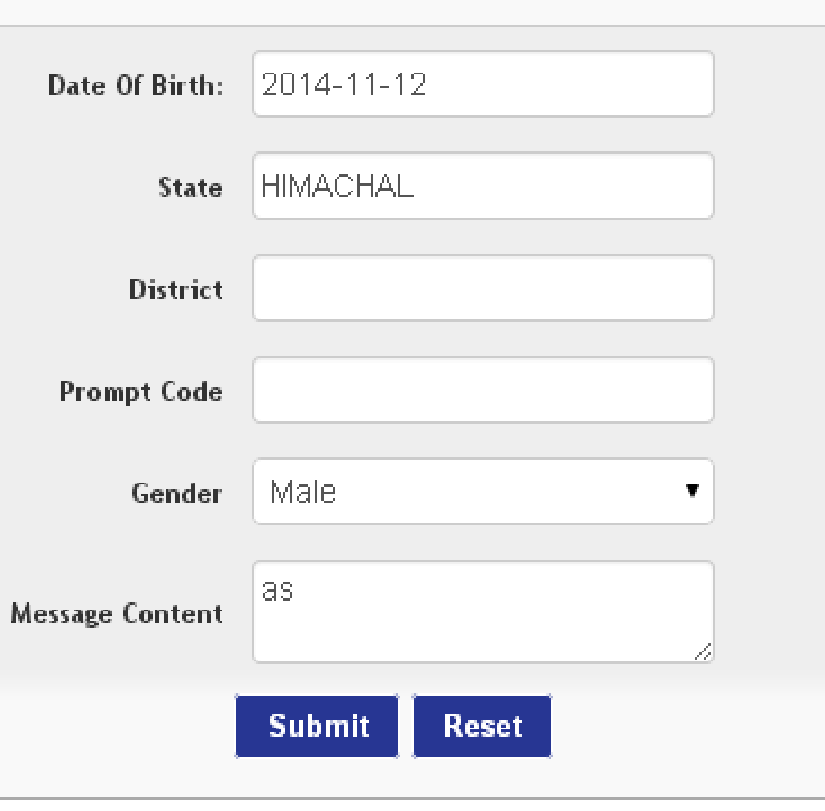

**MIS TAG AND SUB TAGS**

**<MIS type='speaker' title='CC Panel' index="4" refresh='10'>**

* **type :** is contain two values generic and speaker :a) Generic will contain the mis without any hyperlink and moderator and sound files b). speaker contain the hyperlink and moderator contain the link of sound files to download and listen.
* **Title** : title is the heading of the tab.
* **Index** : no. of search option are we showing in the search criteria
* **refresh :** pass this attribute when you want to refresh the mis page after a specified amount of time.

**<DBNAME>**campaignmanager**</DBNAME>**  
 **<TABLENAME>**hpcl_ccpanel_help**</TABLENAME>**  
 **<TABLEPARTITIONING>**0**</TABLEPARTITIONING>**  
 **<DEFAULTQUERY>** **</DEFAULTQUERY>**  
 **<DOWNLOAD>**YES**</DOWNLOAD>**  
 **<DISPLAYQUERY>** SELECT now() from dual**</DISPLAYQUERY>**  
 **<ORDERBY>** order by callid desc **</ORDERBY>**  
 **<LIMIT>**2**</LIMIT>**

**<ENCLOSEDBY>”</ENCLOSEDBY>**

**<SHOWPAGEINFO>**YES/NO/NAVIGATE**</SHOWPAGEINFO>**

**<REMOTEDOWNLOAD>TRUE</REMOTEDOWNLOAD>**

**<SHOWRESETBUTTON>TRUE</SHOWRESETBUTTON>**

**<RESETBUTTONNAME>HELLO BUTTON</RESETBUTTONNAME>**

**<SUBMITBUTTONNAME>TRUE</SUBMITBUTTONNAME>**

**<FORCESHOWSUBMITBUTTON>TRUE</FORCESHOWSUBMITBUTTON>**

**<EDITCOLUMNSINROW>2</EDITCOLUMNSINROW>**

**<SHOWROWPERPAGE>FALSE</SHOWROWPERPAGE>**

**<UPDATEQUERY>**update db.tbl1,db.tbl2 set tbl1.name=tbl2.name where tbl1.caller_number=tbl2.caller_number**</UPDATEQUERY>**

* **DBNAME** : Name of the database from which the table is exist to display the data
* **TABLENAME** : name of the table from which data is displayed in the mis
* **TABLEPARTITIONING** : used to show the data from the backup table. There is a restriction for the backup table that is the backup table end with year(4 digit)month(two digit).
* **REMOTEDOWNLOAD** : This tag is added under mis section of the xml. This is used to download the mis if database server is not a local machine.
* **DEFAULTQUERY :** write the part of query where clause which you want to add in the where clause of the query.
* **ENCLOSEDBY** : This is used to when you are downloading the csv or xls file.
* **SHOWPAGEINFO** : If you do not want to show the page info like number of pages mis contain current page etc then this is very useful.NAVIGATE : In this option you are able to move forward and backward in the mis.
* **DOWNLOAD** : to disable or enable the download of the mis
* **DISPLAYQUERY** : to display the result of the query as a summary of the panel auto refreshed after a particular time period
* **ORDERBY** : order by clasuse of the query.
* **LIMIT** : limit is used when you want to restrict the user to see the number of records.
* **EDITCOLUMNSINROW** : With the help of this you are able to manage that how many columns you want to show in a row while mis type is speak and edit popup is appear.
* **UPDATEQUERY :** this is used if you want to execute any additional update while editing a record.
* **RESETBUTTONNAME** : this is used when you want to give the name for Reset Button.
* **SHOWRESETBUTTON** : this is used when you do not want to show the Reset Button in a particular mis tab.
* **FORCESHOWSUBMITBUTTON** : this is when you want to show the Search Button in a mis tab when there is not options provided to the user in the interface only a button will appear the records will appear only when you click to this submit/search button of the mis tab.
* **SUBMITBUTTONNAME** : this is to change the name of submit/Search Button.

**SMS TEMPLATE**

<**SMSTEMPLATE**>

<**SMS** **smsText**="'Testing Msg'" **receiver**_**no**='9911773883' **appid**_**value**='20' **appid**_**from**='' **appName**_**value**='VINEET' **appName**_**from**='' **senderText**_**value**='IIMI' **senderText**_**from**='' **config**_**where**_**value**='' **update**_**clmn**_**value**='' **smsDbAndTable**='db_smsserver.tbl_smsrequest'/> </**SMSTEMPLATE**>

This tag is used to send the sms from the panel. We are able to design the different sms content and where clauses on which we have to send the sms

* **smsText** : you can pass the value of the sms text or the name of the column from which sms text is to be selected. If you are passing the value then it should be enclosed within the ' or “ quotes.
* **receiver_no** : you can pass the name of the column or the value from which the sms number is selected.
* **appid**_**value :** In this we have to pass the sms app id from which is configured for sms account.
* **appid_from** : If appid is choosen from a table column.
* **appName_value** : for passing the application name value
* **appName_from** : for passing the application name from the table column
* **senderText_value** : for setting the sms sender text by the value
* **senderText_from** : for setting the sender text based on the value of the table column.
* **config_where_value** : for configure the sms where clause which is to be satisfied before sending the sms.
* **update_clmn_value**: pass the column name if you want to modify the value of the source table In which the record exist.
* **SmsDbAndTable** : In this we have to pass the value of the sms database and table name in which the sms record is inserted for the processing.

You can configure the multiple sms tag inside the SMSTEMPLATE tag.

**<SEARCHOPTIONS>**

In this section we have to put all the search criteria of the mis tab.

<**CALENDER** title='From Date' attribute='date(inserttime)' operator='&gt;=' property='c_date' value='' dynamicuse=”” format=”DATE” mandatory=”true”/>

in format attribute you can pass on of the above values YEAR,MONTH,MONTHYEAR,DATE,TIME,DATETIME

Calender is used for the date picker.

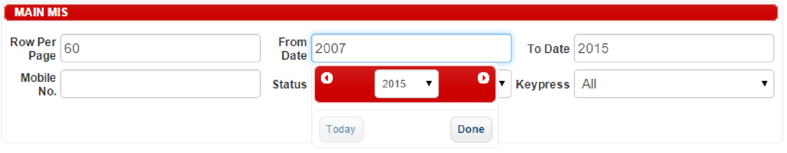

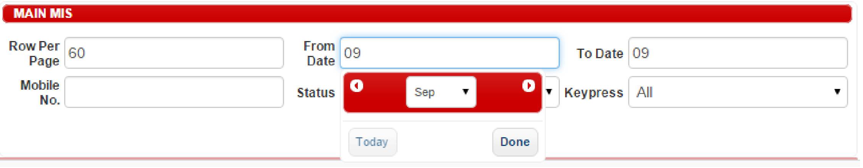

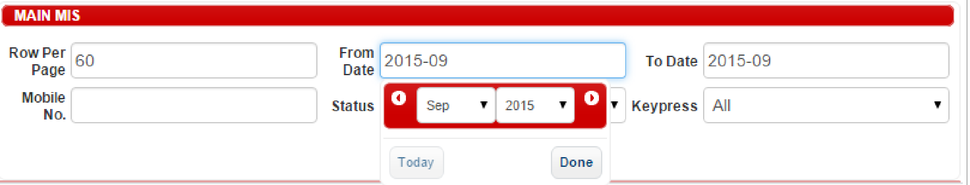

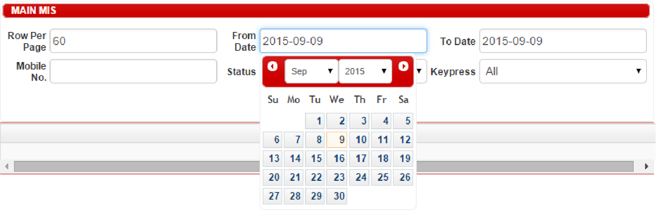

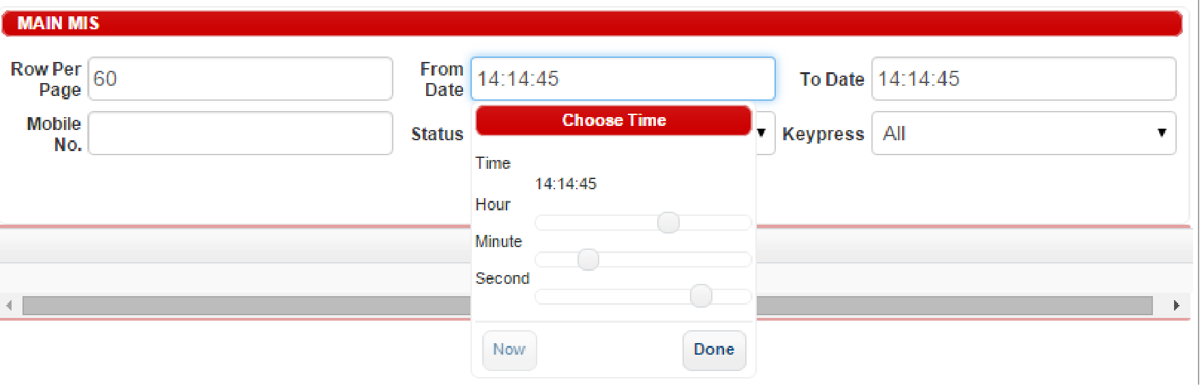

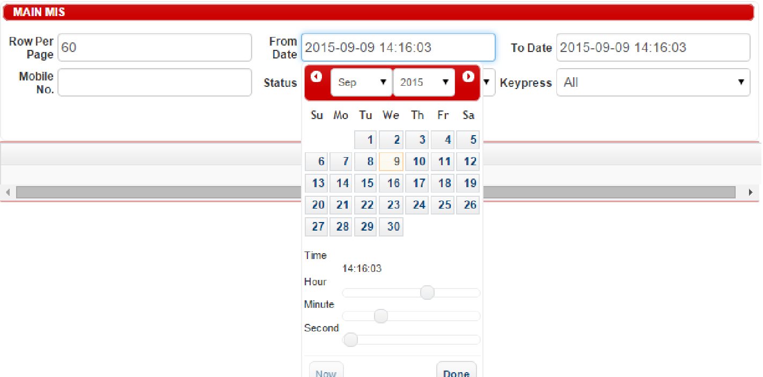

<**TEXT** title='Calling Number' attribute='msisdn' operator='=' property='' value='' mandatory=”true”/>

TEXT is used to take the text input for the searching. We are able to put the validation on the text like TEXT will take the numeric value and the length of input not be less than or greater than 10 etc through the property attribute like

<**TEXT** title='Calling Number' attribute='msisdn' operator='=' property='int,10,S' value='' dynamicuse=”” mendatory='true'/>

Pattern for the validation is

type of validation------>string or int

restricted length------->S

length ------------------>any digit

Example :

property=”string,,10”

input type is a string and contain maximum 10 character length

property=”int,S,10”

input type is number and contain exact 10 character length

you can make the other combination of the same also using these three parameters.

|  |  |  |  |  |  |  |  |  |  |  |  |  |  |  |  |  |  |  |  |  |  |  |  |  |  |  |  |  |  |  |  |  |  |  |  |  |  |  |  |  |  |  |  |  |  |  |  |  |  |  |  |  |  |  |  |  |  |
| --- | --- | --- | --- | --- | --- | --- | --- | --- | --- | --- | --- | --- | --- | --- | --- | --- | --- | --- | --- | --- | --- | --- | --- | --- | --- | --- | --- | --- | --- | --- | --- | --- | --- | --- | --- | --- | --- | --- | --- | --- | --- | --- | --- | --- | --- | --- | --- | --- | --- | --- | --- | --- | --- | --- | --- | --- | --- |
|  |  |  |  |  |  |  |  |  |  |  |  |  |  |  |  |  |  |  |  |  |  |  |  |  |  |  |  |  |  |  |  |  |  |  |  |  |  |  |  |  |  |  |  |  |  |  |  |  |  |  |  |  |  |  |  |  |  |

**UNIQE OR UNIQUE** : This tag is used when you want to show the unique data based on a database table attribute. The attribute which are linked with this tag is mentioned below :

attribute : name of the database table column

value : unique/all

title : display name which is shown in the mis search option

hidden : true if you do not want to display in mis search

**SELECT :** This tag is used to show the drop down box in the mis search options the options which are associated with this tag is mentioned below :

<SELECT title='Server Name' dynamicuse="table_name" index="1" attribute='pool' query="select distinct pool,pool from db_cdr_reporting.?" autoquery='select server_tablename,server_id from db_cdr_reporting.cdr_server_tabledetails order by id' value='all,='></SELECT>  
 <SELECT title='Pool' attribute='pool' value='all,=' mandatory=”true”></SELECT>

<SELECT title='Call Status' value='all,='>  
 <OPTION value="Complete" operator="=" attribute="ccstatus">Complete</OPTION>  
 <OPTION value="Call Back" operator="=" attribute="ccstatus">Call Back</OPTION>  
 <OPTION value="Call Closed" operator="=" attribute="ccstatus">Call Closed</OPTION>  
 <OPTION value="No Answer" operator="=" attribute="ccstatus">No Answer</OPTION>  
 <OPTION value=" " operator="=" attribute="ccstatus">Not Attempted</OPTION>  
 </SELECT>

This is used for the dropdown option selection

**dynamicuse** : used when you want to replace the selected value in the dyamic query like table name etc. if you pass table_name then it will replace the table name with the selected or entered value.

**index** : it is used when you want to fill the dropdown on the basis of current dropdown selection.

**query**: this query will fill the next dropdown if index of the next dropdown in mentioned. In this query we have to put **?** Where we want to put the current dropdown selected value.

**mendatory** : If this attribute is true then this is mendatory to fill before start searching in the mis.

**<VIEWDETAILS>**

In this section we provide the information of the table entity through which we have to show the data to the end user.

<COLUMNS attribute='inserttime' isdownload='true' update="no" orderbylink="inserttime" style="background-color:pink;" scrolling="100,100" validation="all,1,G,300,L" edit_type=”textarea” color_coding=”active→green;closed→red;” skipmendatoryformfieldif=”FAIL,ABORT” mendatory=”true”>DateTime</COLUMNS>

**skipmendatoryformfieldif** : this is used if your mis type is speaker. If you use this tag then you are able to skip the mandatory field while editing the records if value provided in this and you can provided multiple values in this through comma seperated.

**update** : value possible is **no** and **yes** if you want to update the value of the column then you have to put the value of yes this will work only when the value of MIS type must be speaker instead of generic

**orderbylink :** In this you are able to pass the name of the column on which you want to perform the sorting on the click of the title in the mis view.

**color_coding** : used to change the color of the column according to the value

color_coding=”active→green;closed→red;suspended→yellow;”

**style** : it is used as an css style tag if style is startswith nonsanitize

example style="nonsanitize;"

scrolling : that is used for the settting the height and width of a column displayed in the mis.

First number is the height and the second one is width;

**validation** :validation is used when we have to put the value of the column for editing and restrict this for putting anonomous values.

Type of validations

|  |  |  |  |
| --- | --- | --- | --- |
| **DATA TYPE** | **DESCRIPTION** | **EXAMPLE** | **DESCRIPTION** |
| int | For Integer Value only | int,10 | maximum 10 digit allowed |
| int,10,s | 10 Digit integer only |
| int,3,S,5 | 3 to 5 digit long number is acceptable |
| int,3,R,5 | For 3,4,5 values are allowed |
| int,3,R,5,0 | For 3,4,5 and 0 values are allowed |
| signed_number | For positive integer value only | SAME AS INT | SA ME AS INT BUT FOR POSITIVE VALUES ONLY |
| datetime | For datetime format 0000-00-00 00:00:00 NOT ALLOWED | NA | NA |
| date | For date format 0000-00-00 NOT ALLOWED | NA | NA |
| time | For time format 00:00:00 NOT ALLOWED | NA | NA |
| nospecial | *|,\":<>[]{}`\';()@&$#% characters are not allowed | nospecial,100 | Maximum 100 number of characters allowed |
| Nospecial,100,G | Strictly 100 character long string accepted |
| Nospecial,100,G,200 | A string between 100 and 200 is acceptable |
| nospecial,10,G,100,L | This means that the string is only acceptable only when it contain 10 to 100 characters. |
| nospecial,10,G,100,L,STARTWITH,VINEET | only those string are acceptable which startwith with VINEET or vineet this is non case sensitive |
| nospecial,10,G,100,L,ENDSWITH,VINEET | only those string are acceptable which endswith with VINEET or vineet this is non case sensitive |
| nospecial,10,G,100,L,STARTWITHCS,VINEET | only those string are acceptable which startwith with VINEET and this is case sensitive |
| nospecial,10,G,100,L,ENDSWITHCS,VINEET | only those string are acceptable which endswith with VINEET and this is case sensitive |
| nospecial,10,G,30,L,REGX,MESSAGE,REGEXPRESSION  Example :  all,5,G,20,L,REGX,No special characters are allowed instead _,^[a-zA-Z0-9_ ]*$ | Here REGX is to indicate that REGX check is applicable for the input string if it does not match with the REGEXPRESSION then the MESSAGE is prompted. |
| all | No Restriction | Same as nospecial | Same as nospecial |
| db | No database related special characters are not allowed only “’ NOT ALLOWED | Same as nospecial | Same as nospecial |
| pancard | To validate the pancard number like ABCDS1111G | Same as nospecial | Same as nospecial |
| alphanumeric | For only alphabet and numbers like 123ABC | Same as nospecial | Same as nospecial |
| alpha_numeric | For only alphabet and numbers with _ underscore like 123_ACD | Same as nospecial | Same as nospecial |
| Email | Email id validation like vine@gmail.com | Same as nospecial | Same as nospecial |
| Number | For number validation like 1234 | Same as nospecial | Same as nospecial |
| alphabets | For for alphabets | Same as nospecial | Same as nospecial |

**visibility** : in the speaker mis when you want to hide a particular column then set the value to FALSE

edit_style : you are able to give the style attribute in the edit panel. Like edit_style="display:none;

edit_type : default that is textbox. We can also set that to

time,date,datetime,textarea

**combo :** you can put the combo box also in the editing column of the mis there are 2 ways to put the combo in the editable column

**combo="@Select#Complete@Complete#Call Back@Call back#Call Closed@Call Closed#No Answer@No Answer"**

with the help of this we are making the key value pairing that is seperated through the @ and to put the another key value pair we use # as a seperator

#-------->sepeate different key value pairs

@-------->Seperate value from the key

key is not visible to the end user and value is the visible part. But when we submit the data the key of the selection is submit to the action of the form.

**combo="SELECT country,country FROM campaignmanager.dashboard_testing GROUP BY 1"**

We can also pass the query in the combo there must be two column selected in the drop down

**query :** This attribute is also used with only combo box in this you are able pass the query with ? At the query execution time this ? Is replaced with the selected value.

Example :

**query="SELECT dealer_city FROM db_enterprise_ibd.castrol_minitruck_dealer_detail where dealer_state=%27?%27 group by 1"**

When we use the query then we have to mention an attribute named **referenceto** in this we have to pass the type and name of the form element which you want to fill on the basis of the selection like

**referenceto="COMBO-cc_city"**

**referenceto="LIST-cc_city"**

**referenceto="TEXT-cc_city"**

In this query we are able to pass more dynamic values in the where clause too to do this we have to put **@<column_name>@**

Example

**query="**SELECT sms_text ,dealer_shop_name ,dealer_name from db_enterprise_ibd.castrol_minitruck_dealer_detail WHERE dealer_address=%27?%27 and dealer_state=%27@cc_state@%27 and dealer_city=%27@cc_city@%27 group by 1**"**

**referenceto=**"text-cc_sms_text ,cc_dealer_shopname ,cc_dealer_name"*(selected values of the query is filled on these columns of the mis)*

**referencefrom=**"cc_state,cc_city" *(for where clause values)* **resetonselection=**"cc_dealer_shopname,cc_dealer_name,cc_sms_text" *(on the basis of this column value selection the mentioned columns are set to there default values.)*

**Example**

<COLUMNS style="width:250px;" attribute='cc_dealer_address' isdownload='true' update='yes' combo="@Select" query="SELECT sms_text,dealer_shop_name,dealer_namefromdb_enterprise_ibd.castrol_minitruck_dealer_detailWHEREdealer_address=%27?%27anddealer_state=%27@cc_state@%27anddealer_city=%27@cc_city@%27groupby1"referenceto="text-cc_sms_text,cc_dealer_shopname,cc_dealer_name"referencefrom="cc_state,cc_city"resetonselection="cc_dealer_shopname,cc_dealer_name,cc_sms_text">Dealer Address</COLUMNS>

**SMS AND EDITING attributes**

**buttonname :** we can put the name of the button whatever we like “Send SMS” or SMS or anything whatever we like

buttonname='Save and SendSMS'

**disableonattribute :** Through this we are able to disable the button for sending the sms like if you want to push the sms once only then you have to update a flag on the like

disableonattribute="cc_sms_sent_status"

**disableonoperator : in this attribute we have to pass the**

<,>,<=,>=,=,equals,!=,!equals,in,!in,not in,like,!like,not like,between,!between,not between

If we use in or not in then we have to pass the list of values seperated by #

If we are using between then we have to use space as a sepeator as we use in the standard sql query.

**Disableonvalue:** pass the value of the column on which you want to disable the button.

**edit_type :** the value of the edit_type is **INLINE**, **OFFLINE**,**OFFLINE_VALID_ONLY** for the INLINE editing and OFFLINE for pop model editing.

**isdownload** : set the value of isdownload to sms for sms sending button and edit for editing panel.

If the mis mode is speaker then you can you three more values for the isdownload attribute that is

1. sms : to send the sms

2. edit : for the moderator

3. speaker : to download the audio file (attribute value + speaker path)

4. other : to download the file (attribute value + speaker path)

5. direct : if you want to download the file without adding the speaker path then you should use this

**isdownload=”direct”**

**defaultset** : this is used for editing panel in this we have to put the column name and there value we want to pass. Pass <USERNAME> to replace the value with login username.

**checkquery:** this is used when you want to check anything before running the update command on the table if the query value is false then there is no updation is performed in the table otherwise updation will perform on the table.

checkquery="SELECT IF(COUNT(IF(outdialer_id=0,1,NULL))&lt;3,TRUE,FALSE) FROM test.testing_table"

**failuremsg :** you are able to pass the msg in the case of checkquery. When the checkquery is return false value then you can see you msg in the screen to know that what is the reason why updation is not performed in the table while everything is ok.

failuremsg="invalid pincode :<pincode> to update..";

**successmsg**: See this message when record is updated successfully.

successmsg="Record updated successfully for the caller number : <caller_number>";

in **successmsg** and **failuremsg** you can use the <column name> to show the message with the replaced output message.

**Example**

**SMS SENDING**

<COLUMNS attribute='id' isdownload='sms' visibility="FALSE" update="no" disableonattribute="cc_sms_sent_status" disableonoperator="in" edit_type=”OFFLINE” disableonvalue="Yes#1">Sms Unique Id</COLUMNS>

**EDITING ROW**

<COLUMNS style="width:260px;" attribute='id' isdownload='edit' buttonname='Save and SendSMS' edit_type='OFFLINE' sendsmsonsave="true" defaultset="updatetime=NOW() ,updateflag=1 ,attempt_cnt = attempt_cnt + 1" disableonattribute="cc_callstatus" disableonoperator="in" disableonvalue="Complete#2">Edit</COLUMNS>

**For playing the sound file**

**we have to set the speakerpath in the pathdetails section of the header of the xml and then**

isdownload : set the value to speaker

attribute : it must contain the value of the file name with the partial path information rest static is concatenated from the speakerpath variable of the header.

**EXAMPLE**

<COLUMNS attribute='if(updatetime,updatetime,"0000-00-00 00:00:00")' isdownload='speaker' orderbylink="updatetime">Speaker</COLUMNS>

**FOR RENDERING XML AND HTML TAGS :**

If you want to show html or xml tag in the mis then you have to put the xmp tag with you data then it will display the tag of the columns with interpreting them a tag as it is stored in the database without any change.

<COLUMNS attribute='concat(concat(“&lt;xmp&gt;”,failure_reason),”&lt;/xmp&gt;”)' isdownload='true'>failure reason</COLUMNS>

<xmp> is a html tag use to render the tags in the html/jsp/xml

**FOR THE CHILD MIS**

**isit_link** : set the value of this attribute to true

**source_where** : this will contain the name of the column in the source table from which the current value is going to match in the where clause.

**Select :** in this we have to pass the name of the column which we want to show in the child mis if the column name is not a name then you have to provide the alias name for the same for the labeling of the column in the child mis.

**Tablename :** this will contain the database and table name from which the child mis data is derived.

<COLUMNS attribute='msisdn' isdownload='true' isit_link="true" source_where="msisdn" destination_where="msisdn" select='no2dial@@name@@address@@gender@@if(date(autotime),date(autotime),"0000-00-00") as Creation_Date' tablename="test.testing_table">Link</COLUMNS>

**FOR DELETING THE ROWS**

you are able to delete the records with the help of dashboard for this you have to set the isdownload to delete.

**EXAMPLE**

<COLUMNS attribute='callid' isdownload='delete'>Delete</COLUMNS>

**dataTable :** tryign to cover the all mis and data display according to user convenience :

a) Putting scrolls on both the side of the data.

b) Header become visible all the time while scrolling.

c) Sno or Row No. of the record is visible always while scrolling horizontally.

d) Now no dependencies on the external data table css all the css tag are used from jquery-ui.

e) Information strip icon change making more understandable to the user.

**SNAPSHOTS**

**For ROW Editing OFFLINE**

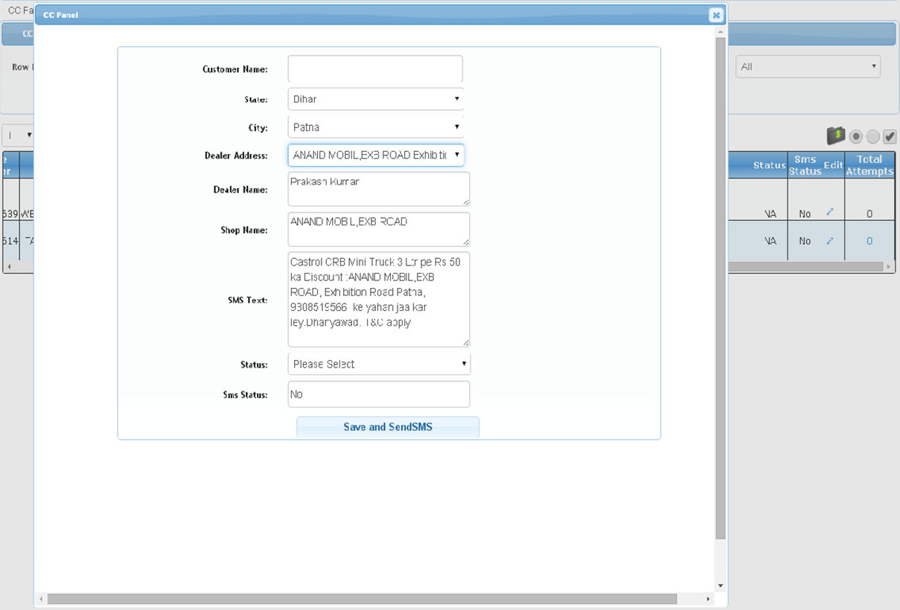

**INLINE EDITING**

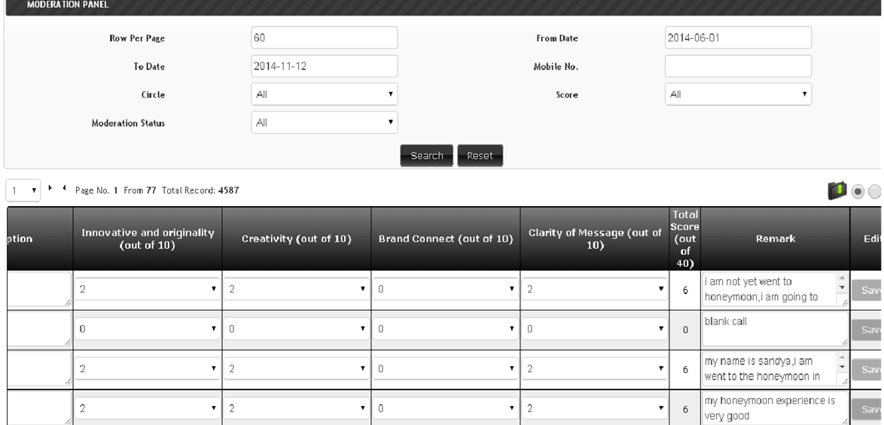

**DELETE ROW FROM THE MIS**

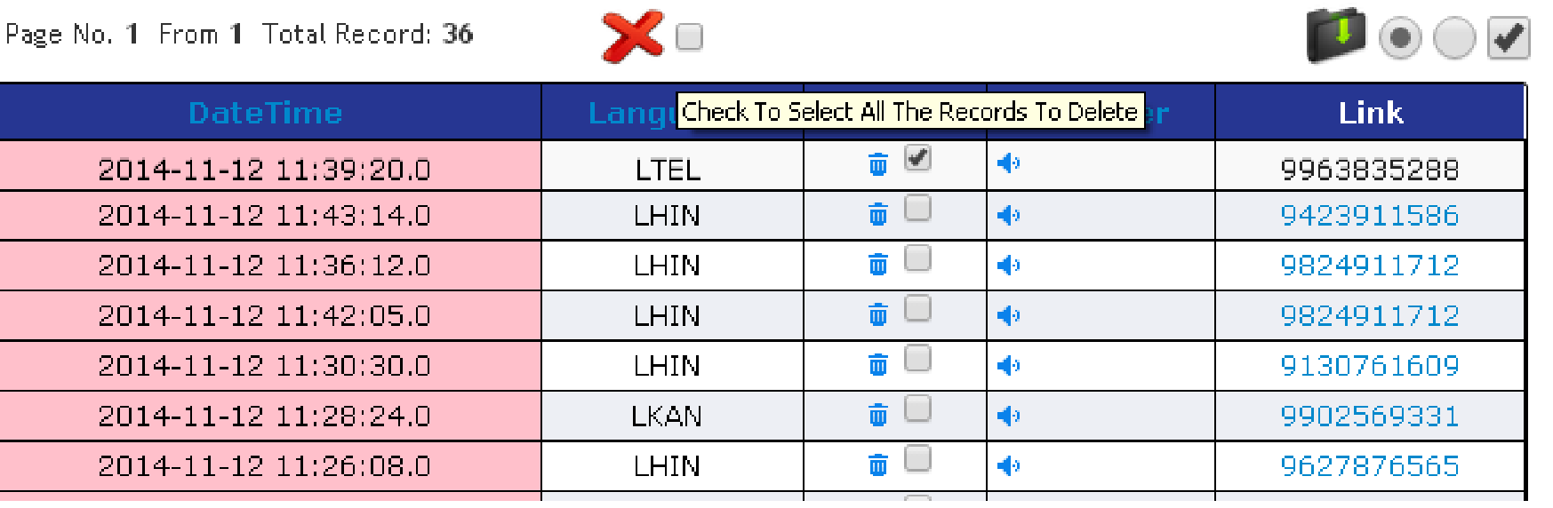

**CHILD MIS BY CLICK ON LINK HEADER VALUE**

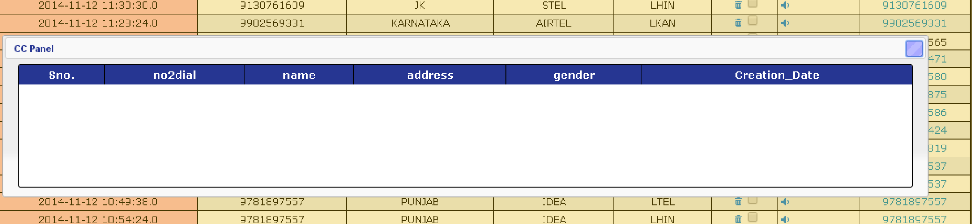

**SHOW WHOLE PAGE WHILE MIS TYPE IS SPEAKER**

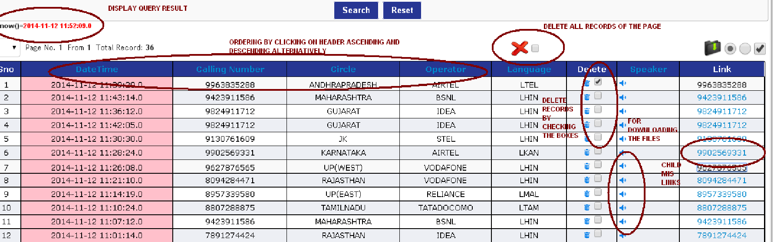

now we break this page for the better visibility

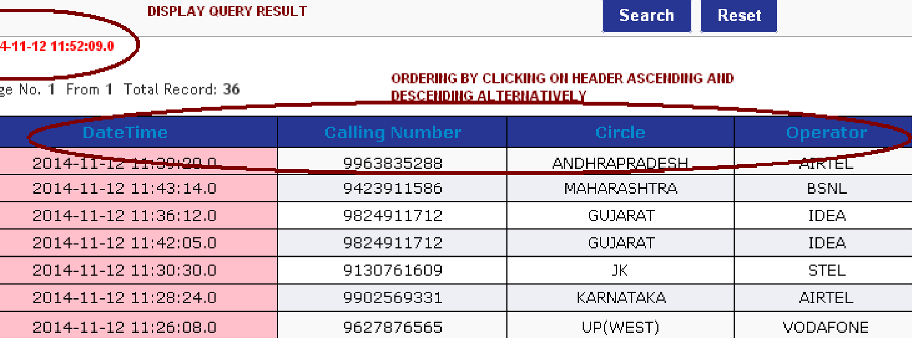

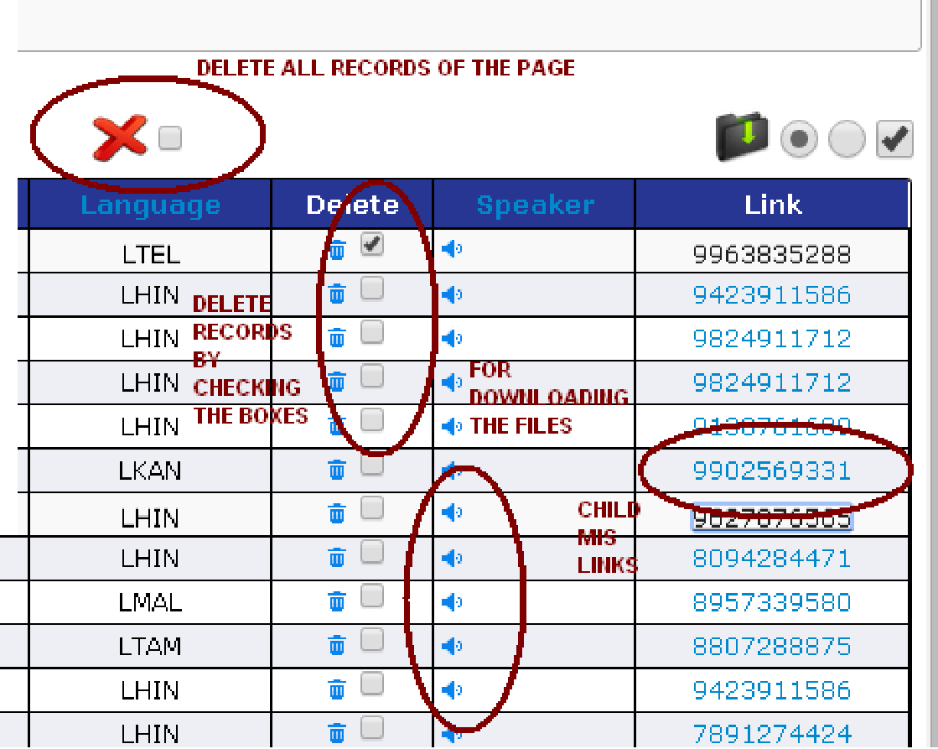

Change in the mis download now you can select the columns which you want to download by default all the columns of the mis is selected.

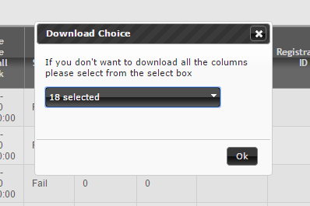

**USE_DB_APPEN_QUERY** : This KEYWORD is use to use the db based login query if this is then we have to replace this KEYWORD from the value configured in the login table for the xml.

Example :

<INSERTPARAMETER>

<TEXT title='Register MSISDN' attribute='trainee_mob' operator='=' value='' property="int,10,S"/>

<CALENDER title='DATE OF JOINING' attribute='trainee_mob' operator='=' value='' format="YYYY-MM-DD"/>

<CALENDER title='BIRTH TIME' attribute='trainee_mob' operator='=' value='' format="HH:MM:SS"/>

<CALENDER title='BIRTH DATE AND TIME' attribute='trainee_mob' operator='=' value='' format="YYYY-MM-DD HH:MM:SS"/>

<SELECT title='Meeting Id' attribute='meeting_id' autoquery="SELECT meeting_id,meeting_id FROM pidlite.pidilite_event_details WHERE 1 USE_DB_APPEN_QUERY and date_in_content=CURRENT_DATE GROUP BY 1,2"/>

</INSERTPARAMETER>

OR

<DISPLAYQUERY> SELECT SUM(total_score) FROM pidlite.meeting_scores WHERE 1 USE_DB_APPEN_QUERY </DISPLAYQUERY>

if you are login by using the database based login then the configured append query in the database is appended in the default query of the mis. If you dnt want to append the database based append query then please use !USE_DB_APPEN_QUERY in the default query this will avoid the appending of the configured query in that tab.

Example

<MIS type='speaker' title='AppConfiguration' index='2'><DBNAME>campaignmanager</DBNAME><TABLENAME>campaign_master</TABLENAME>

<DEFAULTQUERY> !USE_DB_APPEN_QUERY </DEFAULTQUERY>

….

….

</MIS>

**GRAPHICAL CHART DISPLAY**

With the help of graphical mis we are able to display the data in the form of chart currently there are only three type of charts included in this section and that are PIE chart, BAR chart, LINE chart.

There are few limitation also related to the graphic representation these are :

1. Summary Data Table must contain c_date column from which the date for the representation is fetched and the data is calculated.
2. Must contain the column hours if we want to represent the data on hourly bases.

Presentation of the graph is very simple lets look the configuraion part :

**<GRAPH title='VIDEOCON GRAPHS'>  
 <DBNAME>db_outdialer.videocon_geo_summary</DBNAME>  
 <BASEDON>  
 <COLUMNS attribute=''>Based On</COLUMNS>  
 <COLUMNS attribute='4'>Month</COLUMNS>  
 <COLUMNS attribute='3'>Weekly</COLUMNS>  
 <COLUMNS attribute='2'>Daily</COLUMNS>  
 <COLUMNS attribute='1'>Hourly</COLUMNS>  
 </BASEDON>  
 <CHARTTYPE>  
 <COLUMNS attribute=''>Please Select Chart Type</COLUMNS>  
 <COLUMNS attribute='1'>Pie</COLUMNS>  
 <COLUMNS attribute='2'>Bar</COLUMNS>  
 <COLUMNS attribute='3'>Line</COLUMNS>  
 </CHARTTYPE>  
 <SELECT title='Total Call Vs Success' qty1="states" qty2="success" vaxis="States">  
 </SELECT>**

**</GRAPH>**

**GRAPH** : This tags contain attribute title as previous starter tags.

**DBNAME** : In this you are able to pass the database name with table name seperated with . (DOT) symbol.

**BASEDON :** In this you are able to configure that on what bases you want to create the chart.

Daily report,monthly report,hourly report etc.

**CHARTTYPE** : In this we are able to configure the type of charts user can select the desired one from the configured.

**NOW COME TO THE MAIN PART OF THE CHART CREATION THAT IS SELECT PART IN THIS GRAPH SECTION**

1. If you want to represt the simple chart based on two values like state wise call success rate representation then

**<SELECT title='Total Call Vs Success' qty1="states" qty2="success" vaxis="States"> </SELECT>**

In this first we find the distinct states and then we calculate the sum of success for the selected duration. This data can we represented in the pie,bar or line chart.

**PIE**

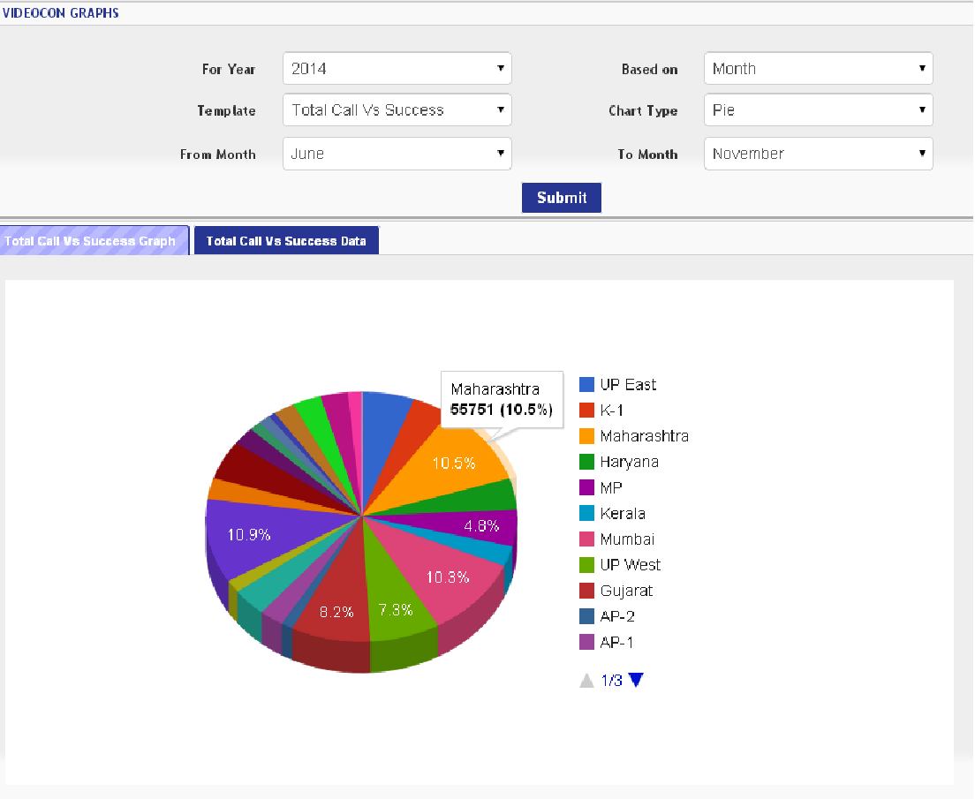

**BAR CHART**

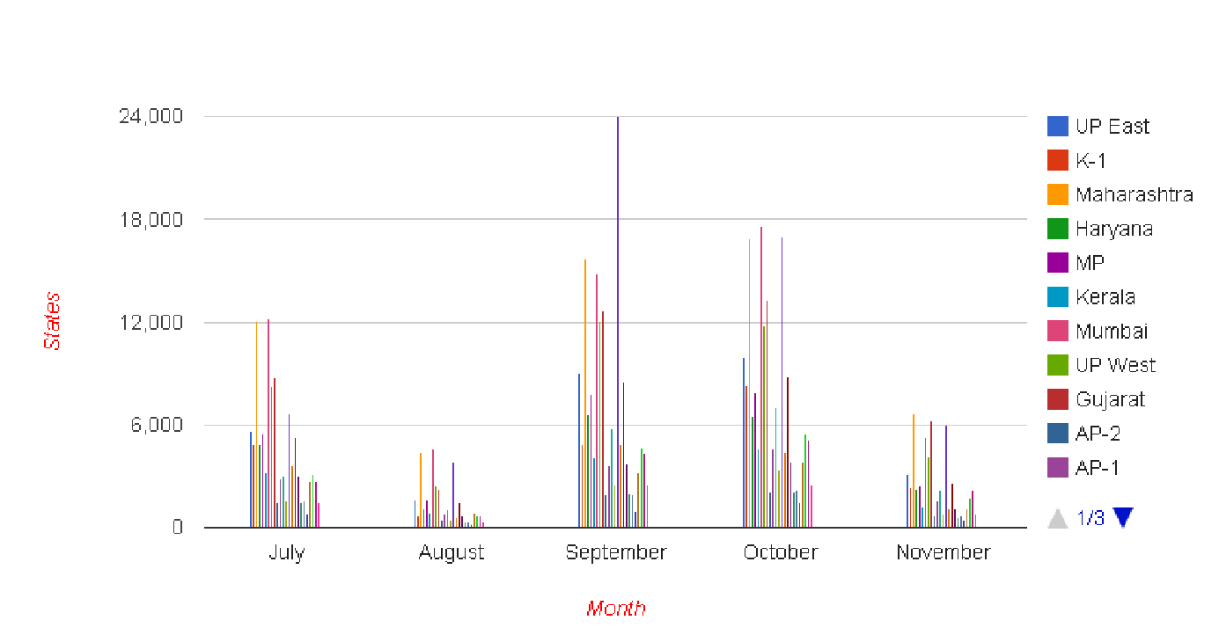

**LINE CHART**

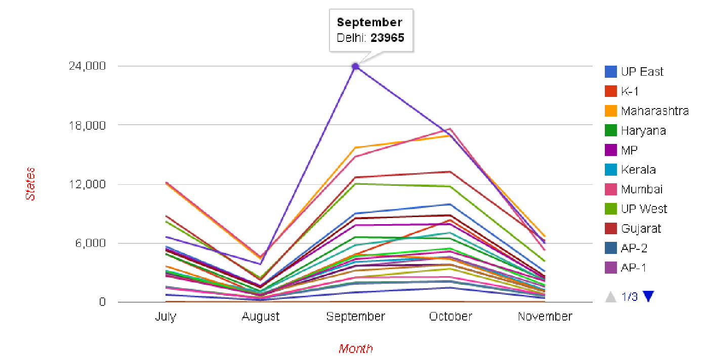

**FINALLY THE DATABASE STRUCTURE REQUIRED IS BELOW**

**dashboard_login_master :**  This table is used to solve the multiple xml creation for the same kind of mis for the different users.

For Example if you want to give the different user name and password for the same xml and want that a login must be able to check there own records not all the records of the campaign then you are able to do this will the help of this table.

*CREATE TABLE `dashboard_login_master` (*

*`tp_user` varchar(50) NOT NULL,*

*`tp_password` varchar(50) NOT NULL,*

*`system_xml` varchar(50) NOT NULL,*

*`appen_query` varchar(100) DEFAULT '',*

*`isActive` tinyint(1) DEFAULT '1',*

*`added_on` timestamp NULL DEFAULT CURRENT_TIMESTAMP,*

*`lang` varchar(20) DEFAULT '',*

*PRIMARY KEY (`tp_user`)*

*);*

**login_details :** This table is used to keep the login and logout timings of the users.

CREATE TABLE `login_details` (

`id` bigint(20) NOT NULL AUTO_INCREMENT,

`user_name` varchar(100) NOT NULL,

`ip` varchar(20) NOT NULL,

`login_time` timestamp NOT NULL DEFAULT CURRENT_TIMESTAMP,

`logout_time` datetime NOT NULL DEFAULT '0000-00-00 00:00:00',

PRIMARY KEY (`id`)

);

**tbl_dnd_file_details :** This table is used when you want to scrub the uploaded base before calling. This table will keep the record of the upload while sending the base file for the filtering and an EXTERNAL utility DNDSCRUBBING use this data and update the status of the uploaded records to start the calling.

CREATE TABLE `tbl_dnd_file_details` (

`id` bigint(20) NOT NULL AUTO_INCREMENT,

`file_id` bigint(20) NOT NULL DEFAULT '0',

`filename` varchar(255) NOT NULL DEFAULT '',

`filepath` varchar(255) NOT NULL DEFAULT '',

`status` tinyint(4) NOT NULL DEFAULT '0' COMMENT '0-Not process,1-processing,2-success',

`max_try` tinyint(4) NOT NULL DEFAULT '0',

`db_name` varchar(255) NOT NULL DEFAULT '',

`main_table` varchar(255) NOT NULL DEFAULT '',

`tmp_table` varchar(255) NOT NULL DEFAULT 'no2dial_dnd',

`not_id_dnd` bigint(20) NOT NULL DEFAULT '0',

`insert_time` timestamp NOT NULL DEFAULT CURRENT_TIMESTAMP,

`update_time` datetime NOT NULL DEFAULT '0000-00-00 00:00:00',

`org_count` int(10) unsigned DEFAULT '0',

PRIMARY KEY (`id`)

);

**user_activity_details_xml :**  This will keep the records of the uploaded file while that is prompt file or base file.

CREATE TABLE `user_activity_details_xml` (

`file_id` bigint(20) NOT NULL AUTO_INCREMENT,

`user_name` varchar(100) NOT NULL DEFAULT '',

`login_id` bigint(20) DEFAULT NULL,

`wav_files` varchar(200) NOT NULL DEFAULT '',

`org_csv_file` varchar(200) NOT NULL DEFAULT '',

`success_csv_file` varchar(200) NOT NULL DEFAULT '',

`fail_csv_file` varchar(200) NOT NULL DEFAULT '',

`org_count` int(11) NOT NULL DEFAULT '-1',

`success_count` int(11) NOT NULL DEFAULT '-1',

`fail_count` int(11) NOT NULL DEFAULT '-1',

`validation` int(11) NOT NULL DEFAULT '0',

`addparams` text,

`activity_time` timestamp NOT NULL DEFAULT CURRENT_TIMESTAMP,

`activity` varchar(100) NOT NULL DEFAULT '',

`suspend_base` tinyint(1) DEFAULT '0',

`suspend_datetime` datetime DEFAULT '0000-00-00 00:00:00',

`dbname` varchar(100) DEFAULT '',

`tblname` varchar(100) DEFAULT '',

`email_flag` tinyint(4) NOT NULL DEFAULT '0',

PRIMARY KEY (`file_id`)

);

**FULL SAMPLE OF THE XML**

<URL>  
<PATHDETAILS> <D_TMP>/tmp/misdownloadfiles/</D_TMP>  
 <D_FINAL>/tmp/misdownloadfiles/</D_FINAL>  
 <U_TMP>/logs/upload/</U_TMP>  
 <SPEAKERPATH>/tmp/recording/daburreal/</SPEAKERPATH>  
 <DND_FILE>/logs/dashboard/all_dnd_file/</DND_FILE>  
 <LOGPATH>E:/logs/dashboard/</LOGPATH>  
 <SPEAKERPATH>E:/EntUtilities/ApplicationFolder/promptPath/</SPEAKERPATH>  
 <UTILITYPATH>E:/</UTILITYPATH>  
 <IMAGE_NAME>logo.png</IMAGE_NAME>  
 <HEADING>One97 Communications Ltd.</HEADING>  
 <SKIN>report17</SKIN>  
 <!--  
base  
report  
report1  
report2  
report3  
report4  
report5  
report6  
report7  
report8  
report9  
report10  
report11  
report12  
report13  
report14  
report15  
report16  
-->  
 <IP>local</IP>  
</PATHDETAILS>  
  
<UPLOADER>  
 <DBDETAILS dbname='uploadcheck' title="Iimi Uploader"> <PASSWORD>iimi</PASSWORD>  
 <TABLENAME>campdesigner_test</TABLENAME>  
 <!--<UNIQUE>replace/ignore</UNIQUE>-->  
 <RESETTABLENAME>campdesigner_test</RESETTABLENAME>  
 <SUSPEND>False</SUSPEND>  
 <RESUME> </RESUME>  
 <RESET>TRUE</RESET>  
  
 <!--<RESETADDONPARAMS>c_date=date_sub(current_date,interval 10 year)</RESETADDONPARAMS>  
 <FILEPARAMETER id="Flow1" appname_clmn="param10" attribute='no2dial,param1,param2,param3'>Mobile No,DD No.,Fee Amount,Dispatch Date</FILEPARAMETER>  
 <FILEPARAMETER id="Flow2" appname_clmn="param10" attribute='no2dial,param5,param3,param4'>Mobile No,Docket Id,Dispatch Date,Delivery Date</FILEPARAMETER>  
 <FILEPARAMETER id="Flow3" appname_clmn="param10" attribute='no2dial,docket_id,param3'>Mobile No,Docket Id,Dispatch Date</FILEPARAMETER>  
 <FILEPARAMETER id="Flow4" appname_clmn="param10" attribute='no2dial,param1,param2,param3'>Mobile No,DD No.,Fee Amount,Dispatch Date</FILEPARAMETER>-->  
 <FILEPARAMETER attribute='no2dial'>Mobile No</FILEPARAMETER>  
 <TEXT title="Campaign Name" attribute="param2" operator="=" property="param2" value=""/>  
 <TEXT title='Calling Number' attribute='msisdn' operator='=' property='msisdn' value=''/>  
 <TIME2RUNINDEX>-1</TIME2RUNINDEX>  
 <REGEX>[0-9]{10}</REGEX> <SET attribute='outdialer_id'>1</SET> <!--<COMBO title="Server Name" attribute='server_ip' property='server_ip' autoquery='select server_name,dailer_uniqueid from db_utilities.server_ip_details where server_ip in ("5","8","9","10") and server_isactive=1 order by server_ip'>  
 </COMBO>-->  
 <COMBO title="CampaignId" attribute="param2" property="campaign_name">  
 <OPTION>  
 <KEY value='Camp1'>Camp1</KEY>  
 </OPTION>  
 <OPTION>  
 <KEY value="76' , session_name='Tata Power_Payment Reminder', app_lang='LHIN',dwh_obd_applog_detail='app_category=Advertising &amp; Marketing;;app_subcategory=TATA Power;;app_type=OUT;;app_name=Tata Power_Payment Reminder;;duration=0;" >Hindi</KEY>  
 </OPTION>  
 <OPTION>  
 <KEY value='Camp2'>Camp2</KEY>  
 </OPTION> </COMBO>  
 <DEFAULTQUERY> </DEFAULTQUERY>  
 </DBDETAILS>  
 <DND default='yes' disable='false'>  
 <OPTION>yes</OPTION>  
 <OPTION>No</OPTION>  
 </DND>  
 <GENIRIC>  
 <!--<RUNBEFOREUPLOAD>hello.bat</RUNBEFOREUPLOAD>-->  
 <!--<RUNBEFOREUPLOAD>hello.bat fileid</RUNBEFOREUPLOAD>-->  
 <!--<RUNAFTERUPLOAD>end.bat</RUNAFTERUPLOAD>-->  
 <!--<RUNAFTERUPLOAD>end.bat fileid</RUNAFTERUPLOAD>-->  
 <SENDPROMPTTOURL>  
 <PROMPTINFO server_attribute="param2" server_property="campaign_name" server_id="Camp1" url="http://10.0.28.35:8080/FileReceiverV2/ReceiveFile?" location="D:/Fwork/"/>  
 <PROMPTINFO server_attribute="param2" server_property="campaign_name" server_id="Camp1" url="http://10.0.28.35:8080/FileReceiverV2/ReceiveFile?" location="D:/Fwork/"/>  
 <PROMPTINFO server_attribute="param2" server_property="campaign_name" server_id="Camp1" url="http://10.0.28.35:8080/FileReceiverV2/ReceiveFile?" location="D:/Fwork/"/>  
 <PROMPTINFO server_attribute="param2" server_property="campaign_name" server_id="Camp1" url="http://10.0.28.35:8080/FileReceiverV2/ReceiveFile?" location="D:/Fwork/"/>  
 </SENDPROMPTTOURL>  
 <!--<TIME2RUN>calendar</TIME2RUN> -->  
 <!--<PROMPTTYPE>DYNAMIC</PROMPTTYPE>-->  
 <!--<PROMPTIDPARAM>param2</PROMPTIDPARAM>-->  
 <PROMPTS>wel</PROMPTS>  
 <!--<PROMPTS>2</PROMPTS>-->  
 <PATH>D:\Fwork\Generic_OBD\Prompts\IIMI\</PATH> <ADDPATH title="Language" attribute="app_lang" property="language">  
 <OPTION>  
 <KEY value='LHIN'>LHIN</KEY>  
 </OPTION>  
 <OPTION>  
 <KEY value='LENG'>LENG</KEY>  
 </OPTION> </ADDPATH>  
 </GENIRIC>  
</UPLOADER>  
<!--$$$$$$$$$$$$$$$$$$$$$$$$$$$$$$$$$$$$$$$$$$$$$$$$$$$$$$$$$$$ GRAPH $$$$$$$$$$$$$$$$$$$$$$$$$$$$$$$$$$$$$$$$$$$$$$$$$$$$$$$$$$$-->  
<LINK title='ADTV' httplocation="http://192.168.1.48:8080/ADTVCampaign/"/>  
  
<INSERT title='Insert Sms'>  
 <DBNAME>test</DBNAME>  
 <TABLENAME>sms_table</TABLENAME>  
 <!--<INSERTIGNORE>IGNORE/ON DUPLICATE KEY UPDATE</INSERTIGNORE>-->  
 <!--<DEFAULTINSERT> isactive=1</DEFAULTINSERT>-->  
 <INSERTPARAMETER> <TEXT title='State' attribute='state' operator='=' value='' property="string,50,"/> <TEXT title='District' attribute='district' operator='=' value='' property="string,50,"/> <TEXT title='Prompt Code' attribute='promptcode' operator='=' value='' property="string,50,"/>  
 <TEXTBOX title='Message Content' attribute='smscontent' operator='=' value='' property="string,360,"/>  
 <CALENDER title='Date Of Birth' attribute='dob' operator='=' value=''/>  
 <SELECT title='Gender' attribute='gender'>  
 <OPTION value='M'>Male</OPTION> <OPTION value='F'>FeMale</OPTION>  
 </SELECT>  
 <!--  
 property=type,length,operator  
 type in (int,)  
 -->  
<!-- -->  
 <!--<SELECT title='Gender' attribute='gender' autoquery="select 'Youth','Youth' from dual"/>-->  
 </INSERTPARAMETER>  
</INSERT>  
<MIS type='speaker' title='CC Panel' index="4">  
 <DBNAME>campaignmanager</DBNAME>  
 <TABLENAME>hpcl_ccpanel_help</TABLENAME>  
 <TABLEPARTITIONING>0</TABLEPARTITIONING>  
 <DEFAULTQUERY> </DEFAULTQUERY>  
 <DOWNLOAD>YES</DOWNLOAD>  
 <DISPLAYQUERY> SELECT now() from dual</DISPLAYQUERY>  
 <ORDERBY> order by callid desc </ORDERBY>  
 <!--<LIMIT>2</LIMIT>-->  
 <SMSTEMPLATE>  
 <SMS smsText="'Testing Msg'" receiver_no='9911773883' appid_value='20' appid_from='' appName_value='VINEET' appName_from='' senderText_value='IIMI' senderText_from='' config_where_value='' update_clmn_value='' smsDbAndTable='db_smsserver.tbl_smsrequest'/> </SMSTEMPLATE> <SEARCHOPTIONS> <CALENDER title='From Date' attribute='date(inserttime)' operator='&gt;=' property='c_date' value=''/>  
 <CALENDER title='To Date' attribute='date(inserttime)' operator='&lt;=' property='c_date' value=''/>  
 <TEXT title='Calling Number' attribute='msisdn' operator='=' property='' value='' mendatory=”true”/>  
 <SELECT title='Server Name' dynamicuse="table_name" index="1" attribute='pool' query="select distinct pool,pool from db_cdr_reporting.?" autoquery='select server_tablename,server_id from db_cdr_reporting.cdr_server_tabledetails order by id' value='all,='></SELECT>  
 <SELECT title='Pool' attribute='pool' value='all,='></SELECT>  
 <!--<SELECT title='App Name' value='all,=' attribute='app_name' autoquery='SELECT DISTINCT AppName,AppName FROM db_smsserver.tbl_application_master'></SELECT>-->  
 <SELECT title='Tnc' value='all,='>  
 <OPTION value="1" attribute='(param7_int' operator='=' default=" or param1_int=2) ">Yes</OPTION>  
 <OPTION value="0" attribute='(param7_int' operator='=' default=" and param1_int!=2) ">No</OPTION>  
 </SELECT>  
 <SELECT title='Call Status' value='all,='>  
 <OPTION value="Complete" operator="=" attribute="ccstatus">Complete</OPTION>  
 <OPTION value="Call Back" operator="=" attribute="ccstatus">Call Back</OPTION>  
 <OPTION value="Call Closed" operator="=" attribute="ccstatus">Call Closed</OPTION>  
 <OPTION value="No Answer" operator="=" attribute="ccstatus">No Answer</OPTION>  
 <OPTION value=" " operator="=" attribute="ccstatus">Not Attempted</OPTION>  
 </SELECT>  
  
 </SEARCHOPTIONS>  
 <VIEWDETAILS> <COLUMNS attribute='inserttime' isdownload='true' update="no" orderbylink="inserttime" style="background-color:pink;">DateTime</COLUMNS>  
 <COLUMNS attribute='msisdn' isdownload='true' update="no" orderbylink="msisdn">Calling Number</COLUMNS>  
 <COLUMNS attribute='circle' isdownload='true' update="no" orderbylink="circle">Circle</COLUMNS>  
 <COLUMNS attribute='operator' isdownload='true' update="no" orderbylink="operator">Operator</COLUMNS>  
 <COLUMNS attribute='language' isdownload='true' update="no" scrolling="100" orderbylink="language">Language</COLUMNS> <!--  
 <COLUMNS style="width:250px;" attribute='cc_state' isdownload='true' update='yes' combo="SELECT dealer_state,dealer_state FROM db_enterprise_ibd.castrol_minitruck_dealer_detail GROUP BY 1" query="SELECT dealer_city FROM db_enterprise_ibd.castrol_minitruck_dealer_detail where dealer_state=%27?%27 group by 1" referenceto="COMBO-cc_city" resetonselection="cc_city,cc_dealer_address,cc_dealer_shopname,cc_dealer_name,cc_sms_text">State</COLUMNS> <COLUMNS style="width:250px;" attribute='cc_city' isdownload='true' update='yes' combo="@Select" query="SELECT dealer_address FROM db_enterprise_ibd.castrol_minitruck_dealer_detail WHERE dealer_city=%27?%27 and dealer_state=%27@cc_state@%27 GROUP BY 1" referenceto="LIST-cc_dealer_address" referencefrom="cc_state" resetonselection="cc_dealer_address,cc_dealer_shopname,cc_dealer_name,cc_sms_text">City</COLUMNS> <COLUMNS style="width:250px;" attribute='cc_dealer_address' isdownload='true' update='yes' combo="@Select" query="SELECT sms_text ,dealer_shop_name ,dealer_name from db_enterprise_ibd.castrol_minitruck_dealer_detail WHERE dealer_address=%27?%27 and dealer_state=%27@cc_state@%27 and dealer_city=%27@cc_city@%27 group by 1" referenceto="text-cc_sms_text ,cc_dealer_shopname ,cc_dealer_name" referencefrom="cc_state,cc_city" resetonselection="cc_dealer_shopname,cc_dealer_name,cc_sms_text">Dealer Address</COLUMNS>   
 <COLUMNS style="width:250px;" attribute='cc_dealer_name'

isdownload='true' edit_type="textarea" update="yes" readonly="true" scrolling="50,200" >Dealer Name</COLUMNS> <COLUMNS style="width:250px;" attribute='cc_dealer_shopname' isdownload='true' edit_type="textarea" update="yes" readonly="true" scrolling="50,200">Shop Name</COLUMNS> <COLUMNS style="height:120px;width:250px;" attribute='cc_sms_text' isdownload='true' edit_type="textarea" update="yes" readonly="true" scrolling="50,200" >SMS Text</COLUMNS> -->  
 <!--  
 <COLUMNS attribute='notes' visibility="FALSE" isdownload='true' update="yes" edit_type="textarea" validation="all,1,G,300,L" >Notes</COLUMNS> <COLUMNS attribute='ccstatus' visibility="FALSE" isdownload='true' update='yes' combo="@Select#Complete@Complete#Call Back@Call back#Call Closed@Call Closed#No Answer@No Answer">Status</COLUMNS>  
 <COLUMNS attribute='c_country' isdownload='true' update='yes' combo="SELECT country,country FROM campaignmanager.dashboard_testing GROUP BY 1" query="SELECT DISTINCT state,state FROM campaignmanager.dashboard_testing WHERE country=%27?%27" type='refrence' referenceto="list-c_state">COUNTRY</COLUMNS>  
 <COLUMNS attribute='c_state' isdownload='true' update='yes' combo="@Select" query="SELECT DISTINCT city,city FROM campaignmanager.dashboard_testing where state=%27?%27" referenceto="list-c_city">STATE</COLUMNS>  
 <COLUMNS attribute='c_city' isdownload='true' update='yes' combo="@Select" query="SELECT DISTINCT pin,pin FROM campaignmanager.dashboard_testing WHERE city=%27?%27" referenceto="list-c_pin">CITY</COLUMNS>  
 <COLUMNS attribute='c_pin' isdownload='true' update='yes' combo="@Select" query="SELECT location_name FROM campaignmanager.dashboard_testing WHERE pin=%27?%27" referenceto="text-c_location_name">PIN</COLUMNS> <COLUMNS attribute='c_location_name' isdownload='true' update='yes' readonly="true" scrolling="20,50">LOCATION</COLUMNS>  
 <COLUMNS attribute='callid' isdownload='sms' visibility="FALSE" disableonattribute="ccstatus" disableonoperator="=" disableonvalue="Complete">Sms Unique Id</COLUMNS>  
 <COLUMNS attribute='callid' isdownload='edit' edit_type='INLINE' defaultwhere="" defaultset="updatetime=NOW(),updateflag=1" disableonattribute="ccstatus" disableonoperator="=" disableonvalue="Complete">Edit</COLUMNS>   
 -->  
 <COLUMNS attribute='callid' isdownload='delete'>Delete</COLUMNS> <COLUMNS attribute='if(updatetime,updatetime,"0000-00-00 00:00:00")' isdownload='speaker' orderbylink="updatetime">Speaker</COLUMNS>   
 <COLUMNS attribute='msisdn' isdownload='true' isit_link="true" source_where="msisdn" destination_where="msisdn" select='no2dial@@name@@address@@gender@@if(date(autotime),date(autotime),"0000-00-00") as Creation_Date' tablename="test.testing_table">Link</COLUMNS>  
 <!--<COLUMNS attribute='sno' isdownload='edit' edit_type='OFFLINE' defaultset="" checkquery="SELECT IF(COUNT(IF(outdialer_id=0,1,NULL))&lt;3,TRUE,FALSE) FROM test.testing_table" successmsg="Edit is Not Allowed The Limit is Reached">Edit</COLUMNS>-->  
 <!--validation  
 (db,length),pancard,(email,length),(nospecial,length),(all,length),(alphabets,length),(number,length),(alphanumeric,length),(alpha_numeric,length)  
 disableonoperator  
 <,>,<=,>=,!=  
 in,!in,!like,!,=,between,!between  
 disableonvalue  
 disableonattribute  
 -->  
 </VIEWDETAILS>  
</MIS>  
<FILESYSTEM title='File System' index="3"> <LOCATION>C:/</LOCATION>  
 <LOCATION>D:/configfile</LOCATION>  
 <LOCATION>E:/</LOCATION>  
</FILESYSTEM>  
<GRAPH title='VIDEOCON GRAPHS'>  
 <DBNAME>db_outdialer.videocon_geo_summary</DBNAME>  
 <BASEDON>  
 <COLUMNS attribute=''>Based On</COLUMNS>  
 <COLUMNS attribute='4'>Month</COLUMNS>  
 <COLUMNS attribute='3'>Weekly</COLUMNS>  
 <COLUMNS attribute='2'>Daily</COLUMNS>  
 <COLUMNS attribute='1'>Hourly</COLUMNS>  
 </BASEDON>  
 <CHARTTYPE>  
 <COLUMNS attribute=''>Please Select Chart Type</COLUMNS>  
 <COLUMNS attribute='1'>Pie</COLUMNS>  
 <COLUMNS attribute='2'>Bar</COLUMNS>  
 <COLUMNS attribute='3'>Line</COLUMNS>  
 </CHARTTYPE>  
 <SELECT title='StateWise Success' qty1="states" qty2="success" vaxis="States"> </SELECT>  
 <SELECT title='StateWise Success Fail' groupby="states">  
 <COLUMNS attribute='success'>Success</COLUMNS>  
 <COLUMNS attribute='fail'>Fail</COLUMNS>  
 </SELECT> </GRAPH>  
</URL>

**UPLOADERAPI IN DASHBOARD**

With the help of API you are able to upload the data with the help of GUI and API too. The parameters of the API is same as we have in enterprise_dashboard like

**SAMPLE XML**

<UPLOADER>

<DBDETAILS dbname='campaignmanager' title="MY UPLOADER">

<PASSWORD>UPLOAD_TEST</PASSWORD>

<SUSPEND>TRUE</SUSPEND>

<RESUME>TRUE</RESUME>

<TABLENAME>camp_broadcast_dialer_bajaj</TABLENAME>

<RESET>TRUE</RESET>

<SUSPEND>TRUE</SUSPEND>

<RESUME>TRUE</RESUME>

<SHIFT server_attribute="server_id">TRUE</SHIFT>

<TEXT title="requestParam7" property="param9" attribute="param9" value="" />

<RESETTABLENAME>camp_broadcast_dialer_bajaj</RESETTABLENAME>

<FILEPARAMETER attribute='no2dial,param1,param2'>Mobile Number,Parameter1,Parameter2</FILEPARAMETER>

<DEFAULTINSERT>c_date=CURRENT_DATE</DEFAULTINSERT>

<TIME2RUNINDEX>-1</TIME2RUNINDEX>

<VALID>0</VALID>

<REGEX>[0-9]{10},([^,]*)</REGEX>

<SET attribute='outdialer_id'>103</SET>

<SET attribute='server_ip'>0</SET>

<!--<COMBO title="CITY" attribute='param1' property='param1'>

<OPTION>

<KEY value="DELHI"> Delhi </KEY>

</OPTION>

<OPTION>

<KEY value="PUNE"> PUNE </KEY>

</OPTION>

</COMBO>-->

<RESETTIME2RUN>TRUE</RESETTIME2RUN>

<RESETTABNAME>RESET PANEL</RESETTABNAME>

<UPLOADZIPBASEFILE>TRUE</UPLOADZIPBASEFILE>

<COLUMNS attribute="user_name">Application Name</COLUMNS>

<COLUMNS attribute="login_id">Login Id</COLUMNS>

<COLUMNS attribute="activity">Activity Name</COLUMNS>

<COLUMNS attribute="activity_time">Activity Time</COLUMNS>

<COLUMNS attribute="login_id">Login Id</COLUMNS>

<COLUMNS attribute="org_count">Uploaded Records</COLUMNS>

</DBDETAILS>

<GENIRIC>

<TIME2RUN>calendar</TIME2RUN>

<SENDPROMPTTOURL>

<PROMPTINFO server_attribute="param2" server_property="campaign_name" server_id="Camp1" url="http://10.0.28.42:8080/FileReceiver/ReceiveFile?" location="/tmp/"/>

</SENDPROMPTTOURL>

<PROMPTS>iim</PROMPTS>

<PATH>D:\Fwork\Generic_OBD\Prompts\IIM\</PATH>

<!--ADDPATH title="Language" attribute="app_lang" property="language">

<OPTION>

<KEY value='LHIN'>LHIN</KEY>

</OPTION>

<OPTION>

<KEY value='LENG'>LENG</KEY>

</OPTION>

</ADDPATH-->

</GENIRIC>

<DND default='yes' disable='false'>

<OPTION>yes</OPTION>

<OPTION>No</OPTION>

</DND>

</UPLOADER>

**API :** http://<SERVER_IP>:<PORT>/enterprise_dashboard/UploadFileDirectAction.do?

List of parameters you have to pass to upload the csv file through dashboard API is

|  |  |  |  |
| --- | --- | --- | --- |
| Parameter Name | Data Type | Description | Mendatory |
| username | String | username provide for authentication | Yes |
| password | String | password provide for authentication | Yes |
| dnd | String (no or yes) | Dnd filtering is required or not | Yes |
| browseType | Number  2 – both csv and wav  1 – wav only  0 – csv only | 0 for uploading only csv file | Yes |
| valid | Number  1- With Validation Regex required in xml  0- Without validation | 0 if you want to upload the file without any validation | Yes |
| csvFile | File | Csv file as per the format shared by the developer | No |
| wavFile1…. wavFilen | Ivr specific format/mp3 | Audio script file which you want to play in IVR | No |
| Other Paramer |  | As per the configured xml |  |

You have to upload at least one file from csvFile or wavFile.

You are able to upload n number of wav file like wavFile1 , wavFile2 and so on as configured in xml file...

**Example :**

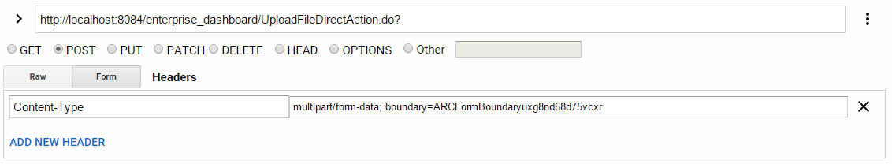

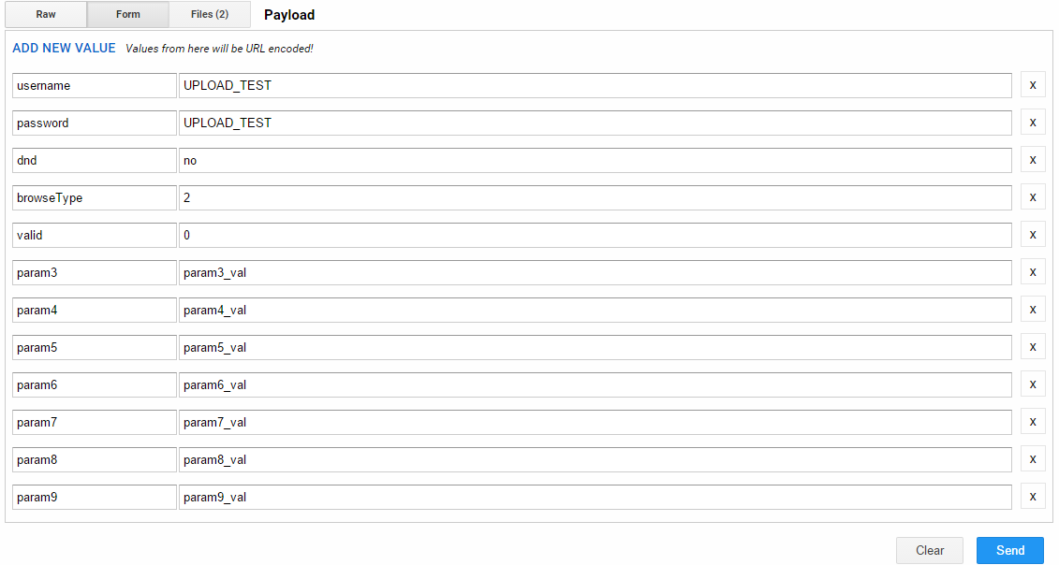

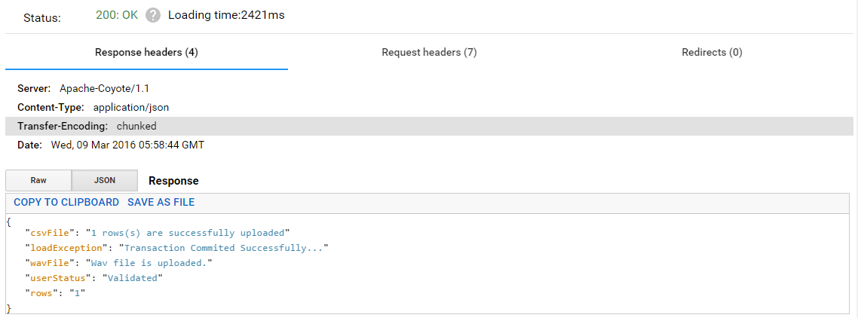

Response From The API

httpResponse statusCode is 200 if request is successfully served

{

"csvFile":"1 rows(s) are successfully uploaded"

"loadException":"Transaction Commited Successfully..."

"wavFile": "Wav file is uploaded."

"userStatus": "Validated"

"rows": "1"

}

|  |  |  |
| --- | --- | --- |
| Parameter Name | Type | Description |
| userStatus | String | Authentication is validated or not |
| wavFile | String | Received status if uploading wav file too avoid if you are uploading only csv file |
| csvFile | String | Message of uploading the csv file |
| rows | String | Number of rows uploaded |
| loadException | String | Exception or success message |

[**LAST CHANGES**](http://www.africau.edu/images/default/sample.pdf)

[**EDITCOLUMNSINROW : 06-May-2016**](http://www.africau.edu/images/default/sample.pdf)

[**22-April-2016**](http://www.africau.edu/images/default/sample.pdf)

[**----THE END----**](http://www.africau.edu/images/default/sample.pdf)