Azure Data Factory
Pipeline Technical Documentation
api_ingestion | PokeAPI Offset-Paginated Ingestion

Pipeline Name | api_ingestion

Data Factory | akhiladf24121999

Source | PokeAPI — https://pokeapi.co/api/v2/pokemon

Sink | Azure Data Lake Storage Gen2 (JSON format)

Pagination | Offset-based (QueryParam: offset, limit=20)

Authored by | Kumar Akhil

Last Run Status | ✅ Succeeded

Document Date | June 2026

1. Overview
This document describes the design, configuration, and execution details of the api_ingestion pipeline built in Azure Data Factory (ADF). The pipeline ingests Pokémon data from the publicly available PokeAPI using offset-based pagination and lands the raw JSON response into Azure Data Lake Storage Gen2.

The pipeline is structured as a two-activity orchestration: a Web activity first fetches the total record count from the API, which is then used to dynamically drive the pagination range in the subsequent Copy Data activity. This approach ensures all records are captured regardless of the total count at runtime.

2. Pipeline Architecture

2.1 Pipeline Canvas Overview
The screenshot below shows the full pipeline canvas in ADF Studio, with both activities (WebCount and ApiDataCopy) and the successful debug run output at the bottom.

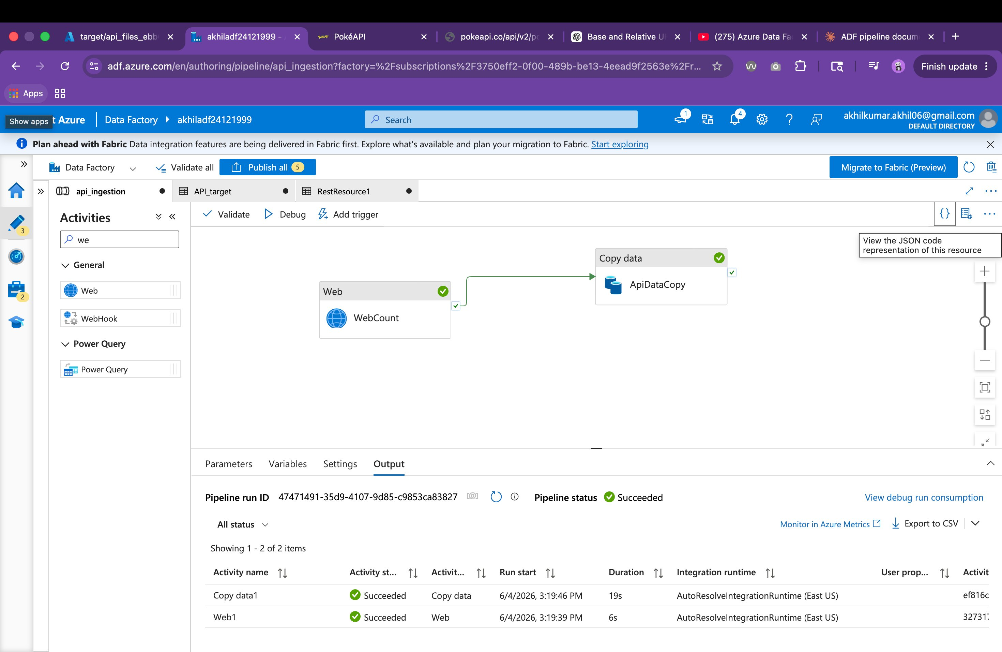
Figure: ADF pipeline canvas showing WebCount → ApiDataCopy flow with successful debug run output

2.2 Activity Flow
The pipeline follows a sequential two-step pattern:

🌐 Web Activity  WebCount  GET total record count | → | 📋 Copy Data Activity  ApiDataCopy  Paginated copy to ADLS | → | 🗄️ ADLS Gen2  JSON Files

ApiDataCopy depends on WebCount with a Succeeded condition. The Copy activity will only execute if the Web activity completes without error, ensuring the pagination range expression has a valid count value to work with.

3. Activity Details

3.1 WebCount (Web Activity)
This activity makes an HTTP GET request to the PokeAPI to retrieve metadata about the Pokémon resource — specifically the total count of available records. The count value from the response is then used dynamically in the pagination expression of the Copy activity.

ADF Configuration Screenshot
The screenshot below shows the WebCount activity settings in ADF, with the PokeAPI URL, GET method, and no authentication configured.

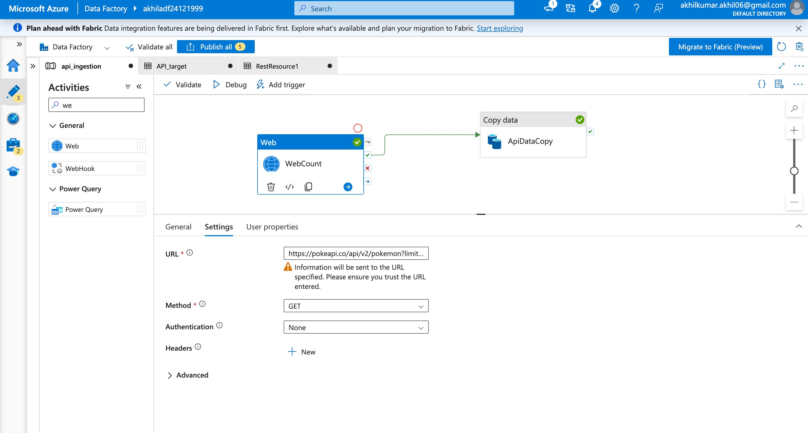
Figure: WebCount activity settings — URL, method, and authentication configuration in ADF Studio

Configuration Reference
Property | Value
Activity Name | WebCount
Activity Type | Web
HTTP Method | GET
URL | https://pokeapi.co/api/v2/pokemon?limit=20
Authentication | None (public API)
Headers | None
Output Used | activity('WebCount').output.count
Timeout | 0.12:00:00 (12 hours)
Retry | 0
Retry Interval | 30 seconds
Run Duration (debug) | 6 seconds
Status | Succeeded

Sample API Response
The Web activity captures the full JSON response. The count field is the key output consumed downstream:
{
"count": 1302,
"next": "https://pokeapi.co/api/v2/pokemon?offset=20&limit=20",
"previous": null,
"results": [ { "name": "bulbasaur", "url": "..." }, ... ]
}

3.2 ApiDataCopy (Copy Data Activity)
This activity reads paginated data from the PokeAPI REST endpoint and writes the raw JSON responses into Azure Data Lake Storage Gen2. Pagination is driven entirely by the offset query parameter, auto-incremented using ADF's built-in pagination rule engine.

Source Tab — Pagination Rule Configuration
The screenshot below shows the Source tab of the ApiDataCopy activity. Key settings visible are the source dataset (RestResource1), GET method, request timeout, request interval, and the offset pagination rule with the RANGE expression.

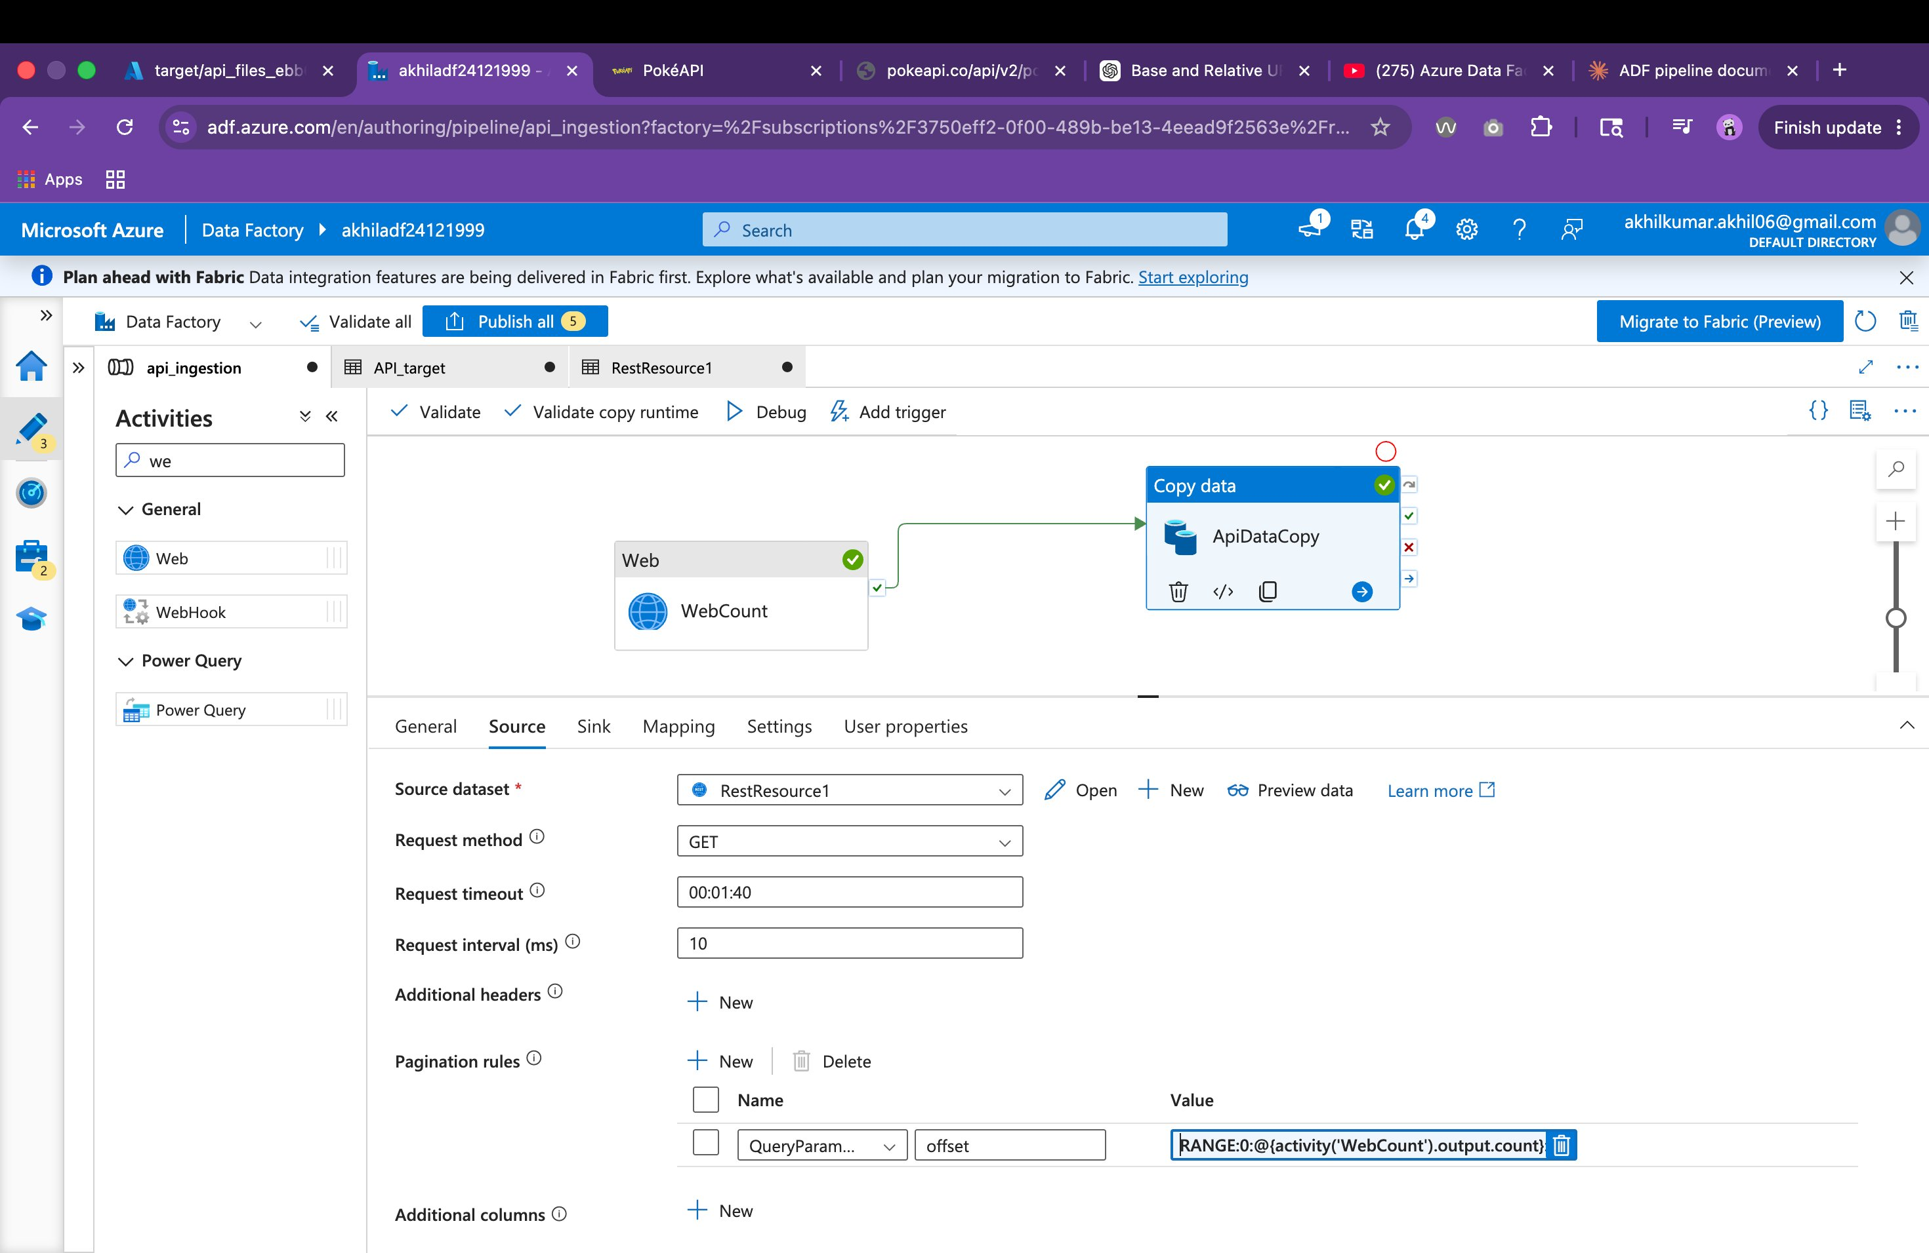
Figure: ApiDataCopy activity — Source tab showing RestResource1 dataset and offset pagination rule with RANGE expression

Source Configuration
Property | Value
Source Dataset | RestResource1
Source Type | RestSource
Request Method | GET
Request Timeout | 00:01:40
Request Interval | 10 ms
Additional Headers | None
Staging Enabled | False

Pagination Rule
ADF's native pagination rule engine is configured to auto-increment the offset across pages:

Property | Value
Rule Type | QueryParameters
Parameter Name | offset
Value Expression | RANGE:0:@{activity('WebCount').output.count}:20
Explanation | Start at 0, go up to total count, step by 20 per page

The RANGE expression tells ADF to iterate the offset from 0 up to the total count fetched dynamically from WebCount, incrementing by 20 on each iteration. This eliminates the need for a ForEach loop or manual offset management.

Sink Tab — ADLS Gen2 Output Configuration
The screenshot below shows the Sink tab of the ApiDataCopy activity, with the API_target dataset selected pointing to Azure Data Lake Storage Gen2 in JSON format.

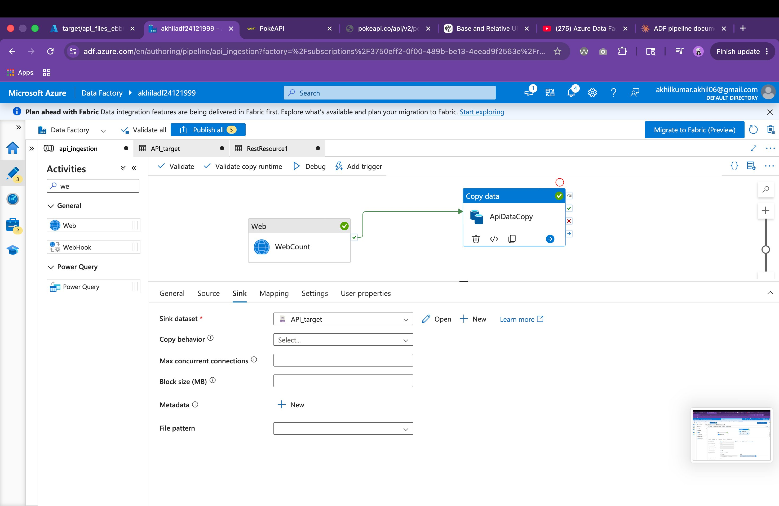
Figure: ApiDataCopy activity — Sink tab showing API_target dataset backed by ADLS Gen2 with JsonSink configuration

Sink Configuration
Property | Value
Sink Dataset | API_target
Sink Type | JsonSink
Store Settings | AzureBlobFSWriteSettings (ADLS Gen2)
Format Settings | JsonWriteSettings
Copy Behavior | Default
Max Concurrent Connections | Default
Block Size | Default

General Configuration
Property | Value
Activity Name | ApiDataCopy
Activity Type | Copy
Depends On | WebCount (Succeeded)
Timeout | 0.12:00:00 (12 hours)
Retry | 0
Retry Interval | 30 seconds
Secure Input/Output | False
Run Duration (debug) | 19 seconds
Status | Succeeded

4. Datasets

4.1 RestResource1 (Source Dataset)
This is the REST linked dataset that points to the PokeAPI endpoint. It is used as the source in the ApiDataCopy activity.

Property | Value
Dataset Name | RestResource1
Type | RestResource
Base URL | https://pokeapi.co/api/v2/pokemon
Linked Service | REST Linked Service (PokeAPI)
Authentication | Anonymous (no auth required)

4.2 API_target (Sink Dataset)
This dataset represents the destination in Azure Data Lake Storage Gen2 where the raw API JSON responses are written.

Property | Value
Dataset Name | API_target
Type | JSON
Storage Type | Azure Data Lake Storage Gen2
Linked Service | ADLS Gen2 Linked Service
File Format | JSON

5. Pagination Design

5.1 How Offset Pagination Works
PokeAPI uses classic offset-limit pagination. Each request returns a fixed number of records (limit=20) and the next batch is fetched by advancing the offset by the same step size.

Request # | URL Called | Records Fetched
1 | ?offset=0&limit=20 | Records 1–20
2 | ?offset=20&limit=20 | Records 21–40
3 | ?offset=40&limit=20 | Records 41–60
... | ... | ...
N | ?offset=(count-20)&limit=20 | Final page

5.2 Dynamic Count-Driven Pagination
Rather than hardcoding the total number of pages, this pipeline dynamically determines the upper bound of the offset range at runtime:

- WebCount fetches the API with limit=20 and reads the count field from the response (e.g., 1302).
- The RANGE expression in the pagination rule uses this count as the upper boundary.
- ADF iterates: offset = 0, 20, 40, … up to count — automatically stopping when the range is exhausted.
- No hardcoded loop count or manual offset tracking is required.

This design is resilient to changes in the total record count over time, making the pipeline future-proof without any configuration changes.

6. Execution Summary

6.1 Debug Run Results

Activity | Status | Duration
WebCount (Web) | ✅ Succeeded | 6 seconds
ApiDataCopy (Copy Data) | ✅ Succeeded | 19 seconds

Property | Value
Pipeline Run ID | 47471491-35d9-4107-9d85-c9853ca83827
Pipeline Status | Succeeded
Integration Runtime | AutoResolveIntegrationRuntime (East US)
Run Type | Debug
Run Date | June 4, 2026, 3:19 PM
Total Duration | ~25 seconds

7. Pipeline JSON Definition
The following is the full ADF pipeline JSON as exported from the Data Factory. This can be used for source control, redeployment, or CI/CD via Azure DevOps.

{
"name": "api_ingestion",
"properties": {
"activities": [
{
"name": "ApiDataCopy",
"type": "Copy",
"dependsOn": [{ "activity": "WebCount", "dependencyConditions": ["Succeeded"] }],
"typeProperties": {
"source": {
"type": "RestSource",
"httpRequestTimeout": "00:01:40",
"requestInterval": "00.00:00:00.010",
"requestMethod": "GET",
"paginationRules": {
"QueryParameters.offset": {
"value": "RANGE:0:@{activity('WebCount').output.count}:20",
"type": "Expression"
}
}
},
"sink": {
"type": "JsonSink",
"storeSettings": { "type": "AzureBlobFSWriteSettings" },
"formatSettings": { "type": "JsonWriteSettings" }
}
},
"inputs": [{ "referenceName": "RestResource1", "type": "DatasetReference" }],
"outputs": [{ "referenceName": "API_target", "type": "DatasetReference" }]
},
{
"name": "WebCount",
"type": "WebActivity",
"typeProperties": {
"method": "GET",
"url": "https://pokeapi.co/api/v2/pokemon?limit=20"
}
}
]
}
}

8. Error Handling & Retry Policy
Property | Value
Retry Attempts | 0 (no automatic retry)
Retry Interval | 30 seconds
Activity Timeout | 12 hours
Secure Input | Disabled
Secure Output | Disabled

Since this is a hands-on learning pipeline using a public API, retry is set to 0. For production use, it is recommended to set retry to at least 2–3 with exponential backoff to handle transient network or API errors.

9. Recommendations for Production
- Enable retry (2–3 attempts) with a 60-second interval on both activities to handle transient API failures.
- Add pipeline-level parameters for the base URL and page size (limit) to make the pipeline reusable across different API endpoints.
- Configure an ADF trigger (schedule or event-based) to automate execution instead of manual debug runs.
- Add a logging mechanism — write pipeline run metadata (run ID, record count, status, timestamp) to a Delta table or Azure SQL for observability.
- Consider partitioning the output files in ADLS by ingestion date (e.g., /raw/pokemon/yyyy/MM/dd/) for easier downstream processing.
- If the API introduces authentication, update the Linked Service and Web activity to use Bearer Token or API Key via ADF's Key Vault integration.

10. Glossary
Term | Full Form | Description
ADF | Azure Data Factory | Cloud-based ETL/ELT data integration service by Microsoft.
ADLS | Azure Data Lake Storage Gen2 | Scalable cloud storage optimized for big data analytics.
REST | Representational State Transfer | API architectural style using HTTP methods.
GET | HTTP GET | HTTP method used to retrieve data from a server.
RANGE | ADF Pagination Expression | Built-in ADF expression to auto-iterate a numeric offset.
PokeAPI | Pokémon API | A free public REST API providing Pokémon game data.
offset | Pagination Query Param | Specifies how many records to skip before returning results.
limit | Pagination Query Param | Max number of records returned per API response.
JSON | JavaScript Object Notation | Lightweight data-interchange format used for API responses.
IR | Integration Runtime | The compute infrastructure used by ADF to run activities.

Document prepared by Kumar Akhil | Sigmoid Analytics | June 2026

