Project Progress Report
1. Project Title
Comparative study between audio domain transfer learning and image based transfer learning on imbalanced birds dataset of 114 bird species.
2. Problem Statement
Ornithologists can identify the birds manually. But today recording devices can collect large amount of data hence manual identification of birds can be slow. Therefore, it becomes harder to study bird species and biodiversity.
3. Objective of the Project
This study aims to compare two approaches to identify birds which has used an imbalanced dataset. In first approach YAMNet model which is pretrained on audio dataset is used. It is not trained again instead it is used as fixed feature extractor. Then those features are trained on Support Vector Machine, Multilayer perceptron and random forest.
In second approach audio is converted to mel spectrogram images. It is given to MobileNetV2 which is pretrained model on ImageNet.
Both these approaches were applied on same Kaggle dataset. Final evaluation has been done using macro-averaged metrics and per species metrics.
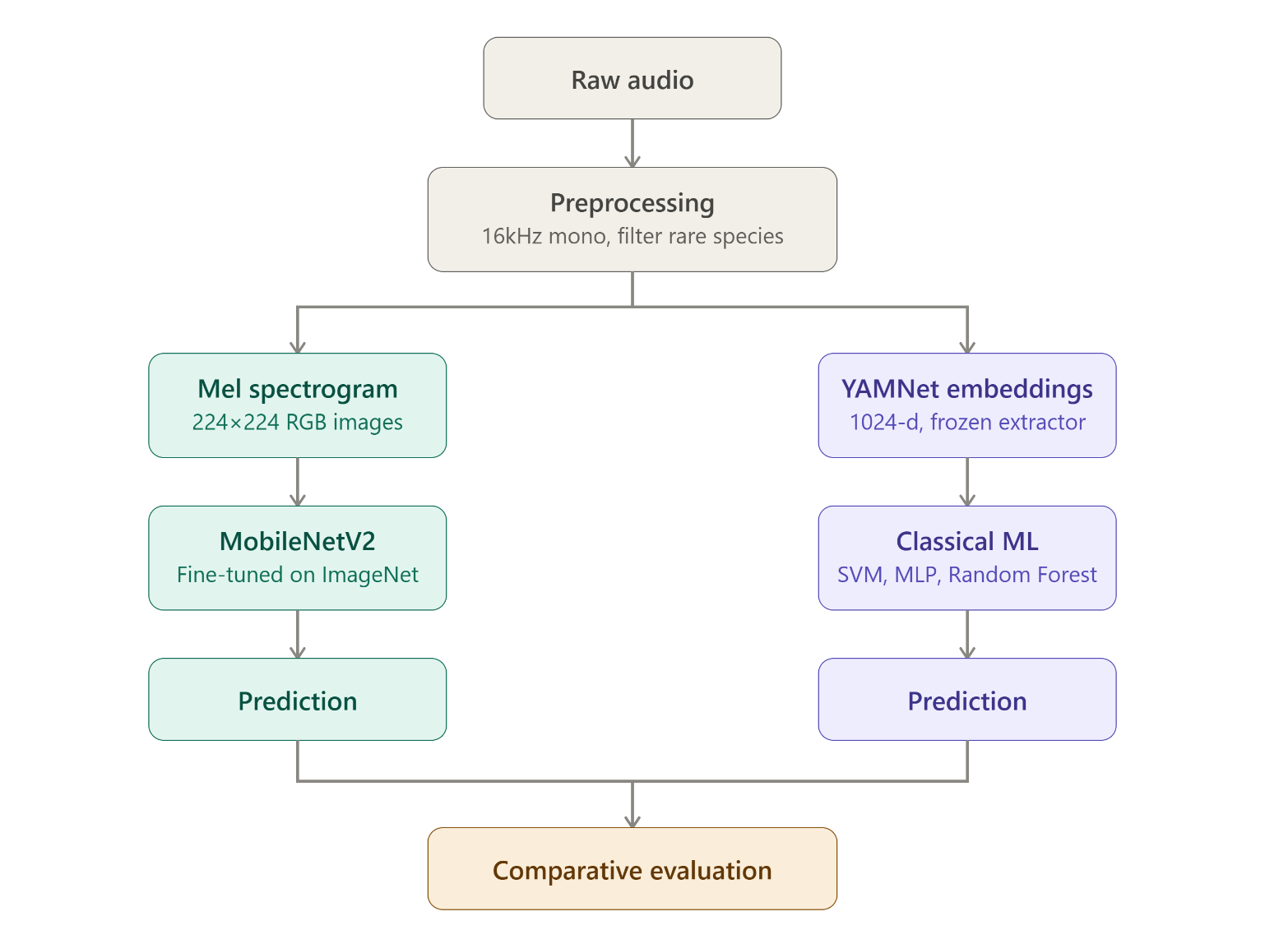
4. Research Gaps (from Literature Review)
Review of 15 research papers was done and following gaps were found:
- Many research papers used either imaged based transfer learning or audio based transfer learning. But our project used both the approaches on same dataset.
- Researchers who used pretrained models used only one classifier. In our project support vector machine, random forest and multi layer perceptron are used.
- Many studies calculated only overall accuracy. But our project calculated both macro averaged metrics and per species metrics.
- In previous studies researchers generally classified 10 to 20 bird species. They used large and complex deep learning models. But our project used a dataset which has 114 birds species and used simple machine learning algorithms.
- Many researchers used BirdNET, Perch which trained specifically on bird audio dataset. But our project uses general purpose pretrained models.
The complete 15-paper literature review matrix is provided in the Appendix at the end of this document.
5. Dataset
Name: Sound of 114 Species of Birds till 2022
Source: Kaggle (derived from Xeno-canto)
Link: https://www.kaggle.com/datasets/soumendraprasad/sound-of-114-species-of-birds-till-2022
Advertised size: 3,336 recordings across 114 bird species
Working sample count after ingestion: 2,161 recordings across 114 species
Metadata fields: species name, recording date, country, recordist
6. Number of Samples and Features
The two pipelines apply slightly different filtering thresholds and split strategies at this progress stage.

Attribute | YAMNet Pipeline | MobileNetV2 Pipeline
Raw samples ingested | 2,161 recordings | 2,161 recordings
Filter threshold (min samples/class) | ≥ 5 samples | ≥ 4 samples
Classes retained | 100 species | 102 species
Classes dropped | 14 rare species | 12 rare species
Effective sample count | 2,128 samples | 2,136 samples
Feature representation | 1024-d YAMNet embeddings | 224×224×3 mel spectrograms
Train / Val / Test split | 70/15/15 → 1489/319/320 | 80/10/10 → 1708/214/214

7. Data Preprocessing Performed
Common preprocessing
- Metadata was read and preprocessed.
- Bird species name were standardized.
- Species with fewer than the pipeline-specific minimum sample threshold were removed.
- Stratified sampling was applied during splitting the dataset into training, validation and testing.
- A safe fallback method was applied for species with less recording.
- Random seed 42 was set so that anyone running the same code will obtain exactly the same train, validation, and test split.
YAMNet pipeline
- All recordings were converted to sampling rate of 16kHz and one audio channel because YAMNet accepts input in this format.
- Each recording was given to YAMNet.
- Audio was divided into segments of 0.96 each. 1024-dimensional embedding was extracted for each segment.
- Since each audio has many segments so average was done of all embedding to make one 1024-dimensional embedding.
- Those embeddings were saved in csv file in Google Drive so that those embeddings could be loaded directly.
- All the embeddings were standardized using StandardScaler.
- Scaler was fitted only on training data. Same scaling parameters were applied on validation and testing data. This avoids data leakage.
- Bird species column were converted into numerical labels using LabelEncoder.
MobileNetV2 pipeline
- All recordings were converted to sampling rate of 16kHz and one audio channel.
- Mel spectrogram is made from all the audios.
- To create spectrogram 128 mel bins, n_fft = 2048 and hop_length = 512 were used. The spectrogram values were converted to log scale. Spectrogram were saved as 224x224 RGB images in zip file in Google Drive.
- These spectrogram images were given as input to MobileNetV2 and weights were calculated.
- Data augmentation was applied on spectrogram images. Keras ImageDataGenerator was used for rescaling and light on-the-fly augmentation.
8. Machine Learning / Deep Learning Models Implemented
Audio-domain pipeline (YAMNet embeddings as fixed features)
- SVM with RBF kernel -> C = 10, gamma = scale, probability estimates enabled.
- MLP with hidden layers (512, 256), max_iter = 300, early stopping.
- Random Forest -> grid-searched over n_estimators, max_depth, and max_features; best configuration cached to Drive.
Image-domain pipeline (MobileNetV2 on mel-spectrograms)
- Base model: MobileNetV2 pretrained on ImageNet, top layer removed.
- Head-only training: 20 epochs, learning rate 1e-3, base frozen.
- Fine-tuning: 15 additional epochs at learning rate 1e-5, deeper layers unfrozen.
- Checkpointing on best validation accuracy; class-weighted training active throughout.

9. Best Model Selected
YAMNet embeddings + Random Forest — achieved the highest test accuracy (70.00%) and highest macro-F1 (0.654) among the four evaluated model configurations.
The audio-domain paradigm as a whole substantially outperformed the image-domain paradigm on this dataset (see next section).
10. Performance Metrics Achieved
Pipeline / Model | Val Acc | Test Acc | Macro Acc | Macro-F1 | Weighted F1
YAMNet + SVM (RBF) | 67.08% | 68.12% | — | 0.646 | —
YAMNet + MLP (512, 256) | 64.89% | 68.44% | — | 0.636 | —
YAMNet + Random Forest ★ | 69.91% | 70.00% | 67.34% | 0.654 | 0.696
MobileNetV2 (fine-tuned) | 53.74% | 57.01% | 50.80% | 0.451 | 0.563

★ Best model selected. All metrics computed on held-out test set. Macro-averaged metrics give equal weight to each species; weighted-averaged metrics weight by class support.

Additional YAMNet pipeline outputs:
- Per-species accuracy CSV saved to Drive (100 species).
- Confusion matrix (100×100) saved to Drive with counts and normalized-row versions.
- Top confusion pairs identified for error analysis (e.g., marail guan → white-throated tinamou; solitary tinamou → great tinamou).
- Top-K prediction pipeline implemented across all three classifiers with confidence scores.
11. Current Findings and Observations
A. Audio-domain transfer outperforms image-domain transfer on this dataset
After trying both approaches, training a Random Forest on YAMNet embeddings came out to be the best model. It had test accuracy of 70% and Macro-F1 score of 0.654. MobileNetV2 model was also fine tuned. It had test accuracy of 57.01% and Macro-F1 of 0.451.
This suggests that image-domain pretraining (MobileNetV2 on ImageNet) does not transfer as effectively as audio-domain pretraining (YAMNet on AudioSet) to bird vocalization classification on this dataset.
B. Classifier choice matters less than feature representation
Within the YAMNet pipeline, the three classifier families (SVM, MLP, Random Forest) achieved test accuracies within a 2-percentage-point band (68.12% – 70.00%). This suggests that the informational content of the YAMNet embeddings is the dominant factor, with the choice of downstream classical classifier making only a secondary contribution, a finding consistent with the shallow-fine-tuning robustness reported by Ghani et al. (2025).
C. Long-tail species drive most of the error
Per-species accuracy analysis reveals a bimodal distribution: many species with sufficient training samples achieve 80–100% accuracy, while species with only 1–3 test samples frequently score 0% (e.g., choco tinamou, little spotted kiwi, northern cassowary, southern cassowary). This confirms the long-tail hypothesis from the submitted problem statement and demonstrates why macro-averaged metrics are essential for honest evaluation.
D. Within-family confusion is a dominant failure mode
Top confusion pairs from the YAMNet + Random Forest confusion matrix show that many misclassifications occur within the same taxonomic family, for example, tinamou species confused with each other, or guan species confused with related chachalaca species. This supports the hypothesis of within-family acoustic similarity being a key failure mode, as anticipated in the problem statement.
12. Challenges Faced
- Severe class imbalance -> 14 of 114 species had fewer than 5 samples (12 species had fewer than 4). These were dropped to enable stratified splitting, but expanding the working species pool is a genuine limitation that motivates future dataset augmentation.
- YAMNet embedding extraction is slow on CPU. Colab GPU allocation was intermittent; embeddings were cached to Google Drive after first extraction to make subsequent runs practical.
- MobileNetV2 training required substantial GPU time; head-only training and full fine-tuning were checkpointed to Drive to survive session timeouts.
- Pipeline-specific filtering thresholds diverged (YAMNet used ≥5 samples/class → 100 species; MobileNetV2 used ≥4 → 102 species). Both satisfy the 100+ species requirement stated in the problem statement; this pipeline-level threshold difference is documented as a limitation of the current experimental setup.
- Debugging stratified splits for very small classes required a safe-fallback mechanism (falling back to unstratified split on the validation branch when class sizes prevented stratification).
- Colab CPU-only sessions cannot run the MobileNetV2 fine-tuning end-to-end; GPU sessions were needed to fully validate that pipeline.

13. Next Steps and Planned Improvements
The experimental work has been completed. The remaining tasks involve discussing the results in the context of existing literature, documenting the strengths and limitations of the proposed approaches, completing the conclusion and future work sections, and finalizing the dissertation through proofreading, formatting, and reference verification before submission.

Appendix — Literature Review Matrix
15 papers reviewed to identify research gaps addressed by this project
S.No | Reference | Problem Addressed | Methodology | Dataset | Results | Limitations | Research Gap
1 | Kahl, S., Wood, C. M., Eibl, M., & Klinck, H. (2021). BirdNET: A deep learning solution for avian diversity monitoring. Ecological Informatics, 61, 101236. | Expert-based bird classification is time-consuming. | Deep Neural Network (BirdNET) trained end-to-end. | Xeno-canto, Macaulay Library. | Precision 0.791 (single-species); F0.5 = 0.414 (soundscapes). | High computational cost. | Requires bird-specific pretraining; our project tests general YAMNet embeddings with lightweight classifiers.
2 | Ghani, B., Denton, T., Kahl, S., & Klinck, H. (2023). Global birdsong embeddings enable superior transfer learning for bioacoustic classification. Scientific Reports, 13, 22876. | Deep learning models need large labeled data. | Extract embeddings from pretrained models; train logistic regression. | Multiple bioacoustic datasets (birds, bats, mammals). | BirdNET embeddings outperformed YAMNet, VGGish, AudioMAE. | Only logistic regression as downstream classifier. | Our project compares three classifier families (SVM/MLP/RF) on YAMNet.
3 | Improved Detection of Bird Vocalisations Using BirdNET Embeddings and ML (2025). | Detecting specific vocalizations in noisy, low-data conditions. | BirdNET embeddings + shallow classifiers (SVM, RF, XGBoost). | 97 Xeno-canto recordings, 501 pos / 2505 neg segments. | BirdNET alone 84% precision; +SVM raised to 99-100%. | Single-species binary detection only. | Extends embedding + shallow-ML idea to 114-species multi-class.
4 | Ghani, B., et al. (2025). Impact of transfer learning methods and dataset characteristics on generalization. Scientific Reports, 15, 16273. | Bird classifiers struggle to generalize across species. | Full fine-tuning vs shallow fine-tuning vs knowledge distillation. | Xeno-canto. | Shallow fine-tuning most robust to distribution shift. | Only deep-learning tuning strategies compared. | Uses classical (non-neural) classifiers on frozen embeddings instead of trainable heads.
5 | Endalamaw, H. A., Yang, C. K., & Hsu, C. H. (2026). A real-time bird sound recognition app via deep learning techniques. Multimedia Tools and Applications, 85(2), 62. | Real-time on-device bird prediction without server. | Compared six deep learning models; best deployed as Android app. | Curated Xeno-canto, 610 Taiwanese species. | ResNet-18 accuracy 0.955. | Regional (Taiwan) dataset; efficiency-focused. | Uses YAMNet as fine-tuning target; our project uses YAMNet as fixed extractor.
6 | Shashidhar, R., et al. (2025). Deep learning approaches for automated bird sound classification using MFCC features. International Journal of Information Technology. | Manual bird classification is slow and error-prone. | MFCC features fed to CNN, RNN, LSTM, BiLSTM. | Kaggle dataset with 10 species. | BiLSTM 92.68% accuracy; deployed on Raspberry Pi 3. | Only 10 species; MFCC-dependent; 20-35s inference. | Uses YAMNet embeddings with classical classifiers on 100+ species instead of DL on MFCC.
7 | Kamarajugadda, R., et al. (2024/2025). Optimizing avian species recognition with MFCC features and deep learning models. International Journal of Information Technology. | Manual classification of recordings is difficult. | MFCC preprocessing + CNN/LSTM/RNN/BiLSTM comparison. | Kaggle bird sound dataset. | BiLSTM performed best. | Only overall accuracy reported; MFCC-only. | Our project adds macro-averaged and per-species metrics; uses YAMNet embeddings.
8 | Baowaly, M. K., et al. (2024). Deep transfer learning-based bird species classification using mel spectrogram images. PLOS ONE, 19(8), e0305708. | Robust classification of East African bird species. | Mel spectrograms + EfficientNet + GRU/LSTM; minority oversampling. | BirdCLEF 2023 (East African subset), 264 species. | EfficientNet-B7 + GRU: 84.03% accuracy, macro-precision 0.8342. | Only image-domain transfer; oversampling risks overfitting. | Our project directly compares image-domain (MobileNetV2) vs audio-domain (YAMNet) transfer.
9 | Zhang, F., et al. (2021). Bird species identification using spectrogram based on multi-channel fusion of DCNNs. Entropy, 23(11), 1507. | Highly imbalanced datasets need better feature handling. | Multi-channel DCNN fusion on STFT, MFCC, chirplet spectrograms. | Custom dataset + BirdCLEF2019. | Decision-fusion MAP 0.914; 300ms optimal window. | Requires training/fusing three DCNNs — computationally heavy. | Our project compares two pretrained transfer paradigms without training custom DCNNs.
10 | A Bird Song Detector for improving bird identification through Deep Learning: Doñana case study (2025). arXiv:2503.15576. | Classifiers fail on real noisy field recordings under imbalance. | Bird Song Detector pre-filter + BirdNET vs ResNet50/MobileNetV2 on 3s spectrograms. | Doñana field soundscape recordings. | Detector improved pipeline; ResNet50/MobileNetV2 accuracy as low as 0.02; F1 <0.02. | Single site; poor CNN performance may partly reflect insufficient fine-tuning. | Tests same MobileNetV2 paradigm on curated focal recordings to isolate dataset effects.
11 | Kahl, S., et al. (2022). Overview of BirdCLEF 2022: Endangered bird species recognition. CLEF Working Notes. | Detect rare/endangered species lacking training data. | Shared task, 21 target species, 5s soundscape windows, macro-F1 scoring. | Hawaiian soundscape recordings. | Per-species F1 varied widely with data availability. | 21 species only; CNN-ensemble solutions. | Adopts same macro-F1 evaluation on focal Xeno-canto recordings for two-paradigm comparison.
12 | Conde, M. V., & Choi, U. J. (2022). Few-shot Long-Tailed Bird Audio Recognition. CLEF Working Notes, arXiv:2206.11260. | Long-tailed real-world bird datasets bias classifiers toward common species. | 5s clips + spectrograms + nine CNN models trained. | BirdCLEF 2022. | Placed 18th of 807 teams; macro-F1-style evaluation. | Complex CNN ensembles focused on 21 Hawaiian species. | Handles same imbalance via stratified splitting and macro-averaged reporting.
13 | Xie, J., et al. (2025). Decoding nature's melody: significance and challenges of ML in bird diversity via soundscape analysis. Artificial Intelligence Review, 59(1), 10. | PAM generates vast soundscape datasets needing automated analysis. | Systematic review of two soundscape approaches — component recognition and acoustic indices. | Not applicable (review paper). | Synthesizes ML method strengths/limitations and open research gaps. | No new experimental results. | Explicitly identifies need for controlled model comparisons — this project fulfills that.
14 | Automated bird sound recognition in ecology: A methodological review and application framework (2026). ScienceDirect. | Practitioners need methodological guidance on features, metrics, and architectures for ABSR. | Reviews the ABSR pipeline and evaluation-metric choices. | Not applicable (review paper). | Argues macro-averaging is essential for fair evaluation; flags rare-species bias risks. | General guidance without task-specific validation. | Our project operationalizes macro-averaged per-species evaluation on a two-paradigm comparison.
15 | Dogandzic, T., et al. (2026). Classifying birds of South America via CNN and boosting optimized by metaheuristics. Iran Journal of Computer Science, 9, 13. | Automated bird call categorization for biodiversity surveillance. | CNN feature extraction + CatBoost/LightGBM tuned by modified VNS metaheuristic. | Same Kaggle 114-species dataset (restricted to 6 species). | CNN + LightGBM (IAVNS): 76.47% accuracy, MCC 0.7224. | Only 6 species used. | Our project uses the same dataset at ~100 species scale with fixed pretrained embeddings and classical ML.

