Advanced Data Analysis
and Visualization in Logistics
Week 3 Internship Report
Prepared by: SHARMI V
Internship role: Logistics Data Analyst Intern
Submission date: 28 October 2026
GitHub repository: https://github.com/sharmeV/logistics-data-analytics

1. Introduction
Logistics teams monitor delivery speed, shipment activity, and transportation expenses to plan operations effectively. Exploratory data analysis (EDA) helps an analyst inspect data, summarize important measures, identify unusual values, and communicate patterns through charts. This report demonstrates a beginner-level Python workflow using delivery time, shipment volume, and transportation cost.

2. Objectives
- Summarize central tendency and spread of the example metrics.
- Explore delivery-time distribution and potential unusual values.
- Compare shipment-volume values across example records.
- Examine the relationship between shipment volume and transportation cost.
- Develop cautious, data-informed operational recommendations.

3. Dataset Description
The dataset contains 10 hypothetical records and three numeric fields. The values are intentionally simple. Because the data are synthetic and limited, the findings demonstrate methods rather than prove actual business performance.
Variable | Meaning | Unit
Delivery_Days | Elapsed delivery time | Days
Shipment_Volume | Volume/quantity value | Illustrative units
Transportation_Cost | Transportation expense | Illustrative cost units

4. Methodology
- Create a pandas DataFrame from the hypothetical values.
- Use describe() to calculate count, mean, standard deviation, minimum, quartiles, and maximum.
- Use a histogram and box plot to inspect delivery-time distribution and spread.
- Use a bar chart to compare shipment-volume values.
- Use a scatter plot and correlation heatmap to explore numeric relationships.
- Save charts as PNG files and embed them in the report.

5. Exploratory Data Analysis

5.1 Summary statistics
There are 10 example records. Mean delivery time is 3.6 days and median delivery time is 3.5 days. Delivery times range from 2 to 6 days. Mean shipment volume is 152.0 illustrative units, and mean transportation cost is 705.0 illustrative cost units.
Metric | Mean | Median | Range
Delivery time | 3.60 | 3.50 | 2–6 days
Shipment volume | 152.00 | 155.00 | 90–220
Transportation cost | 705.00 | 675.00 | 450–1000

5.2 Delivery-time distribution
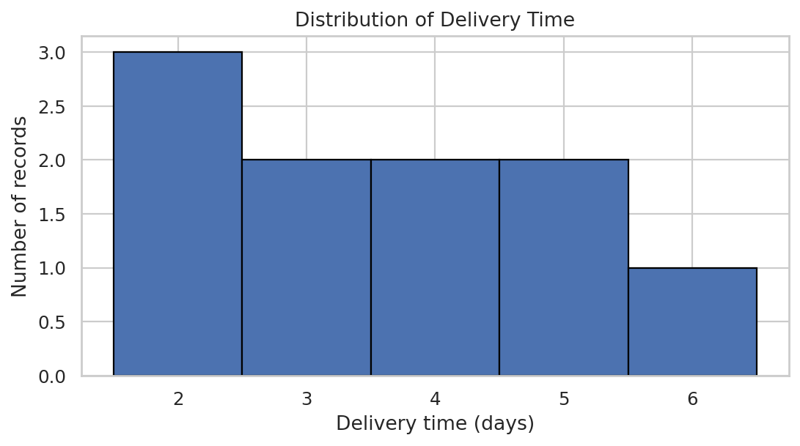
Interpretation: A histogram groups numeric values into intervals. Delivery times range from 2 to 6 days. The small sample cannot establish a reliable service-level pattern.

5.3 Delivery-time spread and potential outliers
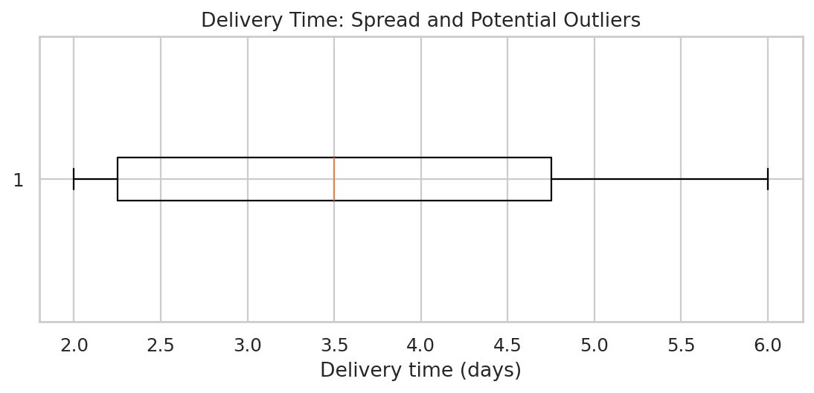
Interpretation: A box plot summarizes the median and spread and can flag potentially unusual values. Verify the operational context before changing or removing a record.

5.4 Shipment-volume comparison
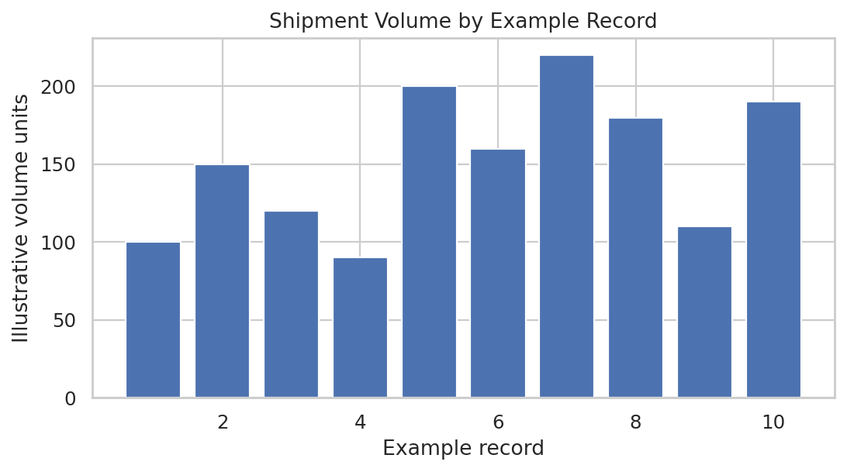
Interpretation: The bar chart shows variation between example records. A real dataset should have shipment IDs and clearly defined volume units.

5.5 Volume and transportation cost
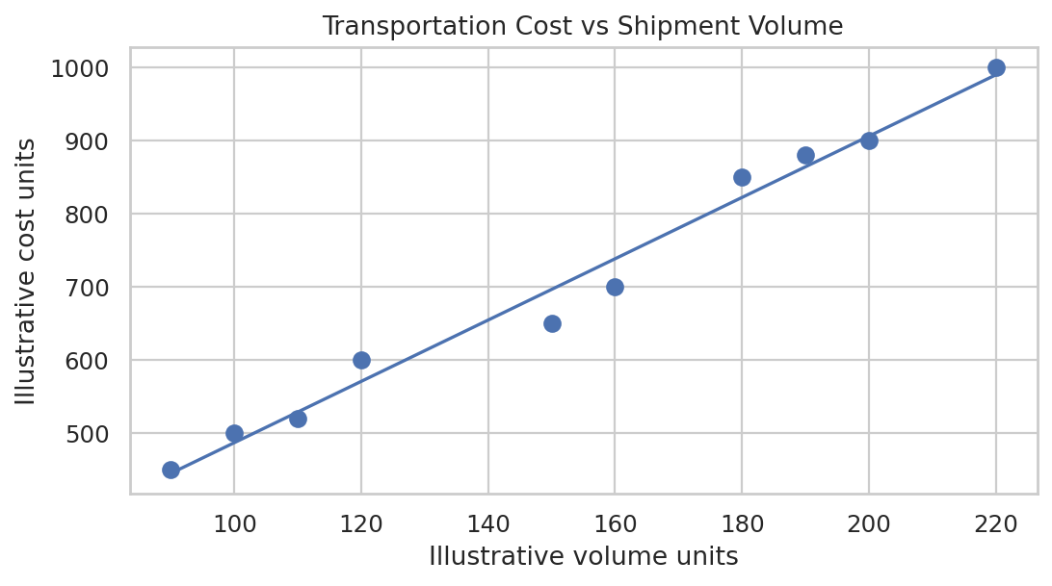
Interpretation: The sample correlation between volume and cost is approximately 0.99, showing a positive association in these hypothetical values. This does not prove causation: distance, vehicle type, route, fuel price, and shipment mix may also affect cost.

5.6 Correlation heatmap
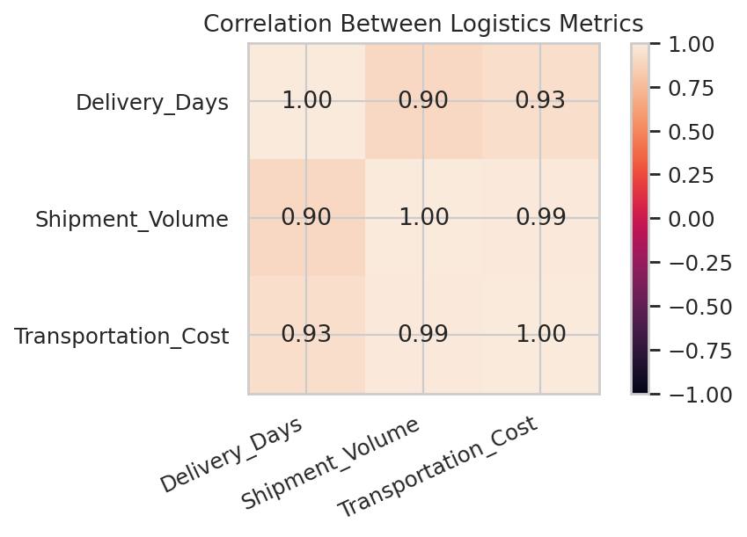
Interpretation: The heatmap summarizes the direction and strength of linear relationships. With only 10 synthetic records, correlation values may be unstable and should not be used as a forecast.

6. Key Findings
- Delivery times range from 2 to 6 days.
- Average delivery time is 3.6 days and the median is 3.5 days.
- Shipment volume ranges from 90 to 220 illustrative units.
- Transportation costs range from 450 to 1000 illustrative cost units.
- Volume and cost have a positive sample correlation of 0.99; more data is needed to assess this reliably.

7. Recommendations
- Track delivery time by route, carrier, service type, and date to identify delay patterns.
- Define consistent units for shipment volume and transportation cost.
- Compare costs with distance, fuel expense, vehicle utilization, weight, and shipment volume to investigate cost drivers.
- Review unusual records before correcting them or excluding them from analysis.
- Use a larger real operational dataset covering multiple weeks or months before making business decisions.
- If data are available, monitor average delivery time, on-time delivery rate, total cost, and volume trends in a dashboard.

8. Limitations
This teaching example has only 10 synthetic records. It lacks dates, routes, promised delivery dates, distance, carrier, fuel cost, and on-time/late status. Therefore, it cannot measure real trends over time, calculate a real on-time delivery rate, or confirm an operational bottleneck. Real conclusions require validated operational data.

9. Python Code
The following code reproduces the dataset, summary statistics, correlation analysis, and charts in this report.
import pandas as pd
import matplotlib.pyplot as plt
import seaborn as sns

# Hypothetical data for demonstration only
data = {
"Delivery_Days": [2, 3, 4, 2, 5, 3, 6, 4, 2, 5],
"Shipment_Volume": [100, 150, 120, 90, 200, 160, 220, 180, 110, 190],
"Transportation_Cost": [500, 650, 600, 450, 900, 700, 1000, 850, 520, 880]
}
df = pd.DataFrame(data)
print(df)
print(df.describe())
print(df.corr(numeric_only=True))
sns.set_theme(style="whitegrid")

plt.figure(figsize=(8, 5))
sns.histplot(x=df["Delivery_Days"], bins=5, color="skyblue")
plt.title("Distribution of Delivery Time")
plt.xlabel("Delivery Time (Days)")
plt.ylabel("Number of Shipments")
plt.tight_layout()
plt.savefig("delivery_time_histogram.png", dpi=180)
plt.show()

plt.figure(figsize=(8, 4))
sns.boxplot(x=df["Delivery_Days"], color="lightgreen")
plt.title("Delivery Time: Spread and Potential Outliers")
plt.tight_layout()
plt.savefig("delivery_time_boxplot.png", dpi=180)
plt.show()

plt.figure(figsize=(8, 5))
sns.barplot(x=list(range(1, len(df) + 1)), y=df["Shipment_Volume"], color="cornflowerblue")
plt.title("Shipment Volume by Example Record")
plt.xlabel("Example Record")
plt.ylabel("Illustrative Volume Units")
plt.tight_layout()
plt.savefig("shipment_volume.png", dpi=180)
plt.show()

plt.figure(figsize=(8, 5))
sns.regplot(data=df, x="Shipment_Volume", y="Transportation_Cost")
plt.title("Transportation Cost vs Shipment Volume")
plt.xlabel("Illustrative Volume Units")
plt.ylabel("Illustrative Cost Units")
plt.tight_layout()
plt.savefig("cost_vs_volume.png", dpi=180)
plt.show()

plt.figure(figsize=(7, 5))
sns.heatmap(df.corr(numeric_only=True), annot=True, cmap="coolwarm", vmin=-1, vmax=1, fmt=".2f")
plt.title("Correlation Between Logistics Metrics")
plt.tight_layout()
plt.savefig("correlation_heatmap.png", dpi=180)
plt.show()

10. Conclusion
This task demonstrates how Python supports exploratory data analysis and visualization in logistics. Summary statistics describe typical values and variation, while histograms, box plots, bar charts, scatter plots, and correlation heatmaps communicate patterns. The hypothetical example suggests a positive association between volume and transportation cost, but its small size limits conclusions. The next step is to apply this workflow to verified operational data with clear units, dates, routes, and delivery outcomes.

Appendix: GitHub Repository
https://github.com/sharmeV/logistics-data-analytics
Upload the final report and Python script to the repository if supporting files are required by the internship instructions. Enter the repository URL in the submission form.

