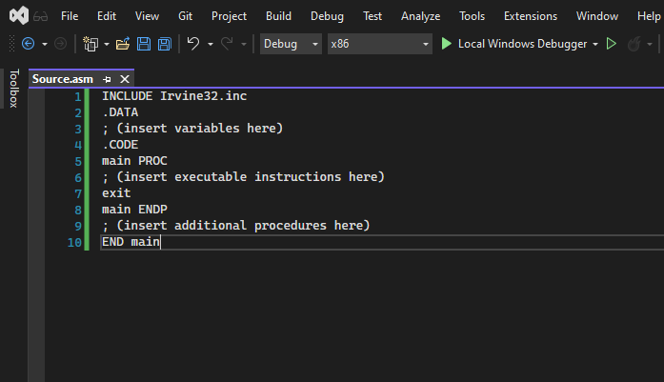

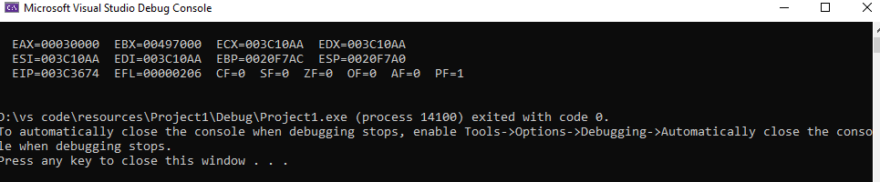

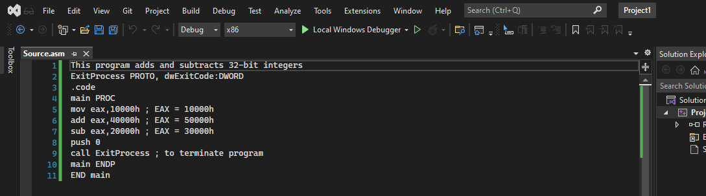

Book :

Question 1:

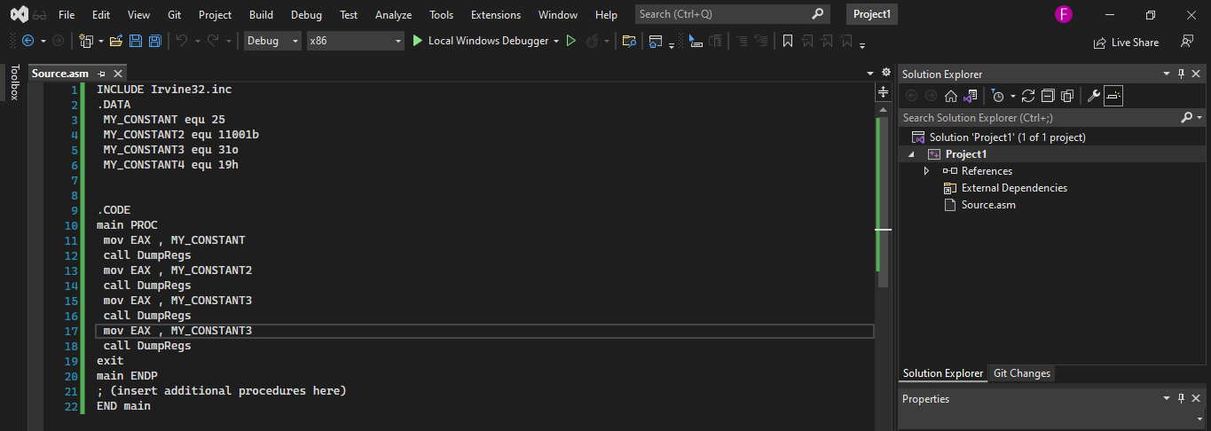

Question 4

: