IT HELP DESK MANAGEMENT SYSTEM
FINAL PROJECT REPORT
Student Name: Sharmeen Ahsan
Student email : sharmeens19@gmail.com
Course: CompTIA IT Fundamentals (ITF+)

1. Introduction
The IT Help Desk Management System is a Python-based application designed to simulate a real-world IT support environment. The system allows users to register, create support tickets, view submitted tickets, and update ticket statuses. This project demonstrates concepts learned in CompTIA IT Fundamentals, including troubleshooting, software applications, data management, and programming fundamentals.

2. Project Overview
The application provides a simple console-based interface for managing support requests. Users can create and track tickets while administrators can monitor and update ticket statuses.

3. Problem Statement
Organizations often struggle to track technical support requests efficiently. This project provides a structured way to record, manage, and resolve support issues.

4. Project Objectives
• Create a user registration system.
• Allow users to submit support tickets.
• Track ticket status.
• Store information using text files.
• Demonstrate IT Fundamentals concepts.

5. Technologies Used
Python 3, Visual Studio Code, Text Files (.txt), Windows Operating System.

6. System Design
Workflow:
User Registration → Create Ticket → Store Ticket Information → View Tickets → Update Status → Resolve Issue

7. Features and Functionality
User Registration, Ticket Creation, Ticket Tracking, Ticket Status Management (Open, In Progress, Resolved).

8. Testing and Results
All major functions were tested successfully including user registration, ticket creation, ticket viewing, ticket updates, and application exit.

9. Skills Demonstrated
Software Applications, Data Management, Troubleshooting Concepts, Programming Fundamentals, File Handling, Problem Solving.

10. Future Improvements
Database integration, GUI development, login authentication, email notifications, and reporting dashboards.

11. Conclusion
The project successfully demonstrates foundational IT support and programming skills through a practical help desk management solution.

12. References
CompTIA IT Fundamentals (ITF+) Course Materials
Python Documentation: https://docs.python.org
Visual Studio Code Documentation

Appendix - Screenshots
Insert screenshots of:
1. Main Menu
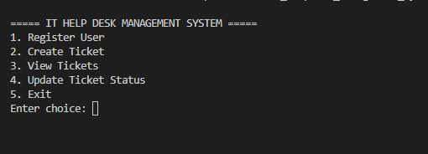
2. User Registration
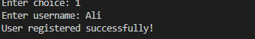
3. Ticket Creation
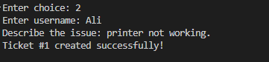
4. View Tickets
5. Ticket Status Update
