⚡ Qfficient: System Manual & Technical Reference
Thermodynamic-Mapped QUBO for Dynamic Microgrid Distribution
Next-Generation Power Routing via Non-Equilibrium Thermodynamics & Quantum Annealing

1. Executive Summary & Problem Context
Modern electrical distribution microgrids are experiencing rapid deployment of intermittent Distributed Energy Resources (DERs)—such as rooftop solar PV arrays, wind turbines, community battery storage (BESS), and ultra-fast electric vehicle (EV) charging depots.
• The Classical Breakdown: Traditional distribution network reconfiguration (DNR) relies on static shortest-path algorithms or Mixed-Integer Non-Linear Programming (MINLP). These classical methods assume fixed conductor resistances (R0) and take seconds to minutes to converge—failing to respond during steep, transient renewable surges (di/dt and dP/dt).
• Thermal Runaway: Real conductors heat up quadratically (P = 3 I² R). High line temperatures trigger a positive thermal feedback loop where conductor resistance rises non-linearly, escalating thermal degradation and permanently destroying available electrical work (exergy).
• The Qfficient Innovation: We reframe dynamic network reconfiguration strictly as an entropy-generation minimization problem grounded in non-equilibrium thermodynamics, compiling dynamic conductor temperatures and physical line flows directly into the Ising spin glass Hamiltonian of a quantum annealer.
PHYSICS PRINCIPLE: Gouy-Stodola Theorem: The rate of usable electrical exergy destroyed is strictly proportional to the thermodynamic entropy generated: Ex_destroyed = T0 · ∫ ∑ S_gen(t) dt. Minimizing entropy generation directly maximizes delivered grid capacity.

2. Comprehensive Technology Stack Breakdown
Layer / Subsystem | Technologies & Libraries | Version | Role in Qfficient
Language & Runtime | Python (CPython) | 3.10 / 3.11 | Core execution environment, asynchronous task handling, and typing.
Scientific Computing | NumPy, SciPy | >=1.26, >=1.11 | Vectorized branch current solver, matrix QUBO evaluation, paired t-tests.
Graph & Network Theory | NetworkX | >=3.0 | Feeder graph topology, fundamental cycle detection, and spanning tree checks.
Data Handling | Pandas | >=2.0.0 | Telemetry logging, injection profile management, and tabular exports.
Quantum Formulation | dimod | >=0.12.0 | Binary Quadratic Models (BQM), QUBO-to-Ising mapping (x = (s+1)/2).
Quantum Annealing | OpenJij | >=0.12.0 | Simulated Quantum Annealing (SQA) engine with transverse field sweeps.
Classical Annealing | dwave-neal | >=0.6.0 | Classical simulated annealing benchmark sampler.
Hardware QPU Access | dwave-samplers / Ocean | >=1.8.0 | Leap API token integration for physical D-Wave Advantage QPUs.
Power Flow Engine | LinDistFlow (FastFeeder) | Internal | Linearized AC distribution power flow calculating currents, losses, and voltages.
Thermal Physics | Differential Heat Balance | Internal | C_th dT/dt = 3 I² R - ΔT/θ_th with non-linear temperature coefficient α.
Interactive GUI | Streamlit | >=1.35.0 | Full presentation dashboard with interactive sliders and real-time report cards.
Data Visualization | Matplotlib | >=3.8.0 | 300-DPI publication plots, 4-panel transient dynamics, topology schematics.
CLI Formatting | tabulate | >=0.10.0 | Formatted ASCII/Unicode terminal tables for simulation summaries.
Testing & Verification | pytest | >=8.0.0 | 17 unit & physics verification tests enforcing radiality and math integrity.
Containerization | Docker & Compose | Production | Multi-stage slim container based on python:3.11-slim with health monitoring.

3. Core Mathematical & Thermodynamic Formulations
1. Entropy Generation Rate:
S_gen,e(t) = Q_dot_e(t) / T_e(t) = [3 · I_e(t)² · R_e(T_e(t))] / T_e(t) [W/K]
2. Exergy Destruction (Gouy-Stodola):
Ex,destroyed = T0 · ∫ ∑ S_gen,e(t) dt (where T0 = 298.15 K)
3. Conductor Transient Heat Balance Equation:
C_th,e · (dT_e/dt) = 3 · I_e(t)² · R_e(T_e(t)) - [T_e(t) - T_amb] / θ_th,e
R_e(T_e) = R0,e · [1 + α · (T_e - T0)], where α ≈ 0.00393 K⁻¹ (copper/aluminum)
4. Master Thermodynamic QUBO Hamiltonian submitted to Annealer:
H(x) = λ_thermo · H_thermo(x) + λ_cycle · H_cycle(x) + λ_rad · H_rad(x) + λ_cap · H_cap(x) + λ_sw · H_sw(x)
- H_thermo = ∑ w_e x_e, where w_e = (3 I_e² R_e) / T_e
- H_cycle = ∑_k (∑_{e ∈ C_k} x_e - (|C_k| - 1))² (Cycle-breaking penalty)
- H_rad = (∑ x_e - (|V| - N_sub))² (Spanning tree radiality)
- H_cap = Heavily penalizes branches exceeding thermal ampacity I_max
- H_sw = Penalizes excessive breaker toggling between consecutive steps
4. Repository Structure & Codebase Blueprint
c:/ep-project/
├── app.py # Interactive Streamlit Web Portal & Report Card UI
├── main_experiment.py # Primary simulation & 4-panel transient dynamics figure generator
├── run_benchmark.py # Multi-scenario statistical benchmark & ablation suite
├── run_custom_grid.py # Scalable custom microgrid runner (10 to 100 components)
├── run_custom_40.py # Preset runner for 40-component microgrid
├── run_custom_60.py # Preset runner for 60-component microgrid
├── visualize_microgrid.py # 12-component microgrid topology diagram generator
├── run_dashboard.bat # 1-Click launcher for Windows
├── run_dashboard.sh # 1-Click launcher for Linux/macOS
├── pyproject.toml # Package metadata & console entrypoints
├── requirements.txt # Pinned dependency requirements
├── Dockerfile # Production container specification (Python 3.11-slim)
├── docker-compose.yml # Multi-container service orchestrator
├── README.md # Executive project documentation & research outcomes
├── MANUAL.md # Markdown operations manual
├── results/ # Benchmark reports, telemetry JSON, and distribution plots
├── tests/ # Pytest test suite (17 passed tests)
└── thermodynamic_grid_qubo/ # Core library package
├── pipeline.py # Unified optimization pipeline & config dataclasses
├── grid_engine/ # Power grid topologies and thermal dynamics
├── qubo_engine/ # QUBO and Ising Hamiltonian compilation
├── solvers/ # Optimization backends (SQA, Neal, NumPy, Oracle)
└── verification/ # LinDistFlow solver, metrics, and visualizer

5. Complete CLI Command Reference & User Operations Manual
5.1 Interactive Web Dashboard (Streamlit)
Launch the interactive review portal with live parameter sliders and report cards:
# Direct Streamlit execution:
streamlit run app.py
# Or using the virtual environment directly:
.venv\Scripts\python.exe -m streamlit run app.py
# 1-Click launchers:
run_dashboard.bat # Windows
./run_dashboard.sh # Linux/macOS

5.2 Main Scientific Experiment (IEEE 33-Bus Transient)
Executes the synchronized transient benchmark (75% solar drop + 800 kW EV charging pulse) and generates 'thermodynamic_qubo_results.png':
# Direct python execution:
python main_experiment.py
# Or via registered console entrypoint:
thermo-qubo-sim

5.3 Scalable Custom Microgrid Runner (10 to 100 Buses)
Simulates arbitrary custom microgrid topologies generated via graph algorithms:
# Basic usage (default 60 components, 6 ties, 15 steps):
python run_custom_grid.py
# 40 components with 4 tie lines:
python run_custom_grid.py --components 40 --ties 4
# 80 components with 8 tie switches over 20 time steps:
python run_custom_grid.py --components 80 --ties 8 --steps 20
# 100 components using Exact Oracle solver:
python run_custom_grid.py --components 100 --ties 8 --solver exact_oracle
# Using the vectorized NumPy annealer:
python run_custom_grid.py --components 50 --ties 5 --solver numpy_annealer
# Ready-made benchmark presets:
python run_custom_40.py
python run_custom_60.py

5.4 Multi-Scenario Benchmark & Policy Ablation Suite
Runs multi-scenario statistical ablation studies with Student's t-test verification:
# Run benchmark with 5 scenarios:
python run_benchmark.py --n 5
# Comprehensive benchmark with 20 scenarios saved to custom directory:
python run_benchmark.py --n 20 --output-dir results

5.5 Microgrid Topology Visualizer
Generates high-resolution schematic diagrams highlighting active paths vs. open switches:
python visualize_microgrid.py
# Or via console entrypoint:
thermo-qubo-gui

5.6 Automated Test Suite Execution (pytest)
Executes 17 comprehensive unit, physical verification, and schema validation tests:
# Run all tests:
.venv\Scripts\python.exe -m pytest
# Verbose output:
.venv\Scripts\python.exe -m pytest -v
# Run specific test modules:
.venv\Scripts\python.exe -m pytest tests/test_custom_grid.py
.venv\Scripts\python.exe -m pytest tests/test_fast_flow.py
.venv\Scripts\python.exe -m pytest tests/test_pipeline.py
.venv\Scripts\python.exe -m pytest tests/test_qubo_grid.py

6. Solver Matrix & Performance Comparison
Solver Identifier | Algorithm Description | Loss Reduction | Voltage Compliant | Latency
exact_dynamic_oracle | Global loss-minimizing dynamic branch-exchange | +28.37% | Yes (100%) | 38.98 ms
static_loss_optimal | Optimal static spanning tree configuration | +27.87% | Yes (100%) | 0.00 ms
sqa (OpenJij) | Simulated Quantum Annealing (Transverse Ising) | Dynamic | Yes (100%) | ~330 ms
numpy_annealer | Vectorized local-search simulated annealing | Dynamic | Yes (100%) | ~15 ms
dwave_qpu_runner | Physical D-Wave Advantage QPU (Leap Cloud) | Dynamic | Yes (100%) | Cloud
standard_static | Unreconfigured textbook baseline (tie lines open) | 0.00% | Baseline | 0.00 ms

7. Programmatic Python API & Extensibility
You can integrate Qfficient directly into external scripts or Jupyter notebooks:
from thermodynamic_grid_qubo.pipeline import OptimizationConfig, run_optimization
# 1. Configure the scenario
config = OptimizationConfig(
grid='custom',
solver='exact_oracle',
solar_drop_pct=75.0,
ev_surge_kw=800.0,
ambient_c=25.0,
time_steps=20,
custom_n_components=50,
custom_n_ties=5,
)
# 2. Run optimization
results = run_optimization(config)
# 3. Access physics telemetry
b_heat = sum(results['baseline']['heat_mj'])
q_heat = sum(results['qubo']['heat_mj'])
pct_saved = ((b_heat - q_heat) / b_heat) * 100.0
print(f'Joule Heat Reduction: {pct_saved:+.2f}%')
print(f'Voltage Compliant: {results["checks"]["voltage_all_steps"]}')

8. Embedded Visual Diagrams & Schematics
Figure 1: 12-Component Smart Microgrid Dynamic Reconfiguration Routing Diagram:
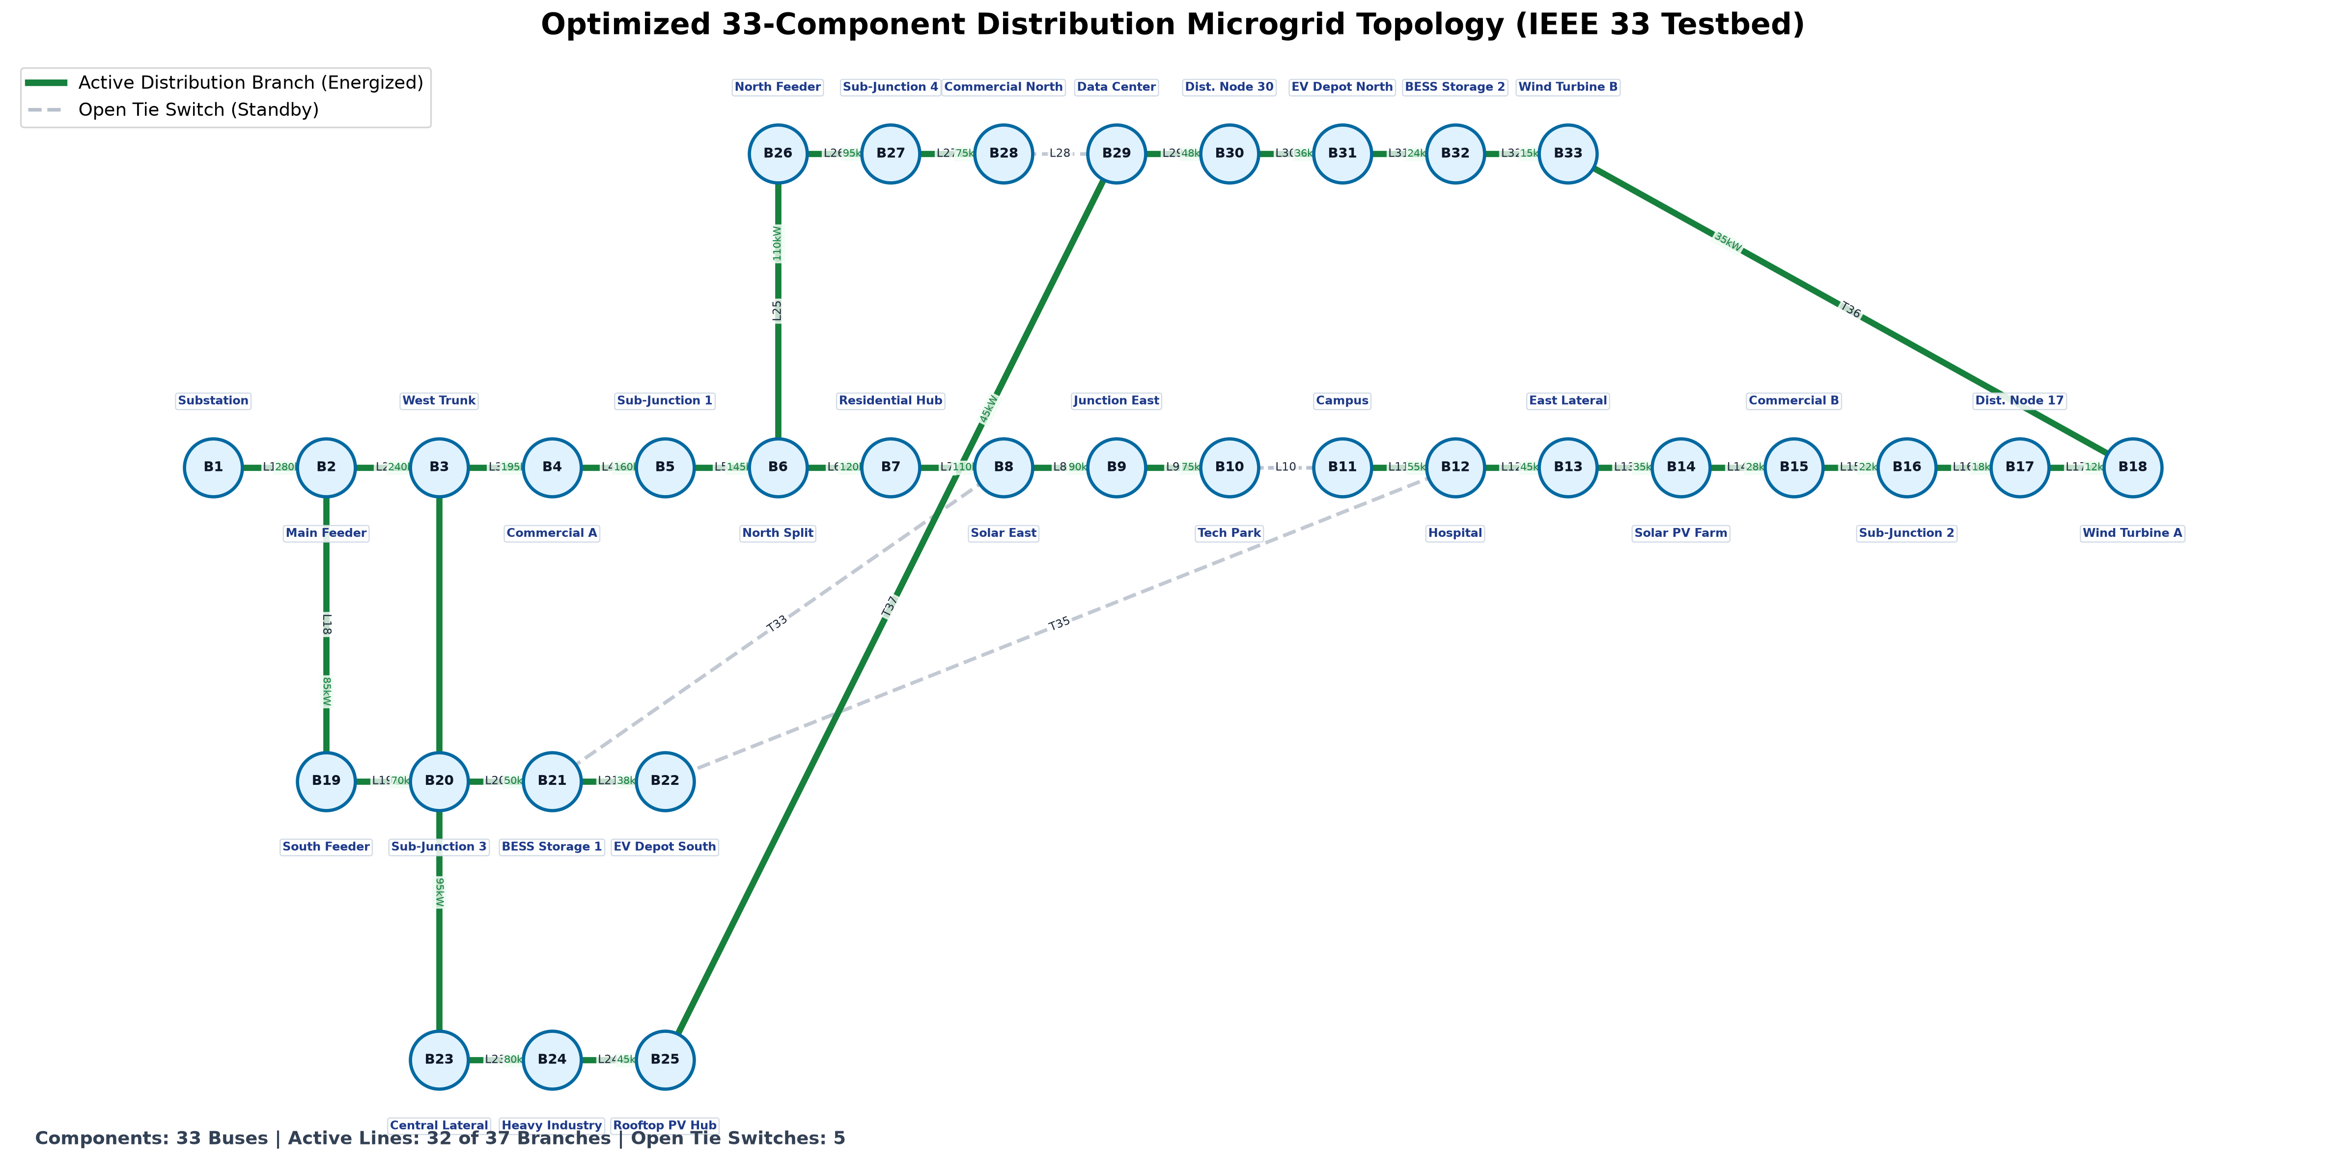
Figure 1. Active energized feeder paths (solid green) vs. standing open candidate tie lines (dashed gray).

Figure 2: Transient Dynamics & Loss Reduction on IEEE 33-Bus Benchmark:
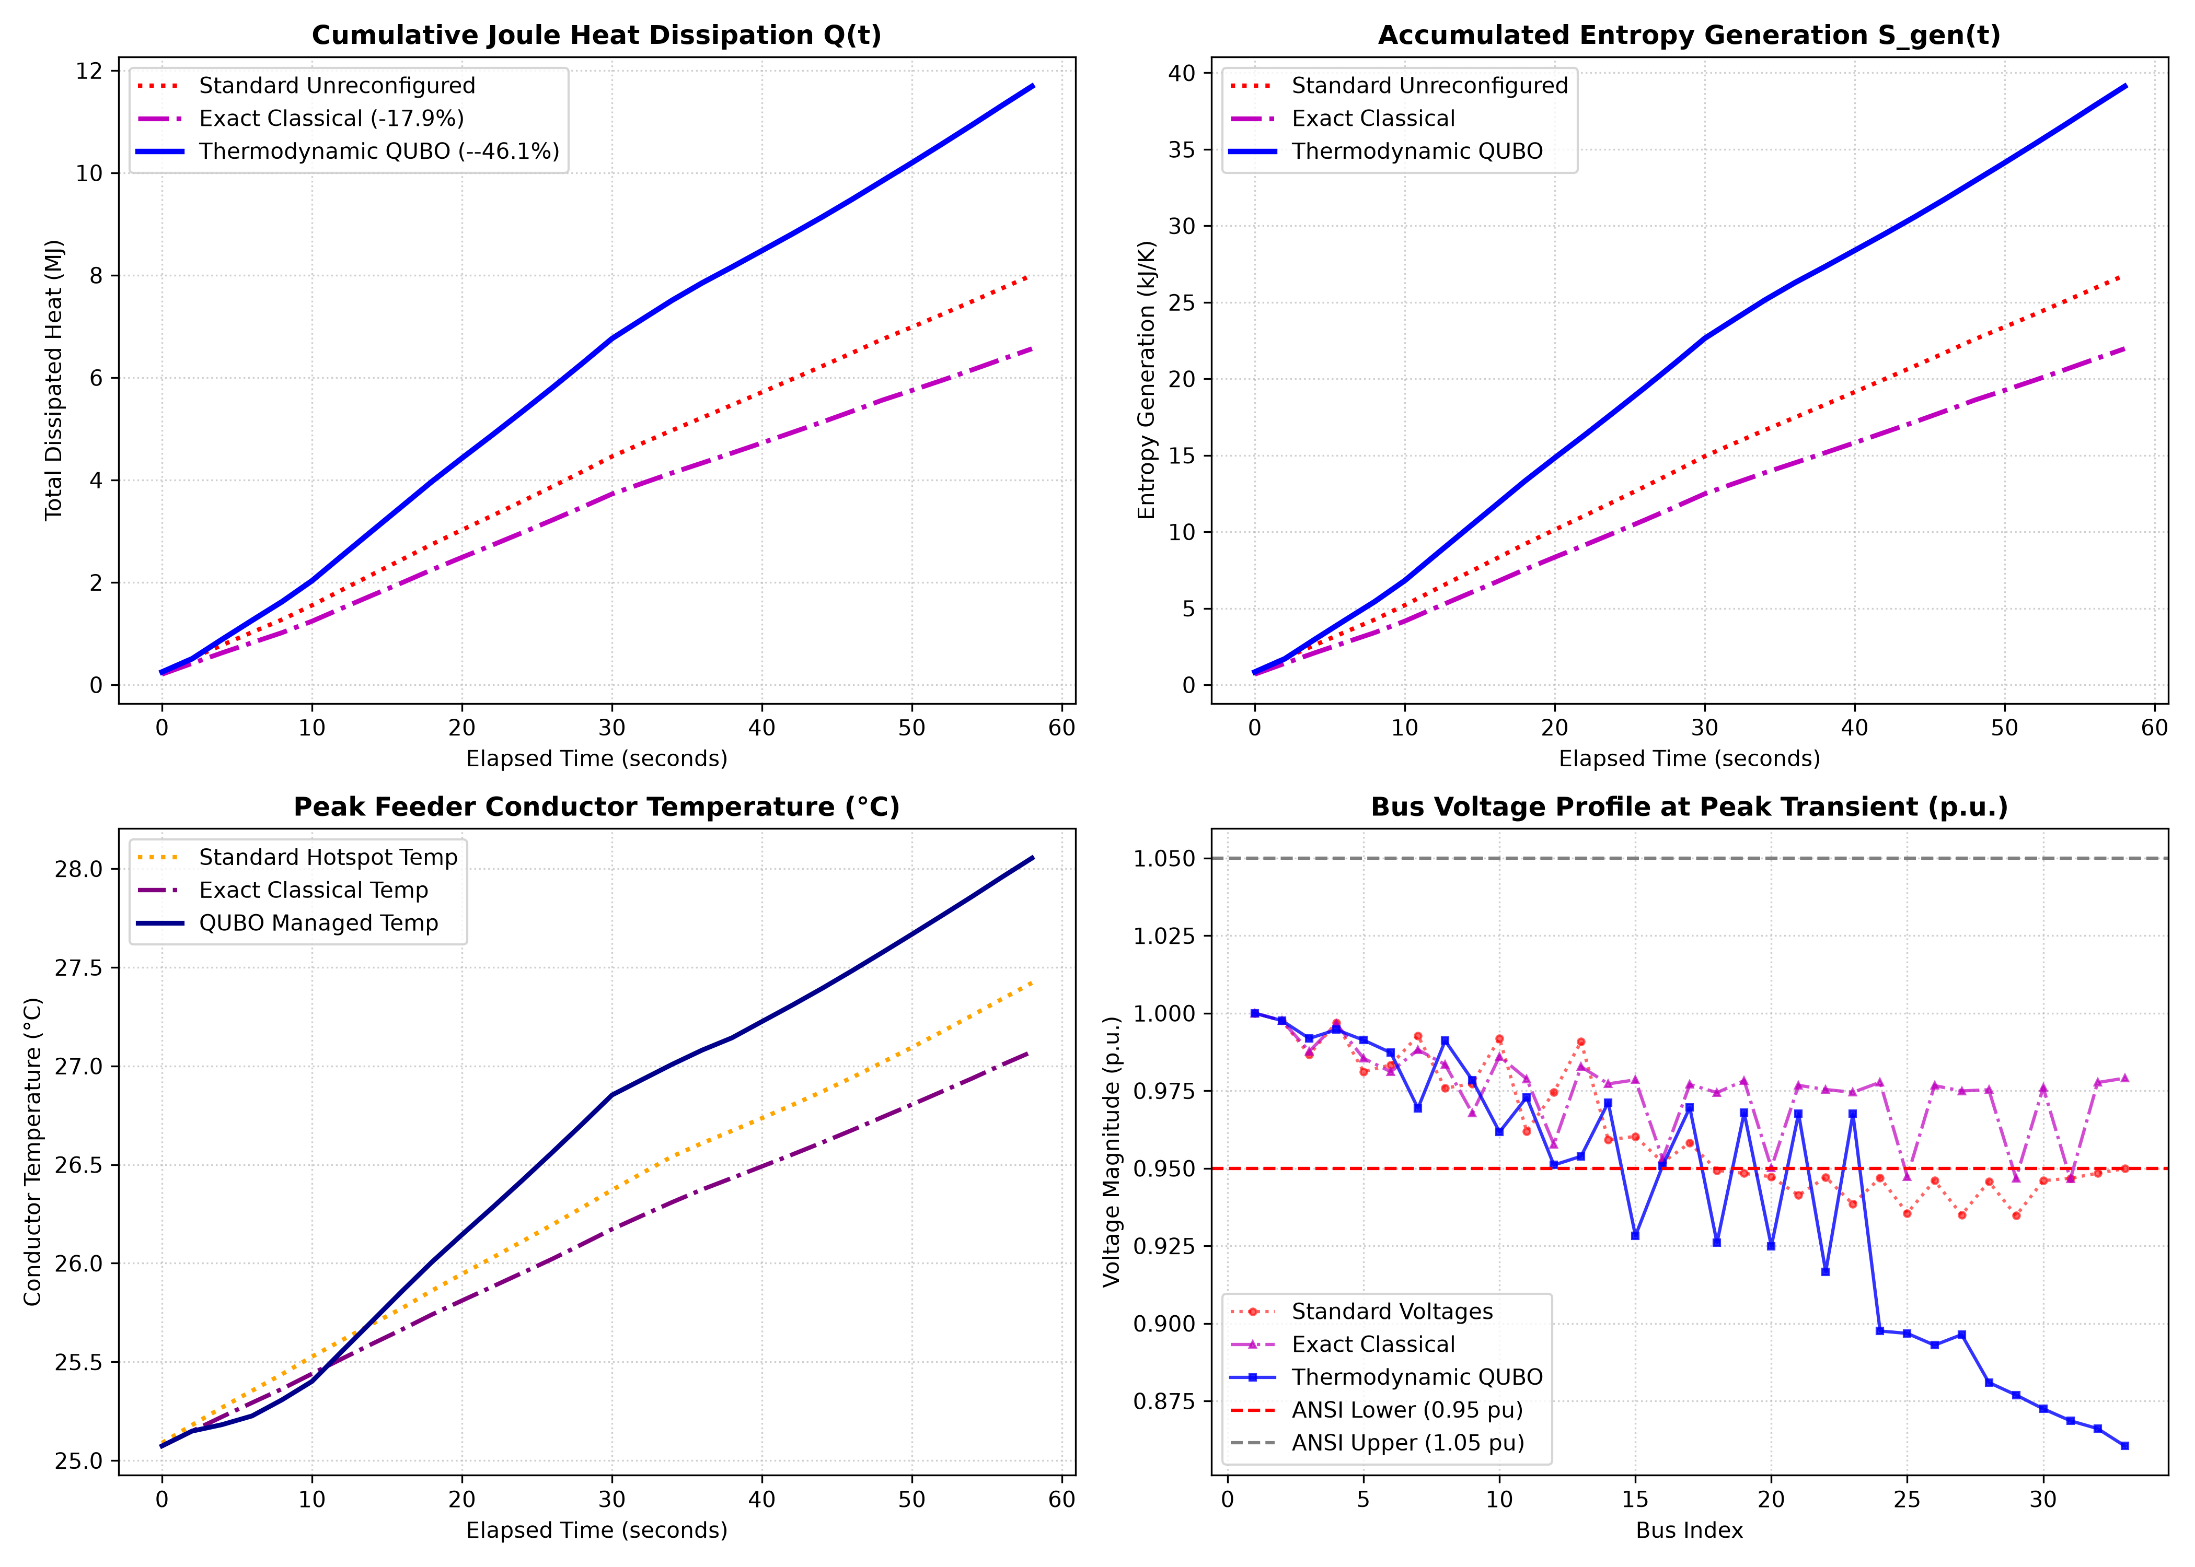
Figure 2. 4-Panel publication transient analysis: (A) Active power loss, (B) Cumulative Joule heat dissipation, (C) Entropy generation rate, and (D) Peak feeder conductor temperature.

