ETL-Based Data Warehouse for Multi-Source Data Integration and Reporting
Requirement Analysis & Planning
Introduction
In modern educational institutions, a large amount of student data is generated from various sources such as examination systems, attendance records, and departmental databases. Managing and analyzing this data using traditional methods is difficult and inefficient. It becomes challenging to track student performance, identify trends, and make informed decisions.
A Data Warehouse system helps in integrating data from multiple sources, storing it in a structured format, and enabling efficient analysis. By using ETL (Extract, Transform, Load) processes, raw data is cleaned and transformed before storing in the warehouse. Further, OLAP tools are used to analyze the data and generate meaningful insights.

Problem Statement
In many organizations, data is generated from multiple heterogeneous sources such as databases, spreadsheets, web applications, and external systems. These data sources often differ in format, structure, and quality, making it difficult to consolidate and analyze information effectively. The lack of a unified data repository leads to inconsistencies, redundancy, and delays in decision-making.
Objectives
- Integrate data from multiple sources
- Build an efficient ETL process
- Improve data quality and consistency
- Generate fast and accurate reports
- Support scalable data storage

Feasibility Study
The proposed ETL-based data warehouse system is feasible from multiple perspectives. From a technical point of view, the project can be developed using available tools such as database management systems and ETL technologies, making implementation practical. Economically, the system is cost-effective as it can utilize open-source tools and reduces manual effort, saving both time and resources. Operationally, the system is user-friendly and helps organizations efficiently integrate and analyze data for better decision-making. In terms of schedule, the project can be completed within the allocated time frame with proper planning and execution. Additionally, the system ensures basic data security and follows standard data handling practices, making it legally acceptable. Overall, the project is practical and beneficial to implement
Design & Architecture
The Academic Performance Analysis system is designed using a Data Warehouse architecture. It collects data from multiple sources, processes it using ETL techniques, and stores it in a centralized data warehouse for analysis.
The architecture ensures that data is clean, consistent, and easily accessible for reporting and decision-making.
Components Explanation
1. Data Sources
These are the origins of data such as databases, Excel files, web applications, and external systems. The data may be in different formats and structures.
2. ETL Process (Extract, Transform, Load)
This is the core component of the system.
- Extract – Collects data from various sources
- Transform – Cleans, filters, and converts data into a consistent format
- Load – Stores the processed data into the data warehouse
3. Data Warehouse
A central repository where all integrated data is stored. It is designed for efficient querying and analysis.
4. Data Marts
These are smaller subsets of the data warehouse, created for specific departments or purposes like sales or finance.
5. Reporting and Analysis Tools
These tools help users generate reports, dashboards, and insights from the data for decision-making.
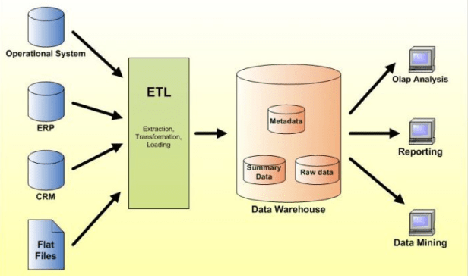
Database Design
The system uses a simple relational database structure with the following tables:
1. Student Table
- Student_ID (Primary Key)
- Name
- Department
2. Marks Table
- Student_ID (Foreign Key)
- Subject
- Marks
3. Department Table
- Department_ID
- Department_Name
Schema Design
A Star Schema is used for designing the data warehouse:
- Fact Table: Marks
- Dimension Tables: Student, Department
This design helps in faster data retrieval and efficient analysis.

Implementation / Coding
Implementation and SQL Queries
The implementation of the project is carried out using SQL for creating and managing the data warehouse. The following steps are performed:
1. Database Creation
The database is created to store all the required tables.
CREATE DATABASE StudentDW;
USE StudentDW;
2. Table Creation
Tables are created for storing student, department, and marks data.
CREATE TABLE Student (
Student_ID INT PRIMARY KEY,
Name VARCHAR(100),
Department VARCHAR(50)
);
CREATE TABLE Department (
Department_ID INT PRIMARY KEY,
Department_Name VARCHAR(50)
);
CREATE TABLE Marks (
Student_ID INT,
Subject VARCHAR(50),
Marks INT,
FOREIGN KEY (Student_ID) REFERENCES Student(Student_ID)
);
3. Data Insertion
Sample data is inserted into the tables.
INSERT INTO Student VALUES
(1,'Ravi','CSE'),
(2,'Sita','IT'),
(3,'Arun','CSE');
INSERT INTO Marks VALUES
(1,'Maths',85),
(2,'Maths',90),
(3,'Maths',75);
4. Query Implementation
Average Marks
SELECT AVG(Marks) AS Average_Marks FROM Marks;

Top Students
SELECT Student_ID, MAX(Marks) AS Top_Marks
FROM Marks
GROUP BY Student_ID;
Department-wise Result
SELECT Department, AVG(Marks)
FROM Student S
JOIN Marks M ON S.Student_ID = M.Student_ID
GROUP BY Department;

- SQL queries are used for data retrieval and analysis
- Data is structured for efficient querying
- Results support decision-making and reporting

Testing & Debugging
Testing and Validation
Testing and debugging are important to ensure that the system works correctly and produces accurate results.
1. Test Cases
Different test cases are applied to check system performance:
- Valid student data is inserted and verified
- Queries are tested for correct output (average, top students)
- Department-wise results are checked
2. Error Handling
The system handles possible errors effectively:
- Invalid marks (e.g., negative values) are avoided
- Duplicate student IDs are restricted using primary key
- Foreign key ensures valid relationship between tables
3. Validation
Data validation is performed to maintain quality:
- Null values are checked and handled properly
- Data types are verified (INT, VARCHAR)
- Correct mapping between tables is ensured
4. Quality Assurance
- Queries are tested multiple times
- Output is compared with expected results
- Ensures accuracy and consistency of data
Report & Presentation
Documentation and Presentation
The project is documented and presented in a clear and organized manner for better understanding.
1. Documentation Quality
- All steps are explained clearly
- Proper headings and subheadings are used
- Simple language is used for easy understanding
2. Report Structure
- Introduction, ETL, Implementation, Testing sections included
- Logical flow is maintained throughout the report
- Tables and bullet points improve readability
3. Diagrams and Visuals
- ETL process diagram included
- Star schema diagram added
- Helps in better visualization of the system

4. Presentation Clarity
- Concepts are explained neatly
- Easy to present during viva
- Structured format helps quick understanding
5. Project Demonstration
- SQL queries are executed successfully
- Outputs like average marks, top students are shown
- Working model is demonstrated clearly
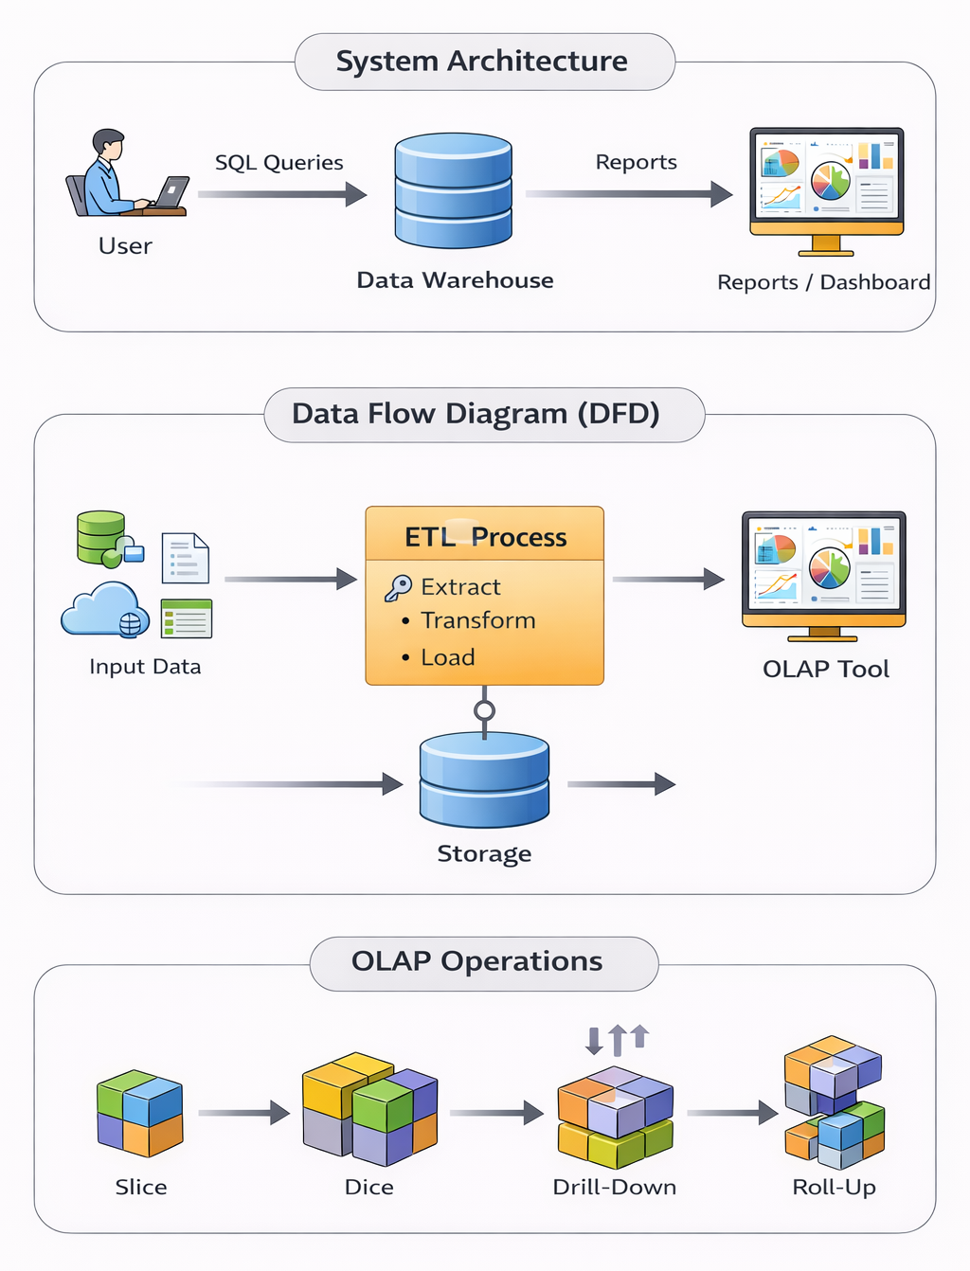
Conclusion & Future Scope
Conclusion
The project successfully demonstrates the design and implementation of a Data Warehouse system for student performance analysis.
- Data from different sources is integrated using ETL process
- Star schema is used for efficient data organization
- SQL queries help in analyzing student performance
- OLAP tools can be used for better visualization
The system provides accurate and meaningful insights such as average marks, top students, and department-wise analysis.
Benefits of the System
- Improves decision-making process
- Provides structured and organized data
- Enables fast and efficient data analysis
- Reduces data redundancy
Future Scope
The project can be further enhanced with advanced features:
- Integration with real-time data sources
- Use of cloud-based data warehouse systems
- Advanced dashboards using tools like Power BI
- Adding more dimensions like semester, subject difficulty
- Applying machine learning for performance prediction

