Your Name: Sharmila Gopal

Section 1: Project Direction Overview

PromptVault is a database designed as a personal and team library for managing prompts sent to AI tools like ChatGPT, Claude, and Gemini. In 2026, most knowledge workers use AI assistants daily, yet there is no good way to organize the prompts they write, track which ones produced the best results, or compare the same prompt across different AI models. People lose good prompts after a few weeks, retype the same questions, and have no idea whether their prompts are improving over time. PromptVault solves this by giving users a structured database to save, tag, rate, version, and compare every prompt they send to AI tools.

What makes PromptVault distinctive is cross-model effectiveness tracking. Unlike commercial prompt marketplaces (such as PromptBase) that sell prompts as one-off products, and unlike personal favorites lists embedded in tools like ChatGPT, PromptVault lets a user run the same prompt across multiple AI models and compare which one produced the best response. Over time, the database can tell the user which AI model is most effective for which type of task — for example, that Claude tends to outperform GPT-4 for long-form writing, while GPT-4 outperforms Claude for structured JSON output. No current commercial product offers this as a primary, evidence-based feature. While various AI prompt collections exist as Git-hosted repositories, command-line tools (such as Fabric), and marketplaces (such as PromptBase), none of these model prompts and responses in a relational database with cross-model comparison as a primary schema concern. PromptVault occupies this specific gap by treating AIModel, PromptRun, and Rating as first-class entities whose relationships are the foundation of the evidence-based comparison feature.

A short example illustrates how PromptVault would be used. Aria, a marketing manager, wrote a prompt three weeks ago that generated a perfect product description for a new headphone launch — she gave the response five stars in PromptVault and tagged it "product description." Today she needs another description for a new pair of earbuds. Instead of starting over, she opens PromptVault, filters by her tag and highest ratings, finds the winning prompt, swaps "headphones" for "earbuds," and runs it again. What used to take an hour now takes two minutes. PromptVault also tells her this kind of prompt has historically performed best on Claude Opus, so she chooses that model directly.

Three groups would use PromptVault. Individual knowledge workers (writers, marketers, developers, analysts, students) would use it to organize their personal prompt library. Teams inside companies would use it as a shared prompt repository, with permissions ensuring sensitive prompts stay private. AI power users and prompt engineers would use it as a structured testing ground, running experiments across models. A complete deployment would have a polished interface, but my focus for this course is the database backend — the schema, the relationships between tables, the rules that protect the data, and the queries that make all of this possible.

I am personally interested in this project because I use AI tools daily and have firsthand experience with the frustration of losing good prompts and not knowing which AI model is best for which task. The rapid growth in AI use has created a genuinely new data problem that no commercial product yet solves well. By the end of this course, I want to point to PromptVault and explain how a real prompt management system would be structured, including every entity, relationship, and constraint behind it.

The database will track users, the prompts they save, the responses generated by different AI models, the tags and categories they assign, the ratings they give, and the versions of each prompt over time as they refine it. It distinguishes between free-tier users and paid users: free-tier users cannot save more than fifty prompts (a deliberate cap that encourages upgrade while still demonstrating value), while paid users have unlimited storage and access to team-sharing features. Other business rules include that a rating can only be added after a response has been received (preventing meaningless ratings on prompts that have never run), and that shared workspace prompts require admin approval before publishing (so a team's shared library is curated, not chaotic). One important storage tradeoff PromptVault must address is that AI responses vary widely in length — from a few hundred characters to over one hundred thousand for long-form generations or extended-thinking outputs. Short responses can be stored directly as text columns, but very long responses may need a hybrid approach where the database stores a reference to object storage rather than the full text inline, similar to how production SaaS applications handle large text payloads. Additional details will surface as the term progresses.

Section 2: Artifacts and Analysis
Artifact 1: Claude Conversation History Sidebar
Where I sourced it: Anthropic's Claude interface at claude.ai, captured in May 2026. The left sidebar displays a running history of the user's past conversations, each saved automatically and labeled with an auto-generated title summarizing the opening prompt (for example, "CS669 Term project submission," "PromptVault database entities," "Portfolio automation with Selenium"). Conversations are listed in reverse chronological order with a search bar at the top. This sidebar directly illustrates the problem PromptVault solves: people accumulate many prompts over time and need a way to find, organize, and reuse them rather than losing them.

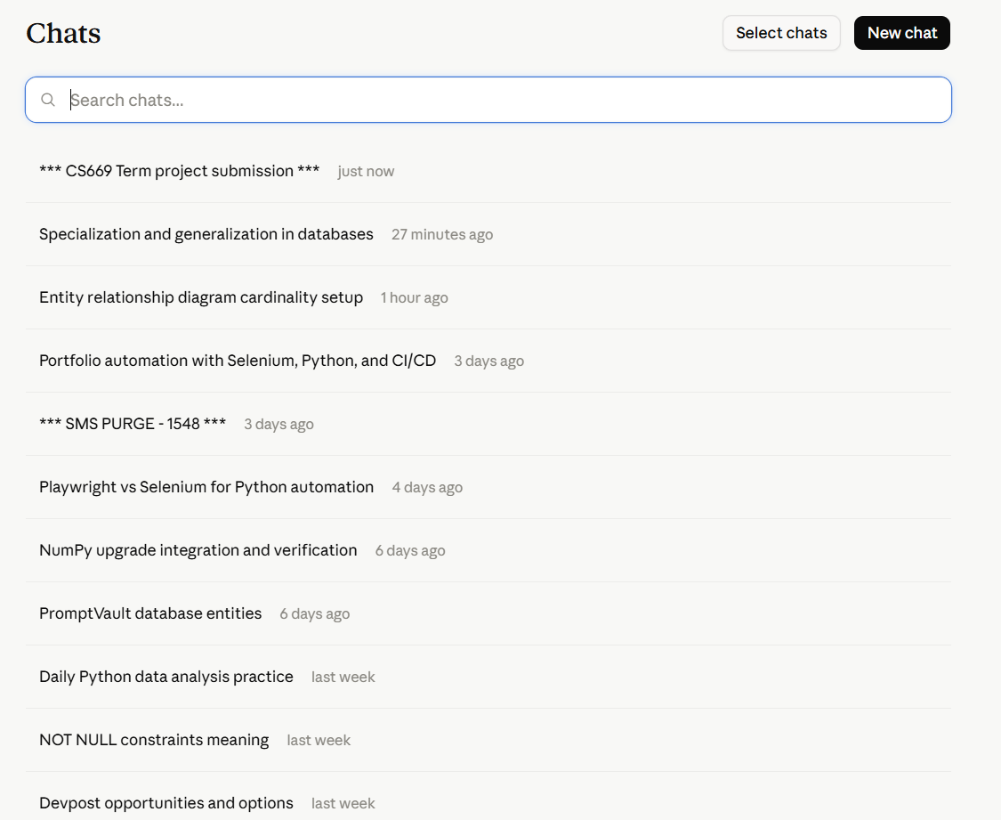
Entities
User — The sidebar is specific to one logged-in account; each user sees only their own conversation history. PromptVault must store a User entity with user_id, email, and account_tier.
Prompt — Each conversation begins with a prompt the user typed, and the conversation title is derived from that prompt. This is the central Prompt entity in PromptVault, storing prompt_id, title, prompt_text, and created_at.
PromptRun — Each saved conversation represents an actual execution of a prompt against a model, producing a response. This maps to PromptVault's PromptRun entity, which records when a prompt was run and what came back.
AIModel — Claude lets the user pick which model handles the conversation (for example, Claude Opus 4.7 vs Claude Sonnet 4.6), tied to each conversation. This validates AIModel as a first-class entity in PromptVault.
Tag — While Claude organizes conversations chronologically, users often want to categorize them by topic. PromptVault formalizes this with a Tag entity so prompts can be organized by subject (marketing, coding) rather than only by date.
Actions
Saving a conversation automatically — Every time a user starts a chat, Claude saves it to the sidebar. In PromptVault, this maps to inserting a new Prompt and its PromptRun into the user's library.
Renaming a conversation — Users rename conversations to make them findable later. This maps to editing a Prompt's title in PromptVault.
Searching conversation history — As the list grows, users use the search bar to find an old conversation. This maps directly to PromptVault's search-the-library use case (Use Case 3).
Deleting a conversation — Users remove conversations they no longer need. This maps to archiving a Prompt in PromptVault using the is_archived flag.
Constraints and Business Rules
- Every conversation belongs to exactly one user. The sidebar is private to the logged-in account. PromptVault enforces that each Prompt is owned by exactly one User.
- Conversations are saved automatically and ordered by time. Each conversation has a creation timestamp used for ordering. PromptVault stores created_at on every Prompt and PromptRun.
- Each conversation is tied to one model at a time. The response comes from the model selected for it. In PromptVault, each PromptRun references exactly one AIModel.
- History availability may differ by plan. Free and paid Claude plans differ in usage limits, mirroring PromptVault's rule that free-tier users are limited to fifty saved prompts while paid users are not — directly supporting the FreeUser/PaidUser specialization.
How It Shapes PromptVault
This artifact is the clearest real-world illustration of PromptVault's core purpose. The Claude sidebar shows that users naturally accumulate a large history of prompts and need them saved, titled, time-ordered, and searchable — but it also exposes the gap PromptVault fills. Claude organizes conversations chronologically but offers no tagging by topic, no rating of which response was best, and no way to compare the same prompt across different AI models. These missing capabilities are exactly PromptVault's distinctive features. The artifact validates the User, Prompt, PromptRun, and AIModel entities, confirms that prompts must be owned per-user and timestamped, and reinforces the FreeUser/PaidUser distinction since plan limits differ by tier. Replacing the earlier pricing-focused artifact with this one ties Section 2 directly to PromptVault's primary focus — capturing, organizing, and reusing prompts — addressing prior feedback that the artifacts did not clearly support the project's core.

Artifact 2: Anthropic Claude API Documentation
Where I sourced it: Anthropic's public Claude API documentation landing page at docs.anthropic.com, captured in May 2026. The page introduces Claude as an AI platform, lists three current model variants (Claude Opus 4.7, Claude Sonnet 4.6, Claude Haiku 4.5), and describes how developers send prompts to models and receive responses. The documentation details runtime options including extended thinking, structured outputs, streaming, and batch processing, along with how token usage and stop reasons are reported for each request. While Artifact 1 showed how prompts are saved and organized, this artifact shows what happens when a prompt is actually run — the execution layer that PromptVault must record to power its cross-model comparison feature.
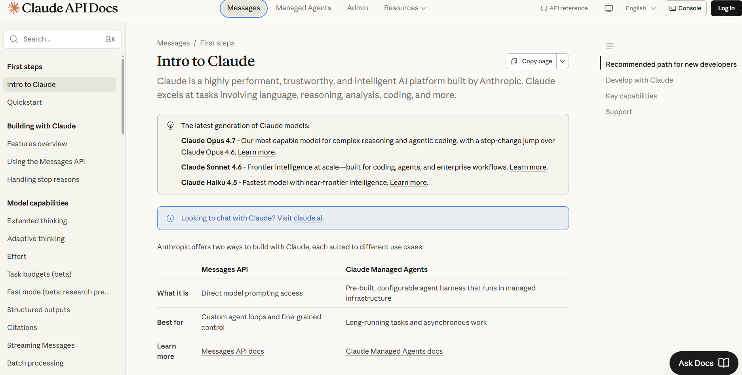
Entities
AIModel — The page explicitly lists three named models with distinct positioning. PromptVault must store AIModel as a first-class entity with model_id, model_name, model_family (Opus, Sonnet, Haiku), and intended_use_description.
Prompt — The Messages API centers on the prompt (the messages sent to the model). PromptVault stores Prompt with prompt_id, prompt_text, user_id, and created_at.
PromptRun — The documentation distinguishes a prompt from a specific execution of it, where each execution records token usage, cost, and a stop reason. This validates PromptVault's PromptRun entity as separate from Prompt.
Rating — Because the docs show responses vary in quality and length depending on model and settings, users need a way to judge which response was best. This supports PromptVault's Rating entity, which scores each PromptRun.
Actions
Selecting a model for a prompt — A user chooses which model variant to send a prompt to. Recorded as the model_id reference on a PromptRun.
Running a prompt and recording usage — Each run reports input tokens, output tokens, and cost. PromptVault stores these on PromptRun to support cost analytics and the effectiveness score.
Submitting single versus batch requests — The same prompt can be run as a one-off or in a batch. PromptVault records this distinction on PromptRun.
Constraints and Business Rules
- Each run must reference exactly one model. Every API call specifies one model. In PromptVault, each PromptRun references exactly one AIModel.
- Token usage and cost are recorded on every successful run. The API returns usage data per request. PromptVault stores token counts and cost on each PromptRun.
- Responses vary in length and structure. A streamed response arrives in chunks; a batch response arrives in bulk; long responses can be very large. This supports PromptVault's design decision to handle variable-length response storage.
- Stop reasons describe how a run ended. The API reports why generation stopped (natural completion, max tokens, stop sequence). PromptVault stores stop_reason on each PromptRun.
How It Shapes PromptVault
This documentation surfaces the execution layer that makes PromptVault's distinctive feature possible. Where Artifact 1 showed prompts being saved and organized, this artifact shows what must be recorded each time a prompt is run: which model handled it, how many tokens it used, what it cost, and how it ended. This directly validates PromptVault's decision to model PromptRun as a separate entity from Prompt — a single saved prompt can be run many times across many models, and each run carries its own usage data. It also confirms that AIModel must be a first-class entity (since runs reference specific models) and that capturing per-run cost and token data is realistic, since the real API reports exactly this information. Together, these enable the cross-model effectiveness comparison at the heart of PromptVault.

Artifact 3: ChatGPT Custom GPT Builder Interface
Where I sourced it: OpenAI's ChatGPT Custom GPT Builder, accessed at chatgpt.com/gpts/editor, captured in May 2026. The interface is split into two panels. The left panel ("Create") is a conversational AI-guided builder that walks the user through GPT creation by asking questions ("What would you like to make?") and suggesting names automatically ("How about Content Refinery?"). The right panel ("Preview") shows a live, testable version of the GPT being built, complete with four auto-generated conversation starters. A "Configure" tab offers a form-based editor. The GPT is shown in "Draft" status with a "Create" button to publish it. This artifact shows how a reusable, named prompt configuration is built and refined — the prompt-creation lifecycle PromptVault supports through versioning.

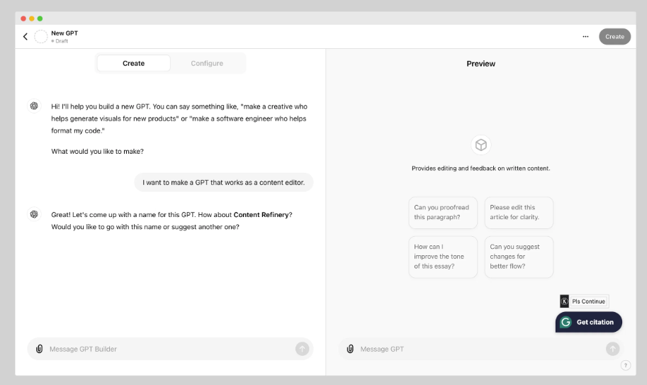

Entities
Prompt — The GPT being built is itself a named, reusable prompt configuration ("Content Refinery") that bundles instructions and behavior under one identity. This maps to PromptVault's Prompt entity with a title, text, and owner.
PromptVersion — The builder progressively constructs and refines the prompt through multiple turns before publishing. This validates PromptVault's PromptVersion entity, which captures how a prompt evolves over time.
User — The GPT has an owner who builds and publishes it. This supports PromptVault's User entity as the owner of prompts.
ConversationStarter — The Preview panel shows four auto-generated example prompts attached to the GPT. These are linked to a parent prompt in a one-to-many relationship, similar to how PromptVault links example runs to a prompt.
(Note: The "Draft" indicator on the page is a status attribute of the prompt configuration, not an entity itself — it is a single value describing one prompt at a point in time.)
Actions
Building a prompt through conversation — The user constructs a reusable prompt by chatting with the builder. In PromptVault, this maps to creating and refining a Prompt.
Refining before publishing — The user revises the configuration across turns before clicking "Create." This maps to creating new PromptVersions in PromptVault.
Publishing a draft — Clicking "Create" transitions the prompt from draft to published. PromptVault models this lifecycle with a status attribute on Prompt.
Previewing without publishing — The Preview panel tests the prompt without saving a public record. PromptVault distinguishes test runs from real runs so they don't pollute analytics.
Constraints and Business Rules
- A prompt cannot be published without a name and instructions. The builder requires both before allowing "Create." PromptVault enforces that a Prompt has a non-empty title and text.
- A prompt configuration has a lifecycle. It moves draft → published → archived. PromptVault models this with a status attribute and an is_archived flag.
- Each builder session belongs to exactly one prompt configuration. The construction history cannot be reassigned to a different GPT. In PromptVault, each PromptVersion belongs to exactly one Prompt.
- Preview runs do not count against usage. The sandbox preview is excluded from billing and analytics. PromptVault distinguishes preview/test runs from real PromptRuns.
How It Shapes PromptVault
This artifact shows that prompts are not always written once and left alone — they are constructed, refined, and versioned over time before reaching a final form. This directly validates PromptVault's PromptVersion entity and the refine-and-version use case: a single Prompt can have many versions as the user improves it, and PromptVault preserves that history so users can compare which version performed best. It also reinforces that prompts have a lifecycle (draft → published → archived) rather than existing in a single state, supporting the status attribute on Prompt. Finally, the distinction between preview runs and real runs confirms PromptVault's need to separate test executions from genuine PromptRuns so that only real runs feed the cross-model effectiveness analytics. Together with Artifacts 1 and 2, this completes a picture of the full prompt lifecycle: prompts are saved and organized (Artifact 1), executed and measured (Artifact 2), and built and refined over time (Artifact 3).

Section 3: Use Cases
The following five use cases describe how a person or application would typically interact with the PromptVault database. They cover the most common workflows: saving a new prompt, running a prompt across multiple AI models for comparison, searching the library, refining a prompt over time, and sharing a prompt with a team workspace. These use cases are consistent with the entities and actions identified in Section 2 and reflect how individual users and teams would use PromptVault on a daily basis.

Use Case 1: User Saves a New Prompt to Their Library
One of the most common interactions with PromptVault is when a user saves a prompt they have crafted so they can find and reuse it later.
- The user opens PromptVault and clicks "New Prompt." The application authenticates the user against their stored credentials.
- The user pastes the prompt text into the editor and gives it a short title (for example, "Product description generator for consumer electronics").
- The user selects one or more tags from existing categories (such as "marketing," "product copy") or creates new tags. The application records each tag relationship in a PromptTag table.
- The user selects which AI model the prompt is designed for (for example, Claude Opus 4.7, GPT-5.5 Thinking, or Gemini Pro). The application validates that the selected AIModel exists in the AIModel table.
- The application inserts a new Prompt row referencing the User, the title, the prompt text, the selected AIModel, the created_at timestamp, and a version_number of 1.
- The application returns a confirmation and a unique prompt_id the user can later reference.

Use Case 2: User Runs the Same Prompt Across Multiple AI Models
PromptVault's distinguishing feature is letting users test the same prompt across different AI models and compare the results side by side.
- The user selects a saved Prompt from their library and clicks "Run Across Models." The application authenticates the user and verifies they have access to the selected Prompt.
- The user selects two or more AI models to run the prompt against (for example, Claude Opus 4.7, GPT-5.5 Thinking, and Gemini Pro). The application validates that each selected model is available on the user's current subscription tier.
- For each selected model, the application creates a new PromptRun row referencing the Prompt, the AIModel, the run_timestamp, and an initial status of "pending."
- As each model returns its response, the application records the response text, input_tokens, output_tokens, total_cost, and stop_reason on the PromptRun. The PromptRun status is updated to "completed."
- The user reviews the responses side by side and assigns each one a star rating from 1 to 5. The application inserts a Rating row for each PromptRun, referencing the User and the rating_value.
- The application updates the Prompt's aggregated model-effectiveness statistics, which inform future "best model for this type of prompt" recommendations.

Use Case 3: User Searches Their Prompt Library
Over time, a user's library grows to hundreds or thousands of saved prompts, so fast and accurate search becomes essential.
- The user opens the PromptVault search interface and enters keywords (for example, "product description"). The application authenticates the user and limits results to prompts they own or have access to through a shared team.
- The user optionally applies filters: tags (for example, only "marketing" prompts), minimum star rating (for example, only prompts rated 4 or higher), AI model (for example, only prompts that performed best on Claude), and date range.
- The application executes a query against the Prompt, PromptTag, Rating, and PromptRun tables, joining on the relevant keys and applying the filters.
- The application returns matching prompts ranked by a combination of relevance to the search keywords and the average Rating across all PromptRuns for that Prompt.
- The user selects a matching prompt to view its full details, including past PromptRuns and Ratings. The application logs this view as a UsageEvent for analytics.

Use Case 4: User Refines and Versions an Existing Prompt
Prompts are rarely perfect on the first try; users typically iterate to improve them. PromptVault preserves the history of these refinements.
- The user opens an existing Prompt and clicks "Edit." The application verifies the user owns the Prompt or has edit permission through a shared team.
- The user revises the prompt text — perhaps adding clarifying instructions or examples — and saves the changes.
- The application creates a new PromptVersion row referencing the Prompt, the new prompt_text, the user_id of the editor, the edited_at timestamp, and an incremented version_number.
- The application marks the previous PromptVersion's is_current flag as false and the new PromptVersion's is_current flag as true, ensuring only one version is active at a time.
- The user runs the new version against an AI model to test the refinement. The PromptRun is associated with the specific PromptVersion that was used, preserving the link between performance and version.
- The user can later compare ratings across versions to see whether the refinement actually improved results.

Use Case 5: User Shares a Prompt with a Team Workspace
PromptVault supports both private libraries and shared teams, allowing colleagues to learn from each other's best prompts.
- The user selects a Prompt from their private library and clicks "Share to Team." The application verifies the user is a member of at least one Team.
- The user chooses a target Team and sets the visibility (for example, view-only, can-edit, or can-run). The application validates that the user has permission to share into the selected Team.
- The application inserts a new PromptShare row referencing the Prompt, the Team, the shared_by_user_id, the shared_at timestamp, and the permission level.
- If the Team requires admin approval before publishing, the PromptShare row is created with a status of "pending_approval." Otherwise, the status is "published."
- Other members of the Team can now find the Prompt through search and run it themselves. Each run from another user creates a new PromptRun row, with the run still attributed to the original Prompt.
- The original prompt owner can view aggregated statistics on how the shared Prompt is being used across the Team — how often it is run, by whom, and what ratings it receives

Section 4: Structural Database Rules (revised)
The following structural database rules define the entities, relationships, and constraints for PromptVault. They are derived from the five use cases in Section 3. The rules include associative ("has a") relationships and one specialization-generalization ("is a") relationship. Together they identify thirteen entities: eleven base entities from the previous iteration plus two subtypes (FreeUser and PaidUser) introduced in this iteration. The rules include both one-to-many and many-to-many relationships.
Associative Structural Rules
- A User may save many Prompts; a Prompt is saved by exactly one User.
- A Prompt may have many PromptVersions; a PromptVersion belongs to exactly one Prompt.
- A Prompt may be tagged with many Tags; a Tag may be applied to many Prompts.
- A Prompt may have many PromptRuns; a PromptRun executes exactly one Prompt.
- An AIModel may be used in many PromptRuns; a PromptRun runs on exactly one AIModel.
- A PromptRun may receive many Ratings; a Rating evaluates exactly one PromptRun.
- A User may give many Ratings; a Rating is given by exactly one User.
- A User may belong to many Teams; a Team may include many Users.
- A Team may receive many shared Prompts; a Prompt may be shared with many Teams.
Specialization-Generalization Structural Rule
- A User is a FreeUser or a PaidUser.

Section 5: Conceptual ERD (revised)
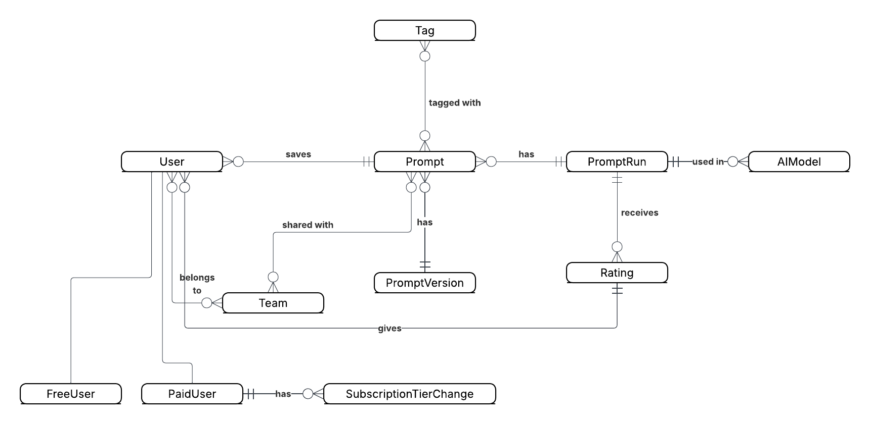

Section 6: Physical ERD (revised)
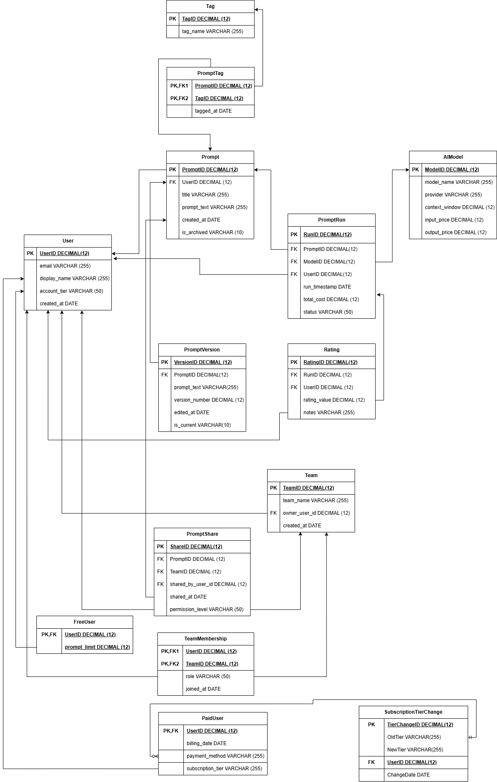

Section 7: Attribute Reasoning
I added significant attributes to eight entities in the PromptVault physical ERD. My choices and reasoning are on the table below.

Table | Attribute | Datatype | Reasoning | Example Data
User | email | VARCHAR(255) | Every user needs an email address for login and notifications. 255 characters is the standard maximum length for email addresses per RFC 5321. | aria@gmail.com
User | display_name | VARCHAR(255) | Users need a visible name shown in the interface and team workspaces. 255 characters allows for long names or pseudonyms. | Aria Johnson
User | account_tier | VARCHAR(50) | Stores whether the user is free or paid. VARCHAR(50) is sufficient for short tier labels. This works alongside the FreeUser/PaidUser specialization. | free, paid
User | created_at | DATE | Records when the account was created, useful for analytics and account management. | 2026-01-15
Prompt | title | VARCHAR(255) | Every prompt needs a short human-readable title so users can identify it in search results and their library without reading the full text. | Product description generator
Prompt | prompt_text | VARCHAR(255) | The actual prompt text the user saved. 255 characters covers most practical prompts. | Write a product description for...
Prompt | is_archived | VARCHAR(10) | Tracks whether the prompt has been soft-deleted. Using VARCHAR(10) stores "true"/"false" as text, consistent with the course datatype conventions. | true, false
Prompt | created_at | DATE | Records when the prompt was first saved. Used for sorting the library by date and for analytics. | 2026-03-10
PromptVersion | prompt_text | VARCHAR(255) | Each version stores its own copy of the prompt text so the full edit history is preserved even as the prompt changes. | Write a detailed product description...
PromptVersion | version_number | DECIMAL(12) | Tracks the sequential version number of each edit. DECIMAL(12) is consistent with other numeric fields in the schema. | 1, 2, 3
PromptVersion | edited_at | DATE | Records when this version was created, allowing users to see when each revision was made. | 2026-04-02
PromptVersion | is_current | VARCHAR(10) | Flags which version is the active one. Only one version per prompt can be current at a time. | true, false
AIModel | model_name | VARCHAR(255) | The name of the AI model as it would appear to users. VARCHAR(255) accommodates long model names from any provider. | Claude Opus 4.7
AIModel | provider | VARCHAR(255) | The company that makes the model. Stored separately from model_name so users can filter by provider. | Anthropic, OpenAI, Google
AIModel | context_window | DECIMAL(12) | The maximum number of tokens the model can process in one request. Stored as a number for comparison queries. | 200000
AIModel | input_price | DECIMAL(12) | The cost per token for input, used to calculate total_cost on each PromptRun. | 3
AIModel | output_price | DECIMAL(12) | The cost per token for output, used alongside input_price to calculate run costs. | 15
PromptRun | run_timestamp | DATE | Records when the prompt was executed. Used for time-based analytics and sorting run history. | 2026-05-01
PromptRun | total_cost | DECIMAL(12) | The calculated cost of the run based on token usage and model pricing. Allows users to track spending. | 2
PromptRun | status | VARCHAR(50) | Tracks the state of the run. A run starts as pending, becomes completed or failed. | pending, completed, failed
Rating | rating_value | DECIMAL(12) | Stores the star rating from 1 to 5 the user assigned to the run. DECIMAL(12) is consistent with other numeric fields. | 1, 2, 3, 4, 5
Rating | notes | VARCHAR(255) | Optional text notes the user can add to explain their rating, useful for comparing runs later. | Great response, very detailed
Team | team_name | VARCHAR(255) | The display name of the team shown in the interface. VARCHAR(255) allows for descriptive team names. | Marketing Team
Team | owner_user_id | DECIMAL(12) | FK referencing the User who created and owns the team. Determines who has admin rights. | 1001
Team | created_at | DATE | Records when the team was created, useful for team management and analytics. | 2026-02-20
PromptShare | shared_at | DATE | Records when the prompt was shared with the team, providing an audit trail of sharing activity. | 2026-05-10
PromptShare | permission_level | VARCHAR(50) | Defines what shared members can do with the prompt. VARCHAR(50) is sufficient for short permission labels. | view-only, can-edit, can-run

Section 8: Normalization Reasoning
I reviewed each entity in the PromptVault physical ERD for normalization to BCNF. My analysis is below.

Entities that did not need normalization:
Tag — Contains only TagID (PK) and tag_name. Every attribute depends solely on the primary key. Already in BCNF.
PromptTag — Junction table with composite PK (PromptID, TagID) and tagged_at. All attributes depend on the full composite key. Already in BCNF.
PromptVersion — All attributes (prompt_text, version_number, edited_at, is_current) depend solely on VersionID. No partial or transitive dependencies. Already in BCNF.
Rating — All attributes (rating_value, notes) depend solely on RatingID. RunID and UserID are foreign keys with no transitive dependencies. Already in BCNF.
TeamMembership — Junction table with composite PK (UserID, TeamID). role and joined_at depend on the full composite key. Already in BCNF.
PromptShare — All attributes depend on ShareID. The three foreign keys (PromptID, TeamID, shared_by_user_id) do not create transitive dependencies. Already in BCNF.
FreeUser — Contains only UserID (PK FK) and prompt_limit. prompt_limit depends solely on UserID. Already in BCNF.
PaidUser — Contains only UserID (PK FK), billing_date, payment_method, and subscription_tier. All attributes depend solely on UserID. Already in BCNF.
AIModel — All attributes (model_name, provider, context_window, input_price, output_price) depend solely on ModelID. Already in BCNF.
Entities examined for potential normalization issues:
User — I considered whether account_tier creates a transitive dependency since it overlaps with the FreeUser/PaidUser specialization. However, account_tier is a simple discriminator attribute stored directly on User for fast lookup without joining subtype tables. It does not determine any other attribute in the User table. No normalization needed.
Prompt — I considered whether is_archived could be moved to a separate status table. However, is_archived is a single binary attribute specific to each prompt individually — it does not repeat across rows in a way that creates redundancy. No normalization needed.
PromptRun — I considered whether status (pending, completed, failed) should be normalized into a lookup table. However, the set of status values is small, stable, and does not carry additional attributes that would repeat. Normalizing it into a separate table would add unnecessary complexity with no real benefit. No normalization needed.
Team — I considered whether team_name could repeat across rows creating redundancy. However, team_name is a unique descriptive attribute of each team, not a repeating value that determines other attributes. No normalization needed.

One normalization decision — PromptRun and AIModel pricing:
I noticed that input_price and output_price live on the AIModel entity. If a provider changes their pricing, every PromptRun that references that model would reflect the new price rather than the price at the time of the run. This is a real-world concern. However, since total_cost is stored directly on each PromptRun (capturing the actual cost at run time), the historical accuracy is preserved at the run level. The AIModel prices represent current pricing, which is acceptable for this design. No additional normalization is needed

Conclusion:
No new entities or relationships were introduced through normalization. All thirteen tables are already in BCNF. The structural database rules, conceptual ERD, and physical ERD from Sections 4, 5, and 6 do not require revision as a result of normalization.

Section 9: SQL Script (revised)

-- Step 1: Drop existing tables and sequences
DROP TABLE IF EXISTS FreeUser CASCADE;
DROP TABLE IF EXISTS PaidUser CASCADE;
DROP TABLE IF EXISTS PromptShare CASCADE;
-- ... (remaining DROP statements)

-- Step 2: Create tables
CREATE TABLE User_Account (
UserID DECIMAL(12) NOT NULL PRIMARY KEY,
email VARCHAR(255) NOT NULL,
display_name VARCHAR(255) NOT NULL,
account_tier VARCHAR(50) NOT NULL,
created_at DATE NOT NULL
);
-- ... (remaining CREATE TABLE statements)

-- Step 3: Create sequences
CREATE SEQUENCE user_seq START WITH 1;
-- ... (remaining sequences)

-- Step 4: Create stored procedures, insert data,
-- run queries, create indexes,
-- add history table and trigger

Screenshot: pgAdmin index verification confirming script ran successfully

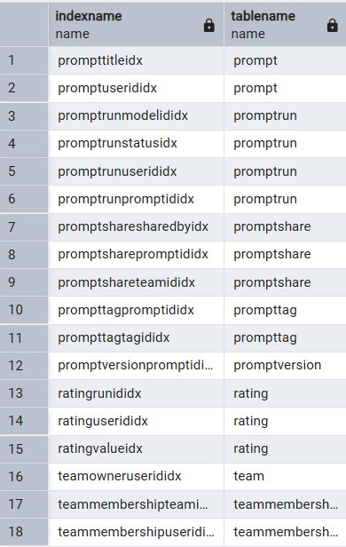

Section 10: Transactions
Transaction 1 — AddFreeUser

This transaction implements Use Case 1 — a user creates a free account. The stored procedure AddFreeUser takes three parameters: email, display_name, and created_at. It inserts one row into User_Account using nextval to generate a new UserID, then inserts one row into FreeUser using currval to reference the same UserID. Both inserts are wrapped in a START TRANSACTION and COMMIT to ensure they succeed or fail together.

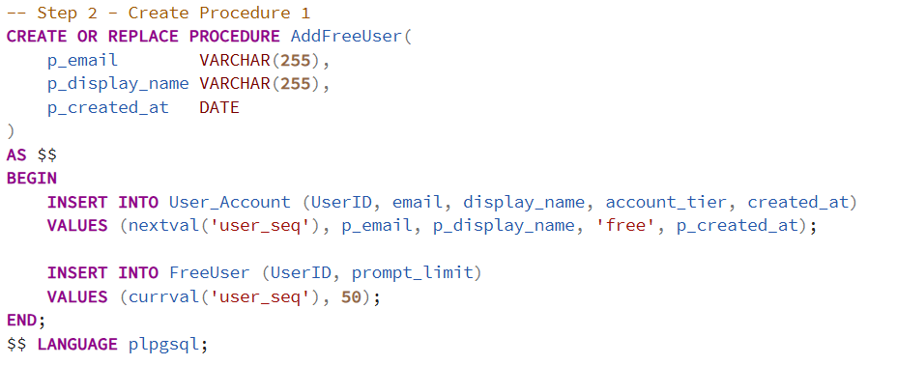

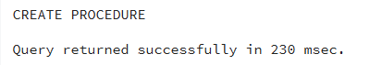
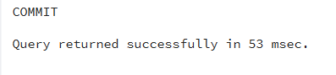
Transaction 2 — AddPromptShare

This transaction implements Use Case 5 — a user shares a prompt with a team. The stored procedure AddPromptShare takes five parameters: prompt_id, team_id, shared_by_user_id, shared_at, and permission_level. It inserts one row into PromptShare using nextval to generate a new ShareID. The execution uses subquery lookups to find the correct FK values without hardcoding any IDs.
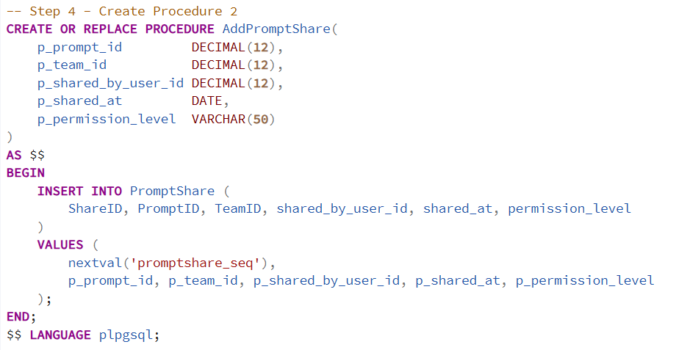
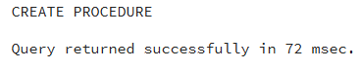
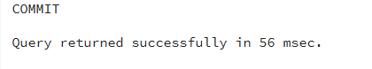

Section 11: Questions and Queries
Title: Run History with Ratings
Question:
Which prompts has each user run, on which AI model, and what rating did they give, for all completed runs?
Why it's useful:
This query is useful for PromptVault's core feature — letting users see their full run history with ratings in one view so they can identify which prompt and model combinations performed best.

The query below joins User_Account, PromptRun, Prompt, AIModel, and Rating across five tables. It filters to completed runs only and orders results by user name and star rating descending. The results show each user's prompt runs with the model used and the rating given.
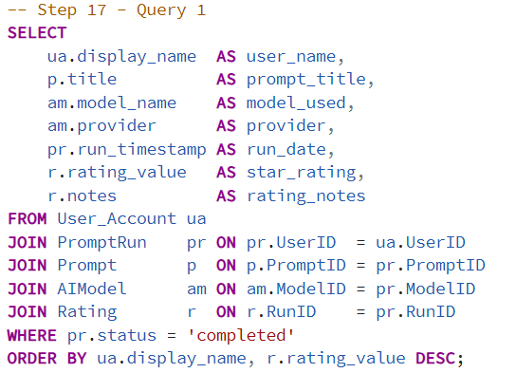

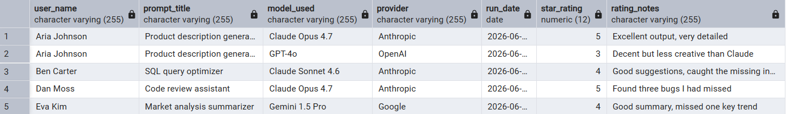

Title: User Account Details by Tier
Question:
What are the account details and tier-specific entitlements for every user in the system?
Why it's useful:
This query is useful for the admin dashboard to see all users in one view with their free prompt limits or paid billing information, without running two separate queries.

The query below joins User_Account to FreeUser and PaidUser using LEFT JOIN so all users appear regardless of subtype. Free users show prompt limits while paid users show subscription tier and billing date. Null values in the paid columns confirm the user is a free account.

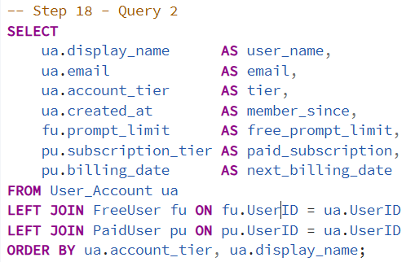

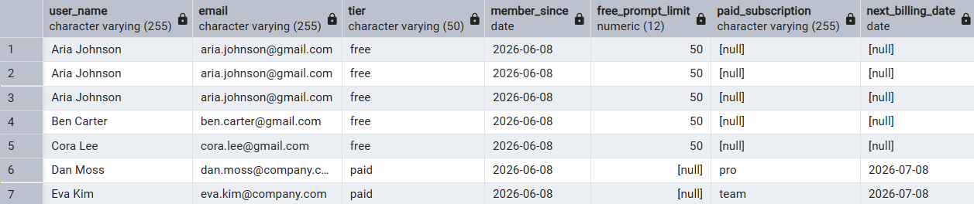

Title: Best Performing AI Model by Average Rating
Question:
Which AI model earns the highest average rating across all completed runs, for models with at least two runs?
Why it's useful:
This query is useful for PromptVault's model recommendation feature, helping users pick the best performing model before running a prompt.

The view ModelEffectiveness joins AIModel, PromptRun, and Rating filtered to completed runs. The query groups by model, counts total runs, and calculates average rating. The HAVING clause limits results to models with at least two runs. Claude Opus 4.7 ranks highest with an average rating of 5.00 across two runs.
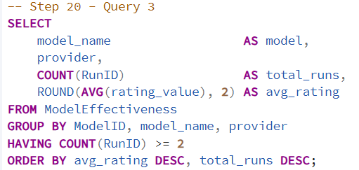

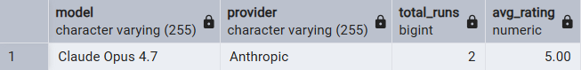

Section 12: Indexes
Primary Keys
The following primary key columns are automatically indexed by PostgreSQL. No additional index creation is needed.

- User_Account.UserID
- FreeUser.UserID
- PaidUser.UserID
- Prompt.PromptID
- PromptVersion.VersionID
- Tag.TagID
- PromptTag.PromptID, PromptTag.TagID (composite)
- AIModel.ModelID
- PromptRun.RunID
- Rating.RatingID
- Team.TeamID
- TeamMembership.UserID, TeamMembership.TeamID (composite)
- PromptShare.ShareID

Foreign Key Indexes
All foreign key columns are indexed as non-unique since multiple rows can share the same foreign key value.

Column | Unique? | Reason
Prompt.UserID | Non-unique | One user owns many prompts
PromptVersion.PromptID | Non-unique | One prompt has many versions
PromptTag.PromptID | Non-unique | One prompt can have many tags
PromptTag.TagID | Non-unique | One tag appears on many prompts
PromptRun.PromptID | Non-unique | One prompt can be run many times
PromptRun.ModelID | Non-unique | One model is used in many runs
PromptRun.UserID | Non-unique | One user can execute many runs
Rating.RunID | Non-unique | One run can receive many ratings
Rating.UserID | Non-unique | One user can give many ratings
Team.owner_user_id | Non-unique | One user can own many teams
TeamMembership.UserID | Non-unique | One user can belong to many teams
TeamMembership.TeamID | Non-unique | One team has many members
PromptShare.PromptID | Non-unique | One prompt can be shared many times
PromptShare.TeamID | Non-unique | One team can receive many shares
PromptShare.shared_by_user_id | Non-unique | One user can share many prompts

Query Driven Indexes
Three additional indexes were added based on the queries defined in Section 11.

1. PromptRun.status — Non-unique Used in the WHERE clause of Query 1 and the ModelEffectiveness view. Filtering by status = 'completed' is the most common access pattern in PromptVault.
2. Rating.rating_value — Non-unique Used in the AVG aggregate and ORDER BY of Query 1 and Query 3. Many ratings share the same star value so the index is non-unique.
3. Prompt.title — Non-unique Used in prompt search and subquery lookups. Searching by title is one of the most frequent operations in PromptVault. Non-unique because two users could save prompts with the same title.

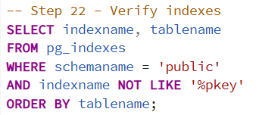

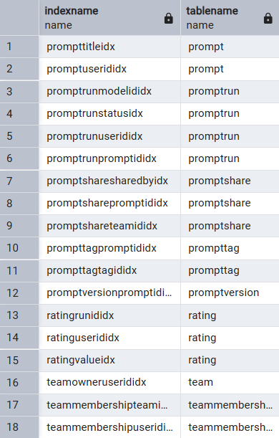

Section 13: Attribute History
In reviewing my schema, the subscription_tier column in the PaidUser table would benefit most from historical tracking. Paid users may upgrade or downgrade their subscription tier over time. Without a history table, there is no way to know what tier a user was on at any point in the past. Tracking this history allows PromptVault to analyze upgrade and downgrade patterns, identify churn risk, and make better pricing decisions.
My new structural database rule is: Each paid user may have zero or many subscription tier changes recorded; each subscription tier change record belongs to exactly one paid user.

Attribute | Description | Example
TierChangeID | Primary key of the history table. DECIMAL(12) to allow many values. | 1
OldTier | The subscription tier before the change. Mirrors subscription_tier datatype in PaidUser. | pro
NewTier | The subscription tier after the change. Mirrors subscription_tier datatype in PaidUser. | team
UserID | Foreign key to PaidUser, referencing the user whose tier changed. | 1
ChangeDate | The date the tier change occurred. DATE datatype. | 2026-06-14
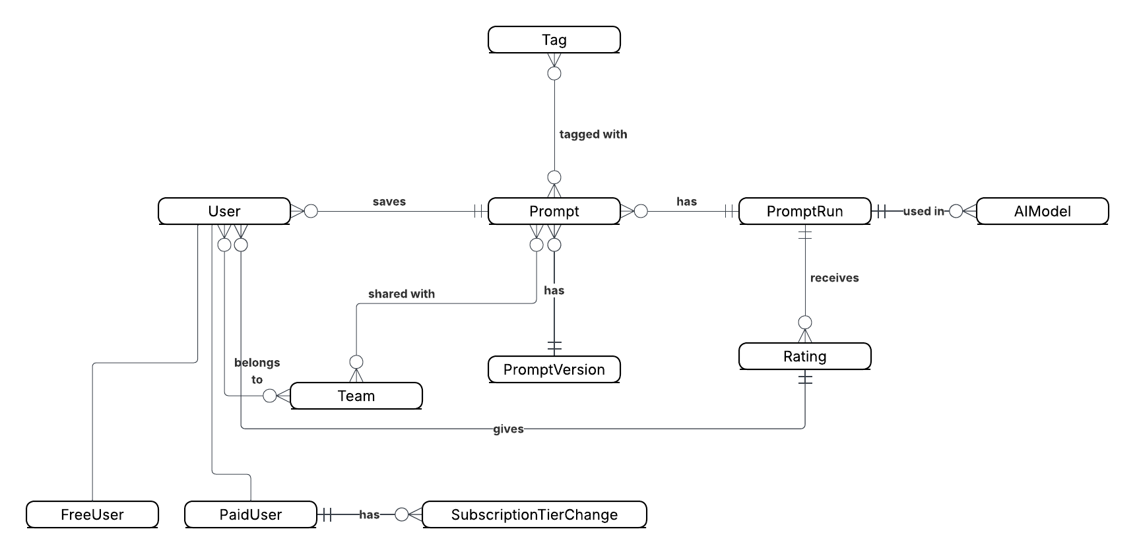

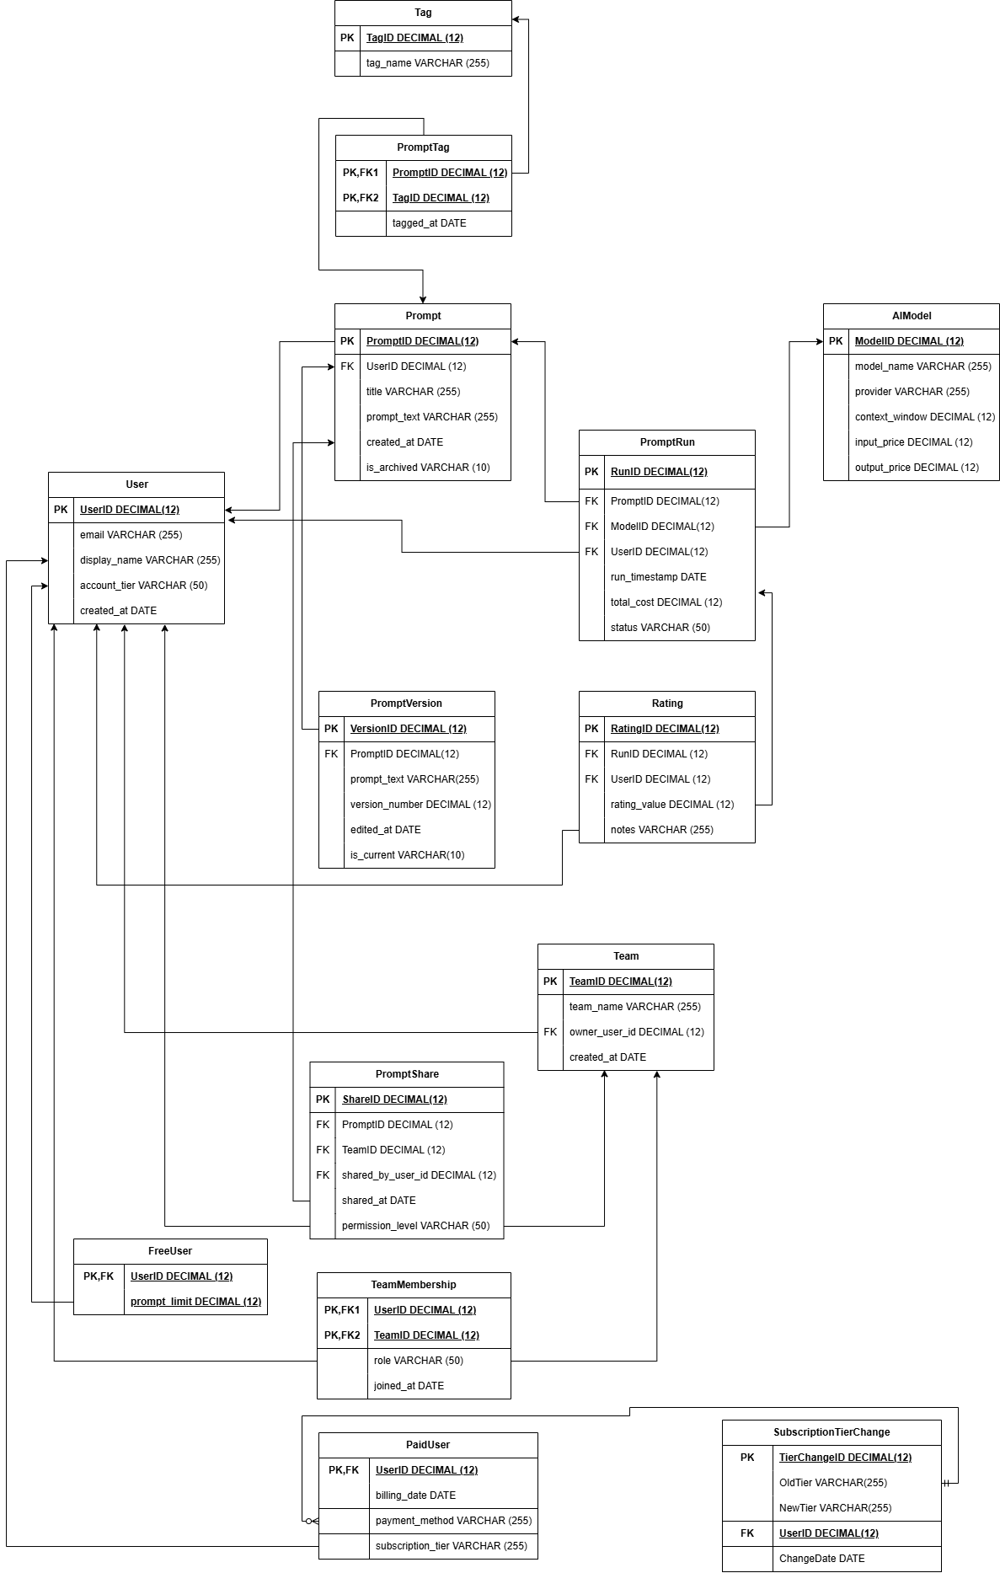
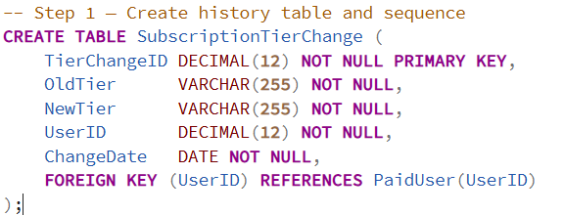
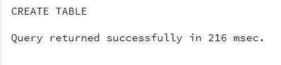

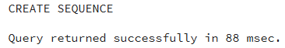

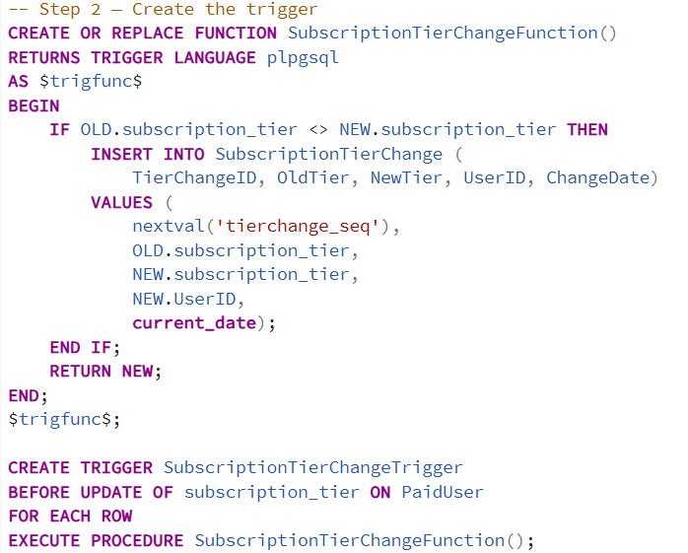

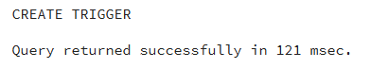

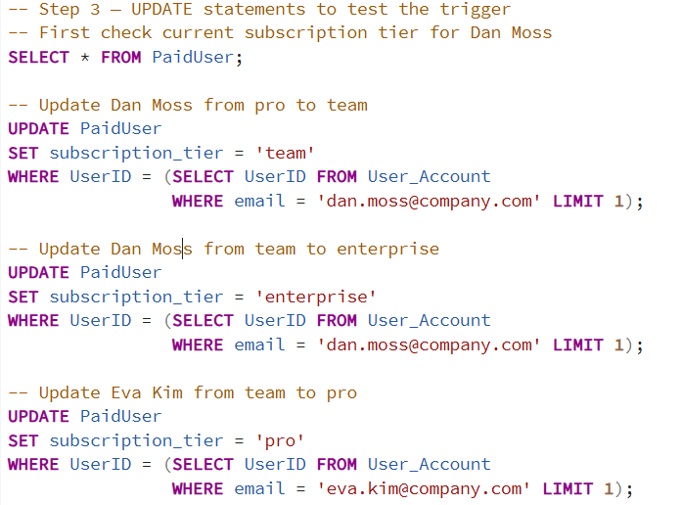

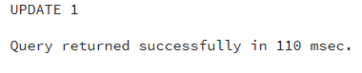
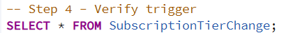

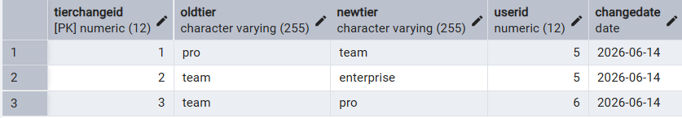

The results demonstrate that the trigger correctly captured all three subscription tier changes. Dan Moss changed from 'pro' to 'team', then from 'team' to 'enterprise'. Eva Kim changed from 'team' to 'pro'. Each change was automatically recorded in the SubscriptionTierChange table with the old tier, new tier, user ID, and date of change.

Code | Description
CREATE OR REPLACE FUNCTION SubscriptionTierChangeFunction() | Creates the function that the trigger will execute
RETURNS TRIGGER LANGUAGE plpgsql | Specifies this is a trigger function written in plpgsql
IF OLD.subscription_tier <> NEW.subscription_tier | Only records a change if the tier value actually changed
INSERT INTO SubscriptionTierChange | Inserts a new row into the history table
nextval('tierchange_seq') | Generates a new unique ID using the sequence
OLD.subscription_tier | Captures the tier value before the update
NEW.subscription_tier | Captures the tier value after the update
NEW.UserID | Gets the UserID from the updated row
current_date | Records the date the change occurred
RETURN NEW | Returns the new row to complete the trigger
CREATE TRIGGER SubscriptionTierChangeTrigger | Creates the trigger and names it
BEFORE UPDATE OF subscription_tier ON PaidUser | Fires before any update to subscription_tier column
FOR EACH ROW | Runs once for each row that is updated
EXECUTE PROCEDURE SubscriptionTierChangeFunction() | Calls the function when the trigger fires

Section 14: Data Visualizations

Visualization 1 — Average Rating by AI Model

Which AI model receives the highest average rating from PromptVault users?
This visualization helps PromptVault users and administrators identify which AI model consistently produces the best results, supporting the model recommendation feature.

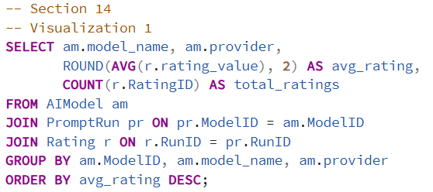

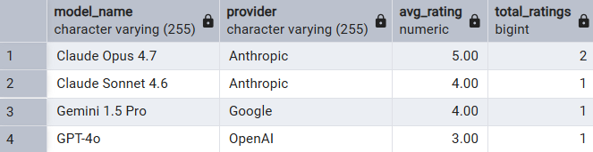

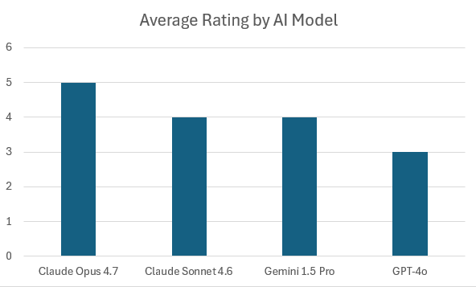

This visualization shows that Claude Opus 4.7 is the highest rated model with a perfect average of 5.00, followed by Claude Sonnet 4.6 and Gemini 1.5 Pro both at 4.00, and GPT-4o at 3.00. All three Anthropic models outperform GPT-4o in user ratings. This tells PromptVault that users find Claude models more effective for their prompting needs. PromptVault could use this data to recommend Claude Opus 4.7 as the default model and highlight it in the interface. It also suggests that expanding the model library with more Anthropic models may increase user satisfaction.

Visualization 2 — Number of Prompts per User

How many prompts has each user saved in PromptVault?
This visualization helps identify the most active users and understand engagement levels across the platform.

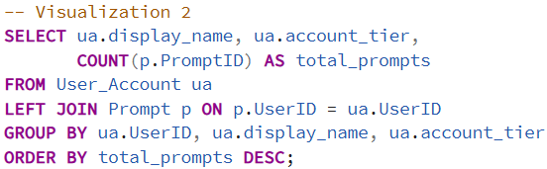

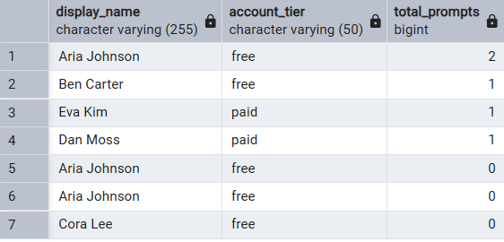
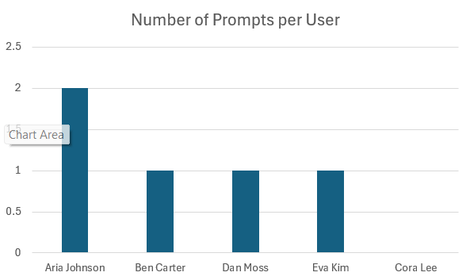

This visualization shows that Aria Johnson is the most active user with 2 saved prompts, while Ben Carter, Dan Moss, and Eva Kim each have 1 prompt. Cora Lee has no saved prompts yet. This tells PromptVault that most users are just getting started with saving prompts and engagement is still low. PromptVault could use this data to identify users like Cora Lee who have not yet saved any prompts and send them onboarding tips to encourage engagement. Increasing the average number of saved prompts per user would be a key growth metric for the platform.

AI Collaboration and Transcript
For Iteration 6, I used AI assistance across three main areas: designing the history table and trigger, verifying my SQL code, and creating data visualizations. My collaboration followed a structured and iterative approach throughout. I began with a vague prompt — "Write a PostgreSQL trigger for my database that tracks changes to a column" — and used AI feedback to identify what was missing, then revised the prompt section by section using the TASK, ROLE, CONTEXT, and WHAT TO DO template. The before-and-after comparison demonstrated clearly that the revised prompt produced schema-specific, ready-to-run PostgreSQL code while the original would have produced a generic example requiring significant rewriting. Rather than asking AI to write my SQL for me, I wrote the trigger function and both visualization queries independently and used AI to verify correctness, confirm logic, and identify edge cases such as the importance of using COUNT(p.PromptID) instead of COUNT(*) in a LEFT JOIN. I also used AI to review my Section 13 writeup and received specific feedback that improved the precision of my structural database rule and trigger description. This iterative process — write, verify, refine — produced a stronger final submission than I would have achieved by either working alone or asking AI to generate everything from scratch.

