WEEK – 1

Singleton Pattern Example

  - Logger.java

public class Logger {
private static Logger instance;

private Logger() {
System.out.println("Logger instance created.");
}

public static Logger getInstance() {
if (instance == null) {
instance = new Logger();
}
return instance;
}

public void log(String message) {
System.out.println("Log: " + message);
}
}

  - SingletonTest.java
public class SingletonTest {

public static void main(String[] args) {

Logger logger1 = Logger.getInstance();
logger1.log("This is the first log message.");
Logger logger2 = Logger.getInstance();
logger2.log("This is the second log message.");

if (logger1 == logger2) {
System.out.println("\nOnly one Logger instance exists.");
} else {
System.out.println("\nMultiple Logger instances exist.");
}
System.out.println("Logger1: " + logger1);
System.out.println("Logger2: " + logger2);
}
}

  - OUTPUT:

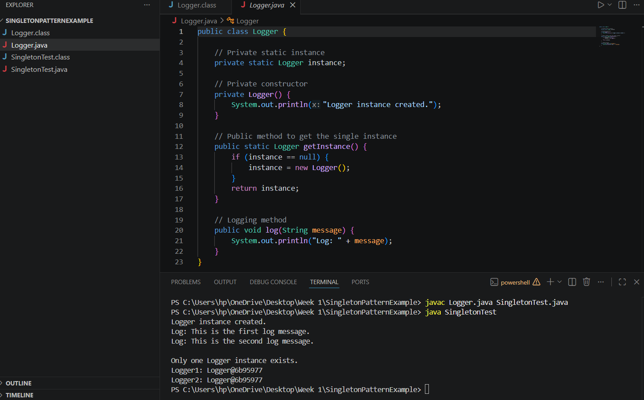

Factory Method Pattern

  - Document.java
public interface Document {
void open();
}
  - DocumentFactory.java
public abstract class DocumentFactory {
public abstract Document createDocument();
}
  - ExcelDocument.java
public class ExcelDocument implements Document {

@Override
public void open() {
System.out.println("Opening Excel Document.");
}
}
  - ExcelDocumentFactory.java
public class ExcelDocumentFactory extends DocumentFactory {

@Override
public Document createDocument() {
return new ExcelDocument();
}
}
  - FactoryMethodTest.java
public class FactoryMethodTest {

public static void main(String[] args) {

DocumentFactory wordFactory = new WordDocumentFactory();
Document word = wordFactory.createDocument();
word.open();

DocumentFactory pdfFactory = new PdfDocumentFactory();
Document pdf = pdfFactory.createDocument();
pdf.open();

DocumentFactory excelFactory = new ExcelDocumentFactory();
Document excel = excelFactory.createDocument();
excel.open();
}
}
  - PdfDocument.java
public class PdfDocument implements Document {

@Override
public void open() {
System.out.println("Opening PDF Document.");
}
}
  - PdfDocumentFactory.java
public class PdfDocumentFactory extends DocumentFactory {

@Override
public Document createDocument() {
return new PdfDocument();
}
}
  - WordDocument.java
public class WordDocument implements Document {

@Override
public void open() {
System.out.println("Opening Word Document.");
}
}
  - WordDocumentFactory.java
public class WordDocumentFactory extends DocumentFactory {

@Override
public Document createDocument() {
return new WordDocument();
}
}
  - OUTPUT:
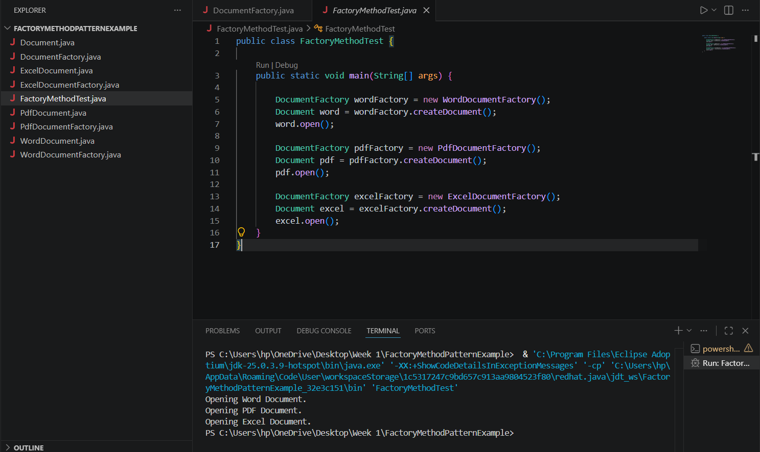

E-commerce Platform Search Function
  - Product.java
public class Product {

private int productId;
private String productName;
private String category;

public Product(int productId, String productName, String category) {
this.productId = productId;
this.productName = productName;
this.category = category;
}

public int getProductId() {
return productId;
}

public String getProductName() {
return productName;
}

public String getCategory() {
return category;
}

  - SearchAlgorithms.java
public class SearchAlgorithms {

public static Product linearSearch(Product[] products, int targetProductId) {

for (Product product : products) {
if (product.getProductId() == targetProductId) {
return product;
}
}

return null;
}
public static Product binarySearch(Product[] products, int targetProductId) {

int left = 0;
int right = products.length - 1;

while (left <= right) {

int middle = left + (right - left) / 2;

if (products[middle].getProductId() == targetProductId) {
return products[middle];
}

if (products[middle].getProductId() < targetProductId) {
left = middle + 1;
} else {
right = middle - 1;
}
}

return null;
}
}
  - EcommerceSearchTest.java
import java.util.Arrays;
import java.util.Comparator;

public class EcommerceSearchTest {

public static void main(String[] args) {
Product[] products = {
new Product(104, "Wireless Mouse", "Electronics"),
new Product(101, "Laptop", "Electronics"),
new Product(105, "Running Shoes", "Footwear"),
new Product(102, "Smartphone", "Electronics"),
new Product(103, "Backpack", "Accessories")
};

int targetProductId = 102;

System.out.println("Linear Search");
System.out.println("----------------------------");

Product linearResult =
SearchAlgorithms.linearSearch(products, targetProductId);

if (linearResult != null) {
System.out.println("Product found:");
System.out.println(linearResult);
} else {
System.out.println("Product not found.");
}
Product[] sortedProducts = Arrays.copyOf(products, products.length);
Arrays.sort(
sortedProducts,
Comparator.comparingInt(Product::getProductId)
);

System.out.println("\nSorted Products");
System.out.println("----------------------------");

for (Product product : sortedProducts) {
System.out.println(product);
}
System.out.println("\nBinary Search");
System.out.println("----------------------------");
Product binaryResult =
SearchAlgorithms.binarySearch(sortedProducts, targetProductId);

if (binaryResult != null) {
System.out.println("Product found:");
System.out.println(binaryResult);
} else {
System.out.println("Product not found.");
}
}
}
  - OUTPUT:
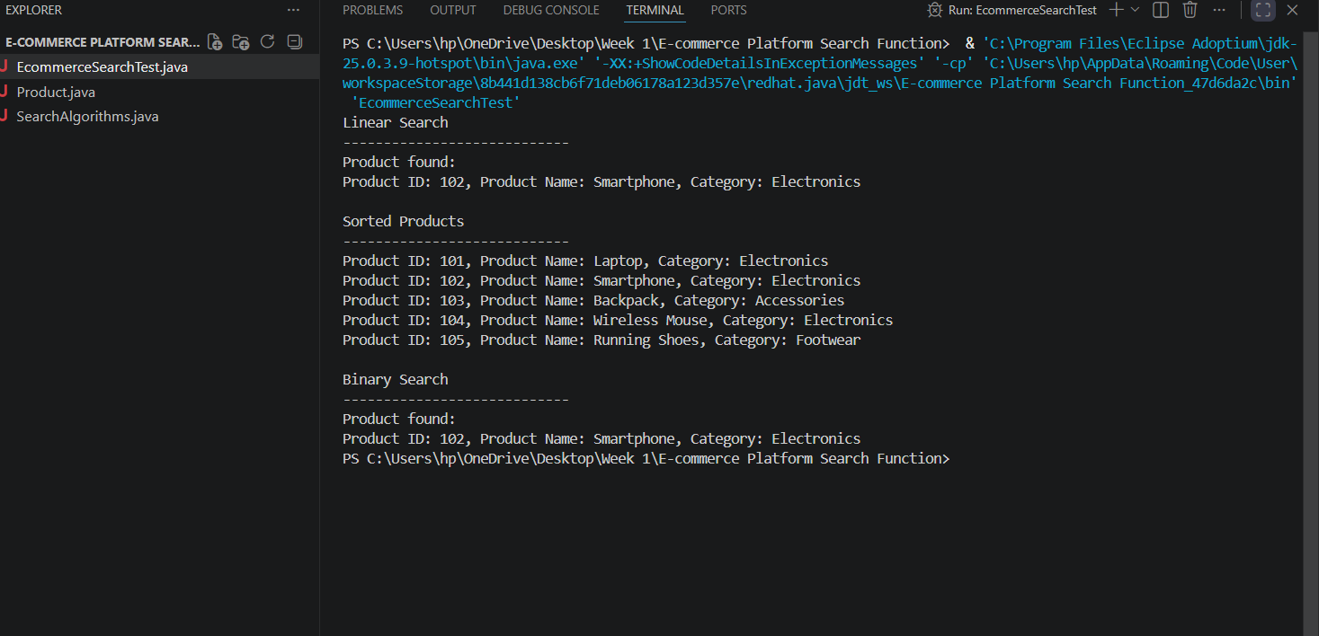

Financial Forecasting
  - FinancialForecasting.java
import java.util.Scanner;

public class FinancialForecasting {

public static double calculateFutureValue(
double presentValue,
double growthRate,
int years) {

if (years == 0) {
return presentValue;
}

// Recursive case
return calculateFutureValue(
presentValue,
growthRate,
years - 1
) * (1 + growthRate);
}

public static void main(String[] args) {

Scanner scanner = new Scanner(System.in);

System.out.print("Enter the present value: ");
double presentValue = scanner.nextDouble();

System.out.print("Enter the annual growth rate in percentage: ");
double growthRatePercentage = scanner.nextDouble();

System.out.print("Enter the number of years: ");
int years = scanner.nextInt();

if (presentValue < 0 || years < 0) {
System.out.println(
"Present value and number of years cannot be negative."
);
scanner.close();
return;
}

double growthRate = growthRatePercentage / 100;

double futureValue = calculateFutureValue(
presentValue,
growthRate,
years
);

System.out.printf(
"Predicted value after %d years: %.2f%n",
years,
futureValue
);

scanner.close();
}
}
  - OUTPUT:
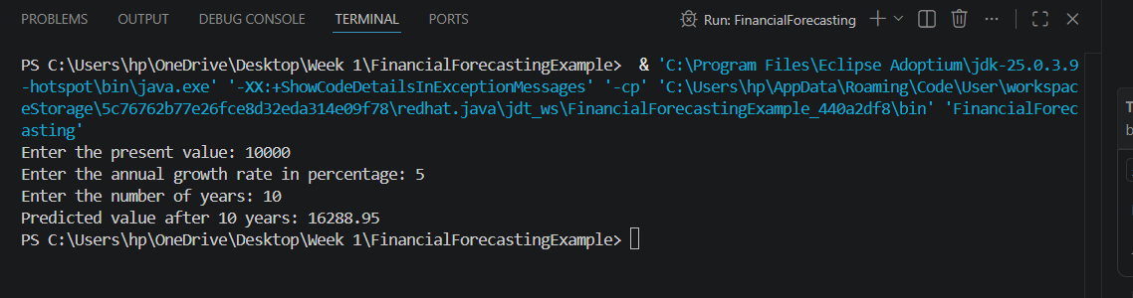

Control Structures
  - Scenario1.sql
SET SERVEROUTPUT ON;

DECLARE
CURSOR customer_cursor IS
SELECT CustomerID, CustomerName, Age
FROM Customers;

BEGIN
FOR customer_record IN customer_cursor LOOP

IF customer_record.Age > 60 THEN

UPDATE Loans
SET InterestRate = InterestRate - 1
WHERE CustomerID = customer_record.CustomerID;

DBMS_OUTPUT.PUT_LINE(
'1% interest rate discount applied for customer: '
|| customer_record.CustomerName
);

END IF;

END LOOP;

COMMIT;

DBMS_OUTPUT.PUT_LINE(
'Interest rate discounts updated successfully.'
);

EXCEPTION
WHEN OTHERS THEN
ROLLBACK;
DBMS_OUTPUT.PUT_LINE('Error: ' || SQLERRM);
END;
/
  - Scenario2.sql
SET SERVEROUTPUT ON;

DECLARE
CURSOR customer_cursor IS
SELECT CustomerID, CustomerName, Balance
FROM Customers;

BEGIN
FOR customer_record IN customer_cursor LOOP

IF customer_record.Balance > 10000 THEN

UPDATE Customers
SET IsVIP = 'Y'
WHERE CustomerID = customer_record.CustomerID;

DBMS_OUTPUT.PUT_LINE(
customer_record.CustomerName
|| ' has been promoted to VIP status.'
);

ELSE

UPDATE Customers
SET IsVIP = 'N'
WHERE CustomerID = customer_record.CustomerID;

END IF;

END LOOP;

COMMIT;

DBMS_OUTPUT.PUT_LINE('VIP statuses updated successfully.');

EXCEPTION
WHEN OTHERS THEN
ROLLBACK;
DBMS_OUTPUT.PUT_LINE('Error: ' || SQLERRM);
END;
/
  - Scenario3.sql
SET SERVEROUTPUT ON;

DECLARE
CURSOR loan_cursor IS
SELECT
l.LoanID,
l.DueDate,
c.CustomerID,
c.CustomerName
FROM Loans l
JOIN Customers c
ON l.CustomerID = c.CustomerID
WHERE l.DueDate BETWEEN TRUNC(SYSDATE)
AND TRUNC(SYSDATE) + 30
ORDER BY l.DueDate;

BEGIN
FOR loan_record IN loan_cursor LOOP

DBMS_OUTPUT.PUT_LINE(
'Reminder: Dear '
|| loan_record.CustomerName
|| ', your loan with Loan ID '
|| loan_record.LoanID
|| ' is due on '
|| TO_CHAR(loan_record.DueDate, 'DD-MON-YYYY')
|| '. Please make the payment before the due date.'
);

END LOOP;

EXCEPTION
WHEN OTHERS THEN
DBMS_OUTPUT.PUT_LINE('Error: ' || SQLERRM);
END;
/

Stored Procedures
  - ProcessMonthlyInterest.sql
CREATE OR REPLACE PROCEDURE ProcessMonthlyInterest
IS
BEGIN
UPDATE Accounts
SET Balance = Balance + (Balance * 0.01)
WHERE AccountType = 'Savings';

COMMIT;

DBMS_OUTPUT.PUT_LINE(
'Monthly interest processed successfully for all savings accounts.'
);

EXCEPTION
WHEN OTHERS THEN
ROLLBACK;
DBMS_OUTPUT.PUT_LINE('Error: ' || SQLERRM);
END;
/
  - UpdateEmployeeBonus.sql
CREATE OR REPLACE PROCEDURE UpdateEmployeeBonus (
p_DepartmentID IN Employees.DepartmentID%TYPE,
p_BonusPercentage IN NUMBER
)
IS
BEGIN
UPDATE Employees
SET Salary = Salary + (Salary * p_BonusPercentage / 100)
WHERE DepartmentID = p_DepartmentID;

COMMIT;

DBMS_OUTPUT.PUT_LINE(
'Employee salaries updated successfully for department '
|| p_DepartmentID
);

EXCEPTION
WHEN OTHERS THEN
ROLLBACK;
DBMS_OUTPUT.PUT_LINE('Error: ' || SQLERRM);
END;
/
  - TransferFunds.sql
CREATE OR REPLACE PROCEDURE TransferFunds (
p_SourceAccountID IN Accounts.AccountID%TYPE,
p_DestinationAccountID IN Accounts.AccountID%TYPE,
p_Amount IN NUMBER
)
IS
v_SourceBalance Accounts.Balance%TYPE;
BEGIN
IF p_Amount <= 0 THEN
RAISE_APPLICATION_ERROR(
-20001,
'Transfer amount must be greater than zero.'
);
END IF;

SELECT Balance
INTO v_SourceBalance
FROM Accounts
WHERE AccountID = p_SourceAccountID
FOR UPDATE;

IF v_SourceBalance < p_Amount THEN
RAISE_APPLICATION_ERROR(
-20002,
'Insufficient balance in the source account.'
);
END IF;

UPDATE Accounts
SET Balance = Balance - p_Amount
WHERE AccountID = p_SourceAccountID;

UPDATE Accounts
SET Balance = Balance + p_Amount
WHERE AccountID = p_DestinationAccountID;

IF SQL%ROWCOUNT = 0 THEN
RAISE_APPLICATION_ERROR(
-20003,
'Destination account not found.'
);
END IF;

COMMIT;

DBMS_OUTPUT.PUT_LINE(
'Amount ' || p_Amount
|| ' transferred successfully from account '
|| p_SourceAccountID
|| ' to account '
|| p_DestinationAccountID
);

EXCEPTION
WHEN NO_DATA_FOUND THEN
ROLLBACK;
DBMS_OUTPUT.PUT_LINE('Source account not found.');

WHEN OTHERS THEN
ROLLBACK;
DBMS_OUTPUT.PUT_LINE('Error: ' || SQLERRM);
END;
/

Setting Up JUnit
  - pom.xml
<project xmlns="http://maven.apache.org/POM/4.0.0"
xmlns:xsi="http://www.w3.org/2001/XMLSchema-instance"
xsi:schemaLocation="http://maven.apache.org/POM/4.0.0
http://maven.apache.org/xsd/maven-4.0.0.xsd">

<modelVersion>4.0.0</modelVersion>

<groupId>com.example</groupId>
<artifactId>JUnitExample</artifactId>
<version>1.0</version>

<dependencies>

<dependency>
<groupId>junit</groupId>
<artifactId>junit</artifactId>
<version>4.13.2</version>
<scope>test</scope>
</dependency>

</dependencies>

</project>
  - Calculator.java
public class Calculator {

public int add(int a, int b) {
return a + b;
}

}
  - CalculatorTest.java
import static org.junit.Assert.assertEquals;

import org.junit.Test;

public class CalculatorTest {

@Test
public void testAddition() {

Calculator calculator = new Calculator();

int result = calculator.add(10, 20);

assertEquals(30, result);

}

}

Assertions in Junit
  - AssertionsTest.java
import static org.junit.Assert.assertEquals;
import static org.junit.Assert.assertTrue;
import static org.junit.Assert.assertFalse;
import static org.junit.Assert.assertNull;
import static org.junit.Assert.assertNotNull;

import org.junit.Test;

public class AssertionsTest {

@Test
public void testAssertions() {

// Assert equals
assertEquals(5, 2 + 3);

// Assert true
assertTrue(5 > 3);

// Assert false
assertFalse(5 < 3);

// Assert null
assertNull(null);

// Assert not null
assertNotNull(new Object());
}
}

Arrange-Act-Assert (AAA) Pattern, Test Fixtures, Setup and Teardown Methods in JUnit
  - Calculator.java
public class Calculator {

public int add(int a, int b) {
return a + b;
}

public int subtract(int a, int b) {
return a - b;
}
}
  - CalculatorTest.java
import static org.junit.Assert.assertEquals;

import org.junit.After;
import org.junit.Before;
import org.junit.Test;

public class CalculatorTest {

private Calculator calculator;

// Setup method
@Before
public void setUp() {
calculator = new Calculator();
System.out.println("Setup: Calculator object created.");
}

// Teardown method
@After
public void tearDown() {
calculator = null;
System.out.println("Teardown: Calculator object destroyed.");
}

@Test
public void testAddition() {

// Arrange
int a = 10;
int b = 20;

// Act
int result = calculator.add(a, b);

// Assert
assertEquals(30, result);
}

@Test
public void testSubtraction() {

// Arrange
int a = 20;
int b = 5;

// Act
int result = calculator.subtract(a, b);

// Assert
assertEquals(15, result);
}
}

Mocking and Stubbing
  - ExternalApi.java
public interface ExternalApi {

String getData();

}
  - MyService.java
public class MyService {

private ExternalApi externalApi;

public MyService(ExternalApi externalApi) {
this.externalApi = externalApi;
}

public String fetchData() {
return externalApi.getData();
}

}
  - MyServiceTest.java
import static org.junit.jupiter.api.Assertions.assertEquals;
import static org.mockito.Mockito.when;

import org.junit.jupiter.api.Test;
import org.mockito.Mockito;

public class MyServiceTest {

@Test
public void testExternalApi() {

// Create a mock object
ExternalApi mockApi = Mockito.mock(ExternalApi.class);

// Stub the method
when(mockApi.getData()).thenReturn("Mock Data");

// Create service using mocked API
MyService service = new MyService(mockApi);

// Call the service method
String result = service.fetchData();

// Verify the result
assertEquals("Mock Data", result);
}
}

Verifying Interactions
  - ExternalApi.java
public interface ExternalApi {

String getData();

}
  - MyService.java
public class MyService {

private ExternalApi externalApi;

public MyService(ExternalApi externalApi) {
this.externalApi = externalApi;
}

public String fetchData() {
return externalApi.getData();
}

}
  - MyServiceTest.java
import static org.mockito.Mockito.verify;

import org.junit.jupiter.api.Test;
import org.mockito.Mockito;

public class MyServiceTest {

@Test
public void testVerifyInteraction() {

// Create a mock object
ExternalApi mockApi = Mockito.mock(ExternalApi.class);

// Create service using the mock
MyService service = new MyService(mockApi);

// Call the method
service.fetchData();

// Verify that getData() was called once
verify(mockApi).getData();
}
}

Logging Error Messages and Warning Levels
  - pom.xml
<dependencies>

<dependency>
<groupId>org.slf4j</groupId>
<artifactId>slf4j-api</artifactId>
<version>1.7.30</version>
</dependency>

<dependency>
<groupId>ch.qos.logback</groupId>
<artifactId>logback-classic</artifactId>
<version>1.2.3</version>
</dependency>

</dependencies>
  - LoggingExample.java
import org.slf4j.Logger;
import org.slf4j.LoggerFactory;

public class LoggingExample {

private static final Logger logger =
LoggerFactory.getLogger(LoggingExample.class);

public static void main(String[] args) {

logger.error("This is an error message");

logger.warn("This is a warning message");

}
}

