### GOVERNMENT OF TAMILNADU

### Naan Mudhalvan – Project Based Experiential Learning

### Project Report on

### A QUANTITATIVE ANALYSIS OF CANDIDATES IN THE 2019 LOK SABHA ELECTIONS

# Submitted by

R. JOTHIMANI (C31154FDCA1BDF0900042394D3995C8E)

S. NAGESWARI (5F38D599377D774B3B04B2DEBCB34C7C)

P. SHARMILADEVI ( E33B0B7EE5B8D2FAB644BCDEA5C90205)

R. YUGAVEERALAKSHMI (642B97C63CE095FB5D44779CAFC5BDC1)

(TEAM ID :NM2023TMID07170)

**Under the guidance of**

**Dr. M. GAYATHRI M.Sc., Ph.D**

**Guest Lecturer**

**Department of Mathematics**

GOVERNMENT ARTS COLLEGE FOR WOMEN,

(Affiliated to Mother Teresa Women’s University, Kodaikanal)

Reaccredited with “C” Grade by NAAC

NILAKOTTAI-624

# 1.INTRODUCTION

### 1.1Overview:

### The Lok Sabha is composed of representatives of people chosen by direct election on the basis of Universal Adult Suffrage. The Constitution of India allows for a maximum of 550 members in the House, with 530 members representing the States and 20 representing the Union Territories. The 17th Lok Sabha was formed by the members elected in the 2019 Indian general election. Elections, all across India, were conducted in seven phases from 11 April 2019 to 19 May 2019 by the Election Commission of India.

### The Bharatiya Janata Party received 37.36% of the vote, the highest vote share by a political party since the 1989 general election, and won 303 seats, further increasing its substantial majority. In addition, the BJP-led National Democratic Alliance (NDA) won 353 seats.

### 1.2 Purpose:

### The Requirement is to analyse the winners and total voters and electors and Postal Votes of Lok Sabha, and criminal Cases in Each State & Party. In which State There are more winners and which party got more seats and liabilities and assets of each state. For this Created KPI’s and interactive Visualizations and Dashboard and story Board to bring clean and deep understanding of the data.

# 2 PROBLEM DEFINITION & DESIGN THINKING

### Analysing the nature of candidates in the 2019 LOK SABHA elections and creating Dashboard, Strong using Tableau.

### 2.1 Empathy Map:

### Untitled_2023-10-06_14-48-51.png

### 2.2 Ideation & Brainstorming Map:

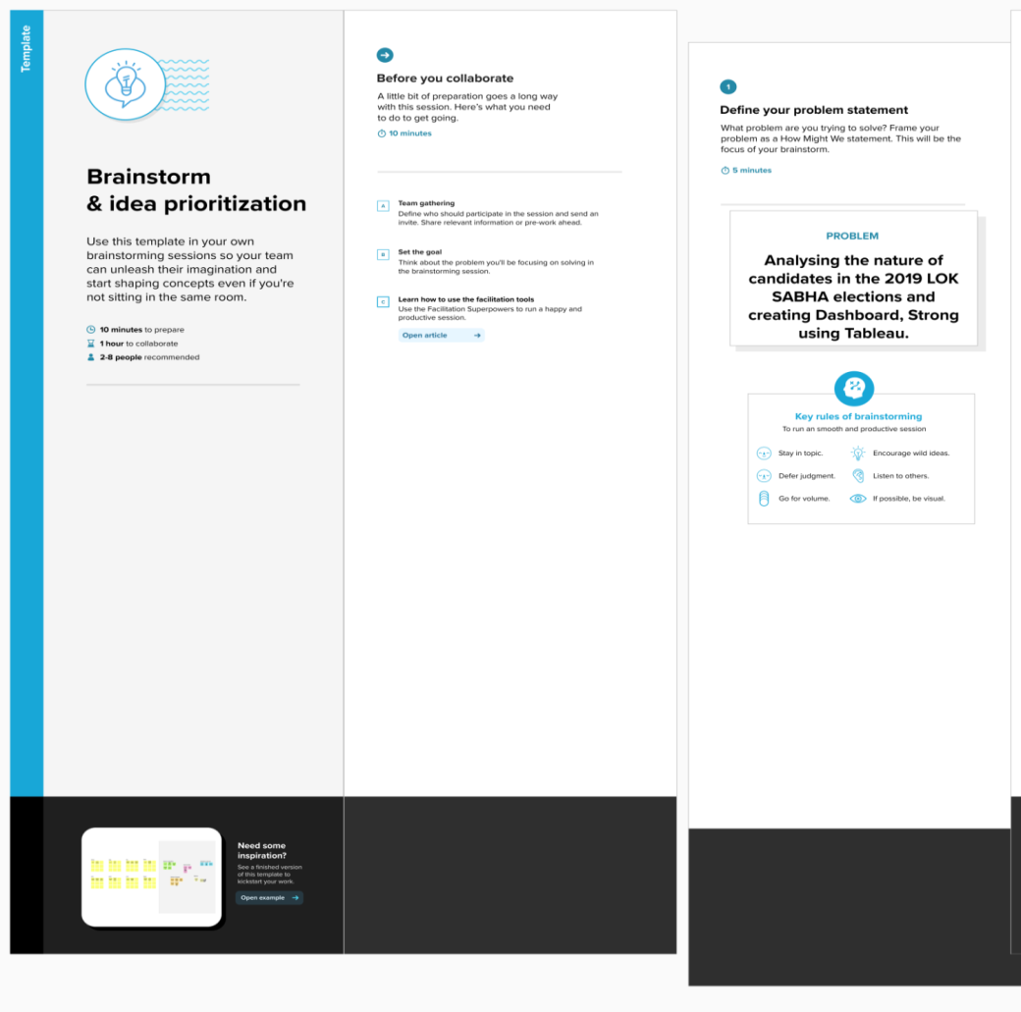

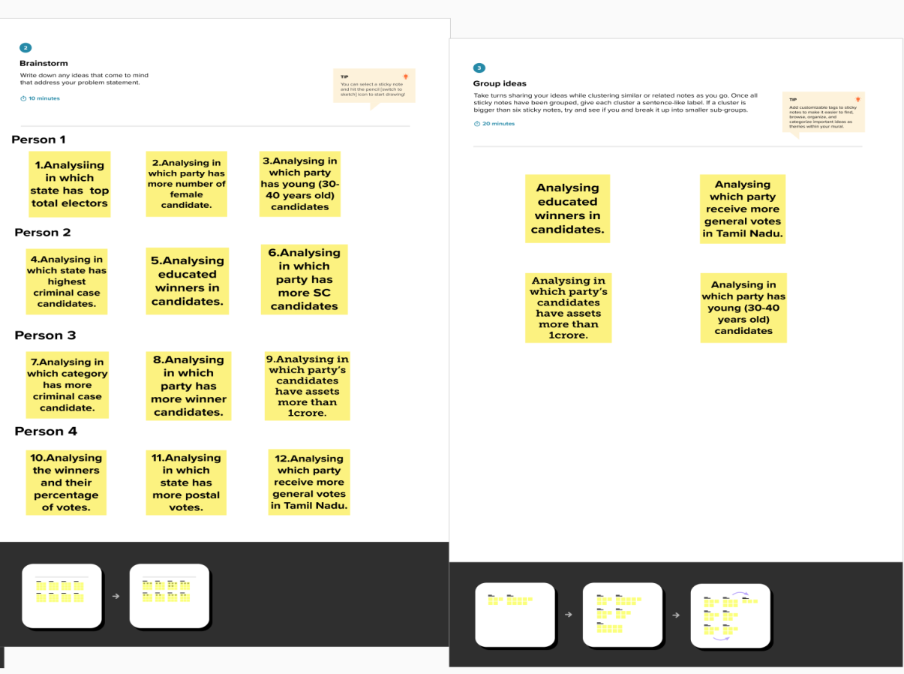

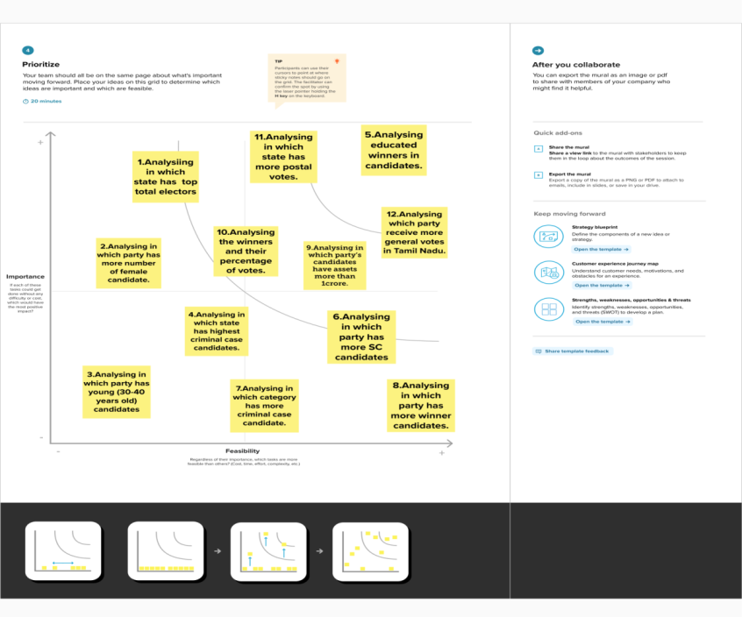

# 3 RESULTS:

Activity1: Total Winners



Activity2: Total Criminal Cases

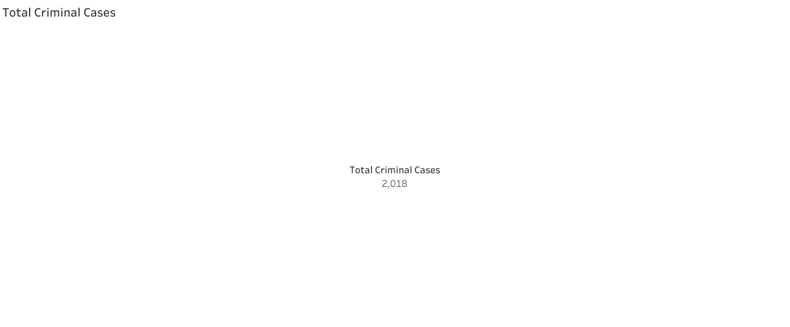

Activity3: Total Voters

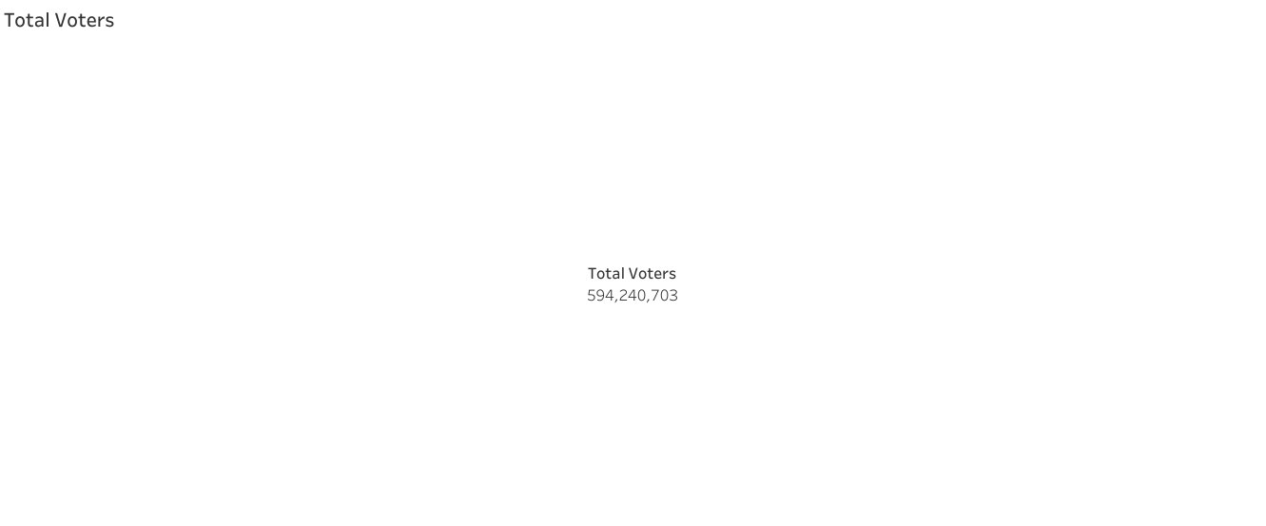

Activity4: Total Electors By State Wise

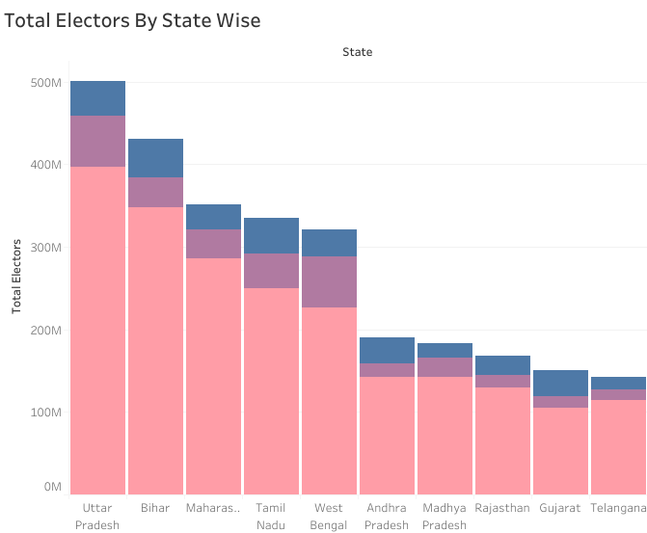

Activity5: Total 10 Winners States

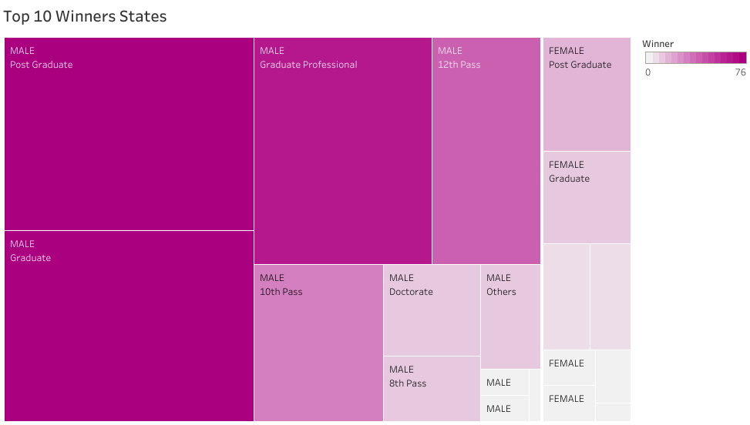

Activity6: Top 10 Winners By Party Wise

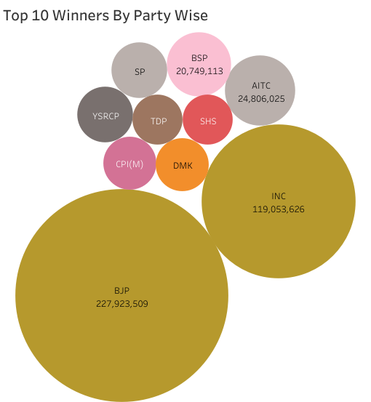

Activity7: General Voters Divided By Their Education Qualification & Gender

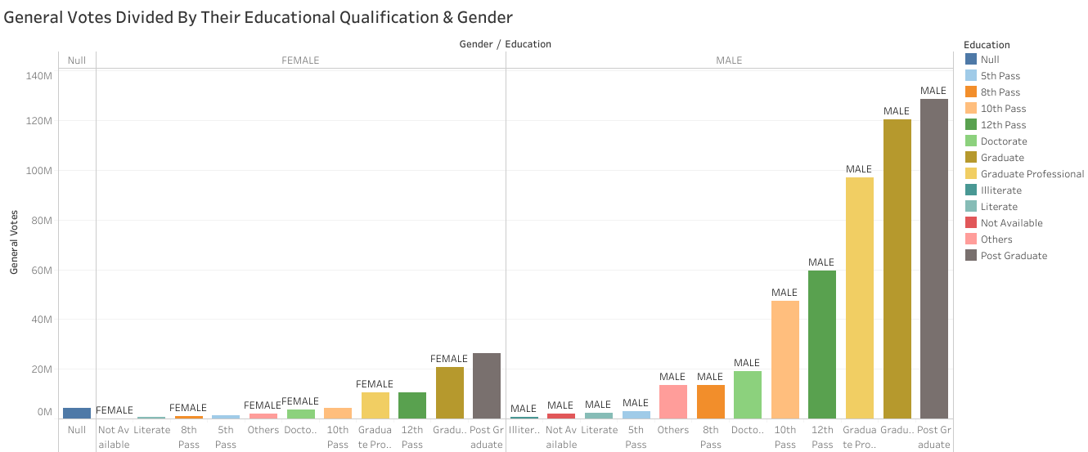

Activity8: Total Postal Votes & General Votes By State Wise

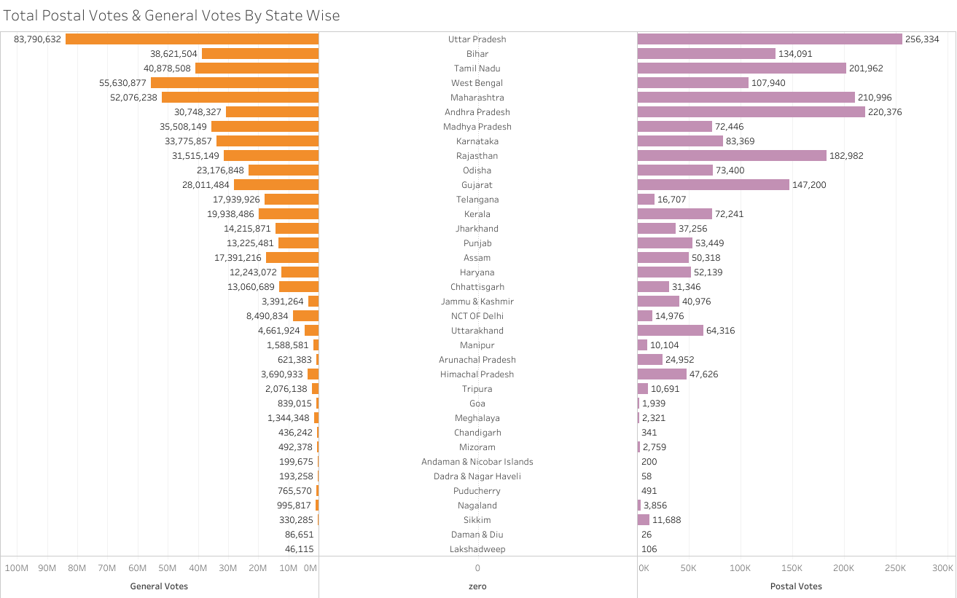

Activity9: Criminal Cases By State WIse

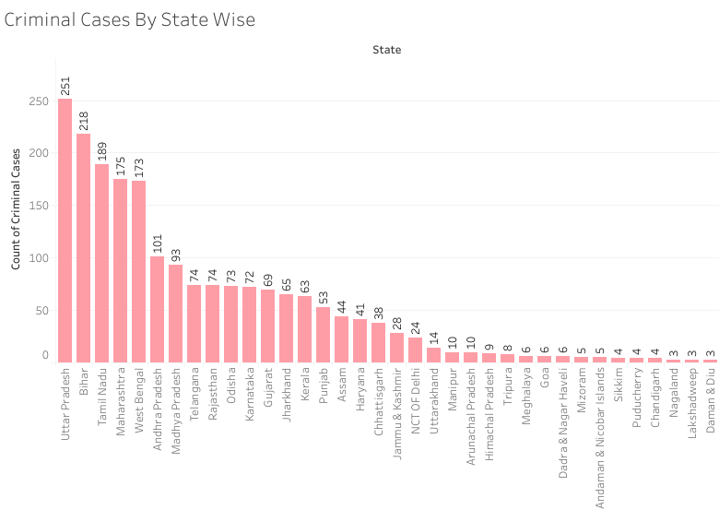

Activity10: Total Electors& Total Winners In Each Constituency

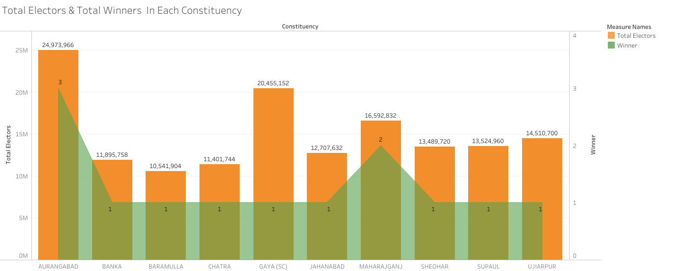

Activity11: Winners By Category & Educational Qualification

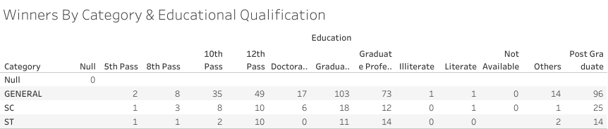

Activity12: Total Postal Votes In Each Party

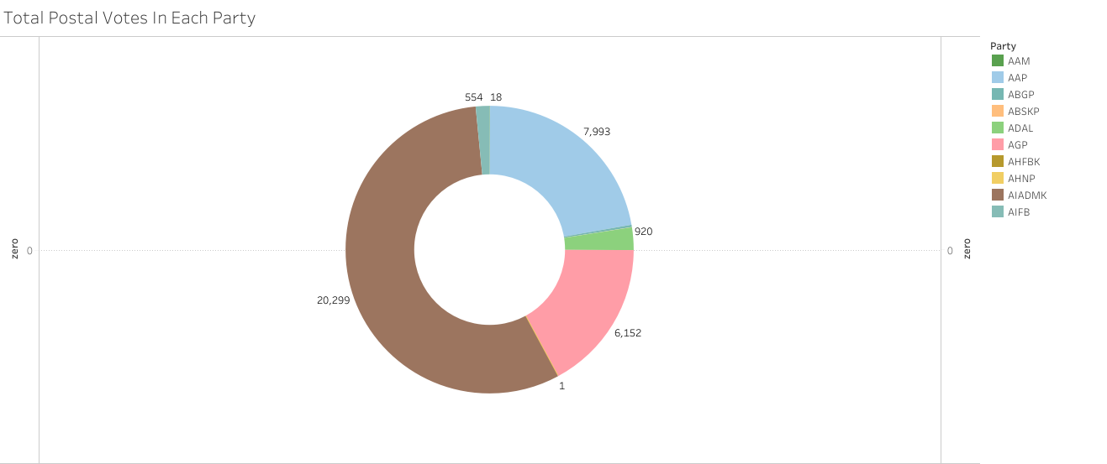

Dashboard: LOK SABHA ANALYSIS 2019

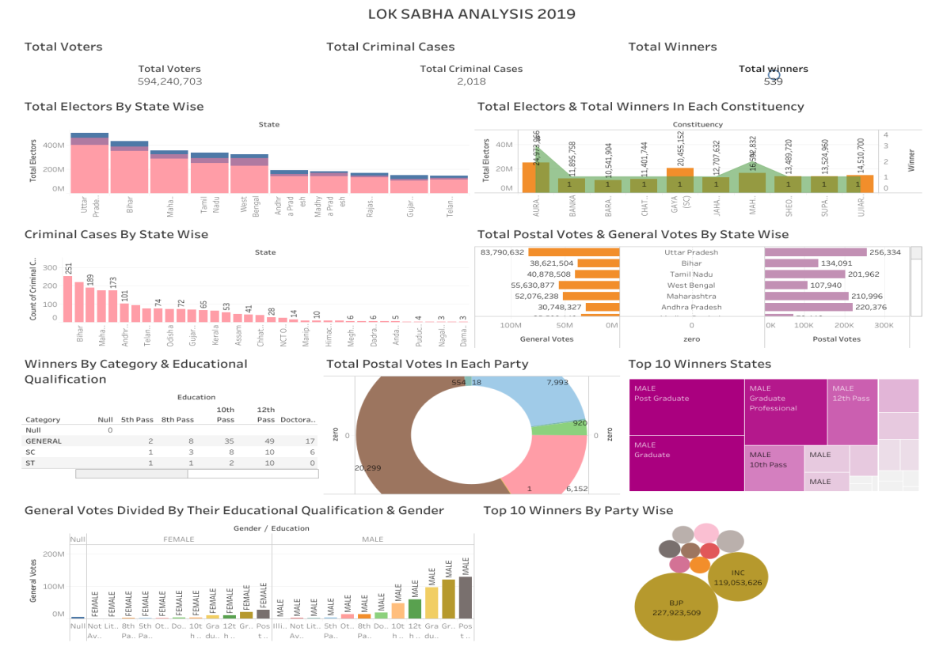

Story:

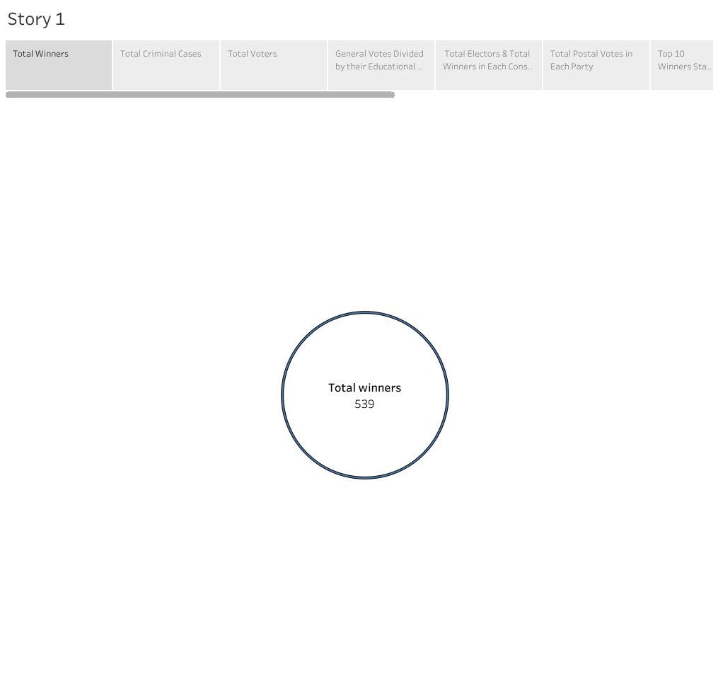

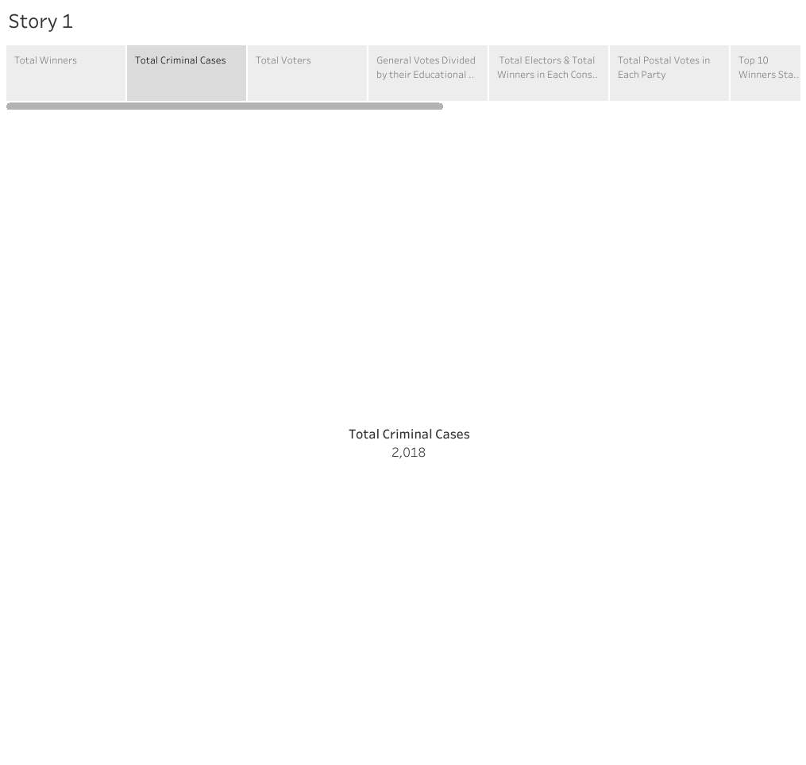

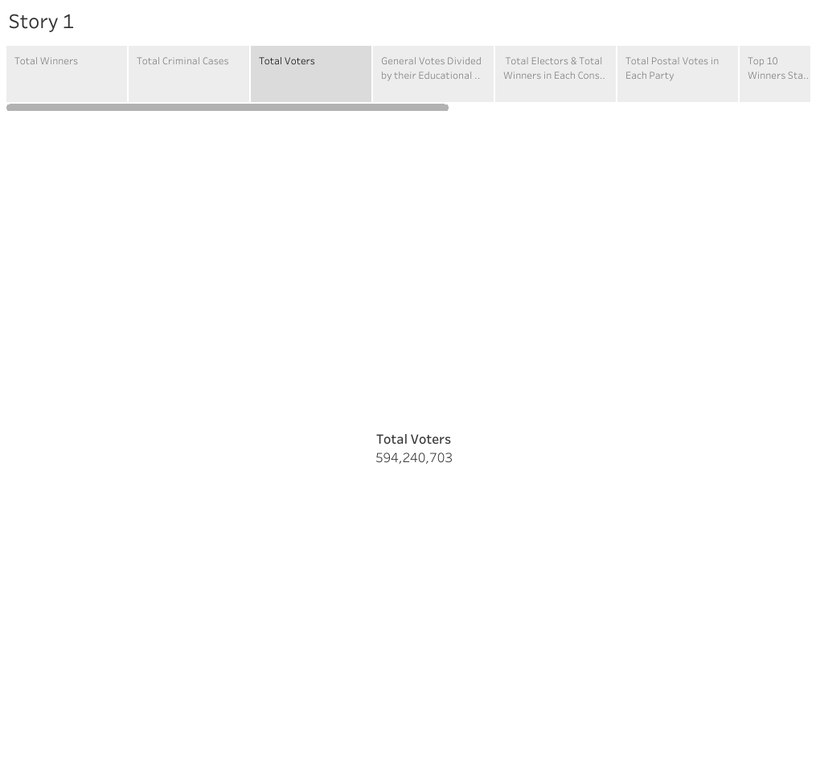

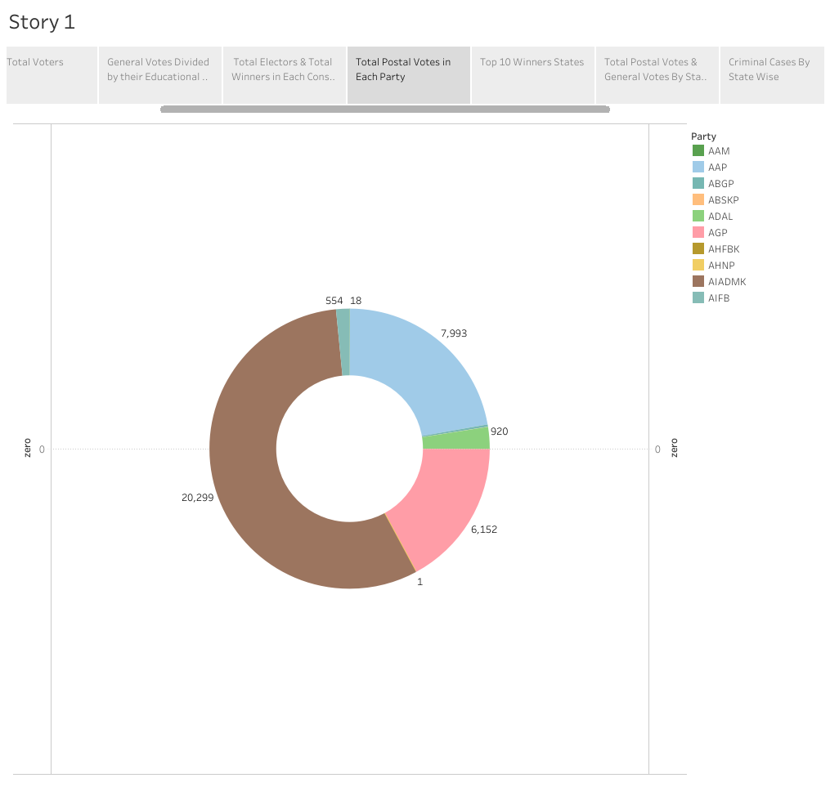

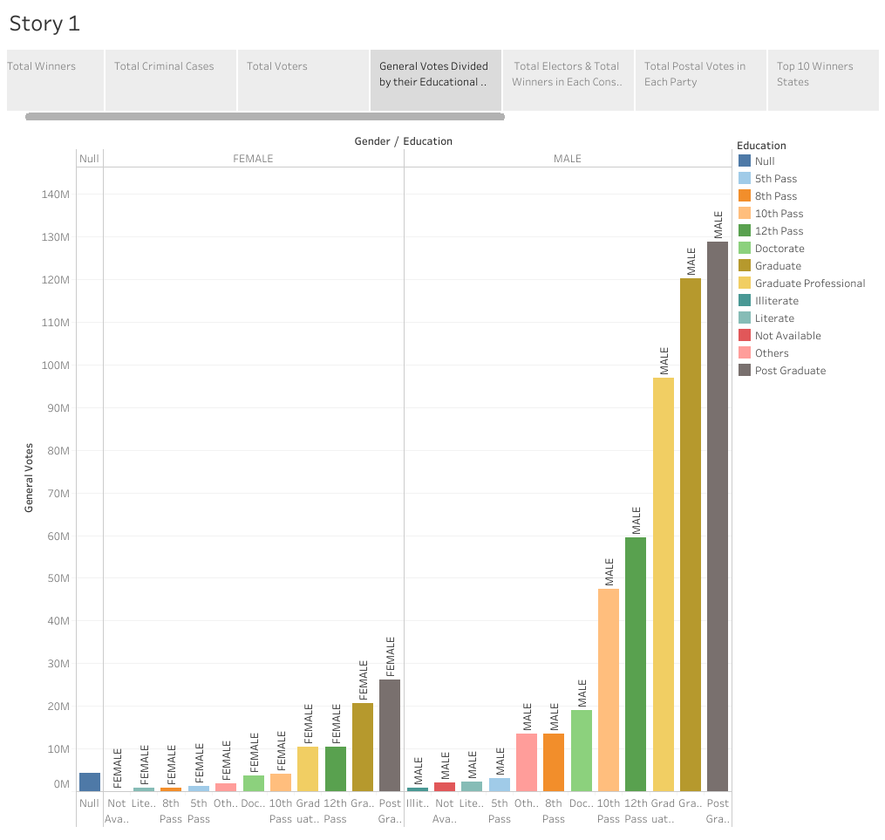

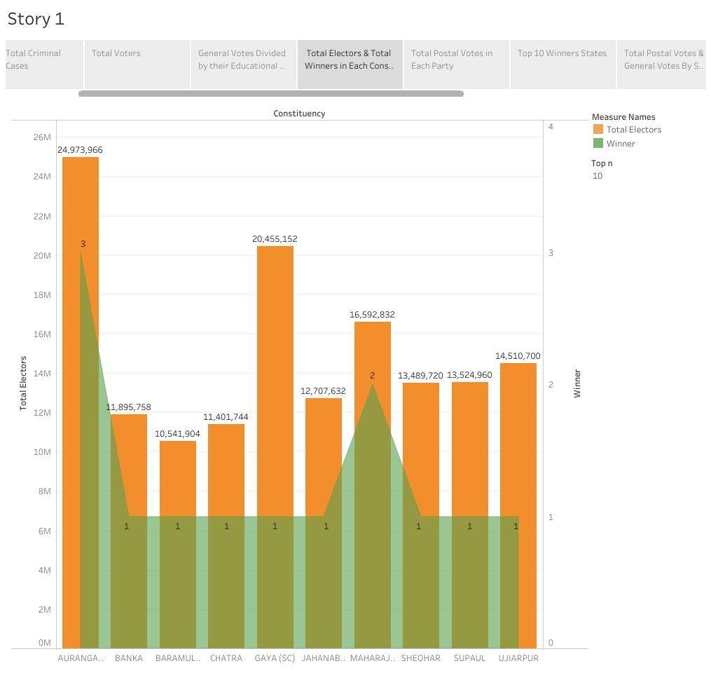

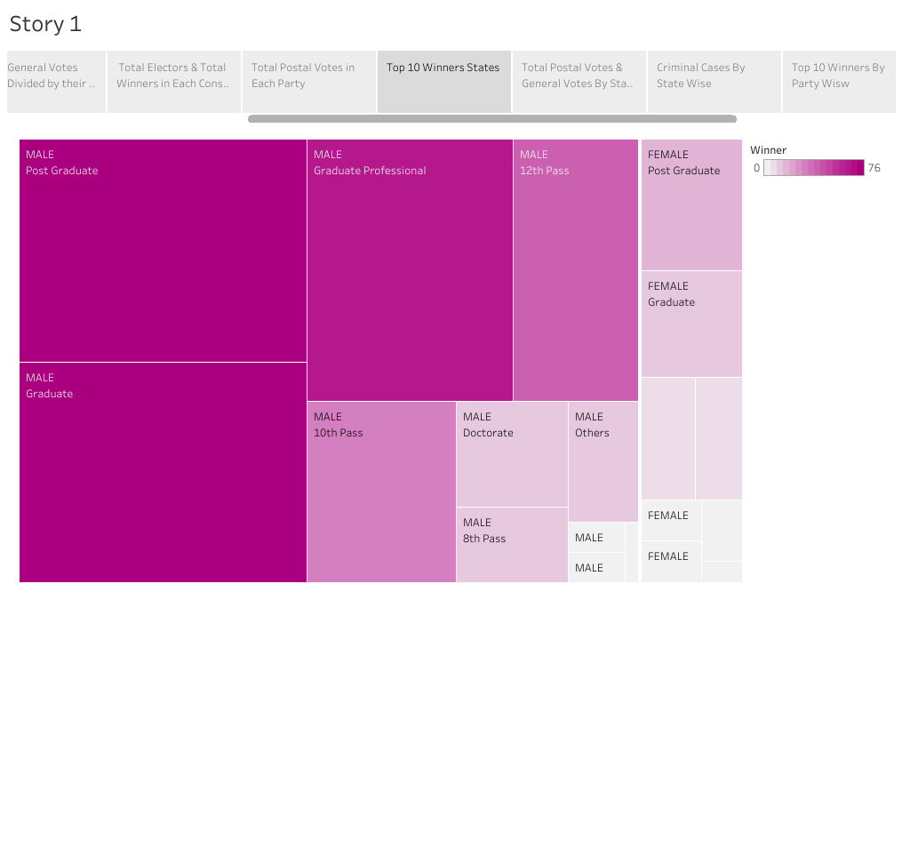

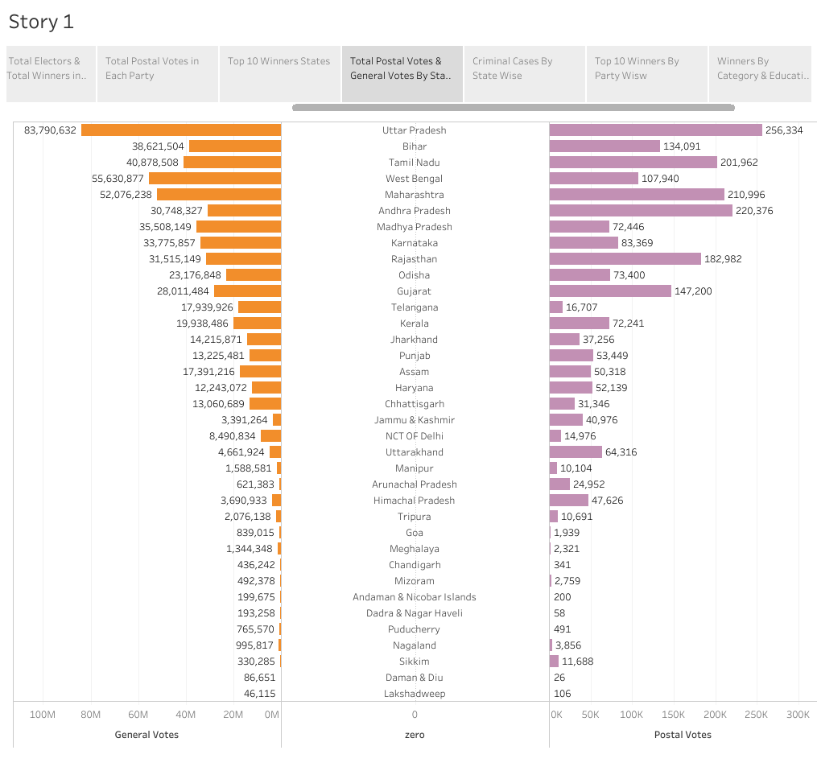

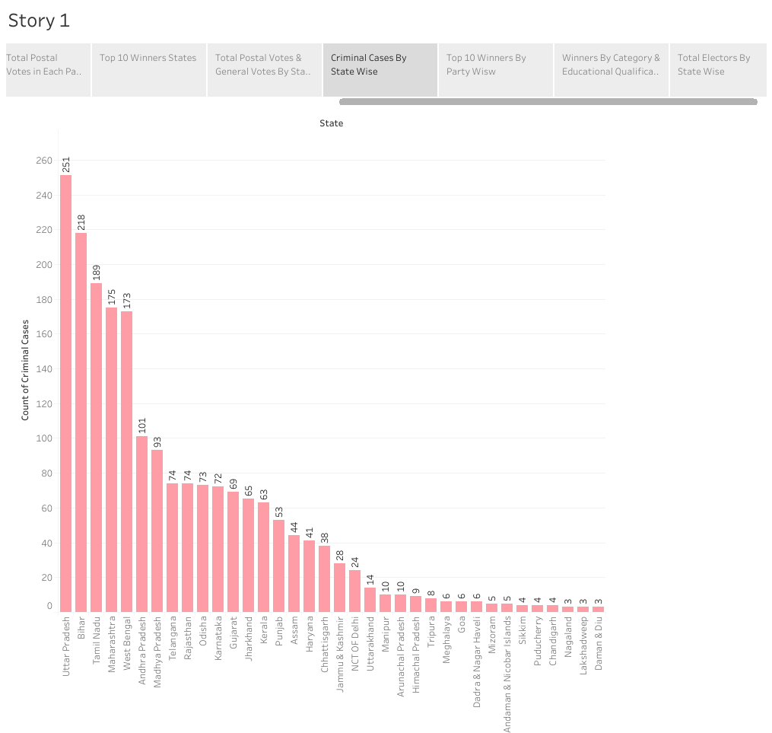

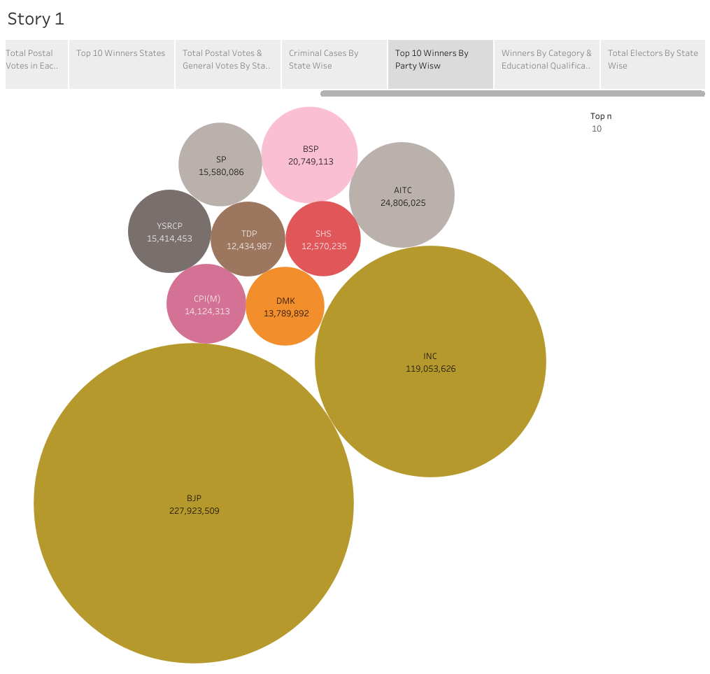

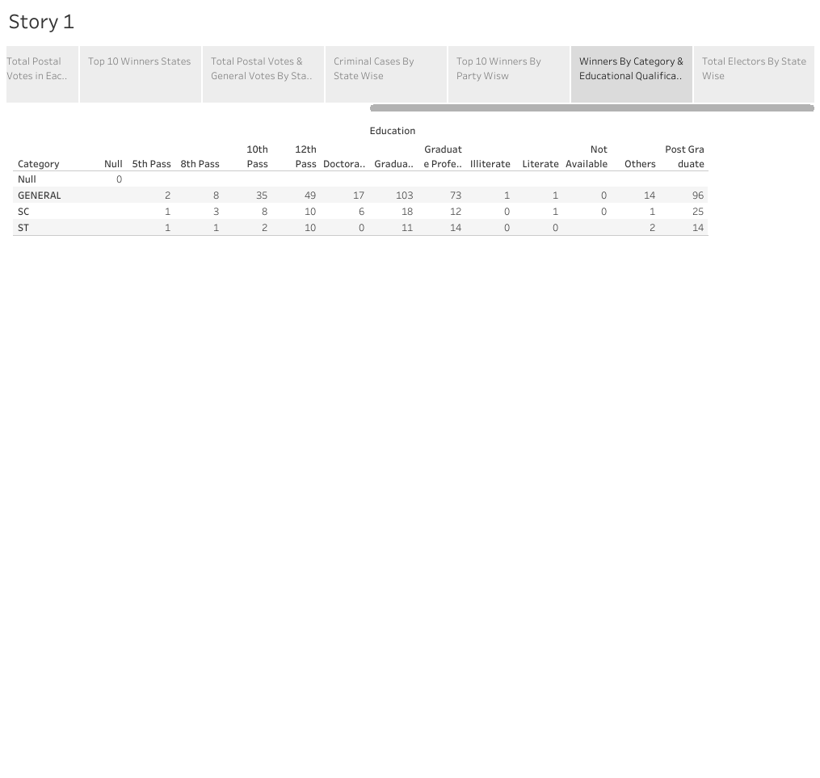

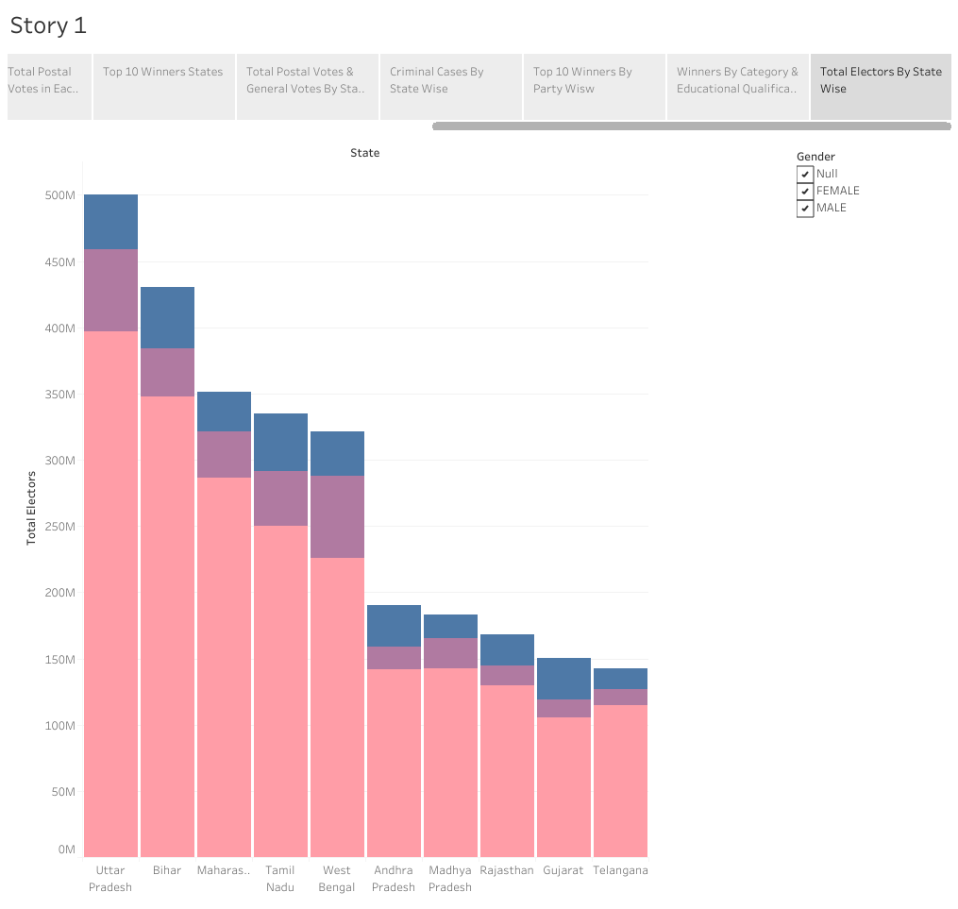

# 4 ADVANTAGES & DISADVANTAGES:

### The main advantage of this project is a party can analyze their strong places and can improve the loyalty of voters in other places. Also they can decide the candidates of each location based on their nature such as educational qualification, caste etc. by the visualizations we have created.

# 5 APPLICATIONS:

### It brings a Clarity to know what are the weak places and which type of votes supports which party and which Category votes support which Party. Model/Impact: By conducting an analysis the Party can identify areas for improvement and take steps to enhance the Votes, and increase voter satisfaction and loyalty. Improve its Party reputation, which can lead to increased Voter loyalty.

# 6 CONCLUSION:

In this project, we haveanalyzed the winners and total voters and electors and Postal Votes of LokSabha, and criminal Cases in Each State & Party. In which State There are more winners and which party got more seats and liabilities and assets of each state. For this Created KPI’s and interactive Visualizations and Dashboard and story Board to bring clean and deep understanding of the data.

# 7 FUTURE SCOPE:

### In future, a candidate can decide to choose a party and his suitable location by analyzing the data given in this project.