Development phase -1

# Machine Learning model deployment using IBM Cloud Watson Studio

## Product Recommendation System for E-commerce

The recommendation system I've designed is tailored to the customer journey of individuals who visit an e-commerce website, aiming to enhance their experience and boost customer acquisition and retention. This system is structured into three components to align with the specific needs of the business:

Part I: Popularity-Based Recommendation System for New Customers

When a new customer arrives on the website without any prior purchase history, they are initially presented with product recommendations based on the overall popularity of items. These recommendations help newcomers discover the most sought-after products available on the website.

Part II: Model-Based Collaborative Filtering System

Once the new customer makes their first purchase, the recommendation system transitions to a more personalized approach. It leverages collaborative filtering techniques, which take into account the customer's purchase history and incorporate ratings provided by other users who have bought similar items. This results in tailored product recommendations based on the customer's individual preferences and behavior.

Part III: Recommendations for Businesses Without Product Ratings

In scenarios where a business is setting up its e-commerce website and lacks product ratings, the recommendation system is capable of offering valuable suggestions based on alternative data points and customer behavior.

By dividing the recommendation system into these three parts, we ensure that it caters to the diverse needs of customers, whether they are newcomers or returning shoppers, and whether or not product ratings are available. This approach ultimately contributes to an improved customer experience and supports the business in acquiring and retaining customers effectively.

## Part I: Popularity-Based Recommendation System for New Customers

Utilizing a popularity-based strategy to engage new customers with the top-selling products on an e-commerce website is a highly effective approach, especially when launching a recommendation engine from scratch or dealing with limited data.

Dataset: Amazon Product Review Dataset

To implement this recommendation system, we begin by working with the Amazon product review dataset, a valuable source of information for product popularity and customer preferences.

**Data cleaning:**

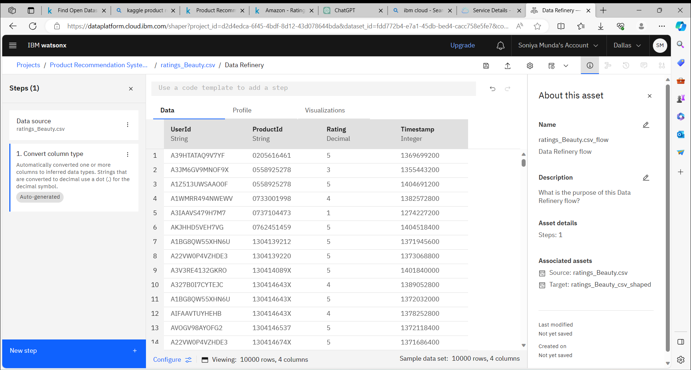

**Removing Duplicates:**

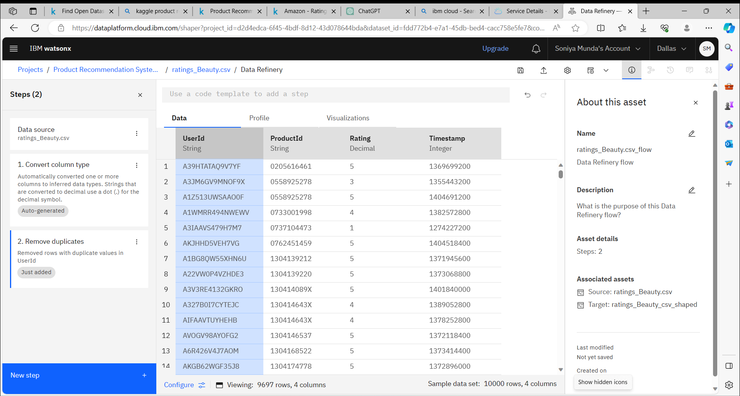

#### **Importing libraries:**

The first step involves importing the necessary libraries and tools to build and execute the recommendation system. This step ensures that we have the required resources at our disposal to work with the dataset and create meaningful recommendations.

import numpy as np

import pandas as pd

import matplotlib.pyplot as plt

# %matplotlib inline

plt.style.use("ggplot")

import sklearn

from sklearn.decomposition import TruncatedSVD

#### **Loading the dataset:**

amazon_ratings = pd.read_csv('r Desktop\archive\ratings_Beauty.csv')

amazon_ratings = amazon_ratings.dropna()

amazon_ratings.head()

UserId ProductId Rating Timestamp

0 A39HTATAQ9V7YF 0205616461 5.0 1369699200

1 A3JM6GV9MNOF9X 0558925278 3.0 1355443200

2 A1Z513UWSAAO0F 0558925278 5.0 1404691200

3 A1WMRR494NWEWV 0733001998 4.0 1382572800

4 A3IAAVS479H7M7 0737104473 1.0 1274227200

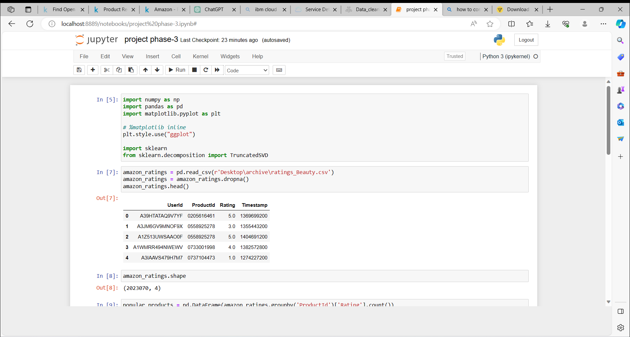

amazon_ratings.shape

(2023070, 4)

popular_products = pd.DataFrame(amazon_ratings.groupby('ProductId')['Rating'].count())

most_popular = popular_products.sort_values('Rating', ascending=False)

most_popular.head(10)

| ProductId | Rating |
| --- | --- |
| B001MA0QY2 | 7533 |
| B0009V1YR8 | 2869 |
| B0043OYFKU | 2477 |
| B0000YUXI0 | 2143 |
| B003V265QW | 2088 |
| B000ZMBSPE | 2041 |
| B003BQ6QXK | 1918 |
| B004OHQR1Q | 1885 |
| B00121UVU0 | 1838 |
| B000FS05VG | 1589 |

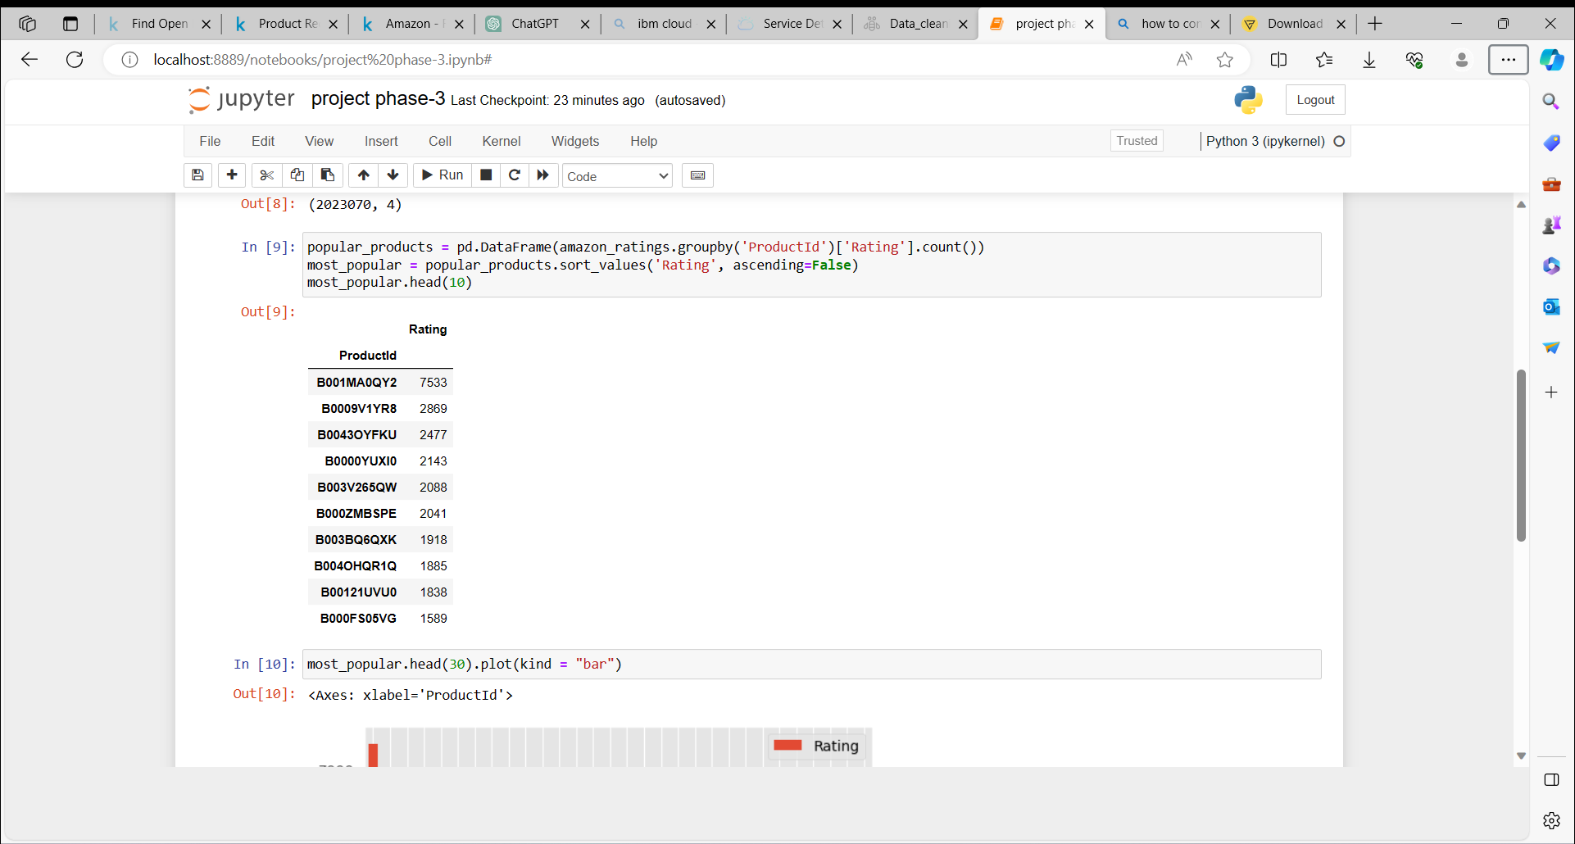

most_popular.head(30).plot(kind = "bar")

<matplotlib.axes._subplots.AxesSubplot at 0x7fd439e493c8>

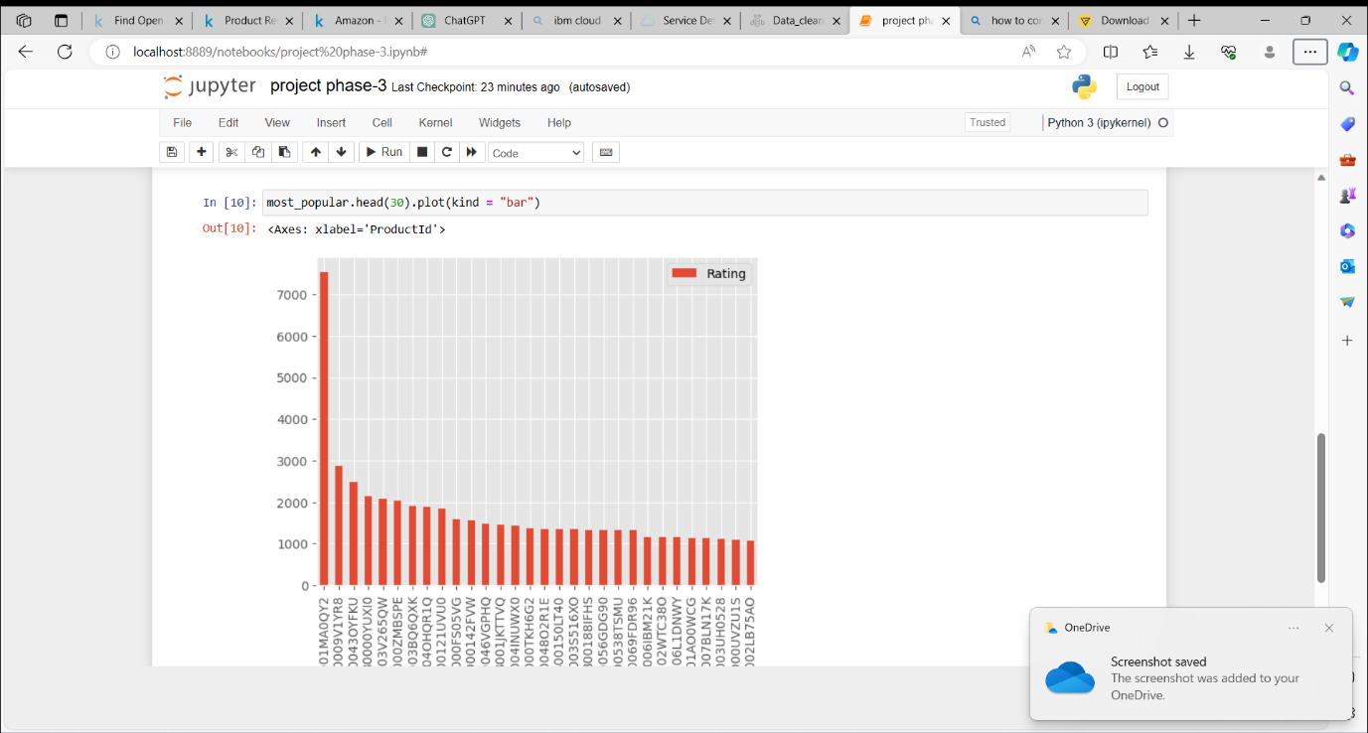

**Analysis:**

* The above graph gives us the most popular products (arranged in descending order) sold by the business.
* For eaxmple, product, ID # B001MA0QY2 has sales of over 7000, the next most popular product, ID # B0009V1YR8 has sales of 3000, etc.