Idea :

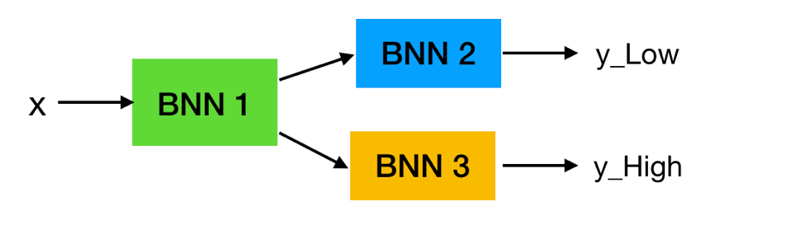

**Try 1:**

H =10, tanh activation

BNN1 : [H, H] (half of BNN 1 outputs go BNN2 and BNN3 respectively)

BNN2: [H, 1]

BNN3: [H, 1]

*ADVI result:*

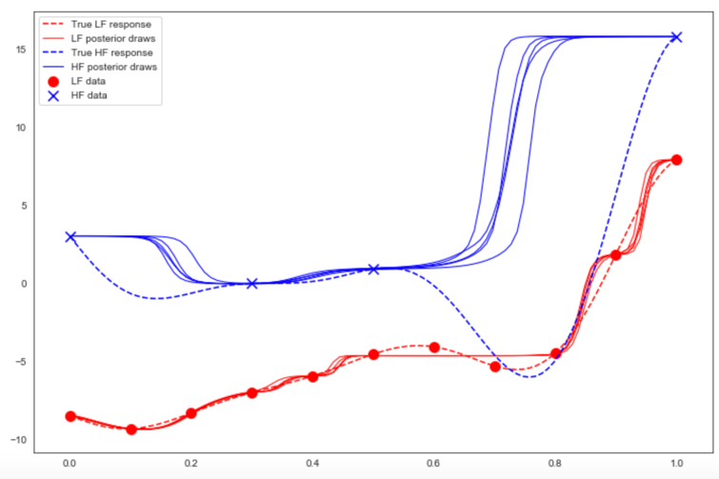

**Try 2:**

H =10, P = int(H/2), tanh activation

BNN1 : [H, H] (half of BNN 1 outputs go BNN2 and BNN3 respectively)

BNN2: [P, 1]

BNN3: [P, 1]

*ADVI result:*

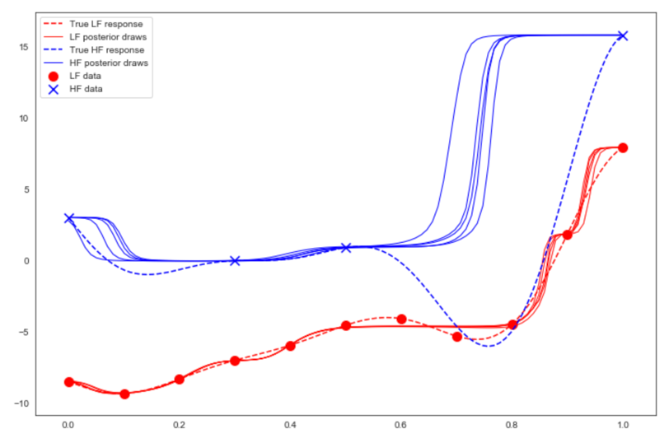

**Try 3:**

H =10, P = int(H/2), “swish” activation

BNN1 : [H, H] (half of BNN 1 outputs go BNN2 and BNN3 respectively)

BNN2: [P, 1]

BNN3: [P, 1]

*ADVI result:*

