System Design Document

Mirror

Version : 1.2
Date : 21-11-2015
Project : Mirror
Author : Usha Devi .K

Document Revisions

Date | Version | Description | Author | Approved By
30-10-2015 | 1.0 | Mirror – SDD | Usha Devi K | Dhanalakshmi SB
03-11-2015 | 1.1 | Mirror – SDD | Usha Devi K | Dhanalakshmi SB
21-11-2015 | 1.2 | Mirror – SDD | Usha Devi K | Dhanalakshmi SB

Index
1 Overview 4
2 Development Tools 4
3 System Process 6
3.1 Scope of the Project 6
4 System Design 6
4.1 Architecture Diagram 6
4.2 Data flow Diagram 7
5 Database Design 9
5.1 Schema Definition – Knowledge Database 9
5.2 Schema Definition – Client Database 16
5.3 Schema Diagram – Knowledge Database 22
5.4 Schema Diagram – Client Database 23

Overview
The project Mirror was designed and hosted for Aparajitha Corporate Services Private Limited. This web application is designed to manage the following modules. The indent of this project is to manage the below mentioned modules effectively, efficiently and improve the overall performance in order to moving forward the next level.
- Administrator Module
- Knowledge Team Module
- Techno Functional Team Module
- Client Module
- Service Provider Module
Proposed system of the Web application is the some of features, which are listed and explained below. Proposed system will be categorized by the seven kind of users. That user's are,
      - Admin
      - Knowledge Team Manager
      - Knowledge Team User
      - Techno Functional Team User
      - Client Admin
      - Client User
      - Service Provider

Development Tools
The following Technologies are to be used for developing Web Application for Mirror:
      - Python 2.7
      - Tornado Framework
      - jQuery
      - HTML
      - CSS
      - MySQL

System Process

Scope of the Project
The project was designed for Aparajitha Corporate Services Private Limited. From here on the database will be the storage of all the important data. This will provide the effective security to the system more over the ultimate user can be able to get back with any kind of highly usable reports which he/she would like to see. The system will help to input the specified data in a sequential manner.

System Design

Architecture Diagram
Access to this web system is possible using browsers with internet connection. For Android Mobile App/Tablet App, iPhone/iPad App, Blackberry 10 App, accessing will be made through the Apps for the respective platforms with internet connection.

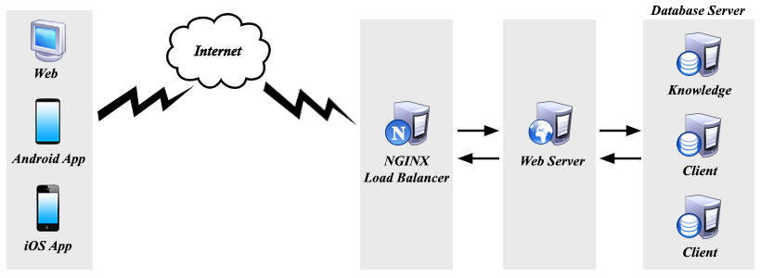

Data flow Diagram

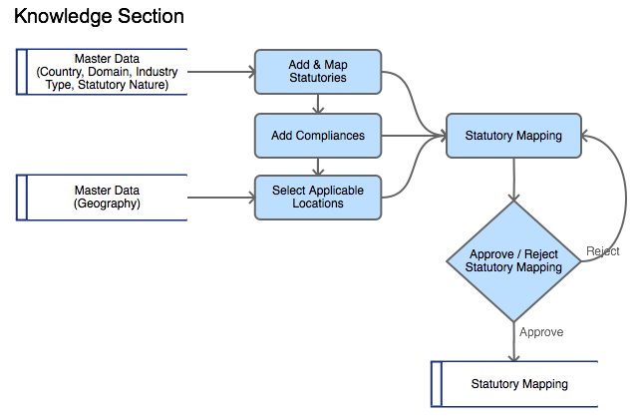

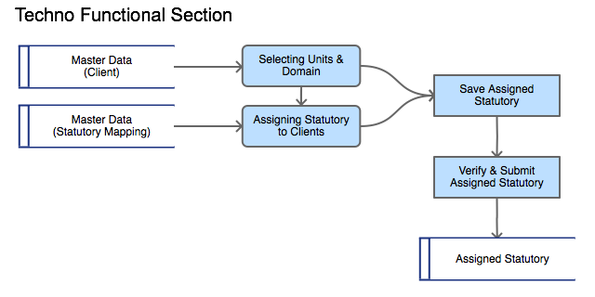

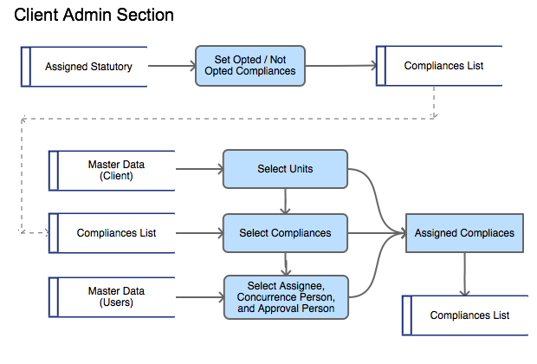

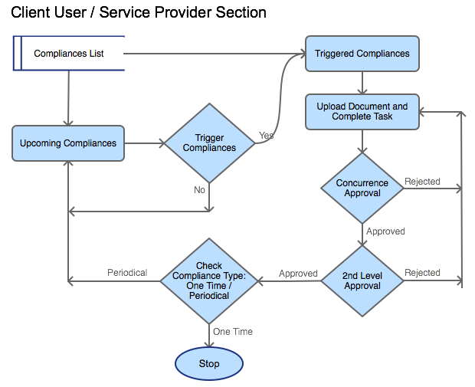

Database Design

Schema Definition – Knowledge Database
# | Table Name | Fields | Data type | Size | Default Value | Key | Reference
Forms
1 | tbl_forms | form_id | INT | 11 |  | PK
1 | tbl_forms | form_name | VARCHAR | 50
1 | tbl_forms | form_url | VARCHAR | 50
1 | tbl_forms | form_order | VARCHAR | 50
1 | tbl_forms | form_type | VARCHAR | 20 |  |  | (It/Knowledge/Techno/Client/Serviceprovider)
1 | tbl_forms | category | VARCHAR | 20 |  |  | (Masters/Transactions/Reports/ Settings)
1 | tbl_forms | admin_form | TINYINT | 1
1 | tbl_forms | parent_menu | VARCHAR | 50
User Groups
2 | tbl_user_groups | user_group_id | INT | 11 |  | PK
2 | tbl_user_groups | user_group_name | VARCHAR | 50
2 | tbl_user_groups | form_type | VARCHAR | 20 |  |  | (It/ Knowledge/Techno/Client/Serviceprovider)
2 | tbl_user_groups | form_ids | VARCHAR | 250 |  |  | Multiple form_ids concatenated with “,”
2 | tbl_user_groups | is_active | TINYINT | 1 | 1
2 | tbl_user_groups | created_by | INT | 11
2 | tbl_user_groups | created_on | TIMESTAMP
2 | tbl_user_groups | updated_by | INT | 11
2 | tbl_user_groups | updated_on | TIMESTAMP
Users
3 | tbl_users | user_id | INT | 11 |  | PK
3 | tbl_users | username | VARCHAR | 100
3 | tbl_users | password | VARCHAR | 50
3 | tbl_users | client_id | INT | 11
3 | tbl_users | is_active | TINYINT | 1 | 1
3 | tbl_users | created_by | INT | 11
3 | tbl_users | created_on | TIMESTAMP
3 | tbl_users | updated_by | INT | 11
3 | tbl_users | updated_on | TIMESTAMP
User Details
4 | tbl_user_details | user _id | INT | 11 |  | FK | tbl_users
4 | tbl_user_details | email_id | VARCHAR | 100
4 | tbl_user_details | user_group_id | INT | 11 |  | FK | tbl_user_groups
4 | tbl_user_details | form_type | VARCHAR | 20 |  |  | (It/Knowledge/Techno/Client/Serviceprovider)
4 | tbl_user_details | employee_name | VARCHAR | 50
4 | tbl_user_details | employee_code | VARCHAR | 50
4 | tbl_user_details | contact_no | INT | 11
4 | tbl_user_details | address | VARCHAR | 250
4 | tbl_user_details | designation | VARCHAR | 50
4 | tbl_user_details | domain_ids | VARCHAR | 50 |  |  | Multiple domain_ids concatenated with “,”
4 | tbl_user_details | country_ids | VARCHAR | 50 |  |  | Multiple country_ids concatenated with “,”
4 | tbl_user_details | client_ids | VARCHAR | 50 |  |  | Multiple client_ids concatenated with “,”
4 | tbl_user_details | created_by | INT | 11
4 | tbl_user_details | created_on | TIMESTAMP
4 | tbl_user_details | updated_by | INT | 11
4 | tbl_user_details | updated_on | TIMESTAMP
User Sessions
5 | tbl_user_sessions | session_id | VARCHAR | 50 |  | PK
5 | tbl_user_sessions | user_id | INT | 11 |  | FK | tbl_users
5 | tbl_user_sessions | login_time | TIMESTAMP
Countries
6 | tbl_countries | country_id | INT | 11 |  | PK
6 | tbl_countries | country_name | VARCHAR | 50
6 | tbl_countries | is_active | TINYINT | 1 | 1
6 | tbl_countries | created_by | INT | 11
6 | tbl_countries | created_on | TIMESTAMP
6 | tbl_countries | updated_by | INT | 11
6 | tbl_countries | updated_on | TIMESTAMP
Domains
7 | tbl_domains | domain_id | INT | 11 |  | PK
7 | tbl_domains | domain_name | VARCHAR | 50
7 | tbl_domains | is_active | TINYINT | 1 | 1
7 | tbl_domains | created_by | INT | 11
7 | tbl_domains | created_on | TIMESTAMP
7 | tbl_domains | updated_by | INT | 11
7 | tbl_domains | updated_on | TIMESTAMP
Industries
8 | tbl_industries | industry_id | INT | 11 |  | PK
8 | tbl_industries | industry_name | VARCHAR | 50
8 | tbl_industries | is_active | TINYINT | 1 | 1
8 | tbl_industries | created_by | INT | 11
8 | tbl_industries | created_on | TIMESTAMP
8 | tbl_industries | updated_by | INT | 11
8 | tbl_industries | updated_on | TIMESTAMP
Statutory Natures
9 | tbl_statutory_natures | statutory_nature_id | INT | 11 |  | PK
9 | tbl_statutory_natures | statutory_nature_name | VARCHAR | 50
9 | tbl_statutory_natures | is_active | TINYINT | 1 | 1
9 | tbl_statutory_natures | created_by | INT | 11
9 | tbl_statutory_natures | created_on | TIMESTAMP
9 | tbl_statutory_natures | updated_by | INT | 11
9 | tbl_statutory_natures | updated_on | TIMESTAMP
Statutory Levels
10 | tbl_statutory_levels | level_id | INT | 11 |  | PK
10 | tbl_statutory_levels | level_position | INT | 11 |  |  | 1-10
10 | tbl_statutory_levels | level_name | VARCHAR | 50
10 | tbl_statutory_levels | country_id | INT | 11 |  | FK | tbl_countries
10 | tbl_statutory_levels | domain_id | INT | 11 |  | FK | tbl_domains
10 | tbl_statutory_levels | is_active | TINYINT | 1 | 1
10 | tbl_statutory_levels | created_by | INT | 11
10 | tbl_statutory_levels | created_on | TIMESTAMP
10 | tbl_statutory_levels | updated_by | INT | 11
10 | tbl_statutory_levels | updated_on | TIMESTAMP
Geography Levels
11 | tbl_geography_levels | level_id | INT | 11 |  | PK
11 | tbl_geography_levels | level_position | INT | 11 |  |  | 1-10
11 | tbl_geography_levels | level_name | VARCHAR | 50
11 | tbl_geography_levels | country_id | INT | 11 |  | FK | tbl_countries
11 | tbl_geography_levels | is_active | TINYINT | 1 | 1
11 | tbl_geography_levels | created_by | INT | 11
11 | tbl_geography_levels | created_on | TIMESTAMP
11 | tbl_geography_levels | updated_by | INT | 11
11 | tbl_geography_levels | updated_on | TIMESTAMP
Geographies
12 | tbl_geographies | geography_id | INT | 11 |  | PK
12 | tbl_geographies | geography_name | VARCHAR | 50
12 | tbl_geographies | level_id | INT | 11 |  | FK | tbl_geography_levels
12 | tbl_geographies | parent_ids | VARCHAR | 50 |  |  | Multiple geography_ids concatenated with ","
12 | tbl_geographies | is_active | TINYINT | 1 | 1
12 | tbl_geographies | created_by | INT | 11
12 | tbl_geographies | created_on | TIMESTAMP
12 | tbl_geographies | updated_by | INT | 11
12 | tbl_geographies | updated_on | TIMESTAMP
Statutory Mappings
13 | tbl_statutory_mappings | statutory_mapping_id | INT | 11 |  | PK
13 | tbl_statutory_mappings | country_id | INT | 11 |  | FK | tbl_countries
13 | tbl_statutory_mappings | domain_id | INT | 11 |  | FK | tbl_domains
13 | tbl_statutory_mappings | industry_id | INT | 11 |  | FK | tbl_industries
13 | tbl_statutory_mappings | statutory_nature_id | INT | 11 |  | FK | tbl_statutory_natures
13 | tbl_statutory_mappings | approval_status | TINYINT | 2 | 0
13 | tbl_statutory_mappings | is_active | TINYINT | 1 | 1
13 | tbl_statutory_mappings | created_by | INT | 11
13 | tbl_statutory_mappings | created_on | TIMESTAMP
13 | tbl_statutory_mappings | updated_by | INT | 11
13 | tbl_statutory_mappings | updated_on | TIMESTAMP
Statutories
14 | tbl_statutories | statutory_id | INT | 11 |  | PK
14 | tbl_statutories | statutory_name | VARCHAR | 50
14 | tbl_statutories | level_id | INT | 11 |  | FK | tbl_statutory_levels
14 | tbl_statutories | parent_ids | VARCHAR | 50 |  |  | Multiple statutory_ids concatinated with ","
14 | tbl_statutories | is_active | TINYINT | 1 | 1
14 | tbl_statutories | statutory_mapping_id | INT | 11 |  | FK | tbl_statutory_mappings
14 | tbl_statutories | created_by | INT | 11
14 | tbl_statutories | created_on | TIMESTAMP
14 | tbl_statutories | updated_by | INT | 11
14 | tbl_statutories | updated_on | TIMESTAMP
Compliances
15 | tbl_compliances | compliance_id | INT | 11
15 | tbl_compliances | statutory_provision | VARCHAR | 250
15 | tbl_compliances | compliance_task | VARCHAR | 100
15 | tbl_compliances | compliance_description | LONGTEXT
15 | tbl_compliances | document_name | VARCHAR | 100
15 | tbl_compliances | format_file | VARCHAR | 100
15 | tbl_compliances | penal_consequences | LONGTEXT
15 | tbl_compliances | compliance_frequency | VARCHAR | 20 |  |  | (OneTime /Periodical/ Review/ OnOccurrence)
15 | tbl_compliances | statutory_dates | LONGTEXT |  |  |  | json-string: list of dictionaries with keys statutory_date, statutory_month, trigger_before_days
15 | tbl_compliances | repeats_every | INT | 11
15 | tbl_compliances | repeats_type | VARCHAR | 20 |  |  | (Yearly/Monthly/Days)
15 | tbl_compliances | duration | INT | 11 | 1
15 | tbl_compliances | duration_type | VARCHAR | 20 |  |  | (Hours/Days)
15 | tbl_compliances | statutory_mapping_id | INT | 11 |  | FK | tbl_statutory_mappings
15 | tbl_compliances | is_active | TINYINT | 1 | 1
15 | tbl_compliances | created_by | INT | 11
15 | tbl_compliances | created_on | TIMESTAMP
15 | tbl_compliances | updated_by | INT | 11
15 | tbl_compliances | updated_on | TIMESTAMP
Statutory Mappings – Applicable Location
16 | tbl_statutory_geographies | statutory_mapping_id | INT | 11
16 | tbl_statutory_geographies | geography_id | INT | 11 |  | FK | tbl_geographies
Statutories Backup
17 | tbl_statutories_backup | statutory_backup_id | INT | 11 |  | PK
17 | tbl_statutories_backup | country_name | VARCHAR | 50
17 | tbl_statutories_backup | domain_name | VARCHAR | 50
17 | tbl_statutories_backup | industry_name | VARCHAR | 50
17 | tbl_statutories_backup | statutory_nature | VARCHAR | 50
17 | tbl_statutories_backup | statutory_provision | VARCHAR | 500
17 | tbl_statutories_backup | applicable_location | VARCHAR | 500
Compliances Backup
18 | tbl_compliances_backup | statutory_backup_id | INT | 11 |  | FK | tbl_statutories_backup
18 | tbl_compliances_backup | statutory_provision | VARCHAR | 250
18 | tbl_compliances_backup | compliance_task | VARCHAR | 100
18 | tbl_compliances_backup | compliance_description | LONGTEXT
18 | tbl_compliances_backup | document_name | VARCHAR | 100
18 | tbl_compliances_backup | format_file | VARCHAR | 100
18 | tbl_compliances_backup | penal_consequences | LONGTEXT
18 | tbl_compliances_backup | compliance_frequency | VARCHAR | 20 |  |  | (OneTime / Periodical/ Review/ OnOccurrence)
18 | tbl_compliances_backup | statutory_dates | LONGTEXT |  |  |  | json-string: list of dictionaries with keys statutory_date, statutory_month, trigger_before_days
18 | tbl_compliances_backup | repeats_every | INT | 11
18 | tbl_compliances_backup | repeats_type | VARCHAR | 20 |  |  | (Yearly/ Monthly/ Days)
18 | tbl_compliances_backup | duration | INT | 11 | 1
18 | tbl_compliances_backup | duration_type | VARCHAR | 20 |  |  | (Hours/ Days)
Client Groups
19 | tbl_client_groups | client_id | INT | 11
19 | tbl_client_groups | group_name | VARCHAR | 50
19 | tbl_client_groups | incharge_persons | VARCHAR | 50 |  |  | Multiple user_ids concatenated with ‘,’
19 | tbl_client_groups | created_by | INT | 11
19 | tbl_client_groups | created_on | TIMESTAMP
19 | tbl_client_groups | updated_by | INT | 11
19 | tbl_client_groups | updated_on | TIMESTAMP
Units
20 | tbl_units | unit_id | INT | 11 |  | PK
20 | tbl_units | country_id | INT | 11 |  | FK | tbl_countries
20 | tbl_units | geography_id | INT | 11 |  | FK | tbl_geographies
20 | tbl_units | unit_code | VARCHAR | 50
20 | tbl_units | unit_name | VARCHAR | 50
20 | tbl_units | industry_id | INT | 11 |  | FK | tbl_industries
20 | tbl_units | is_active | TINYINT | 1 | 1
20 | tbl_units | created_by | INT | 11
20 | tbl_units | created_on | TIMESTAMP
20 | tbl_units | updated_by | INT | 11
20 | tbl_units | updated_on | TIMESTAMP
Statutory Notifications Log
21 | tbl_statutory_notifications | statutory_notification_id | INT | 11 |  | PK
21 | tbl_statutory_notifications | statutory_backup_id | INT | 11 |  | FK | tbl_statutories_backup
21 | tbl_statutory_notifications | country_name | VARCHAR | 50
21 | tbl_statutory_notifications | domain_name | VARCHAR | 50
21 | tbl_statutory_notifications | industry_name | VARCHAR | 50
21 | tbl_statutory_notifications | statutory_nature | VARCHAR | 50
21 | tbl_statutory_notifications | statutory_provision | LONGTEXT
21 | tbl_statutory_notifications | applicable_location | LONGTEXT
21 | tbl_statutory_notifications | notification_text | LONGTEXT
21 | tbl_statutory_notifications | updated_on | TIMESTAMP
Statutory Notification units
22 | tbl_statutory_notification_units | statutory_notification_id | INT | 11 |  | PK
22 | tbl_statutory_notification_units | client_id | INT | 11 |  | FK | tbl_client_groups
22 | tbl_statutory_notification_units | business_group_id | INT | 11
22 | tbl_statutory_notification_units | legal_entity_id | INT | 11
22 | tbl_statutory_notification_units | division_id | INT | 11
22 | tbl_statutory_notification_units | unit_id | INT | 11
Statutory Notification Status
23 | tbl_statutory_notification_status | statutory_notification_id | INT | 11 |  | FK | tbl_statutory_notification_units
23 | tbl_statutory_notification_status | user_id | INT | 11 |  | FK | tbl_users
23 | tbl_statutory_notification_status | read_status | TINYINT | 1 | 0 |  | 0 - Unread, 1 - Read
Activity Log
24 | tbl_activity_log | activity_log_id | INT | 11 |  | PK
24 | tbl_activity_log | user_id | INT | 11 |  | FK | tbl_users
24 | tbl_activity_log | form_id | INT | 11 |  | FK | tbl_forms
24 | tbl_activity_log | action | VARCHAR | 500
24 | tbl_activity_log | ticker_text | VARCHAR | 500
24 | tbl_activity_log | ticker_link | VARCHAR | 100 |  |  | (optional)
24 | tbl_activity_log | created_on | TIMESTAMP
Activity Log Ticker Status
25 | tbl_activity_log_ticker_status | activity_log_id | INT | 11 |  | FK | tbl_activity_log
25 | tbl_activity_log_ticker_status | user_id | INT | 11 |  | FK | tbl_users
25 | tbl_activity_log_ticker_status | read_status | TINYINT | 1 | 0 |  | 0 - Unread, 1 - Read
Client Saved Statutories
26 | tbl_client_saved_statutories | client_id | INT | 11 |  | FK | tbl_client_groups
26 | tbl_client_saved_statutories | client_saved_statutory_id | INT | 11 |  | PK
26 | tbl_client_saved_statutories | country_id | INT | 11 |  | FK | tbl_countries
26 | tbl_client_saved_statutories | domain_id | INT | 11 |  | FK | tbl_domains
26 | tbl_client_saved_statutories | unit_ids | VARCHAR | 250 |  |  | Multiple unit_ids concatinated with ","
26 | tbl_client_saved_statutories | client_compliance_id | INT | 11 |  | PK
26 | tbl_client_saved_statutories | geography_id | INT | 11 |  | FK | tbl_geographies
26 | tbl_client_saved_statutories | created_by | INT | 11
26 | tbl_client_saved_statutories | created_on | TIMESTAMP
26 | tbl_client_saved_statutories | updated_by | INT | 11
26 | tbl_client_saved_statutories | updated_on | TIMESTAMP
Client Statutories
27 | tbl_client_statutories | client_id | INT | 11 |  | FK | tbl_client_groups
27 | tbl_client_statutories | client_assigned_statutory_id | INT | 11 |  | PK
27 | tbl_client_statutories | country_id | INT | 11 |  | FK | tbl_countries
27 | tbl_client_statutories | domain_id | INT | 11 |  | FK | tbl_domains
27 | tbl_client_statutories | unit_id | INT | 11
27 | tbl_client_statutories | client_compliance_id | INT | 11 |  | PK
27 | tbl_client_statutories | geography_id | INT | 11 |  | FK | tbl_geographies
27 | tbl_client_statutories | created_by | INT | 11
27 | tbl_client_statutories | created_on | TIMESTAMP
27 | tbl_client_statutories | updated_by | INT | 11
27 | tbl_client_statutories | updated_on | TIMESTAMP
Client Compliances
28 | tbl_client_compliances | client_compliance_id | INT | 11
28 | tbl_client_compliances | statutory_id | INT | 11 |  | FK | (only ACT - 1st level) tbl_statutories
28 | tbl_client_compliances | applicable | TINYINT | 1
28 | tbl_client_compliances | not_applicable_remarks | VARCHAR | 250
28 | tbl_client_compliances | compliance_id | INT | 11
28 | tbl_client_compliances | compliance_applicable | TINYINT | 1
28 | tbl_client_compliances | compliance_opted | TINYINT | 1
28 | tbl_client_compliances | compliance_remarks | VARCHAR | 250
28 | tbl_client_compliances | created_by | INT | 11
28 | tbl_client_compliances | created_on | TIMESTAMP
28 | tbl_client_compliances | updated_by | INT | 11
28 | tbl_client_compliances | updated_on | TIMESTAMP

Schema Definition – Client Database
# | Table Name | Fields | Data type | Size | Default Value | Key | Reference
Countries
1 | tbl_countries | country_id | INT | 11 |  | PK
1 | tbl_countries | country_name | VARCHAR | 50
1 | tbl_countries | is_active | TINYINT | 1 | 1
Domains
2 | tbl_domains | domain_id | INT | 11 |  | PK
2 | tbl_domains | domain_name | VARCHAR | 50
2 | tbl_domains | is_active | TINYINT | 1 | 1
Compliances
3 | tbl_compliances | compliance_id | INT | 11
3 | tbl_compliances | statutory_mapping | VARCHAR | 500
3 | tbl_compliances | statutory_provision | VARCHAR | 250
3 | tbl_compliances | compliance_task | VARCHAR | 100
3 | tbl_compliances | compliance_description | LONGTEXT
3 | tbl_compliances | document_name | VARCHAR | 100
3 | tbl_compliances | format_file | VARCHAR | 100
3 | tbl_compliances | penal_consequences | LONGTEXT
3 | tbl_compliances | compliance_frequency | VARCHAR | 100 |  |  | (OneTime / Periodical/ Review/ OnOccurrence)
3 | tbl_compliances | statutory_dates | LONGTEXT |  |  |  | json-string: list of dictionaries with keys statutory_date, statutory_month, trigger_before_days
3 | tbl_compliances | repeats_every | INT | 11
3 | tbl_compliances | repeats_type | VARCHAR | 20 |  |  | (Yearly/ Monthly/ Days)
3 | tbl_compliances | duration | INT | 11 | 1
3 | tbl_compliances | duration_type | VARCHAR | 20 |  |  | (Hours/ Days)
3 | tbl_compliances | is_active | TINYINT | 1 | 1
3 | tbl_compliances | updated_on | TIMESTAMP
Client Settings
4 | tbl_client_settings | domain_ids |  | 250 |  |  | Multiple domain_id concatenated with “,”
4 | tbl_client_settings | logo_url | VARCHAR | 200
4 | tbl_client_settings | contract_from | DATE
4 | tbl_client_settings | contract_to | DATE
4 | tbl_client_settings | no_of_user_licence | INT | 11
4 | tbl_client_settings | total_disk_space | INT | 11
4 | tbl_client_settings | is_sms_subscribed | TINYINT | 1 | 0
4 | tbl_client_settings | two_levels_of_approval | TINYINT | 1
4 | tbl_client_settings | assignee_reminder | INT | 11
4 | tbl_client_settings | escalation_reminder_In_advance | INT | 11
4 | tbl_client_settings | escalation_reminder | INT | 11
Client Configurations
5 | tbl_client_configurations | country_id | INT | 11 |  | FK | tbl_countries
5 | tbl_client_configurations | domain_id | INT | 11 |  | FK | tbl_domains
5 | tbl_client_configurations | period_from | INT | 11 |  |  | (1-12)
5 | tbl_client_configurations | period_to | INT | 11 |  |  | (1-12)
5 | tbl_client_configurations | updated_by | INT
5 | tbl_client_configurations | updated_on | TIMESTAMP
Business Groups
6 | tbl_business_groups | business_group_id | INT | 11 |  | PK
6 | tbl_business_groups | business_group_name | VARCHAR | 100
6 | tbl_business_groups | created_by | INT | 11
6 | tbl_business_groups | created_on | TIMESTAMP
6 | tbl_business_groups | updated_by | INT | 11
6 | tbl_business_groups | updated_on | TIMESTAMP
Legal Entities
7 | tbl_legal_entities | legal_entity_id | INT | 11 |  | PK
7 | tbl_legal_entities | legal_entity_name | VARCHAR | 100
7 | tbl_legal_entities | business_group_id | INT | 11 |  | FK | tbl_business_groups
7 | tbl_legal_entities | created_by | INT | 11
7 | tbl_legal_entities | created_on | TIMESTAMP
7 | tbl_legal_entities | updated_by | INT | 11
7 | tbl_legal_entities | updated_on | TIMESTAMP
Divisions
8 | tbl_divisions | division_id | INT | 11 |  | PK
8 | tbl_divisions | division_name | VARCHAR | 100
8 | tbl_divisions | legal_entity_id | INT | 11 |  | FK | tbl_legal_entities
8 | tbl_divisions | business_group_id | INT | 11 |  | FK | tbl_business_groups
8 | tbl_divisions | created_by | INT | 11
8 | tbl_divisions | created_on | TIMESTAMP
8 | tbl_divisions | updated_by | INT | 11
8 | tbl_divisions | updated_on | TIMESTAMP
Units
9 | tbl_units | unit_id | INT | 11 |  | PK
9 | tbl_units | division_id | INT | 11 |  | FK | tbl_divisions
9 | tbl_units | legal_entity_id | INT | 11 |  | FK | tbl_legal_entities
9 | tbl_units | business_group_id | INT | 11 |  | FK | tbl_business_groups
9 | tbl_units | country_id | INT | 11 |  | FK | tbl_countries
9 | tbl_units | geography | LONGTEXT
9 | tbl_units | unit_code | VARCHAR | 50
9 | tbl_units | unit_name | VARCHAR | 50
9 | tbl_units | industry_name | VARCHAR | 50
9 | tbl_units | address | VARCHAR | 500
9 | tbl_units | postal_code | INT | 11
9 | tbl_units | domain_ids | VARCHAR | 100 |  |  | Multiple domain_id concatenated with “,”
9 | tbl_units | is_active | TINYINT | 1 | 1
Service Provider
10 | tbl_service_provider | servicer_provider_id | INT | 11 |  | PK
10 | tbl_service_provider | service_provider_name | VARCHAR | 50
10 | tbl_service_provider | address | VARCHAR | 500
10 | tbl_service_provider | contract_from | DATE
10 | tbl_service_provider | contract_to | DATE
10 | tbl_service_provider | contact_person | VARCHAR | 50
10 | tbl_service_provider | contact_no | INT | 11
10 | tbl_service_provider | created_by | INT | 11
10 | tbl_service_provider | created_on | TIMESTAMP
10 | tbl_service_provider | updated_by | INT | 11
10 | tbl_service_provider | updated_on | TIMESTAMP
Client User Groups
11 | tbl_client_user_groups | user_group_id | INT | 11 |  | PK
11 | tbl_client_user_groups | user_group_name | VARCHAR | 50
11 | tbl_client_user_groups | form_type | VARCHAR | 20 |  |  | ( It/ Knowledge/ Techno/ Client/ ServiceProvider)
11 | tbl_client_user_groups | form_ids | LONGTEXT |  |  |  | Multiple form_ids concatenated with “,”
11 | tbl_client_user_groups | is_active | TINYINT | 1 | 1
11 | tbl_client_user_groups | created_by | INT | 11
11 | tbl_client_user_groups | created_on | TIMESTAMP
11 | tbl_client_user_groups | updated_by | INT | 11
11 | tbl_client_user_groups | updated_on | TIMESTAMP
Client User Details
12 | tbl_client_user_details | user_id | INT | 11 |  | PK
12 | tbl_client_user_details | email_id | VARCHAR | 100
12 | tbl_client_user_details | user_group_id | INT | 11 |  | FK | tbl_client_user_groups
12 | tbl_client_user_details | employee_name | VARCHAR | 50
12 | tbl_client_user_details | employee_code | VARCHAR | 50 |  |  | Optional for service providers
12 | tbl_client_user_details | contact_no | INT | 11
12 | tbl_client_user_details | seating_unit_id | INT | 11
12 | tbl_client_user_details | user_level | INT | 11
12 | tbl_client_user_details | country_ids | VARCHAR | 250 |  |  | Multiple country_ids concatenated with “,”
12 | tbl_client_user_details | domain_ids | VARCHAR | 250 |  |  | Multiple domain_ids concatenated with “,”
12 | tbl_client_user_details | unit_ids | LONGTEXT |  |  |  | Multiple units_ids concatenated with “,”
12 | tbl_client_user_details | is_admin | TINYINT | 1 | 0
12 | tbl_client_user_details | is_service_provider | TINYINT | 1 | 0
12 | tbl_client_user_details | service_provider_id | INT | 11 |  | FK | tbl_service_provider
12 | tbl_client_user_details | created_by | INT | 11
12 | tbl_client_user_details | created_on | TIMESTAMP
12 | tbl_client_user_details | updated_by | INT | 11
12 | tbl_client_user_details | updated_on | TIMESTAMP
Assigned Compliances
13 | tbl_assigned_compliances | country_id | INT | 11 |  | FK | tbl_countries
13 | tbl_assigned_compliances | unit_id | INT | 11 |  | FK | tbl_units
13 | tbl_assigned_compliances | compliance_id | INT | 11 |  | FK | tbl_compliances
13 | tbl_assigned_compliances | trigger_before_days | LONGTEXT | 11 |  |  | json-string: list of dictionaries with keys date, day
13 | tbl_assigned_compliances | due_date | DATE | 11
13 | tbl_assigned_compliances | validity_date | DATE | 11
13 | tbl_assigned_compliances | assignee | INT | 11 |  | FK | tbl_client_user_details
13 | tbl_assigned_compliances | concurrence_person | INT | 11 |  | FK | tbl_client_user_details
13 | tbl_assigned_compliances | approval_person | INT | 11 |  | FK | tbl_client_user_details
13 | tbl_assigned_compliances | is_reassigned | TINYINT | 1 | 0
13 | tbl_assigned_compliances | is_active | TINYINT | 1 | 1
13 | tbl_assigned_compliances | created_by | INT | 11
13 | tbl_assigned_compliances | created_on | TIMESTAMP
13 | tbl_assigned_compliances | updated_by | INT | 11
13 | tbl_assigned_compliances | updated_on | TIMESTAMP
Reassigned Compliances History
14 | tbl_reassigned_compliances_history | unit_id | INT | 11 |  | FK | tbl_units
14 | tbl_reassigned_compliances_history | compliance_id | INT | 11 |  | FK | tbl_compliances
14 | tbl_reassigned_compliances_history | assignee | INT | 11 |  | FK | tbl_client_user_details
14 | tbl_reassigned_compliances_history | reassigned_from | INT | 11 |  | FK | tbl_client_user_details
14 | tbl_reassigned_compliances_history | reassigned_date | DATE | 11
14 | tbl_reassigned_compliances_history | remarks | VARCHAR | 500
14 | tbl_reassigned_compliances_history | created_by | INT | 11
14 | tbl_reassigned_compliances_history | created_on | TIMESTAMP
14 | tbl_reassigned_compliances_history | updated_by | INT | 11
14 | tbl_reassigned_compliances_history | updated_on | TIMESTAMP
Compliance history
15 | tbl_compliance_history | compliance_history_id | INT | 11 |  | PK
15 | tbl_compliance_history | unit_id | INT | 11 |  | FK | tbl_units
15 | tbl_compliance_history | compliance_id | INT | 11 |  | FK | tbl_compliances
15 | tbl_compliance_history | start_date | DATE
15 | tbl_compliance_history | due_date | DATE
15 | tbl_compliance_history | completion_date | TIMESTAMP
15 | tbl_compliance_history | documents | LONGTEXT
15 | tbl_compliance_history | validity_date | DATE
15 | tbl_compliance_history | next_due_date | DATE
15 | tbl_compliance_history | remarks | VARCHAR | 500
15 | tbl_compliance_history | completed_by | INT | 11 |  | FK | tbl_client_user_details
15 | tbl_compliance_history | completed_on | TIMESTAMP
15 | tbl_compliance_history | concurrence_status | VARCHAR | 20 |  |  | (Approved/ Rejected)
15 | tbl_compliance_history | concurred_by | INT | 11
15 | tbl_compliance_history | concurred_on | TIMESTAMP
15 | tbl_compliance_history | approve_status | VARCHAR | 20 |  |  | (Approved/ Rejected)
15 | tbl_compliance_history | approved_by | INT | 11
15 | tbl_compliance_history | approved_on | TIMESTAMP
Compliance Activity Log
16 | tbl_compliance_activity_log | compliance_activity_id | INT | 11
16 | tbl_compliance_activity_log | unit_id | INT | 11 |  | FK | tbl_units
16 | tbl_compliance_activity_log | compliance_id | INT | 11 |  | FK | tbl_compliance
16 | tbl_compliance_activity_log | activity_date | DATE
16 | tbl_compliance_activity_log | activity_status | VARCHAR | 20 |  |  | Submitted/ Concurred/ Approved/ Rejected
16 | tbl_compliance_activity_log | compliance_status | VARCHAR | 20 |  |  | (Complied/ DelayedCompliance/ Inprogress/ NotComplied)
16 | tbl_compliance_activity_log | remarks | LONGTEXT
16 | tbl_compliance_activity_log | updated_on | TIMESTAMP
Notifications Log
17 | tbl_notifications_log | notification_id | INT | 11 |  | PK
17 | tbl_notifications_log | notification_type | VARCHAR | 20 |  |  | ( Notification/ Reminder/ Escalation)
17 | tbl_notifications_log | country_id | INT | 11 |  | FK | tbl_countries
17 | tbl_notifications_log | domain_id | INT | 11 |  | FK | tbl_domains
17 | tbl_notifications_log | business_group_id | INT | 11 |  | FK | tbl_business_groups
17 | tbl_notifications_log | legal_entity_id | INT | 11 |  | FK | tbl_legal_entities
17 | tbl_notifications_log | division_id | INT | 11 |  | FK | tbl_divisions
17 | tbl_notifications_log | unit_id | INT | 11 |  | FK | tbl_units
17 | tbl_notifications_log | statutory_provision | VARCHAR | 250
17 | tbl_notifications_log | compliance_id | INT | 11 |  | FK | tbl_compliances
17 | tbl_notifications_log | assignee | INT | 11 |  | FK | tbl_client_user_details
17 | tbl_notifications_log | concurrence_person | INT | 11 |  | FK | tbl_client_user_details
17 | tbl_notifications_log | approval_person | INT | 11 |  | FK | tbl_client_user_details
17 | tbl_notifications_log | notification_text | LONGTEXT
17 | tbl_notifications_log | extra_details | LONGTEXT |  |  |  | (dictionary type in JSON string)
17 | tbl_notifications_log | updated_on | TIMESTAMP
Notifications User Log
18 | tbl_notification_user_log | notification_id | INT | 11 |  | FK | tbl_notifications_log
18 | tbl_notification_user_log | user_id | INT | 11 |  | FK | tbl_client_user_details
18 | tbl_notification_user_log | read_status | TINYINT | 1 | 0 |  | 0 - Unread, 1 - Read
18 | tbl_notification_user_log | updated_on | TIMESTAMP

Schema Diagram – Knowledge Database

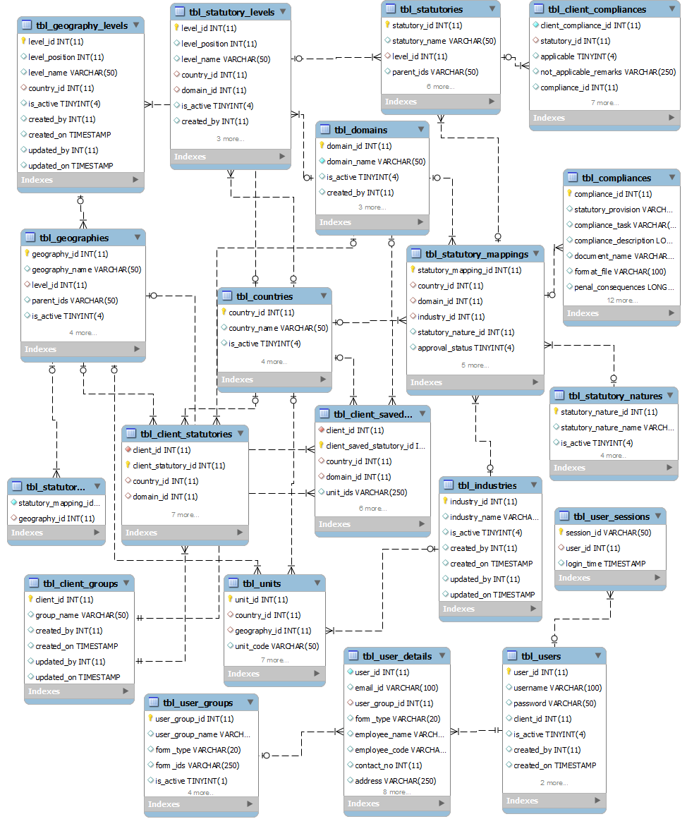

Schema Diagram – Client Database

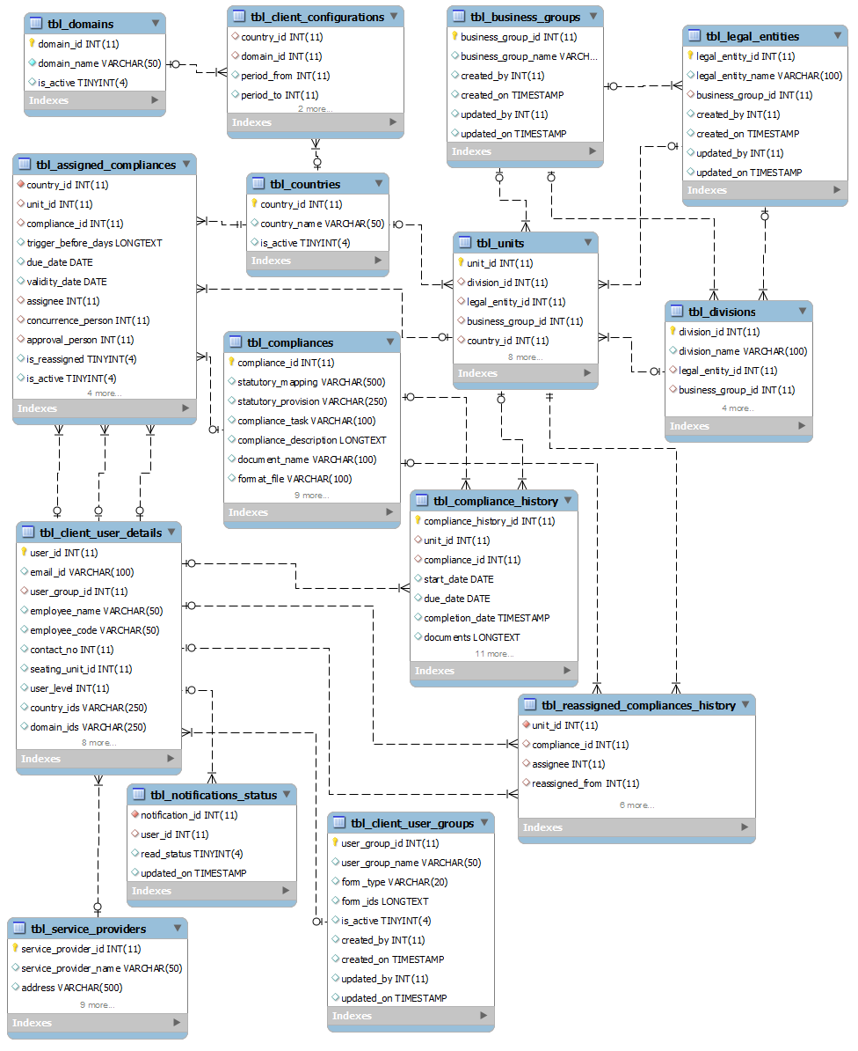

Note: These documents are strictly for Mindssoft Technology with the specific client Aparajitha Corporate Services Private Limited use only. They shall not be shared with an external party other than the client concerned. These documents should always be kept securely from unauthorized use or disclosure to a third party.

Document Approval

Mindssoft Technology and Aparajitha Corporate Services Private Limited have reviewed this document and agree that the contents of the document are accurate. Any changes to this document must be communicated in writing, approved and signed off by both parties.

Signature | Signature
Date: | Date:
Name: N.R. Venkatesh Ram Mohan | Name:
Designation: Project Director | Designation:
Supplier: Mindssoft Technology | Client: Aparajitha

