System Design Document

Mirror

Version : 1.4
Date : 09-12-2015
Project : Mirror
Author : Usha Devi .K

Document Revisions

Date | Version | Description | Author | Approved By
30-10-2015 | 1.0 | Mirror – SDD | Usha Devi K | Dhanalakshmi SB
03-11-2015 | 1.1 | Mirror – SDD | Usha Devi K | Dhanalakshmi SB
21-11-2015 | 1.2 | Mirror – SDD | Usha Devi K | Dhanalakshmi SB
25-11-2015 | 1.3 | Mirror – SDD | Usha Devi K | Dhanalakshmi SB
09-12-2015 | 1.4 | Mirror – SDD | Usha Devi K | Dhanalakshmi SB

Index
1 Overview 4
2 Technology 4
3 System Process 5
3.1 Scope of the Project 5
4 System Design 6
4.1 Architecture Diagram 6
4.2 Data flow Diagram 7
5 Database Design 9
5.1 Schema Definition – Knowledge Database 9
5.2 Schema Definition – Client Database 19
5.3 Schema Diagram – Knowledge Database 28
5.4 Schema Diagram – Client Database 28
5.5 Schema Definition – Mobile Database 30

Overview
The project Mirror is designed and hosted for Aparajitha Corporate Services Private Limited. This web application is designed to manage the following modules. The indent of this project is to manage the below mentioned modules effectively, efficiently and improve the overall performance in order to moving forward the next level.
- Administrator Module
- Knowledge Team Module
- Techno Functional Team Module
- Client Module
- Service Provider Module
From the proposed system of the Web application, some of the features are listed and explained below. Proposed system will be categorized by seven types of users. That user's are,
      - Admin
      - Knowledge Team Manager
      - Knowledge Team User
      - Techno Functional Team Manager
      - Techno Functional Team User
      - Client Admin
      - Client User
      - Service Provider

Technology
The following Technologies are to be used for developing Web Application for Mirror:
      - Python 2.7
      - Tornado Framework
      - MySQL
      - HTML
      - CSS
      - JavaScript & jQuery
      - Nginx

The following Technologies are to be used for developing Mobile Apps for Mirror:
      - Android
        - Android SDK
        - SQLite
        - Android Studio 15.X
      - iPhone
        - Objective C
        - Coredata
        - XCode 5.X
      - BlackBerry 10
        - Native SDK
        - SQLite

System Process

Scope of the Project
The project is designed for Aparajitha Corporate Services Private Limited. From here on, the database will be the storage of all the important data. This will provide the effective security to the system more over the ultimate user can be able to get back with any kind of highly usable reports which he/she would like to see. The system will help to input the specified data in a sequential manner.

System Design

Architecture Diagram
Access to this web system is possible using browsers with internet connection. For Android Mobile App/Tablet App, iPhone/iPad App, Blackberry 10 App, accessing will be made through the Apps for the respective platforms with internet connection.

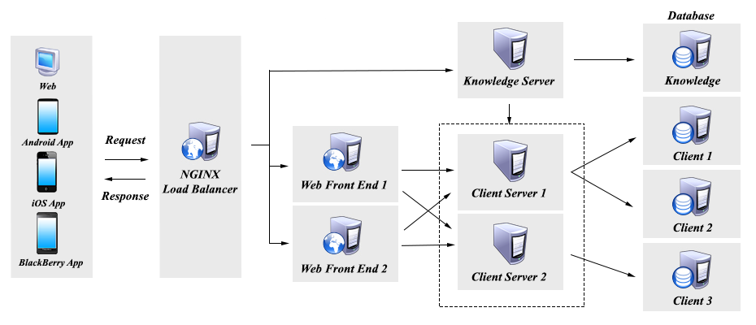

Data flow Diagram

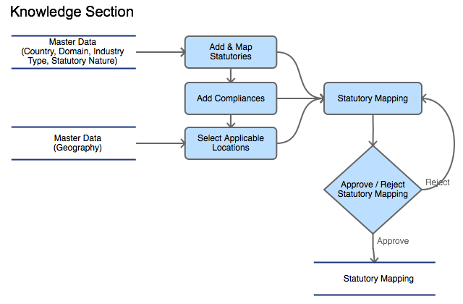

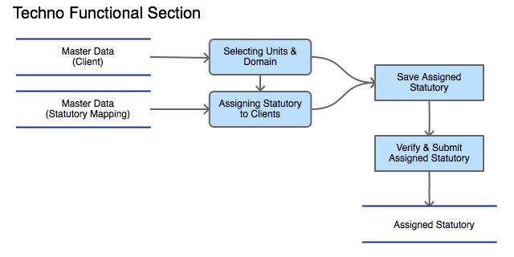

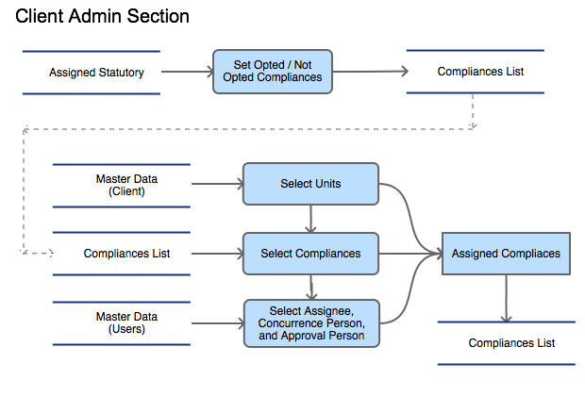

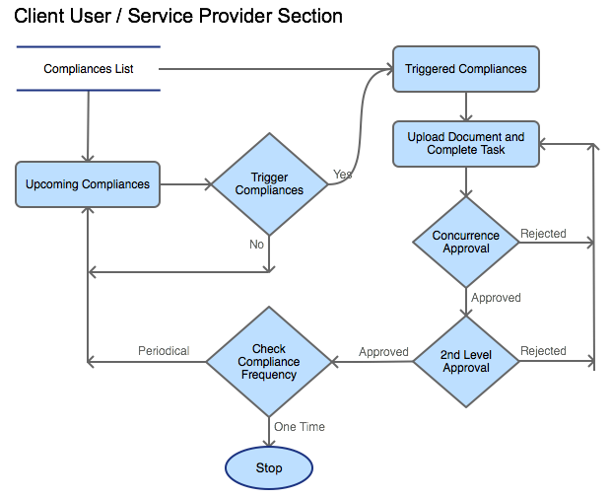

Database Design

Schema Definition – Knowledge Database
# | Table Name |  |  |  | Fields |  | Data type |  |  | Size |  |  | Default Value |  |  | Key | Null | Reference
Category
1 |  |  | tbl_form_category |  | form_category_id |  | INT |  |  | 11 |  |  |  |  | PK
 |  |  |  |  | form_category |  | VARCHAR |  |  | 20
Form Type
2 |  |  | tbl_form_type |  | form_type_id |  | INT |  |  | 11 |  |  |  |  | PK
 |  |  |  |  | form_type |  | VARCHAR |  |  | 20
Forms
3 |  |  | tbl_forms |  | form_id |  | INT |  |  | 11 |  |  |  |  |  | PK
 |  |  |  |  | form_category_id |  | INT |  |  | 11 |  |  |  |  |  | FK |  | tbl_form_category
 |  |  |  |  | form_type_id |  | INT |  |  | 11 |  |  |  |  |  | FK |  | tbl_form_type
 |  |  |  |  | form_name |  | VARCHAR |  |  | 50
 |  |  |  |  | form_url |  | VARCHAR |  |  | 50
 |  |  |  |  | form_order |  | INT |  |  | 11
 |  |  |  |  | parent_menu |  | VARCHAR |  |  | 50 |  |  |  |  |  |  | Yes
User Groups
4 |  |  | tbl_user_groups |  | user_group_id |  | INT |  |  | 11 |  |  |  |  |  | PK
 |  |  |  |  | form_category_id |  | INT |  |  | 11 |  |  |  |  |  | FK |  | tbl_form_category
 |  |  |  |  | user_group_name |  | VARCHAR |  |  | 50
 |  |  |  |  | form_ids |  | VARCHAR |  |  | 250
 |  |  |  |  | is_active |  | TINYINT |  |  | 1 |  |  | 1
 |  |  |  |  | created_by |  | INT |  |  | 11
 |  |  |  |  | created_on |  | TIMESTAMP
 |  |  |  |  | updated_by |  | INT |  |  | 11
 |  |  |  |  | updated_on |  | TIMESTAMP
Admin
5 |  |  | tbl_admin |  | user _name |  | VARCHAR |  |  | 50
 |  |  |  |  | password |  | VARCHAR |  |  | 50
Users
6 |  |  | tbl_users |  | user _id |  | INT |  |  | 11 |  |  |  |  |  | FK |  | tbl_users
 |  |  |  |  | user_group_id |  | INT |  |  | 11 |  |  |  |  |  | FK |  | tbl_user_groups
 |  |  |  |  | email_id |  | VARCHAR |  |  | 100
 |  |  |  |  | Password |  | VARCHAR |  |  | 50
 |  |  |  |  | employee_name |  | VARCHAR |  |  | 50
 |  |  |  |  | employee_code |  | VARCHAR |  |  | 50
 |  |  |  |  | contact_no |  | VARCHAR |  |  | 20
 |  |  |  |  | Address |  | VARCHAR |  |  | 250 |  |  |  |  |  |  | Yes
 |  |  |  |  | designation |  | VARCHAR |  |  | 50 |  |  |  |  |  |  | Yes
 |  |  |  |  | Is_active |  | TINYINT |  |  | 1
 |  |  |  |  | created_by |  | INT |  |  | 11
 |  |  |  |  | created_on |  | TIMESTAMP
 |  |  |  |  | updated_by |  | INT |  |  | 11
 |  |  |  |  | updated_on |  | TIMESTAMP
User Countries
7 |  |  | tbl_user_countries |  | user_id |  | INT |  |  | 11 |  |  |  |  |  | FK, PK |  | tbl_users
 |  |  |  |  | country_id |  | INT |  |  | 11 |  |  |  |  |  | FK,PK |  | tbl_countries
User Domains
8 |  |  | tbl_user_domains |  | user_id |  | INT |  |  | 11 |  |  |  |  |  | FK, PK |  | tbl_users
 |  |  |  |  | domain_id |  | INT |  |  | 11 |  |  |  |  |  | FK,PK |  | tbl_domains
User Login History
9 |  |  | tbl_user_login_history |  | user_id |  | INT |  |  | 11 |  |  |  |  |  | FK |  | tbl_users
 |  |  |  |  | login_time |  | INT |  |  | 11
 |  |  |  |  | logout_time |  | INT |  |  | 11
Session Types
10 |  |  | tbl_session_types | session_type_id |  |  |  |  | INT |  |  | 11 |  |  | PK
 |  |  | tbl_session_types | session_type |  |  |  |  | VARCHAR |  |  | 20
User Sessions
11 |  | tbl_user_sessions |  |  | session_token |  | VARCHAR |  |  | 50 |  |  |  |  |  | PK
 |  |  |  |  | user_id |  | INT |  |  | 11 |  |  |  |  |  | FK |  | tbl_users
 |  |  |  |  | session_type_id |  | INT |  |  | 11 |  |  |  |  |  | FK |  | tbl_session_types
 |  |  |  |  | last_accessed_time |  | TIMESTAMP
Countries
12 |  | tbl_countries |  |  | country_id |  | INT |  |  | 11 |  |  |  |  |  | PK
 |  |  |  |  | country_name |  | VARCHAR |  |  | 50
 |  |  |  |  | is_active |  | TINYINT |  |  | 1 |  |  | 1
 |  |  |  |  | created_by |  | INT |  |  | 11
 |  |  |  |  | created_on |  | TIMESTAMP
 |  |  |  |  | updated_by |  | INT |  |  | 11
 |  |  |  |  | updated_on |  | TIMESTAMP
Domains
13 |  | tbl_domains |  |  | domain_id |  | INT |  |  | 11 |  |  |  |  |  | PK
 |  |  |  |  | domain_name |  | VARCHAR |  |  | 50
 |  |  |  |  | is_active |  | TINYINT |  |  | 1 |  |  | 1
 |  |  |  |  | created_by |  | INT |  |  | 11
 |  |  |  |  | created_on |  | TIMESTAMP
 |  |  |  |  | updated_by |  | INT |  |  | 11
 |  |  |  |  | updated_on |  | TIMESTAMP
Industries
14 |  | tbl_industries |  |  | industry_id |  | INT |  |  | 11 |  |  |  |  |  | PK
 |  |  |  |  | industry_name |  | VARCHAR |  |  | 50
 |  |  |  |  | is_active |  | TINYINT |  |  | 1 |  |  | 1
 |  |  |  |  | created_by |  | INT |  |  | 11
 |  |  |  |  | created_on |  | TIMESTAMP
 |  |  |  |  | updated_by |  | INT |  |  | 11
 |  |  |  |  | updated_on |  | TIMESTAMP
Statutory Natures
15 |  | tbl_statutory_natures |  |  | statutory_nature_id |  | INT |  |  | 11 |  |  |  |  |  | PK
 |  |  |  |  | statutory_nature_name |  | VARCHAR |  |  | 50
 |  |  |  |  | is_active |  | TINYINT |  |  | 1 |  |  | 1
 |  |  |  |  | created_by |  | INT |  |  | 11
 |  |  |  |  | created_on |  | TIMESTAMP
 |  |  |  |  | updated_by |  | INT |  |  | 11
 |  |  |  |  | updated_on |  | TIMESTAMP
Statutory Levels
16 |  | tbl_statutory_levels |  |  | level_id |  | INT |  |  | 11 |  |  |  |  |  | PK
 |  |  |  |  | country_id |  | INT |  |  | 11 |  |  |  |  |  | FK |  | tbl_countries
 |  |  |  |  | domain_id |  | INT |  |  | 11 |  |  |  |  |  | FK |  | tbl_domains
 |  |  |  |  | level_position |  | INT |  |  | 11 |  |  |  |  |  |  |  | 1-10
 |  |  |  |  | level_name |  | VARCHAR |  |  | 50
 |  |  |  |  | is_active |  | TINYINT |  |  | 1 |  |  | 1
 |  |  |  |  | created_by |  | INT |  |  | 11
 |  |  |  |  | created_on |  | TIMESTAMP
 |  |  |  |  | updated_by |  | INT |  |  | 11
 |  |  |  |  | updated_on |  | TIMESTAMP
Geography Levels
17 |  | tbl_geography_levels |  |  | level_id |  | INT |  |  | 11 |  |  |  |  |  | PK
 |  |  |  |  | country_id |  | INT |  |  | 11 |  |  |  |  |  | FK |  | tbl_countries
 |  |  |  |  | level_position |  | INT |  |  | 11 |  |  |  |  |  |  |  | 1-10
 |  |  |  |  | level_name |  | VARCHAR |  |  | 50
 |  |  |  |  | is_active |  | TINYINT |  |  | 1 |  |  | 1
 |  |  |  |  | created_by |  | INT |  |  | 11
 |  |  |  |  | created_on |  | TIMESTAMP
 |  |  |  |  | updated_by |  | INT |  |  | 11
 |  |  |  |  | updated_on |  | TIMESTAMP
Geographies
18 |  | tbl_geographies |  |  | geography_id |  | INT |  |  | 11 |  |  |  |  |  | PK
 |  |  |  |  | level_id |  | INT |  |  | 11 |  |  |  |  |  | FK |  | tbl_geography_levels
 |  |  |  |  | geography_name |  | VARCHAR |  |  | 50
 |  |  |  |  | parent_ids |  | VARCHAR |  |  | 50
 |  |  |  |  | is_active |  | TINYINT |  |  | 1 |  |  | 1
 |  |  |  |  | created_by |  | INT |  |  | 11
 |  |  |  |  | created_on |  | TIMESTAMP
 |  |  |  |  | updated_by |  | INT |  |  | 11
 |  |  |  |  | updated_on |  | TIMESTAMP
Statutory Mappings
19 |  | tbl_statutory_mappings |  |  | statutory_mapping_id |  | INT |  |  | 11 |  |  |  |  |  | PK
 |  |  |  |  | country_id |  | INT |  |  | 11 |  |  |  |  |  | FK |  | tbl_countries
 |  |  |  |  | domain_id |  | INT |  |  | 11 |  |  |  |  |  | FK |  | tbl_domains
 |  |  |  |  | statutory_nature_id |  | INT |  |  | 11 |  |  |  |  |  | FK |  | tbl_statutory_natures
 |  |  |  |  | industry_ids |  | VARCHAR |  |  | 50
 |  |  |  |  | statutory_ids |  | VARCHAR |  |  | 50
 |  |  |  |  | compliance_ids |  | VARCHAR |  |  | 50
 |  |  |  |  | geography_ids |  | VARCHAR |  |  | 50
 |  |  |  |  | approval_status |  | TINYINT |  |  | 2 |  |  | 0
 |  |  |  |  | rejected_reason |  | VARCHAR |  |  | 500 |  |  |  |  |  |  | Yes
 |  |  |  |  | is_active |  | TINYINT |  |  | 1 |  |  | 1
 |  |  |  |  | created_by |  | INT |  |  | 11
 |  |  |  |  | created_on |  | TIMESTAMP
 |  |  |  |  | updated_by |  | INT |  |  | 11
 |  |  |  |  | updated_on |  | TIMESTAMP
Statutories
20 |  | tbl_statutories |  |  | statutory_id |  | INT |  |  | 11 |  |  |  |  |  | PK
 |  |  |  |  | level_id |  | INT |  |  | 11 |  |  |  |  |  | FK |  | tbl_statutory_levels
 |  |  |  |  | statutory_name |  | VARCHAR |  |  | 50
 |  |  |  |  | parent_ids |  | VARCHAR |  |  | 50
 |  |  |  |  | statutory_mapping_ids |  | VARCHAR |  |  | 50 |  |  |  |  |  |  | Yes
 |  |  |  |  | created_by |  | INT |  |  | 11
 |  |  |  |  | created_on |  | TIMESTAMP
 |  |  |  |  | updated_by |  | INT |  |  | 11
 |  |  |  |  | updated_on |  | TIMESTAMP
Statutory Geographies
21 |  | tbl_statutory_geographies |  |  | statutory_mapping_id |  | INT |  |  | 11 |  |  |  |  |  | FK |  | tbl_statutory_mappings
 |  |  |  |  | geography_id |  | INT |  |  | 11 |  |  |  |  |  | FK |  | tbl_geographies
Compliances Frequency
22 |  | tbl_compliance_frequency |  |  | frequency_id |  | INT |  |  | 11 |  |  |  |  |  | PK
 |  |  |  |  | frequency |  | VARCHAR |  |  | 20
Compliances Repeat Type
23 |  | tbl_compliance_repeat_type |  |  | repeat_type_id |  | INT |  |  | 11 |  |  |  |  |  | PK
 |  |  |  |  | repeat_type |  | VARCHAR |  |  | 20
Compliances Duration Type
24 |  | tbl_compliance_duration_type |  |  | duration_type_id |  | INT |  |  | 11 |  |  |  |  |  | PK
 |  |  |  |  | duration_type |  | VARCHAR |  |  | 20
Compliances
25 |  | tbl_compliances |  |  | compliance_id |  | INT |  |  | 11 |  |  |  |  |  | PK
 |  |  |  |  | statutory_mapping_id |  | INT |  |  | 11 |  |  |  |  |  | FK |  | tbl_statutory_mappings
 |  |  |  |  | frequency_id |  | INT |  |  | 11 |  |  |  |  |  | FK |  | tbl_compliance_frequency
 |  |  |  |  | repeats_type _id |  | INT |  |  | 11 |  |  |  |  |  | FK |  | tbl_compliance_repeat_type
 |  |  |  |  | duration_type_id |  | INT |  |  | 11 |  |  |  |  |  | FK |  | tbl_compliance_duration_type
 |  |  |  |  | statutory_provision |  | VARCHAR |  |  | 250 |  |  |  |  |  |  | Yes
 |  |  |  |  | compliance_task |  | VARCHAR |  |  | 100
 |  |  |  |  | compliance_description |  | LONGTEXT
 |  |  |  |  | document_name |  | VARCHAR |  |  | 100 |  |  |  |  |  |  | Yes
 |  |  |  |  | format_file |  | VARCHAR |  |  | 100 |  |  |  |  |  |  | Yes
 |  |  |  |  | format_file_size |  | INT |  |  | 11
 |  |  |  |  | penal_consequences |  | LONGTEXT |  |  |  |  |  |  |  |  |  | Yes
 |  |  |  |  | statutory_dates |  | LONGTEXT |  |  |  |  |  |  |  |  |  |  | json-string: list of dictionaries with keys statutory_date, statutory_month, trigger_before_days
 |  |  |  |  | repeats_every |  | TINYINT |  |  | 4
 |  |  |  |  | duration |  | TINYINT |  |  | 11 |  |  | 1
 |  |  |  |  | is_active |  | TINYINT |  |  | 4 |  |  | 1
 |  |  |  |  | created_by |  | INT |  |  | 11
 |  |  |  |  | created_on |  | TIMESTAMP
 |  |  |  |  | updated_by |  | INT |  |  | 11
 |  |  |  |  | updated_on |  | TIMESTAMP
Statutories Backup
26 |  | tbl_statutories_backup |  |  | statutory_backup_id |  | INT |  |  | 11 |  |  |  |  |  | PK
 |  |  |  |  | country_name |  | VARCHAR |  |  | 50
 |  |  |  |  | domain_name |  | VARCHAR |  |  | 50
 |  |  |  |  | industry_name |  | VARCHAR |  |  | 50
 |  |  |  |  | statutory_nature |  | VARCHAR |  |  | 50
 |  |  |  |  | statutory_provision |  | VARCHAR |  |  | 500
 |  |  |  |  | applicable_location |  | VARCHAR |  |  | 500
Compliances Backup
27 |  | tbl_compliances_backup |  |  | statutory_backup_id |  | INT |  |  | 11 |  |  |  |  |  | FK |  | tbl_statutories_backup
 |  |  |  |  | frequency_id |  | INT |  |  | 11 |  |  |  |  |  | FK |  | tbl_compliance_frequency
 |  |  |  |  | repeats_type _id |  | INT |  |  | 1 |  |  |  |  |  | FK |  | tbl_compliance_repeat_type
 |  |  |  |  | duration_type_id |  | INT |  |  | 11 |  |  |  |  |  | FK |  | tbl_compliance_duration_type
 |  |  |  |  | statutory_provision |  | VARCHAR |  |  | 250
 |  |  |  |  | compliance_task |  | VARCHAR |  |  | 100
 |  |  |  |  | compliance_description |  | LONGTEXT
 |  |  |  |  | document_name |  | VARCHAR |  |  | 100 |  |  |  |  |  |  | Yes
 |  |  |  |  | format_file |  | VARCHAR |  |  | 100 |  |  |  |  |  |  | Yes
 |  |  |  |  | format_file_size |  | INT |  |  | 11
 |  |  |  |  | penal_consequences |  | LONGTEXT |  |  |  |  |  |  |  |  |  | Yes
 |  |  |  |  | statutory_dates |  | LONGTEXT |  |  |  |  |  |  |  |  |  |  | json-string: list of dictionaries with keys statutory_date, statutory_month, trigger_before_days
 |  |  |  |  | repeats_every |  | INT |  |  | 11
 |  |  |  |  | Duration |  | INT |  |  | 11 |  |  | 1
Client Groups
28 |  | tbl_client_groups |  |  | client_id |  | INT |  |  | 11 |  |  |  |  |  | PK
 |  |  |  |  | group_name |  | VARCHAR |  |  | 50
 |  |  |  |  | logo_url |  | VARCHAR |  |  | 100
 |  |  |  |  | logo_size |  | INT |  |  | 11
 |  |  |  |  | contract_from |  | DATE
 |  |  |  |  | contract_to |  | DATE |  |  | 11
 |  |  |  |  | no_of_user_licence |  | INT |  |  | 11
 |  |  |  |  | total_disk_space |  | INT |  |  | 11
 |  |  |  |  | total_space_used |  | INT |  |  | 11
 |  |  |  |  | is_sms_subscribed |  | TINYINT |  |  | 1
 |  |  |  |  | url_short_name |  | VARCHAR |  |  | 50
 |  |  |  |  | incharge_persons |  | VARCHAR |  |  | 50
 |  |  |  |  | created_by |  | INT |  |  | 11
 |  |  |  |  | created_on |  | TIMESTAMP
 |  |  |  |  | updated_by |  | INT |  |  | 11
 |  |  |  |  | updated_on |  | TIMESTAMP
Client Countries
29 |  | tbl_client_countries |  |  | client_id |  | INT |  |  | 11 |  |  |  |  |  | FK,PK |  | tbl_client_groups
 |  |  |  |  | country_id |  | INT |  |  | 11 |  |  |  |  |  | FK, PK |  | tbl_countries
Client Domains
30 |  | tbl_client_domains |  |  | client_id |  | INT |  |  | 11 |  |  |  |  |  | FK,PK |  | tbl_client_groups
 |  |  |  |  | domain_id |  | INT |  |  | 11 |  |  |  |  |  | FK, PK |  | tbl_domains
User Clients
31 |  | tbl_users_clients |  |  | client_id |  | INT |  |  | 11 |  |  |  |  |  | FK,PK |  | tbl_client_groups
 |  |  |  |  | user_id |  | INT |  |  | 11 |  |  |  |  |  | FK, PK |  | tbl_users
Client Configuration
32 |  | tbl_client_configurations |  |  | country_id |  | INT |  |  | 11 |  |  |  |  | FK, PK |  |  | tbl_countries
 |  |  |  |  | domain_id |  | INT |  |  | 11 |  |  |  |  | FK, PK |  |  | tbl_domains
 |  |  |  |  | period_from |  | TINYINT |  |  | 2
 |  |  |  |  | period_to |  | TINYINT |  |  | 2
 |  |  |  |  | updated_on |  | TIMESTAMP
 |  |  |  |  | updated_by |  | TIMESTAMP
Business Groups
33 |  |  | tbl_business_groups |  | business_group_id |  | INT |  |  | 11 |  |  |  |  | PK
 |  |  |  |  | business_group_name |  | VARCHAR |  |  | 100
 |  |  |  |  | created_by |  | INT |  |  | 11
 |  |  |  |  | created_on |  | TIMESTAMP
 |  |  |  |  | updated_by |  | INT |  |  | 11
 |  |  |  |  | updated_on |  | TIMESTAMP
Legal Entities
34 |  |  | tbl_legal_entities |  |  | legal_entity_id |  | INT |  |  | 11 |  |  |  | PK
 |  |  |  |  |  | business_group_id |  | INT |  |  | 11 |  |  |  | FK |  | Yes | tbl_business_groups
 |  |  |  |  |  | legal_entity_name |  | VARCHAR |  |  | 100
 |  |  |  |  |  | created_by |  | INT |  |  | 11
 |  |  |  |  |  | created_on |  | TIMESTAMP
 |  |  |  |  |  | updated_by |  | INT |  |  | 11
 |  |  |  |  |  | updated_on |  | TIMESTAMP
Divisions
35 |  |  | tbl_divisions |  |  | division_id |  | INT |  |  | 11 |  |  |  | PK
 |  |  |  |  |  | business_group_id |  | INT |  |  | 11 |  |  |  | FK |  | Yes | tbl_business_groups
 |  |  |  |  |  | legal_entity_id |  | INT |  |  | 11 |  |  |  | FK |  |  | tbl_legal_entities
 |  |  |  |  |  | division_name |  | VARCHAR |  |  | 100
 |  |  |  |  |  | created_by |  | INT |  |  | 11
 |  |  |  |  |  | created_on |  | TIMESTAMP
 |  |  |  |  |  | updated_by |  | INT |  |  | 11
 |  |  |  |  |  | updated_on |  | TIMESTAMP
Units
36 |  | tbl_units |  |  | unit_id |  | INT |  |  | 11 |  |  |  |  |  | PK
 |  |  |  |  | client_id |  | INT |  |  | 11 |  |  |  |  |  | FK |  | tbl_client_groups
 |  |  |  |  | Businesss_group_id |  | INT |  |  | 11 |  |  |  |  |  | FK |  | tbl_business_groups
 |  |  |  |  | legal_entity_id |  | INT |  |  | 11 |  |  |  |  |  | FK |  | tbl_legal_entities
 |  |  |  |  | division_id |  | INT |  |  | 11 |  |  |  |  |  | FK |  | Tbl_divisions
 |  |  |  |  | country_id |  | INT |  |  | 11 |  |  |  |  |  | FK |  | tbl_countries
 |  |  |  |  | geography_id |  | INT |  |  | 11 |  |  |  |  |  | FK |  | tbl_geographies
 |  |  |  |  | industry_id |  | INT |  |  | 11 |  |  |  |  |  | FK |  | tbl_industries
 |  |  |  |  | unit_code |  | VARCHAR |  |  | 50
 |  |  |  |  | unit_name |  | VARCHAR |  |  | 50
 |  |  |  |  | is_active |  | TINYINT |  |  | 1 |  |  | 1
 |  |  |  |  | address |  | VARCHAR |  |  | 250
 |  |  |  |  | postal_code |  | INT |  |  | 20
 |  |  |  |  | domain_ids |  | VARCHAR |  |  | 50
 |  |  |  |  | created_by |  | INT |  |  | 11
 |  |  |  |  | created_on |  | TIMESTAMP
 |  |  |  |  | updated_by |  | INT |  |  | 11
 |  |  |  |  | updated_on |  | TIMESTAMP
Client User
37 |  |  | tbl_client_users |  | user_id |  | INT |  |  | 11 |  |  |  |  | PK
 |  |  |  |  | seating_unit_id |  | INT |  |  | 11 |  |  |  |  | FK |  |  | tbl_units
 |  |  |  |  | email_id |  | VARCHAR |  |  | 100
 |  |  |  |  | employee_name |  | VARCHAR |  |  | 50
 |  |  |  |  | employee_code |  | VARCHAR |  |  | 50
 |  |  |  |  | contact_no |  | VARCHAR |  |  | 20
 |  |  |  |  | is_admin |  | TINYINT |  |  | 1 |  |  | 0
 |  |  |  |  | is_active |  | TINYINT |  |  | 1 |  |  | 1
Statutory Notifications Log
38 |  | tbl_statutory_notifications_log |  |  | statutory_notification_id |  | INT |  |  | 11 |  |  |  |  |  | PK
 |  |  |  |  | statutory_backup_id |  | INT |  |  | 11 |  |  |  |  |  | FK |  | tbl_statutories_backup
 |  |  |  |  | country_name |  | VARCHAR |  |  | 50
 |  |  |  |  | domain_name |  | VARCHAR |  |  | 50
 |  |  |  |  | industry_name |  | VARCHAR |  |  | 50
 |  |  |  |  | statutory_nature |  | VARCHAR |  |  | 50
 |  |  |  |  | statutory_provision |  | LONGTEXT
 |  |  |  |  | applicable_location |  | LONGTEXT
 |  |  |  |  | notification_text |  | LONGTEXT
 |  |  |  |  | updated_on |  | TIMESTAMP
Activity Log
39 |  | tbl_activity_log |  |  | activity_log_id |  | INT |  |  | 11 |  |  |  |  |  | PK
 |  |  |  |  | user_id |  | INT |  |  | 11 |  |  |  |  |  | FK |  | tbl_users
 |  |  |  |  | form_id |  | INT |  |  | 11 |  |  |  |  |  | FK |  | tbl_forms
 |  |  |  |  | Action |  | VARCHAR |  |  | 500
 |  |  |  |  | created_on |  | TIMESTAMP
Notifications
40 |  | tbl_notifications |  |  | notification_id |  | INT |  |  | 11 |  |  |  |  |  | PK
 |  |  |  |  | notification_text |  | VARCHAR |  |  | 250
 |  |  |  |  | link |  | VARCHAR |  |  | 100 |  |  |  |  |  |  | Yes
 |  |  |  |  | created_on |  | TIMESTAMP
Notification Status
41 |  | tbl_notification_status |  |  | notification _id |  | INT |  |  | 11 |  |  |  |  |  | PK,FK |  | tbl_notifications
 |  |  |  |  | user_id |  | INT |  |  | 11 |  |  |  |  |  | PK,FK |  | tbl_users
 |  |  |  |  | read_status |  | TINYINT |  |  | 1 |  |  | 0 |  |  |  |  | 0 - Unread, 1 – Read
Client Saved Statutories
42 |  | tbl_client_saved_statutories |  |  | client_saved_statutory_id |  | INT |  |  | 11 |  |  |  |  |  | PK
 |  |  |  |  | client_id |  | INT |  |  | 11 |  |  |  |  |  | FK |  | tbl_client_groups
 |  |  |  |  | geography_id |  | INT |  |  | 11 |  |  |  |  |  | FK |  | tbl_geographies
 |  |  |  |  | country_id |  | INT |  |  | 11 |  |  |  |  |  | FK |  | tbl_countries
 |  |  |  |  | domain_id |  | INT |  |  | 11 |  |  |  |  |  | FK |  | tbl_domains
 |  |  |  |  | unit_ids |  | VARCHAR |  |  | 250 |  |  |  |  |  |  |  | Multiple unit_ids concatinated with ","
 |  |  |  |  | created_by |  | INT |  |  | 11
 |  |  |  |  | created_on |  | TIMESTAMP
 |  |  |  |  | updated_by |  | INT |  |  | 11
 |  |  |  |  | updated_on |  | TIMESTAMP
Client Saved Compliances
43 |  | tbl_client_saved_compliances |  |  | client_saved_statutory_id |  | INT |  |  | 11 |  |  |  |  |  | PK,FK |  | tbl_client_saved_statutories
 |  |  |  |  | compliance_id |  | INT |  |  | 11 |  |  |  |  |  | PK, FK |  | tbl_compliances
 |  |  |  |  | statutory_id |  | INT |  |  | 11 |  |  |  |  |  | FK |  | (only ACT - 1st level) tbl_statutories
 |  |  |  |  | applicable |  | TINYINT |  |  | 1
 |  |  |  |  | not_applicable_remarks |  | VARCHAR |  |  | 250
 |  |  |  |  | compliance_applicable |  | TINYINT |  |  | 1
Client Statutories
44 |  | tbl_client_statutories |  |  | client_statutory_id |  | INT |  |  | 11 |  |  |  |  |  | PK
 |  |  |  |  | client_id |  | INT |  |  | 11 |  |  |  |  |  | FK |  | tbl_client_groups
 |  |  |  |  | geography_id |  | INT |  |  | 11 |  |  |  |  |  | FK |  | tbl_geographies
 |  |  |  |  | country_id |  | INT |  |  | 11 |  |  |  |  |  | FK |  | tbl_countries
 |  |  |  |  | domain_id |  | INT |  |  | 11 |  |  |  |  |  | FK |  | tbl_domains
 |  |  |  |  | unit_id |  | INT |  |  | 11
 |  |  |  |  | created_by |  | INT |  |  | 11
 |  |  |  |  | created_on |  | TIMESTAMP
 |  |  |  |  | updated_by |  | INT |  |  | 11
 |  |  |  |  | updated_on |  | TIMESTAMP
Client Compliances
45 |  | tbl_client_compliances |  |  | client_statutory_id |  | INT |  |  | 11 |  |  |  |  |  | PK,FK |  | tbl_client_statutories
 |  |  |  |  | compliance_id |  | INT |  |  | 11 |  |  |  |  |  | PK, FK |  | tbl_compliances
 |  |  |  |  | statutory_id |  | INT |  |  | 11 |  |  |  |  |  | FK |  | (only ACT - 1st level) tbl_statutories
 |  |  |  |  | applicable |  | TINYINT |  |  | 1
 |  |  |  |  | not_applicable_remarks |  | VARCHAR |  |  | 250
 |  |  |  |  | compliance_applicable |  | TINYINT |  |  | 1
 |  |  |  |  | compliances_opted |  | TINYINT |  |  | 1
 |  |  |  |  | compliance_remarks |  | VARCHAR |  |  | 250
 |  |  |  |  | submitted_on |  | TIMESTAMP
 |  |  |  |  | created_by |  | INT |  |  | 11
 |  |  |  |  | created_on |  | TIMESTAMP
 |  |  |  |  | updated_by |  | INT |  |  | 11
 |  |  |  |  | updated_on |  | TIMESTAMP
Email Verification
46 |  | tbl_email_verification |  |  | verification_code |  | VARCHAR |  |  | 50 |  |  |  |  |  | PK
 |  |  |  |  | user_id |  | INT |  |  | 11 |  |  |  |  |  | FK |  | tbl_users
Mobile Registration
47 |  | tbl_mobile_registration |  |  | registration_key |  | VARCHAR |  |  | 50 |  |  |  |  |  | PK
 |  |  |  |  | device_type_id |  | INT |  |  | 11 |  |  |  |  |  | FK |  | tbl_session_type
 |  |  |  |  | user_id |  | INT |  |  | 11 |  |  |  |  |  | FK |  | tbl_users
Machines
48 |  | tbl_machines |  |  | machine_id |  | INT |  |  | 11 |  |  |  |  |  | PK
 |  |  |  |  | ip |  | VARCHAR |  |  | 20
 |  |  |  |  | port |  | INT |  |  | 11
 |  |  |  |  | client_ids |  | VARCHAR |  |  | 100
 |  |  |  |  | server_full |  | TINYINT |  |  | 1
Clients Database
49 |  | tbl_client_database |  |  | client_id |  | INT |  |  | 11 |  |  |  |  |  | PK,FK |  | tbl_client_groups
 |  |  |  |  | machine_id |  | INT |  |  |  |  |  |  |  |  | FK |  | tbl_machines
 |  |  |  |  | database_ip |  | VARCHAR |  |  | 20
 |  |  |  |  | database_port |  | INT |  |  | 11
 |  |  |  |  | database_username |  | VARCHAR |  |  | 50
 |  |  |  |  | database_password |  | VARCHAR |  |  | 50
 |  |  |  |  | client_short_name |  | VARCHAR |  |  | 20
 |  |  |  |  | database_name |  | VARCAR |  |  | 50
Database Server
50 |  | tbl_database_server |  |  | Ip |  | VARCHAR |  |  | 20 |  |  |  |  |  | PK |  | tbl_client_groups
 |  |  |  |  | server_username |  | VARCHAR |  |  | 50
 |  |  |  |  | server_password |  | VARCHAR |  |  | 50
 |  |  |  |  | client_ids |  | VARCHAR |  |  | 250
 |  |  |  |  | length |  | INT |  |  | 11
 |  |  |  |  | server_full |  | TINYINT |  |  | 1

Schema Definition – Client Database
# | Table Name |  |  |  |  |  |  | Fields |  |  | Data type |  |  |  |  | Size |  |  |  |  |  |  |  | Default Value |  |  |  |  |  | Key |  |  |  | Null |  |  |  | Reference
Form Type
1 | tbl_form_type |  |  |  |  |  |  | form_type_id |  |  | INT |  |  |  |  | 11 |  |  |  |  |  |  |  |  |  |  | PK
1 |  |  |  |  |  |  |  | form_type |  |  | VARCHAR |  |  |  |  | 20
Forms
2 | tbl_forms |  |  |  |  |  |  | form_id |  |  | INT |  |  |  |  | 11 |  |  |  |  |  |  |  |  |  |  |  |  |  | PK
2 |  |  |  |  |  |  |  | form_type_id |  |  | INT |  |  |  |  | 11 |  |  |  |  |  |  |  |  |  |  |  |  |  | FK |  |  |  |  |  |  |  | tbl_form_category
2 |  |  |  |  |  |  |  | form_name |  |  | VARCHAR |  |  |  |  | 50
2 |  |  |  |  |  |  |  | form_url |  |  | VARCHAR |  |  |  |  | 50
2 |  |  |  |  |  |  |  | form_order |  |  | INT |  |  |  |  | 11
2 |  |  |  |  |  |  |  | parent_menu |  |  | VARCHAR |  |  |  |  | 50 |  |  |  |  |  |  |  |  |  |  |  |  |  |  |  |  |  | Yes
Countries
3 | tbl_countries |  |  |  |  |  |  | country_id |  |  | INT |  |  |  |  | 11 |  |  |  |  |  |  |  |  |  |  |  |  |  | PK
3 |  |  |  |  |  |  |  | country_name |  |  | VARCHAR |  |  |  |  | 50
3 |  |  |  |  |  |  |  | is_active |  |  | TINYINT |  |  |  |  | 1 |  |  |  |  |  |  |  | 1
Domains
4 | tbl_domains |  |  |  |  |  |  | domain_id |  |  | INT |  |  |  |  | 11 |  |  |  |  |  |  |  |  |  |  |  |  |  | PK
4 |  |  |  |  |  |  |  | domain_name |  |  | VARCHAR |  |  |  |  | 50
4 |  |  |  |  |  |  |  | is_active |  |  | TINYINT |  |  |  |  | 1 |  |  |  |  |  |  |  | 1
Compliances Frequency
5 |  | tbl_compliance_frequency |  |  | frequency_id |  |  |  |  |  |  |  |  | INT |  |  |  | 11 |  |  |  |  |  |  |  |  |  | PK
 |  |  |  |  | frequency |  |  |  |  |  |  |  |  | VARCHAR |  |  |  | 20
Compliances Repeat Type
6 |  | tbl_compliance_repeat_type |  |  | repeat_type_id |  |  |  |  |  |  |  |  | INT |  |  |  | 11 |  |  |  |  |  |  |  |  |  | PK
 |  |  |  |  | repeat_type |  |  |  |  |  |  |  |  | VARCHAR |  |  |  | 20
Compliances Duration Type
7 |  | tbl_compliance_duration_type | duration_type_id |  |  |  |  |  |  |  |  | INT |  |  |  |  |  | 11 |  |  |  |  |  |  |  |  |  | PK
 |  | tbl_compliance_duration_type | duration_type |  |  |  |  |  |  |  |  | VARCHAR |  |  |  |  |  | 20
Compliances
8 | tbl_compliances |  |  | compliance_id |  |  |  |  |  |  | INT |  |  |  |  | 11 |  |  |  |  |  |  |  |  |  |  |  |  |  | PK
8 |  |  |  | frequency_id |  |  |  |  |  |  | INT |  |  |  |  | 11 |  |  |  |  |  |  |  |  |  |  |  |  |  | FK |  |  |  |  |  |  |  | tbl_compliance_frequency
8 |  |  |  | repeats_type_id |  |  |  |  |  |  | INT |  |  |  |  | 11 |  |  |  |  |  |  |  |  |  |  |  |  |  | FK |  |  |  |  |  |  |  | tbl_compliance_repeats_types
8 |  |  |  | duration_type_id |  |  |  |  |  |  | INT |  |  |  |  | 11 |  |  |  |  |  |  |  |  |  |  |  |  |  | FK |  |  |  |  |  |  |  | tbl_compliance_duration_type
8 |  |  |  | statutory_mapping |  |  |  |  |  |  | VARCHAR |  |  |  |  | 500
8 |  |  |  | statutory_provision |  |  |  |  |  |  | VARCHAR |  |  |  |  | 250 |  |  |  |  |  |  |  |  |  |  |  |  |  |  |  |  |  | Yes
8 |  |  |  | compliance_task |  |  |  |  |  |  | VARCHAR |  |  |  |  | 100
8 |  |  |  | compliance_description |  |  |  |  |  |  | LONGTEXT
8 |  |  |  | document_name |  |  |  |  |  |  | VARCHAR |  |  |  |  | 100 |  |  |  |  |  |  |  |  |  |  |  |  |  |  |  |  |  | Yes
8 |  |  |  | format_file |  |  |  |  |  |  | VARCHAR |  |  |  |  | 100 |  |  |  |  |  |  |  |  |  |  |  |  |  |  |  |  |  | Yes
8 |  |  |  | format_file_size |  |  |  |  |  |  | INT |  |  |  |  | 11
8 |  |  |  | penal_consequences |  |  |  |  |  |  | LONGTEXT |  |  |  |  |  |  |  |  |  |  |  |  |  |  |  |  |  |  |  |  |  |  | Yes
8 |  |  |  | statutory_dates |  |  |  |  |  |  | LONGTEXT |  |  |  |  |  |  |  |  |  |  |  |  |  |  |  |  |  |  |  |  |  |  |  |  |  |  | json-string: list of dictionaries with keys statutory_date, statutory_month, trigger_before_days
8 |  |  |  | repeats_every |  |  |  |  |  |  | INT |  |  |  |  | 11
8 |  |  |  | duration |  |  |  |  |  |  | INT |  |  |  |  | 11 |  |  |  |  |  |  |  | 1
8 |  |  |  | is_active |  |  |  |  |  |  | TINYINT |  |  |  |  | 1 |  |  |  |  |  |  |  | 1
Client Settings
9 | tbl_client_settings |  |  |  |  |  |  | group_name |  |  | VARCHAR |  |  |  |  | 50
9 |  |  |  |  |  |  |  | country_ids |  |  | VARCHAR |  |  |  |  | 250
9 |  |  |  |  |  |  |  | domain_ids |  |  | VARCHAR |  |  |  |  | 250
9 |  |  |  |  |  |  |  | logo_url |  |  | VARCHAR |  |  |  |  | 200
9 |  |  |  |  |  |  |  | logo_size |  |  | INT |  |  |  |  | 11
9 |  |  |  |  |  |  |  | contract_from |  |  | DATE
9 |  |  |  |  |  |  |  | contract_to |  |  | DATE
9 |  |  |  |  |  |  |  | no_of_user_licence |  |  | INT |  |  |  |  | 11
9 |  |  |  |  |  |  |  | total_disk_space |  |  | INT |  |  |  |  | 11
9 |  |  |  |  |  |  |  | total_disk_space_used |  |  | INT |  |  |  |  | 11
9 |  |  |  |  |  |  |  | is_sms_subscribed |  |  | TINYINT |  |  |  |  | 1 |  |  |  |  |  |  |  | 0
9 |  |  |  |  |  |  |  | two_levels_of_approval |  |  | TINYINT |  |  |  |  | 1 |  |  |  |  |  |  |  | 1
9 |  |  |  |  |  |  |  | assignee_reminder |  |  | INT |  |  |  |  | 11 |  |  |  |  |  |  |  | 7
9 |  |  |  |  |  |  |  | escalation_reminder_In_advance |  |  | INT |  |  |  |  | 11 |  |  |  |  |  |  |  | 7
9 |  |  |  |  |  |  |  | escalation_reminder |  |  | INT |  |  |  |  | 11 |  |  |  |  |  |  |  | 7
Client Configurations
10 | tbl_client_configurations |  |  |  |  |  |  | country_id |  |  | INT |  |  |  |  | 11 |  |  |  |  |  |  |  |  |  |  |  |  |  | FK,  PK |  |  |  |  |  |  |  | tbl_countries
10 |  |  |  |  |  |  |  | domain_id |  |  | INT |  |  |  |  | 11 |  |  |  |  |  |  |  |  |  |  |  |  |  | FK,  PK |  |  |  |  |  |  |  | tbl_domains
10 |  |  |  |  |  |  |  | period_from |  |  | TINYINT |  |  |  |  | 2 |  |  |  |  |  |  |  |  |  |  |  |  |  |  |  |  |  |  |  |  |  | (1-12)
10 |  |  |  |  |  |  |  | period_to |  |  | TINYINT |  |  |  |  | 11 |  |  |  |  |  |  |  |  |  |  |  |  |  |  |  |  |  |  |  |  |  | (1-12)
Business Groups
11 | tbl_business_groups |  |  |  |  |  |  | business_group_id |  |  | INT |  |  |  |  | 11 |  |  |  |  |  |  |  |  |  |  |  |  |  | PK
11 |  |  |  |  |  |  |  | business_group_name |  |  | VARCHAR |  |  |  |  | 100
Legal Entities
12 | tbl_legal_entities |  |  |  |  |  |  | legal_entity_id |  |  | INT |  |  |  |  | 11 |  |  |  |  |  |  |  |  |  |  |  |  |  | PK
12 |  |  |  |  |  |  |  | business_group_id |  |  | INT |  |  |  |  | 11 |  |  |  |  |  |  |  |  |  |  |  |  |  | FK |  |  |  | Yes |  |  |  | tbl_business_groups
12 |  |  |  |  |  |  |  | legal_entity_name |  |  | VARCHAR |  |  |  |  | 100
Divisions
13 | tbl_divisions |  |  |  |  |  |  | division_id |  |  | INT |  |  |  |  | 11 |  |  |  |  |  |  |  |  |  |  |  |  |  | PK
13 |  |  |  |  |  |  |  | business_group_id |  |  | INT |  |  |  |  | 11 |  |  |  |  |  |  |  |  |  |  |  |  |  | FK |  |  |  | Yes |  |  |  | tbl_business_groups
13 |  |  |  |  |  |  |  | legal_entity_id |  |  | INT |  |  |  |  | 11 |  |  |  |  |  |  |  |  |  |  |  |  |  | FK |  |  |  |  |  |  |  | tbl_legal_entities
13 |  |  |  |  |  |  |  | division_name |  |  | VARCHAR |  |  |  |  | 100
Units
14 | tbl_units |  |  |  |  |  |  | unit_id |  |  | INT |  |  |  |  | 11 |  |  |  |  |  |  |  |  |  |  |  |  |  | PK
14 |  |  |  |  |  |  |  | business_group_id |  |  | INT |  |  |  |  | 11 |  |  |  |  |  |  |  |  |  |  |  |  |  | FK |  |  |  | Yes |  |  |  | tbl_business_groups
14 |  |  |  |  |  |  |  | legal_entity_id |  |  | INT |  |  |  |  | 11 |  |  |  |  |  |  |  |  |  |  |  |  |  | FK |  |  |  |  |  |  |  | tbl_legal_entities
14 |  |  |  |  |  |  |  | division_id |  |  | INT |  |  |  |  | 11 |  |  |  |  |  |  |  |  |  |  |  |  |  | FK |  |  |  | Yes |  |  |  | tbl_divisions
14 |  |  |  |  |  |  |  | country_id |  |  | INT |  |  |  |  | 11 |  |  |  |  |  |  |  |  |  |  |  |  |  | FK |  |  |  |  |  |  |  | tbl_countries
14 |  |  |  |  |  |  |  | geography |  |  | LONGTEXT
14 |  |  |  |  |  |  |  | unit_code |  |  | VARCHAR |  |  |  |  | 50
14 |  |  |  |  |  |  |  | unit_name |  |  | VARCHAR |  |  |  |  | 50
14 |  |  |  |  |  |  |  | industry_name |  |  | VARCHAR |  |  |  |  | 50
14 |  |  |  |  |  |  |  | address |  |  | VARCHAR |  |  |  |  | 500
14 |  |  |  |  |  |  |  | postal_code |  |  | INT |  |  |  |  | 11
14 |  |  |  |  |  |  |  | domain_ids |  |  | VARCHAR |  |  |  |  | 100
14 |  |  |  |  |  |  |  | is_active |  |  | TINYINT |  |  |  |  | 1 |  |  |  |  |  |  |  | 1
Service Provider
15 | tbl_service_provider |  |  |  |  |  |  | servicer_provider_id |  |  | INT |  |  |  |  | 11 |  |  |  |  |  |  |  |  |  |  |  |  |  | PK
15 |  |  |  |  |  |  |  | service_provider_name |  |  | VARCHAR |  |  |  |  | 50
15 |  |  |  |  |  |  |  | address |  |  | VARCHAR |  |  |  |  | 500 |  |  |  |  |  |  |  |  |  |  |  |  |  |  |  |  |  | Yes
15 |  |  |  |  |  |  |  | contract_from |  |  | DATE
15 |  |  |  |  |  |  |  | contract_to |  |  | DATE
15 |  |  |  |  |  |  |  | contact_person |  |  | VARCHAR |  |  |  |  | 50
15 |  |  |  |  |  |  |  | contact_no |  |  | INT |  |  |  |  | 11
15 |  |  |  |  |  |  |  | is_active |  |  | TINYINT |  |  |  |  | 1
15 |  |  |  |  |  |  |  | created_by |  |  | INT |  |  |  |  | 11
15 |  |  |  |  |  |  |  | created_on |  |  | TIMESTAMP
15 |  |  |  |  |  |  |  | updated_by |  |  | INT |  |  |  |  | 11
15 |  |  |  |  |  |  |  | updated_on |  |  | TIMESTAMP
User Groups
16 | tbl_user_groups |  |  |  |  |  |  | user_group_id |  |  | INT |  |  |  |  | 11 |  |  |  |  |  |  |  |  |  |  |  |  |  | PK
16 |  |  |  |  |  |  |  | user_group_name |  |  | VARCHAR |  |  |  |  | 50
16 |  |  |  |  |  |  |  | form_ids |  |  | LONGTEXT
16 |  |  |  |  |  |  |  | is_active |  |  | TINYINT |  |  |  |  | 1 |  |  |  |  |  |  |  | 1
16 |  |  |  |  |  |  |  | created_by |  |  | INT |  |  |  |  | 11
16 |  |  |  |  |  |  |  | created_on |  |  | TIMESTAMP
16 |  |  |  |  |  |  |  | updated_by |  |  | INT |  |  |  |  | 11
16 |  |  |  |  |  |  |  | updated_on |  |  | TIMESTAMP
Admin
17 | tbl_admin |  |  |  |  |  |  |  | user _name |  | VARCHAR |  |  |  | 50
17 |  |  |  |  |  |  |  |  | password |  | VARCHAR |  |  |  | 50
User
18 | tbl_users |  |  |  |  |  |  | user_id |  |  | INT |  |  |  |  | 11 |  |  |  |  |  |  |  |  |  |  |  |  |  | PK
18 |  |  |  |  |  |  |  | user_group_id |  |  | INT |  |  |  |  | 11 |  |  |  |  |  |  |  |  |  |  |  |  |  | FK |  |  |  |  |  |  |  | tbl_user_groups
18 |  |  |  |  |  |  |  | service_provider_id |  |  | INT |  |  |  |  | 11 |  |  |  |  |  |  |  |  |  |  |  |  |  |  |  |  |  | Yes
18 |  |  |  |  |  |  |  | email_id |  |  | VARCHAR |  |  |  |  | 100
18 |  |  |  |  |  |  |  | Password |  |  | VARCHAR |  |  |  |  | 50
18 |  |  |  |  |  |  |  | employee_name |  |  | VARCHAR |  |  |  |  | 50
18 |  |  |  |  |  |  |  | employee_code |  |  | VARCHAR |  |  |  |  | 50
18 |  |  |  |  |  |  |  | contact_no |  |  | VARCHAR |  |  |  |  | 20
18 |  |  |  |  |  |  |  | seating_unit_id |  |  | INT |  |  |  |  | 11 |  |  |  |  |  |  |  |  |  |  |  |  |  | FK |  |  |  |  |  |  |  | tbl_units
18 |  |  |  |  |  |  |  | user_level |  |  | TINYINT |  |  |  |  | 2
18 |  |  |  |  |  |  |  | is_admin |  |  | TINYINT |  |  |  |  | 1 |  |  |  |  |  |  |  | 0
18 |  |  |  |  |  |  |  | is_service_provider |  |  | TINYINT |  |  |  |  | 1 |  |  |  |  |  |  |  | 0
18 |  |  |  |  |  |  |  | Is_active |  |  | TINYINT |  |  |  |  | 1 |  |  |  |  |  |  |  | 1
18 |  |  |  |  |  |  |  | created_by |  |  | INT |  |  |  |  | 11
18 |  |  |  |  |  |  |  | created_on |  |  | TIMESTAMP
18 |  |  |  |  |  |  |  | updated_by |  |  | INT |  |  |  |  | 11
18 |  |  |  |  |  |  |  | updated_on |  |  | TIMESTAMP
User Countries
19 | tbl_user_countries |  |  |  |  |  |  | user_id |  |  | INT |  |  |  |  | 11 |  |  |  |  |  |  |  |  |  |  |  |  |  | PK,FK |  |  |  |  |  |  |  | tbl_users
19 |  |  |  |  |  |  |  | country_id |  |  | INT |  |  |  |  | 11 |  |  |  |  |  |  |  |  |  |  |  |  |  | PK,FK |  |  |  |  |  |  |  | tbl_countries
User Domains
20 | tbl _user_domains |  |  |  |  |  |  | user_id |  |  | INT |  |  |  |  | 11 |  |  |  |  |  |  |  |  |  |  |  |  |  | PK,FK |  |  |  |  |  |  |  | tbl_users
20 |  |  |  |  |  |  |  | domain_id |  |  | INT |  |  |  |  | 11 |  |  |  |  |  |  |  |  |  |  |  |  |  | PK,FK |  |  |  |  |  |  |  | tbl_domains
User Units
21 | tbl_user_units |  |  |  |  |  |  | user_id |  |  | INT |  |  |  |  | 11 |  |  |  |  |  |  |  |  |  |  |  |  |  | PK,FK |  |  |  |  |  |  |  | tbl_users
21 |  |  |  |  |  |  |  | unit_id |  |  | INT |  |  |  |  | 11 |  |  |  |  |  |  |  |  |  |  |  |  |  | PK,FK |  |  |  |  |  |  |  | tbl_units
User Login History
22 | tbl_user_login_history |  |  |  |  |  |  | user_id |  |  | INT |  |  |  | 11 |  |  |  |  |  |  |  |  |  |  |  |  |  |  | FK |  |  |  |  |  |  |  | tbl_users
22 |  |  |  |  |  |  |  | login_time |  |  | INT |  |  |  | 11
22 |  |  |  |  |  |  |  | logout_time |  |  | INT |  |  |  | 11 |  |  |  |  |  |  |  |  |  |  |  |  |  |  |  |  |  |  | Yes
Session Types
23 | tbl_session_types |  |  |  |  |  |  | session_type_id |  |  | INT |  |  |  | 11 |  |  |  |  |  |  |  |  |  |  |  |  |  |  | PK
23 |  |  |  |  |  |  |  | session_type |  |  | VARCHAR |  |  |  | 20
User Sessions
24 | tbl_user_sessions |  |  |  |  |  |  | session_token |  |  | VARCHAR |  |  |  | 50 |  |  |  |  |  |  |  |  |  |  |  |  |  |  | PK
24 |  |  |  |  |  |  |  | user_id |  |  | INT |  |  |  | 11 |  |  |  |  |  |  |  |  |  |  |  |  |  |  | FK |  |  |  |  |  |  |  | tbl_users
24 |  |  |  |  |  |  |  | session_type_id |  |  | INT |  |  |  | 11 |  |  |  |  |  |  |  |  |  |  |  |  |  |  | FK |  |  |  |  |  |  |  | tbl_session_types
24 |  |  |  |  |  |  |  | last_accessed_time |  |  | TIMESTAMP
Client Statutories
25 | tbl_client_statutories |  |  |  |  |  | client_statutory_id |  |  |  |  |  | INT |  |  | 11 |  |  |  |  |  |  |  |  |  |  |  |  |  | PK
25 |  |  |  |  |  |  | client_id |  |  |  |  |  | INT |  |  | 11 |  |  |  |  |  |  |  |  |  |  |  |  |  | FK |  |  |  |  |  |  |  | tbl_client_groups
25 |  |  |  |  |  |  | geography_id |  |  |  |  |  | INT |  |  | 11 |  |  |  |  |  |  |  |  |  |  |  |  |  | FK |  |  |  |  |  |  |  | tbl_geographies
25 |  |  |  |  |  |  | country_id |  |  |  |  |  | INT |  |  | 11 |  |  |  |  |  |  |  |  |  |  |  |  |  | FK |  |  |  |  |  |  |  | tbl_countries
25 |  |  |  |  |  |  | domain_id |  |  |  |  |  | INT |  |  | 11 |  |  |  |  |  |  |  |  |  |  |  |  |  | FK |  |  |  |  |  |  |  | tbl_domains
25 |  |  |  |  |  |  | unit_id |  |  |  |  |  | INT |  |  | 11
Client Compliances
26 | tbl_client_compliances |  |  |  |  | client_statutory_id |  |  |  |  |  |  | INT |  |  | 11 |  |  |  |  |  |  |  |  |  |  |  |  | PK,FK |  |  |  |  |  |  |  |  | tbl_client_statutories
26 |  |  |  |  |  | compliance_id |  |  |  |  |  |  | INT |  |  | 11 |  |  |  |  |  |  |  |  |  |  |  |  | PK, FK |  |  |  |  |  |  |  |  | tbl_compliances
26 |  |  |  |  |  | statutory_id |  |  |  |  |  |  | INT |  |  | 11 |  |  |  |  |  |  |  |  |  |  |  |  | FK |  |  |  |  |  |  |  |  | (only ACT - 1st level) tbl_statutories
26 |  |  |  |  |  | applicable |  |  |  |  |  |  | TINYINT |  |  | 1
26 |  |  |  |  |  | not_applicable_remarks |  |  |  |  |  |  | VARCHAR |  |  | 250
26 |  |  |  |  |  | compliance_applicable |  |  |  |  |  |  | TINYINT |  |  | 1
26 |  |  |  |  |  | compliances_opted |  |  |  |  |  |  | TINYINT |  |  | 1
26 |  |  |  |  |  | compliance_remarks |  |  |  |  |  |  | VARCHAR |  |  | 250
26 |  |  |  |  |  | created_on |  |  |  |  |  |  | TIMESTAMP
26 |  |  |  |  |  | updated_by |  |  |  |  |  |  | INT |  |  | 11
26 |  |  |  |  |  | updated_on |  |  |  |  |  |  | TIMESTAMP
Assigned Compliances
27 | tbl_assigned_compliances |  |  |  |  |  |  | country_id |  |  | INT |  |  |  |  | 11 |  |  |  |  |  |  |  |  |  |  |  |  |  | FK |  |  |  |  |  |  |  | tbl_countries
27 |  |  |  |  |  |  |  | unit_id |  |  | INT |  |  |  |  | 11 |  |  |  |  |  |  |  |  |  |  |  |  |  | FK |  |  |  |  |  |  |  | tbl_units
27 |  |  |  |  |  |  |  | compliance_id |  |  | INT |  |  |  |  | 11 |  |  |  |  |  |  |  |  |  |  |  |  |  | FK |  |  |  |  |  |  |  | tbl_compliances
27 |  |  |  |  |  |  |  | Assignee |  |  | INT |  |  |  |  | 11 |  |  |  |  |  |  |  |  |  |  |  |  |  | FK |  |  |  |  |  |  |  | tbl_user_details
27 |  |  |  |  |  |  |  | concurrence_person |  |  | INT |  |  |  |  | 11 |  |  |  |  |  |  |  |  |  |  |  |  |  | FK |  |  |  | Yes |  |  |  | tbl_user_details
27 |  |  |  |  |  |  |  | approval_person |  |  | INT |  |  |  |  | 11 |  |  |  |  |  |  |  |  |  |  |  |  |  | FK |  |  |  |  |  |  |  | tbl_user_details
27 |  |  |  |  |  |  |  | trigger_before_days |  |  | LONGTEXT |  |  |  |  | 11 |  |  |  |  |  |  |  |  |  |  |  |  |  |  |  |  |  |  |  |  |  | json-string: list of diction aries with keys date, day
27 |  |  |  |  |  |  |  | due_date |  |  | DATE |  |  |  |  | 11
27 |  |  |  |  |  |  |  | validity_date |  |  | DATE |  |  |  |  | 11
27 |  |  |  |  |  |  |  | is_reassigned |  |  | TINYINT |  |  |  |  | 1 |  |  |  |  |  |  |  | 0
27 |  |  |  |  |  |  |  | is_active |  |  | TINYINT |  |  |  |  | 1 |  |  |  |  |  |  |  | 1
27 |  |  |  |  |  |  |  | created_by |  |  | INT |  |  |  |  | 11
27 |  |  |  |  |  |  |  | created_on |  |  | TIMESTAMP
27 |  |  |  |  |  |  |  | updated_by |  |  | INT |  |  |  |  | 11
27 |  |  |  |  |  |  |  | updated_on |  |  | TIMESTAMP
Reassigned Compliances History
28 | tbl_reassigned_compliances_history |  |  |  |  |  |  | unit_id |  |  | INT |  |  |  |  | 11 |  |  |  |  |  |  |  |  |  |  |  |  |  | FK |  |  |  |  |  |  |  |  | tbl_units
28 |  |  |  |  |  |  |  | compliance_id |  |  | INT |  |  |  |  | 11 |  |  |  |  |  |  |  |  |  |  |  |  |  | FK |  |  |  |  |  |  |  |  | tbl_compliances
28 |  |  |  |  |  |  |  | assignee |  |  | INT |  |  |  |  | 11 |  |  |  |  |  |  |  |  |  |  |  |  |  | FK |  |  |  |  |  |  |  |  | tbl_client_user_details
28 |  |  |  |  |  |  |  | reassigned_from |  |  | INT |  |  |  |  | 11 |  |  |  |  |  |  |  |  |  |  |  |  |  | FK |  |  |  |  |  |  |  |  | tbl_client_user_details
28 |  |  |  |  |  |  |  | reassigned_date |  |  | DATE |  |  |  |  | 11
28 |  |  |  |  |  |  |  | remarks |  |  | VARCHAR |  |  |  |  | 500
28 |  |  |  |  |  |  |  | created_by |  |  | INT |  |  |  |  | 11
28 |  |  |  |  |  |  |  | created_on |  |  | TIMESTAMP
28 |  |  |  |  |  |  |  | updated_by |  |  | INT |  |  |  |  | 11
28 |  |  |  |  |  |  |  | updated_on |  |  | TIMESTAMP
Compliance Status
29 | tbl_compliance_status |  |  |  |  |  |  | compliance_status_id |  |  | INT |  |  |  |  | 11 |  |  |  |  |  |  |  |  |  |  |  |  |  | PK
29 |  |  |  |  |  |  |  | Compliances_status |  |  | VARCHAR |  |  |  |  | 20
Approval Status
30 | tbl_ approval_status |  |  |  |  |  |  | approval_status_id |  |  | INT |  |  |  |  | 11 |  |  |  |  |  |  |  |  |  |  |  |  |  | PK
30 |  |  |  |  |  |  |  | approval_status |  |  | VARCHAR |  |  |  |  | 20
Compliance history
31 | tbl_compliance_history |  |  |  |  |  |  | compliance_history_id |  |  | INT |  |  |  |  | 11 |  |  |  |  |  |  |  |  |  |  |  |  |  | PK
31 |  |  |  |  |  |  |  | unit_id |  |  | INT |  |  |  |  | 11 |  |  |  |  |  |  |  |  |  |  |  |  |  | FK |  |  |  |  |  |  | tbl_units
31 |  |  |  |  |  |  |  | compliance_id |  |  | INT |  |  |  |  | 11 |  |  |  |  |  |  |  |  |  |  |  |  |  | FK |  |  |  |  |  |  | tbl_compliances
31 |  |  |  |  |  |  |  | completed_by |  |  | INT |  |  |  |  | 11 |  |  |  |  |  |  |  |  |  |  |  |  |  | FK |  |  |  | Yes |  |  | tbl_client_user_details
31 |  |  |  |  |  |  |  | concurrence_status |  |  | INT |  |  |  |  | 11 |  |  |  |  |  |  |  |  |  |  |  |  |  | FK |  |  |  | Yes |  |  | tbl_approval_status
31 |  |  |  |  |  |  |  | approve_status |  |  | INT |  |  |  |  | 11 |  |  |  |  |  |  |  |  |  |  |  |  |  | FK |  |  |  | Yes |  |  | tbl_approval_status
31 |  |  |  |  |  |  |  | start_date |  |  | DATE
31 |  |  |  |  |  |  |  | due_date |  |  | DATE
31 |  |  |  |  |  |  |  | completion_date |  |  | TIMESTAMP |  |  |  |  |  |  |  |  |  |  |  |  |  |  |  |  |  |  |  |  |  |  | Yes
31 |  |  |  |  |  |  |  | documents |  |  | LONGTEXT |  |  |  |  |  |  |  |  |  |  |  |  |  |  |  |  |  |  |  |  |  |  | Yes
31 |  |  |  |  |  |  |  | document_size |  |  | INT |  |  |  |  | 11
31 |  |  |  |  |  |  |  | validity_date |  |  | DATE |  |  |  |  |  |  |  |  |  |  |  |  |  |  |  |  |  |  |  |  |  |  | Yes
31 |  |  |  |  |  |  |  | next_due_date |  |  | DATE |  |  |  |  |  |  |  |  |  |  |  |  |  |  |  |  |  |  |  |  |  |  | Yes
31 |  |  |  |  |  |  |  | remarks |  |  | VARCHAR |  |  |  |  | 500 |  |  |  |  |  |  |  |  |  |  |  |  |  |  |  |  |  | Yes
31 |  |  |  |  |  |  |  | completed_on |  |  | TIMESTAMP |  |  |  |  |  |  |  |  |  |  |  |  |  |  |  |  |  |  |  |  |  |  | Yes
31 |  |  |  |  |  |  |  | concurred_by |  |  | INT |  |  |  |  | 11 |  |  |  |  |  |  |  |  |  |  |  |  |  |  |  |  |  | Yes
31 |  |  |  |  |  |  |  | concurred_on |  |  | TIMESTAMP |  |  |  |  |  |  |  |  |  |  |  |  |  |  |  |  |  |  |  |  |  |  | Yes
31 |  |  |  |  |  |  |  | approved_by |  |  | INT |  |  |  |  | 11 |  |  |  |  |  |  |  |  |  |  |  |  |  |  |  |  |  | Yes
31 |  |  |  |  |  |  |  | approved_on |  |  | TIMESTAMP |  |  |  |  |  |  |  |  |  |  |  |  |  |  |  |  |  |  |  |  |  |  | Yes
Compliance Activity Log
32 | tbl_compliance_activity_log |  |  |  |  |  |  | compliance_activity_id |  |  | INT |  |  |  |  | 11 |  |  |  |  |  |  |  |  |  |  |  |  |  | PK
32 |  |  |  |  |  |  |  | unit_id |  |  | INT |  |  |  |  | 11 |  |  |  |  |  |  |  |  |  |  |  |  |  | FK |  |  |  |  | tbl_units
32 |  |  |  |  |  |  |  | compliance_id |  |  | INT |  |  |  |  | 11 |  |  |  |  |  |  |  |  |  |  |  |  |  | FK |  |  |  |  | tbl_compliance
32 |  |  |  |  |  |  |  | activity_status |  |  | VARCHAR |  |  |  |  | 20 |  |  |  |  |  |  |  |  |  |  |  |  |  | FK |  |  |  |  | tbl_approval_status
32 |  |  |  |  |  |  |  | compliance_status |  |  | VARCHAR |  |  |  |  | 20 |  |  |  |  |  |  |  |  |  |  |  |  |  | FK |  |  |  |  | tbl_compliance_status
32 |  |  |  |  |  |  |  | activity_date |  |  | DATE
32 |  |  |  |  |  |  |  | Remarks |  |  | LONGTEXT |  |  |  |  |  |  |  |  |  |  |  |  |  |  |  |  |  |  |  |  |  |  | Yes
32 |  |  |  |  |  |  |  | updated_on |  |  | TIMESTAMP
Activity Log
33 | tbl_activity_log |  |  |  |  |  |  | activity_log_id |  |  | INT |  |  |  |  | 11 |  |  |  |  |  |  |  |  |  |  |  |  | PK
33 |  |  |  |  |  |  |  | user_id |  |  | INT |  |  |  |  | 11 |  |  |  |  |  |  |  |  |  |  |  |  | FK |  |  |  |  |  | tbl_users
33 |  |  |  |  |  |  |  | form_id |  |  | INT |  |  |  |  | 11 |  |  |  |  |  |  |  |  |  |  |  |  | FK |  |  |  |  |  | tbl_forms
33 |  |  |  |  |  |  |  | Action |  |  | VARCHAR |  |  |  |  | 500
33 |  |  |  |  |  |  |  | created_on |  |  | TIMESTAMP
Email Verification
34 | tbl_email_verification |  |  |  |  |  |  |  | verification_code |  |  |  | VARCHAR |  |  |  | 50 |  |  |  |  |  |  |  |  |  |  |  | PK
34 |  |  |  |  |  |  |  |  | user_id |  |  |  | INT |  |  |  | 11 |  |  |  |  |  |  |  |  |  |  |  | FK |  |  |  |  |  | tbl_users
Mobile Registration
35 | tbl_mobile_registration |  |  |  |  |  |  |  | registration_key |  | VARCHAR |  |  |  |  | 50 |  |  |  |  |  |  |  |  |  |  |  |  | PK
35 |  |  |  |  |  |  |  |  | device_type_id |  | INT |  |  |  |  | 11 |  |  |  |  |  |  |  |  |  |  |  |  | FK |  |  |  |  |  | tbl_session_type
35 |  |  |  |  |  |  |  |  | user_id |  | INT |  |  |  |  | 11 |  |  |  |  |  |  |  |  |  |  |  |  | FK |  |  |  |  |  | tbl_users
Statutory Notifications Log
36 | tbl_statutory_notifications_log |  |  |  |  |  |  |  | statutory_notification_id |  | INT |  |  |  | 11 |  |  |  |  |  |  |  |  |  |  |  | PK
36 |  |  |  |  |  |  |  |  | statutory_backup_id |  | INT |  |  |  | 11 |  |  |  |  |  |  |  |  |  |  |  | FK |  |  |  |  |  |  |  |  | tbl_statutories_backup
36 |  |  |  |  |  |  |  |  | country_name |  | VARCHAR |  |  |  | 50
36 |  |  |  |  |  |  |  |  | domain_name |  | VARCHAR |  |  |  | 50
36 |  |  |  |  |  |  |  |  | industry_name |  | VARCHAR |  |  |  | 50
36 |  |  |  |  |  |  |  |  | statutory_nature |  | VARCHAR |  |  |  | 50
36 |  |  |  |  |  |  |  |  | statutory_provision |  | LONGTEXT
36 |  |  |  |  |  |  |  |  | applicable_location |  | LONGTEXT
36 |  |  |  |  |  |  |  |  | notification_text |  | LONGTEXT
36 |  |  |  |  |  |  |  |  | updated_on |  | TIMESTAMP
Statutory Notification units
37 | tbl_statutory_notification_units |  |  |  |  |  |  |  |  | statutory_notification_id |  |  | INT |  |  | 11 |  |  |  |  |  |  |  |  |  | PK
37 |  |  |  |  |  |  |  |  |  | business_group_id |  |  | INT |  |  | 11 |  |  |  |  |  |  |  |  |  | FK |  |  |  |  |  |  |  | Yes | tbl_business_groups
37 |  |  |  |  |  |  |  |  |  | legal_entity_id |  |  | INT |  |  | 11 |  |  |  |  |  |  |  |  |  | FK |  |  |  |  |  |  |  |  | tbl_legal_entity_id
37 |  |  |  |  |  |  |  |  |  | division_id |  |  | INT |  |  | 11 |  |  |  |  |  |  |  |  |  | FK |  |  |  |  |  |  |  | Yes | tbl_divisions
37 |  |  |  |  |  |  |  |  |  | unit_id |  |  | INT |  |  | 11 |  |  |  |  |  |  |  |  |  | FK |  |  |  |  |  |  |  | Yes | tbl_units
Statutory Notification Status
38 | tbl_statutory_notification_status |  |  |  |  |  |  |  |  | statutory_notification_id |  |  | INT |  |  | 11 |  |  |  |  |  |  |  |  |  |  |  |  | PK,  FK |  |  |  |  |  | tbl_statutory_notification_units
38 |  |  |  |  |  |  |  |  |  | user_id |  |  | INT |  |  | 11 |  |  |  |  |  |  |  |  |  |  |  |  | PK,  FK |  |  |  |  |  | tbl_users
38 |  |  |  |  |  |  |  |  |  | read_status |  |  | TINYINT |  |  | 1 |  |  |  | 0 |  |  |  |  |  |  |  |  |  |  |  |  |  |  | 0 - Unread, 1 - Read
Notification Types
39 | tbl_notification_types |  |  |  |  |  |  | notification_type_id |  |  | INT |  |  |  |  | 11 |  |  |  |  |  |  |  |  |  |  |  |  | PK
39 |  |  |  |  |  |  |  | notification_type |  |  | VARCHAR |  |  |  |  | 20
Notifications Log
40 | tbl_notifications_log |  |  |  |  |  |  | notification_id |  |  | INT |  |  |  |  | 11 |  |  |  |  |  |  |  |  |  |  |  |  |  | PK
40 |  |  |  |  |  |  |  | country_id |  |  | INT |  |  |  |  | 11 |  |  |  |  |  |  |  |  |  |  |  |  |  | FK |  |  |  |  | tbl_countries
40 |  |  |  |  |  |  |  | domain_id |  |  | INT |  |  |  |  | 11 |  |  |  |  |  |  |  |  |  |  |  |  |  | FK |  |  |  |  | tbl_domains
40 |  |  |  |  |  |  |  | business_group_id |  |  | INT |  |  |  |  | 11 |  |  |  |  |  |  |  |  |  |  |  |  |  | FK |  |  |  | Yes | tbl_business_groups
40 |  |  |  |  |  |  |  | legal_entity_id |  |  | INT |  |  |  |  | 11 |  |  |  |  |  |  |  |  |  |  |  |  |  | FK |  |  |  |  | tbl_legal_entities
40 |  |  |  |  |  |  |  | division_id |  |  | INT |  |  |  |  | 11 |  |  |  |  |  |  |  |  |  |  |  |  |  | FK |  |  |  | Yes | tbl_divisions
40 |  |  |  |  |  |  |  | unit_id |  |  | INT |  |  |  |  | 11 |  |  |  |  |  |  |  |  |  |  |  |  |  | FK |  |  |  |  | tbl_units
40 |  |  |  |  |  |  |  | compliance_id |  |  | INT |  |  |  |  | 11 |  |  |  |  |  |  |  |  |  |  |  |  |  | FK |  |  |  |  | tbl_compliances
40 |  |  |  |  |  |  |  | Assignee |  |  | INT |  |  |  |  | 11 |  |  |  |  |  |  |  |  |  |  |  |  |  | FK |  |  |  |  | tbl_client_user_details
40 |  |  |  |  |  |  |  | concurrence_person |  |  | INT |  |  |  |  | 11 |  |  |  |  |  |  |  |  |  |  |  |  |  | FK |  |  |  | Yes | tbl_client_user_details
40 |  |  |  |  |  |  |  | approval_person |  |  | INT |  |  |  |  | 11 |  |  |  |  |  |  |  |  |  |  |  |  |  | FK |  |  |  |  | tbl_client_user_details
40 |  |  |  |  |  |  |  | notification_type_id |  |  | INT |  |  |  |  | 11 |  |  |  |  |  |  |  |  |  |  |  |  |  | FK |  |  |  |  | tbl_notification_types
40 |  |  |  |  |  |  |  | statutory_provision |  |  | VARCHAR |  |  |  |  | 250
40 |  |  |  |  |  |  |  | notification_text |  |  | LONGTEXT
40 |  |  |  |  |  |  |  | extra_details |  |  | LONGTEXT |  |  |  |  |  |  |  |  |  |  |  |  |  |  |  |  |  |  |  |  |  |  | Yes | (dictionary type in JSON string)
40 |  |  |  |  |  |  |  | updated_on |  |  | TIMESTAMP
Notifications User Log
41 | tbl_notification_user_log |  |  |  |  |  |  | notification_id |  |  | INT |  |  |  |  | 11 |  |  |  |  |  |  |  |  |  |  |  |  |  | PK,FK |  |  |  |  |  |  |  |  |  |  | tbl_notifications_log
41 |  |  |  |  |  |  |  | user_id |  |  | INT |  |  |  |  | 11 |  |  |  |  |  |  |  |  |  |  |  |  |  | PK,FK |  |  |  |  |  |  |  |  |  |  | tbl_client_user_details
41 |  |  |  |  |  |  |  | read_status |  |  | TINYINT |  |  |  |  | 1 |  |  |  |  |  |  |  | 0 |  |  |  |  |  |  |  |  |  |  |  |  |  |  |  |  | 0 - Unread, 1 – Read
41 |  |  |  |  |  |  |  | updated_on |  |  | TIMESTAMP

Schema Diagram – Knowledge Database

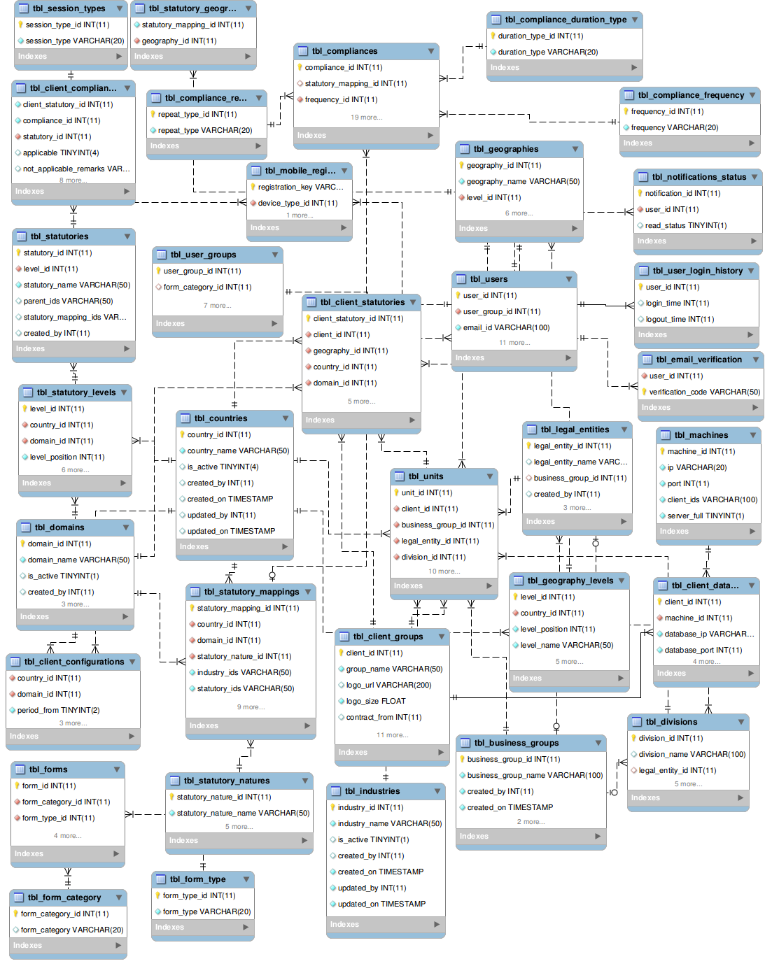

Schema Diagram – Client Database

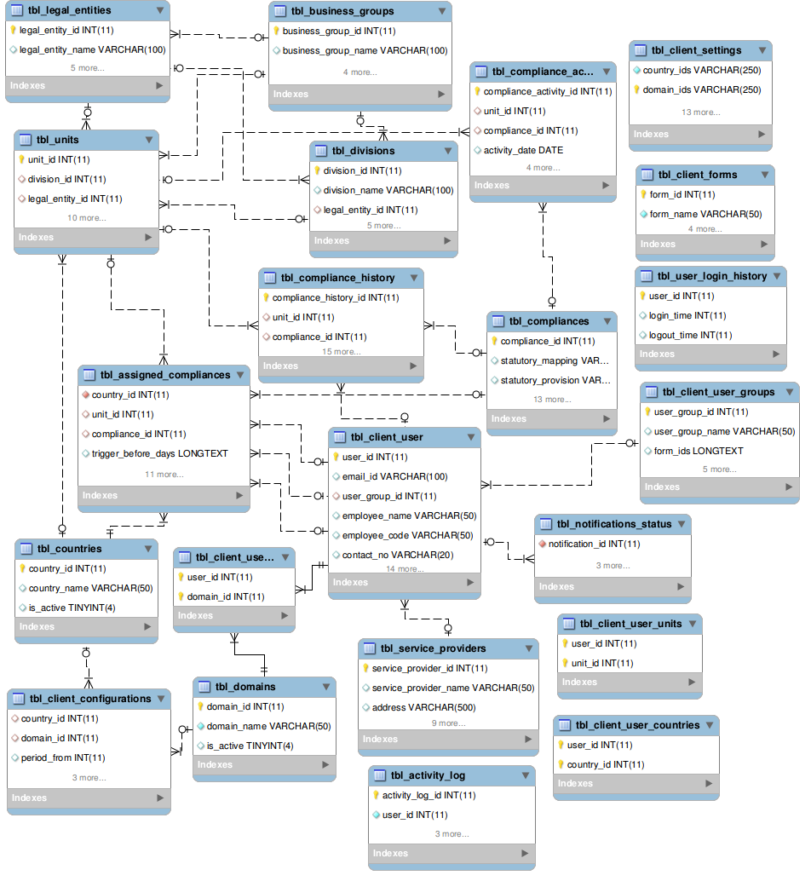

Schema Definition – Mobile Database

Following Schema definition is common for Android, iOS and Blackberry. Data types will be changed according to the mobile native databases
# | Table Name | Fields | Data type | Size | Default Value | Key | Reference
Session
1 | tbl_session | user_id | INT | 11
1 | tbl_session | user_name | VARCHAR | 50
1 | tbl_session | session_token | VARCHAR | 100
1 | tbl_session | login_time | TIMESTAMP
Versions
2 | tbl_versions | unit_details | INT | 11
2 | tbl_versions | user_details | INT | 11
2 | tbl_versions | compliance_applicability | INT | 11
2 | tbl_versions | compliance_history | INT | 11
2 | tbl_versions | reassign_history | INT | 11
Countries
3 | tbl_countries | country_id | INT | 11 |  | PK
3 | tbl_countries | country_name | VARCHAR | 50
Domains
4 | tbl_domains | domain_id | INT | 11 |  | PK
4 | tbl_domains | domain_name | VARCHAR | 50
Industries
5 | tbl_industries | industry_id | INT | 11 |  | PK
5 | tbl_industries | industry_name | VARCHAR | 50
Group Company
6 | tbl_group_company | group_company_id | INT | 11 |  | PK
6 | tbl_group_company | group_company_name | VARCHAR | 50
Business Groups
7 | tbl_business_groups | business_group_id | INT | 11 |  | PK
7 | tbl_business_groups | business_group_name | VARCHAR | 50
Legal Entities
8 | tbl_legal_entities | legal_entity_id | INT | 11 |  | PK
8 | tbl_legal_entities | business_group_id | INT | 11 |  | FK | tbl_business_groups
8 | tbl_legal_entities | legal_entity_name | VARCHAR | 50
Divisions
9 | tbl_divisions | division_id | INT | 11 |  | PK
9 | tbl_divisions | legal_entity_id | INT | 11 |  | FK | tbl_legal_entities
9 | tbl_divisions | business_group_id | INT | 11 |  | FK | tbl_business_groups
9 | tbl_divisions | division_name | VARCHAR | 50
Units
10 | tbl_units | unit_id | INT | 11 |  | PK
10 | tbl_units | division_id | INT | 11 |  | FK | tbl_divisions
10 | tbl_units | legal_entity_id | INT | 11 |  | FK | tbl_legal_entities
10 | tbl_units | business_group_id | INT | 11 |  | FK | tbl_business_groups
10 | tbl_units | unit_name | VARCHAR | 50
Users
11 | tbl_users | user_id | INT | 11 |  | PK
11 | tbl_users | user_name | VARCHAR | 50
11 | tbl_users | seating_unit | INT | 11 |  | FK | tbl_units
Statutory Mapping
12 | tbl_statuatory_mappings | mapping_id | INT | 11 |  | PK
12 | tbl_statuatory_mappings | country_id | INT | 11 |  | FK | tbl_countries
12 | tbl_statuatory_mappings | domain_id | INT | 11 |  | FK | tbl_domains
12 | tbl_statuatory_mappings | industry_id | INT | 11 |  | FK | tbl_industries
12 | tbl_statuatory_mappings | statutory_nature_name | VARCHAR | 50
12 | tbl_statuatory_mappings | statutories | VARCHAR | 250
12 | tbl_statuatory_mappings | compliance_ids | VARCHAR | 100
12 | tbl_statuatory_mappings | geographies | VARCHAR | 250
12 | tbl_statuatory_mappings | approval_status | BOOLEAN |  | 0
12 | tbl_statuatory_mappings | Remarks | VARCHAR | 250
Compliances
13 | tbl_compliances | compliance_id | INT | 11 |  | PK
13 | tbl_compliances | statutory_provision | VARCHAR | 250
13 | tbl_compliances | compliance_task | VARCHAR | 50
13 | tbl_compliances | compliance_description | VARCHAR | 250
13 | tbl_compliances | document_name | VARCHAR | 50
13 | tbl_compliances | format_file_name | VARCHAR | 50
13 | tbl_compliances | penal_consequences | VARCHAR | 250
13 | tbl_compliances | compliance_frequency | VARCHAR | 20
13 | tbl_compliances | statutory_dates | VARCHAR | 250
13 | tbl_compliances | repeats_every | INT | 11
13 | tbl_compliances | repeats_type | VARCHAR | 20
13 | tbl_compliances | Duration | INT | 11
13 | tbl_compliances | duration_type | VARCHAR | 20
13 | tbl_compliances | statutory_mapping_id | INT | 11 |  | FK | tbl_statutory_mappings
Compliance Applicability
14 | tbl_compliance_applicability | country_id | INT | 11 |  | FK | tbl_countries
14 | tbl_compliance_applicability | domain_id | INT | 11 |  | FK | tbl_domains
14 | tbl_compliance_applicability | unit_id | INT | 11 |  | FK | tbl_units
14 | tbl_compliance_applicability | compliance_id | INT | 11 |  | FK | tbl_compliances
14 | tbl_compliance_applicability | compliance_name | VARCHAR | 50
14 | tbl_compliance_applicability | compliance_frequency | VARCHAR | 20
14 | tbl_compliance_applicability | compliance_applicability | BOOLEAN
14 | tbl_compliance_applicability | compliance_opted | BOOLEAN
Compliance History
15 | tbl_compliance_history | compliance_history_id | INT | 11 |  | PK
15 | tbl_compliance_history | unit_id | INT | 11 |  | FK | tbl_units
15 | tbl_compliance_history | compliance_id | INT | 11 |  | FK | tbl_compliances
15 | tbl_compliance_history | start_date | DATE
15 | tbl_compliance_history | due_date | DATE
15 | tbl_compliance_history | completion_date | DATE
15 | tbl_compliance_history | documents | VARCHAR | 250
15 | tbl_compliance_history | validity_date | DATE
15 | tbl_compliance_history | next_due_date | DATE
15 | tbl_compliance_history | Remarks | VARCHAR | 500
15 | tbl_compliance_history | completed_by | INT | 11
15 | tbl_compliance_history | completed_on | DATE
15 | tbl_compliance_history | concurrence_status | BOOLEAN |  | 0
15 | tbl_compliance_history | concurred_by | INT | 11
15 | tbl_compliance_history | concurred_on | DATE
15 | tbl_compliance_history | approval_status | BOOLEAN |  | 0
15 | tbl_compliance_history | approved_by | INT | 11
15 | tbl_compliance_history | approved_on | DATE
Reassigned History
16 | tbl_reassign_history | unit_id | INT | 11 |  | COMPOSITE  KEY | tbl_untis
16 | tbl_reassign_history | compliance_history_id | INT | 11 |  | COMPOSITE  KEY | tbl_compliance_history
16 | tbl_reassign_history | Assignee | INT | 11
16 | tbl_reassign_history | reassigned_from | INT | 11
16 | tbl_reassign_history | reassigned_date | DATE
16 | tbl_reassign_history | Remarks | VARCHAR | 500
Escalations
17 | tbl_escalations | unit_id | INT | 11 |  | COMPOSITE  KEY | tbl_units
17 | tbl_escalations | Year | INT | 11 |  | COMPOSITE  KEY
17 | tbl_escalations | delayed_compliance_count | INT | 11
17 | tbl_escalations | not_complied_count | INT | 11
Trend Chart
18 | tbl_trend_chart | unit_id | INT | 11 |  | COMPOSITE  KEY | tbl_units
18 | tbl_trend_chart | Year | INT | 11 |  | COMPOSITE  KEY
18 | tbl_trend_chart | total_compliances | INT | 11
18 | tbl_trend_chart | complied_compliances_count | INT | 11
Notifications
19 | tbl_notifications | notification_id | INT | 11 |  | PK
19 | tbl_notifications | notification_type | VARCHAR | 20
19 | tbl_notifications | notification_text | VARCHAR | 500
19 | tbl_notifications | read_status | BOOLEAN

Note: These documents are strictly for Mindssoft Technology with the specific client Aparajitha Corporate Services Private Limited use only. They shall not be shared with an external party other than the client concerned. These documents should always be kept securely from unauthorized use or disclosure to a third party.

Document Approval

Mindssoft Technology and Aparajitha Corporate Services Private Limited have reviewed this document and agree that the contents of the document are accurate. Any changes to this document must be communicated in writing, approved and signed off by both parties.

Signature | Signature
Date: | Date:
Name: N.R. Venkatesh Ram Mohan | Name:
Designation: Project Director | Designation:
Supplier: Mindssoft Technology | Client: Aparajitha

