Customer Retention &
Sales Analytics Dashboard
Using SQL + Excel – dataset – Online retail II (Kaggle)
£480,590  Total Revenue | 771  Total Customers | 1,059  Total Orders | 21.9%  Repeat Rate
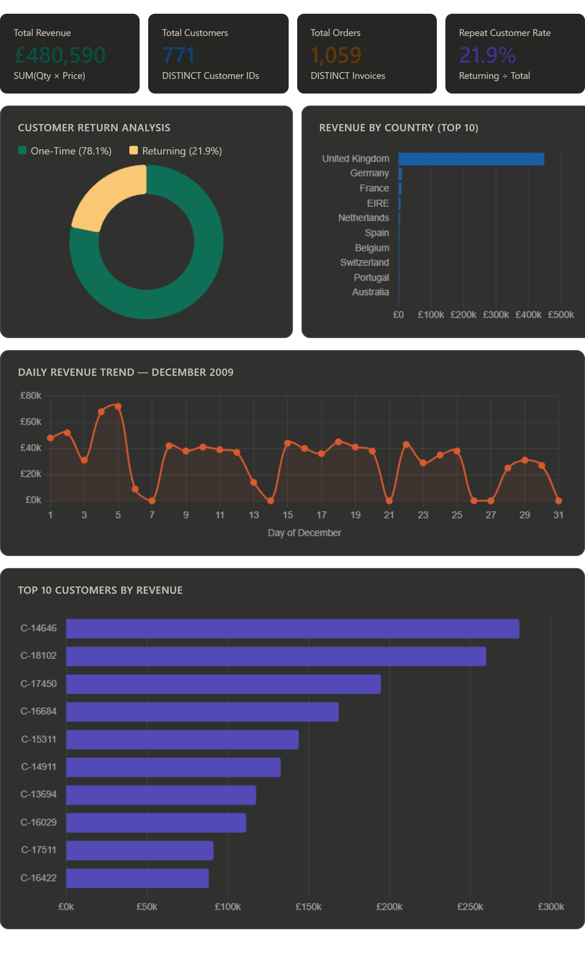

1. Introduction

This project analyzes real e-commerce transaction data to understand how customers behave — specifically whether they return to buy again, how much they spend, and which customers and countries drive the most revenue.

The entire pipeline was built using two tools:

Tool | What It Does
SQL (MySQL) | Clean raw data, remove bad records, calculate every KPI and metric
Excel | Visualize the results — KPI cards, bar charts, pie charts, and line trends

Why this project matters for interviews
End-to-end flow: raw data -> cleaning -> aggregation -> visualization
Uses real-world SQL patterns: subqueries, GROUP BY, CASE WHEN, HAVING
Covers core DS/analyst skills: retention analysis, KPI design, business storytelling
Dashboard screenshots show practical Excel charting ability

2. Dataset Overview

What is this dataset?
Online Retail II is a real transaction dataset from a UK-based gift and homeware store. Every row represents one line item on a customer invoice — one product, on one invoice, for one customer, on one date.

Dataset size (after cleaning)

22,218  Transactions | 771  Customers | 1,059  Orders

Key columns and their meaning

Column | What It Means
Invoice | Unique ID per transaction. If it starts with 'C', it's a cancellation.
Customer ID | Who bought it. Rows without this are anonymous guests — excluded.
InvoiceDate | When the purchase happened. Used for trend analysis.
Quantity | Units sold. Negative = returned item. Must be excluded from revenue.
Price | Price per unit. Zero or negative = bad data. Must be excluded.
Country | Where the customer is located. UK dominates this dataset.

3. Data Cleaning

Raw data is almost never ready to analyse. This section covers the 5 problems found in this dataset and exactly how they were fixed.

Interview tip
Always clean before calculating. Interviewers love when you say: 'I quantified
the issues first, then excluded them, then created a clean table for all KPIs.'
It shows systematic thinking, not just code.

Problem 1 — Duplicate rows
Same invoice, same product, same customer, same price appearing twice. Causes double-counting of revenue and orders.

-- Find exact duplicate rows
SELECT Invoice, StockCode, `Customer ID`, InvoiceDate, Quantity, Price,
COUNT(*) AS duplicate_count
FROM online_retail_ii
GROUP BY Invoice, StockCode, `Customer ID`, InvoiceDate, Quantity, Price
HAVING COUNT(*) > 1;

GROUP BY all business-key columns — any group with count > 1 is a duplicate. Zero rows returned = clean on this check.

Problem 2 — Missing Customer ID
~25% of rows have no Customer ID (guest checkouts). These can't be used for retention analysis since we can't track whether they returned.

-- Count and % of missing Customer IDs
SELECT COUNT(*) AS total_rows,
SUM(CASE WHEN `Customer ID` IS NULL THEN 1 ELSE 0 END) AS missing_id,
ROUND(SUM(CASE WHEN `Customer ID` IS NULL THEN 1 ELSE 0 END)
* 100.0 / COUNT(*), 2) AS missing_pct
FROM online_retail_ii;

Quantifying before excluding is key — knowing 25% are guests is itself a business insight (significant anonymous traffic).

Problem 3 — Negative Quantity (Returns)
Negative quantity = customer returned the item. Including these would reduce revenue unfairly. Zero quantity = data entry error with no business meaning.

-- Count returns (negative) vs bad data (zero)
SELECT SUM(CASE WHEN Quantity < 0 THEN 1 ELSE 0 END) AS return_rows,
SUM(CASE WHEN Quantity = 0 THEN 1 ELSE 0 END) AS zero_qty_rows
FROM online_retail_ii;

Returns and zeros are two different problems. Treating them separately shows precision. Returns could even be analysed separately (return rate by product).

Problem 4 — Invalid Price
Prices of zero or below are meaningless for revenue calculations. These are typically test entries or free samples.

-- Find zero or negative prices
SELECT COUNT(*) AS invalid_price_rows,
MIN(Price) AS min_price,
MAX(Price) AS max_price
FROM online_retail_ii
WHERE Price <= 0;

Problem 5 — Cancelled Invoices
Cancelled orders start with the letter 'C' in the Invoice column. These are not real sales and must be excluded.

-- Cancellations are flagged in Invoice itself
SELECT COUNT(*) AS cancelled_orders
FROM online_retail_ii
WHERE Invoice LIKE 'C%';

Final: Creating the Clean Table
All five exclusions are combined into one CREATE TABLE statement. All KPI queries run against this clean table only.

CREATE TABLE online_retail_clean AS
SELECT *
FROM online_retail_ii
WHERE `Customer ID` IS NOT NULL -- removes guests
AND Quantity > 0 -- removes returns & zeros
AND Price > 0 -- removes invalid prices
AND Invoice NOT LIKE 'C%'; -- removes cancellations

4. KPI Analysis

All KPIs below are calculated from online_retail_clean. For each one: what it measures, the SQL used, and how to interpret it in an interview.

KPI 1 — Total Customers
SELECT COUNT(DISTINCT `Customer ID`) AS total_customers
FROM online_retail_clean;
-- Result: 771

How to explain this
COUNT(DISTINCT) ensures each customer is counted once, even if they placed 10 orders.
This is the baseline for all percentage-based retention metrics.

KPI 2 — Total Orders
SELECT COUNT(DISTINCT Invoice) AS total_orders
FROM online_retail_clean;
-- Result: 1,059

How to explain this
One invoice = one order, even if it has 50 line items.
DISTINCT prevents counting each product row as a separate order.

KPI 3 — Total Revenue
SELECT ROUND(SUM(Quantity * Price), 2) AS total_revenue
FROM online_retail_clean;
-- Result: £480,590.06

How to explain this
Revenue is calculated at the row level (Quantity x Price per line item), then summed.
Since returns and zero-price rows are already excluded, this is net clean revenue.

KPI 4 — Average Order Value (AOV)
SELECT ROUND(AVG(order_revenue), 2) AS avg_order_value
FROM (
SELECT Invoice, SUM(Quantity * Price) AS order_revenue
FROM online_retail_clean
GROUP BY Invoice
) AS order_totals;

How to explain this
The subquery first calculates total revenue per invoice (order level).
The outer query then averages those order totals.
You cannot use AVG(Quantity*Price) directly — that averages line items, not orders.

KPI 5 — Repeat Customer Rate
SELECT ROUND(
COUNT(CASE WHEN order_count > 1 THEN 1 END) * 100.0 / COUNT(*), 2
) AS repeat_customer_rate_pct
FROM (
SELECT `Customer ID`, COUNT(DISTINCT Invoice) AS order_count
FROM online_retail_clean
GROUP BY `Customer ID`
) AS customer_orders;
-- Result: 21.9%

How to explain this
Inner query: count how many orders each customer placed.
Outer query: what % of customers placed more than 1?
21.9% means roughly 1 in 5 customers came back. Context: industry average is 25-40%.
Interview angle: 'This tells us retention has room to improve.'

KPI 6 — One-Time vs Returning Customers
SELECT customer_type, COUNT(*) AS customer_count
FROM (
SELECT `Customer ID`,
CASE WHEN COUNT(DISTINCT Invoice) = 1 THEN 'One-Time'
ELSE 'Returning' END AS customer_type
FROM online_retail_clean
GROUP BY `Customer ID`
) AS segments
GROUP BY customer_type;

How to explain this
CASE WHEN inside a subquery segments each customer into a bucket.
The outer GROUP BY then counts each bucket.
High one-time count = churn risk. These customers need re-engagement campaigns.

KPI 7 — Purchase Frequency
SELECT ROUND(AVG(order_count), 2) AS avg_purchase_frequency
FROM (
SELECT `Customer ID`, COUNT(DISTINCT Invoice) AS order_count
FROM online_retail_clean
GROUP BY `Customer ID`
) AS freq;

How to explain this
Frequency feeds into CLV: CLV = AOV x Frequency x Lifespan.
A higher frequency = customers are engaged and returning regularly.

KPI 8 — Top 10 Customers by Revenue
SELECT `Customer ID`,
COUNT(DISTINCT Invoice) AS total_orders,
ROUND(SUM(Quantity * Price), 2) AS total_revenue,
ROUND(AVG(Quantity * Price), 2) AS avg_order_value
FROM online_retail_clean
GROUP BY `Customer ID`
ORDER BY total_revenue DESC
LIMIT 10;

How to explain this
Shows the VIP customer segment in a single query.
Three metrics per customer: total revenue, how often they order, and AOV.
Interview angle: 'Top 10 customers often drive 30-40% of total revenue.
Losing even one is a significant business risk — they need priority retention.'

5. Excel Dashboard

The dashboard translates SQL output into visuals. Here is how each chart was built and what it tells the business.

Sheet structure

Sheet | Purpose
Sheet 1 — Raw Data | SQL export pasted here. Never edited directly.
Sheet 2 — KPI Summary | One row per KPI. All cards reference this sheet.
Sheet 3 — Chart Data | Monthly, country, top 10 aggregates for charts.
Sheet 4 — Dashboard | Final view: KPI cards + 4 charts. Gridlines off.

KPI Cards (Row 1)

£480,590  Total Revenue | 771  Total Customers | 1,059  Total Orders | 21.9%  Repeat Rate

How to build: Merge 4-5 cells per card. Type =Sheet2!B2 to link to KPI sheet. Bold the number, mute the label. Fill with a light background color.

Chart 1 — Daily Revenue Trend (Line Chart)
What | Detail
SQL to export | DAY(InvoiceDate), SUM(Qty*Price) grouped by day
Chart type in Excel | Line chart. Day on X-axis, Revenue on Y-axis.
Business insight | Sharp spikes at days 4-5 show bulk/wholesale orders. Dips after day 6 suggest mid-period slowdowns. Useful for staffing and inventory planning.

Chart 2 — Customer Return Analysis (Pie/Doughnut)
What | Detail
SQL to export | customer_type, customer_count (KPI 6 query)
Chart type in Excel | Doughnut chart. Two slices: One-Time and Returning.
Business insight | High one-time slice = majority of customers don't return. This is the core business problem this project is designed to surface.

Chart 3 — Top 10 Customers by Revenue (Bar Chart)
What | Detail
SQL to export | Customer ID, total_revenue from KPI 8 query (LIMIT 10)
Chart type in Excel | Horizontal bar chart, sorted descending by revenue.
Business insight | Revenue is concentrated in a small group. Losing the top customer alone could mean losing ~6% of total revenue. Retention offers for this group have high ROI.

Chart 4 — Revenue by Country (Bar Chart)
What | Detail
SQL to export | Country, SUM(Qty*Price) grouped by country, top 10
Chart type in Excel | Vertical bar chart, sorted by revenue descending.
Business insight | UK = 93% of revenue. All other markets are tiny. This means either the store hasn't expanded marketing internationally, or international demand is low. Either way, it's a strategic question worth raising.

6. Key Insights

These are the business conclusions from the data. In an interview, always connect numbers back to actions.

Insight | Business Action
21.9% Repeat Rate | Only 1 in 5 customers comes back. Below the 25-40% industry benchmark. Suggests a need for loyalty programs, email re-engagement, or post-purchase follow-ups.
Revenue concentration | Top 10 customers drive a disproportionate share of revenue. VIP retention is higher ROI than acquiring new customers.
UK = 93% of revenue | The store is almost entirely UK-dependent. Germany, Netherlands and France show small but present demand — potential expansion markets.
Day-level revenue spikes | Certain days (4-5 in the dataset) show very high revenue — likely wholesale orders. Identifying these patterns helps with inventory and logistics planning.
High one-time customer volume | Most customers buy once and never return. Reducing this through re-engagement campaigns is the single highest-impact lever for revenue growth.

7. SQL Patterns Used — Interview Cheat Sheet

These are the core SQL patterns in this project. Understand each one — interviewers often ask you to explain your queries.

Pattern | When Used in This Project
COUNT(DISTINCT col) | Count unique values only. Used for customers and orders.
SUM(col1 * col2) | Row-level calculation then rolled up. Used for revenue.
Subquery + AVG() | Aggregate at one level, then average at a higher level. Used for AOV and frequency.
CASE WHEN inside GROUP BY | Segment rows into categories before counting. Used for one-time vs returning.
HAVING COUNT(*) > 1 | Filter after aggregation. Used for duplicate detection.
NOT LIKE 'C%' | Pattern exclusion on a text column. Used to remove cancellations.
ORDER BY x DESC LIMIT 10 | Rank and cap results. Used for top 10 customers and countries.

8. Conclusion

This project demonstrates a complete analytics workflow — from messy raw data to a clean, visual, interview-ready dashboard.

The most important things to communicate in an interview:

- You cleaned first, then calculated — not the other way around
- Every exclusion was deliberate and quantified before applying it
- Each KPI connects to a business question, not just a number
- The dashboard is designed to be read by a non-technical stakeholder
- 21.9% repeat rate is the headline finding — and you know what to do about it

One-liner summary for interviews
I used SQL to clean ~22K retail transactions — removing nulls, returns, bad prices,
and cancellations — then calculated retention, revenue, and customer value KPIs,
visualized in an Excel dashboard. Key finding: 21.9% repeat rate, below benchmark,
with revenue concentrated in the UK and a small group of VIP customers.

Customer Retention & Sales Analytics | SQL + Excel Project | Interview Reference

