GREENPOD LABS
ASSESSMENT–1
Banana Leaf Disease Detection and Classification
Computer Vision Pipeline – Summary Report

Item | Details
Problem | Detection and classification of different banana leaf diseases
Approaches implemented | HOG feature extraction + SVM; MobileNetV2 transfer learning
Number of classes | 7
Test images | 62
Best test accuracy | 76.00% (MobileNetV2)
Prepared for Assessment-1 submission

1. Introduction
Banana is an important agricultural crop, and leaf diseases can significantly affect plant health and yield. Early identification of disease symptoms from leaf images can help farmers and agricultural professionals take appropriate action. The objective of this assessment is to build a computer vision pipeline capable of classifying banana leaf images into different disease categories and to compare two different modelling approaches.
The implemented solution compares a traditional computer-vision approach based on Histogram of Oriented Gradients (HOG) features and a Support Vector Machine (SVM) classifier against a deep-learning approach based on MobileNetV2 transfer learning. The comparison demonstrates the difference between hand-crafted image features and learned visual representations.

2. Assessment Requirements Addressed
Requirement | How it was addressed
Two different approaches | HOG feature extraction + SVM and MobileNetV2 transfer learning
Dataset understanding | Seven classes, image validation, train/validation/test split, class-support analysis
Outliers / quality issues | Image-file validation and inspection of class folders; invalid/corrupt image files are treated as data-quality issues
Class imbalance | Test-set class supports range from 3 to 13 images, indicating an uneven class distribution
Model selection | Each model is justified according to dataset characteristics and computational constraints
Evaluation metrics | Accuracy, precision, recall, F1-score, classification report and confusion matrix
Model comparison | HOG + SVM: 48.39%; MobileNetV2: 76.00% test accuracy
Example run | A held-out Banana Healthy Leaf image is correctly classified by MobileNetV2; all 13 test images of that class were correctly predicted
Mandatory questions | Production performance, drawbacks, improvements with more time, and time spent during the assignment are answered in Section 10

3. Understanding of the Dataset
The dataset is an image-based banana leaf disease dataset organized into class-specific folders. The working pipeline identified seven categories. The final experimental split used 285 training images, 61 validation images and 62 test images, giving 408 images in total.
The seven classes and their observed test-set supports are:
No. | Class | Test Support
1 | Banana Black Sigatoka Disease | 10
2 | Banana Bract Mosaic Virus Disease | 8
3 | Banana Healthy Leaf | 13
4 | Banana Insect Pest Disease | 13
5 | Banana Moko Disease | 9
6 | Banana Panama Disease | 6
7 | Banana Yellow Sigatoka Disease | 3
The dataset contains real image variability such as differences in orientation, illumination, background, leaf appearance and disease severity. These variations are important because a classifier must learn disease patterns rather than memorizing a particular background or image arrangement.

3.1 Data Quality, Outliers and Biases
Image validation: The image-loading pipeline validated image filenames before model training. This reduces the risk of training on unreadable or unsupported files.
Visual outliers: Images with unusual lighting, framing, background, leaf orientation or very severe/weak symptoms can behave as visual outliers even though they are valid files.
Class imbalance: The test supports are not equal. Banana Healthy Leaf and Banana Insect Pest Disease each have 13 test images, while Banana Yellow Sigatoka Disease has only 3. This makes accuracy alone insufficient for judging class-level performance.
Potential dataset bias: A model may learn background, camera or acquisition characteristics that correlate with disease labels. Image augmentation and more diverse samples would help reduce this risk.

4. Computer Vision Pipeline
The overall workflow used for the assessment can be summarized as:
Dataset → Image Validation → Preprocessing → Feature/Representation Extraction → Model Training → Validation → Test Prediction → Metrics → Model Comparison

4.1 Data Preparation
Images were organized by class labels using the directory structure.
The dataset was divided into training, validation and test subsets.
For the deep-learning pipeline, images were resized to a common input size and converted into tensors suitable for MobileNetV2.
For the classical pipeline, image features were transformed into HOG descriptors before classification.
The test set was kept separate for final performance comparison.

5. Understanding of Model Selection

5.1 Approach 1 – HOG + SVM
Histogram of Oriented Gradients (HOG) is a hand-crafted image descriptor that captures local edge and shape information. The extracted HOG feature vectors were supplied to a Support Vector Machine (SVM) classifier.
Why it was selected: HOG + SVM provides a strong and interpretable traditional baseline for image classification. It is comparatively lightweight and useful when computational resources are limited. It also provides a meaningful comparison against a learned deep representation.
Limitation for this dataset: banana disease symptoms can depend on color, texture, spatial patterns and larger visual structures. HOG focuses primarily on local gradient/shape information and therefore may lose disease-specific information that a deep neural network can learn.

5.2 Approach 2 – MobileNetV2 Transfer Learning
MobileNetV2 is a lightweight convolutional neural network designed for efficient image recognition. Transfer learning was used so that a pre-trained visual representation could be adapted to the seven banana-leaf classes.
Why it was selected: the dataset is relatively small for training a deep CNN completely from scratch. Transfer learning allows the model to reuse general visual features learned from a large image corpus while learning a new classification head for the banana disease classes. MobileNetV2 is also substantially lighter than many large CNN architectures, making it a practical choice for future deployment.
Criterion | HOG + SVM | MobileNetV2
Representation | Hand-crafted HOG features | Learned CNN features
Classifier | Support Vector Machine | Neural-network classification head
Training requirement | Lower | Higher
Feature learning | Manual feature design | Automatic feature learning
Expected deployment suitability | Very lightweight | Lightweight deep-learning option
Observed test accuracy | 48.39% | 76.00%

6. Understanding of Evaluation Metrics
Because this is a multi-class disease-classification problem with unequal class supports, several metrics are considered instead of relying only on accuracy.
Metric | Meaning | Why used
Accuracy | Fraction of all test images classified correctly | Provides an overall measure of correct predictions
Precision | Of images predicted as a class, how many truly belong to that class | Important when false disease identification is undesirable
Recall | Of the actual images in a class, how many were detected | Important for detecting disease cases and avoiding missed cases
F1-score | Harmonic mean of precision and recall | Balances false positives and false negatives
Confusion matrix | Counts actual vs predicted classes | Shows which diseases are being confused
For this assessment, macro-average metrics are particularly informative because they give each disease class equal importance, while weighted averages reflect the actual number of images in each class. The confusion matrix is also important because a model with acceptable overall accuracy can still perform poorly on a minority disease class.

7. Results and Model Comparison
The final held-out test results show a clear improvement from the traditional HOG + SVM approach to the MobileNetV2 transfer-learning approach.
Model | Test Accuracy | Macro Precision | Macro Recall | Macro F1 | Weighted F1
HOG + SVM | 48.39% | 0.54 | 0.44 | 0.43 | 0.45
MobileNetV2 | 76.00% | 0.75 | 0.68 | 0.67 | 0.75
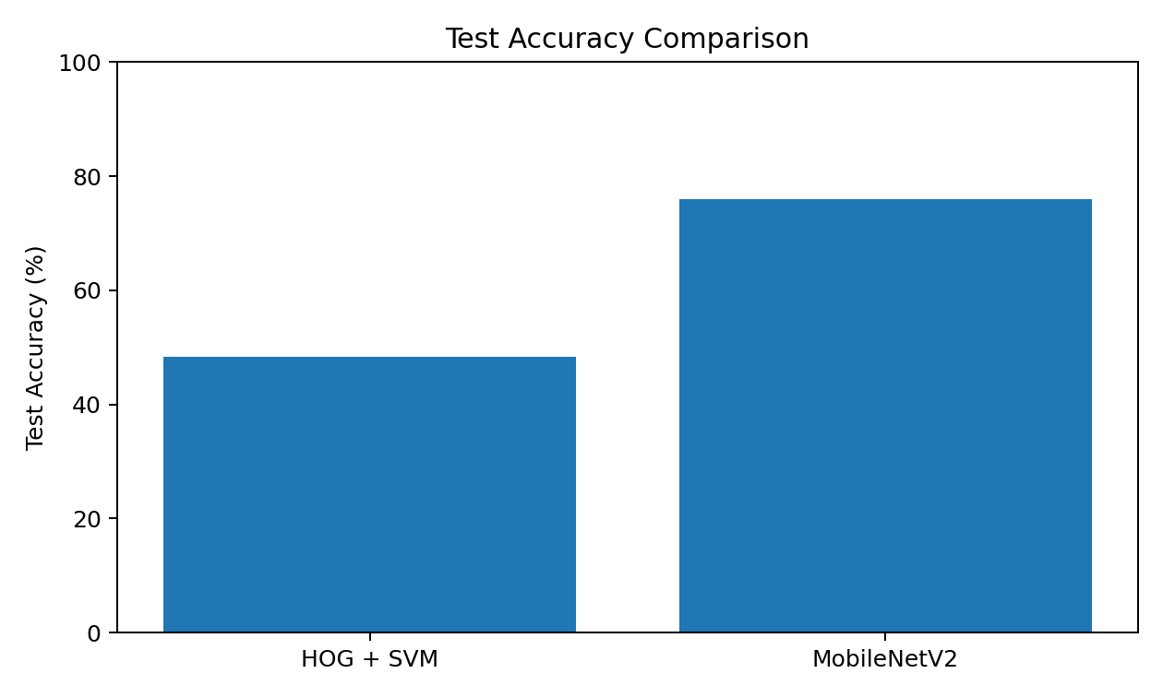
MobileNetV2 improved test accuracy by 27.61 percentage points over HOG + SVM. The improvement in macro precision, macro recall and macro F1 also indicates that the gain was not limited to a single overall accuracy number.

7.1 HOG + SVM Classification Results
Class | Precision | Recall | F1-score | Support
Black Sigatoka | 0.17 | 0.10 | 0.12 | 10
Bract Mosaic Virus | 0.70 | 0.88 | 0.78 | 8
Healthy Leaf | 0.75 | 0.92 | 0.83 | 13
Insect Pest | 0.27 | 0.46 | 0.34 | 13
Moko Disease | 0.40 | 0.22 | 0.29 | 9
Panama Disease | 1.00 | 0.17 | 0.29 | 6
Yellow Sigatoka | 0.50 | 0.33 | 0.40 | 3
The HOG + SVM model performed well on some classes such as Healthy Leaf, but it struggled considerably with Black Sigatoka and Insect Pest Disease. This indicates that hand-crafted gradient features were not sufficient to consistently separate visually similar disease patterns.

7.2 MobileNetV2 Classification Results
Class | Precision | Recall | F1-score | Support
Black Sigatoka | 0.50 | 0.70 | 0.58 | 10
Bract Mosaic Virus | 0.88 | 0.88 | 0.88 | 8
Healthy Leaf | 1.00 | 1.00 | 1.00 | 13
Insect Pest | 0.91 | 0.77 | 0.83 | 13
Moko Disease | 0.67 | 0.89 | 0.76 | 9
Panama Disease | 1.00 | 0.17 | 0.29 | 6
Yellow Sigatoka | 0.33 | 0.33 | 0.33 | 3
MobileNetV2 produced especially strong results for Healthy Leaf, Bract Mosaic Virus and Moko Disease. The main weakness was Panama Disease recall (0.17), meaning most Panama Disease test images were not recognized as Panama Disease. Yellow Sigatoka also remains difficult, but its support is only three test images, so that class-level estimate is less stable.

8. Confusion Matrix Interpretation
The MobileNetV2 confusion matrix shows strong diagonal performance for several classes. All 13 Healthy Leaf test images were classified correctly. Seven of ten Black Sigatoka images were correctly classified, while Insect Pest and Moko Disease also achieved substantial correct counts.
The matrix also shows that some disease classes are confused with one another. In particular, Panama Disease has only one correctly classified test image out of six. This confirms why recall and the confusion matrix are necessary in addition to overall accuracy.

9. Example Run Demonstrating the Model
A single image can be processed through the trained pipeline as follows:
Input: a banana leaf image from the test set.
Preprocessing: resize/normalize the image using the same preprocessing used during model training.
Feature/representation stage: MobileNetV2 extracts a compact visual representation from the image.
Classification: the final classification layer assigns probabilities to the seven disease classes.
Output: the class with the highest predicted probability is returned as the predicted disease label.
A representative verified class-level example from the final test results is Banana Healthy Leaf: the MobileNetV2 confusion matrix contains 13 correct predictions for this class out of 13 test images. Therefore, a held-out Healthy Leaf example can be correctly identified as Banana Healthy Leaf by the trained model.

10. Mandatory Questions

10.1 In production, how does your model perform?
The MobileNetV2 model is the stronger of the two tested approaches, reaching 76.00% accuracy on the held-out test set with a weighted F1-score of 0.75. This suggests that the model is useful as a prototype for automated banana-leaf disease screening. However, 76% test accuracy is not sufficient by itself to claim reliable production diagnosis. In production, the system should be evaluated on larger and more diverse images collected under real farm conditions, and class-specific recall should be monitored carefully.

10.2 What is the drawback of your model?
The main drawback of the MobileNetV2 model is that its performance is uneven across disease classes. For example, Panama Disease has a recall of only 0.17, and Yellow Sigatoka has an F1-score of 0.33. The model also depends on the quality and representativeness of the training images. Changes in lighting, background, camera quality and disease severity may reduce performance. Compared with HOG + SVM, it also requires more computational resources.

10.3 If given more time, what would you improve?
Increase the number and diversity of images for underrepresented disease classes.
Apply stronger and carefully chosen data augmentation, especially for lighting, rotation, scale and viewpoint changes.
Tune the MobileNetV2 learning rate, dropout, classifier-head size and fine-tuning strategy.
Use class weights or targeted sampling to improve minority-class recall.
Perform systematic hyperparameter tuning and cross-validation where appropriate.
Evaluate additional lightweight transfer-learning models such as EfficientNet-Lite or MobileNet variants.
Test the final model on images collected outside the original dataset to measure real-world generalization.
Build a simple deployment interface so that a user can upload a leaf image and receive the predicted class and confidence score.

10.4 Where did you spend more time during solving the assignment?
The largest amount of effort was spent on dataset handling and making the computer-vision pipeline run correctly. This included obtaining/extracting the dataset, checking the folder and class structure, validating image files, creating the training/validation/test inputs, resolving path and runtime issues, training the two approaches, and generating the classification reports and confusion matrices. Additional effort was required to save the trained MobileNetV2 model and prepare the final comparison.

11. Conclusion
This assessment successfully implemented and compared two computer vision approaches for banana leaf disease classification: HOG feature extraction with SVM and MobileNetV2 transfer learning. The experiment used seven classes and a final test set of 62 images. HOG + SVM achieved 48.39% test accuracy, whereas MobileNetV2 achieved 76.00%, giving MobileNetV2 a 27.61 percentage-point advantage.
The evaluation demonstrates that the learned visual representations of a lightweight CNN are more effective for this dataset than the hand-crafted HOG representation. At the same time, the class-level results show that further work is required, especially for difficult or underrepresented disease classes such as Panama Disease and Yellow Sigatoka. Therefore, MobileNetV2 is selected as the better approach for the current prototype, while future work should focus on dataset expansion, class balancing, augmentation, fine-tuning and real-world validation.

12. References / Technical Resources
GreenPod Labs Assessment-1 problem statement and dataset link provided with the assignment.
MobileNetV2: Sandler et al., “MobileNetV2: Inverted Residuals and Linear Bottlenecks,” IEEE/CVF Conference on Computer Vision and Pattern Recognition (CVPR), 2018.
Histogram of Oriented Gradients: Dalal and Triggs, “Histograms of Oriented Gradients for Human Detection,” CVPR, 2005.
Scikit-learn documentation for Support Vector Classification and classification metrics.
TensorFlow/Keras documentation for image loading, transfer learning and MobileNetV2.

