## 7145-United Institute of Technology

## MEDIA STREAMING WITH IBM CLOUD VIDEO STREAMING

**Team Members:**

Abarna S

Abiraj C

Aswin L

Rahul B

Sharmila R

Suganth R

**Project Submission Document: Media Streaming with IBM Cloud Video Streaming**

**Phase 3: Development Part - 1**

**Project Overview:**

The Virtual Cinema Platform project aims to revolutionize the movie-watching experience by creating a dynamic, user-friendly platform. Leveraging the power of IBM Cloud Video Streaming, the project ensures seamless deployment, robust security, and engaging user interactions.

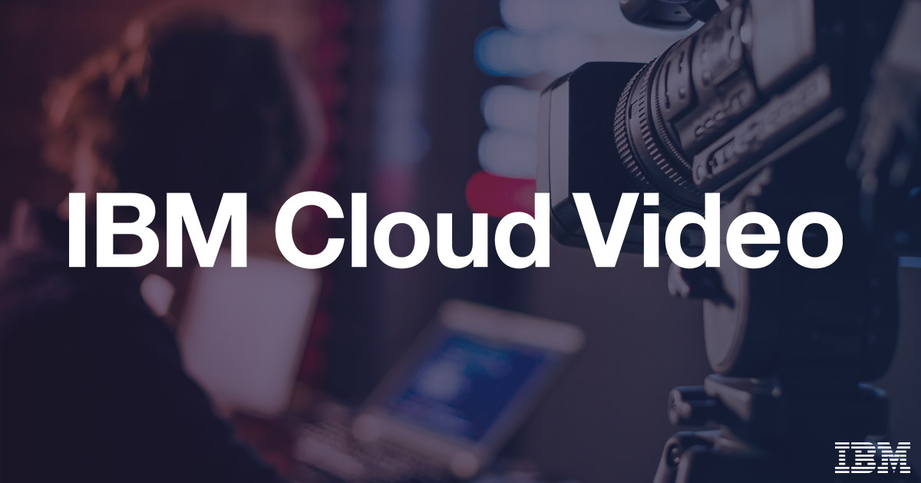

**Project Activities:**

***1. Setting Up IBM Cloud :***

**IBM Cloud Account Creation:**

* Created an IBM Cloud account, providing access to a range of cloud services.

**Creating Db2 in Resource:**

* Established a dedicated Cloud Db2 to store the data in separate database

***2. Application Development and Deployment:***

**Technology Stack Selection:**

* Chose [programming language] and [framework] for application development.

**Manifest File Configuration:**

* Defined application configurations in the `manifest.yml` file, specifying app name, memory allocation, and other settings.

**Code snippet:**

Applications:

- name: virtual-cinema-platform

memory: 256M

instances: 1

buildpacks:

- nodejs_buildpack

services:

- mongodb-service-instance

**Deployment Process:**

* Utilized the `CHANGE.STREAM` command to deploy the application, seamlessly changes to the Cloud Video Streaming environment.



***3. Service Integration:***

**Database Integration:**

* Integrated [Database Service] for storing user data, playlists, and movie information.

**Authentication Service Integration:**

* Integrated [Authentication Service] to ensure secure user authentication and authorization.

**Secure Handling of Credentials:**

* Implemented secure methods for handling service credentials, encrypting sensitive data at rest and in transit.

**code snippet:**

const express = require('express');

const passport = require('passport');

const LocalStrategy = require('passport-local').Strategy;

const User = require('./models/user'); // User model

passport.use(new LocalStrategy(

function(username, password, done) {

User.findOne({ username: username }, function (err, user) {

if (err) { return done(err); }

if (!user) { return done(null, false, { message: 'Incorrect username.' }); }

if (!user.validPassword(password)) { return done(null, false, { message: 'Incorrect password.' }); }

return done(null, user);

});

}

));

// Serialize and deserialize user for session management

passport.serializeUser(function(user, done) {

done(null, user.id);

});

passport.deserializeUser(function(id, done) {

User.findById(id, function(err, user) {

done(err, user);

});

});

***4. Environment Variables and Configuration:***

**Environment Variable Setup:**

* Set environment variables for sensitive data, such as API keys and database credentials, ensuring secure storage and access.

**Configuration Management:**

* Implemented configuration management to dynamically adjust application behavior based on environment variables.

**Code snippet:**

const express = require('express');

const router = express.Router();

const Playlist = require('./models/playlist'); // Playlist model

// Create a new playlist

router.post('/create', (req, res) => {

const { userId, playlistName, movies } = req.body;

const newPlaylist = new Playlist({ userId, playlistName, movies });

newPlaylist.save()

.then(playlist => {

res.json(playlist);

})

.catch(err => {

res.status(500).json({ error: err.message });

});

});

***5. Monitoring and Logging:***

**Logging Implementation:**

* Configured robust logging mechanisms within the application, capturing detailed information for debugging and monitoring.

**IBM Cloud Monitoring Services:**

* Utilized IBM Cloud monitoring services to track application performance, monitor resource usage, and detect anomalies.



***CONCLUSION:***

In conclusion, cloud video streaming represents a dynamic and transformative force in the world of media and online content delivery. Its ability to efficiently store, process, and distribute video content to a global audience has empowered creators, businesses, and educators to reach, engage, and inform audiences in ways previously unimaginable.

The cloud video streaming ecosystem offers a rich set of features, including adaptive streaming, security, monetization options, and detailed analytics, allowing content providers to deliver a seamless and personalized viewing experience while safeguarding their assets.

As the demand for high-quality video content continues to surge, cloud video streaming services, provided by tech giants and specialized platforms alike, offer scalable and reliable solutions to meet these ever-growing needs. This technology's flexibility and adaptability make it accessible to a wide range of use cases, from live events and on-demand libraries to corporate training and video conferencing.