**WEEK 8 HANDSON – GIT :**

**Task 1 :**

In this hands-on lab, you will learn how to

* Setup your machine with Git Configuration
* Integrate notepad++.exe to Git and make it a default editor
* Add a file to source code repository

CODES AND OUTPUTS :

**Step 1: Setup your machine with Git Configuration**

To create a new repository, signup with GitLab and register your credentials

Login to GitLab and create a “GitDemo” project

1. To check if Git client is installed properly: Open Git bash shell and execute

git version

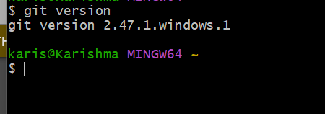

1. To configure user level configuration of user ID and email ID execute
2. To check if the configuration is properly set, execute the following command.

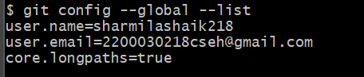

**Step 2: Integrate notepad++.exe to Git and make it a default editor**

1. To check, if notepad++.exe execute from Git bash

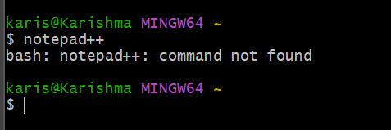

To add path of notepad++.exe to environment variable, go to control panel -> System -> Advanced System settings. Go to Advanced tab -> Environment variables -> Add path of notepad++.exe to the path user variable by clicking on “Edit”

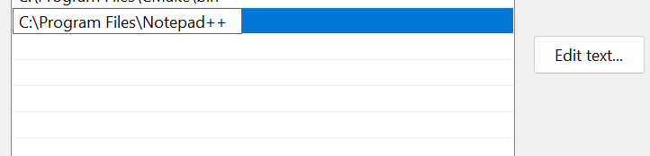

1. Exit Git bash shell, open bash shell and execute

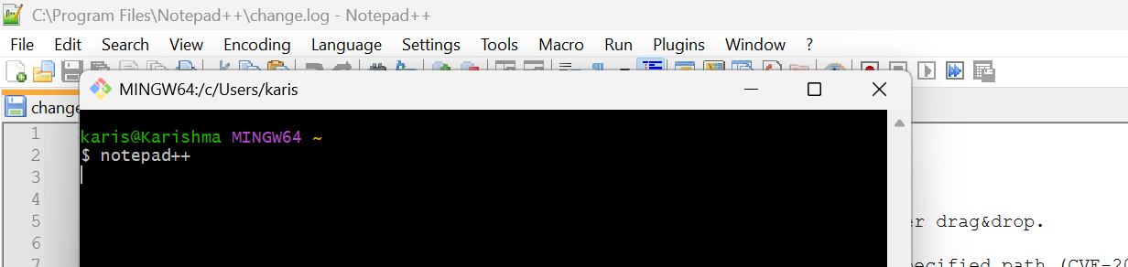

1. To create an alias command for notepad++.exe, execute

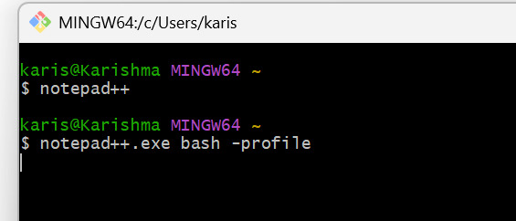

It will open notepad++ from bash shell, and create a user profile by adding the line in notepad++

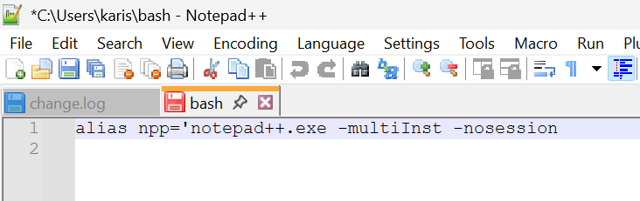

1. To configure the editor, execute the command and To verify if notepad++ is the default editor, execute the command

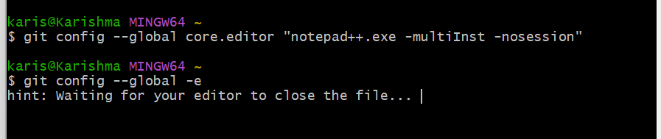

It will show the entire global configuration as shown below,

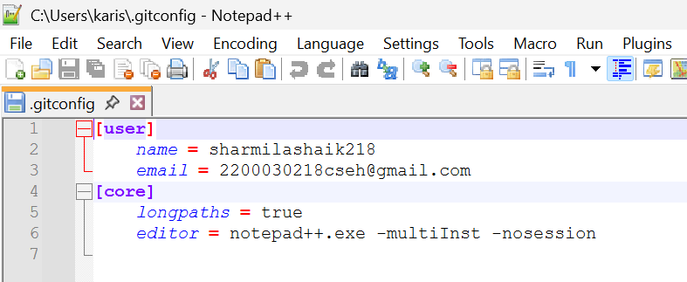

**Step 3: Add a file to source code repository**

1. Open Git bash shell and create a new project “**GitDemo**” by executing the command

git init GitdEMO

ls -al

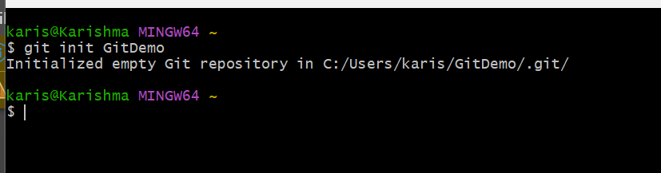

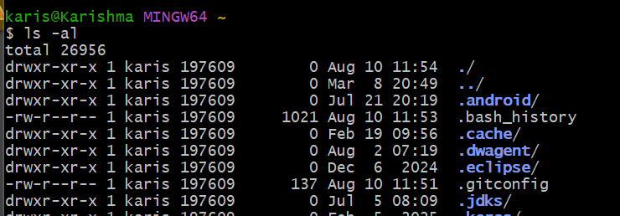

1. To create a file **“welcome.txt”** and add content to the file, execute the command

$ echo "Welcome to the version control" >> welcome.txt

ls -al

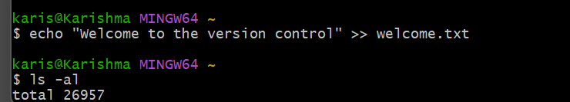

1. To verify the content, execute the command\

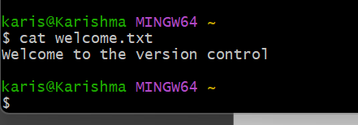

1. Check the status by executing

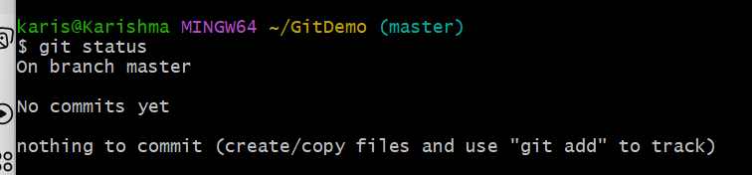

Now the file **“welcome.txt”** is available in Git “working directory”

1. To make the file to be tracked by Git repository, execute the command



1. **welcome.txt** is added to the local repository.

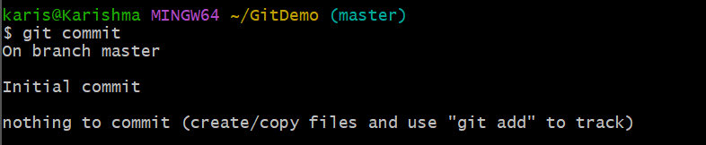

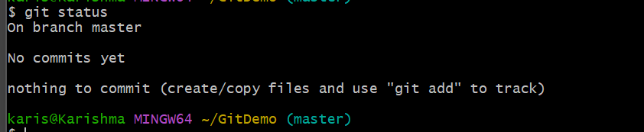

1. Signup with GitLab and create a remote repository **“GitDemo”**

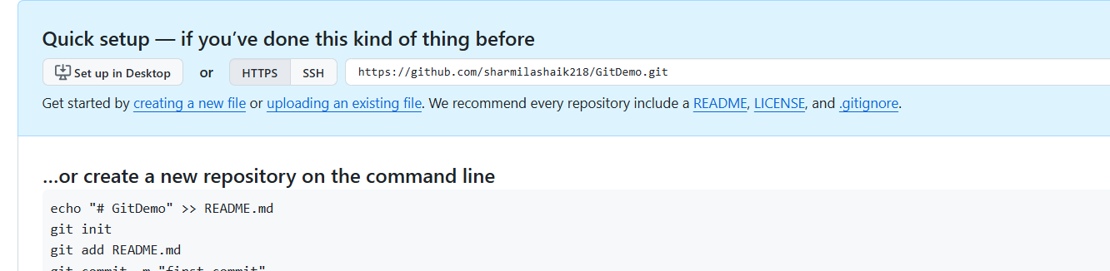

1. To pull the remote repository, execute

git pull origin master

1. To push the local to remote repository, execute

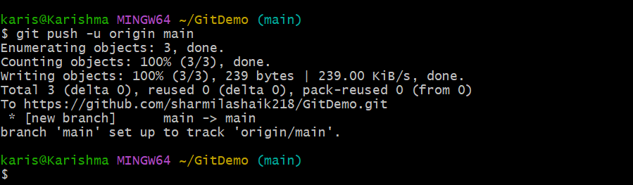

DONE !!!