**WEEK 8 HANDSON : GIT**

**TASK 2 :**

* **Explain git ignore**
* **Explain how to ignore unwanted files using git ignore**

**In this hands-on lab, you will learn how to:**

* **Implement git ignore command to ignore unwanted files and folders**

**git ignore :**

1. .gitignore is a configuration file that tells Git which files and folders to ignore.
2. Files listed inside .gitignore will:

* Not be tracked.
* Not be staged or committed.
* Not be pushed to the remote repository.

1. Useful for:

* Temporary files (.tmp, .log)
* Build outputs (/dist, /bin)
* Sensitive data (.env, API keys)
* System/IDE configs (.vscode, .idea)

**How to Ignore Files Using .gitignore**

* Create a .gitignore file in your project root.
* Add file/folder patterns you want to ignore.
* If the file was **already tracked**, you must remove it from Git’s index before ignoring it.

**Step 1 :**

**Navigate to your Git repository**

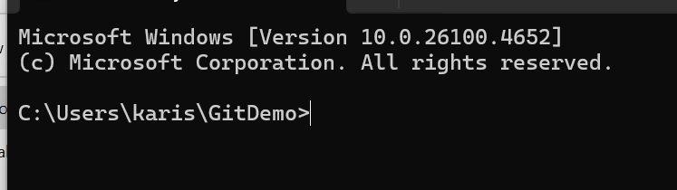

**Step 2: Create a .log file and log folder**

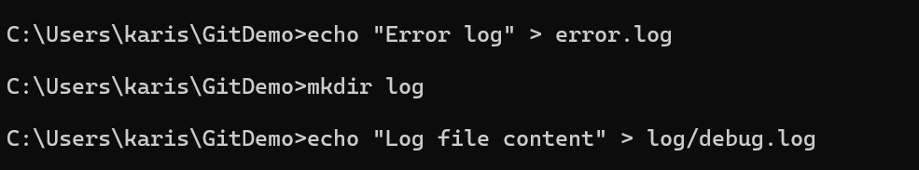

**Step 3: Create or edit .gitignore**

**notepad++ gitignore**

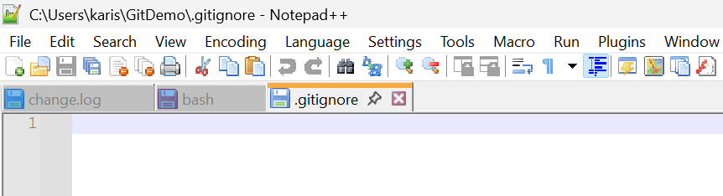

**Mention what to ignore :**

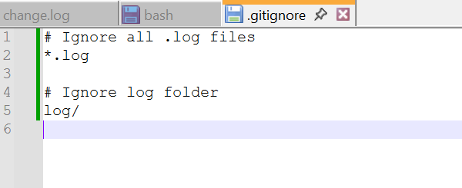

**Step 4: Verify ignored files**

**git status**

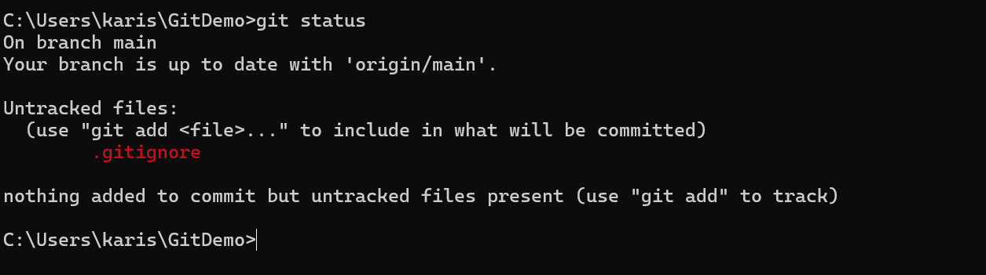

Here we are **not** seeing .log files or the log folder in the list of untracked files ,since we used git ignore to ignore those files

**Step 5: Commit changes**

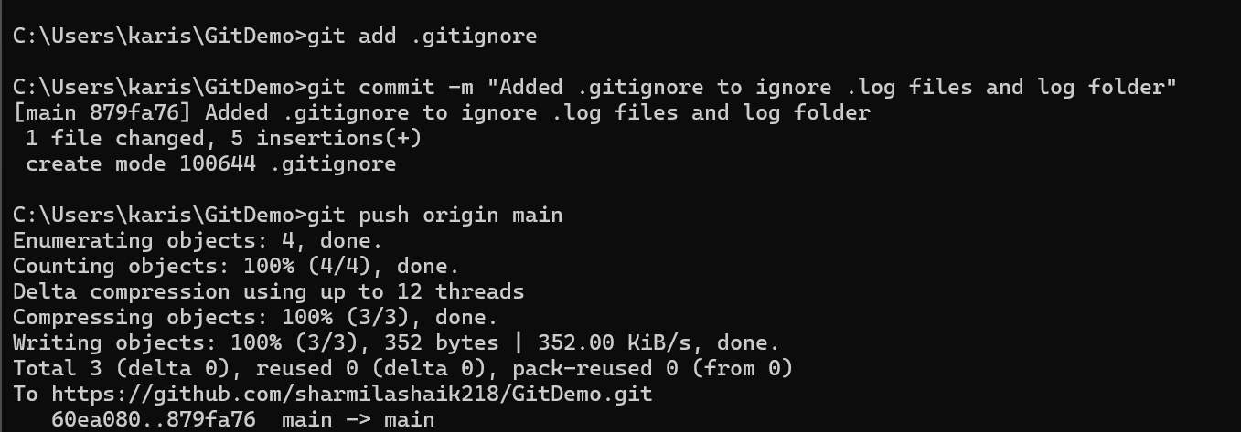

**Step 6: Confirm on GitHub**

* **Open repository on GitHub.**
* **Verify .log files and log folder are not present.**

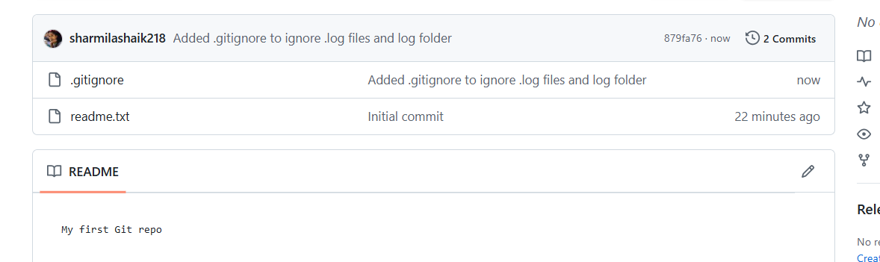

**successfully implemented .gitignore to ignore .log files and a log folder, preventing them from being tracked in Git.**